Homework_10_19_10_20
Solve. Show your steps and check. Circle your answer.
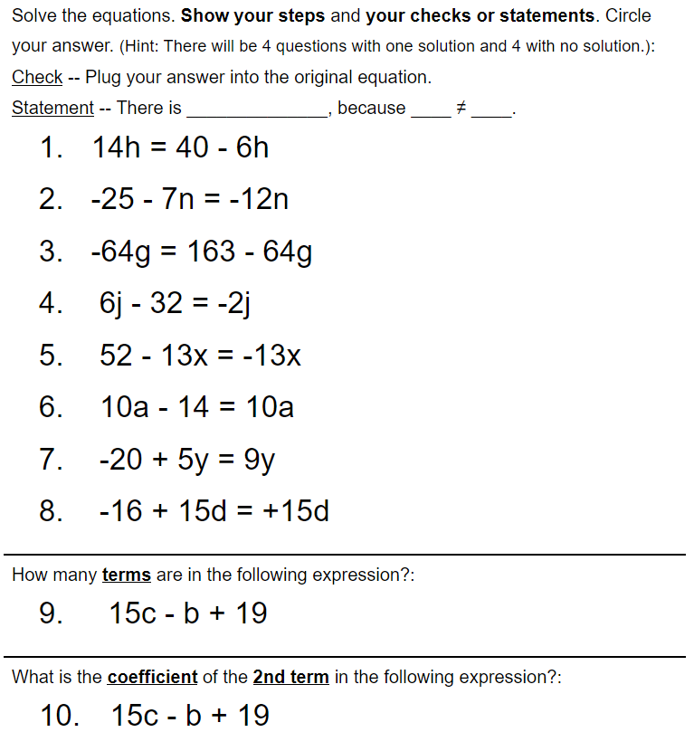

Take a picture and upload (insert) below:

