Project Number: DZT1610

An Interactive Qualifying Project Report: Submitted to the Faculty of
WORCESTER POLYTECHNIC INSTITUTE
in partial fulfillment of the requirements for the
Degree of Bachelor of Science
By

Michael Hellmich

Submitted:
August 14, 2016

Approved by Professor Dalin Tang, Project Advisor

___________________________________________

Abstract

In this Interactive Qualifying Project (IQP), several investment avenues were investigated. It was found that there is no single great investment for balancing risk and reward. A 6-week stock market simulation was performed to test out two different trading strategies. Technical trading made a 22% profit through risky trades, while buy and hold trading steadily increased to a 5% profit. It was learned through this IQP that there are no shortcuts in the world of finance and the best, steady results require time.

List of Figures

Figure 4.5.1....................................................................................................................................26
Figure 4.5.2....................................................................................................................................27
Figure 4.5.3....................................................................................................................................28
Figure 4.5.4....................................................................................................................................29
Figure 4.5.5....................................................................................................................................30
Figure 4.5.6....................................................................................................................................30
Figure 4.5.7....................................................................................................................................31
Figure 4.5.8....................................................................................................................................32
Figure 4.5.9....................................................................................................................................33
Figure 4.5.10..................................................................................................................................34
Figure 4.5.11..................................................................................................................................35
Figure 4.5.12..................................................................................................................................36
Figure 4.5.13..................................................................................................................................37
Figure 4.5.14..................................................................................................................................38
Figure 4.5.15..................................................................................................................................39
Figure 5.1.......................................................................................................................................41
Figure 5.2.......................................................................................................................................42
Figure 6.2.......................................................................................................................................46
Figure 6.3.1....................................................................................................................................47
Figure 6.3.2....................................................................................................................................48
Figure 6.4.1....................................................................................................................................49
Figure 6.4.2....................................................................................................................................51
Figure 6.5.1....................................................................................................................................52
Figure 7.1.......................................................................................................................................56
Figure 7.2.......................................................................................................................................58
Figure 7.3.1....................................................................................................................................59
Figure 7.3.2....................................................................................................................................60
Figure 7.3.3....................................................................................................................................61
Figure 7.4.1....................................................................................................................................62
Figure 7.5.1....................................................................................................................................65

List of Tables

Table 6.1........................................................................................................................................45
Table 6.2........................................................................................................................................46
Table 6.3........................................................................................................................................48
Table 6.4.1.....................................................................................................................................50
Table 6.4.2.....................................................................................................................................51
Table 6.5.1.....................................................................................................................................53
Table 6.5.2.....................................................................................................................................53
Table 6.6........................................................................................................................................54
Table 7.1........................................................................................................................................56
Table 7.2........................................................................................................................................58
Table 7.3........................................................................................................................................61
Table 7.4.1.....................................................................................................................................63
Table 7.4.2.....................................................................................................................................63
Table 7.5........................................................................................................................................66
Table 7.6........................................................................................................................................67

Table of Contents
Abstract 2
List of Figures 3
List of Tables 4
1. Introduction 7
1.1 Goals and Methods 7
1.2 Simulation Program 7
1.3 History of the Stock Market 8
1.4 Investing benefits 8
2 Investment Comparisons 9
2.1 Introduction 9
2.2 Peer-To-Peer Lending 9
2.3 Precious Metals 10
2.4 Real-Estate 11
2.5 U.S Treasury Securities 13
2.6 CD Ladder 14
2.7 Collectibles 15
2.8 Hedge Funds 16
2.9 Silent Partner 17
3 Investment Strategies 18
3.1 Buy and Hold 18
3.2 Technical Trading 19
3.3 Shorting 21
4 Stock Selections 22
4.1 Stock Research 22
4.2 Company Selection 24
5 Trends in Stocks 39
5.1 Yearly 39
5.2 Seasonally 40
5.3 Weekly 41
5.4 Daily 42
6 Buy and Hold Simulation 43
6.1 Week 1 43
6.2 Week 2 44
6.3 Week 3 46
6.4 Week 4 49
6.5 Week 5 52
6.6 Week 6 55
7 Technical Trading/ Shorting Simulations 57
7.1 Week 1 57
7.2 Week 2 58
7.3 Week 3 60
7.4 Week 4 64
7.5 Week 5 66
7.6 Week 6 68
8 Analyses and Comparison 71
8.1 Methods Comparison 71
8.2 Company analyses 72
8.3 Investment Method Comparison 73
References 75

1. Introduction

1.1 Goals and Methods

The goal of this IQP project is to gain practical knowledge of the stock market, which will allow me to confidently trade on my own in the future. I will be looking for trends in the economy during certain times, in order to generally predict when a stock will rise or fall. I plan to train myself to discern reliable information that can be used to make accurate investments as well. I will research and monitor a small group of stocks using day trading and long-term investing. In addition to monitoring at the stock market, I will be researching other investment methods.

1.2 Simulation Program

There are many simulation programs on the Internet. Google, Bing, and other companies allow people to monitor their stock in portfolios. However, Yahoo is a little more convenient and goes more in-depth with its features. It allows one to view basic information like the price of your portfolio and in just one click, one can see a whole yearly summary, news on the company, their statistics, and filings. It allows everyone to research to a higher and faster degree then Google finance. All of this can be done on a smartphone, as well.
I have used both Google finance and Yahoo finance. I believe the latter is far easier to use because there is more content available and it is convenient. It gives P/E ratios and headlines about the companies, which will be crucial for stocks like Facebook and Alphabet since they fluctuate a lot and are well known.

1.3 History of the Stock Market

The history of the stock market begins in Venice in 1300. Local merchants would pass debt and give loans to people as a way to make money from the interest rates. Later on, in the 1600’s, ship owners would ask lenders to give them money for voyages in order to bring back cloth, spices, and sugar because the venture was considered a massive risk due to pirates, weather, and poor navigation. Later, the East India Company offered joint stocks and allowed people to make money off of stocks if the voyage was a success. However, when companies began to lose money, they took down the entire economy. The New York Stock Exchange arose in 1792. Brokers would sell stocks on Wall Street for small promising companies, just starting up. This later blossomed and created other stock exchanges around the world. The NASDAQ was born later and allowed people to trade electronically from anywhere; instead of in the pits of Wall Street. (Beattie, 2007)

1.4 Investing benefits

Investing early in life yields incredible benefits over time. By investing early in your career you can have more money at the end when compared to people who choose to invest later on in their life. Investing early also provides compound returns over a longer period and will result in higher yields and a bigger profit in the end. Studies have shown that people who invest early in their life have far better spending habits, they quickly understand their finances and investments better, and can easily rectify their mistakes early on. (Short, 2004) Investing early on in life also gives flexibility if a person runs into hospital bills or is forced to dip into their savings. Dipping into your savings is always a better option then taking on more credit card debt, which will continue to grow with time.

2 Investment Comparisons

2.1 Introduction

The stock market is not the only investment option available to people. Many consider the stock market to be gambling because people do not know the outcome of the stocks. (Schick, 2003) Many people are hesitant about how to invest their savings and explore different options. I have researched many different ways people may invest their money. Many of these options can have severe risk and could be considered very dangerous financially if a person does not do proper research or keep enough money on hand. However, some of these options could be considered better than the stock market because they give a guaranteed increase in their investments with little to no risk.

2.2 Peer-To-Peer Lending

There are many investment opportunities in the world. One of these opportunities is called peer-to-peer lending. This type of investment allows people to invest in other people like banks. If somebody cannot get a loan from a credit card company or bank they can use peer-to-peer lending to raise funds from other people online. You can get higher returns by backing high-risk lenders who have defaulted in the past. (Wolfe) However, these higher risk people could potentially default on their investors. Although there are many sites for this that say they’re safe and secure, many of them are not secure. People with a good credit score could still default on their investors with a huge amount of money. Many people tend to invest in several small loans with people who have repaid loans in the past in order to reduce their risk. This type of investment is a huge risk compared to traditional investments and is not FDIC-insured, which means the government will not repay the money lost. However, despite all of the risk involved in this investment method, people continue to invest for a good reason. The companies offer a significantly greater interest rate to people compared to banks and are willing to try and find people that default in exchange for large portions of the profit that would be collected if the defaulters were caught.
The peer-to-peer lending companies online, that control membership for their sites, have been slowly letting in large banks that use their employees to make peer-to-peer loans on their behalf. However, this has caused a lot of controversy because this defeats the idea of peer-to-peer lending. Allegations have also risen that these companies tend to make riskier investments and use the resources at their disposal to track down those that default. However, the fact that banks have entered into this market suggests that peer-to-peer lending for the most part can be better than letting money just sit collecting a lower interest at a bank. Companies have recently been reporting better numbers and the larger companies have only about a 1% default rate. Overall this type of investment is very new and dangerous because it is online and hard to enforce, but it is improving and establishing itself as a true investment method.

2.3 Precious Metals

Lately there have been more companies, which gives cash for gold. These companies help support people who have gold on hand and are storing it until the price goes up. Precious metals are not a guaranteed investment. The price of metals can be affected by economic events and it does not always go up under bad economic conditions, as many people believe. Recently, a large number of investors bought actual silver because they believed they couldn’t lose anything with a hard asset. After the government past a few trading restrictions on silver, the price plummeted by 25% in four days, showing the devastating possibilities that could occur with this investment. Beginners must be constantly aware of the price of their precious metals in order to know when and when not to sell it. Another thing to be aware of is the prices of other companies and other products such as platinum, silver, and copper. Many people buy any gold or any silver they see, which is a fatal mistake because that metal could be scrap gold instead of pure gold. (Mladjenovic) Many people get worried about the price of their metal fluctuating and will often sell prematurely. However, people confident with their metal and know the price will rise should try and buy as much as they can at lower prices so when the metals value rises, they will have more gold on hand and have more profit. People can invest in precious metals through the stock market or by having actual gold bullion coins. Physical money usually has less risk in comparison to the stock market, which has more direct types of risk such as a company’s political factor. Investing in gold during bad economic conditions often shows a profit do to concern of the value of a countries currency. In 2009, gold went up almost 24% by the end of the year and has had a stable increase since, which is a record high since the Great Depression. Overall, investing in precious metals is a long-term investment and requires good research in order to know when to sell and what metal to invest.

2.4 Real-Estate

Investing in real estate requires a large amount of capital and dedication. Real estate is more of a long-term investment; over several years. Whether it is renting out a house or fixing up a rundown house, waiting for a profit can be time consuming. Real estate takes up quite a bit of time, when done right. It is very hard to fix a house unless you are a very skilled worker or have a great deal on a plot of land. If someone tries to fix up a house with a few skills then they will have to pay a lot of contractors to help them with their project, which will quickly eat away their profits. Real estate requires a lot of capital because it requires constant upkeep of the properties in order to insure they are up to code and look attractive to prospective buyers. This upkeep came become very stressful to investors under poor economic times and may cause investors to lower the price of the property significantly in order to avoid paying the constant upkeep. Another risk in real estate is whom you sell your property to at the end of the project. Like any other investment investors have to know that the person they are selling to can pay them back. Many banks did not consider this during the 2008 crisis when many people defaulted on their loans for their houses and mortgages. (Tyson, 2015) Investing in large companies can be risky too because they may not have the land yet or may have to go through certain committees and regulations in order to approve their buildings. Getting approval to build from communities can be very hard and time consuming in Florida due to their environmental protection laws. Investing in smaller real estate or living in a house that you plan to flip can lead to smaller risk by spreading out the risk over time by waiting for the price to go up or personally investing into a project in order to have no debt and see all of the profits. Some investors may not want to devote that much capital or time into their real estate investments, so they simply aim to reduce their cost of living buy getting a roommate or renter to share the payments. Renters have become more common and renting can be as good as having a house if investors are concerned with economic conditions in their area. The risk involved with having a roommate or renter will always be defaulting of their payments. However, by interviewing roommate or renters, along with written contracts, the chances of defaulting goes down considerably. Even having a friend as a roommate can save investors money and gives them someone to talk. The biggest determination of a properties value is its location and this is a cardinal rule in real estate and can even determine how hard it will be to build. Overall, real estate requires a lot of patience, constant effort over years, large sums of capital, and requires numerous skills in order to try and repair a house alone. Renting a house can be the safest approach, but no investment is perfect and should be taken seriously in order to avoid as much risk as possible.

2.5 U.S Treasury Securities

US treasury securities are considered to be very secure due to the fact that the US government backs them. The main risk with these sort bonds isn’t that the US government will default on these bonds or go bankrupt. The real risk is with long term maturity, which can fluctuate quite frequently in response to prevailing interest-rates and investor confidence in the economy. (Wild) Although these bonds have very low risk, the yield of these bonds can be very moderate or low compared to corporate bonds because of their stability. One perk of US government bonds is that the interest is off limits to state and local tax authorities. However, people do have to pay federal taxes on them. Treasury bills are short-term investments with low and unfixed interest rates. Treasury notes and bonds are securities that have fixed interest rates and paid at yearly intervals until their maturity. Notes are issued in 2,3,5 and 10 year terms. Bonds are long-term investments with terms greater than 10 years.
Interest rate risk deals with yields for bonds. The higher the yield, the lower the price of the bond and vice versa. Interest and inflation rate changes can affect the yield and over time it is considered that both will go up, which is why long-term bonds have higher interest rates. However, it is important to mention that changes in short term rates have little effect on long term rates and vice versa because they are different time periods and payment intervals that will be effected differently over time.

2.6 CD Ladder

CDs are certificates of deposit and they’re considered the highest yielding government insured investments available to the public. This allows people to grow their investments without any risk. The only difficulty with CDs is that you have to lock in your investment for a set time and take heavy penalties if you choose to withdraw your funds before the maturity date. CDs are similar to bonds in that higher interest rates are with long-term investments as compared to small rates for short-term investments. Many expert investors recommend a ladder approach when it comes to creating an investment. Taking a ladder approach will give you money on hand at given intervals, flexibility with how much you want invest, better interest rates while still having certificates maturing frequently, and the ability a choose whether you want to keep investing in CD’s or go a different route like the stock market during low interest rates. If you had $10,000 dollars to invest, $2000 would be spread out every year for five years on continuously longer terms. After the first year you would continue the cycle by reinvesting in a five year CD. After the first five years, every CD would be considered long term even though you would get annual payouts. (Gower, 2014) This investment requires a lot of planning and a stable lifestyle because you will be unable to touch your investment without getting a massive penalty charge.
Many countries have different rates for CDs because their economies are in different conditions along with their governments. Germany and the US have close to the lowest CD and interest rates in the world because the economies are considered to be very stable and inflation is very low as well. If inflation increases over time than the money someone invested in is worth less and they may have lost money because it couldn’t keep up with the inflation. Higher inflation usually means better interest rates in order to get people to invest. This strategy can be good and with enough investment, reduce the economies inflation and make it more stable, which would make a large profit because the dollar value would be higher at the end of the CD and with the added interest it would be a huge gain in profits. However, another concern in other countries can be governments defaulting or freezing civilians assets and losing the entire CD investment.

2.7 Collectibles

Collectibles can be a very tricky investment however; they can have very big payoffs if you know exactly what you’re buying. It doesn’t matter whether you’re collecting art, baseball cards, or wine. Collectibles can be very hard to liquidate because it can be very hard to find somebody who is willing to buy at a certain price. Unlike the New York Stock Exchange there is no exchange for collectibles. This makes it very difficult for people to sell off their collectibles and liquidate their assets. Another key difference of collectibles is that they don’t have a fixed price. The price of a collectible is determined by the person who is buying the product not by the seller. This can make it very difficult to make a profit because you must have more than one person willing to buy your product. Collectibles can have trends, which make them more valuable at sometimes and less valuable at others. Many experts tell you to invest in a product that you know very well and that you have a passion in. The reason they tell you to do this is because it is very hard to make a profit and you’ll often keep that collectible for a very long period of time, since it will be hard to sell that product at a profit quickly. (Sauter, 2013) Collectibles should be considered as more of a hobby and should not be taken seriously as a long-term investment.

2.8 Hedge Funds

Investing in a hedge fund requires a large amount of capital and almost always requires people to be accredited investors. (Rusak) The requirements to become an accredited investor are having a net worth of $1 million without including your primary property as an asset and making at least $200,000 in the past two years or $300,000 with a spouse. Many people do not meet these requirements and those that do often have to invest $1-$5 million in larger hedge funds. Another downside with hedge funds is that you cannot get the money that you have invested in it until a certain period of time within the year. However, there are even more limitations to hedge funds due to the fact that they cannot guarantee success and have even, in some instances, led to fraud. Hedge funds can be billion dollar companies or million-dollar companies. Recent statistics have shown that million-dollar hedge funds have produced roughly the same results as larger hedge funds and these smaller hedge funds are on the rise. (Sherman, 2000) The option to invest in hedge funds should be left to the wealthy people who can afford to meet all the requirements and still have cash on hand to live their lives. It would be very dangerous financially to go without a safety net for months at a time.
Billion dollar hedge funds get a bad reputation and get investigated for fraud because they frequently bully small countries or business that are weak and sue them for higher payments. These companies have been called “vulture” funds and have targeted Greece, Argentina, Detroit, and Puerto Rico. They first buy discounted bonds and then force these places, through legal action, to pay on par in order to make huge profits. These funds make economic situations even worse and make it difficult for places like Greece to recover. One other strategy that big hedge funds can use is mud slinging. The hedge funds will short healthy businesses and then claim that they are about to collapse and rely on their reputation to get people to sell so the stock will go down considerably and make a good profit. However, these strategies can only be used by big hedge funds since they are powerful and shouldn’t reflect upon smaller hedge funds that genuinely play the stock market.

2.9 Silent Partner

Another investing option is becoming a partner in a new company. Silent partners do not have any responsibilities with day-to-day operations of the company. Silent partners simply invest in a company that they have thoroughly researched and trust. The only work involved in this investment option is the research beforehand; which is critical to the investment. The investor has to have a company that they can trust completely with their investment because their investment is going to be very large and all in one pot. Investing most of your money in one place is a heavy risk with any company because every company has a chance of going bankrupt. (Gull) However, silent partners have to do almost no work after their initial research and investment into the company. Once they are invested they may get a steady stream of income from the company they have invested in and continue to do so until they are bought out by the company or leave. Many silent partners have to sign contracts assuring companies that they will not interfere with the company even during financial trouble. However, some owners will try to include silent partners as a way to make them feel included on their investment if they want more say in a companies direction. This investment option can be very lucrative if the right company is chosen and it is fairly new, so it will not require a lot of money to become a silent partner. It is nearly impossible to become a silent partner with an older and well-established company.

3 Investment Strategies

3.1 Buy and Hold

Long-term investors who don’t want to monitor their stocks on a daily basis often use this trading method. All the work for this method is researching the stocks before purchasing them. Also, by holding onto the stocks over a long period of time, investors do not have to worry about commissions and have fewer fees. This method involves investing in the actual companies themselves because the objective is to catch a company that is expanding and growing in an industry. However, always look for or wait for a good deal to buy the stock. If a stock is bought at it’s highest point of the year then it will take years before that will become it’s average price and investors will lose out on all of the potential gain they could have had if they had waited for the ideal time. Another big factor for this method is the state of the economy over a long time. Several articles have shown that the stock market will actually go within 1% of its opening price several times throughout the year. This means that the stock market rarely has significant growth to give an adequate profit over long-term investments. However, investing in companies which meet certain factors have been shown to make a good profit over time. Companies must have control of a vital product, which wouldn’t be cut by people during a recession. (Laura, 2012) They also need to have a great management history in order to continue to expand and avoid wasted opportunities. These companies should also show a constant growing annual trend and have reasonable balance sheets and financial statements. Another thing to heavily consider is if a company shows a significant loss, it should only be due to aggressive expansion and have a history profit afterwards. These factors can significantly help an investor to predict a company’s success over a twenty-year period. It has been repeatedly been shown that buying and holding stocks over long periods of time is usually better than going with expert hedge funds because many can’t outperform the DOW and S&P 500 indexes. This method is rather low risk with low-medium profits, but the biggest challenge will to be patient even in a time of economic instability. The risks involved with this method include a company going bankrupt, shut down by fraud, or being destroyed by scandal. These risks may seem rare, but GM was considered to big to fail and it went bankrupt anyway and after 2008 many executives were tried for fraud. Investors should keep these events in mind when they think about selling.

3.2 Technical Trading

The key aspect of technical trading is keeping track of long-term charts for both long-term and short-term trends. Short-term charts can often be deceiving and won’t give the full view of the stock in question. Only using short term charts will limit the trend history of the stock and make the trends seem quicker and more unstable than they actually are. Using a technical trading method for day trading requires a lot of research into daily and intra-daily charts in order to estimate specific trends in time. A good time to buy and sell stocks is at supportive and resistance levels of the stock over the previous days and weeks. (Murphy) Other critical factors are keeping track of moving averages, drawing trend lines, and looking for convergence and divergence movements. (Brakke).
A crucial part of technical trading is analyzing indicators of a stock like moving averages (MA), Relative Strength Index (RSI), volume trends, and moving average convergence and divergence (MACD). These indicators are the tools technical traders use to predict which stocks will have positive or negative future trends. Technical trading is all about the charts and numbers so it is necessary for an investor to know about all the indicators they will use and be able to read when they should buy or sell based on indicator readings.
Using at small moving averages will help an investor look at the long term trends of companies because an average with more data points will give a better representation for a prediction as opposed to using it for day trading with varying data points. Moving averages have been also used to make other indicators as well like the MACD. However, moving averages can only give information to a certain point. An investor has to take a risk that something won’t change the average dramatically, which can occur when companies release-earning reports.
Relative Strength Indices are line graphs that try to chart the value of a companies stock compared to the actual stock market price. These charts are quite accurate at predicting ups and downs. This accuracy may be due to the fact that the indicator doesn’t recommend sell until it reaches 70 points and buying at 30 points in order to allow room for error and minor changes. This indicator can work well in a financial crisis because it will give a better value of a company compared to the price. However, this indicator can be misleading if a company is growing or heading towards bankruptcy. This occurs because it can’t tell if a stock is simply rising because something happened or if the company is growing and has a naturally growing stock price.
Volume trends are good indicators to look at to see changing trends. If more people start buying a stock consistently then the stock will have a steady rise. It will occasionally go down, which may mean a trend is changing or it is just a bad trading day. Regardless of how the volume changes, it is a better way to look at and predict a familiar stock then just looking at the change in price.
Moving average convergence and divergence is a great indicator to look at for long-term intervals and is even good with day trading as well. This accuracy is due to the use of both short and long term average comparisons. If the short term average crosses above the long term average line then this indicates it is a good time to buy stock and vice versa. This stock is very familiar in technical trading and is most accurate during normal business days when dramatic changes are not likely to occur and skew the averages.
Overall, technical trading is a great method to use when companies are having normal business days. Earnings reports and other news coverage are the only things that can’t be predicted from the indicators and investors should consider this when using this method in order to avoid trading on these unpredictable days.

3.3 Shorting

Shorting a stock means that the shares will be sold and the proceeds will go to the sellers account. However, the same amount of shares has to be bought back at some point in the future. It is possible to profit from this by buying back the stock at a lower price and profiting from the difference. (Picard, 2003) The methods to shorting a stock are quite similar to buying stock and the only key difference is looking for the opposite signals. Technical trading can show trends in stocks, which may determine when they will rise or fall. If there is a clear indication that a stock will go down, it isn’t necessary to look at other stocks to invest. Shorting allows people the option to buy and sell stocks that are closely monitored and saves time in looking into other stocks during a low period in the economy. Shorting can benefit any trading method and should be used in a similar fashion to buying stock because it allows stocks to keep moving even during low periods. Shorting stock should be equally effective if the research and methods from buying stock don’t change. However, it can be hard to receive payment if a company goes bankrupt and it is also possible that the government can bail a company out to prevent it from failing completely.

4 Stock Selections

4.1 Stock Research

I began my research for stocks by analyzing what type of stocks I would need for each method. For buy and hold investing, my research led me to believe that I should look for newer companies that have shown promise and expansion in their industry. I also considered older companies that had very little debt because they would be less likely to expand do to the fact that they are quite large already and wouldn’t want to risk going into an unknown market. (Schick, 2003) I also looked for companies that had a product that everybody needed and wasn’t considered a luxury in order to get business with constant sales throughout the year. I also considered a companies P/E ratios, which determines that a higher P/E will give less profits, as a way to find stocks that would yield higher profits. However, larger companies tend to have higher P/E ratios despite the fact that they show increased growth. I even looked at recent news, chart indicators, and their revenues in order to make sure they would have a positive long-term trend during the simulation. After considering these factors for my long-term investing, I looked for about ten stocks that best fit the descriptions above and showed large profits in the last three months.
My research for good day-trading stocks told me to find stocks that fluctuate frequently because this can lead to sharper rises then stable long-term stocks. However, penny stocks are very risky and considered to be very dangerous because they are very unstable and believed to have many cases of fraud. I decided to look for stocks, which cost more then penny stocks, fluctuate on day-to-day or weekly bases, and have a little less stability then my long-term stocks. After looking at weekly trends, I came up with a list of eight stocks that best fit my descriptions. I noticed that these stocks were very well known, so news coverage could be a cause for fluctuation. The news coverage will probably make it hard to predict these stocks using technical trading, but I also noticed that usually only scheduled reports affect their stock price significantly. They also happened to cost a large amount per share, which would give it stability. In addition to looking for good day-trading factors, I started to do research for technical trading on these stocks. I noticed that most of the stocks had a history of stable growing volume, MACD, moving average, and stable RSI trends that would allow me to easily predict how well they would do over a long period of time in order to avoid constant research.
When I was pick my stocks, I decided that I should grab a variety of different companies ranging from internet businesses to grocery store chains in order to avoid a huge loss if the tech sector had a crisis that brought down other tech stocks. By diversifying my portfolio I will also be able to use my research on precious metals to help predict gold trends in gold companies I picked. Another reason why I diversified my portfolio was to spread out my investment to avoid investing in one stock with all of my investment in it. I believe all of my research and careful planning will allow me to adequately reduce my risk and bring higher profits by the end of the simulation.

4.2 Company Selection

Buy and Hold stocks:
Amazon
This company sells and ships online goods ranging from books to food. It has also been expanding into other industries like television, online gaming, and more. It competes on a global scale by finding new customers and evolving industries. It has shown a very steady and large increase over the last year and it has a huge P/E ratio, which is because it has great growth prospects. In addition, it does not have a bad reputation or debts (see Fig. 4.5.1). Its Volume trends have been going up based on long term charts and its SM keeps climbing as well. Its RSI is a little misleading considering how it continues increasing in value. Overall, it seems like a great new company that has many ambitions.
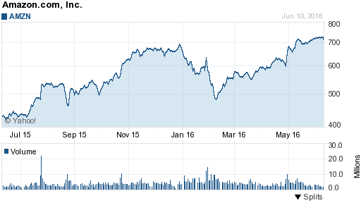
Figure 4.5.1 Amazon 1 year price chart from June 10

Bristol-Myers Squibb Company
This is a biopharmaceutical company that discovers, develops, and delivers brand new medicines to people. Its products are not directed at one disease in particular, but it has targeted several different cancers. It has ten products, each of which makes one billion dollars in sales annually and shows a gradual increase over time (see Figure 4.5.2). Drug companies can be a bit of a gamble because they cannot truly expand unless they produce new viable drugs. However, this company has many drugs that have worked and produce annual income and it has several drugs that have been developed and are awaiting approval from the government. Their stock has gone up in the last few years and their management shows signs of expansion. Several of the indicators I use show the stock has an upward trend including SM and MACD averages.
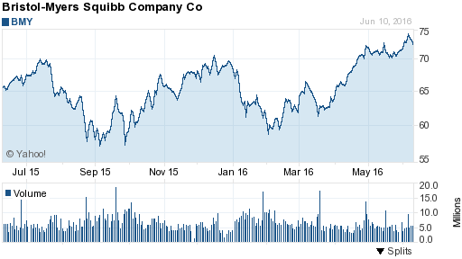
Figure 4.5.2 Bristol-Myers Squibb Company 1 year price chart from June 10

Mead Johnson Nutrition Company
This company sells regular food to people and is well-known for producing nutritious baby formulas around the globe. It has a major focus on nutrition and it continues to develop products for people with food allergies or other conditions. This strategy of monopolizing the food market for rare food disorders has helped it. It has a rising P/E ratio and some bad publicity, but it has shown an impressive gain in the last month (see Figure 4.5.3). Its products are also essential and it has a huge number of customers annually, which suggests it will be around and growing for a long time. All of its volume trends and moving averages look good as well, this company would make a great asset and may even be the biggest competitor in the food industry if it tries to expand to other markets.

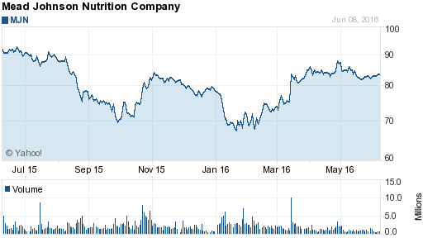
Figure 4.5.3 Mead Johnson Nutrition Company 1 year price chart from June 10

Microsoft
This is a software producer, which has a very well known brand due to their worldwide success with Microsoft Word, Excel, Office, and Power Point. It releases new software programs used by millions around the world and its brand is so reliable that few people switch from their products. Microsoft also has goals of developing AI and other technology to gain control of future markets. It is also growing and rather stable throughout each year due to its continued earnings with its software. Its past performance is shown below in Figure 4.5.4 and shows a steady stock price. However, the volume and moving average indicators still show it is having upward trends and its management’s ambitions may lead to a breakthrough and propel this company further.
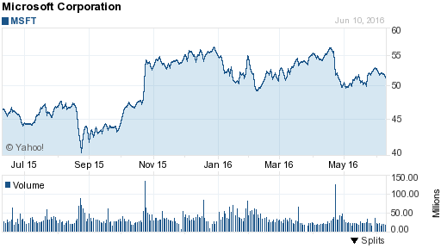
Figure 4.5.4 Microsoft Corporation 1 year price chart from June 10

Shopify Inc.
This company helps people set up an online store to sell their products to customers in exchange for a minor commission. It also is a great organizational tool, allows credit card payments, and tracks customer orders making it easy on consumers and encouraging business. This company is on an upward and stable trend, which fits with its low P/E ratio. As shown in Figure 4.5.5. The indicators for this company have shown upward long term trends and show signs of its expansion in the market place. The management of the company is rather new and has had some minor mistakes, but it displays a solid platform that has found a market with small businesses.
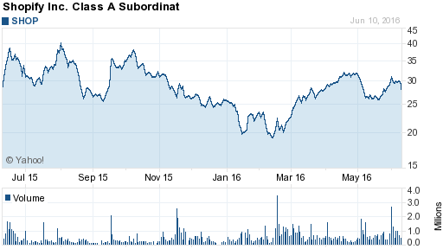
Figure 4.5.5 Shopify 1 year price chart from June 10

Whole Foods Market Inc.
This company sells organic food to the public, which is an alternative to GMO foods sold by other grocery stores. It is a certified organic retailer and makes millions annually due to its reputation and consumer base of health advocates. I believe that this company will get increasing attention as people grow aware that healthy living can prevent heart disease, which is the biggest killer in America. It is projected to keep growing at a steady pace (see Fig. 4.5.6) due to people switching to a healthier lifestyle and its convenience in many cities. The indicators for volume and long term moving average changes predict that it will continue to increase annually at a reliable pace. The management of the company is good, but they have to make sure that their stores pass all FDA tests in order to maintain its reputation and customers.
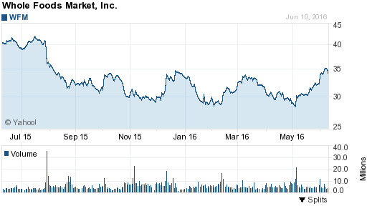
Figure 4.5.6 Whole Foods Markets 1 year price chart from June 10

W.R. Berkley Corporation
This is a Fortune 500 insurance company that has a well-known and respected reputation in the business world. This company sells every type of insurance that businesses need and they have a huge client base of international businesses. It supports many countries and even backs other insurance companies. I believe this business is well established and ever growing in several marketplaces throughout the world. The volume, RSI, and moving averages have been showing a stable growth over the last month and are estimated to keep rising. It has a modest P/E ratio and is quite stable (see Fig. 4.5.7) considering how diverse and necessary their company has become.
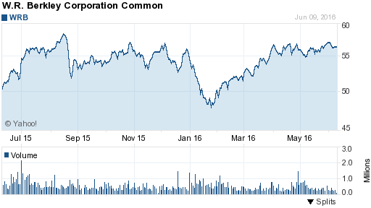
Figure 4.5.7 W.R. Berkley Corporation 1 year price chart from June 10

Technical Trading Stocks:
Apple
This is a very famous hardware and software company with their best-known product being the iPhone. It is a very well-known company with signs of continued growth through advancing technology. Its new management has been developing new ideas to keep it the leader of the technology sector. It has had a steady rise in the past month (see Fig. 4.5.8) and stable growth in the long term. All indicators still show a rise in investors buying stock and the long-term moving averages look promising. This business is deeply rooted throughout the world and I believe little could go wrong by investing in them due to their brand recognition.
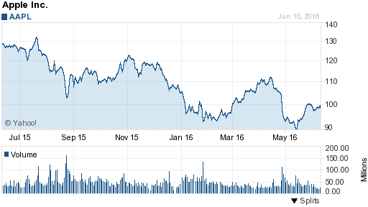
Figure 4.5.8 Apple 1 year from price chart June 10

Facebook
This company runs a social network and gets paid by other companies for advertisements on their website. A possible concern is that if people put ad blockers on their computer, companies may stop supporting Facebook. Although it is an established social media company, many other new social medial companies have been created and may replace it. However, Facebook is still doing well and has many clients that are unmatched by other social medial companies (see Fig. 4.5.9). The indicators for Facebook show that it does grow slightly on annual basis. The management has made some mistakes, which could lead people away from Facebook. Facebook has a slightly higher P/E ratio, which reflect its growth prospects.
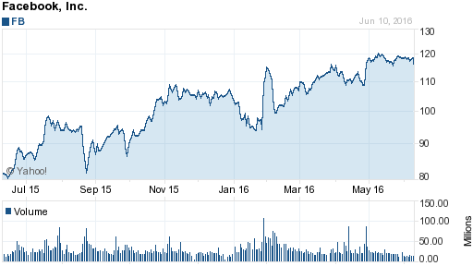
Figure 4.5.9 Facebook 1 year price chart from June 10

Franco-Nevada Corporation
This company operates as a gold-focused royalty and stream company in the United States, Canada, and more. It also has hundreds of other assets in various metals, minerals, and oil. This company has extensive lobbying, which indicates that its management knows how to expand and keep its controversial investments in various countries. It has a tremendous P/E ratio due to its declining value from the stock markets recent highs. However, it has risen significantly in the past year. I believe these indications mean it will have a stable rise over my entire simulation, but it could do poorly long term after the simulation. It fluctuates a bit on a weekly basis allowing day trading if I want to try short-term investments (see Fig. 4.5.10).
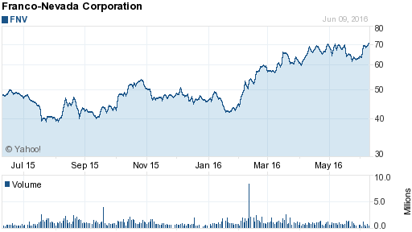
Figure 4.5.10 Franco-Nevada Corporation 1 year price chart from June 10

Alphabet
This company runs the Google search engine and gets funding from other companies who pay to have their company show up first on search results. Alphabet is a very well known giant and it is worldwide with many well-established clients. This company is not going away and shows signs of growth in other markets to stay competitive with other companies. The indicators show a steady annual growth and investors buying stock regularly (see Fig. 4.5.11). Alphabet has great management and Goggle has great brand recognition.
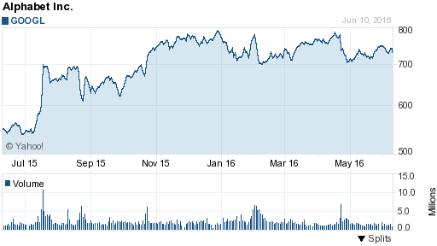
Figure 4.5.11 Alphabet 1 year price chart from June 10

Netflix
This company runs an online movie rental company that has millions of daily streamers. Netflix is still a growing business and was ranked in the top five for most streamed companies. It has been trying to expand with their own television shows and movies. It has many deals with other companies to run their business with more efficiency and security. It also provides regular updates to keep their services advanced. It has a huge P/E ratio and it has gone down last month, which would make it a good stock to short on occasion. (see Fig. 4.5.12). However, it has a long-term gain and indicators show that it will keep rising at its current pace. The RSI even indicates that it may be slightly undervalued and due to rise.

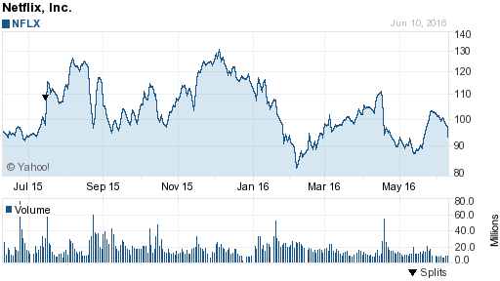
Figure 4.5.12 Netflix 1 year price chart from June 10

Nova Gold Resources Inc.
It is a mining company that searches for gold, silver, and copper. It has 50% interests in many other companies as well in order to expand its network and influence in other countries. It has a low price and indicators put it as unstable due to many highs and lows year after year. It could be an excellent stock to short to test out the shorting approach to the stock market (see Fig. 4.5.13). However, I also want this stock in order to have a diverse portfolio that will be able to handle a financial crisis. The management also looks promising, but mining can be tricky and they could run out of resources in the long run.
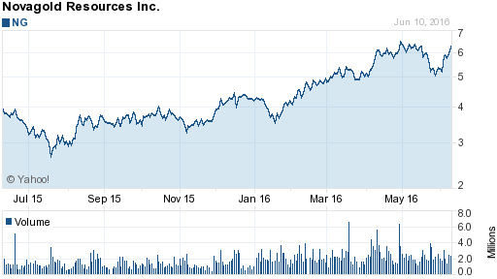
Figure 4.5.13 Nova Gold Resources 1 year price chart from June 10

Tesla
This company produces electric cars in order to revolutionize energy and fuse AI technology with cars. It has had mixed reviews, but it continues to develop many new features and more affordable cars. This company also received government backing and shows signs of expansion. It is rather unstable and the indicators are a little unpredictable due to constant annual fluctuation. However, it could be another good stock to short and observe the trends of a major automobile company (see Fig. 4.5.14).
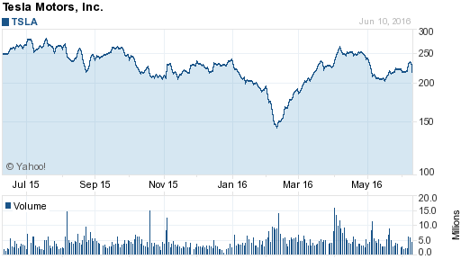
Figure 4.5.14 Tesla Motors 1 year price chart from June 10

Yelp
This company runs a platform that connects people to local businesses for insight into the service they provide their clients. This is a great tool that people can use to rate businesses and it is a well-respected brand that carries weight with customer satisfaction. It is having a good month and it fluctuates a little bit. The price per share is also low, so fluctuations would have a tremendous effect on a large volume of shares (see Fig. 4.5.15). The low price per share is attractive because it would allow flexibility to purchase various amounts of stock.
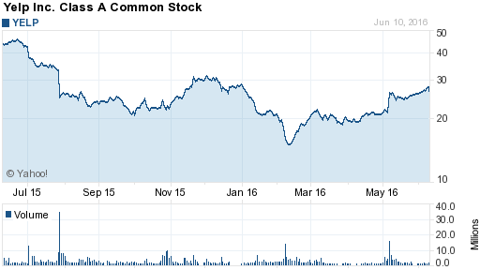
Figure 4.5.15 Yelp 1 year price chart from June 10

5 Trends in Stocks

5.1 Yearly

Statistics have shown that the stock market doesn’t vary a lot year after year over a fifty-year period. The only statistically significant trend over a long period is an election cycle trend in the stock market. This theory goes back a long ways and may symbolize the effect of politics on the stock market. (Baden, 2011) However, this theory requires a little background and history into politics to understand the full power governments have over their respected economies.
All throughout history politicians have noticed that when times are tough and trade goes down, people blame and often rebel against the politicians holding power. This can be seen in ancient Rome. When it was on the verge of falling apart the politicians would have gladiator battles and try to distract people through this tactic of bread and circuses. President Hoover is a great example of a politician being blamed for the tragic economy of the time and being quickly replaced. Manny people associated his name with poverty like a person pulling out their pockets with no money and calling them Hoover flags. Hoover eventually lost 49 of the 50 states in the election.
Politicians do everything they can during election years to boost the economy in order to win their upcoming elections despite the possible downsides it could have to the economy and country. This has been statistically proven by looking back at 60-year periods. (Griswold) The two years leading to an election have always been positive from 1942 to 2002. The worst economic period of time occurs 75% of the time during a presidents second year in office when his position is secure. (Burton, 2010) Test simulations have always shown a positive gain over the two years leading to a presidential election as shown in Figure 5.1. 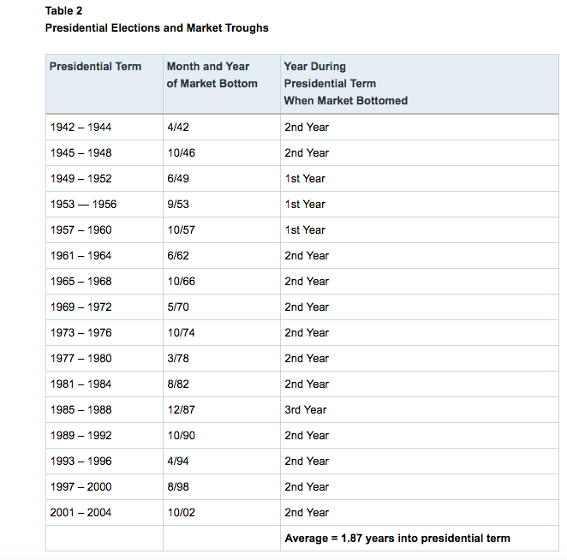
Figure 5.1 US Stock Market Election Cycle Trends from 1942-2004

5.2 Seasonally

The summer has been rumored to be a bad time to sell because stocks are at their lowest point during the year. (Yang) Over a forty-year period from 1970 to 2010 a decline in performance can be seen throughout summer and a rise after September in Figure 5.2. 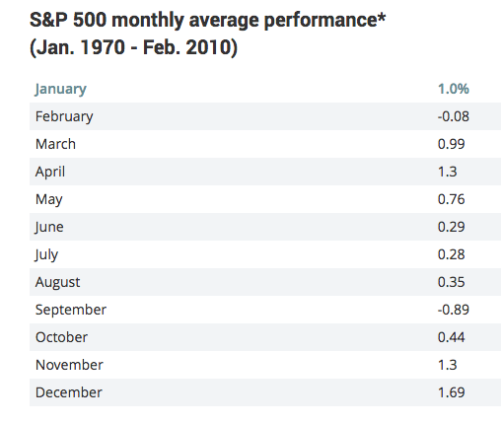
Figure 5.2 S&P 500 Individual Month Performance from 1970-2010

Another occurrence happens on a monthly basis. Many trades occur during the end and beginning of a month and the strategy is to buy at the end of the month and sell three to four days into the new month. The statistics are only good for this trend during bad economic times and it has less risk then holding year round. However, profits are much lower during good years as compared to holding.

5.3 Weekly

Friday afternoons tend to end on a slightly weaker stock because stock brokers want to avoid any type of risk over the weekend. The types of risks they are avoiding are events that could affect a company in a way they did not anticipate. For example, a company could be forced to recall their product over the weekend and force that companies stock to plummet before the stock market opens. (Nickles) However, this can allow investors a lower price on stocks that they predict will rise over time and make a larger product. (Utermohlen, 2016)

5.4 Daily

Many stocks have a lot of trades at the beginning and end of the day. This is due to avoid risk after hours and to buy stocks low or short them quick in the day. Another trend is a lull in the noon until as late as two because traders are having a lunch break and are not buying at the time. This can allow someone to buy a stock during the day at a lower price at one than at eleven in the morning. (Curtis, 2007) A rare occurrence also happens during the day but it has to be caught very quickly because it is a spike that does not accurately match the price of a stock. When a big buyer like a hedge fund manager buys a large amount of stock, the price of that stock will temporarily rise for a few minutes due to the massive volume increase. (Fuhrmann, 2016) Seeing these spikes is easy and can make a big quick profit, but it requires total attention on a stock throughout the day and quick trades to get the price in time. One last trend is holiday trends. A few days before a holiday like Christmas, investors buy stock because of shopping deals over a holiday. These trends don’t last long and don’t yield big gains, but they are very likely to happen statistically and even new investors know this strategy.

6 Buy and Hold Simulation

6.1 Week 1

This week I mainly spent my time reviewing the group of stocks I selected and deciding on when they would be at their lowest point. I reviewed stock prices over the past five years and then looked at the summer periods to see what price would be considered low. I used the relative strength index to determine if any were undervalued so I could buy them now and have them the rest of the simulation. However, I was also willing to consider other stocks that were close to 50 points because I wanted to see how much the average RSI value would change over the simulation. I also looked at volume trends to see if the stocks were believed to be low by investors themselves. This method wasn’t as useful though because it doesn’t work well for long-term trends. My research shows that volume trends are generally more accurate over daily and weekly intervals. My moving averages were generally used to help me determine a buying price for the stocks. However, the MACD helped provide me with the general trends of the companies and how they may perform over the next three months. I only bought a few stocks because it is very important to choose when you buy and sell a stock that you keep for a long-term investment as shown in Table 6.1. For these stocks, I am trying to buy on the opening and closing positions of the stocks because I am trying to take advantage of daily trends, i.e. looking for investors to sell and drive the price of the stock down. There wasn’t any material news this week that I thought would affect the stock prices I have been watching. My companies have been on a normal routine and there are no warning signs for any of the stocks that I have picked for my portfolio.
One thing I really looked for in choosing my stocks was the trends from the previous month and week. If it had a large increase then I decided to wait until it falls and buy it at a lower price. The other stocks seen below show small rises or minor losses, which led me to believe they would go up if they were about even, due to the fact that they all are estimated to grow.

Date | Symbol | buy/  Sell | Price | Shares | Net Cost/  Proceeds | Profit/  Loss | Total  Cash | Total  Profit
05/31/16 |  |  |  |  |  |  | 500,000
05/31/16 | AMZN | Buy | $712.33 | 200 | $142,467 |  | 357,533
05/31/16 | BYM | Buy | $71.50 | 500 | $35,751 |  | 321,782
05/31/16 | MJN | Buy | $82.29 | 500 | $41,146 |  | 280,636
05/31/16 | WFM | Buy | $32.11 | 1000 | $32,111 |  | 248,526
Table 6.1 Weekly Transaction Record

6.2 Week 2

This week I was able to get all but one of the stocks on my list at what I believe to be low and reasonable prices. I did not buy Shopify because the trend kept going up and there was a volume increase, which has shown to be a small spike followed by a drop. The RSI for Shopify also didn’t give any indication to buy or sell and was actually close to 50 points. However, the RSI may not be the best indicator and could be to slow to anticipate a quick change in trend. The MACD went has shown slight upward trend, but the short term moving average was above the long term moving average indicating an upward trend. The MACD signal told me to buy the stock this week, but I believe buying it this week would have been buying it close to it’s peak and decided to wait for a definitive downtrend. It is very important to buy the stocks at the right time and price in order to get a good profit at the end. It is hard to earn a large profit using this method because the stock market usually doesn’t grow a lot annually, and it can be heavily influenced by the economy.
I believe that buying these stocks at these prices, as shown in Table 6.2, will allow me to ride out any slumps in the stock market and allow me to earn a little money with relatively little risk involved.
During this week I have been monitoring the stocks that I bought last week and I am happy to say, that despite a harsh last day, everyone of my stocks went up and I have made roughly a $5,000 profit. I looked over all of their volume changes, RSI, MACDs, and SMs in order to predict how they will do next week and I believe nearly all of my stocks will go up in the beginning of the week and start to fall into a downward trend. This downward trend prediction makes sense considering how well all of my stocks have done this week and may effect Shopify enough to lower its price and buy it. I know this prediction is bad but this week is rare and I don’t expect it to last since the stock market fluctuates quite a bit and has unique trends for every company. I am very proud of my Amazon stock, which has gone up $5.58 as shown in Figure 6.2. However, I am amazed at the huge fluctuations because it had a high of almost $732 on Monday.

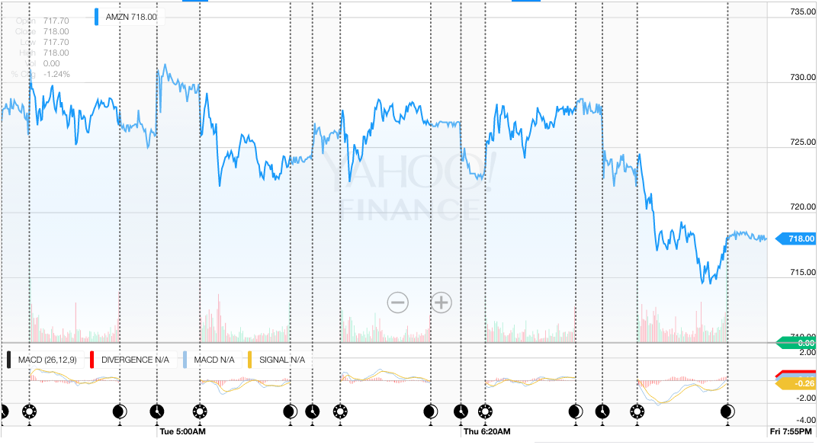
Figure 6.2 Amazon MACD and price chart from 5d 6/06-6/10

Date | Symbol | buy/  Sell | Price | Shares | Net Cost/  Proceeds | Profit/  Loss | Total  Cash | Total  Profit
06/06/16 |  |  |  |  |  |  | 248,527
06/10/16 | MSFT | Buy | $51.01 | 2000 | $102,021 |  | 146,505
06/10/16 | WRB | Buy | $56.02 | 1500 | $84,031 |  | 62,475

Table 6.2 Weekly Transaction Record

6.3 Week 3

This week was generally a bad week to be trading. I also discovered in my recent research into stock market trends that I am trading in summer, which usually goes down over time. I should have shorted stocks since I am only trading in the summer, and relied on lower trading volumes to lower stock prices and make a profit. I have looked at my indicators in order to predict what will happen next week and I believe that about half of my stocks will start to rise while the others will continue their downward trend. The RSI indicator is reading below 50 points for most of my stocks, which leads me to believe that an upward trend is coming late next week or even into the following week. The MACD and SM are both indicating a downward trend with a negative slope. Even the volume changes are showing more selling than buying. This is a hard thing to witness and has given me more insight into how stressful this job can be and how fearful emotions could overpower logic and lead to worse actions. However, this method only allows me to hold so I am unable to change anything-let alone short Whole Foods. Whole Foods received a warning from the FDA about the food they were selling, which is a massive part of their company. Their price per share has been plummeting ever since the announcement and doesn’t look like it will recover anytime soon as seen in Figure 6.3.1.

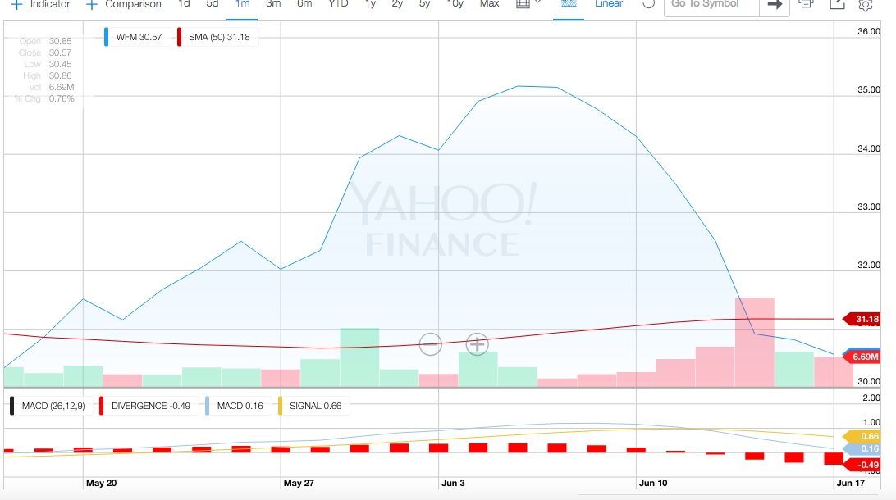
Figure 6.3.1 Whole Food Market MACD and price chart 1month 5/17-6/17

All of my other stocks, besides W.R. Berkley as seen in Figure 6.3.2, have gone down this week as well. Other minor bad news came from Bristol-Myers Squibb because government drug officials have been criticizing all cancer companies for not looking for cures and instead just researching ways to prolong life. This was a black mark on the company and made many believe that they were possibly committing fraud. This would explain why the price fell this week but showing a recovery.
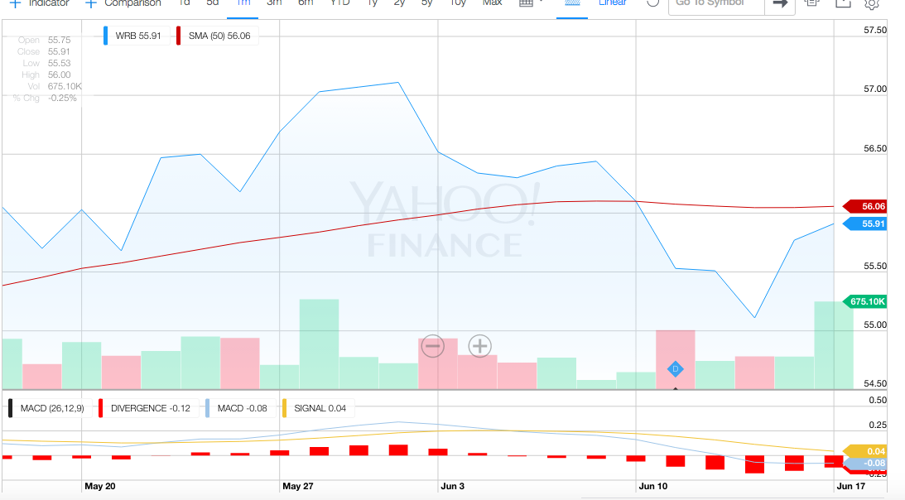
Figure 6.3.2 W.R. Berkley MACD and price chart 1month 5/17-6/17

I have also realized that it may not have been a wise idea to get a stock like Amazon that fluctuates so radically. It lost more than ten dollars per share for no reason other than simple fluctuation. I have a net lost of nearly $3,200, which is actually staggering considering how well my first two weeks of trading went as seen in Table 6.3. I expect Whole Foods to continue to sink and it will be very hard to make a profit with the other companies on a downward trend as well.

Date | Symbol | buy/  Sell | Price | Shares | Net Cost/  Proceeds | Profit/  Loss | Total  Cash | Total  Profit
06/10/16
06/13/16 | AMZ |  | $712.33 | 200 | $142,467 |  | 357,533
06/13/16 | BMY |  | $71.50 | 500 | $35,751 |  | 321,782
06/13/16 | MJN |  | $82.29 | 500 | $41,146 |  | 280,636
06/13/16 | WFM |  | $32.11 | 1000 | $32,111 |  | 248,526
06/16/16 | MSFT |  | $51.01 | 2000 | $102,021 |  | 146,505
06/16/16 | WRB |  | $56.02 | 1500 | $84,031 |  | 62,475

Table 6.3 Week 3 Transaction Record

6.4 Week 4

This week for buying and holding I decided to purchase my final stock Shopify (SHOP) because I finally caught the stock at a low price. This week absolutely wrecked my stocks and now I am down on nearly everyone one of them except Mead Johnson Nutrition and Whole Foods. Mead Johnson Nutrition managed to have a positive profit this week because it had a great beginning to the week and began to fall on Friday. Whole Foods on the other hand was puzzling because it increased Monday. However, there is a very strong trend for it to increase after it’s massive loss last week from the FDA warning as shown in Figure 6.4.1.

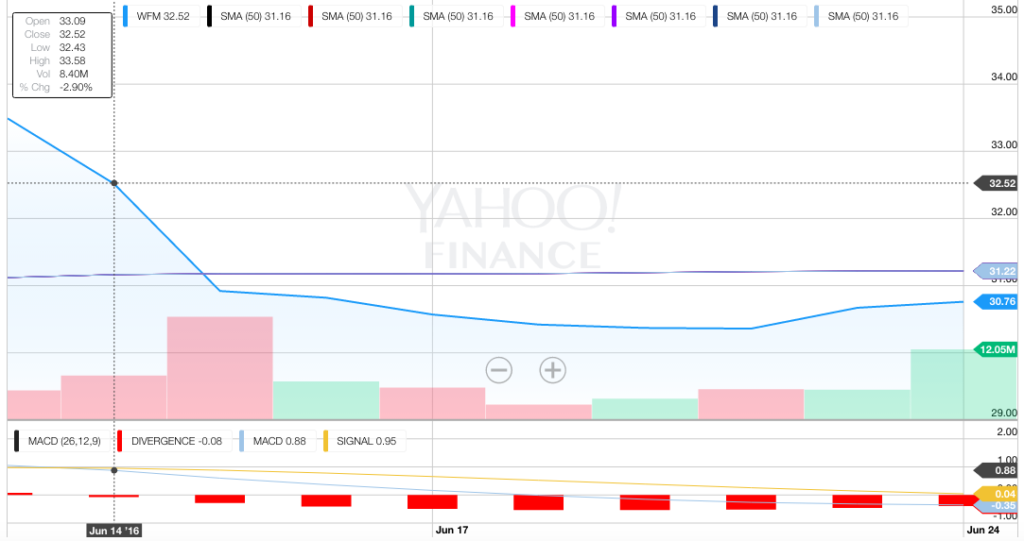
Figure 6.4.1 Whole Food Market MACD and price change 2 Week analyses

The reason my stocks went down this week was entirely to do with Brexit as shown in Table 6.4.1. Brexit was a British referendum to leave the EU, ostensibly due to an overflow of immigration coming into Britain that was a mandatory requirement. It was so unlikely that Britain would leave the EU that they held the vote on Thursday, instead of Friday to allow people to unwind over the weekend. This result even caused the prime minister to hand in his registration Friday morning, which made people lose confidence and begin to sell stocks.
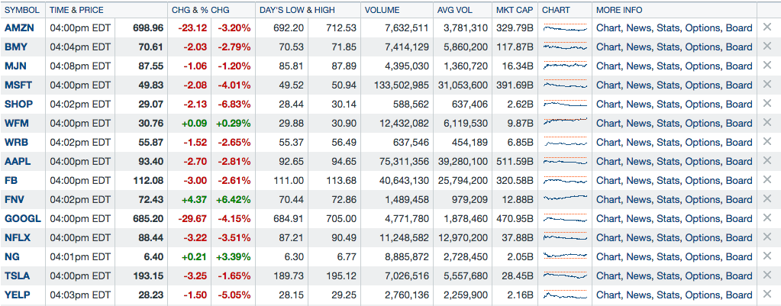
Table 6.4.1 all stocks performance on June 24

I decided to buy Shopify stock this week, as seen in Table 6.4.2, because I believe it will have a two week long trend and make quite a profit as seen in Figure 6.4.2. I also believe it will pull back from this weeks losses quickly after everything calms down in Britain. I am not sure how connect the company is to Britain, but it looks like the trend will make up for whatever losses are predicted.

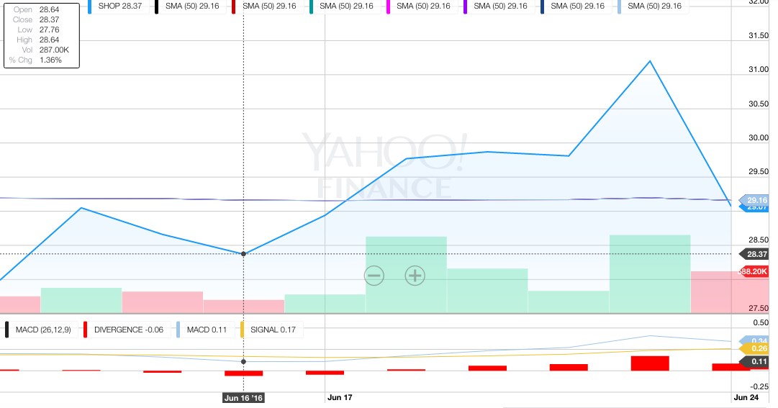
Figure 6.4.2 Shopify MACD and price change 2 Week analyses

Date | Symbol | buy/  Sell | Price | Shares | Net Cost/  Proceeds | Profit/  Loss | Total  Cash | Total  Profit
06/16/16 |  |  |  |  |  |  | 62475
06/24/16 | SHOP | Buy | $29.07 | 2149 | $62,472 |  | 3

Table 6.4.2 Weekly Transaction Record

6.5 Week 5

This week I witnessed several situations that I have thought about during my research with trends and investments unfold. I wasn’t sure if the stock markets poor performance last Friday was due to just Brexit or if it was complimented by the Friday afternoon sell trend. This Monday I realized that a lot of the news from the previous week has diminished and often bad news doesn’t last past the weekend. This was very compelling to me and leads me to believe that people should buy on Friday afternoons because the prices are lower and the weekend usually dissipates news stories for the following week. I also noticed that the stock market immediately began to increase right around noon, when people finish lunch. I have been noticing this trend nearly everyday and a day trader could use it to make a profit almost every day.
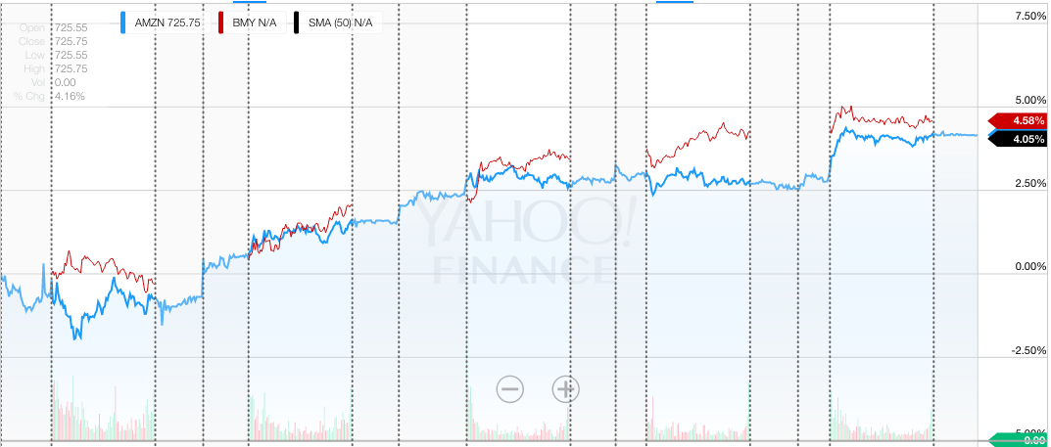
Figure 6.5.1 Comparison: Amazon-Bristol Meyer Squibb of daily price changes June 27-July 1

I noticed that my stocks that do business worldwide saw the same bump in profits due to undervaluing. These stocks are going back to their initial prices before Brexit. However, I am worried that they will be similar to my gold stocks and become very heavily valued and fall again. This situation is mitigated due to only slight increases in volume, MACD, and RSI. I will have to monitor these stocks very close next week because these stocks will eventually develop their own trends again and looking at these companies as one group would be very costly. I want to see whether these companies will follow the trends they were in before Brexit or if they will develop totally new ones instead.
My stocks for my long-term investment recovered significantly this week, as shown by Table 6.5.1, and this method may be profitable at the end of this simulation. However, my research was correct in assessing that although this method is rather safe, it yields very small profits when it works, as shown by Table 6.5.2. My total profit is nearly 3.5% for this method, which is modest for an index over this amount of time. I should have bought Shopify sooner and allowed myself to rely on it to increase with time. These stocks have tremendous growth and I think once all the initial research is done, an investor should not touch their index until they decide to pull out of the stock market entirely. This would allow companies to grow and receive the maximum profit for investors while they stop watching it for a long stretch of time.
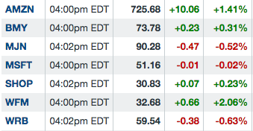
Table 6.5.1 all long-term investment stocks price on July 1

Date | Symbol | buy/  Sell | Price | Shares | Net Cost/  Proceeds | Profit/  Loss | Total  Cash | Total  Profit
06/10/16
06/13/16 | AMZ |  | $712.33 | 200 | $142,467 |  | 357,533
06/13/16 | BMY |  | $71.50 | 500 | $35,751 |  | 321,782
06/13/16 | MJN |  | $82.29 | 500 | $41,146 |  | 280,636
06/13/16 | WFM |  | $32.11 | 1000 | $32,111 |  | 248,526
06/16/16 | MSFT |  | $51.01 | 2000 | $102,021 |  | 146,505
06/16/16 | WRB |  | $56.02 | 1500 | $84,031 |  | 62,475
06/24/16 | SHOP |  | $29.07 | 2149 | $62,472 |  | 3

Table 6.5.2 Week 5 Transaction Record

6.6 Week 6

This week was a short week due to the long weekend. I noticed, over the course of the early opening hours, that the stock prices were either steady or slightly lower than the closing prices from last week. I believe this was due to the fact that investors recognized that their stocks were fully recovered and around their proper relative strengths. The stocks that went down had higher relative strength values, which make me confident that investors recognized companies were starting to get overvalued after the recovery from Brexit. The break for the weekend also provided investors enough time to come up with new strategies, which can be reflected in the unique trends that companies started to form during the beginning of the week. This week was very steady on Wednesday and Thursday, which might indicate less trading in anticipation of the monthly employment report on Friday. However, it could also be an adjustment period when investors were trying to reevaluate the company trends. I was surprised to see Shopify and Whole Foods go down after the weekend, but I have figured out that the price probably went down due to the Fourth of July. Investors are known to buy stocks in grocery stores during holidays due to the boost in sales for family gatherings. What I was seeing at the beginning of the week was investors pulling out to collect the profits they had made over the weekend.
Another interesting event I saw this week was the effect of the unemployment report on the stock market. Every stock I had went up on Friday due to the report’s good news about more jobs in the various industries. However, this effect will probably fade over the weekend because it doesn’t affect any company specifically. This news was a good way to end my buy and hold stimulation because it ended on a slightly up trending week and an overall up trending final day.
This method proved to be quite profitable in the end because all of my stocks ended above the price that I had bought them. This is pretty rare and usually indexes have at least a couple stocks that are poor. However, I was very precise about buying my stocks, which is the real work involved for this method. As shown in Table 5.6, I made a total profit of $25,047 over this simulation, which is a 5% profit. Investing in the Dow would have yielded a little less than 4% profit over this six-week period. The profit I yielded was rather high compared to the yearly averages of the stock market. However, I would like to mention that had I been a little flexible, I could have avoided the Brexit slump and yielded an even higher profit. This method doesn’t encourage any transactions, but I feel that type of methodology is a mistake and measures should be taken when major financial events occur.

Date | Symbol | buy/  Sell | Price | Shares | Net Cost/  Proceeds | Profit/  Loss | Total  Cash | Total  Profit
07/01/16 |  |  |  |  |  |  | 3 | 0
07/08/16 | AMZ | Sell | $745.81 | 200 | $149,161 | 6,694 | 149,164 | 6,694
07/08/16 | BMY | Sell | $75.28 | 500 | $37,639 | 1,888 | 186,803 | 8,582
07/08/16 | MJN | Sell | $89.36 | 500 | $44,679 | 3,533 | 231,482 | 12,115
07/08/16 | WFM | Sell | $33.58 | 1000 | $33,579 | 1,469 | 265,061 | 13,584
07/08/16 | MSFT | Sell | $52.30 | 2000 | $104,599 | 2,578 | 369,660 | 16,162
07/08/16 | WRB | Sell | $59.18 | 1500 | $88,769 | 4,739 | 458,429 | 20,901
07/08/16 | SHOP | Sell | $31.00 | 2149 | $66,618 | 4,146 | 525,047 | 25,047

Table 6.6 Week 6 Transaction Record

7 Technical Trading/ Shorting Simulations

7.1 Week 1

This week for technical trading I have been looking for positive trends in stocks and following the news to see if anything major would affect the stocks I have been researching. I tried to buy all of the stocks I have been researching and monitoring the past highs and lows of the stocks to determine the oscillation of the prices day-to-day and figure out which prices to buy and sell them at as seen in Figure 7.1. However, trading every day seems rather unpredictable and makes it hard to predict what will happen day-to-day. I have done a very good job so far in predicting the trends of stocks from weekly analysis as seen in Table 7.1. I bought several stocks based on their indicators signals. The majority of RSIs were close to 70 points, which is the indication to start buying stocks because they were believed to be undervalued. The MACDs also showed that the stocks I obtained were having an upward trend because the short term moving average rose above the long term moving average. The volume changes also showed more buying then selling, which raises the prices of stocks and is another indicator of a future upward trend. However, I need to start selling some stock, and I am having a difficult time letting go. I want to try and have the price reach it’s highest peak and be able to sell the stock. However, this method may be to hard to do while day trading and I believe I will keep monitoring the stock market, but I will trade on a weekly bases to make buying and selling at their highs and lows easier. Day trading can be a very dangerous plan and I believe next week I will sell a lot of my stock, to make room for my other stocks if their trends improve in the long run.
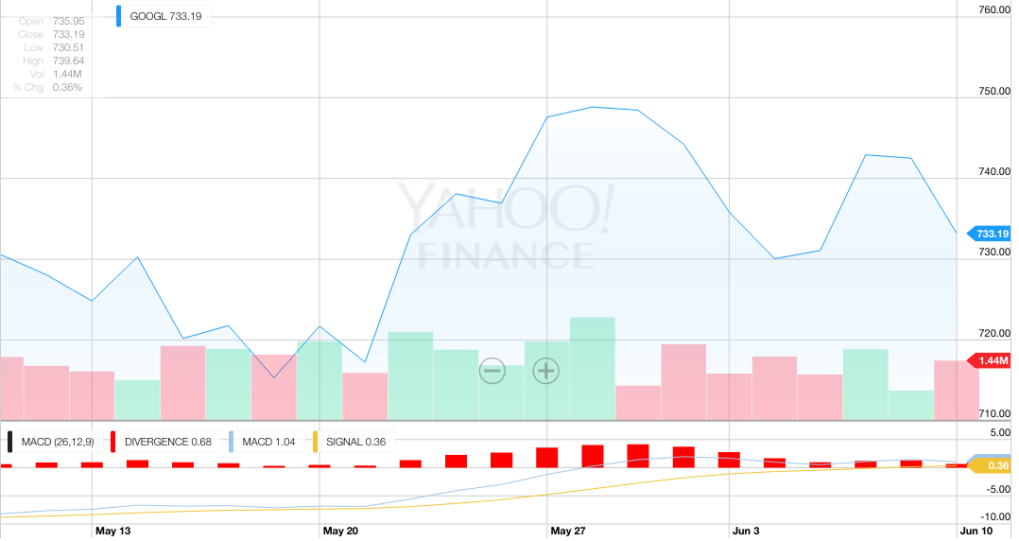
Figure 7.1 Alphabet MACD and price change 1month 5/10-6/10

Date | Symbol | buy/  Sell | Price | Shares | Net Cost/  Proceeds | Profit/  Loss | Total  Cash | Total  Profit
05/31/16 |  |  |  |  |  |  | 500,000
05/31/16 | FNV | buy | $62.82 | 1000 | $62,821 |  | 437,179
05/31/16 | GOOG | buy | $731.74 | 150 | $109,762 |  | 327,417
05/31/16 | NG | buy | $5.03 | 10000 | $50,301 |  | 277,116
06/1/16 | YELP | buy | $25.52 | 2000 | $51,041 |  | 226,076
06/5/16 | WFM | buy | $219.00 | 1000 | $219,001 |  | 7,075

Table 7.1 Weekly Transaction Record

7.2 Week 2

This week was fantastic and every stock went up throughout the week. I was very patient with my stocks and mainly looked at volume changes to try and predict what would happen to the price later on. However, I looked through my other indicators as well in order to corroborate my predictions and have continued to do so in order to get an understanding of what will happen next week. The indicators for my stocks RSI and volume changes were rather stable and hard to read because it seems that a trend change is about to occur, but my indicators gave me signals to stay were I currently am and ride this upward trend a little longer. However, my MACDs were a little more concise and lead me to believe that most of my stocks may be on a plateau and could fall later next week or the week after.
Relying on this indicator strategy worked out very well for me this week, and I am thrilled that I came very close to selling Nova Gold Resources at its peak of the week as seen in Figure 7.2.1. However, I am a little disappointed that Facebook and Apple do not seem to be stable. I believe that Facebook is going to continue to fall next week due to a lot of selling trend in volume and a declining MACD, so I am going to try to short the stock next week. I want to determine, in practice, that seeing rising trends means it is possible to determine and short dropping stocks. I am happy I have not had any losses so far, but I am worried that I may have sold all of my stock a little too soon as seen in Table 7.2. It will be interesting to see in the long run if it would have been better to simply hold these stocks instead of looking for trends in Apple and Facebook. Another interesting thing to see was the accuracy of the MACD charts and how it always goes up and down. I am going to try to rely on all of my indicators next week instead of mainly looking at volume changes. I believe that looking at volume changes is a good method for day trading, but I want to do more weekly trades and volume changes don’t predict long term trends nearly as well as shorter trends.

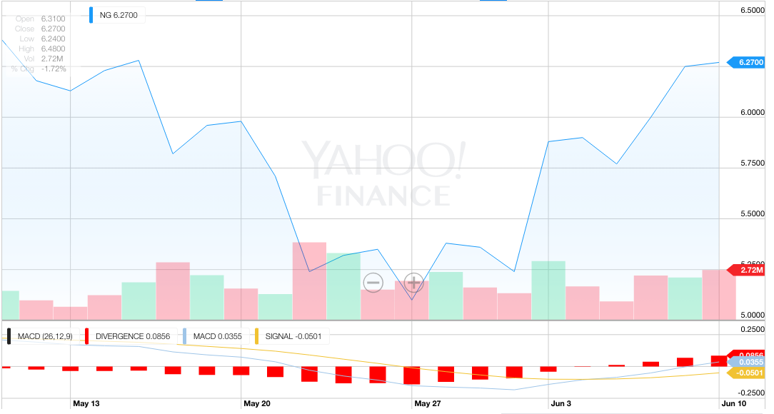
Figure 7.2 Nova Gold MACD and price change 1month 5/10-6/10

Date | Symbol | buy/  Sell | Price | Shares | Net Cost/  Proceeds | Profit/  Loss | Total  Cash | Total  Profit
06/6/16 |  |  |  |  |  |  | 7075
06/10/16 | FNV | Sell | $71.38 | 1000 | $71,377 | 8556 | 78452 | 8556
06/9/16 | GOOG | Sell | $742.52 | 150 | $111,377 | 1615 | 189829 | 10171
06/10/16 | NG | Sell | $6.40 | 10000 | $63999 | 13699 | 253828 | 23870
06/10/16 | YELP | Sell | $26.83 | 2000 | $53659 | 2618 | 307487 | 26488
06/9/16 | TSLA | Sell | $229.36 | 1000 | $229359 | 10358 | 536846 | 36847

Table 7.2 Weekly Transaction Record

7.3 Week 3

I am very happy that I sold all of my stock last week due to the fact that all of the stocks went down from last week. I tried to predict the trend of Tesla and Yelp, but it backfired on me because the volume changes did not change the price of the stocks. The other indicators I use also made me believe that stocks were going to have trends that they didn’t see this week. The RSIs and MACDs were misleading because they both had changing slopes on their charts, but they did not indicate to buy or sell. I decided to rely on my volume change trends because they were the most concise and lined up with some SM averages. I thought Tesla was due for an upward trend, but it instead kept falling this week as shown in Figure 7.3.1 below. I tried to buy Yelp however the volume changes were small and fluctuating so it didn’t have much of an effect on the price of the stock.

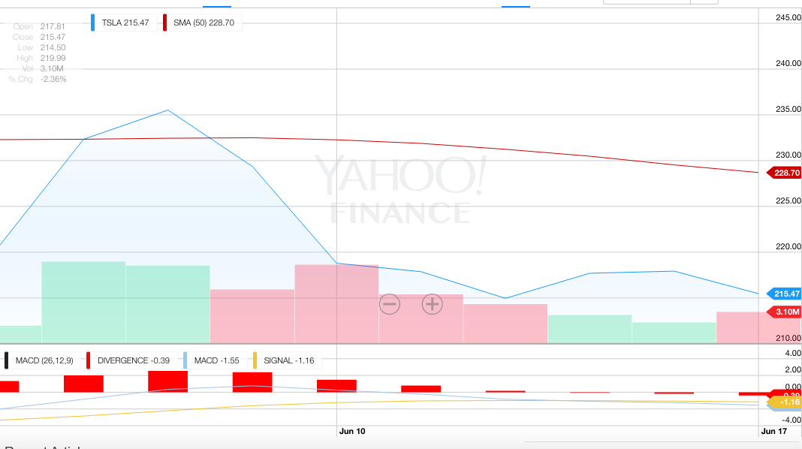
Figure 7.3.1 Tesla MACD and price change 1month 5/17-6/17

I also thought Nova Gold Resources was overvalued due to the RSI indicator and the government’s news of lowering interest rates last week and decided to short it. However, it had only a very minor fall that I pulled out of to pursue Alphabet. I shorted Apple as well in the beginning of the week because I believed that its steady rise over the past month was ending do to MACD and SM graphs and I believe I will ride it down for a few weeks as shown by Figure 7.3.2.

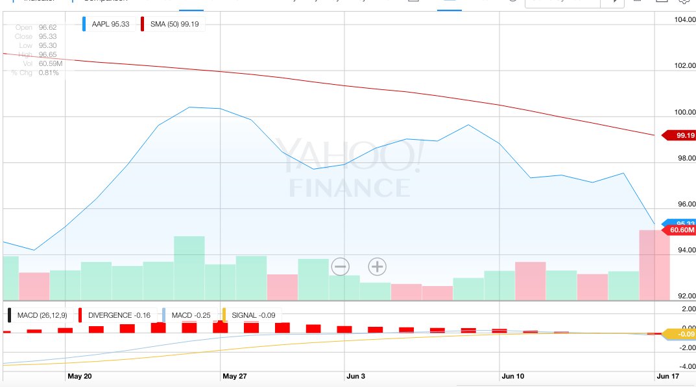
Figure 7.3.2 Apple MACD and price change 1month 5/17-6/17

Alphabet issued a press release that showed a decline in advertising during the quarter, which is their main revenue. This lowered many people’s expectations and predicts very low quarterly earnings. I made this decision based on future data from MACD indicators and news and not on volume trends. This has so far proved to be a wise move as shown by Figure 7.3.3 and I plan on holding on to it for another week.
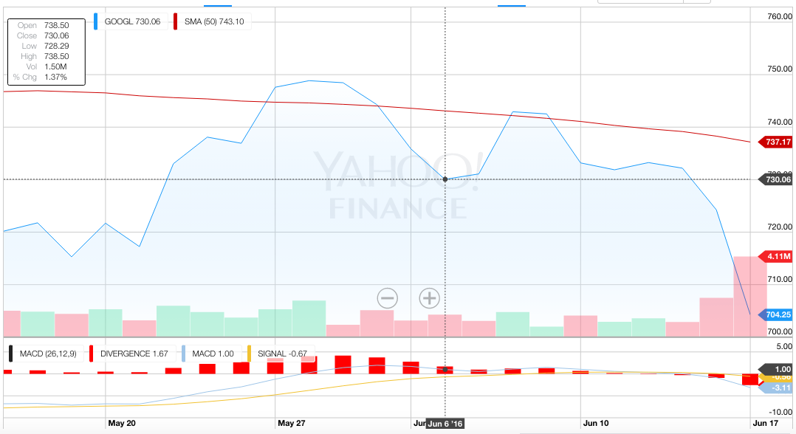
Figure 7.3.3 GOOGL MACD and price chart 1m 5/17-6/17

Despite minor losses I was able to make a profit from shorting the market as seen in Table 7.3.
.
Date | Symbol | buy/  Sell | Price | Shares | Net Cost/  Proceeds | Profit/  Loss | Total  Cash | Total  Profit
06/10/16 |  |  |  |  |  |  | 536,846 | 36,847
06/13/16 | Apple | Sell | $98.83 | 2,000 | $197,661 |  | 339,189 | 36,847
06/13/16 | NG | Sell | $6.27 | 30,000 | $188,101 |  | 151,092 | 36,847
06/13/16 | YELP | Buy | $26.83 | 4,000 | $107,321 |  | 43,771 | 36,847
06/13/16 | TSLA | Buy | $218.79 | 200 | $43,759 |  | 12 | 36,847
06/16/16 | NG | Buy | $6.29 | 30,000 | $188,699 | 598 | 188,711 | 37,445
06/16/16 | GOOG | Sell | $724.25 | 260 | $188,306 |  | 405 | 37,445

Table 7.3 Weekly Transaction Record

7.4 Week 4

This week I focused on exploring trends, as I have done the previous weeks and looking at a few more indexes. However, on Thursday I started to look at the EU referendum since the news was saying it could completely bring down the stock market on Friday if Britain left the EU. I started to research what I should do in case this occurred and I figured out a great stock to short. I know my trading method for these stocks should be based only on trends in data. However, there was no way of seeing this outcome from stock market charts and I knew for a fact that this would largely impact the stock market. The fall in the stock market can be reflected by Yelp’s performance shown in Figure 7.4.1.

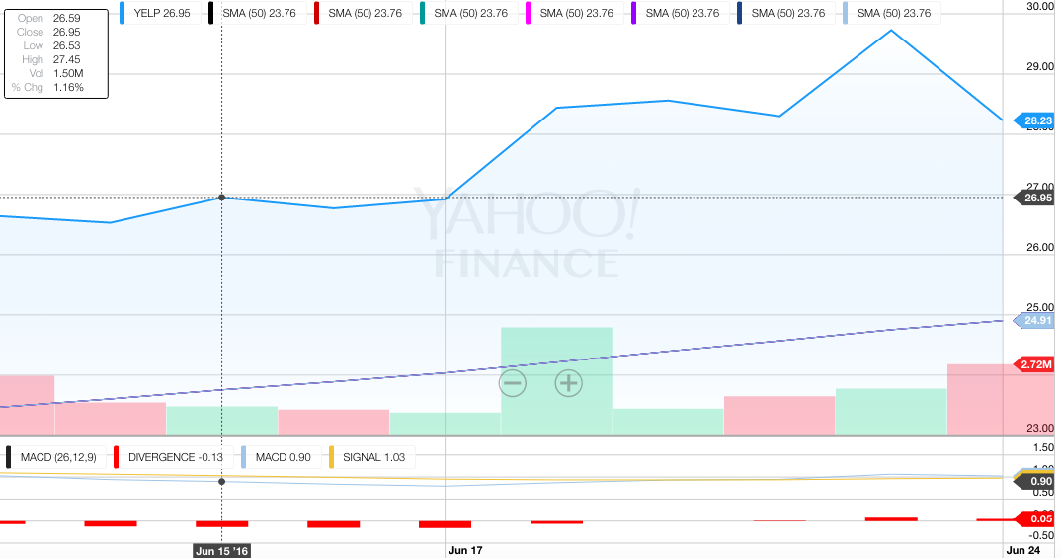
Figure 7.4.1 Yelp 2 Week divergence analysis

I also wanted to try and see how to trade foreign currencies in the stock market. I discovered that currencies trade on different markets from stock markets. I soon found Rakuten, which is affiliated with the Royal Mint in London. I believed that if the currency rate went down then the Royal Mint would, as well, along with all of its partners. After doing all of this research I decided to sell all of my stocks before the stock market opened and put everything on shorting Rakuten as seen in Table 7.4.1. I know this is a terrible investment policy, but in this case it was a ‘sure thing’ that nearly all of the stock market would fall and I tried to figure out the stock that would fall the most.
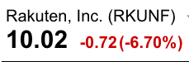
Table 7.4.1 Rakuten after June 24

All of my research paid off as shown in Table 7.4.2 and this also taught me an important lesson about the stock market. NO METHOD IS FACT. Using only one method will really hinder an investor and cause them to lose on a large scale. I plan on holding onto Rakuten for at least a few hours to see where it will go during next week.

Date | Symbol | buy/  Sell | Price | Shares | Net Cost/  Proceeds | Profit/  Loss | Total  Cash | Total  Profit
06/16/16 |  |  |  |  |  |  | 405 | 37,445
06/23/16 | Apple | Buy | $96.10 | 2,000 | $192,199 | 5,460 | 203,524 | 42,905
06/23/16 | YELP | Sell | $29.80 | 4,000 | $119199 | 11,880 | 322,723 | 54,785
06/23/16 | TSLA | Sell | $196.40 | 200 | $39,279 | 4,477 | 362,002 | 50,308
06/23/16 | GOOG | Buy | $714.87 | 260 | $185,865 | 2,438 | 552,743 | 52,746
06/24/16 | RKUNF | Sell | $10.74 | 51,465 | $552,735 |  | 8 | 52,746

Table 7.4.2 Weekly Transaction Record

7.5 Week 5

I spent this week researching RSI indicators in order to see which stocks would be undervalued due to the Brexit vote. I was surprised to see that the media and politics can affect the market for over half a week regardless of its performance. The volume trends were misleading for Monday’s performance along with the MACD indicators. The volume trends showed more buying then selling which is a possible signal that there will be a trend change. The MACD was only making slight movements which signaled a continuous and possibly weekly downward trend. I found that the most reliable indicator for evaluating stocks this week was the RSI indicator because it is sensitive to numerous factors and measures value rather than averages. The RSI was below fifty and showed increasingly lower values for many of my stocks. This meant they were significantly undervalued for reasons other than their merits; indicating that after the Brexit hysteria, these stocks would increase in value quite significantly. I decided to hold off buying immediately on Monday and closely monitor the stock market for the beginning of the week to see when the RSI and other indicators began to increase. I bought at noon on Monday when the RSI was still near 30, but climbing for Facebook, Netflix, Tesla, and Apple as shown by Table 7.5. These stocks showed continuous increases in volume, MACD, and RSI for the remainder of the week. These stocks also had connections to Britain, which means they would have experienced the same effects from Brexit, including trends. The indicators show an upward trend leading into next week so I will hold on to them until the volume trends decrease and the RSI approaches 70 as shown by Figure 7.5.1.
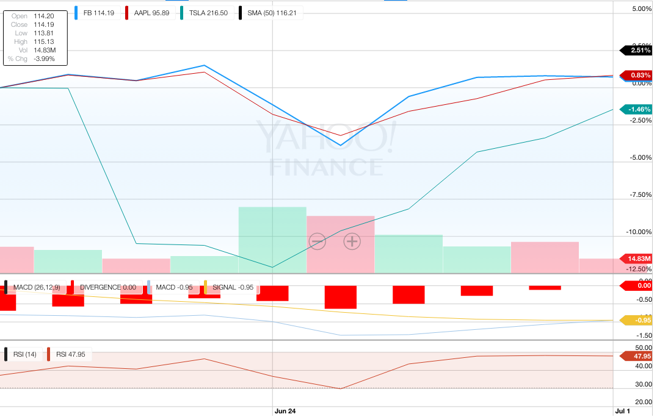
Figure 7.5.1 Comparison of MACD, Volume trend, and RSI with Facebook, Apple, and Tesla

I was happy to see that my research on investing in precious metals was accurate and saw how gold really does spike during political or financial emergencies. I did not buy any gold stocks because their volume was decreasing, the MACD was going lower, and the RSI was higher than 50. However, their price per share quickly rose this week and my RSI indicators show they are far past 70. This means that these stocks are heavily overvalued due to the financial situation. These stocks are going to fall quite significantly in the near future as the financial situation with Britain stabilizes. I will try to target these stocks next week after I sell my other stocks in order to short them at their overvalued prices.
I haven’t put a lot of value in RSI indicators until now because they seem to lead to better predictions with extreme increases or decreases in value rather than small day to day fluctuations. I also have been looking at SMA less often because it is always fairly constant and is a better indicator for very short-term investments. I am relying on weekly trends and predictions because they are more stable and easier to capitalize on.

Date | Symbol | buy/  Sell | Price | Shares | Net Cost/  Proceeds | Profit/  Loss | Total  Cash | Total  Profit
06/24/16 |  |  |  |  |  |  | 8 | 52,746
07/01/16 | RKUNF | Buy | $10.02 | 51,465 | $515,678 | 37,054 | 589,794 | 89,800
07/01/16 | Apple | Buy | $91.64 | 2,000 | $183,281 |  | 406,513 | 89,800
07/01/16 | FB | Buy | $109.21 | 1,000 | $109,211 |  | 297,302 | 89,800
07/01/16 | TSLA | Buy | $188.80 | 1,000 | $188,801 |  | 108,501 | 89,800
07/01/16 | NFLX | Buy | $85.65 | 1,266 | $108,433 |  | 68 | 89,800

Table 7.5 Weekly Transaction Record

7.6 Week 6

This week was hard to predict because the RSI was a little high for Yelp, Nova Gold Resources, Franco-Nevada, and a couple of others. However, these stocks only went down on Tuesday and eventually rose back up toward the end of the week. This week marked the official recovery from Brexit, which is clearly seen in the different trends companies are forming, independent of each other. The RSI was near 70 for Nova Gold Resources and Franco-Nevada, which fooled me into thinking that they would go down this week. I ended up taking a loss on these stocks because I tried to short them at the beginning of the week and I had to buy them at the end of the week because my simulation concluded. However, I believe that with more time, shorting these stocks would have brought me a sizable profit.
The MACD proved to be the best indicator this week due to it’s clear upward path that even crossed the signal. This is the indication to buy stock, but I chose to follow the RSI indicator rather than the MACD. I now realize that the MACD is quite a bit better at predicting a short-term trend than the RSI. It also is good in weeks that seem rather steady. The MACD for nearly all of my stocks continued to project an upward trend in the future. This clearly showed a better prediction for the price of gold throughout the week and the RSI could simply indicate the raise in the price of gold stocks. However, enough time or news over the weekend can change the MACD quite a bit, whereas the RSI remains relatively the same. The volume changes showed a definite upward trend from the consecutive buying days toward the end of the week. This means that there will be a positive trend next week and it will probably start to change midway through the week as the RSI rises to 70. However, Tuesday of this week showed selling and a downward trend, which was obviously just a minor slump in the week and meant nearly nothing for the overall trends in my stocks.
This method of trading turned out to be quite profitable and gave me a significantly larger profit as opposed to just buying and holding stock. I ended up with a profit of $111,903 or nearly 22.38% as seen in Table 7.6. However, I didn’t use trends to avoid the Brexit slump, which is the reason why I have made such a large profit. This method of trading is great for analyzing the stock market for most of the year. However, I do believe that this method should be combined with swing trading in order to optimize profits and avoid big financial scares. It would also allow investors to account for holidays, quarterly reports, government reports, and government investigations. I still believe technical trading is better than swing trading, but adding in a little swing trading could allow a person to not only avoid a major financial disaster, but also capitalize on it.

Date | Symbol | buy/  Sell | Price | Shares | Net Cost/  Proceeds | Profit/  Loss | Total  Cash | Total  Profit
07/01/16 |  |  |  |  |  |  | 68 | 89,800
07/05/16 | Apple | Sell | $95.46 | 2,000 | $190,919 | 7,639 | 190,987 | 97,439
07/05/16 | FB | Sell | $114.16 | 1,000 | $114,159 | 4,948 | 305,146 | 102,387
07/05/16 | TSLA | Sell | $206.44 | 1,000 | $206,438 | 17,638 | 511,584 | 120,025
07/05/16 | NG | Sell | $6.34 | 20,000 | $126,801 |  | 384,783 | 120,025
07/05/16 | FNV | Sell | $77.81 | 2,000 | $155,621 |  | 229,162 | 120,025
07/08/16 | NFLX | Sell | $94.04 | 1,266 | $119,053 | 10,620 | 348,215 | 130,645
07/08/16 | NG | Buy | $7.13 | 20,000 | $142,599 | 15,798 | 459,218 | 114,843
07/08/16 | FNV | Buy | $79.28 | 2,000 | $158,559 | 2,938 | 611,901 | 111,903

Table 7.6 Weekly Transaction Record

8 Analyses and Comparison

8.1 Methods Comparison

My initial research on these methods turned out to be largely correct. I anticipated that the buy and hold method would yield a small and steady profit that would nearly match the DOW index. I also knew that this method would not yield a huge profit margin due to the inability to avoid major negative financial events. This method has been shown through many simulations and past history to have very stable and positive trends, which makes this method a great long-term investment over several decades. Another crucial factor for my success with this method was my thorough research of the companies and their management. By doing a significant amount of research, I was able to determine when stock prices were low enough to buy. I liked this method due to its stability and very minor amount of work when compared to the length of the investment. This type of investment would be easy to manage as opposed to technical trading, which can seem like a part-time job. The technical trading method was solid for me as well because it can be done over different intervals of time. I have noticed that weekly time intervals yield far more stable results than daily trading. Using the indicators on graphs to predict trends proved useful during weeks with little news. It also proved to be very effective in determining the true value of stocks during financial situations, which was the biggest payoff for me. This method allowed me to make far greater profits than the buy and hold method, which could make it seem like the superior method. One drawback is that technical trading limits investors because they don’t take news into account. This lack of foresight into the social part of economics makes this method susceptible to great losses that would only be detected by charts over several days. However, I like this method because it allows investors to yield higher profits than long-term traders. Although, I feel that ignoring the news makes this method too risky and would yield the same results as the buy and hold method, except there would be a significantly higher amount of weekly research involved. I think technical trading would only be an advisable method to follow if it was expanded to consider major financial events.
During my simulations, I made several trades that produced profits for my buy and hold method and only a few losses during technical trading. I learned that the best stock market investors have a success rate of nearly 53%. This means that I was on an unprecedented hot streak, which would most likely lead to a few weeks of losses. However, my buy and hold stocks would probably still give me far more profitable trades than technical trading as seen from numerous stockbrokers. I believe this is another reason why the buy and hold method is a better investment plan than technical trading.

8.2 Company analyses

The companies that I chose for my simulations were pretty diverse. This diversity gave them unique trends in their different markets. My gold stocks (Nova Gold Resources and Franco-Nevada) did very well because Brexit caused a financial panic that made people lose faith in money and rely on gold as currency. The majority of my companies made most of their profits from websites they established. These website based companies can be deeply impacted by events from around the globe, which is why they got dragged down by Brexit and then made a fast recovery. However, they usually show a general increase in production over time due to familiarity with their company. These companies are ideal for investing in if they are able to establish themselves in a market with a large client bases. I believe the success of the website based companies I chose was due to the fact that they are still young, but have a firm grip on consumers that will keep growing. A few of my other companies included grocery stores, which showed varying degrees of success due to the Whole Foods FDA warning and lack of growth in their market. However, Shopify showed a significant increase in the amount of time from when I bought and sold it. I believe this is due to its continuous expansion and broad target base. Bristol-Myers Squibb was the only outlier because it is a pharmaceutical company; and I believe they will soon see losses because they have not been able to develop any new products that could potentially delay cancer deaths. They are simply making products that reduce side effects, which will only take them so far in their ever-advancing market. In general these companies varied from one another due to their different market and products. However, during the Brexit fallout, the companies seemed to move the same way. This is a very rare occurrence and shouldn’t be given much consideration because this often only happens once or twice a year. If I was able to re-pick my companies again, I would have chosen some newer website based companies that had lower prices per share in order to see greater profits. I prefer to invest my money in companies that I strongly believe will rise in price due to indicators, general knowledge about the market, and current events. However, I realized on my final week that this is a bad method because it can easily lead to huge losses instead of gains. This simulation has showed me to be more cautious with investments and to consider many variables before making decisions. I also believe that it has made me favor long-term investments due to their stability and lower effort.

8.3 Investment Method Comparison

In addition to my work on stock market simulations and judging the success of various trading methods for the stock market, I also researched alternative investment methods. I have not been able to test out most of these methods, but after constant research I was able to determine what investment methods work best. The best investment method, based on a risk and reward system, would be long term mutual funds in the stock market. The buy and hold method was very effective for my simulation and further analysis supports that long term trades have a far better chance at producing a bigger profit than most hedge funds can generate. CD ladders and treasury securities were the safest investment, but recently the interest rates are so low that it would be easier to put the money in the bank in order to be more liquid. Another reason to invest in the stock market is due to its ease of liquidating assets. Collectibles, precious metals, and buildings/houses all have major problems with liquidating assets quickly and one could be forced to accept a lower price if it takes a long time to find a buyer. Precious metals are probably the best hard asset because they are more liquid, but it can be difficult to find the best price available. The stock market is also superior because the prices are based on facts and numbers, which can be predicted and assigned a level of risk. Silent partnerships and peer-to-peer lending are based on trusting individuals with personal loans, which is largely based on qualitative rather than quantitative information. It can often be difficult to judge a person’s ethics, determination, and character, which are major factors in lending money. This could lead to losing an entire investment due to defaults. I learned from all of my research that the best investment is a long-term commitment to the stock market in order to generate modest, stable profits with a low risk profile.

References
- Beattie, A. (2007). The Birth Of Stock Exchanges | Investopedia. Retrieved June 19, 2016, from http://www.investopedia.com/articles/07/stock-exchange-history.asp

- Short, E. (2004). Investing 101: The Concept Of Compounding | Investopedia. Retrieved July 8, 2016, from http://www.investopedia.com/university/beginner/beginner2.asp

- Schick, K. (2003). An Introduction To Stock Market Indexes | Investopedia. Retrieved June 19, 2016, from http://www.investopedia.com/articles/analyst/102501.asp

- Wolfe, R. (n.d.). What Is Peer-to-Peer Lending? Retrieved June 19, 2016, from http://www.dummies.com/how-to/content/what-is-peertopeer-lending.html

- Mladjenovic, P. (n.d.). Precious Metals Investing For Dummies. Retrieved June 19, 2016, from http://www.dummies.com/how-to/content/precious-metals-investing-for-dummies-cheat-sheet.html

- Tyson, E. (2015). Real Estate Investing For Dummies. Retrieved June 19, 2016, from http://www.dummies.com/how-to/content/real-estate-investing-for-dummies-cheat-sheet.html

- Wild, J. “Risk-Free” Investing: U.S. Treasury Bonds. (n.d.). Retrieved June 19, 2016, from http://www.dummies.com/how-to/content/riskfree-investing-us-treasury-bonds.html

- Gower, J. (2014). Building the Perfect CD Ladder - NerdWallet. Retrieved June 19, 2016, from https://www.nerdwallet.com/blog/banking/building-perfect-cd-ladder/

- Sauter, G. (2013, February 28). The Experts: Is investing in Collectibles a Recipe for Disaster? Retrieved June 19, 2016, from http://www.wsj.com/articles/SB10001424127887324662404578330651775508058

- Rusak, Gili. Investor Bulletin: Accredited Investors. (n.d.). Retrieved June 19, 2016, from https://www.investor.gov/news-alerts/investor-bulletins/investor-bulletin-accredited-investors#.VNI7IdLF9Qg

- Sherman, L. (2000, July 15). Hedge Fund Investing 101. Retrieved June 19, 2016, from http://www.forbes.com/2000/07/15/feat.html

- Gull, J. Becoming a Silent Partner. (n.d.). Retrieved June 19, 2016, from https://www.legalnature.com/article-center/partnership-agreement/becoming-a-silent-partner

- Laura, R. (2012, May 31). Wake Up! Buy And Hold Doesn't Work. Retrieved June 19, 2016, from http://www.forbes.com/sites/robertlaura/2012/05/31/wake-up-buy-and-hold-doesnt-work/#7da218db177f

- Murphy, J. (n.d.). John Murphy's Ten Laws of Technical Trading. Retrieved June 19, 2016, from http://stockcharts.com/school/doku.php?id=chart_school:trading_strategies:john_murphy_s_ten_laws_of_technical_trading

- Brakke, T. Key Stock Market Indicators Include Price, Volume, and Moving Average Lines. (n.d.). Retrieved June 19, 2016, from http://www.marketsmith.com/stock-market/stock-market-indicators/

- Picard, E. (2003). What Is Short Selling? | Investopedia. Retrieved June 19, 2016, from http://www.investopedia.com/university/shortselling/shortselling1.asp
- Baden, B. (2011, July 14). 5 Factors That Drive Stock Prices. Retrieved June 19, 2016, from http://money.usnews.com/money/personal-finance/mutual-funds/articles/2011/07/14/5-factors-that-drive-stock-prices

- Griswold, R. Dow 30 Companies. (n.d.). Retrieved June 19, 2016, from http://money.cnn.com/data/dow30/

- Burton, J. (2010). Timing is everything. Retrieved June 19, 2016, from http://www.marketwatch.com/story/how-to-profit-from-seasonal-patterns-in-stocks-2010-03-12

- Yang, S. Monthly Market Returns - The January Effect, Etc. (n.d.). Retrieved June 19, 2016, from http://www.moneychimp.com/features/monthly_returns.htm

- Nickles, M. (n.d.). Graziadio Business Review | Graziadio School of Business and Management | Pepperdine University. Retrieved June 19, 2016, from https://gbr.pepperdine.edu/2010/08/presidential-elections-and-stock-market-cycles/

- Utermohlen, K. (2016). GOOG, GOOGL: Why Google Stock Is Down Today. Retrieved June 19, 2016, from http://www.nasdaq.com/article/goog-googl-why-google-stock-is-down-today-cm637332

- Curtis, G. (2007). Eight Items That Impact Daily Trades | Investopedia. Retrieved June 19, 2016, from http://www.investopedia.com/articles/stocks/07/impact_daily_trades.asp

- Fuhrmann, R. GOOGL Interactive Stock Chart | Yahoo! Inc. Stock - Yahoo! Finance. (n.d.). Retrieved June 19, 2016, from https://finance.yahoo.com/echarts?s=GOOGL

