The content used in each post should fall into the following categories. There may be overlap between some of the categories because some of the strategies can be combined for certain posts.

Engaging | Informative | “Call to Action”
Posts that are aimed at grabbing the attention of viewers through visuals.  E.g. Pictures of kids, videos and pictures from CASA events, catchy quotes | Posts that educate the audience. These posts can be information pertinent to both current and potential volunteers.  E.g. statistics about children entering foster care, CASA milestones, information from DCF, volunteer resources, CASA event information | Posts that ask something of the viewer, typically in the caption of the post.  E.g. “Like this post!”, “Share this post!”, “Comment (x)!”, “Go to (x) website!”

Other types on calendar:
Month specific: Posts for that month, e.g. April is National Child Abuse Prevention Month, so posts that raise awareness for the issue at hand. Month specific posts can fall into any of the main three categories but should relate back to what national month it is.
Volunteer of the Month!: Posts that praise CASA’s volunteer of the month on both platforms. These posts can fall into any of the main three categories.

The following test posts were most successful with the focus group we conducted. Under each post is the category of social media content they fit into. Note that, as mentioned, there is overlap between the categories for many of the posts.

Engaging Engaging

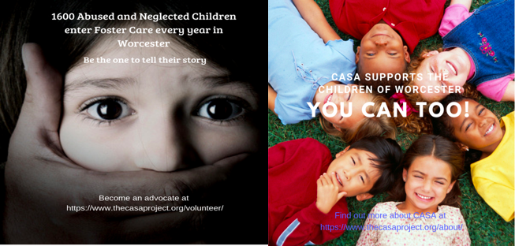
Informative / Call to action
Engaging / “Call to Action”

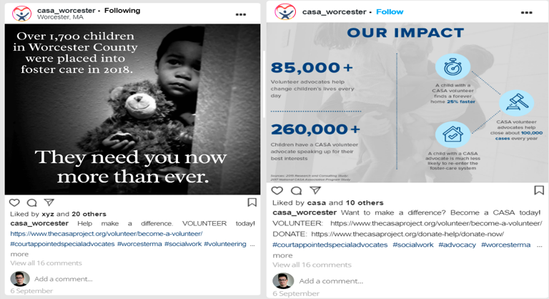
Informative / “Call to Action” Informative / “Call to Action”

Heat map for best times to post by platform:

Legend:
Best | Good | Bad | Worse

FACEBOOK | Sunday | Monday | Tuesday | Wednesday | Thursday | Friday | Saturday
9:00 AM
10:00 AM
11:00 AM
12:00 PM
1:00 PM
2:00 PM
3:00 PM
4:00 PM
5:00 PM
6:00 PM
7:00 PM
8:00 PM
9:00 PM
10:00 PM

INSTAGRAM | Sunday | Monday | Tuesday | Wednesday | Thursday | Friday | Saturday
9:00 AM
10:00 AM
11:00 AM
12:00 PM
1:00 PM
2:00 PM
3:00 PM
4:00 PM
5:00 PM
6:00 PM
7:00 PM
8:00 PM
9:00 PM
10:00 PM

Hashtags for Instagram:

Extremely popular | Moderately popular | Niche | Branded
#volunteerwork | #givebacktothecommunity | #courtappointedspecialadvocate | #thecasaproject
#advocacy | #childabuseawareness | #becomeacasa | #casaworcestercounty
#advocate | #childabuseprevention | #becomeanadvocate | #casaworcesterma
#giveback | #fostercareawareness | #volunteeringopportunities
#dogood | #fostercare | #worcesternassachusetts
#communityservice | #childabusepreventionmonth
#nonprofit | #fostercare
#nonprofitorganization
#worcester
#worcesterma

