WORCESTER POLYTECHNIC INSTITUTE

Supplemental Materials
For
“Building a Cost Efficient School Holiday Program for CERES:
Environmental Education Today for a Sustainable Tomorrow”

B Term 2019

Authors:
Adora Le
Bianca Amarasekera
Courtney Campagna
Yael Rogoszinski

Advisors:
Professor Lindsay Davis
Professor Lorraine Higgins

Sponsor:
Centre for Education and Research (CERES)

An Interactive Qualifying Project submitted to the Faculty of Worcester Polytechnic Institute in partial fulfillment of the requirements for the Degree of Bachelor of Science

Table of Contents
Part A - Competitor Matrix 2
Part B - Competitor Matrix Graphical Analysis 4
Part C - PESTLE Factors Explanation 6
Part D - Interview Preambles 7
Part E - CERES Interview Questions 8
Part F - CERES Staff Interview Analysis Matrix 13
Part G - Stop Start Continue Board Instructions 14
Part H - Parent Interview Analysis Matrices 15
Part I - CERES Term 2, Week 2, 2019 Calendar 17
Part J - Layers on Google My Maps 18
Part K - CVP Analysis 19
Part L - Focus Group Slides and Activities 21
Part M - Duty of Care, Children’s Services Licenses and Other Legal Information 23
Part N - Marketing Information 28
Part O - Contributions 29

Part A - Competitor Matrix
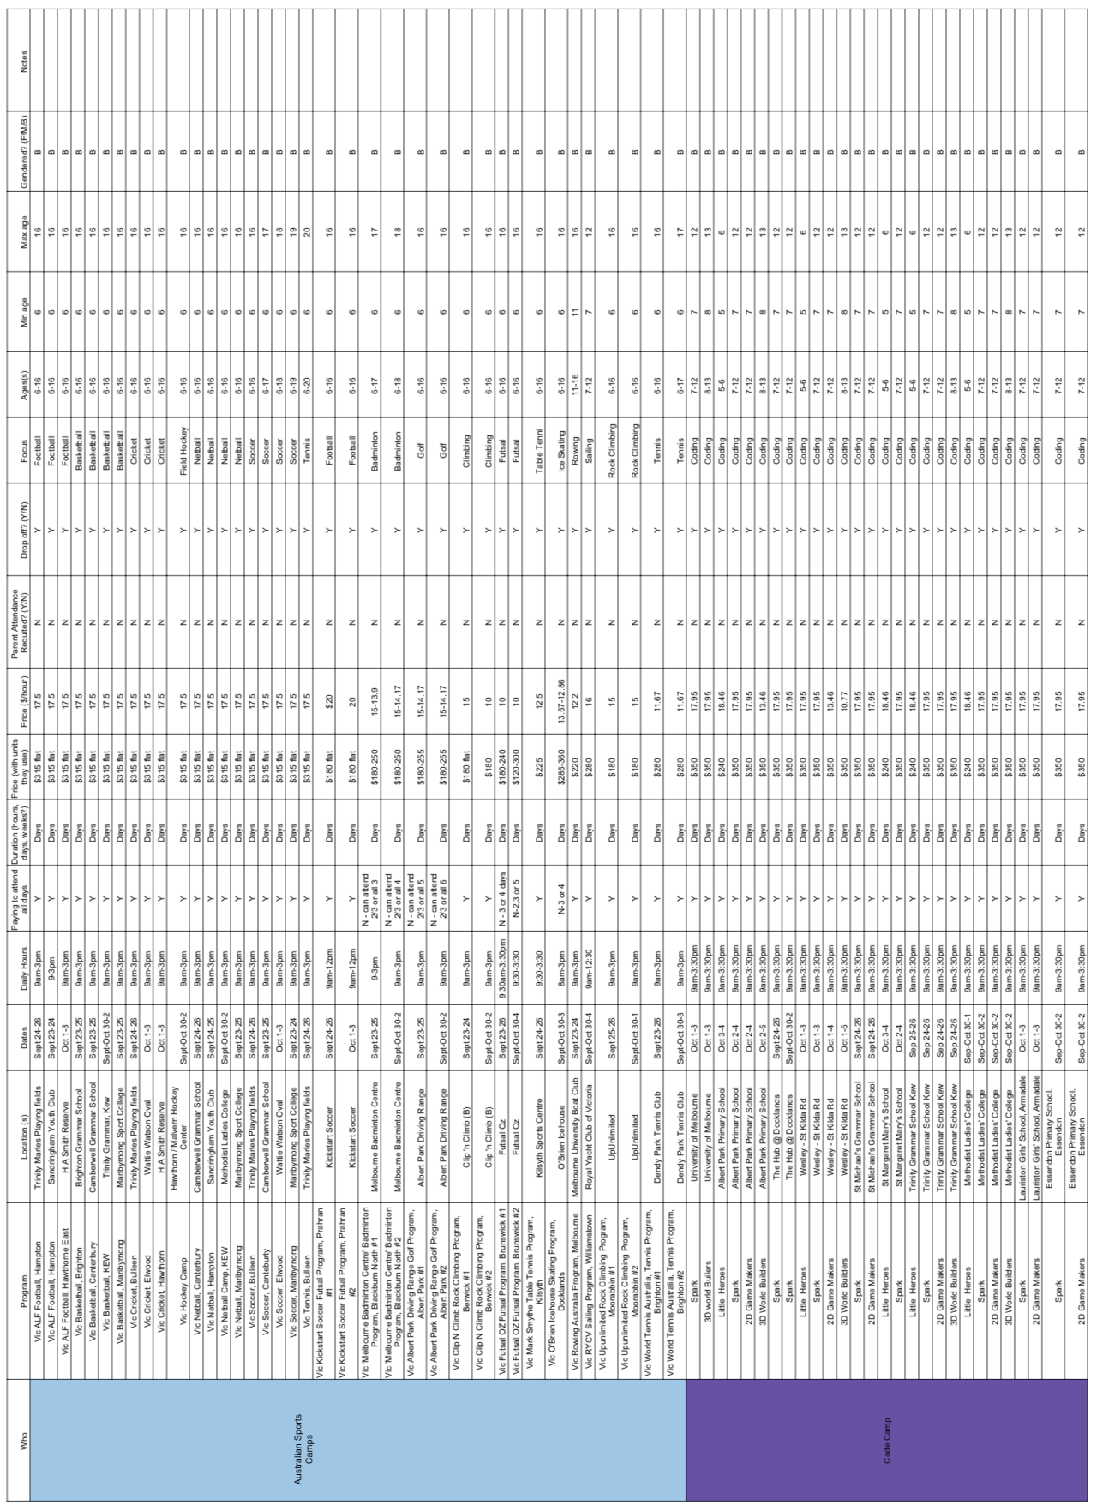
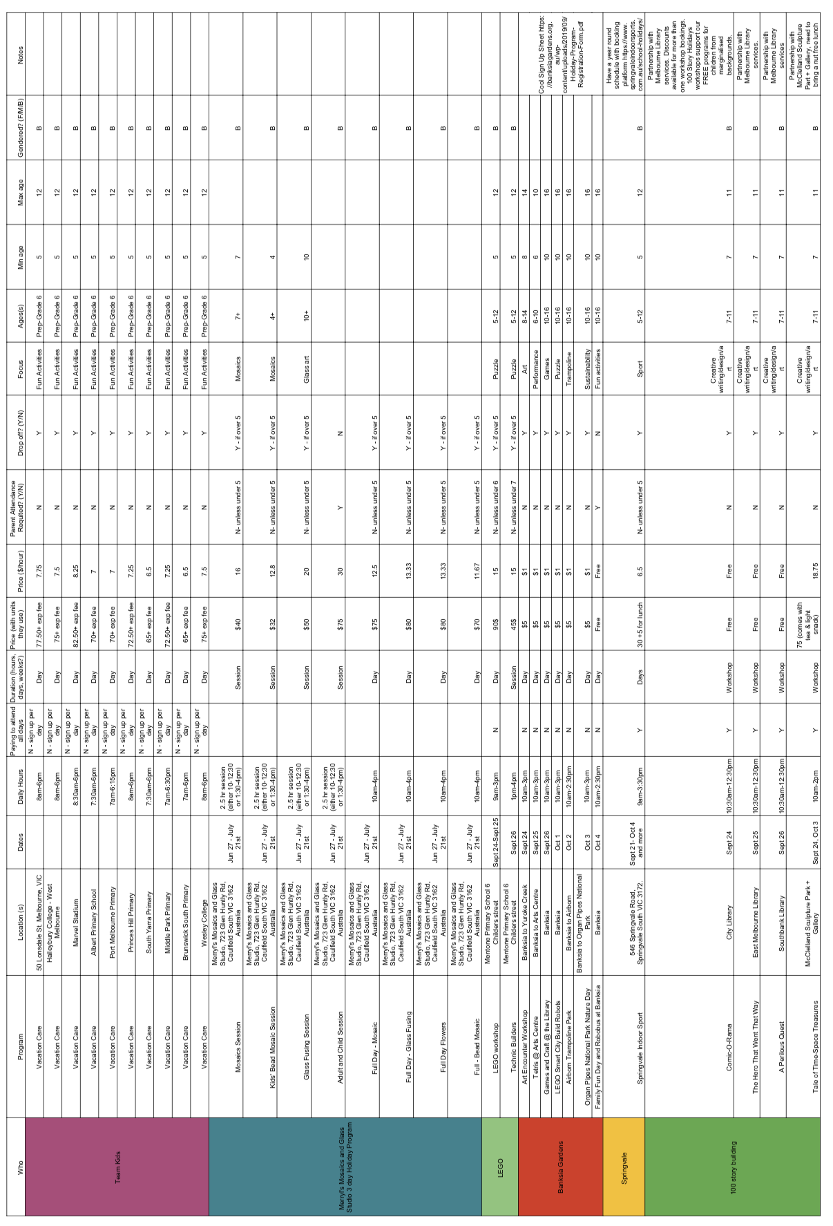

Part B - Competitor Matrix Graphical Analysis

Age and Parent Attendance Analysis
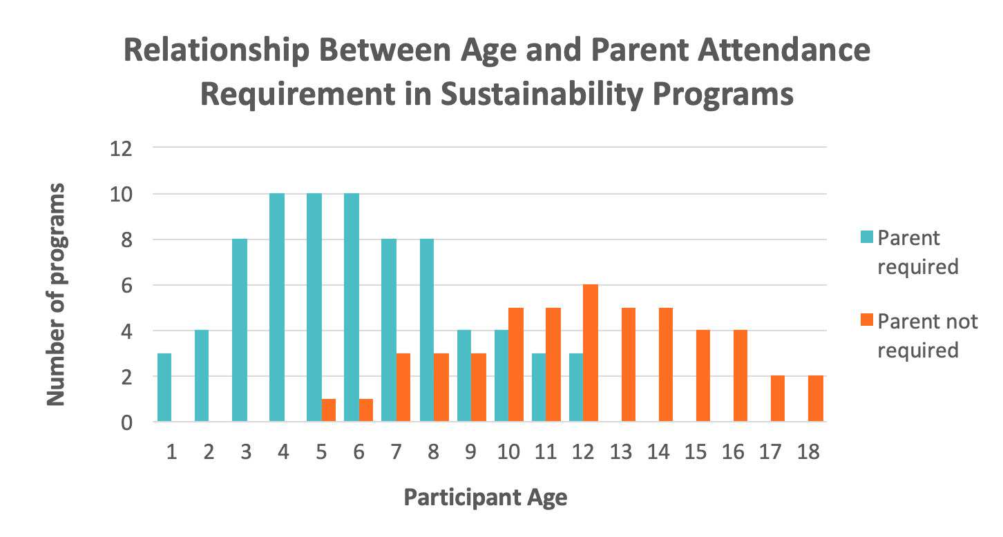
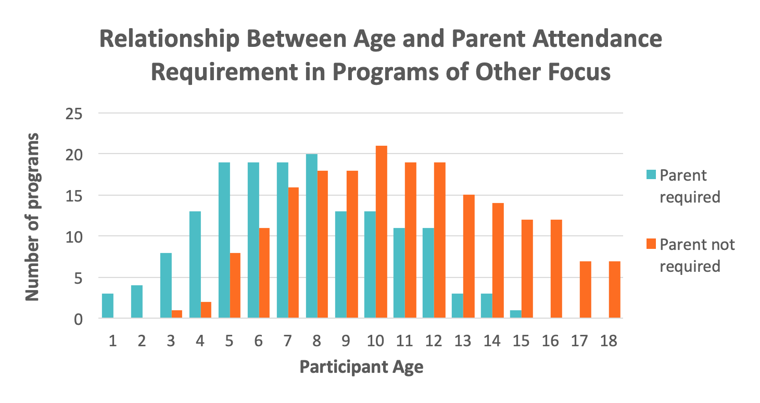

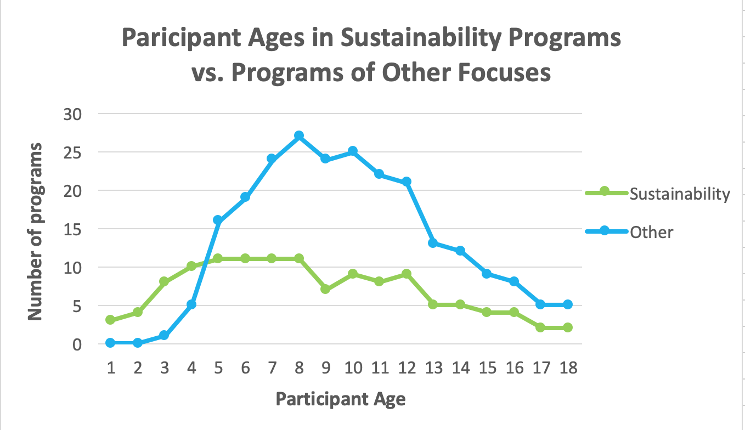

Pricing Analysis
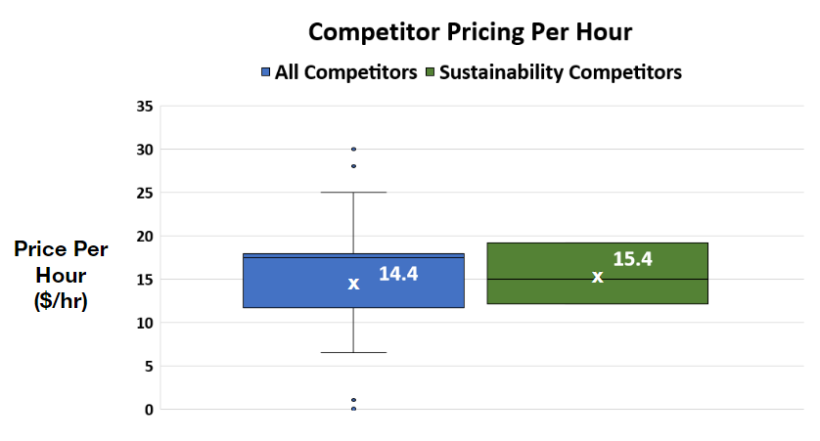

Part C - PESTLE Factors Explanation
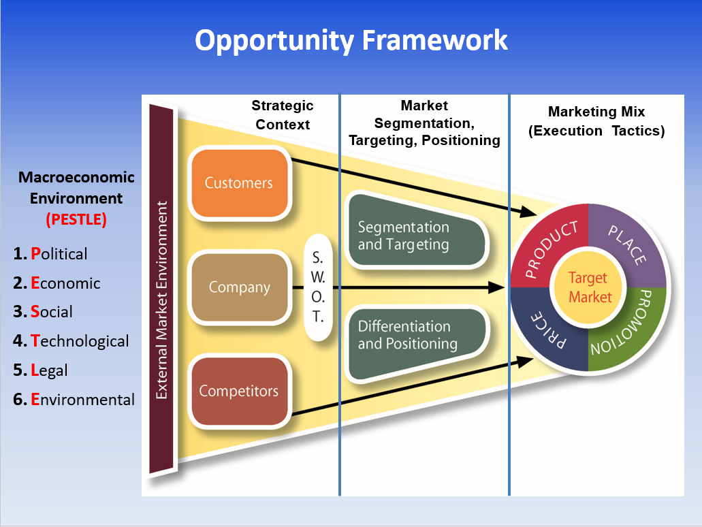
The political element includes governmental policies and politically motivated factors that impact the business. For example, Victoria state’s implementation of AuSSI opens opportunity for many sustainability education organizations, such as EcoExplorer and CERES. The economic element includes market factors that impact the organization’s prosperity in the long term. The social structures of the targeted participants (the parents), which includes the demographic of participants, or their behaviours, also determine the direction of the program. Access to technologies, communication, participants’ awareness and research, positively elevate the program’s values, making them important aspects in building a marketing scheme. Legal liabilities, such as declaration of risk management policies, is a must-mention in the advertisement. Additionally, physical environment factors (example: the weather) indirectly influence the advertising plan through influencing the structure of the program.

Part D - Interview Preambles

CERES Managers Consent Preamble
We are a team of university students from Worcester Polytechnic Institute (WPI) in America. We are currently doing a project to help your organization create a school holiday program. The purpose of this interview is to understand more about CERES educational programs, its goals and finances, and your ideas for adapting them to a school holiday program. We will not publish any financial information you disclose to us that is not already public. If you choose to this interview, you consent to us using your responses in our research and development of the program. You will be invited to our final presentation and may ask to see a copy of our final report, where we may include some of your ideas. The report will be published on our university’s website and shared with you and the rest of CERES’ staff to help you provide a school holiday program. If you have any questions, feel free to contact us at gr-B19ceres@wpi.edu or our advisor Professor Lorraine Higgins at ldh@wpi.edu or Professor Lindsay Davis at lgdavis@wpi.edu. Thank you for your time.

CERES Educators Consent Preamble
We are a team of university students from Worcester Polytechnic Institute (WPI) in America. We are currently doing a project to help your organization create a school holiday program. The purpose of this interview is to understand more about your current programs and your ideas for adapting them. Ms. Horner suggested we interview you, but this interview is voluntary. If you choose to this interview, you consent to us using your responses in our research and development of the program. You will be invited to our final presentation and may ask to see a copy of our final report, where we may include some of your ideas. The report will be published on our university’s website and shared with you and the rest of CERES’ staff to help you provide a school holiday program. If you have any questions, feel free to contact us at gr-B19ceres@wpi.edu or our advisor Professor Lorraine Higgins at ldh@wpi.edu or Professor Lindsay Davis at lgdavis@wpi.edu. Thank you for your time.

“Stop Start Continue” Board Preamble
This board is to collect information on educators’ ideas and opinions of activities with children. We, the WPI student team, are collecting this information to analyze which activities CERES should offer during school holidays. This data will be anonymous and published in our research. Our project is to help CERES create a school holiday program for children. If you have any questions or would like to see our final report, feel free to contact us at gr-B19ceres@wpi.edu or our advisor Professor Lorraine Higgins at ldh@wpi.edu or Professor Lindsay Davis at lgdavis@wpi.edu. Thank you for your time!

CERES Visitors Consent Preamble
We are a team of university students from Worcester Polytechnic Institute (WPI) in America. We are currently doing a project to help CERES create a school holiday program for children. We’re interested in talking to parents and educators about their ideas for creating this program. Have you ever brought your own or other’s children to the park here for any of CERES programs? If yes, would you be willing to take a short survey on this? This interview is voluntary. We will be considering your input as we design programs for children here. We will not publish your name in our research. You are free to end the interview at any time, however we will review all your survey responses to make recommendations to CERES. If you have any questions or would like to see our final report, feel free to contact us at gr-B19ceres@wpi.edu or our advisor Professor Lorraine Higgins at ldh@wpi.edu or Professor Lindsay Davis at lgdavis@wpi.edu. Thank you for your time.

Public Parents Consent Preamble
We are a team of university students from Worcester Polytechnic Institute (WPI) in America. We are currently doing a project to help CERES, an environmental education park in Brunswick East, create a school holiday program. We want to get the input of local parents. If you live near Melbourne and have kids we would like to hear your input in a short survey that should take only 5-10 minutes. Would you be willing? If so, this interview is voluntary. We will not publish your name in our research. You are free to end the interview at any time, however we will review all your survey responses to make recommendations to CERES. If you have any questions or would like to see our final report, feel free to contact us at gr-B19ceres@wpi.edu or our advisor Professor Lorraine Higgins at ldh@wpi.edu or Professor Lindsay Davis at lgdavis@wpi.edu. Thank you for your time.

Part E - CERES Staff Interview Questions

Semi Structured Interview with Chloe Horner
- Could you talk more about your role as the School Program Manager - Excursion and Incursion and being a part of the education team?
- How successful are the excursions and incursions? What makes them successful?
- Typically, what is the total cost for your incursion and excursions? How much profit do they bring in after covering staff, materials, overhead, and other costs?
- Are there any topics that are missing in the excursions and incursions that you hope would be filled by the school holiday program?
- Are there any successful lesson plans that are not offered to younger ages that you would like to adapt?
- Can you estimate how many people are interested in the school holiday program?
- We looked at Junior Farmer online and would like to know more about it.
  - Did you teach the Junior Farmer program? Who did?
  - How long was it?
  - What did you observe about the program?
  - How many people signed up for the program?
  - How much are parents charged (units?)? What did the parents pay?
  - Did you get any feedback from the program?
  - What was the profit of the program
- What were other school holiday activities CERES has offered?
  - Did you get any feedback from the program?
- Do you foresee any barriers to a schedule that runs multiple offerings simultaneously or if we should be aware of constraints in offering one day, a couple of days, a week long program?
- Are there any constraints due to space, weather, budget, or staff?
  - Do you want to bring in seasonal staff or only use your current staff?
- Are there any opportunities to work with partner organizations by either having them bring their kids here for an event or program, or is there a way to involve them somehow?
- How does the relationship with EcoExplorers work when they use your space to provide school holiday programs?
- What is the budget and target profit for the school holiday program?
- Have you ever looked into getting a Duty of Care license?
  - Are you willing to get the Duty of Care license for the school holiday program?
- We would like to interview CERES visitors and Melbourne parents in public parks? Do you recommend that we do this?
- We would like to interview people who have in-depth knowledge about the on-site educational programs and finance, we have identified Ms. Pettifer and Mr. Porter respectively from the CERES website. Could we interview them or anyone else who will have this knowledge?
  - Could you look at our questions for them? Specifically the ones about finance?

Semi Structured Interview with Lorna Pettifer
  - Could you talk more about your role as the senior manager of education and training?
  - What is your vision for the holiday program?
    - What age range do you want to focus on right now? And then in the future?
  - What does CERES currently do well in their youth education programs that you want continued in a school holiday model?
  - What improvements needed in the youth education programs can be carried out in the school holiday program?
    - Are there any topics that are missing in the excursions and incursions that you hope would be filled by the school holiday program?
    - We noticed it's a bit hard to find out attendance numbers and demographics of participants for current education programs
      - Have you ever collected any information (interests, demographics, etc.) about your past student program participants?
  - You mentioned poor mentality is something CERES can get rid of at the meeting last Wednesday could you expand on that? How do you think a school holiday program can improve people’s mentality?
  - Who are your current partners that could help with a school holiday program and are willing to make new partnerships?
    - For example, when we were talking about the current state at the meeting one of the get rid of ideas was the energy park so could CERES partner with someone else who has an energy park to still provide those activities? Another get rid of was being stuck to the site so where would you like CERES to take children?
    - How do you suggest we present the idea of mutually beneficial partnerships to the incursions and excursions team?
  - What are your current staff development programs?
    - What topics do these trainings cover?
    - Should new ones be made for school holiday programs?
  - Are the current educators adequately trained for the school holiday program?
  - Have you ever collected any information (interests, demographics, etc.) about your past student program participants?
  - How do you want to market the school holiday program?
    - What do you want CERES to be known for?
    - What words should we use when marketing to parents? Nature? Farm? Love the earth?
  - What topic activities and amenities would you want, as a parent, for CERES to provide the children in the program?
  - Have your children ever participated in a CERES education program here or in their schools?
    - What was that like? Did your children give you any input?
  - Any other advice or ideas you have about this program?
  - Could we use the exact wording of the CERES acknowledgement of the environment and climate crisis that you used in the presentation on Oct 23rd?

Semi Structured Interview with Nico Porter
- Could you talk more about your role as the Senior Manager of Finance?
- What made you want to work at CERES?
- You started at CERES at a financially difficult time. What methods did you employ to make CERES more cost efficient and financially smart?
- How did you convince everyone to implement your financial related changes?
- What are your current financial goals for CERES?
- Have the education programs been financially successful?
- What financial practices of education programs do you want to improve?
- Typically, what is the total cost for your incursion and excursions? How much profit do they bring in after covering staff, materials, overhead, and other costs?
- How much does CERES roughly earn from excursions? From incursions?
- What income do you hope to generate with the school holiday program?
- What methods do you use to calculate profits?
  - Have you previously done calculations relating to cost-volume-profit analysis?
- We’ve looked at pricing strategies for the school holiday program such as demand-based, odd-even and bundling. Is there a particular one you do or don’t recommend for CERES?
- Are there any other financial strategies you recommend we look at?

Semi Structured Interview with Kat Young
  - Could you talk more about your role as the education bookings coordinator and being a part of the education team?
  - We looked at Junior Farmer online and would like to know more about it.
    - Did you teach the Junior Farmer program? Who did?
    - How long was it?
    - What did you observe about the program?
    - How many people signed up for the program?
    - Did you get any feedback from the program?
  - What were other school holiday activities CERES has offered?
    - Did you get any feedback from the program?
  - What schedule would you recommend for the school holiday program (length of activity, how many occurrences one activity a day or week, multiple activities a day, max # of students)?
    - Do you foresee any barriers to a schedule that runs multiple offerings simultaneously or if we should be aware of constraints in offering one day, a couple of days, a week long program?
  - Are there enough staff for the program?
    - Do you want to bring in seasonal staff or only use your current staff?
  - How does the booking system work right now for school holiday programs?
  - How does the relationship with EcoExplorers work when they use your space to provide school holiday programs?
  - Would CERES be open to partnering with other organizations to provide school holiday programs?
  - What programs would you recommend to be included in the school holiday program and why?
    - Are there any materials students prefer using?
  - Are there any topics that are missing in the excursions and incursions that you hope would be filled by the school holiday program?
  - Have parents made any suggestions or requests for excursions and incursions or any other CERES programs for students that could be fulfilled by a school holiday program?
  - Are there any other difficulties you foresee coming up with the school holiday program?
  - Any other advice or ideas you have about this program?

Semi Structured Interview with Taylor Foster
- Could you talk more about your role as being a part of the education team and marketing team?
- What are your current marketing practices?
- What social media do you advertise on?
  - How many people does this bring in?
  - Do you get feedback from parents on education programs?
    - What programs would you recommend to be included in the school holiday program and why?
- What is your vision for CERES marketing future?
- What is the connotation of sustainability programs in Australia (specifically Melbourne area)? Should we use different words?
  - We sat in one of the education teams meetings where they said wording matters for example love the earth is well received but loving the earth is not
- Have you ever collected any information (addresses, demographics, etc.) about your past student program participants?
  - If yes, does it help?
  - If no, would it help education programs to do this??
- Do you partner with any other organizations to market your programs?
  - Would CERES benefit in doing this?
- How much do you invest in marketing the educational programs at CERES?
- Is there marketing photos we could use for our final booklet we submit to WPI
- Is there anything else you want us to know or anything you want to know?

Semi Structured Interview with Thomas Kelly
- Could you talk more about your role as being a part of the education team?
- We looked at the 2018 holiday program from a provided folder and would like to know more about it.
  - How long was it?
  - What did you observe about the program?
  - How many people signed up for the program?
  - How much are parents charged (units?)?
  - Did you get any feedback from the program?
  - What was the profit of the program?
  - Kat mentioned the partnership with Team Holiday/Kids was helpful because they brought 1000 kids to CERES over 2 weeks but Team Holiday never came back, do you know why?
- What current excursion and incursion programs are fun and stress free rather than academic based?
- Are there other school holiday programs you have created that you would like us to look at? Could you tell us about it/them?
- Can you estimate how many people are interested in the school holiday program?
- What are some difficulties you encountered when creating a school holiday program?
  - How did you combat theses difficulties
- What programs would you recommend to be included in the school holiday program and why?
- Is there anything else you want us to know?

Semi Structured Interview with Luisa Cardamone
- Could you talk more about your role as the training area manager and being a part of the education team?
- We looked at Junior Farmer online and would like to know more about it.
  - Did you teach the Junior Farmer program? Who did?
  - How long was it?
  - What did you observe about the program?
  - How many people signed up for the program?
  - How much are parents charged (units?)? What did the parents pay?
  - Did you get any feedback from the program?
  - What was the profit of the program
  - What was the booking system you used? Can we use a similar one for a school holiday program with multiple activities?
  - What was the feedback from educators?
  - What was the feedback from parents?
- Are there enough staff to run Junior Farmer and any other activities you have ideas for in the school holiday program?
- How did you run Junior Farmer without the Duty of Care certification?
- Based on Junior Farmer, what schedule would you recommend for the school holiday program (length of activity, how many occurrences one activity a day or week, multiple activities a day, max # of students)?
  - Do you foresee any barriers to a schedule that runs multiple offerings simultaneously or if we should be aware of constraints in offering one day, a couple of days, a week long program?
- We noticed from your bio that your programs support diversity of participants and sustainability themes, how do you think diversity can be achieved in a school holiday program?
- Do you have additional advice or ideas you have about this program?

Semi Structured Interview with Lauren Kaszubski
  - Could you talk more about your role as the Excursions Waste Programs Coordinator & Outreach Educator and as part of the education team?
  - Could you talk about waste program for students?
  - What are your most hands on programs that we could include in the school holiday program?
    - Are there any materials students prefer using?
  - Are there any successful lesson plans that are not offered to younger ages that you would like to adapt?
  - Are there any gaps in the educational aspects of the excursions and incursions that you hope would be filled by the school holiday program?
  - Have you ever collected any information (addresses, demographics, etc.) about your past student program participants?
    - Have parents made any suggestions on improving the waste management or any other CERES programs for students?
  - What are some difficulties you foresee coming up with the school holiday program?
    - Do you foresee any barriers to a schedule that runs multiple offerings simultaneously or if we should be aware of constraints in offering one day, a couple of days, a week long program?
    - Are there any constraints due to space, weather, budget, or staff?
    - As an educator, do you think you will need additional staff training for the school holiday programs?
  - Can you estimate how many people are interested in the school holiday program?
  - What are some advice or ideas you have about this program?
CERES Parent Interview Questions
- What brought you to CERES today?
- How often do you come to CERES?
  - First time
  - Daily
  - Weekly
  - Monthly
  - Several times a year
- What parts of the park do you visit and enjoy the most?
- Have your children or students ever participated in a CERES education program here or in through their schools?
- What was that like? Did the children give you any input?
- Would you be interested in bringing your children to a future school holiday program at CERES, either a half, whole day, or week-long program during the school break? If no, why not?
- What topic activities and amenities would you want or expect CERES to provide the children in the program?
- How long does it take for you to get to CERES?
  - On what mode of transportation?
- Is there anything else you want us to know about CERES and their education programs?

Melbourne Parent Interview Questions
- Have you ever heard of CERES?
- Has your child/children participate in any of CERES ed programs in the park or in their school? What was the program and did your child/children enjoy it?
- Do your children participate in school holiday programs? (Yes or No)
  - If not, would you ever consider enrolling your child in a half day, full day, or week long day program at CERES during the school break?
    - If so, what sort of program would you be looking for? What kind of activities would you want CERES to provide?
    - If not, why not? Skip to question
  - If yes,
    - What program?
    - How did you find it?
- Why did you choose it? (If not already answered with the preceding question)
- Is there something you would have wanted the school holiday programs to improve or add?
How much time are you willing to spend on public transport or driving to a school holiday program?

Part F - CERES Staff Interview Analysis
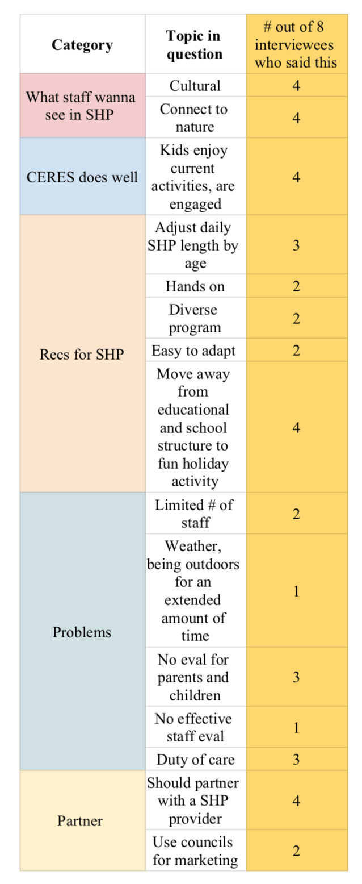

Part G- Stop Start Continue Board Instructions

The “Stop” category is for activities you believe CERES should discontinue
To add to “Stop”:
- Take a sticky note and write all the activities you believe CERES should stop from the activities list provided
- Paste the sticky note in the “Stop” category

The “Start/Change” category is for new activities ideas or themes you believe CERES should offer or existing activities that need to “change”
To add to “Start”:
- Take a sticky note and write your idea for a new activity or theme for activities you think children will enjoy or existing activities that you think should change because of materials or teaching styles
- Paste the sticky note in the “Start” category

The “Continue” category is for activities you think CERES should continue (this can be based on your preference or kids feedback)
To add to “Continue” :
- Take a sticky note and write all activities you believe should continue from the list provided
- Paste the sticky note in the “Continue” category

Part H - Parent Interview Analysis Matrices

Parent Interview Responses
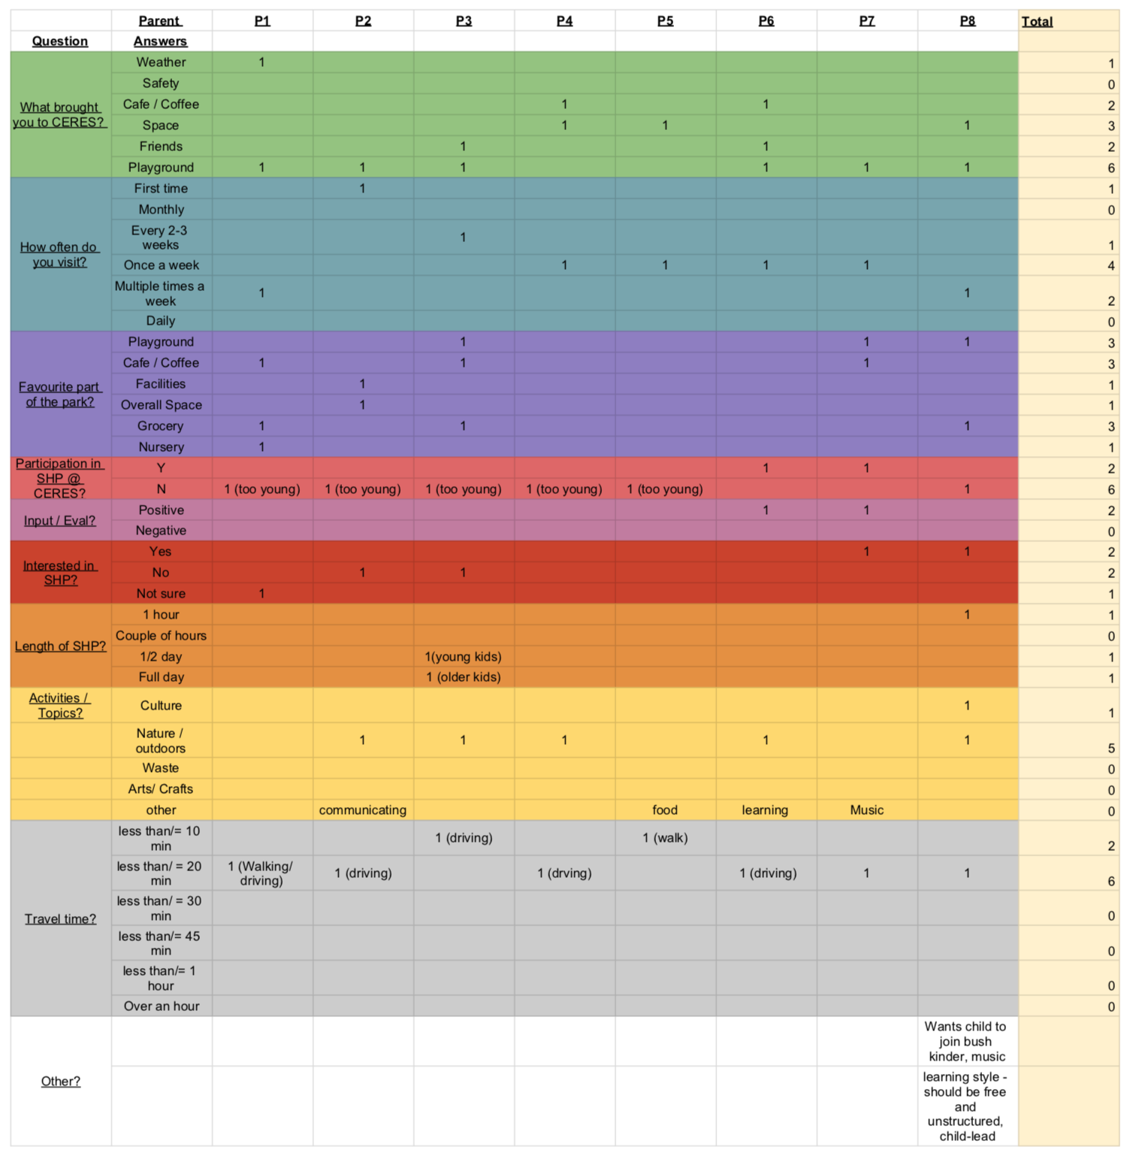

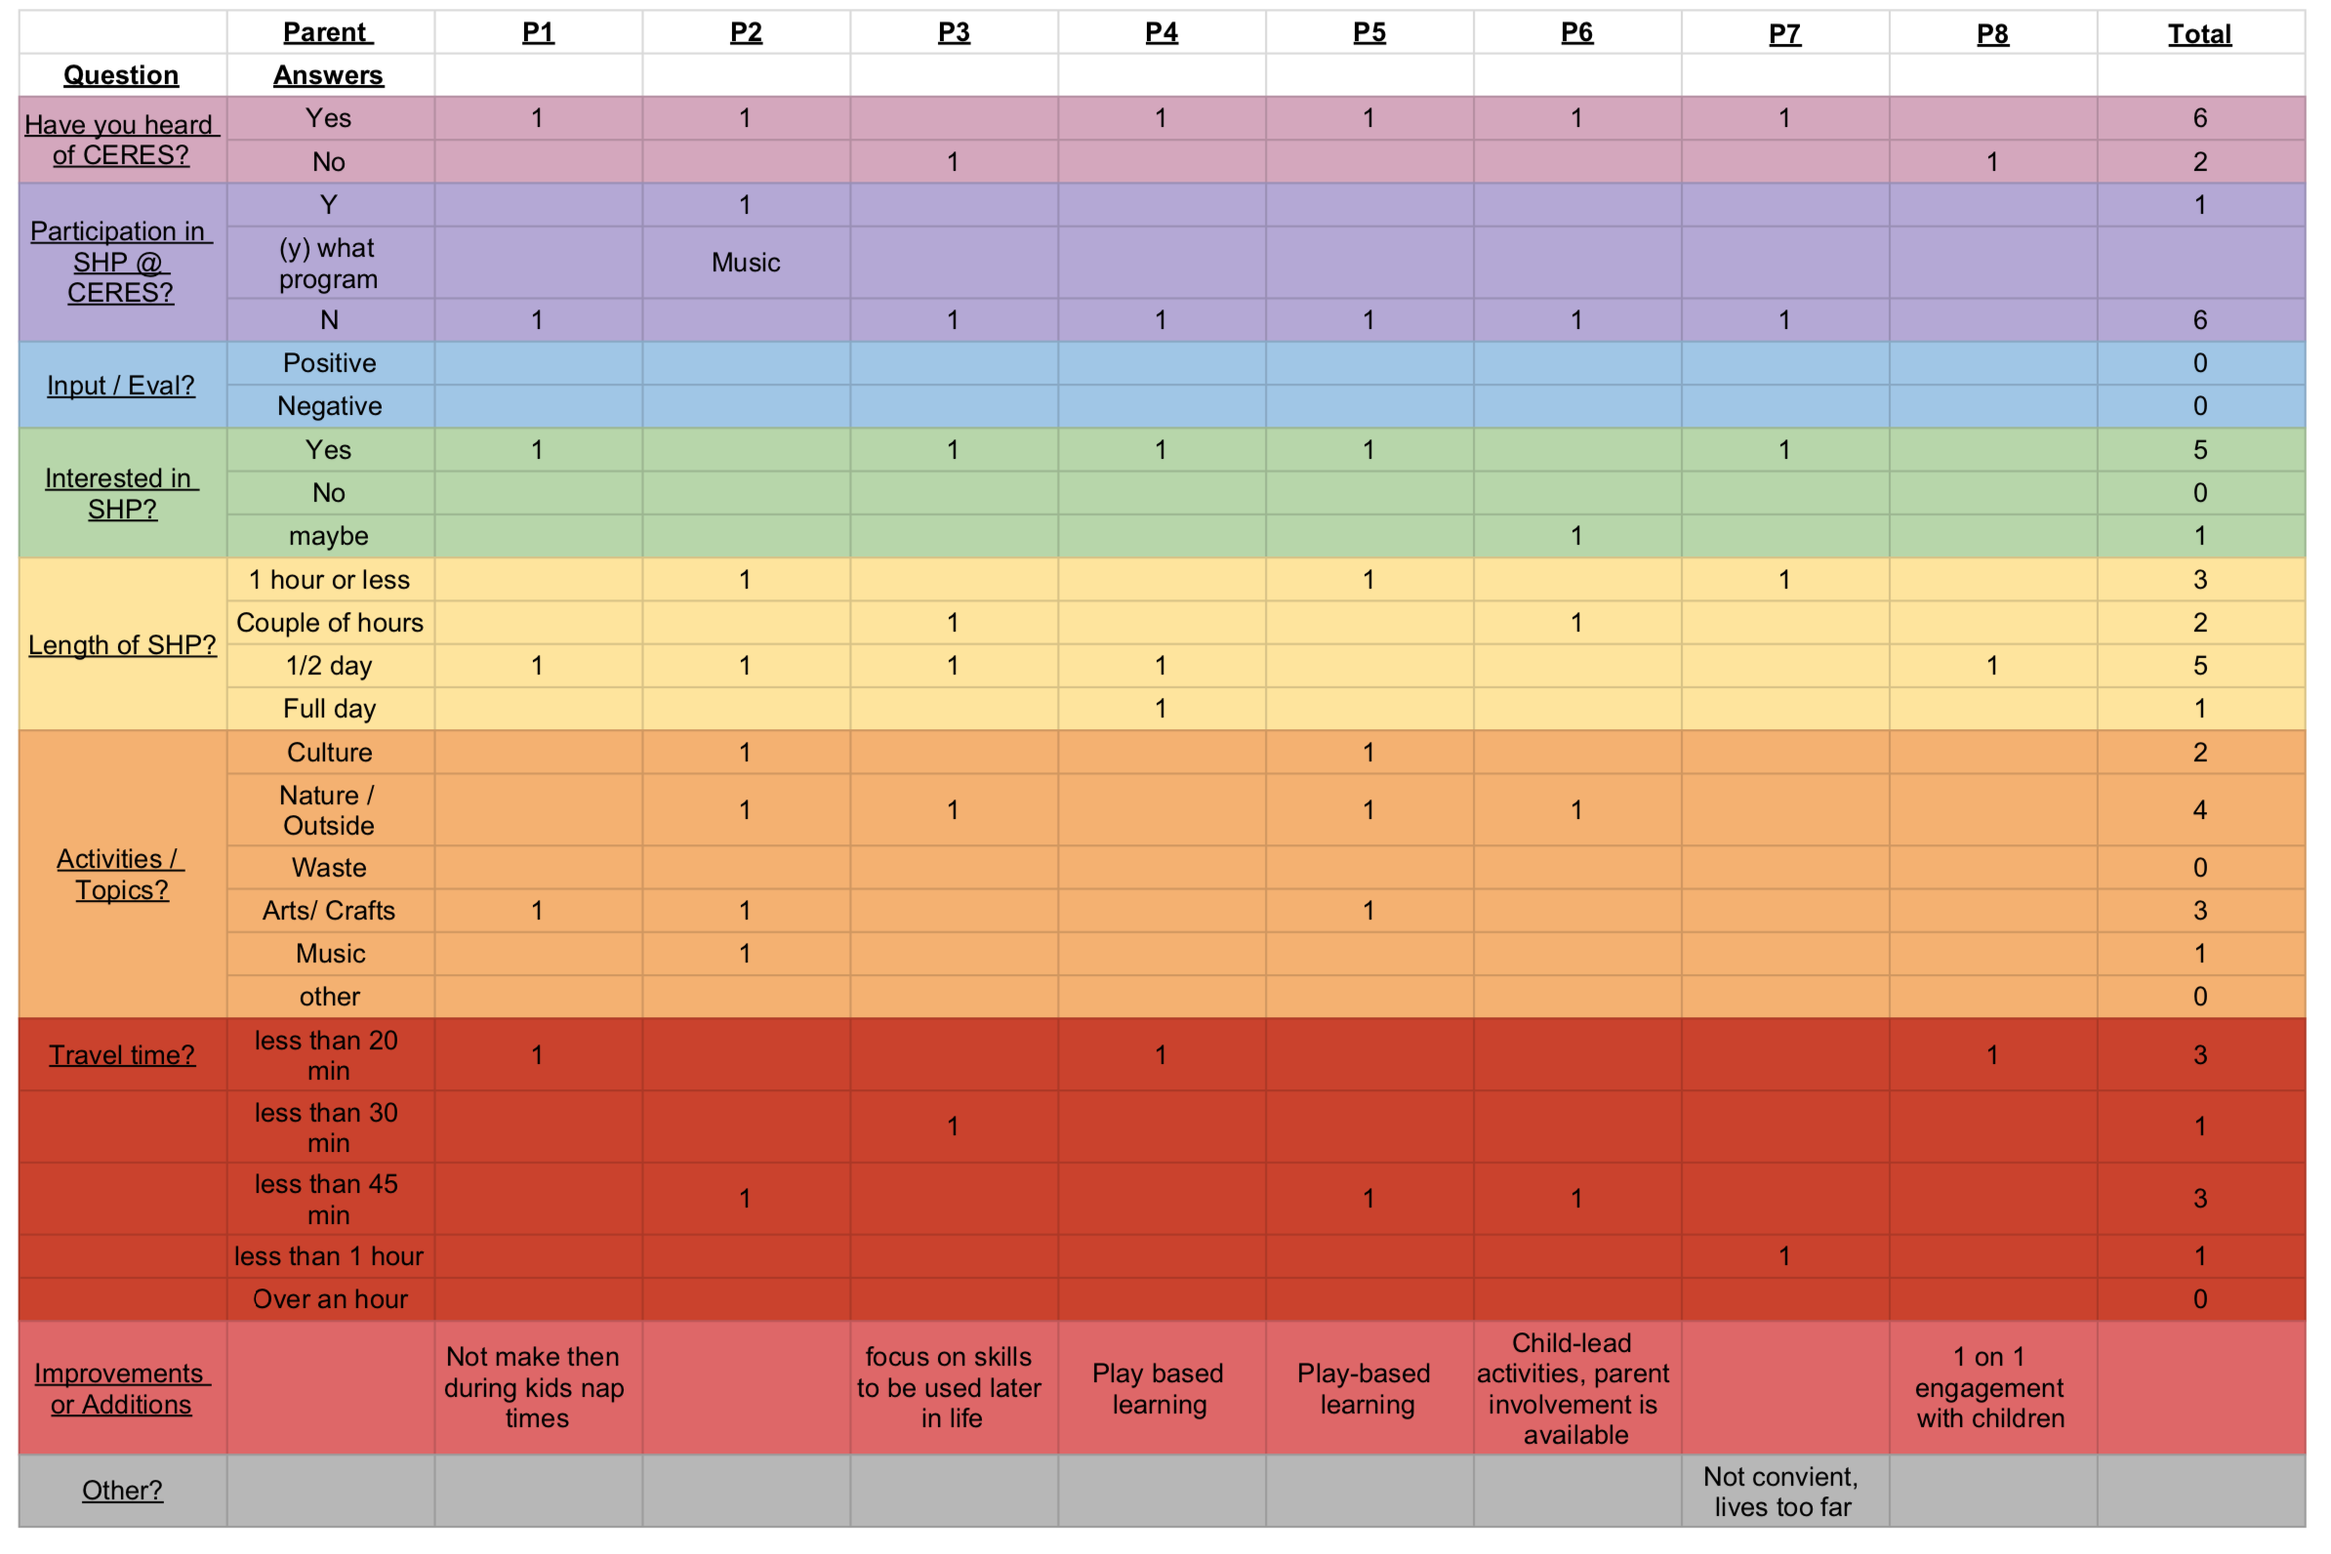

Part I - CERES Term 2, Week 2, 2019 Calendar.
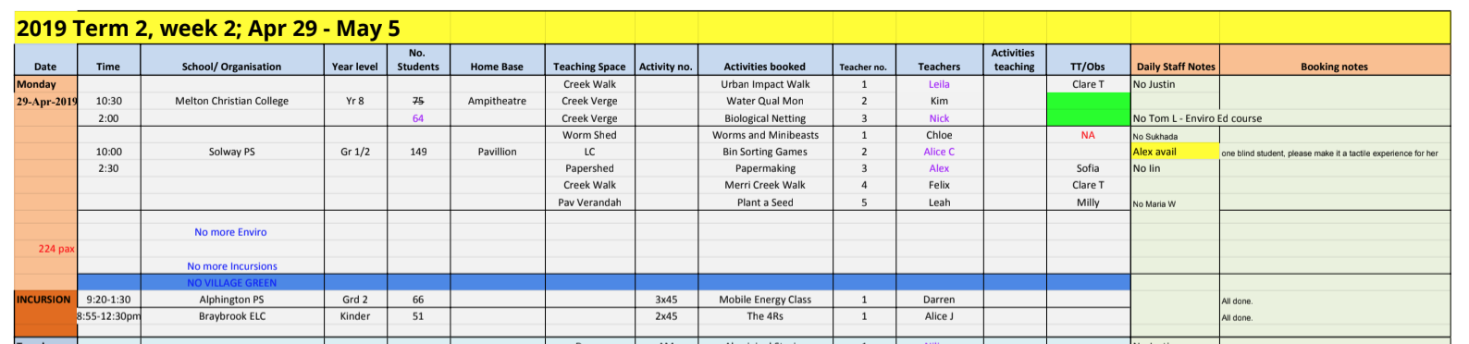

Part J - Layers on Google My Maps
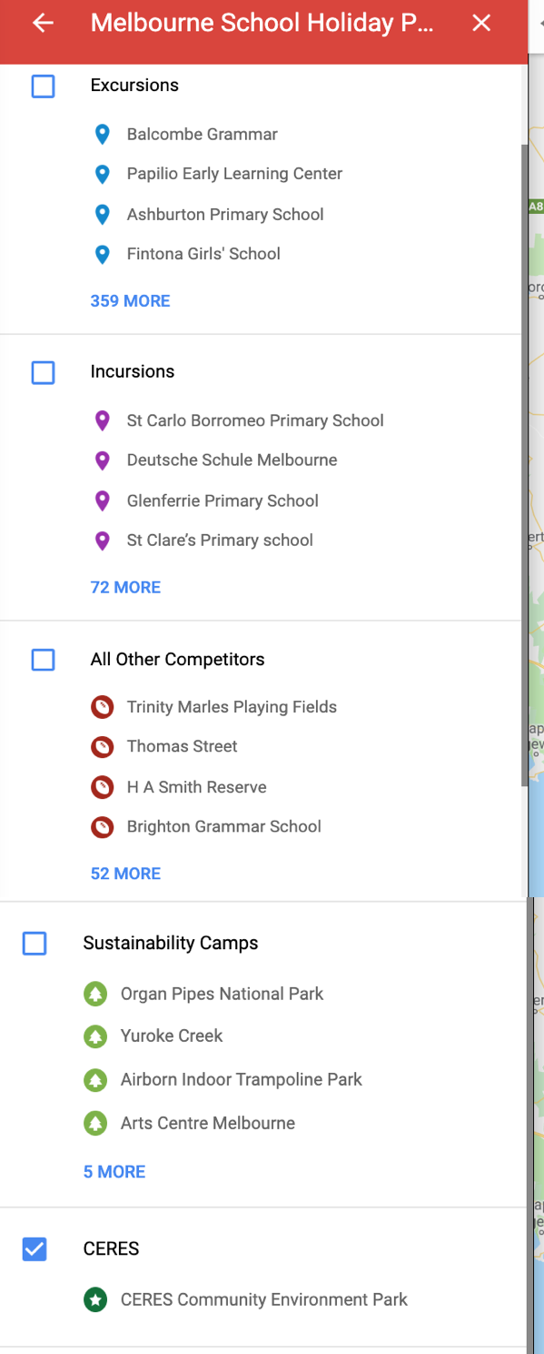

Part K - CVP Analysis Calculations

Various fixed costs ($/ hour) structures we tested using CVP equation

 | Mr. Porter |  | Ms. Horner |  | Our team
Legal requirements | Without DoC | With DoC | Without DoC | With DoC | Without DoC (parents) | Without DoC (3rd party provider) | With DoC (2 educators) | With DoC (1 educator)
Overhead | 8 | 8 | 8 | 8 | 8 | 8 | 8 | 8
Staff | 278.88 | 278.88 | 140 | 175 | 140 | 105 | 175 | 140
Licenses | 0 | 0.9357692308 | 0 | 0.9357692308 | 0 | 0 | 0.9357692308 | 0.9357692308
Materials | 2.21 | 2.21 | 2.21 | 2.21 | 2.21 | 2.65 | 2.21 | 2.21
Staff development | 0 | 0 | 0 | 0 | $5.65 | $5.65 | $5.65 | $5.65
Total | 289.09 | 290.0257692 | 150.21 | 186.1457692 | 155.8638462 | 121.3034066 | 191.7996154 | 156.7996154
Rounded total | 290 | 290 | 151 | 187 | 156 | 122 | 192 | 157

Assumptions
- The program will be offered during 3/4 school holiday breaks (spring, autumn and winter)
- There are 3 age groups
- Each child is expected to bring in materials from home
  - If they do not, participants have to pay a materials fee
  - Overhead materials costs to the Education office are accounted for
- There are 3 session lengths
  - 3 hours
  - 6 hours
  - 5 days (30 hours)
- Each educator gets paid 2 extra hours for each session they run to account for set up and take down (1 hour for each)
  - E.g. a 3 hour session an educator will be paid for working 5 hours
- The maximum number of staff on payroll per school holiday break are:
  - 1 school holiday program manager
  - 1 bookings coordinator
  - 1 marketing coordinator
  - 9 educators
    - 2 educators are required for each age group
    - 1 educator as a backup for each age group
- There will be 2 educator meetings (once at the start of the school holiday and once at the end) and this will be facilitated by the manager
  - Each meeting will take up to 1.5 hours
- Staff development activities will take up to 6 hours each term with an outside facilitator, the 9 educators and the program manager are paid to attend
  - The outside facilitator's price per hour is the same as CERES’s staff wage per hour
- Each session has a maximum of 30 places
  - 2/3 age groups have 2 potential session lengths
  - 1/3 age groups has 1 potential session length
  - Potential total number of places is 150 (5 options x 30 places)
- The program falls under the standard child services license requirements and offers 121 or more places
  - The standard program license costs are the same for more than 120 places
  - This is the most expensive option therefore if the program falls under another type of child services, fixed costs will be overestimated
- The program will run for more than 3 years to 5 years (the longest duration) the license covers
- The CVP analysis is only for the 1st year of the program
  - Initial approved provider application fee with Australian Children's Education & Care Quality Authority (ACECQA) and application and license fees with the Victorian state government are accounted for
    - This only affects the costs for session with Duty of Care
  - Subsequent provider approval fees with ACECQA and children’s services license renewal is not accounted for
  - There may be other fees however we have not found them nor accounted for them
  - Overhead, staff wages and materials costs are based on “CERES Excursion Profit and Losses” breakdown for FY 2019 provided by Mr. Porter and hourly staff wages provided by Ms. Horner

Part L - Focus Group Analysis

Duration Schedule | Years Prep - 2 | - T, W, Th
 | Years 3 - 6 | - T, W, Th
 | Years 7 - 10 | - Full week program (5 days)  - Sequence  - Knowledge  - Explore  - Plan Activate
Daily Schedule | Years Prep - 2 | - School Hours
 | Years 3 - 6 | - Full day  - ½ day
 | Years 7 - 10 | - 9am - Arrive  - 10:20 am - Recess  - 1pm - Lunch  - 2:30 - Recess  - 4 pm - leave  - Notes  - Recess - 20 min  - Lunch - 45 min  - Rest of time is working on the project
Activities / Themes | Years Prep - 2 | - Redesign of activities to suit a more relaxed experience  - Pie-making  - Paper-making  - Plant a seed  - Damper  - Netting  - Chickens  - Creek walk  - Cubbies  - Ochre and Dance (face painting for kids  - Chickens  - Worms and minibeasts -> bug safari  - Day by the dam  - Bush cubbies  - Explore creek -> Dora the explorer  - Fire keepers  - Fishing for bugs  - Bees
 | Years 3 - 6 | - Themes  - Ecology  - Citizen science (netting, bird count)  - Creative (paper and rethinker)  - Multicultural  - Aboriginal  - Urban gardener
 | Years 7 - 10 | - Brand new program  - Action + Activism
Training | Educators | - First aid  - Clothing and shoes  - Arrival / finish times and timetable  - Where equipment is stored  - Contact person + information  - # of children attending  - Teaching spaces and availability  - What else is happening at CERES that may interfere  - The activities and their spaces  - Snake protocol  - Extreme weather protocol  - Compost and recycling info/where  - Radio use / phone use  - Evacuation procedure  - First aid  - Water tap location  - Program content  - Booking details  - Access requirements  - Students with behavioral issues  - Safety procedures  - Facilitation styles
Evaluation | Parents | - post visit prompt automatic 24 hours after booking, Greta got a tell us your experience one recently  - Don’t spam  - If someone has a strong opinion you’ll know (Greta)  - Provide an incentive  - Parents aren't helpful about content unless they attend the program  - Invite parents at the very end for a show or performance where kids show what they've been doing  - w/ DoC parents might not have time to come
 | Children | - Record feedback directly from children
 | Educators | - might be a group feedback session 1 hour paid session at the end, makes the educators feel valued too - based on tom’s experience with a big company and it has to do with costs

Part M - Duty of Care, Children’s Services Licenses and Other Legal Information

Children’s Services in Victoria: Information for parents and guardians
https://www.education.vic.gov.au/Documents/childhood/parents/support/infoparentschildrenservices.pdf
This pdf document introduces parents and legal guardians readers to Victoria’s children services legislation. . The document provides a brief introduction into how the license covers Acts and regulations needed to be followed by a child caring services. Lastly, it provides a list of contacts and websites to learn more about what Acts and regulations are needed by a child service organization.
From this document, we learned that CERES is classified as “centre-based care service”, which is any child care service provided away from a home setting. According to the law, if the organization is serving more than four children younger than 13 years of age, they are required to obtain a license for liability of such children. Therefore, we know that CERES will have to obtain this license for their school holiday program. We hope there will be an attendance of 30 children for each age group program.

Legislated tasks prior to opening your service
https://www.education.vic.gov.au/school/teachers/management/OSHC/Pages/legal.aspx
This is a page on the Victoria State Government Education and Training website. It includes different steps that an educational facility must go through to prepare themselves for application of an outside school educational license. From this page, we learned that CERES must develop a quality improvement plan (QIP). This plan compels the organization's practices to follow the National Quality Agenda IT system (NQS) and relevant regulations. It includes aspects such as physical environment, equipment and resources, roles and responsibilities.

Education and Care Services National Law Act 2010
http://www.legislation.vic.gov.au/domino/Web_Notes/LDMS/LTObject_Store/ltobjst10.nsf/DDE300B846EED9C7CA257616000A3571/D38DBD79C4A26CCECA2582270002C054/$FILE/10-69aa012%20authorised.pdf
This document includes the Education and Care Services National Law Act 2010 and its 2018 amendments. This document details the application process to obtain a child care license, and any future steps to maintain this license. This document lays out a list of contacts departments that are useful resources. It also lays out the timeline for application decisions, renewals and changes that are necessary. We suggest relying on this step-by-step instructions of applying for a children's service license.

Application for a License to Operate a Children’s service- School Holidays Care Service
https://www.education.vic.gov.au/Documents/childhood/providers/regulation/schholidayscareform.pdf
Below is an excerpt from the Application for a License to Operate a Children’s service. As stated in this document, an approved provider must fill out this application to obtain a secondary license for operating a school holiday care service.
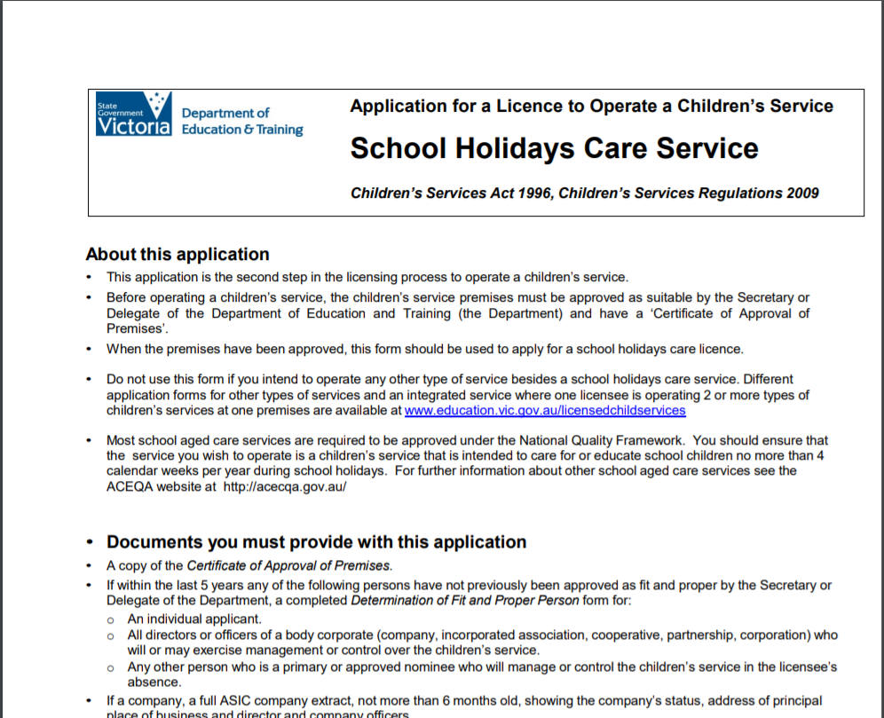

Australian Children’s Education and Care Quality Authority (ACECQA)
https://www.acecqa.gov.au/
The ACECQA is the Australian authority that oversees all educational institutions and organizations through the National Quality Framework. They are who CERES should contact to begin their provider application process. It can be contacted by phone at 1300307415 (dial 2 for Quality Assessment and Regulation team) or by email at licensed.childrensservcies@edumail.vic.gov.au.

Children’s services regulated under State Law
https://www.education.vic.gov.au/childhood/providers/regulation/Pages/vcs.aspx#link2
This Victorian government’s Department of Education and Training webpage includes multiple different files and forms for the registration and payment of a children's services license. We specifically used this website to look at the “2019-20 Children’s Licensing Fees”, which charts the expenses for each license depending on the duration of the license and the number of children it allows the programs to include. We specifically used information with the following charts.

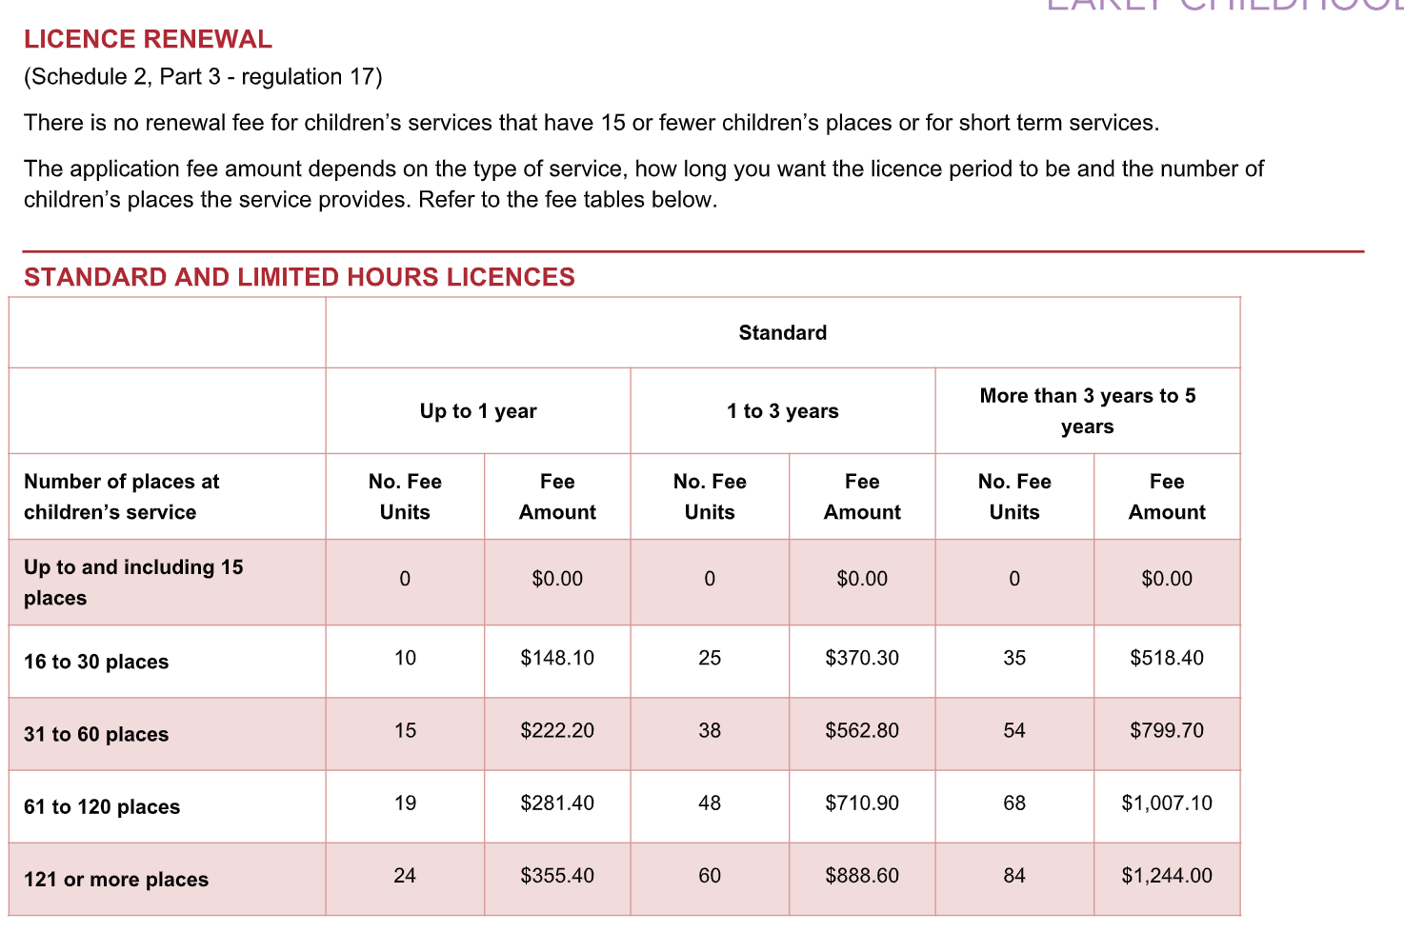

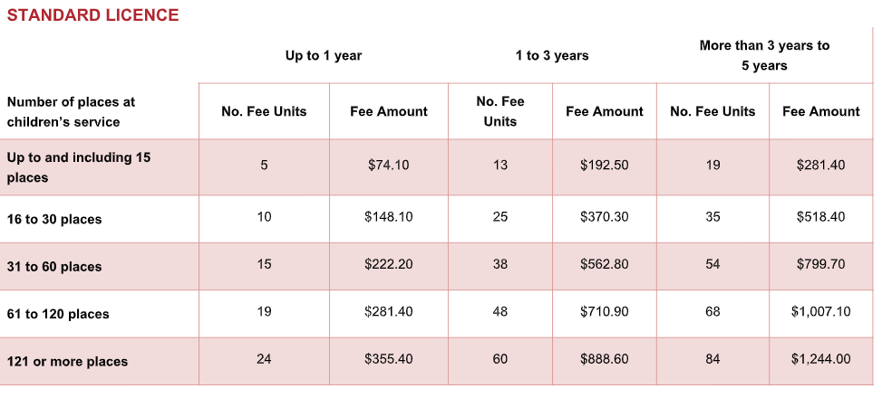

Note from talking with Australian Children’s Education and Care Quality Authority’s representative

The information provided to us below is from Australian Children’s Education and Care Quality Authority (ACECQA)’s phone call representative- Scott. He works in the Quality Assessment and Regulation team. He told us most of the information he gave us, written below, is not posted online. We checked after our phone call and did not find any parts of the information he gave us online.

- Process of Application
The process of applying to be an approved provider consists of multiple simultaneous steps. Be aware that this process will involve your Board of Directors and any other key officers of CERES that will directly and indirectly manage the delivery of an education and care service.
First of all, the organization, known as “the applicator”, must find out what legal entity it is. To proceed, the organization must gather all related documents such as but not limited to:
- List of community members
- Listing from Australian Charities and Not-for-profits Commissions (ACNC).
Meanwhile, the organization’s manager has to fill out two forms: PA01- “Application for Provider Approval” and PA02- “Declaration of Fitness and propriety”. PA02 gives information about which members of CERES will have to go through the assessment. The applicator then access to ACECQA’s website to upload its application forms and gathered documents. The Quality assessment and Regulation team will contact with the applicator regarding its missing documents or its approval. Once the organization is approved, it must schedule a fitness assessment for all board members, the Education department’s managers and other key officers for the school holiday program. Should the applicator pass this assessment, the Regulation team will schedule a property assessment test for the applicator’s facilities. If the organization can pass this test as well, then it is nationally and legally recognized as an OSHC provider. In case the application is unapproved, multiple re-application or partnership with authorized provider is allowed. For further information, the organization should contact the ACECQA by phone at 1300307415 (click 2 for Quality Assessment and Regulation team) or by email licensed.childrensservcies@edumail.vic.gov.au . The person on shift to answer the phone is the same person who replies to the emails. Therefore, the information you will get through the phone and email will be the same.

2) Legal requirements
These are as many legal requirements we could find out without submitting the application.

To be an approved provider, the applicator must have facilities that satisfy space requirements :
- For indoor space, every child needs at least 3.25 square meters of space
- For outdoor space, every child needs at least 7 square meters of space
*The conditions for defining space vary by organisation.
If the provider is not school-affiliated, or not a school itself, then it must be inspected by the Regulation team for facilities assessment. Prior to the assessment, the provider must fill out the application, as mentioned above. In addition, the provider must conduct a fitness assessment session with all the directors, which should be in the same year the application is filled. Within 60 days of the facilities assessment, the result of approval application will be delivered. The assessment process is independent from the application process, thus the provider can start filing the application prior to any necessary facilities renovation.
For regulations of age-appropriate toiletries and other facilities, the provider can visit National Quality Framework’s website: https://public.nqaits.acecqa.gov.au/Pages/Landing.aspx. The information is available with account registration and located under NSW regulations.
The provider’s manager is also responsible for updating documents along with the application.

Part N- Marketing Information

Mummy Blogs | Mum’s Little Explorers https://mumslittleexplorers.com/work-with-us/  - Press Trips:  - Host us at your attraction, restaurant, destination or accommodation allowing us to share it with our readers if we think it will resonate with them.  - Reviews:  - We are happy to try out your products, attraction, or accommodation and write a review for our website.  - Sponsored Posts:  - Let us promote your brand with a family travel related post featuring your brand.  - Open to other ideas  Tot: Hot or Not https://tothotornot.com/about/work-with-me/  - Request a media kit and a rate car  Planning with Kids https://planningwithkids.com/work-with-me/  - There are many ways we can work together. Please peruse the information below or feel free to contact me directly by emailing nicole@planningwithkids.com.  Motherhood Melbourne https://www.motherhoodmelbourne.com.au/letsworktogether  - Media Kit  - Promotional Packages  - Multi-platform promotion via website, social media and email newsletter. For product, service and event based businesses and bloggers.  - Podcast Partner  - Love-bombing your biz on a podcast that is only for Melbourne Mamas. For Australian product, service and event based businesses.  - Sponsored blog post  - ​I'll work my blah-blah magic and write a killer piece about you. For product, service and event based businesses and bloggers.
Newspapers | Moreland City Council Newsletter  - The contact for media enquiries is Council's Senior Media and Communications Advisor on 0407 556 101.  The Saturday Paper  - http://www.schwartzmedia.com.au/titles/the-saturday-paper/tsp-rates  Darebin City Council Newsletter  - Call 8470 8888  - Email mailbox@darebin.vic.gov.au  Melbourne Magazine  - No advertising, but can tell stories  - Submit to:  - Email melbournemag@melbourne.vic.gov.au  - Call 9568 9658  Yarra Council Newsletter  - Call 9205 5555  - Email yarranews@yarracity.vic.gov.au

Part O - Contributions

Name | Adora Le
Role | Editor
Research Topics | School holiday program models in schedules and structure  Lack of education in sustainability  Competitor search  Marketing strategies  Sustainability camps: building and evaluation  Children’s Psychology and effective education methods  Competitor Programs: EcoDiscoverer School Holiday Program, Gresswell Forest school, Port Phillip, Ecocentre, LEGO  workshop, Springvale Indoor sport, Innovate Tech academy, EcoExplorers  Duty of Care
Author | Education today for a sustainable tomorrow  Sustainability education and environmental conservation  Marketing strategies  SWOT Analysis
Other | Edited all drafts and final booklet  Interview note-taker and analyzed interviews  Created evaluation questions

Name | Bianca Amarasekera
Role | Project Manager and Booklet Designer
Research Topics | Effective school holiday program structure  Education teaching and learning methods  Pricing strategy: cost-volume-profit analysis  CERES Excursions and Incursions: Program overview and current lessons  Analysis of CERES finances  Victoria state sustainability policies and implementation  Competitor Programs: 100 Story building, Victoria Zoos, Banksia, Port Phillip EcoCentre, Collingwoods Children’s  Farms, Museums Victoria, Ecoexplorers  Duty of Care
Author | Introduction  CERES (Head, hands and hearts method, Incursion and Excursions, and Finance sections)  Effective summer program models  Introduction of methods and objectives  Intercept interviews with parents  Stop, Start, Continue board  Costs, profits and pricing  Recommendations for prices
Other | Formatted visuals for booklet, designed visuals for proposal slides  Interviewer and interview note-taker

Name | Courtney Campagna
Role | Archivist and Secondary Editor
Research Topics | CERES Overview  Australia’s investment in environmental education (specifically policies)  Schools CERES works with  Pricing strategies  General education programs  CERES park structure  Competitor Programs: Australian Sports Camps, Code Camps, Team Kids, Mettyl’s Mosaics and Glass Studio  Training Methods  Duty of Care
Author | Introduction  Environmental Crisis  Competitor Analysis  Pricing Strategies  Objective 1 (main contributor)  Standardization of price and age  Recommendations (main contributor)  Conclusion
Other | Designed visuals for booklet and proposal slides  Interview note-taker and analyzed interviews  Design comparative analysis matrices for competitors and interviews

Name | Yael Rogoszinski
Role | Designer and Secondary Editor
Research Topics | Environmental natural resource budget  Competitor Programs: Banksia, Melbourne Zoo, Healesville Sanctuary, Norman Bird Sanctuary, Camp Blue, Children's Science  Workshop, Team Kids, YMCA  Advertising methods  Mommy blogs to advertise on  If schools advertise school holiday programs and where  Local council newsletters  Third Party School Holiday Program Providers  CERES program structures for school holiday program  Duty of Care
Author | Introduction  CERES (who CERES is and park layout)  CERES staff wages for educators  Semi-structured interviews with CERES program leaders  Intercept interviews with parents  Creating the final model  Recommendations for Prep to Year 2, Year 3 to 6, Year 7 to 10
Other | Design and formatting of proposal and focus group slides, promotional fliers, and visuals for booklet and proposal slides  Interviewer and interview note-taker

