Enhancing Social Marketing of Consumer Participation in Voluntary Consensus Standards
An Interactive Qualifying Project Report
Submitted to the Faculty of
WORCESTER POLYTECHNIC INSTITUTE
in partial fulfillment of the requirements for the
Degree of Bachelor of Science

Submitted by:
Shaina Lazarus
Winston Lewis
Harry Radenberg

Submitted to:
Professor Hall-Phillips
Professor Mathews
Worcester Polytechnic Institute

December 13, 2023

This report represents the work of one or more WPI undergraduate students submitted to the faculty as evidence of completion of a degree requirement. WPI routinely publishes these reports on the web without editorial or peer review.

Abstract
Voluntary standards are a non-mandatory set of standards that help guide the manufacturing of consumer products. There are a multitude of different standards for any product. These standards account for potential dangers and are an important aspect of making products safer for consumers. However, standards development processes lack consumer representation. Standards development organizations and the CPSC value consumer input, as consumers are the ones using the products. Therefore, they are searching for ways to increase consumer participation in this process. Our project, we created three deliverables to aid the CPSC in increasing consumer participation in voluntary standards through awareness and education.

Acknowledgements
We want to say thank you to many people that helped us get to this point. Thank you for all your time and support and the valuable information that helped us complete this project.
Thank you to:
- Our sponsor liaisons, Scott Ayers and Jonathan Midgett, for providing us with important contact points for research and for providing the framework for us to work on our own to create our resources while checking in on us along the way to make sure we were all on the same page.
- Our advisors, Professor Hall-Phillips and Professor Mathews, for always being there for any questions we may have and for all the important feedback they gave us on our report along the way.
- Our interviewees, including SDO representatives and the consumer participants, who took the time to meet with us and share their insight on this topic.
- Professor Chery for taking the time to look over our character designs in order to ensure that we had a diverse and inclusive set of characters.
- Professor Stimmel for teaching us the skills we need, and constantly providing us with feedback.
- Dean Rissmiller for setting up this unique opportunity for us.

Authorship
When writing and editing this paper, our process was very collaborative. To begin, each subsection was claimed by one person, and written to a good degree. Then, others joined in to help flesh out the section and also update it as new info came in. After all of this, there was an overall editing process that was done by all members to help create the final blend of styles as seen here.

Table of Contents
Abstract 1
Acknowledgements 2
Authorship 3
Executive Summary 5
I. Introduction 8
II. Background 9
III. Methodology 14
IV. Results 19
V. Discussion and Recommendations 30
VI. Conclusion 33
VII. References 34
Appendix 37

Executive Summary
Introduction & background
Voluntary standards are a non-mandatory set of standards that help guide the manufacturing of consumer products. The goal of voluntary standards is to help reduce the risks associated with products before they are sold to consumers. Holding voluntary standards meetings with diverse groups of individuals allows those of various backgrounds and perspectives to voice their concerns about product standards, and in doing so, allows consumer product companies to be more aware of how overlooking certain aspects of a product can bring great harm to certain communities. The importance of having a diverse group of consumers participating in voluntary standards meetings is an issue that the CPSC views as an important step in trying to increase the safety of consumers. The CPSC aims to increase consumer participation in voluntary standards meetings. To that end, the CPSC has various outreach campaigns which try to spread awareness about consumer safety to a broader group of consumers. However, none of these outreach campaigns have genuinely increased consumer participation. Therefore, the goal of this project was to develop educational resources to assist the CPSC with recruitment efforts for voluntary standards development.
Methodology
To accomplish this goal, we addressed three objectives:
    - Identifying the current recruitment practices the CPSC and other standards organizations use for participants in voluntary standards.
    - Evaluating consumer experiences with voluntary standards.
    - Determining the appropriate resources to develop based on findings from objectives 1 and 2.
For objective 1, we interviewed the CPSC and a few select standards organizations in order to learn about how the recruitment for voluntary standards works, the groups of consumers they are finding it hard to get and which they want to acquire, the observations they have made regarding consumer involvement, and the ways that they have tried to make participating in voluntary standards more accessible to consumers. For objective 2, we interviewed consumer participants in order to learn about participation barriers, motivators to participate, and participation experiences. For our third objective, we synthesized the data from the previous two objectives. We then created resources we thought would be good for relaying information, and those we thought would effectively bring attention to voluntary standards.
Results
For objective 1, we interviewed six CPSC employees, as well as eight representatives from six different standards organizations. Through these interviews we learned that headhunting, networking, and participation polls are the main recruitment methods. The most prominent consumer participation barriers are not receiving financial reimbursements for the costs of attending the meetings and lacking an understanding of how the meetings work. We learned that some of the ways standards organizations tried to mitigate consumer voluntary standards meetings are by paying for consumers’ travel costs, waiving membership fees, providing consumers with mentors, and designing modules that teach consumers about the voluntary standards process.
For objective 2, we interviewed six consumer participants from four different consumer groups. Through these interviews, we learned that cost, intimidation, meeting time, meeting length, and self-doubt are the most prominent barriers. Some of the motivators for consumer participation that were stated in our interviews are personal loss, hearing of another’s personal loss, personal injury, and wanting to make the country safer. After asking how the consumers learned about voluntary standards, we learned that most of them learned how to get involved through others who were already attending the meetings or at least heard of them. Among our six consumer interviewees, only one told us that they had learned about voluntary standards through independent research.
For objective 3, we designed three resources to increase consumer participation: a cartoon, a video game, and a social media slide deck. Each resource is designed for a different learning style.
Recommendations
In addition to our deliverables, we provide a number of recommendations that we feel will help increase consumer participation. Our first recommendation is for the SDOs to create and send out a form of the relevant terms and definitions for meetings ahead of time. If consumers read these forms before the meetings, this could mitigate the jargon barrier. Our second recommendation is for the CPSC to promote voluntary standards involvement across multiple social media platforms. This would increase the chances of eligible consumers viewing, gaining a genuine interest in, and participating in voluntary standards.

We hope that our consumer educational tools will spread awareness of voluntary standards, and in doing so, increase consumer participation within them.

Introduction
In the field of consumer product safety there are a variety of precautions in place to ensure that consumers are safe. Some of these precautions are mandatory regulations while others fall into a category known as voluntary standards. Voluntary standards are essentially the safety guidelines that consumer product manufacturers should, but do not have to follow to ensure that their products are reasonably safe for the public to use (CPSC, n.d.). These standards are written by technical committees and subcommittees who work together to write a new standard or adjust a previous one. This process is designed to involve participation from consumers to obtain first-hand experience with product use. The Consumer Product Safety Commission is an independent government organization that is primarily responsible for the testing and regulation of consumer products, such as toys, furniture, cleaning chemicals, and many more (CPSC, n.d.). It is through voluntary standards that the CPSC regulates consumer products and reduces risk of injury and/or death for consumers across the nation. Despite the CPSC’s efforts to try to ensure consumer products are safe, consumers are being injured and dying from using various consumer products (CPSC, 2022). Without consumer participation, the CPSC has less feedback on how products’ standards should be improved since the first-hand insights provided by the consumers who use the products are removed. Currently, there is an overabundance of manufacturers and industry representatives who participate in voluntary standards, and their voice overpowers the few consumers who do participate. Different voices are necessary in voluntary standards, as having a variety of perspectives on standards allows standards development organizations to consider a wider range of issues and angles when discussing what to include. The CPSC wants to have more consumers participate in voluntary standards so that they can more effectively reduce risk of the products they regulate, but the CPSC has yet to create and utilize an effective recruitment method for consumers (Midgett, personal communication).
Our goal was to develop educational resources to assist the CPSC with recruitment efforts for voluntary standards. We accomplished this by:
- Identifying the current recruitment practices the CPSC and other standards organizations use for participants in voluntary standards.
- Evaluating consumer experiences with voluntary standards.
- Determining the appropriate resources to develop based on findings from objectives 1 & 2.

Background
In this section, we begin by explaining voluntary standards and how they connect to product safety. We then elaborate on some of the product safety problems that occurred because the voluntary standards meetings were not composed of diverse groups of people. We end this section by highlighting the importance of having diverse groups of meeting participants and the significance of educating the testers.

2.1 Voluntary Standards
Voluntary standards are a non-mandatory set of standards that help guide the manufacturing of consumer products (CPSC, n.d.). The goal of voluntary standards is to help reduce the risks associated with products before they go to the testing stage at the CPSC. These standards are also referred to as consensus standards, which are a type of standard that is developed by consensus standard bodies using a process that includes different factors to ensure fairness (CPSC, n.d.b). Some of these elements include openness, balance, due process, appeals process, and consensus. In this context, the idea of consensus does not imply unanimous agreement; it means that everyone included gets an equal opportunity to be heard (CPSC, n.d.b).
A voluntary standard is created by a series of meetings involving participation by many different groups of people. CPSC employees and public-interest non-profit organizations, such American National Standards Institute (ANSI) and the American Society for Testing Materials (ASTM) will all attend. In addition, different industries, manufacturers, and consumer groups will also join these meetings to express their viewpoints. The meeting agenda will be sent out with each point that needs to be discussed. People will reach out to the chairmen running the meeting to get onto the agenda (Participant #6, personal communications). These different organizations engage in developing voluntary standards and have different but important roles. ANSI is a private, non-profit organization that helps create a framework for fair standards development (ANSI, n.d). Their job is not to directly develop these standards, but to accredit different standards development organizations. ASTM, one of the top organizations that the CPSC works closest with, and a leader in development of voluntary consensus standards around the globe, directs the meetings and promotes participation from the public in making the standards (ASTM, n.d.a).
Although these organizations work closely with government agencies, they are not a part of the government themselves. Instead, they have been created to help the government save time and resources on creating the requirements. It is intended that a broad range of personnel is represented in voluntary standards meetings to get a variety of opinions and insight. From agency representatives to everyday consumers, any member of the public is permitted to attend the meetings. Having a wide range of people and opinions helps gauge what each individual finds important and how a product can affect one person differently than another (CPSC, n.d.).
However, this is not what is currently happening. In fact, it is very common that there is zero consumer participation at all (ANSI, 2022). It is asserted by the CPSC that consumers should participate as they are “experts on how [they] use consumer products” (CPSC, n.d.b). One of ANSI’s essential requirements for due process is that any party with direct interest should be able to participate, a requirement that is intended to balance the interests of voting members (ANSI, n.d.a). With only experts at these meetings the conversation can feel unbalanced, as they do not necessarily have the perspective of an everyday user of the product (CPSC, n.d.b).

2.2 The Importance of Representative Consumer Participation
Holding voluntary standards meetings with diverse groups of individuals allows those of various backgrounds and perspectives to voice their concerns about product standards, and in doing so, allows consumer product companies to be more aware of how overlooking certain aspects of a product can bring great harm to certain communities. The risks of consumer products can affect some demographic groups disproportionately. For example, self-driving cars are being used more and more in society, but are not equally safe for all pedestrians. Self-driving cars are currently used in more than 20 US cities (NAIC, 2022). One argument in favor of self-driving technology is that they will avoid making the mistakes that humans make when driving. In 2019 alone, there were over 10,000 car accidents that were a result of human error (NAIC, 2022). Self-driving cars could decrease the occurrence of accidents by approximately 90% (NAIC, 2022). Self-driving cars are specifically designed so they do not hit pedestrians. While they easily recognize and avoid white pedestrians, they have slightly more trouble recognizing and avoiding people with darker skin tones. In fact, the precision decreases by about 5% when attempting to recognize those with darker skin tones (Wilson et al., 2019). In this case, the study found that facial recognition systems are not trained for various demographic groups but would likely benefit from doing so (Wilson et al., 2019), and that is why self-driving cars are better at recognizing white people.
Children’s toys are another type of consumer product that has regulations and voluntary standards associated with it. Toys are designed with the intent that their users will use them to have fun and entertain themselves. Ironically, toys have an infamous history of harming children in unexpected ways and the injuries are continuing to happen. In 2021, over 200,000 toy-related injuries occurred (CPSC, 2022).
The CPSC is also responsible for educating people on consumer products and regulations through public outreach (CPSC, n.d.), but the way in which they educate members of different demographic groups and enforce safety procedures is important as well. There has been an ongoing issue involving civilians and traffic safety, as more deaths in the US can be attributed to pedestrians being killed in car accidents (Mamun et al., 2020). Part of the reason for this is that people of different demographic groups (women, men, middle-aged people, the elderly, etc.) have different levels of conformity to street-crossing laws (Mamun et al., 2020). A team of researchers tested educational approaches with various demographics on traffic safety in three ways: education, discussion, and a combination of the two. It was discovered that those educated through discussion showed the most improvement overall–especially women of all ages and people above 25 years old (Mamun et al., 2020). Since these individuals benefited from the teachings they were given, they could use their newfound knowledge at voluntary standards meetings and create more sensible regulations regarding products that relate to traffic safety. They know what mistakes they have made with respect to traffic safety, so they most likely would have some insight on what regulations could help mitigate risks for those in traffic (Mamun et al., 2020).
The need for consumer education extends past traffic safety, as it also applies to playground equipment, another CPSC related product. Children suffer from thousands of playground injuries each year. Between 2009 and 2014, 1017 playground incidents occurred with children under the age of 10 (CPSC, 2017). Also, approximately 20% of all injuries that occurred on playgrounds within this time range were a result of both intentional equipment misuse and unintentional equipment misuse (CPSC, 2017).
When consumers are thoroughly educated on a product and its standards, they can voice their concerns effectively at voluntary standards meetings and potentially cause new standards to be implemented as a result. For example, for years, children were opening microwaves and spilling the hot foods/substances inside the microwaves on themselves (Quinlan et al., 2021). In 2021, 22.5% of burn patients were children, and most of the children received burns because of microwave use (Quinlan et al., 2021). In 2005, a team of individuals involved in the medical field and standards development discussed creating a mechanism that would make it harder for children to open microwave doors. While the group of individuals did not get their initial standard passed for microwave doors, their second proposed standard on how microwave doors should be designed was passed and will be implemented in 2023 (Quinlan et al., 2021).

2.3 The CPSC’s Initiative and Goal
The importance of having a diverse group of consumers participating in voluntary standards meetings is an issue that the CPSC views as an important step in trying to increase the safety of consumers. The CPSC aims to increase consumer participation in voluntary standards meetings. However, there are several potential barriers which make it difficult for the average consumer to participate in these meetings. According to the International Organization for Standardization (ISO), some prominent barriers which consumers must face are the jargon which is used in these meetings and the time that these meetings take place. Since these meetings are held by industry professionals, the jargon used is understood by many of the participants of these meetings, however, this does not apply to the average consumer who will likely not understand many of the terms being used in these meetings and may feel as though they are unable to help or participate due to this (ISO, n.d. Sec. 3.4). Meeting times are another important barrier which prevents the average consumer from participating in these meetings. The meeting times are primarily done during the working day which means that they would have to potentially miss work to attend these meetings (Scott Ayers, 9/28). Another barrier which the ISO mentioned is a lack of awareness of the existence or importance of voluntary standards meetings. Voluntary standards are often overlooked by consumers, and many consumers are unaware that they are even able to participate in voluntary standards meetings (ISO, n.d. Sec. 3.4).
The CPSC is trying to make voluntary standards meetings more appealing to the average consumer. There are many places on their website that show the importance of voluntary standards and try to answer commonly asked questions about what voluntary standards meetings are and how people can participate (CPSC, n.d.b). The CPSC also has videos on YouTube and their website showing the importance of voluntary standards and product safety. A few of these videos have gotten millions of views and have been a very popular way of teaching the public about ways to prevent hazards in their homes (CPSC, 2023a). The CPSC also has an X (formerly known as Twitter) account where they post about consumer safety. The CPSC has also launched social media campaigns that try to focus on issues that primarily affect marginalized groups of people such as the frequency of drownings in Spanish speaking communities (CPSC, 2023). They have been increasing their partnership programs in rural areas to try to increase consumer knowledge of product safety which will help make these underserved communities safer (CPSC, 2023). The CPSC has a page on how you can start a consumer safety program in your community and get involved in consumer safety (CPSC, n.d.c, para. 1). Other organizations such as ANSI have been attempting their own outreach programs in order to reach more consumers. ANSI has created a new staff position for a consumer outreach program, and they have created a fund to cover the costs of consumer’s participating in voluntary standards meetings (ANSI, 2022).
Despite these outreach methods that attempt to show the importance of consumer product safety to the general public, there is still a disparity in the representation of consumer participants in voluntary standards meetings compared to other groups, such as industry experts or product manufacturers. This disparity is often severe enough that many voluntary standards meetings have almost no consumer participants at all, and some meetings do not even have a single consumer participant (ANSI, 2022). Due to this disparity, the CPSC is trying to improve consumer participation in these voluntary standards meetings. These meetings are an integral part of increasing consumer safety, as they help to define what the standard is for product safety. The importance of these meetings makes the lack of consumer involvement within them a concern of the CPSC and other organizations who work with voluntary standards.

Methodology
Our goal was to develop educational resources to assist the CPSC with recruitment efforts for voluntary standards development. We accomplished this by:
- Identifying the current recruitment practices the CPSC and other standards organizations use for participants in voluntary standards.
- Evaluating consumer experiences with voluntary standards.
- Determining the appropriate resources to develop based on findings from objectives 1 & 2.

3.1 Objective 1: Identifying the current recruitment practices the CPSC and other standards organizations use for participants in voluntary standards.
We conducted interviews with CPSC employees and other standards organizations and asked about how the recruitment for voluntary standards works, the groups of consumers they are finding it hard to recruit and who are the target participants, the observations made regarding consumer involvement, and the ways that they have tried to make participating in voluntary standards more accessible to consumers (See Appendix B for interview questions).

3.1.1 Data Collection and Analysis
We collected data by recording and transcribing semi-structured interviews with six CPSC employees (see Table 1), as well as eight standards organization representatives from six different organizations (see Table 2). We conducted these interviews with the hope of finding common themes between them. They were conducted both virtually and in person. Two of the CPSC employees and one of the standards organizations were in person and the rest were hosted over Zoom. We recorded these interviews for our reference. The average length of each interview was 17 minutes, and they were transcribed using Zoom, Microsoft Word, and the website GoTranscribe. After the preliminary transcription we listened through the interviews to check and make sure the words matched the audio.

Table 1: Description of participants and dates of interviews with CPSC employees
Participant | Job Category | Interview Date
Participant #1C | Engineer | 11/03/2023
Participant #2C | Human Factors | 11/08/2023
Participant #3C | Human Factors | 11/09/2023
Participant #4C | Engineer | 11/14/2023
Participant #5C | Engineer | 11/15/2023
Participant #6C | Human Factors | 11/16/2023

Table 2: Organizations and dates of interview with participants
Participants | Organization | Interview Date
Participant #1S | ANSI | 10/31/2023
Participant #2S | CPSC (retired) | 11/07/2023
Participant #3S | CSA | 11/09/2023
Participant #4S | ASTM | 11/10/2023
Participant #5S | ULSE (retired) | 11/10/2023
Participant #6S | ULSE | 11/20/2023
Participant #7S | ULSE | 11/20/2023
Participant #8S | NFPA | 11/20/2023

After the transcriptions were completed, we read the transcripts carefully and performed axial coding on all fourteen of the interview transcripts with the goal of finding commonalities such as common barriers for participation and the methods used for recruitment. After performing axial coding on the interviews, we identified and noted the common characteristics of each interviewee’s responses. To do this we color coded our main topics we wanted to find and then read through each interview highlighting key points that followed these topics. Specifically, we made a note of the barriers for consumer participation, the methods the organizations have used to recruit consumers, the groups they are finding harder to recruit, the groups they want to recruit, the observations they have made regarding consumer involvement, and the action that they have taken to make voluntary standards more accessible to consumers.

3.2 Objective 2: Evaluating consumers experiences with voluntary standards
We interviewed consumers who have previously participated in voluntary standards meetings and inquired about their incentives for participation, barriers they found when trying to participate, how they found out about the voluntary standards meetings, and their experiences with participation.
3.2.1 Data Collection and Analysis
We collected data by recording and transcribing the interviews with the six consumer participants (see Table 3) (Please see Appendix C for interview questions). We conducted these interviews with the hope of discovering the common participation barriers, motivators to participate, and participation experiences among the consumer participants. All of our interviews with the consumer participants were conducted virtually using Zoom and recorded for our reference. Each interview lasted about 15 minutes. After each interview was completed, we generated transcripts of the interviews using GoTranscribe. The transcripts were then inserted into Microsoft Word. We rewatched the interviews and edited the transcripts to make sure the transcripts matched the audio of the interviews.

Table 3: Consumer groups of and the date of interviews with consumers
Consumer | Consumer Group | Interview Date
Consumer #1 | Parents Against Tip-overs | 11/03/2023
Consumer #2 | Kids In Danger | 11/07/2023
Consumer #3 | Kids In Danger | 11/08/2023
Consumer #4 | Consumer Reports | 11/08/2023
Consumer #5 | Parents Against Tip-overs | 11/09/2023
Consumer #6 | National Carbon Monoxide Awareness Alliance | 11/17/2023

We inserted the edited transcripts into Google Documents and performed axial coding on them with the goal of finding commonalities such as common barriers for participation, motivators to participate, and participation experiences. After performing axial coding on the six consumer participant interviews, we identified and noted the common characteristics among the interviewees. Specifically, we paid attention to the participation barriers mentioned, the motivators for participation, and the experiences with participating in voluntary standards.

3.3 Objective 3: Determining the appropriate resources to develop based on findings from objectives 1 & 2.
We integrated the findings from both Objectives 1 and 2, to determine suitable resources for voluntary standards recruitment. We developed three resources to accommodate different ways of learning. We created a cartoon, a video game, and an informational social media slide deck.
Once we had analyzed our data thoroughly from both previous objectives, we compared the data from the two objectives. We identified which themes were most prominent, which themes were least prominent, the consensus of voluntary standards among the three groups, and any unique, insightful responses we received from the interview participants. We then synthesized our findings from all interviews and incorporated the information we gathered into our resources.
From there, we worked on our resources, which came in the form of a video cartoon, a short video game, and an informational social media slide deck. To decide on our resources, we listed ideas for resources that we thought would be good for gaining attention, providing information & education, and that consumers could come across easily when trying to learn about a product (referrals). The resources that we thought would be good for gaining attention were posts on X, advertisements, and videos. The ideas that we thought would be great for providing the public with information and education were video games and an FAQs document. Lastly, the idea we thought would involve referrals was search engine optimization (algorithms), so that information about consumer product safety and voluntary standards would be one of the first results Internet users would come across when searching for information about a product.
We decided that search engine optimization would be too difficult and time consuming to implement given the amount of time we had, so we decided to not work on this idea. We did agree, however, that we should have at least one deliverable that serves mainly to draw attention to voluntary standards and one with the primary goal of informing the public. We also created another deliverable that combined the two. We decided to make an animated cartoon video to bring attention to voluntary standards, since advertisements would be difficult to implement. The cartoon is more suited for those who learn better through passive viewing. The cartoon explains what voluntary standards are, how the meetings are run, how voting works, gives examples on what types of consumer products have voluntary standards associated with them. It will highlight these different aspects both through the voiceover but also on the screen using signaling. Signaling is the use of on-screen text or imagery to showcase important information. It is shown that targeting key information will help with processing in the working memory to improve ability to retain new information. In addition to this, segmenting the video in chunks where learners can go at their own pace helps increase engagement (Brame, 2016). Ultimately, the purpose of the cartoon is to try to get the viewer to understand the voluntary standards process.
As for information and education, we decided to design a video game. We chose to make a video game because we thought being able to experience a fun simulation of what it is like to participate in a voluntary standards meeting would increase consumers’ confidence and make them more comfortable with attending and participating in voluntary standards meetings. For our deliverable, that aims to address the information aspect as well as the attention aspect, we decided to make an informative social media slide deck that can be shared on any platform or can be turned into a brochure format that can be downloaded or printed to give to consumers. We decided to create a slide deck because we understand that some consumers may prefer to view written information. The slide deck would allow consumers to learn the basic, necessary information for participating in voluntary standards at their pace. It allows for a broader outreach to the public, and those who do not follow the CPSC’s social media accounts can view it as well. To make the slide deck accessible for those who do not have social media, the slide deck should be posted on the CPSC website. The three resources would serve to try to make participation in voluntary standards more accessible to the average consumer and hopefully help to increase the amount of consumer participation in the voluntary standards process.
3.3.1 Cartoon Application
We used the common themes which we gathered in our data analysis for objectives 1 and 2 to write the script for the cartoon which we made, then using Pixilart.com we created the art and animated the individual sections of the cartoon. We then compiled the individual sections together on Canva to create the full cartoon. We used Bandlab to record the audio of the script in segments, which was then exported as a “WAV” file, downloaded, and aligned with the corresponding scenes in Canva.
3.3.2 Video Game Application
We used the data gathered from the previous objectives in order to write the script for the second deliverable, which is a simple video game. We used the same art program and art style to do the artwork and animations for the game to make sure the game and the cartoon were cohesive. This is so consumers can go directly from learning about the standards process in the cartoon to experiencing and participating in a mock meeting. The similar program and style create a flow between both. We consulted Professor Farley Chery (Interactive Media and Game Design, WPI), who teaches representation in character design and world building so that we could ensure that the character designs were diverse and did not include stereotyping. Using the feedback that we gathered we made adjustments to character designs such as improving the variety in hair styles and adding more detail and texture to the existing hair styles to reinforce that different hair styles are still professional. Under the guidance of Professor Chery, we added additional characters so that we had a better representation of the US population. Then we used the game engine Visual Novel Maker to develop the game. Next, we structured the script into a format more applicable to a video game with multiple options the user can choose.
3.3.3 Social Media Slide Deck Application
For the social media slide deck, we utilized the data we obtained from the interviews along with our independent findings from background research, and separated the information we determined it was essential to convey to consumers into five sections. Within these five main sections we added bullet points to help describe the main topics in more detail. We tried to keep the information brief in order to keep consumers engaged while also wanting more information. After organizing all the information, we put together a slide deck post consisting of seven different slides, including a beginning and an end.

Results
In this section, we summarize and discuss the results we obtained for each of our three objectives.
4.1 Identifying the current recruitment practices the CPSC and other standards organizations use for participants in voluntary standards.
The CPSC and the other SDOs all have different fundamental roles in the standards process. Voluntary standards are administered and coordinated by ANSI, while the production and testing standards for several industries are published by ASTM. The CPSC also collaborates with standards development organizations to aid in the development of standards. Specifically, Underwriters Laboratories Standards & Engagement (ULSE), National Fire Protection Association (NFPA), and CSA work to develop standards for their respective industries, and the CSA also works to help regulate standards.
We addressed two main groups of results: current recruitment methodologies and ways SDOs have tried to make voluntary standards more accessible. Individual summaries of all of our interviews for objective 1 can be found in Appendix D.

4.1.1 Current Recruitment Methods
Although CPSC is the agency who is responsible for the oversight of voluntary standards and is interested in appealing to more consumers, they do not actively recruit consumers directly. What we discovered was that the SDOs are the organizations who are responsible for recruitment. We found that they have utilized a wide variety of methods to recruit consumers for voluntary standards. One of the recruitment methods is called headhunting. According to Participant #3S, this involves recruiting certain agencies and groups that are knowledgeable about the technical content for the standard. This method is done by CSA, ASTM, and ULSE. Participant #3S discussed another method called “participation polls”, which is done by posting an online solicitation for the public to attend and participate in the development of a standard for a specified product. Participation polls are often done through social media and are the most common recruitment method among ANSI and the SDOs, as CSA, ASTM, and ULSE actively do this. Another common recruitment method among the SDOs is networking, which involves reaching out to those who have signed up to be volunteer members for the SDO and asking them who would be interested in participating in the meetings, then recruiting those and any individuals suggested by the committee members. This method is done by CSA, ASTM, and ULSE.
ANSI solicits people and organizations through articles written for a publication or a newsletter to a specific organization that details the achievements of consumer participants who come from these organizations. The targeted organizations have employees who have previously participated in ANSI’s meetings. Any participants who are recruited by the original solicitation are asked to recruit additional participants from their own organization. For example, ANSI used this method with AARP.
“...I recruited a person from AARP who used to be an employee there... what I've said to this volunteer is, look, when you have done it for a while, will you write an article about your work and the value you found in volunteering? And then I'm hoping to get it in some of their retiree groups” -Participant # 1S
The interview participant developed a personal connection to the volunteer and used this to their advantage, likewise the recruitment method has been used by other ANSI employees. This method was the least common among the standards organizations, as ANSI was the only organization who reported doing this.

4.1.2 Consumer Participation Barriers
We asked the SDOs about consumer participation barriers as well. The participants from ULSE said that jargon, a lack of awareness for the meetings, and intimidation are all barriers. Participant #8S said not knowing how to effectively communicate ideas is a barrier for consumer participation, and Participant #1S stated that a lack of resources and communities being overtaxed make it harder for consumers to attend and participate in the meetings. The participants from ANSI, CSA, ASTM, and a former CPSC employee mentioned that consumers not being paid for attending the meetings is a barrier. The participants from ULSE, NFPA, and a former CPSC employee explained that not having a strong understanding of the topic being discussed is a barrier that prevents consumers from participating. Lastly, Participants #2S and #3S mentioned that the meeting locations are sometimes far from where consumers reside, making them less willing to participate.

4.1.3 Ways SDOs have tried to make voluntary standards more accessible
Once consumers participate in a voluntary standards meeting the next step is to get participants to return and participate in the future. To do that, these standards organizations try to make the voluntary standards process more attainable. Several participants mentioned that one thing that can present challenges for consumers is the time and money it takes to travel to these meetings. Not only do they have to pay for travel but then they might have to take time off work, resulting in even more net cost to the participant and many of these consumers are paying out of pocket. For example, in reference to this problem Participant #1S said:
“...women and men who participated on the … parents against tip overs and the window blinds committees. And they've told me that they've spent at least 13, some of them say $13,000 to $15,000 of their own money, because a lot of these things take many, many years.”
ANSI attempted to address this problem by creating the Consumer Participation Fund. If the standards development organization does not pay for travel or expenses, then ANSI will pay for travel costs through this fund. This is not the end goal though, as eventually they would eventually like to cover additional costs (e.g. childcare). Some organizations also require a membership to participate and to vote. Participant #4S expressed how ASTM has also tried to mitigate the cost issue by waiving their $115 membership fee for any consumers who want to join. In the end though, almost all of the participants we interviewed mentioned how meetings going virtual or also having hybrid meetings have helped lessen the travel barrier. Another thing that some of our interviewees (Participant #2S, #6S, and #8S) mentioned in our interviews was the value of having mentors to help new consumers get adjusted. After being assigned to a standards committee, the group of people making a specific standard, the current members will reach out to help the new members get adjusted. For example, Participant #7S mentioned that their committee members are good at mentoring new members to help them better understand the process and their role at these meetings. Participant #2C stressed the importance of having a mentor to help navigate the overwhelming nature of a first meeting. This is something being looked at across multiple organizations as Participant #5S informed us that ULSE’s project managers offer 1:1 calls to walk new members through the voluntary standards process. On the idea of making the voluntary standards process more understandable, the participants from NFPA, ULSE, and ASTM mentioned that their respective organizations tried to provide self-guided learning modules for consumers to participate in online. ULSE has five different learning modules with many different interactive pieces, such as knowledge check questions, downloadable information guides, and informational videos. These modules help consumers learn about the organization, about voluntary standards, and about how they intertwine (Participant #6S, personal communication). We learned from Participant #3S that ASTM has a consumer section on their website that also provides some videos and documents to help train their consumers for their first meeting.

4.2 Objective 2: Evaluating consumer experiences with voluntary standards
In objective 2 we address the barriers to consumer participation, motivators to consumer participation, and ways consumers discovered standards. These interviews were focused on consumers and consumer advocate groups. Individual summaries of all of our interviews for objective 2 can be found in Appendix E.

4.2.1 Consumer Participation Barriers
When we inquired about barriers to participation, two out of six total consumer participants cited the location of the meetings as a barrier, as it is more difficult for some consumers to physically show up at the meetings due to their residence being far away from the meeting. Three out of six cited cost as a barrier, as some organizations have membership fees, and consumers may have to hire babysitters/take time off from work to attend the meetings. Three out of six also mentioned that self-doubt is a barrier. Some participants do not think they can accomplish change, so they do not participate.
“...a lot of consumers go to one meeting or go to two, don't feel as if they're contributing or making a difference. And so it's easy to stop. Very easy to stop. I've seen it a bunch actually.” -Consumer #5
Three of the consumer participants mentioned that time is a barrier because the meetings are time consuming and may overlap with people’s work schedules. One of the biggest barriers is intimidation, as all but one consumer referenced this as a barrier. Consumer #4 stated that jargon, lack of inclusivity, and lack of respect for consumer participants are some of the major barriers for consumer participation. Some of the other barriers mentioned by Consumer #4 are the lack of knowledge consumers have on the topic when attending and the fact that the consumers are often outnumbered by those who are in the industry. All the previously listed barriers contribute to consumers feeling intimidated, making consumers unwilling to attend voluntary standards meetings.
4.2.2 Motivators to participate
Although we asked consumer interview participants a question about what motivated them to participate in the voluntary standards process, there were only a few reasons given to us as to why the consumer participants who we interviewed were motivated to participate. Two consumer participants cited the death of someone close to them due to an unsafe consumer product as the reason why they were motivated to participate. One consumer participant did not suffer personal loss but noted that other consumer participants joined as a result of personal loss. One consumer participant was motivated solely by their genuine concern for the safety of consumers.
“...my main reason for getting involved was because I wanted to... advance safety protections for consumers. I wanted to get standards in place where there were none, and I wanted to make standards stronger, where they were inadequate” - Consumer #4
One consumer participant knew someone who suffered a personal loss, and this made the individual realize the importance of voluntary standards and made them want to participate. Lastly, one consumer participant and their relative experienced personal injury from a consumer product, which made the participant want to advocate for a change in voluntary standards regarding the product that injured them.

4.2.3 How consumers learned about the standards development process
Four out of the six consumer participants whom we interviewed stated that they learned about how to get involved in voluntary standards development through others who were attending the voluntary standards meetings. Of the consumer participants who learned how to get involved through others, two experienced personal loss because of consumer product use, and they talked to others who experienced loss and wanted to change voluntary standards. One of the consumer participants who learned how to get involved through others heard stories of personal loss and became involved through an associate who was actively participating in voluntary standards meetings. The last consumer participant who learned how to get involved through others learned because of their employer, who informed them about voluntary standards and encouraged them to get involved.
One consumer participant had previously worked in this field full-time, so they were already aware of voluntary standards. Only one of the 6 consumer participants learned about the standards development process by doing their own research on the topic.

4.3 Objective 3: Determining the appropriate resources to develop based on findings from objectives 1 & 2.
In objective 3 we used both sets of interviews to discover ideas to increase consumer participation and then converted our data into our resources.

4.3.1 Ideas to increase consumer participation
With our findings from objective 1 and objective 2 in mind, we developed multiple solutions to some of the barriers presented to us by the consumer participants. Our primary focus was making consumers more aware of standards and how they can participate and creating tools online to aid in their participation. These tools came in the form of a cartoon which talks about standards and what you should expect from the meetings, a video game that is meant to be a short demonstration of what a standards meeting may be like for a consumer and a frequently asked questions document that showcases more detailed information about standards.

4.3.2 Cartoon: “Introduction to Standards”
The cartoon we created informs the viewer about what voluntary standards are, what organizations are involved in standards, and what the viewer can do to prepare to participate in voluntary standards meetings. This cartoon is for people who learn better through visuals.

To watch the cartoon, follow the link here: https://youtu.be/hCFMk3iZfSI

Figure 1
Screenshots from our cartoon.

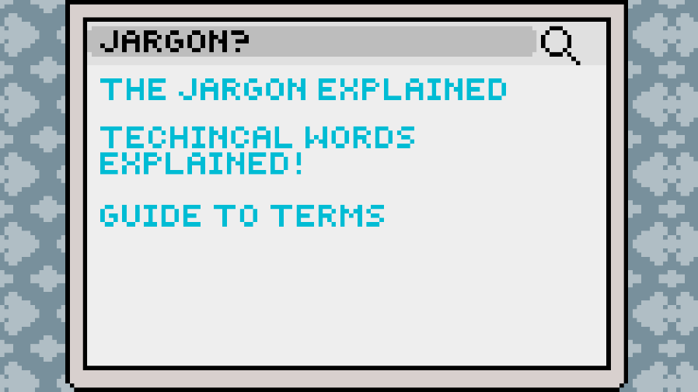

4.3.3 Video Game: “Voluntary Standards Meeting Practice”
The video game we developed takes the user through an interactive demonstration of what a voluntary standards meeting may feel like. This gives the user the ability to orient themselves with standards meetings before they attend one. The video game is tailored to people who learn better from interaction and active participation.
To play the game download the folder below, unzip the folder and run the application in the desired format.
- Windows(x86) version
- Windows(x64) version
- Mac (APPLEM1/ARM64) version
- Mac OS (x64) version

Figure 2
Screenshots of our video game
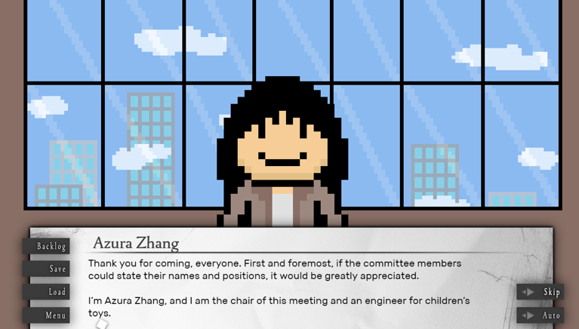
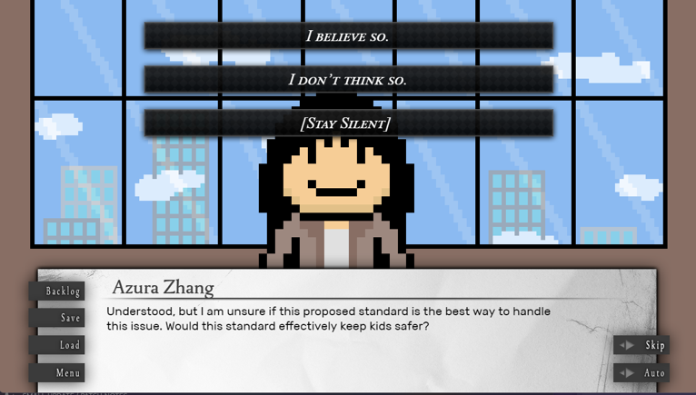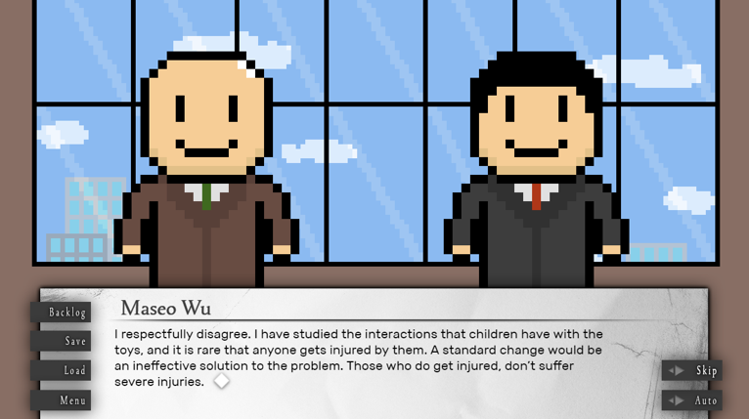

4.3.4: Social Media slide deck
Our social media slide deck is to give consumers a brief explanation of important information needed before consumers participate. It gives enough information to draw consumers’ interest but not enough where they will be led to the website to learn more. Therefore, leading them to the area to sign up.

Figure 3
Screenshots of our Social Media slide deck
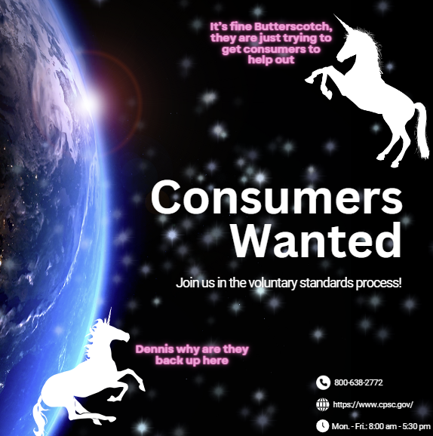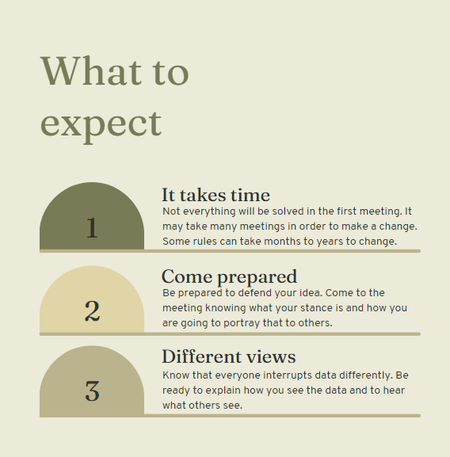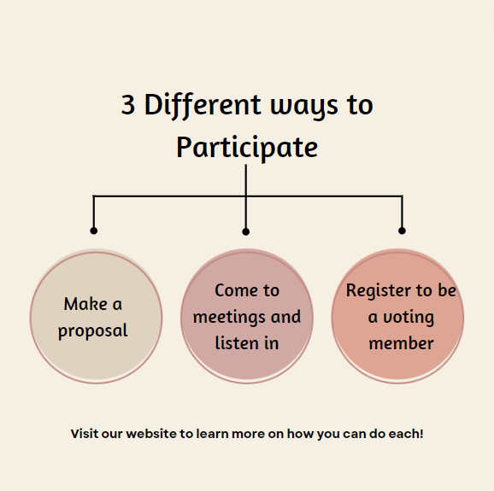

Discussion and Recommendations
Aside from the CPSC, the results of our research are relevant to other organizations involved in standards. While the CPSC asked us to develop educational resources to assist with recruitment efforts, the standards organizations are the ones who often do the recruitment. We also present two recommendations for the CPSC based on our findings and background research.
One of our most interesting findings is that consumer participants often have to pay to attend the voluntary standards meetings. Learning that there are other costs associated with attending the meetings, such as transportation costs and hotel fees was not surprising. However, the fact that some organizations charge money to consumer participants just so they can have the ability to participate is unexpected given that consumer participation is an essential part of the voluntary standards process. Many ways of participation are accessed through being a member, yet there are membership fees. We did learn that some organization fees such as those for membership in ASTM, are waived for consumer participants. Indirect costs, such as travel and hotel costs, are sometimes reimbursed by the standards organizations. Some standards organizations allow consumers to attend meetings for free but require payment if the consumers want to vote. Regardless, our interviews indicated that the financial costs of consumers having to pay to attend or participate in meetings combined with the fact that people may have to take time off work heavily contributes to a lack of consumer participation.
Another interesting finding was that many of the barriers presented by the consumers we interviewed were the same barriers which were referenced by many of the standard organizations we interviewed. These barriers include the technical jargon being used, the meeting times, the cost and time required to attend these meetings, and a lack of awareness of voluntary standards and how the meetings work. Despite the acknowledgement of these barriers from both consumers and standard organizations the barriers persist. We believe that this implies either that it is extremely difficult to fix these barriers, it is incredibly time consuming to fix these barriers, or that there has not been a significant enough investment into these issues. Regardless of the specific reason for why these barriers remain, they need to be addressed in order to increase consumer participation.
Lastly, we found it surprising that targeted recruitment did not work for these organizations to attract more consumers. The standards organizations described finding people who connect with the topic of the standard, whether they have a direct interest or knowledge about the product or maybe are a frequent user, and then reaching out to inform them about the standard their meetings to encourage them to participate. However, even these efforts do not result in a lot of consumers joining. It seems understandable that it is harder for broad recruitment to bring in participants, since it might be about something they have no interest, but if these organizations are targeting individuals who have an interest in the specific topic, it seems like they would get more consumer participants from these efforts. We suggest that the CPSC and standards organizations should invest additional effort in trying to identify the specific barriers that prevent these targeted recruitment efforts from being successful. In addition to our findings, we developed recommendations for CPSC that may assist with the overall issue of consumer recruitment.

5.1 Recommendation: Address the Problem of Technical Jargon
One of the most common barriers mentioned in our research was the use of technical jargon, which has been a point of confusion for many of the consumers we interviewed. This issue was also brought up in several of our SDO interviews. For the SDOs, we recommend sending out a form before each meeting, to all participants registered, of a list of terms and definitions for the subject of the meeting to help people understand what is being said during the meeting. This form could be created by the committee of the given standard. This form could also be reused between meetings that address the same standard or product area. If all participants had a common understanding as to what is being said, it would not only make consumers more likely to participate but it could potentially make their participation more valuable as they would be better able to contribute to discussion. While it would not be possible for everyone to have a full understanding of every technical aspect of a given standard it would be useful for consumers to have a better understanding of the most commonly used jargon and acronyms.

5.2 Recommendation: Broader social media outreach
Another recommendation for the CPSC is to utilize more social media platforms to promote participation in voluntary standards, as promoting voluntary standards participation across multiple social media platforms can increase the chances of eligible consumers viewing, gaining a genuine interest in, and participating in voluntary standards. The CPSC could advertise and post our resources on all of the applicable social media platforms for which they currently have an account. The CPSC currently has ~ 25,400 followers on Instagram (Instagram, n.d.), ~170,300 followers on X (formerly Twitter) (X, n.d.), ~12,100 subscribers on YouTube (YouTube, n.d.), and ~ 63,000 followers on Facebook (Facebook, n.d.). While it is likely that many of the followers will not be able to participate currently, they may be interested in being involved in the future. Furthermore, the CPSC could utilize additional social media platforms, such as TikTok. TikTok currently has 113,200,000 users in the United States (Ceci, 2023), implying that by using this platform to inform the public about voluntary standards participation, the CPSC may be able to expand its potential audience.
On YouTube, Instagram, and Facebook, the CPSC should post the cartoon we have created, as it provides consumers with another way to discover the resource (in addition to X and the CPSC website). Although the CPSC’s X account is the most highly followed account, it still could reach consumers who the CPSC did not reach directly through X and their website. The CPSC could also promote our video game on YouTube, Instagram, Facebook, and X. Since the animation and the video game directly relate to each other, the video game could be advertised in the comments section of the animation post. The social media slide deck could be posted on Instagram, Facebook, and X. As for TikTok, the CPSC could post a video that advertises the animation and game. The CPSC could insert the links to the resources in the comments section of each TikTok video.
To determine the effectiveness of each resource through social media outreach, we suggest that the CPSC work with SDOs to administer surveys that ask consumer participants if they utilized any of the resources online, which resources they used, how they discovered the resources they used, what they learned from the resources, and how they applied the information they learned from the resources to the meeting itself. The SDOs could then submit their surveys to the CPSC, and the CPSC could compile the survey results and see if consumer participation increased and how much consumer participation increased by because of the resources, and if the resources genuinely benefited the consumer participants.

5.3 Limitations
Before our animation can be posted anywhere, it must receive clearance from the CPSC. Agency clearance can take up to a month to receive, and that assumes no edits must be made during the clearance process. In the future, we recommend any student team working with the CPSC on media development start the clearance process as soon as possible.
Although we interviewed consumers who have already participated in voluntary standards development, we were not able to interview target consumers who have not participated in voluntary standards development. Interviewing non-participants is challenging because we are not able to get their barriers for participation. Though we were not able to gather data from this group of stakeholders, we feel that the interferences we received from our consumer inferences are still useful because they had to be new participants once before.

Conclusion
We hope that our consumer educational tools will spread awareness of voluntary standards, and in doing so, increase consumer participation within them. We have worked to understand how recruitment is currently being done and the barriers that prevent consumers from participating. We designed these tools to mitigate some of the barriers of consumer participation, such as a lack of awareness of voluntary standards themselves, not knowing how the process works, and what to do when various issues arise within meetings in general. Ultimately, we hope that an increase in consumer participation will lead to the creation of more sensible standards that will reduce the risks associated with using consumer products and satisfy more consumers nationwide. As the CPSC acquires more consumer participants, they can focus more on the diversity of the consumers who attend the meetings. They can also make sure that those who attend feel included, heard, and actively involved in the standards development process. The creation and modification of standards requires a variety of unique perspectives. If every consumer participant who attended voluntary standards meetings were members of the same few demographic groups, there would likely be less variation in the perspectives, making the resulting voluntary standards less likely to reflect the needs and concerns of the nation overall.

References
American National Standards Institute. (n.d.). American National Standards Institute - ANSI HOME. ANSI. https://ansi.org
American National Standards Institute. (n.d.a). ANSI Essential Requirements. ANSI.
https://www.ansi.org/american-national-standards/ans-introduction/essential- requirements
ANSI. (2022, June 14). The importance of Consumer Voices in standards setting: Q&A with R.
David Pittle. American National Standards Institute. https://www.ansi.corg/standards-news/all-news/2022/06/6-14-22-the-importance-of-consumer-voices-in-standards-setting—quanda-with-r-david-pittle
ASTM. (n.d.a.) Detailed overview - overview - about Us. Detailed overview - Overview - About Us. https://www.astm.org/about/overview/detailed-overview.html
Autonomous Vehicles. (2022). Retrieved September 24, 2023, from https://content.naic.org/cipr- topics/autonomous-vehicles
Brame, C. J. (2016). Effective educational videos: Principles and guidelines for maximizing student learning from video content. CBE life sciences education. https://www.ncbi.nlm.nih.gov/pmc/articles/PMC5132380/
Ceci, Laura. (2023). TikTok – Statistics & facts. Statista,
www.statista.com/topics/6077/tiktok/#topicOverview.
Chan, M., Parikh, S., Shyr, D., Shamasunder, B., Adamkiewicz, G., & James-Todd, T. (2023). Evaluating neighborhood-level differences in hair product safety by environmental working group ratings among retailers in Boston, Massachusetts. Environmental Health Perspectives, 131(9). https://doi.org/10.1289/ehp10653
CPSC. (n.d.a). Office of EEO, diversity, & inclusion. U.S. Consumer Product Safety Commission. https://www.cpsc.gov/About-CPSC/Office-Of-Equal-Employment-Opportunity-And-Minority-Enterprise
CPSC. (n.d.-b). Voluntary Standards Development FAQ for consumers. U.S. Consumer Product Safety Commission. https://www.cpsc.gov/About-CPSC/Consumer-Obudsman/Voluntary-Standards-Devlopment-FAQ-for-Consumers
CPSC. (n.d.-c). Community Outreach Resource Center. U.S. Consumer Product Safety Commission.
https://www.cpsc.gov/old/Safety-Education/Community-Outreach-Resource-Center
CPSC. (2017). Injuries and Investigated Deaths Associated with Playground Equipment 2009-2014. U.S. Consumer Product Safety Commission.
https://www.cpsc.gov/s3fs-public/Injuries%20and%20Investigated%20Deaths%20Associated%20with%20Playground%20Equipment%202009%20to%202014_1.pdf
CPSC. (2023a, September 15). Multimedia. U.S. Consumer Product Safety Commission. https://www.cpsc.gov/Newsroom/Multimedia
CPSC. (n.d.). Voluntary standards. U.S. Consumer Product Safety Commission. https://www.cpsc.gov/Regulations-Laws--Standards/Voluntary-Standards
Detailed overview - overview - about Us. Detailed overview - Overview - About Us. (n.d.). https://www.astm.org/about/overview/detailed-overview.html
Facebook. (n.d.). Retrieved November 21, 2023, from https://www.facebook.com/USCPSC/
Instagram. (n.d.). Retrieved November 21, 2023, from https://www.instagram.com
Ismail, R., Haniff, W. A. A. W., Isa, S. M., Fadzil, R. M., AlSagoff, S. S., & Talib Khalid, K. A. (2020). The approach to safety of children’s toys in United States and European Union: A comparative study. Academic Journal of Interdisciplinary Studies, 9(1), 126–135. https://doi.org/10.36941/ajis-2020-0011
Iso, I. (n.d.). Getting the consumer voice heard in standards development. Copolco. https://www.iso.org/sites/ConsumersStandards/3_consumers.html
Mamun, S., Caraballo, F. J., Ivan, J. N., Ravishanker, N., Townsend, R. M., & Zhang, Y. (2020). Identifying association between pedestrian safety interventions and street-crossing behavior considering demographics and traffic context. Journal of Transportation Safety & Security, 12(3), 441–462. https://doi.org/10.1080/19439962.2018.1490369
Quinlan, K. P., Lowell, G., Robinson, M., Musso, J., & Gottlieb, L. J. (2021). Making Microwave Oven Doors Child Resistant to Protect Young Children, from Severe Scalds. Pediatrics, 147(2), e2020021519. https://doi.org/10.1542/peds.2020-021519
Regulations, Mandatory Standards and Bans. (n.d.). U.S. Consumer Product Safety Commission. Retrieved September 30, 2023, from https://www.cpsc.gov/Regulations- Laws--Standards/Regulations-Mandatory-Standards-Bans
Toy Related Deaths and Injuries Calendar Year 2021. (2022). Retrieved September 25, 2023, from https://www.cpsc.gov/s3fs-public/ToyRelatedDeathsandInjuries2021.pdf
U.S. Equity Action Plan Update(2023)
From https://www.cpsc.gov/s3fs-public/CPSC_EquityActionPlanUpdate_5-16-
23.pdf?VersionId=o2RyXKqGzBMb0MT14goc79w3HnAU7SUu
U.S. Safety Barrier Guidelines for Residential Pools Preventing Child Drownings (2017).
From https://permanent.fdlp.gov/gpo85685/Safety-Barrier-Guidelines-Pub-2017.pdf
Voas, R. B. (2020). Vehicle safety features aimed at preventing alcohol-related crashes. In Alcohol, Drugs, and Impaired Driving (pp. 611–652). essay, CRC Press. doi:10.4324/9781003030799-21
Wilson, B., Hoffman, J., & Morgenstern, J. (2019). Predictive Inequity in Object Detection. 1-
13. https://doi.org/10.48550/arXiv.1902.11097
X (Formerly Twitter). (n.d.). Retrieved November 21, 2023, from https://twitter.com/USCPSC
YouTube. (n.d.). Retrieved November 21, 2023, from https://www.youtube.com/user/USCPSC

Appendix
Appendix A: Consent Agreement for Participation in a Research Study
Informed Consent Agreement for Participation in a Research Study
Investigator: Shaina Lazarus, Winston Lewis, Harry Radenberg
Contact Information: srlazarus@wpi.edu; (805) 358-5843 , wrlewis@wpi.edu; (508) 782-2811
, hradenberg@wpi.edu; (978) 460-8179
Title of Research Study: Enhancing Social Marketing of Consumer Participation in Voluntary Consensus Standards
Sponsor: Scott Ayers, Jonathan Midgett
Introduction: You are being asked to participate in a research study. Before you agree, however, you must be fully informed about the purpose of the study, the procedures to be followed, and any benefits, risks or discomfort that you may experience as a result of your participation. This form presents information about the study so that you may make a fully informed decision regarding your participation.
Purpose of the study: To discover possible reasons for lack of consumer participation in voluntary standards meetings and possible better recruitment techniques.
Procedures to be followed: You will answer questions about voluntary standards meetings. It is approximately 4 - 6 questions and will take 30 minutes.
Risks to study participants: There are no anticipated risks.
Benefits to research participants and others: There are no direct benefits to you for participating in this research study.

Record keeping and confidentiality:
Only the research team will have access to your records. All data will be kept in a secure file that only the research team can access. All data reported in a research poster and manuscript will be aggregated. Records of your participation in this study will be held confidential so far as permitted by law. However, the study investigators, the sponsor or its designee and, under certain circumstances, the Worcester Polytechnic Institute Institutional Review Board (WPI IRB) will be able to inspect and have access to confidential data that identifies you by name. Any publication or presentation of the data will not identify you. The information that you give will be kept anonymous.
Compensation or treatment in the event of injury: This research involves minimal risk of injury or harm. You do not give up any of your legal rights by signing this statement.
Cost/Payment: You will not receive payment, nor will you have to pay for being involved in this study.
For more information about this research or about the rights of research participants, or in case of research-related injury, contact: The primary investigator (Dr. Adrienne Hall-Phillips,
WPI School of Business, Tel. 508-831-4934, Email: ahphillips@wpi.edu), or the IRB Manager (Ruth McKeogh, Tel. 508 831- 6699, Email: irb@wpi.edu) and the Human Protection Administrator (Gabriel Johnson, Tel. 508-831-4989, Email: gjohnson@wpi.edu).
Your participation in this research is voluntary. Your refusal to participate will not result in any penalty to you or any loss of benefits to which you may otherwise be entitled. You may decide to stop participating in the research at any time without penalty or loss of other benefits. The project investigators retain the right to cancel or postpone the experimental procedures at any time they see fit.
By signing below, you acknowledge that you have been informed about and consent to be a participant in the study described above. Make sure that your questions are answered to your satisfaction before signing. You are entitled to retain a copy of this consent agreement.

Date: ____________________________

_____________________________
Study Participant Signature

______________________________________
Study Participant Name (Please print)

Date: _______________________________________

_______________________________________________
Signature of Person who explained this study

Appendix B: Script for interviews with voluntary standards organizations

Hello, we are a team of students from Worcester Polytechnic Institute, collaborating with the Consumer Product Safety Commission to design a recruitment methodology that will be used to increase the diversity of consumer participants in voluntary standards meetings. We are curious about your consumer participant recruitment methods and the struggles of using them. Your participation in this interview is completely voluntary, and you reserve the right to end this interview at any time. Do we have your permission to record this interview? We will keep you anonymous. If you wish to review our results before they are published, please let us know.

Question 1: Please tell me about how recruitment for the voluntary standards meeting works. What methodologies are you currently using to achieve representative testing?
Question 2: Which demographic groups are you finding harder to recruit?
Question 3: Describe the diversity of the current testing groups.
Question 4: What are some of the reasons that consumers do not choose to participate?
Question 5: What are some ways that you have previously tried to make participating in Voluntary Standards more accessible?

Appendix C: Script for interviews with consumers who participated in voluntary standards meetings

Hello, we are a team of students from Worcester Polytechnic Institute, collaborating with the Consumer Product Safety Commission to design a recruitment methodology that will be used to increase the diversity of consumer participants in voluntary standards meetings. We are curious about your experience with participating in voluntary standards meetings. Your participation in this interview is completely voluntary, and you reserve the right to end this interview at any time. Do we have your permission to record this interview? We will keep you anonymous. If you wish to review our results before they are published, please let us know.

Question 1: Tell me about your experience when you participated in a voluntary standards meeting.
Follow-up: Why did you want to participate?
Question 2: On the day that you participated in the standards meeting, how did it impact your life? For example, any special arrangements with your employer or family?
Question 3: How did you find out about the meetings?
Question 4: In what way do you feel that you have made a difference by participating in the voluntary standards meetings?

Appendix D: Interview summaries for the CPSC and standards organization employees
Participant #1C:
In an interview with an engineer we talked about how ASTM is responsible for publishing many types of standards including those of the products which this engineer works with. They mentioned how the CPSC will sometimes get consumers asking about a specific product concern and the CPSC will show them the corresponding ASTM standard. Participant #1C also mentioned how they work with a company that tries to recruit consumers with Intellectual Developmental Disabilities.
Participant #1C mentioned how most consumers who participate in standards are often those who have been injured by a product. They also mentioned how certain product areas that have consumer advocacy groups such as children's products often have more consumer participation. He also mentioned how standards changes and industry involvement are often reactive to incidents.

Participant #2C:
Participant #2C works in human factors and in an interview with them we first discussed the more preventive work of voluntary standards work. They mentioned the preemptive testing which goes into products to make sure they are safe before they go onto market.
They discussed one instance where a consumer participated because of the loss of a child and became a large part of the standard and got other consumers involved by contacting the families of other victims. Participant #2C also mentioned how sometimes consumers will participate in standards if they have near injuries or hear about other injuries.
We discussed potential barriers and Participant #2C mentioned how the cost of travel is a potential barrier for consumer involvement in standards but since many standards are virtual now it has become less of an issue. They mentioned how the wording of things and the procedures in standards can also be discouraging. They also mentioned how the CPSC does try to communicate with consumers who participate in standards and can sometimes schedule meetings with consumers. They also mentioned how they believe that the CPSC doesn’t get enough diverse representation in the consumers who participate and they hope that it will improve.

Participant #3C:
Participant #3C works in human factors and has worked with standards with ASTM and ISO. We discussed why they feel there is a lack of consumer participation in standards and they said that they believe it’s because a lot of consumers don’t realize they can participate and that manufacturers are who they most commonly deal with. They said that they believe that voluntary standards are more tailored towards manufacturers and many consumers don’t realize how important their role is. They mentioned how when consumers do participate that consumer advocacy groups and people with personal injuries are often where the participation comes from.
We also discussed what the CPSC has done to make voluntary standards meetings more accessible. Participant #3C mentioned how the CPSC posts meeting dates on their public calendar and that they are willing to send information about standards to consumers who want to participate. They also message ASTM and tell them about the consumer who is willing to participate.

Participant #4C:
Participant #4C is an engineer at the CPSC and we asked them about recruitment for voluntary standards. They said that SDOS do the majority of the recruitment for standards but the CPSC will give them guidance on how to improve as well as pointing consumers to the right places. They also mentioned how meeting details are posted on the public calendar.
We also asked about different observations they’ve made about consumer involvement in the past. They mentioned how consumers often have unrealistic expectations for how standards meetings are. They also mentioned how it is difficult to get consumers to join who are not already part of advocacy groups or otherwise invested in the standards process. They said that consumers should expect their first few meetings to be uneventful and that the process takes time. They mentioned how consumers who are part of consumer advocacy groups generally understand the standards process better.

Participant #5C:
Participant #5C is an engineer at the CPSC and we discussed what the CPSC does for recruitment and they said that they have recently tried to advise consumers to participate in voluntary standards. However they brought up that a lot of the issues with many recruitment methods is that many consumers get the wrong idea of how standards work. Consumers often believe that they can just simply suggest changes and ideas and that they will happen, when in reality it is a long and complicated process. They also talked about how this expectation isn’t helped by the advice consumers often get which is that if they have an idea it will be considered. While this advice may be true it doesn’t take into account the time it takes for this process to occur. They also mentioned how a lack of experience and knowledge of standards can be daunting to a consumer and make the process much harder for them as a result. They also mentioned how the travel and the meeting times may also be an issue as most standards meetings are during the working day.
We asked which groups of consumers they often get and participant #5 said that people who have experienced a tragedy relating to consumer products and consumers who are retired and formerly in the industry are some of the more common groups of consumer participants. They mentioned how the consumers that they want the most are those who have experienced product issues but don’t have industry experience. They mentioned how that is the group of consumers which they believe should be prioritized.
We also discussed what expectations consumers should have when first going to voluntary standards meetings. Participant #5C mentioned how consumers should expect their first meeting to be fairly uneventful and that it might not accomplish anything significant and that it is important that they do some amount of research prior to the meeting in order to understand the procedures and voting process. They also mentioned how consumers should make sure to put what they want to discuss on the agenda.

Participant #6C:
We interviewed a participant working in Human Factors at the CPSC and we discussed what the CPSC does for recruitment and they mentioned that the CPSC updates a public calendar with meeting dates. They also mentioned that they put their contact information on the public calendar so that when they get contacted they can help out consumers when they contact them.
We also discussed the types of consumers which they have generally observed participating and they mentioned how generally they see a lot of consumers from the advocacy group Consumer Reports. They mentioned that Kids In Danger also participate often. They also mentioned how consumer advocacy groups are fairly established in certain standards. They also mentioned how sometimes consumer advocacy groups members also become members on the meeting sub-committees.

Participant #1S:
In our interview with participant #1S from ANSI we asked them the interview questions found on Appendix B. The main topics they discussed with us were their methodologies for recruitment, barriers of participation, accessibility/availability to consumers, and about their observations with those who participate.
Some of the methodologies discussed were targeting organizations and through advertisements. Most outreach will consist of looking for organizations that care about safety or have a culture of volunteerism. They will also try to draw connections with a person’s personal life and experience to show it is worth it for them to participate. They also try to do targeted articles to reach out to members through membership organizations to share success stories. They want volunteers who have been doing it for a while to write an article about their experiences.
The barriers mentioned are time, money, and consumer groups already being overtaxed. When consumers participate the time and money is not covered. Some have admitted to spending almost $13,000- $15,000 of their own money. They also mention that one of the biggest challenges is that many communities that they want to represent are already overtaxed and therefore have other issues they are fighting for that takes precedence over voluntary standards.
On the topic of accessibility/availability they discuss how covid has made it easier because people do not have to travel that much as more of the meetings are virtual. In addition to that they try to get consumer advocates to act as mentors. To make things more accessible they have ASL interpreters and screen readers.
Lastly they talked about the consumers they want to get. They talk about how it's hard to get everyone but they are focusing on certain groups to try and have them join the process. They would like to focus on people with disabilities, people who are underrepresented, veterans, and students.

Participant #2S:
Participant #2S was able to give us information from two different perspectives. They were able to give us insight to both the consumers and employee side. They discussed how the two experiences are very different. Some of those differences are that consumers don’t get paid and as a consumer they are able to do things they couldn’t do as an employee (i.e vote).
They also discussed the importance of a mentor. They explained how it is needed for a new member to find someone who knows this process to help aid them through the beginning steps of this process. It would help them get acclimated and feel more prepared on what to expect and how it works.

Participant #3S:
In our interview with participant #3S from CSA we asked them the interview questions found on Appendix B. The main topics they discussed with us were their methodologies for recruitment, barriers of participation, accessibility/availability to consumers, and about their observations with those who participate.
They talked about three main ways of recruitment: calls for participation, networking, and headhunting. With calls for participation a solicitation will go out that explains what the committee's mandate is, what the scope of the work is, what the members responsibilities are, and how they would represent different interests and technical content of the standard. Networking is when this participant and others in CSA will ask their current members if anyone knows of any potential candidates who can participate. Lastly, headhunting is targeting recruitment of individuals who specifically align with a certain standard.
The two barriers mentioned were meetings in person and money. Their members are not compensated for their time or paid to be there in any way. This discourages people from participating as it can take money in order to participate in these meetings.
On the topic of accessibility/availability they do have some meetings that are held virtually but majority are in person. They have initiated a consumer program to try and give a voice to these consumers.
Lastly, the people they find hardest to get the opinions from are persons living with disabilities, seniors, and children. Children are difficult as they can not speak to the potential challenges that come with their products.

Participant #4S:
In our interview with participant #4S from ASTM we asked them the interview questions found on Appendix B. The main topics they discussed with us were their methodologies for recruitment, barriers of participation, accessibility/availability to consumers, and about who they get to participate.
The way they recruit is primarily outreach. They will speak out to their current committee members and ask them to share the information with their networks. They also reach out on social media such as press releases. They also will just go on Google and look up different stakeholders that might be relevant to a particular issue and reach out from there.
Participant #4S mentioned two main barriers both surrounding money. One being that none of the ASTM members get paid to participate. The other being that if you are not a member, a thing you have to pay for, you don’t have access to the ballots or to vote.
In order to make this process more available though they will offer free membership to consumers. They also have created a series of training modules in order to help teach consumers about the voluntary standards process, and meetings. Lastly, Participant #4S tries to call every consumer that joins and introduces themselves and helps guide them with their questions.
The consumers they primarily see are consumer advocacy groups, parents or family of someone who was injured, caregivers, or a retiree.

Participant #5S:
In our interview with participant #5S from ULSE we asked them the interview questions found on Appendix B. The main topics they discussed with us were their methodologies for recruitment and accessibility/availability to consumers.
Majority of their recruitment is done through what they described as a call for members. That is an announcement to the public through social media or Linkedin that lets people know that standards development organizations are forming a committee. Another way is making announcements at meetings seeing if anyone wants to or knows of someone who might want to join the new committees.
To make the process more available they said that when they were at the company there were talkthrough training modules. There was also ongoing communication with consumers about how they were feeling about the whole process. They also mentioned that the meetings are open to the public and free for anyone to join.
One point that was discussed was the lack of awareness about these meetings and the voluntary standards process as a whole.

Participant #6S and #7S:
This is a summary for participants #6S and #7S who interviewed with us together. They are from ULSE and we asked them the interview questions found on Appendix B.
They informed us that the recruitment comes from project managers and involves reaching out for recommendations, direct contact, and through word-of-mouth. They also will invite people through newsletters, social media posts, and presentations.
They also talked about the eLearning modules that have been created to help consumers learn the voluntary standards process. The project managers also offer 1:1 calls to walk new members through the process and help them get acclimated.

Participant #8S:
In an interview with an NFPA employee, voluntary standards recruitment methods, consumer participant recruitment struggles and observations, and the accessibility of voluntary standards were discussed.
In the interview, the participant stated that they post information about voluntary standards on their website, have NFPA members attend trade shows and recruit there, and hold open committee meetings in which anyone can participate.
The participant stated that most of the few consumer participants who do participate are not official members of the committee, and that consumers generally are not interested in product design, which is the main focus of the NFPA. The main observation regarding consumer participation the NFPA employee made is that the consumer participants often do not fully understand the standards development process. Consumer participants want to advocate for consumer safety and usually provide good ideas, but do not necessarily know how to voice their concerns.
To make voluntary standards participation more accessible for consumer participants, the NFPA has implemented a mentoring program, online modules to educate people, funding for consumers (because they may have to pay for transportation to attend the meetings), and they try to make meetings hybrid (so people can show up online if they cannot show up in person).

Appendix E: Interview summaries for the consumer participants

Consumer Participant #1:
Our interview with a member of the Parents Against Tip-overs consumer group was primarily focused on the topics of consumer participation barriers, the current state of consumer participation, meeting preparation methods, how consumers learned about voluntary standards, and accessibility methods.
The consumer participation barriers mentioned in this interview are jargon, far away meeting locations, the time of the meetings, and transportation costs. Personal loss is what motivated the interviewee to get involved in voluntary standards. There are hardly any consumers who attend voluntary standards meetings.
The ways the interviewee mentioned consumers should prepare are by using the online tutorials of the SDOs (if they have tutorials), and by doing research on the topic ahead of time. The interviewee learned about voluntary standards through another individual who suffered personal loss. The only accessibility method mentioned is reimbursement for transportation fees.

Consumer Participant #2:
In our interview with a member of the Kids In Danger consumer group, we discussed the barriers for consumer participation, motivators for consumer participation, and meeting preparation methods.
The participant mentioned that a major barrier for consumer participation is lack of awareness, as many people are unaware how voluntary standards work and that they can participate in voluntary standards.
In the interview, the participant stated that they got involved in voluntary standards because their boss told them about it and recommended that they do it. However, the motivator the consumer participant noticed was most prevalent among the other consumers is personal loss.
To prepare for voluntary standards meetings, the participant recommended asking for the meeting agenda ahead of time, and doing research on the subject matter ahead of time.

Consumer Participant #3:
In our interview with another member of the Kids In Danger consumer group, the barriers for consumer participation, motivators for consumer participation, meeting preparation methods, current state of consumer participation, and how consumers learned about voluntary standards were the main topics discussed.
The consumer participant mentioned that participating in voluntary standards meetings is time consuming, consumers may have to travel to participate, it takes a long time to get a standard created, the topics of discussion are very technical, and industry representatives generally do not want to deal with consumer participants. All of the factors mentioned make consumers less willing to participate in voluntary standards.
The interviewee mainly talked about personal loss as a motivator to get involved in voluntary standards. The consumer participant said to prepare for the voluntary standards meetings, consumers should study the standard of the product that is being discussed, the industry the product corresponds to, and consumers should work on getting used to how meeting attendees interact with one another.
The consumer participant stated that there were never more than two consumer advocates at the meetings they attended, and they became involved through others who were involved in the process.

Consumer Participant #4:
In our interview with a member of the Consumer Reports consumer group, the barriers for consumer participation and methods of preparation were the main topics of discussion.
The two consumer participation barriers mentioned in this interview are consumers not knowing how to navigate through disagreements between entities, and some standards failing to reduce risk for consumers. The consumer participant cited wanting to make the world a better place as their sole motivator for getting involved in voluntary standards.
To prepare for voluntary standards meetings, the consumer participant suggested studying and understanding the standard, group dynamics, opinions of various stakeholders, and future meeting plans.

Consumer Participant #5:
In our interview with another member of the consumer group Parents Against Tip-overs, the topics we mainly discussed are consumer participation barriers, consumer participation motivators, preparation methods, how consumers learned about voluntary standards, and accessibility methods.
The consumer participation barriers listed by the interviewee are conflict between industry representatives and consumers, confusion about the overall voluntary standards process, the meetings are time consuming, getting involved is costly, and consumers feeling like they are not making a difference. The interviewee mentioned that they were motivated to participate in voluntary standards because of personal loss.
To prepare for voluntary standards meetings, the interviewee said that they learned about the technicality involved in standards and learned to follow the development of the standards. The interviewee discovered voluntary standards through others who were already involved in them. The only accessibility method mentioned by the interviewee is that there are reimbursement programs in place for those who have to pay for transportation to attend the voluntary standards meetings.

Consumer Participant #6:
The majority of our interview with a member of the National Carbon Monoxide Awareness Alliance was dedicated to consumer participation barriers.
The main consumer participation barriers mentioned are jargon, hidden information, industry dominance, not knowing how to effectively convey ideas, cost, intimidation, and lack of respect. The interviewee became involved after being injured by a consumer product and researching how to make a change.

