Conservation Visual Storyboard
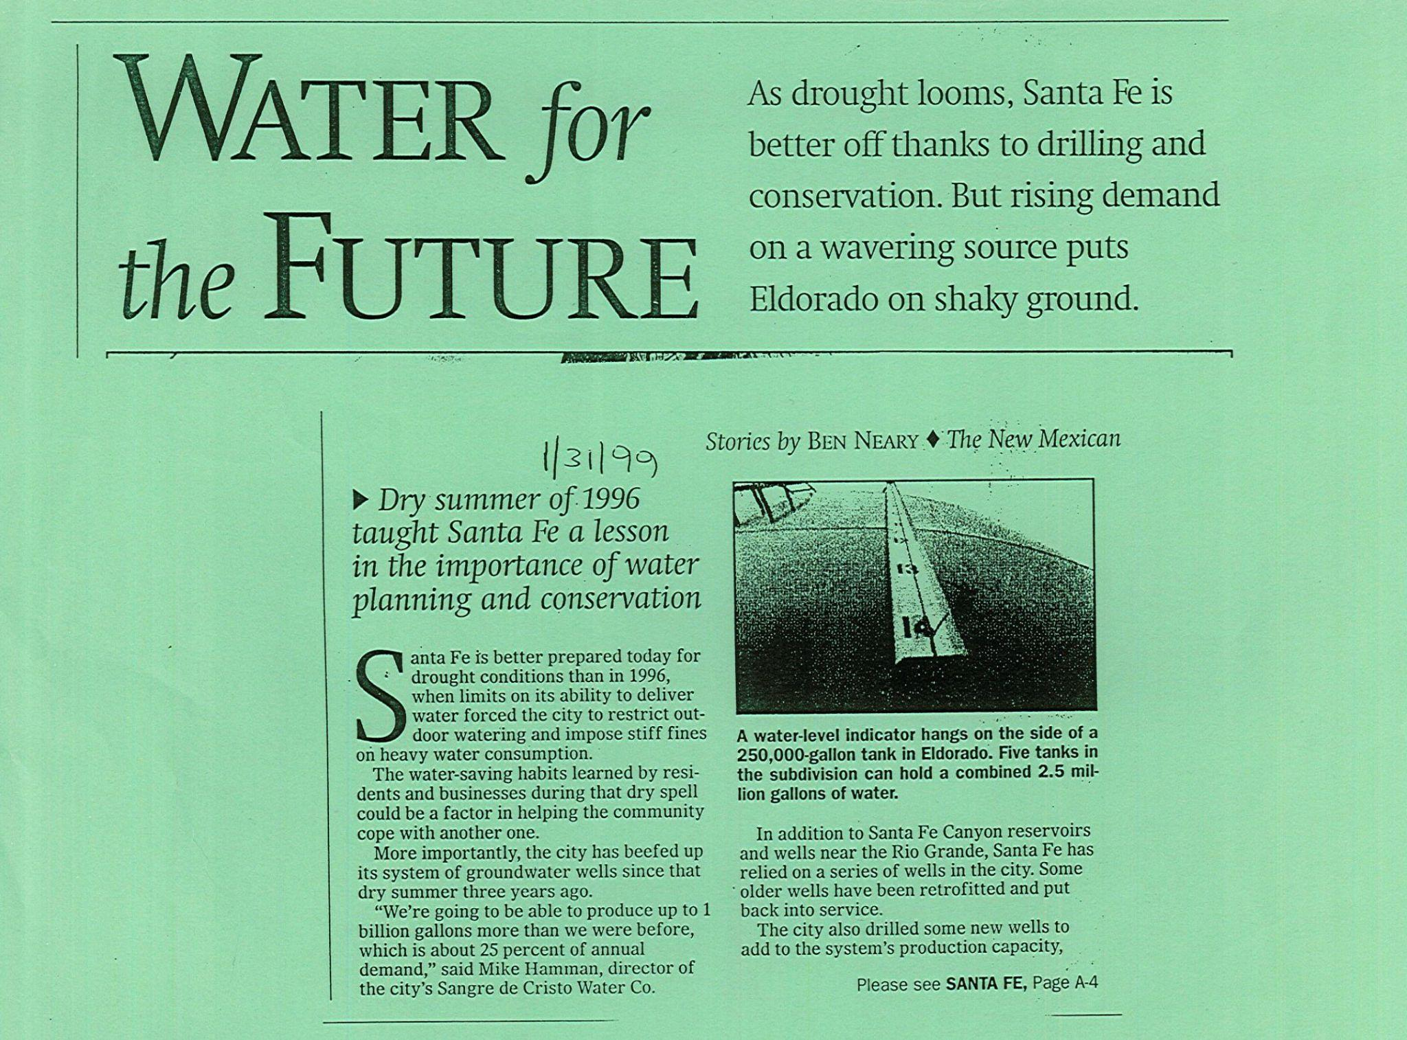
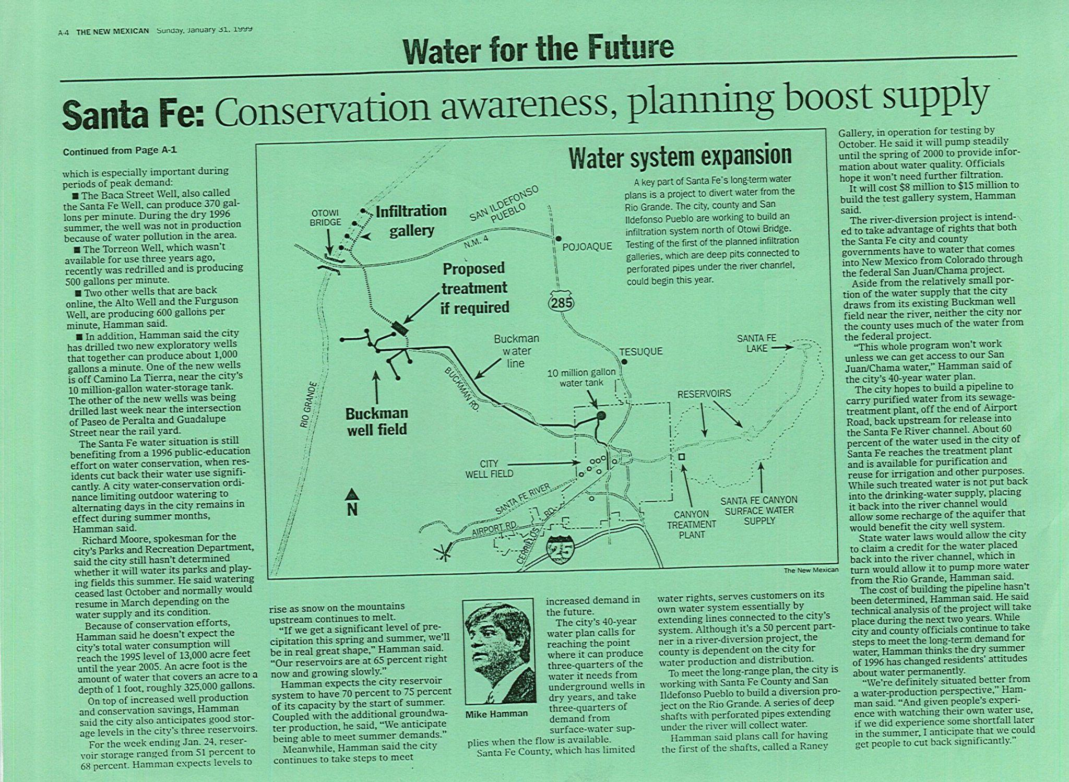
Conservation Success: 1999, Water Conservation Program
Intro with title - misc water videos
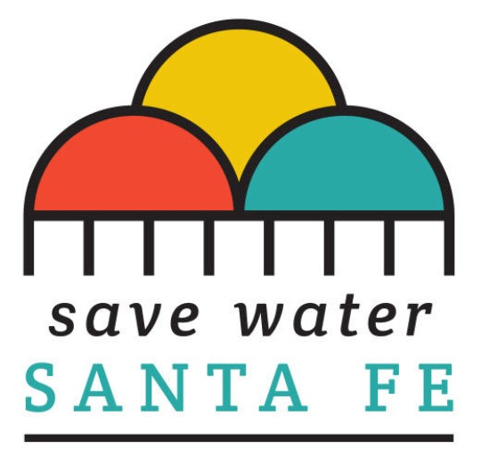
Save Water Santa Fe: Youtube channel - “Save Water Santa Fe” - include video clips?

EyeOnWater Create animated video with Adobe

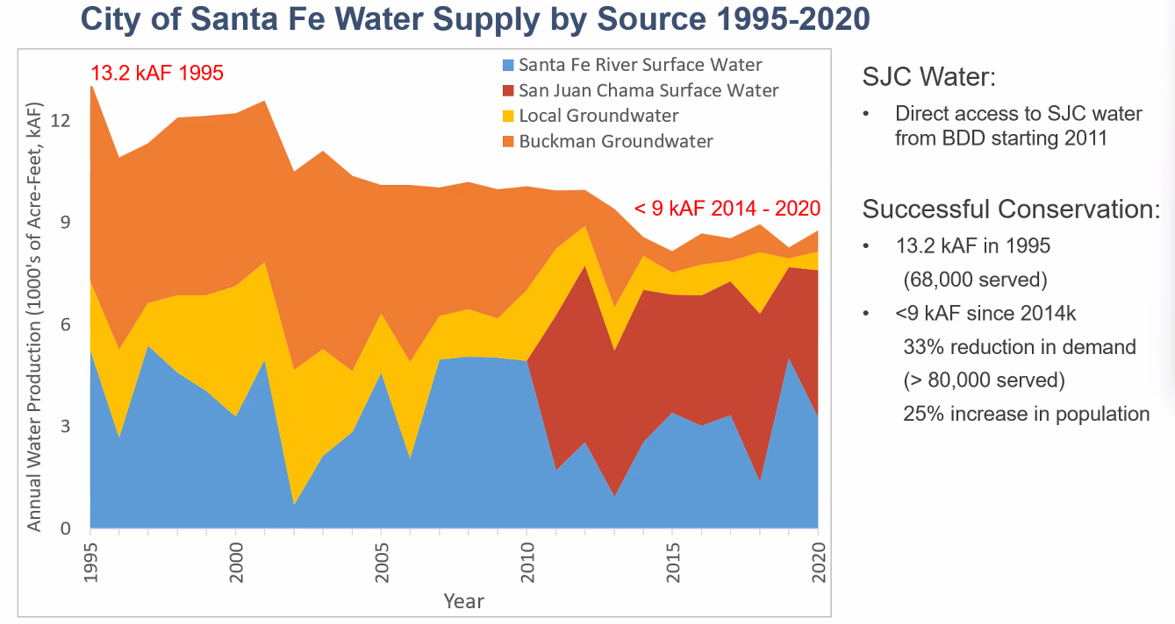
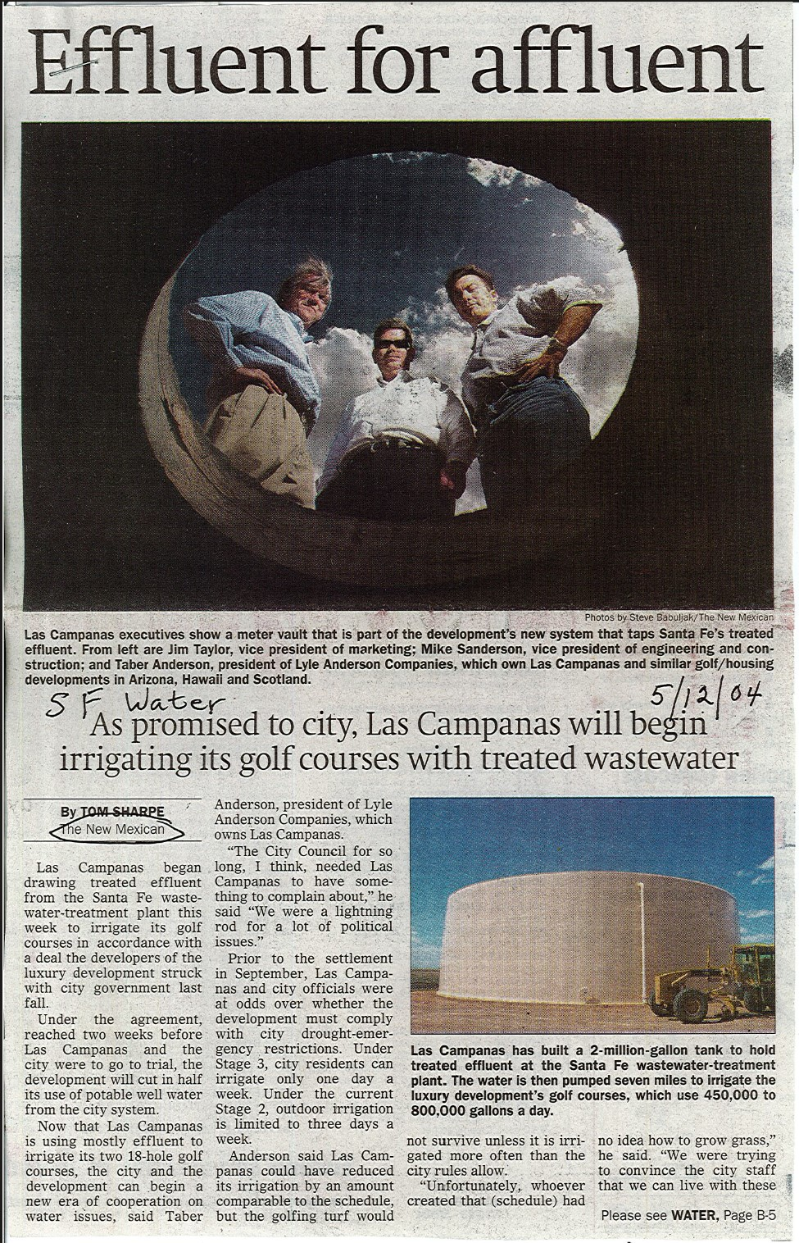

Effluent Water Use instead of Potable at parks and Golf Courses

Santa Fe golf course
Residential Rebates

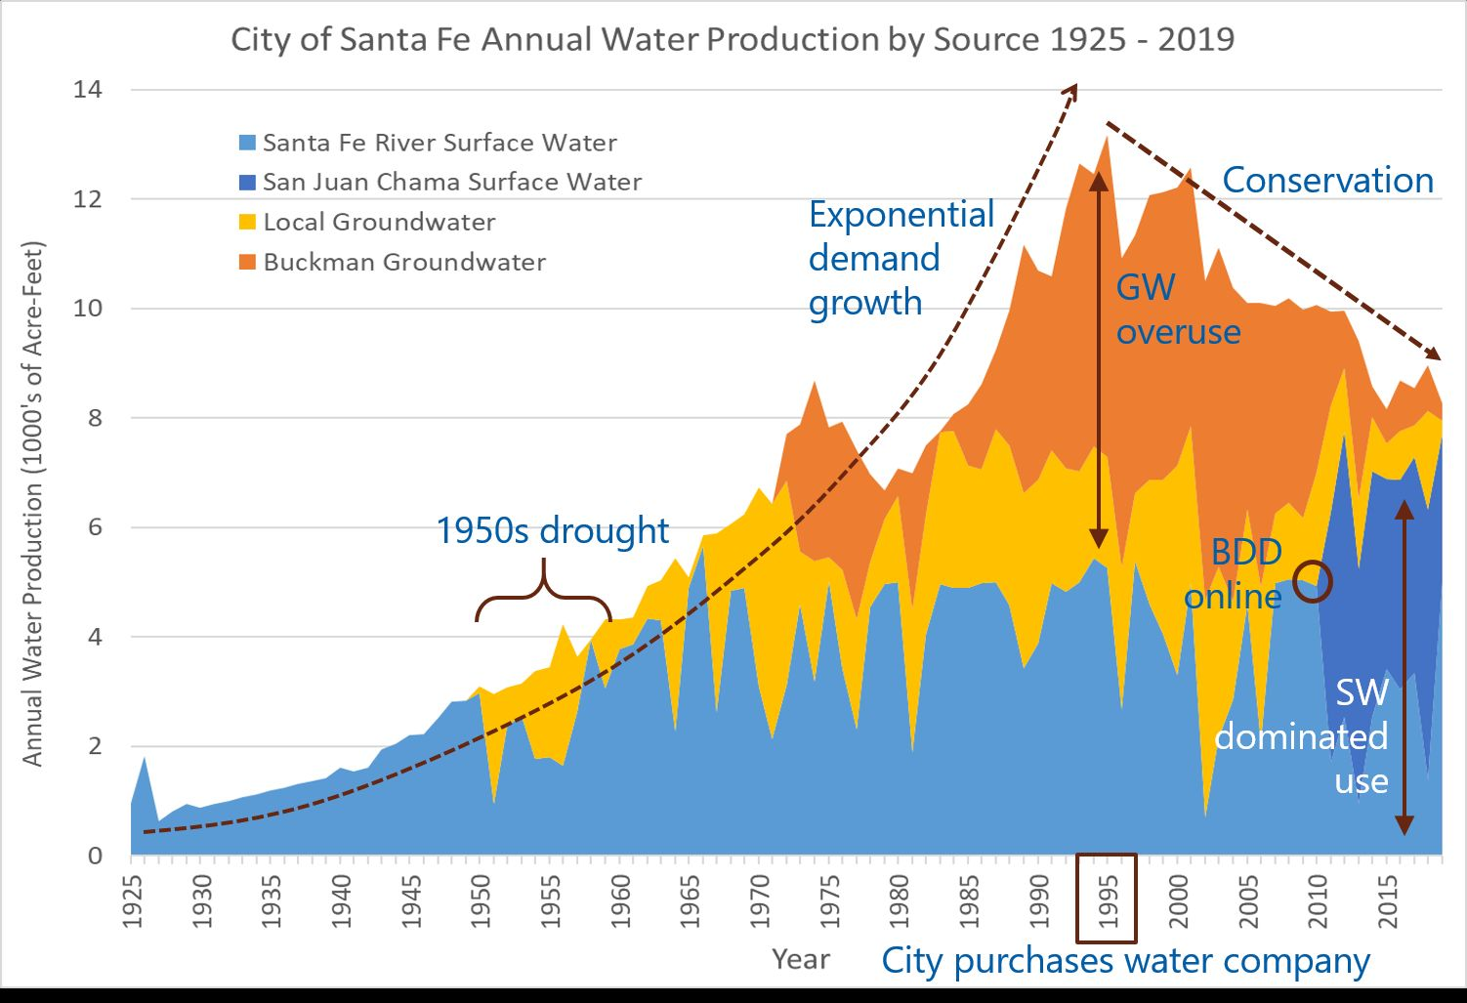

Manage sources, Buckman Wellfield/City WellField/CRTP/Buckman Regional WTP

Water Emergency Stages- Orange & Red
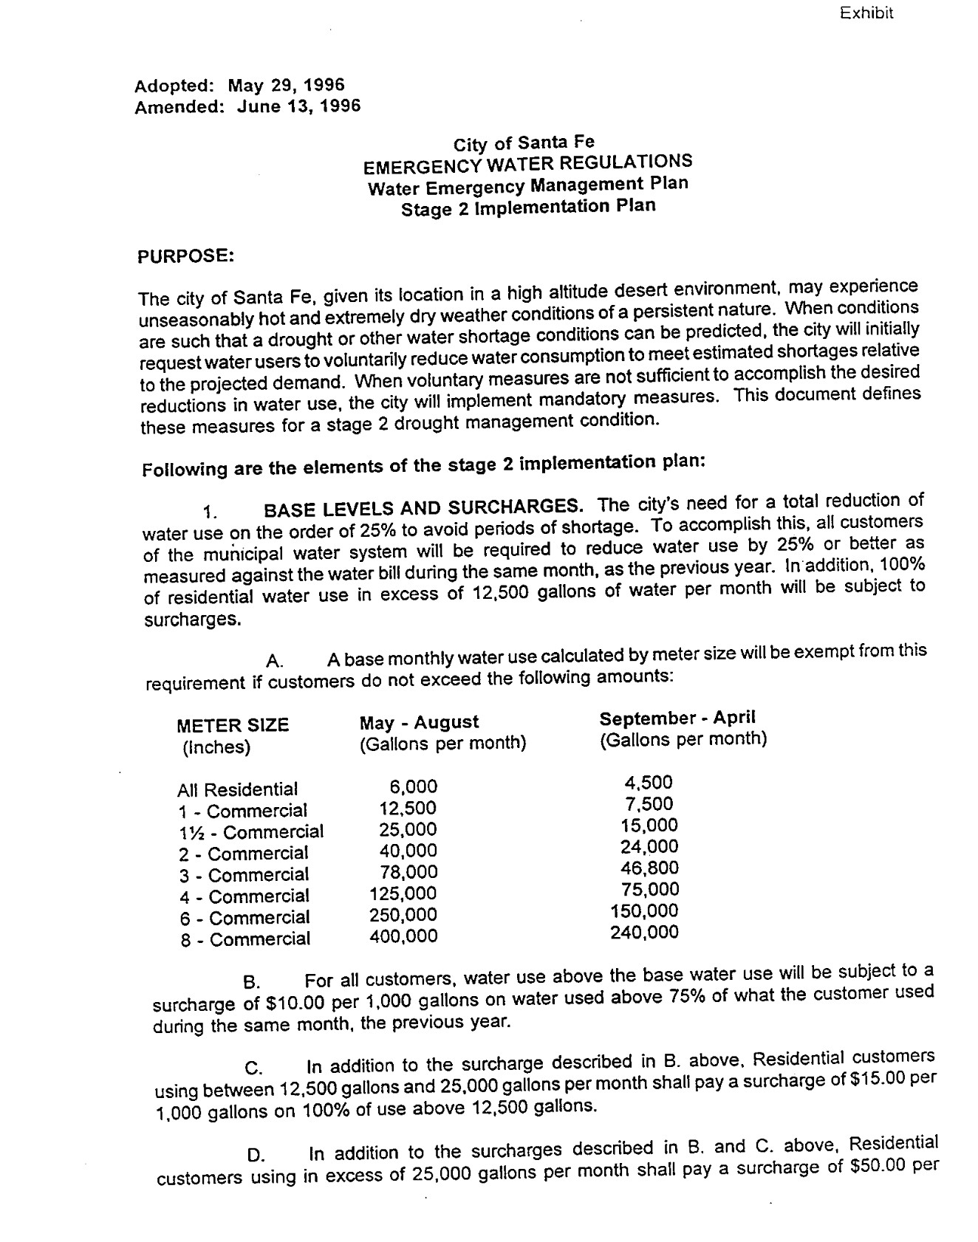
1996 stage 2 implementation plan

2021 mid-year report for progress on 5-year conservation plan (2020) Goals:
- City partnerships
- Complete overhaul of education program
- Work with other city departments to distribute outreach material to children and adults
- Incorporate messaging into the art community
- Updates to rebate program that include passive rainwater capture
- Focus on reducing outdoor water use
- Continue to work closely with the Water Conservation Committee under the leadership of Councilor Romero
2021 Scorecard on Progress
U.S Drought Monitor
NM Governor’s Drought Task Force Planning
Water Conservation Ordinances
What can YOU do: Fix leaks, Rebates, Obey Water Restrictions, Use EyeOnWater video of someone on laptop using website, Irrigation Water Audit (QWEL-Certified)
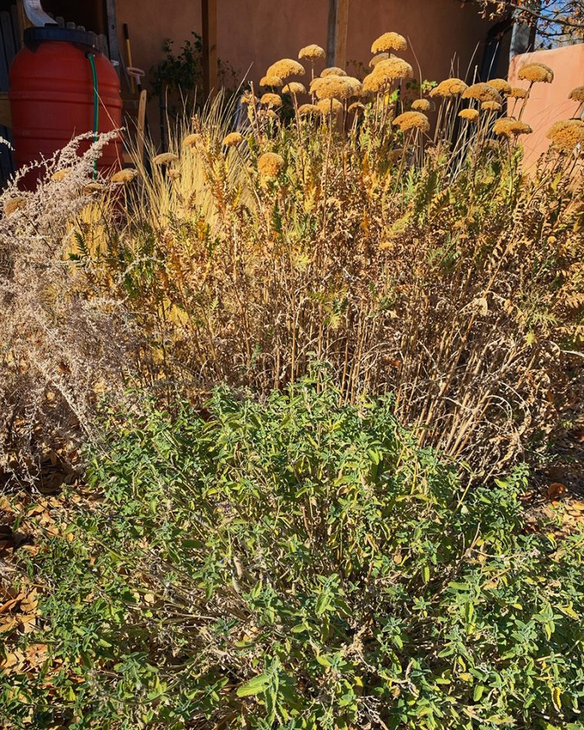
Plant water-conserving plants in your gardens

