  - Day 2 Class Activity

Analysis of Inbreeding in Red Wolves
Partner Work
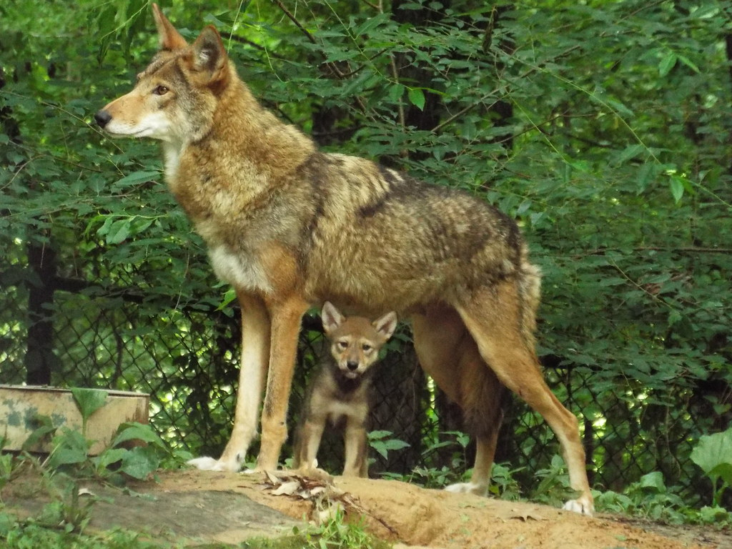
"Red Wolf Pup & Mom" by US Forest Service - Southern Region is marked with CC BY-SA 2.0.

Overview:
Inbreeding is a common trouble that has disproportionately large effects on small population sizes. In this case study on inbreeding in red wolves, you will read about the extent of inbreeding and inbreeding depression and the effects they can have on offspring. You will be tasked with answering three short questions to both gauge your understanding of the text and to stimulate your data-analyzing skills.

Names:
Date:
Question 1: In a short paragraph, (3-5 sentences) explain how inbreeding affects small population sizes more so than large ones.

Question 2: List the different effects that inbreeding has on red wolves.

Question 3: Analyze the following two graphs. Based on the data, describe what we are seeing in terms of inbreeding in red wolf populations. Is there any bias in this data?
