Supplemental Materials
for
Cleaning Up East Potomac Park

12/14/18

Project Team:
Kirsten Doyle
Zhentian Ren
Jarod Thompson
Yuan Wang

Faculty Advisors:
Dominic Golding
Lorraine Higgins

Sponsor:
National Park Service – National Mall and Memorial Parks

Sponsor Liaisons:
Leslie Frattaroli
April Newman

These materials supplement the above named project report and are submitted to the faculty of WPI in partial fulfillment of the requirements for the Degree of Bachelor of Science

Table of Contents

Part A: Authorship 1
Part B: Sponsor Background 4
Part C: Interview Preamble 7
Part D: Research Instruments 8
Part E: Proposed Littering and Fishing Line Container Signage 17
Part F: Proposed Lesson Plan for East Potomac Park Education Program 19
Part G: Interview Summaries 25
Part H: Alumni Programming Poster 33
Part I: Additional References 34

Part A – Authorship
Task | Contributors
Introduction | Written by Kirsten Doyle, Zhentian Ren  Edited by Jarod Thompson
Background
Understanding the causes and consequences of trash | Written by Kirsten Doyle  Edited by Jarod Thompson
Trash in national parks | Written by Kirsten Doyle  Edited by Jarod Thompson
The cause of trash problems in national parks | Written by Kirsten Doyle, Zhentian Ren  Edited by Jarod Thompson
Impacts of trash in the national parks | Written by Kirsten Doyle, Jarod Thompson  Edited by Jarod Thompson
Four types of trash management approaches used in national parks | Infrastructure approaches written by  Kirsten Doyle, Zhentian Ren, Yuan Wang  Information approaches written by  Yuan Wang  Education approaches written by  Zhentian Ren, Yuan Wang  Enforcement approaches written by  Yuan Wang  Edited by Jarod Thompson
Trash problems at East Potomac Park | Written by Jarod Thompson  Edited by Kirsten Doyle
Methodology and Results
Objective 1 methodology | Written by Kirsten Doyle, Zhentian Ren, Jarod Thompson  Edited by Kirsten Doyle, Jarod Thompson
Objective 1 results | Written by Kirsten Doyle, Zhentian Ren  Edited by Kirsten Doyle, Jarod Thompson
Objective 2 methodology | Written by Kirsten Doyle, Jarod Thompson  Edited by Jarod Thompson
Objective 2 results | Written by Jarod Thompson  Edited by Kirsten Doyle
Objective 3 methodology | Written by Yuan Wang  Edited by Kirsten Doyle
Objective 3 results | Written by Yuan Wang  Edited by Kirsten Doyle
Deliverables and Recommendations | Written by Kirsten Doyle  Edited by Jarod Thompson
Conclusion | Written by Kirsten Doyle and Zhentian Ren  Edited by Kirsten Doyle
Abstract | Written by Zhentian Ren  Edited by Kirsten Doyle
Research
National Park Service information | Zhentian Ren
Impacts of trash | Kirsten Doyle
Impacts of trash on wildlife | Kirsten Doyle, Jarod Thompson
Types of management approaches | Jarod Thompson, Yuan Wang
Visitor littering behavior | Kirsten Doyle
Visitor awareness | Kirsten Doyle, Zhentian Ren
Education programs | Zhentian Ren
Subaru study | Zhentian Ren, Yuan Wang
Types of trash bins | Kirsten Doyle, Zhentian Ren
Theory of planned behavior | Jarod Thompson, Yuan Wang
Deliverables
Map of proposed trash bin locations content | Kirsten Doyle, Jarod Thompson
Map of proposed trash bin locations design | Jarod Thompson
Map of proposed fishing line containers content | Kirsten Doyle, Jarod Thompson, Yuan Wang
Map of proposed fishing line containers design | Yuan Wang
Signage for fishing line containers content | Kirsten Doyle
Signage for fishing line containers design | Yuan Wang
Signage using the theory of planned behavior content and design | Kirsten Doyle, Jarod Thompson, Yuan Wang
Lesson plan for proposed education program | Kirsten Doyle
Interviews
Jeffrey Hitchcock
Questions | ALL
Interview | Kirsten Doyle, Jarod Thompson
Summary | Jarod Thompson
Robert Mocko
Questions | ALL
Interview | Jarod Thompson, Yuan Wang
Summary | Jarod Thompson
James Pierce and Jacklyn Meyer
Questions | Kirsten Doyle, Jarod Thompson, Yuan Wang
Interview | Kirsten Doyle, Yuan Wang
Summary | Yuan Wang
Denise Coogan
Questions | Kirsten Doyle
Interview | Kirsten Doyle, Zhentian Ren
Summary | Zhentian Ren
Rock Creek Conservancy
Questions | Kirsten Doyle, Zhentian Ren
Interview | Zhentian Ren, Jarod Thompson
Summary | Zhentian Ren
Jeffrey Gowen
Questions | Kirsten Doyle, Zhentian Ren
Interview | Kirsten Doyle, Zhentian Ren
Summary | Kirsten Doyle
Kathryn Tyler and Nick Soloman
Questions | Kirsten Doyle, Jarod Thompson, Yuan Wang
Interview | Jarod Thompson, Yuan Wang
Summary | Jarod Thompson
Jennifer Epstein
Questions | Kirsten Doyle, Zhentian Ren, Yuan Wang
Interview | Kirsten Doyle, Yuan Wang
Summary | Kirsten Doyle
Officer Conn
Questions | Jarod Thompson, Zhentian Ren
Interview | Zhentian Ren, Yuan Wang
Summary | Zhentian Ren
Don Kirk
Questions | Jarod Thompson
Interview | Jarod Thompson, Yuan Wang
Summary | Jarod Thompson
Heather Zdobysz
Questions | Kirsten Doyle, Zhentian Ren
Interview | Kirsten Doyle, Zhentian Ren
Summary | Kirsten Doyle
Rita Knox
Questions | Jarod Thompson, Zhentian Ren
Interview | Jarod Thompson, Zhentian Ren
Summary | Jarod Thompson
Booklet Design | Jarod Thompson and Yuan Wang
Alumni Programming Poster | Kirsten Doyle
Final Presentation
Design | Yuan Wang
Information | ALL

Part B – Sponsor Background
The National Park Service (NPS) started out as the idea that we, as the American people, need to do whatever we can to help protect important national landmarks in our country, especially as the country expanded west in the 1800s. People wanted places that represented the beauty of America, such as “towering mountains and majestic trees of Yosemite, spouting geysers of Yellowstone, and the arid ruins of Casa Grande,” (Evolution of an Idea, 2009) to be preserved appropriately. This idea came to fruition on August 25th, 1916 when President Woodrow Wilson signed the act that created the NPS, under the jurisdiction of the U.S. Department of the Interior. The different types of parks under the National Park Services’ jurisdiction expanded in the 1930s, with the addition of military parks and national monuments, and again in the 1960s, with the addition of national parkways, seashores and urban parks (Evolution of an Idea, 2009). Today, the NPS is responsible for 417 different sites encompassing more than 84 million acres of land. The mission of the NPS is to preserve the natural and cultural resources and values of the National Park System for the enjoyment, education, and inspiration of this and future generations. The NPS cooperates with partners to extend the benefits of natural and cultural resources, conservation, and outdoor recreation throughout this country and the world.
The number of people visiting national parks has dramatically increased since its creation in 1904, as shown in Figure 1. More than 22,000 employees and 339,000 volunteers maintain the parks and cater to visitor needs every day. The budget for the National Park Service has been around $3 billion for the past few years, with the parks contributing 35.8 billion to the economy (National Park Service Overview, 2018). “In 2017 the National Park Service completed more than $519 million in maintenance and repair work. However, high visitation, aging infrastructure and budget constraints have kept the price for repairs high, according to the Department of the Interior. Ironically, the very popularity of national parks is driving the unmet budget needs,” (Bachmann, 2018). This is shown in the deferred maintenance cost of the Great Smoky Mountains National Park ($215 million), Grand Canyon National Park ($329 million), and Yosemite National Park ($529 million), who all have seen a large increase in park visitation over the last decade (Bachmann, 2018).
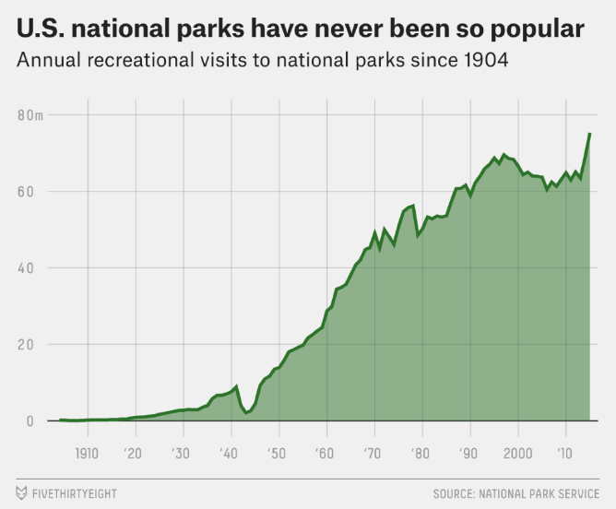
Figure 1. Major increase in national park popularity (Flowers, 2018)

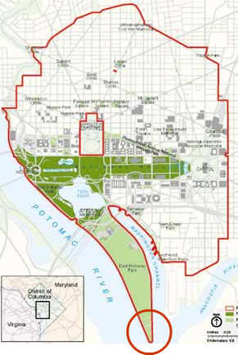
Figure 2. Map of the National Mall & Memorial Parks (Foundation Statement for the National Mall and Pennsylvania Avenue National Historic Park, 2007)

National Mall and Memorial Parks (NAMA) was created by the Act of June 10th, 1933, transferring more than 1,000 acres of land in the Washington D.C. area (Figure 2), including the Lincoln Memorial, Washington Monument and many other historical locations, into its jurisdiction from the Office of Public Buildings and Public Parks of the National Capital (National Malls and Memorial Parks Foundation Document Overview, n.d.). “NAMA now contains more than 80 historic structures and over 150 major named historic parks, squares, circles and triangles,” (History & Culture, 2017), and approximately 24 million visitors from around the world each year (Frequently Asked Questions, 2015). While the visitation to NAMA is 24 million, visitation to the National Capitol Parks – Central, which is the category of parks where Hains Point is located, averages around 1.6 million per year. As shown in Figure 3, visitation has fluctuated in the period between 1997 and 2017 but has higher visitation numbers in the years of presidential inaugurations.
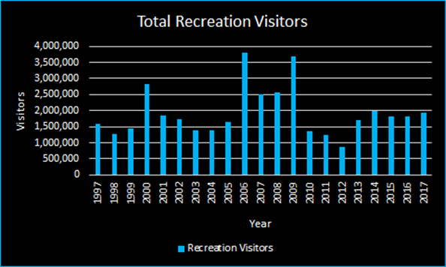
Figure 3. Graph of Annual Recreation Visitors (adapted from Total Recreation Visitors for National Capital Parks Central, n.d.)

NAMA is widely known by tourists for its historical and cultural vibe. The monuments and memorials are worth visiting, and they are open to the public for free. NAMA also provides free events such as ranger walking trips which occur multiple times a month. Most of the events involve a park ranger leading tours of the various memorials and monuments. The walks are about 2 hours and the distances are usually no more than 3 miles. These events are some of the best lessons on American history in the world (Calendar of Events, n.d.). While the monuments and memorials are more for the tourists, the parks provide locals a chance to enjoy outdoor activities.
East Potomac Park is an artificial island surrounded by the Tidal Basin to the north, the Potomac River to the west, the Washington Channel to the east, and the confluence of the river and channel to the south. Hains Point is the tip of East Potomac Park as well as the shoreline, as circled in Figure 2. There is a golf course on East Potomac Park, paddle boats in the Tidal Basin, and many other activities for visitors to experience. Fishing is also allowed in the Tidal Basin, in both West and East Potomac Parks. In addition, there is a heated public pool in the East Potomac Aquatic Center for visitors who like to swim (Outdoor Activities, 2018). Hains Point offers eight picnic areas for reservations and each area accommodates up to 75 people.

Part C – Interview Preamble
We are a group of students from Worcester Polytechnic Institute. We are conducting this interview to help us in our study of the trash problems in East Potomac Park and Hains Point. This project is being done in collaboration with the National Park Service. Your participation in this interview is completely voluntary, and you may withdraw at any time. By agreeing to participate in this interview, you consent that any information given can be used in our research. However, you will be given the right to review, comment on, and/or withdraw information prior to our final paper’s submission and presentation. You will also be given the right to remain anonymous with respect to your personal identity if you so desire.

Part D – Research Instruments
Robert Mocko: Environmental Protection Specialist, National Capital Parks-East
- How is your role as Environmental Protection Specialist related to waste management?
- How much does trash and littering affect the park environment (plants, animals, waterways)? Is there anything you do in relation to this problem?
- What practices are the NPS and the National Capitol Parks – East (NACE) using to handle the trash problems? How effective are these practices?
- Why were these practices chosen?
- Do you know about your waste management strategies/maintenance crew operations?
  - If no, ask who we can talk to for this information
  - Do you subcontract waste management operations or are they in-house?
  - Is the subcontract the same company as East Potomac?
  - Do they clean up litter or only the trash bins?
  - Do you feel they fully complete the work? (all trash in bins for the required amount of times per day, litter if applicable)
- Are you able to tell us how much you spend on trash and recycling? If not, could you recommend someone else to contact?
  - What percentage of the overall maintenance budget is it?
  - Have disposal costs been increasing or decreasing?
- Other parks are removing trash and recycling bins entirely and moving to trash in/trash out policies. Have you considered this approach in NACE parks? What about wildlife safe bins and Big Belly bins?
- Do your parks have any signage alerting visitors to throw away their trash or take it with them?
  - If yes, do you think that type of signage is useful? How has your policy on signage changed over time?
  - If no, do you think it would be useful?
- We understand that many national parks have tried to change visitors’ behaviors and awareness regarding trash through signs and educational efforts. In your role, what practices are you using or developing to change the visitors’ behaviors/raise their awareness? Why were those practices chosen?
- Do you have any data or documents about the practices in changing behaviors?
- Do you have any information on trash or littering reduction programs in effect elsewhere?
- Is there anyone else you recommend we talk to in order to gather more information for our research?
- Are there any further documents you recommend we look at that we haven’t discussed yet?
- We have visited Anacostia Park briefly near the NACE HQ; do you know of any areas that you think we should look at and would you potentially be available to show us around?
- Do you mind if we get back to you if we have any other questions?
- Thank him!

Denise Coogan: Environmental Partnership Manager, Subaru
- Are you able to provide us the full report?
- We heard from the NCPA that a document is in the works to discuss best practices and case studies. Is there any other information you can provide us on what the report will contain?
- How did you measure visitor behavior/awareness?
- What questions did you ask? Why did you ask those specific questions?
- Why do you think it is important to measure visitor behavior/awareness?
- We received a copy of the waste characterization study late yesterday evening from the NCPA, however we haven’t had a chance to look over it yet. We have some questions on the information provided by it but please let me know if any of the questions we ask can be answered by the report.
- What were the results of the waste characterization study?
- Was there a significant amount of trash that could have been recycled or composted?
- Do you think more parks would benefit from recycling bins/composting bins based on the results of the study?
- Was there a specific type of trash that you found was particularly common in parks? Did you find that fishermen were big contributors to the trash problem in parks where fishing is available?
- Based on the press releases about the report we understand that the NPS managed 100 million pounds of trash in 2013. How was that number calculated?
- How were the three parks chosen for the Zero Landfill initiative? (Yosemite, Grand Teton, Denali)
- Is there anyone you recommend we talk to gather more information for our research?
- Are there any further documents you recommend we look at that we haven’t discussed yet?
- Do you mind if we get back to you if we have any other questions?
- Thank you!

Jeffrey Hitchcock: Environmental Compliance Program Manager, NAMA
- How would you describe the trash problems in the park? What are the types of trash problems? What areas have the most trash?
- We want to better understand how trash/debris are removed from Hains Point.
  - Do you have an operation procedure for trash removal?
  - Do you clean the outside bin and the inside bin of the trash cans or just the inside one?
    - Does the current design of the trash cans make it harder for you to empty them?
  - How many times per day/week for the maintenance crews empty the trash bins at Hains Point?
    - Are there set times? What are they?
  - We have seen large amounts of trash grouped up in some areas around the park. Is it the maintenance crews’ job to pick that up or is it left for the landscapers? If they see it, do they pick it up?
  - Why are there no trash bags in the bins? Is it to lessen what is sent to landfill?
  - Is emptying the monofilament fishing line containers your job?
- Do you think a switch to wildlife friendly trash cans would make your job easier?
- From our observations, we noticed that trash is more of a problem in East Potomac rather than Hains Point. Can you offer any reasoning or speculation behind why that is?
  - Is there a difference in trash management between Hains Point and the rest of East Potomac?
- Do your maintenance crews notice different groups of visitors treating the park and trash differently?
- Problems now vs in the past
  - Is there a difference in trash problems now versus when you had more trash cans?
  - Do you notice a difference in trash/litter in different times of the year?
    - What’s the worst time of the year for trash/litter?
  - Do you think trash problems were not as bad when there was signage in the park?
- How much do you spend on trash removal? What percentage of the overall maintenance budget is it? Have disposal costs been increasing or decreasing?
- Do you have any suggestions for improvement in trash removal?
  - Ways to make your job easier
- Do you have someone we can contact in the landscapers to talk about the removal of litter?
- Do you have any data or report for illegal dumping? If no, could you help us asking for the United States Park Police for the data or reports?
- Are there any further documents you recommend we look at that we haven’t discussed yet?
- Do you mind if we get back to you if we have any other questions?
- Thank you!

Don Kirk: Facilities Manager, Rock Creek Park
- What types of trash do you see the most in the park? What areas have the most trash?
- Could you give us a general idea of what your maintenance crews do in terms of collecting trash and litter?
  - Do you have an operation procedure for trash removal?
  - What kind of trash bins do you use? Standard, wildlife safe, Bigbelly?
    - Are you happy with your trash cans or do you think a different design would make your job easier?
    - Do you use trash bags?
  - How many times per day/week do the maintenance crews empty the trash bins? Are there set times? What are they?
  - Whose job is it to pick up litter on the ground, your maintenance crews or someone else?
- Do you notice a difference in trash/litter in different times of the year? What would you consider the worst time of the year for trash/litter?
- Do you ever see or get reports of people dumping their trash from home at the park?
- Are you able to tell us how much do you spend on trash removal? What percentage of the overall maintenance budget is it? Have disposal costs been increasing or decreasing?
- Do you have any suggestions for ways to improve your trash removal process? Anything that you have thought of that would make your job/your maintenance crews’ jobs easier?
- Do you think the removal of trash cans reduces litter?
- Do you think signage is effective in reducing littering? Do you have signage about littering in your park?
- Are there any further documents you recommend we look at that we haven’t discussed yet?
- Do you have any recommendations for someone else to talk to on this topic?
- Do you mind if we get back to you if we have any other questions?
- Thank you!

Jennifer Rudnick: Education Specialist, NAMA
- What are the current partnerships you have with schools/organizations to educate them about the National Park Service?
  - Do you ever talk about trash/littering in these programs?
  - We know one of the WebRangers programs called Trash Talkin’. Is it useful for educating kids and visitors to know about general trash and recycling classifications?
    - What is trash vs. What can be recycled
- There is a brief description online for the GreenLine News update describing its purpose. Can you tell us any more about the Green Line News Update? Has this program made a difference in trash left behind by concessioners?
  - Is it required of concessioners?
  - What’s covered?
  - How often are the sessions run?
  - Can we sit in on a session?
- Leave No Trace works to protect the natural environment. Disposing of trash is only briefly listed in one of the seven principles. However, they do have a “pack it in, pack it out policy.” Do you think Leave No Trace has been effective in reducing trash?
  - Can you give us any more information on these principles?
- On the website, there aren't any Leave No Trace programs listed for DC for the next few months. How often are programs conducted?
- Do you think Leave No Trace is something that can be applied to Hains Point/East Potomac Park? Why/why not? Does Leave No Trace have requirements/guidelines for parks that are interested in implementing it?
- Have you done any work with the Student Conservation Association?
  - What are the programs?
  - Can you tell us more about the curriculum “Talkin’ Trash?” Do you think it’s effective?
- You mentioned that we should come out to a Bridging the Watershed program. Could you provide us with a schedule of the upcoming events?
- Does the Alice Ferguson Foundation have any programs that connect it to East Potomac Park?
- Do you have any knowledge of the trash free initiative?
  - Could you tell us about the education component of this initiative?
    - the regional litter prevention campaign, trash free schools and the annual Potomac watershed Cleanup?
- Do you have any future plans for education programs at East Potomac Park?
- Is there anyone else we should contact about this?
- Do you mind if we get back to you if we have any other questions?
- Thank you!

James Pierce: Volunteer Coordinator, NAMA
and
Jacklyn Meyer: Community Volunteer Ambassador, NAMA
- What volunteer groups are currently running? Any past volunteer groups?
  - Volunteer group that empties the fishing line containers?
  - How did you start the groups?
  - How did you solicit interest?
  - How did you reach out to potential members? Through email? Phones?
- How frequently will volunteers go out into the park/do you have a detailed schedule? Can we participate in one or multiple groups?
- From your email, you said that to your understanding, "both areas are under contract and we are not allowed to pick up any litter or debris as it will be a breach of the contractor.” After looking into the contract provided to us by April, we didn’t see any regulations for not allowing others to pick up trash. Do you mean volunteer groups can’t pick up the trash or do you mean NPS staff can’t?
  - If you aren’t sure, do you have contact info for who could provide us with clarification?
- If the contract permits, do you think it would be a viable option to start a volunteer group for picking up trash/littering Hains Point? According to Robert Mocko at NACE, volunteer groups do a great job removing trash from the river flooding in Anacostia Park and help keep the park clean.
  - Is there any way we would be able to hold a public meeting with park visitors to gauge interest in a volunteer group?
  - Do you have any recommendations for partners to set up a volunteer program?
- Do you think having a volunteer program or “friends of the park” group will raise their awareness about the negative impact of the trash in the parks?
- Can we implement SOLVE in Hains Point? Do you think these groups create a feel of ownership towards the park?
- Any other volunteer groups in other parks we should look at?
- Any other contacts we can talk to about this?
- You cc’d Jeff Gowen in your email. We haven’t been able to find anything online for him. Who is he/what is his job title?
- Do you mind if we get back to you if we have any other questions?
- Thank him.

Arielle Conti: Stewardship Manager, Rock Creek Conservancy
and
John Maleri: Program Manager, Rock Creek Conservancy
- Can you tell us more about the Rock Creek Conservancy?
- How did you start the groups?
- How did you solicit interest?
- How did you recruit or reach out to potential members? Through email? Phones?
- Do the volunteers only work for events (Extreme Cleanup; MLK cleanup)? Or do they have a weekly schedule for cleaning up the park or picking up the trash?
- We’ve read about Extreme Cleanup and we’re impressed by the number of volunteers that participated. How did you gather 2022 people, and how did you organize them to clean up over 60 locations in 33 miles on the same day?
- How did you partner with Montgomery county parks? Could you get us into contact with them?
- Do you think having a volunteer program helps raise visitor awareness about the negative impact of the trash in the parks?
- Do you conduct any education/outreach programs? Can you tell us more about them?
- Are there any other volunteer groups you recommend we look at?
- Is there anyone else you recommend we contact about this?
Jeffrey Gowen: Chief of Facilities Management, NAMA
- How would you describe the trash problems in the park? What are the types of trash problems? What areas have the most trash?
- Do your maintenance crews notice different groups of visitors treating the park and trash differently?
- Problems now vs in the past
  - Is there a difference in trash problems now versus when you had more trash cans?
  - Do you notice a difference in trash/litter in different times of the year?
    - What’s the worst time of the year for trash/litter?
  - Do you think trash problems were not as bad when there was signage in the park?
- How much do you spend on trash removal? What percentage of the overall maintenance budget is it? Have disposal costs been increasing or decreasing?
- We are looking to receive clarification on the contract with the landscapers. If volunteers were to go out into the park and clean up litter, would it be a breach of contract?
- Do you think the contractors fully follow the duties listed in the contract agreement?
- Jeffrey Hitchcock informed us that you started to withhold the contractor’s pay. When did this start? Why? Has it made a significant difference? Do you think it will continue to make a difference?
- Do you have any suggestions for improvement in trash removal?
  - Ways to make your job easier
- Do you have someone we can contact in the landscapers to talk about the removal of litter?
- Are there any further documents you recommend we look at that we haven’t discussed yet?
- Do you mind if we get back to you if we have any other questions?
- Thank you!

Kathryn Tyler: Volunteer Coordinator, Rock Creek Park
and
Nick Solomon: Youth and Volunteer Program Coordinator, Rock Creek Park
- What volunteer groups are currently running? Any past volunteer groups?
  - How did you start the groups?
  - How did you solicit interest?
  - How did you reach out to potential members? Through email? Phones?
  - How frequently will volunteers go out into the park/do you have a detailed schedule?
- We are hoping to understand more about SOLVE and we are looking into implementing something similar in East Potomac. Can you tell us more about SOLVE and how it got started?
- How can you manage 9 different partners in 9 different sites through Rock Creek Park?
- How do you keep volunteers active?
- How did you get the partnerships?
- Is this program effective?
- Any other volunteer groups in other parks we should look at?
- Any other contacts we can talk to about this?
- Do you mind if we get back to you if we have any other questions?
- Thank her.

Officer Conn: US Park Police, District 1
- Could you describe the daily routine for the park police? How often do they come to Hains Point? What are the responsibilities at the park?
  - What kinds of problems are you monitoring for in the park during your rounds?
- From our observations in East Potomac Park, we found that there is illegal bus parking. How do you handle that situation?
  - We also found that bus drivers often park here and dump their trash. What do you do in this situation?
- We have also heard about illegal dumping of furniture, tires and hardware, have you ever seen or caught people doing that? If yes, what did you do?
- Do you have any jurisdiction over littering?
- Do you have the authority to arrest or issue tickets?
- Do you work with park rangers?
  - If yes, do you know what they can do regarding enforcement? Do they have similar responsibilities to park police?
- Do you have any recommendations for someone else to talk to on this topic?
- Do you mind if we get back to you with any other questions?
- Thank you!

Heather Zdobysz: Program Manager of Education, Alice Ferguson Foundation
- What trash related programs does the Alice Ferguson Foundation currently have?
  - Can you tell us more about Trash Free Potomac Watershed Initiative?
  - Can you tell us more about Bridging the Watershed?
  - Can you tell us more about Trash Free Initiative?
  - Can you tell us more about Talkin’ Trash?
- Do you have trash related volunteer programs?
  - Do you have partners?
- Besides the students, who else do you educate about trash?
  - What forms of education?
- Where did you hold the program/events/activities?
  - Why did you choose those places/parks?
- Have any of your program/events/activities been held in East Potomac Park?
  - If yes, what/how was it?
  - If not, would you consider East Potomac Park in the future?
    - Do you have any recommendations on what the program could include?
- Do you have any recommendations for someone else to talk to on this topic?
- Do you mind if we get back to you with any other questions?
- Thank you!

Rita Knox: Park Ranger at C&O Canal National Historical Park
- As a park ranger, what is your daily job?
- How do people know this is a trash can free park? Is it only through your website or do you have signage in the park?
- Why did the park decide to switch to trash bag dispensers rather than trash cans? How did you decide where to place them?
  - How did Leave No Trace influence your decision to make this switch?
- One article you sent us said there were going to be 130 dispensers installed, is that still the number currently in the park? How effective do you think they are?
- Another source you sent us said that in August of 1999, the trash volume was reduced by 75 percent, what is that percentage now?
- How often do you see people litter? Where do you usually see that trash? What type of litter?
- Do a lot of fisherman come to your park?
  - If yes, do you have any fishing line containers?
    - If yes, how many? Are they effective? Are they used properly?
- Do you know how much money the park saves yearly by removing the trash cans? If not, is there any way you could get us that information?
- Do you have any recommendations for someone else to talk to on this topic?
- Do you mind if we get back to you with any other questions?
- Thank you!

Part E – Proposed Littering and Fishing Line Container Signage
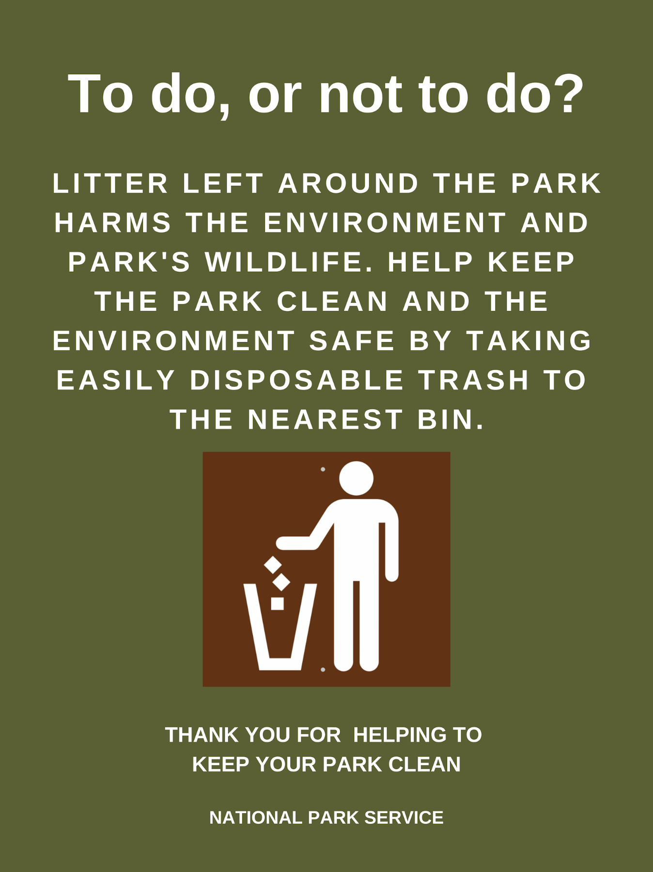
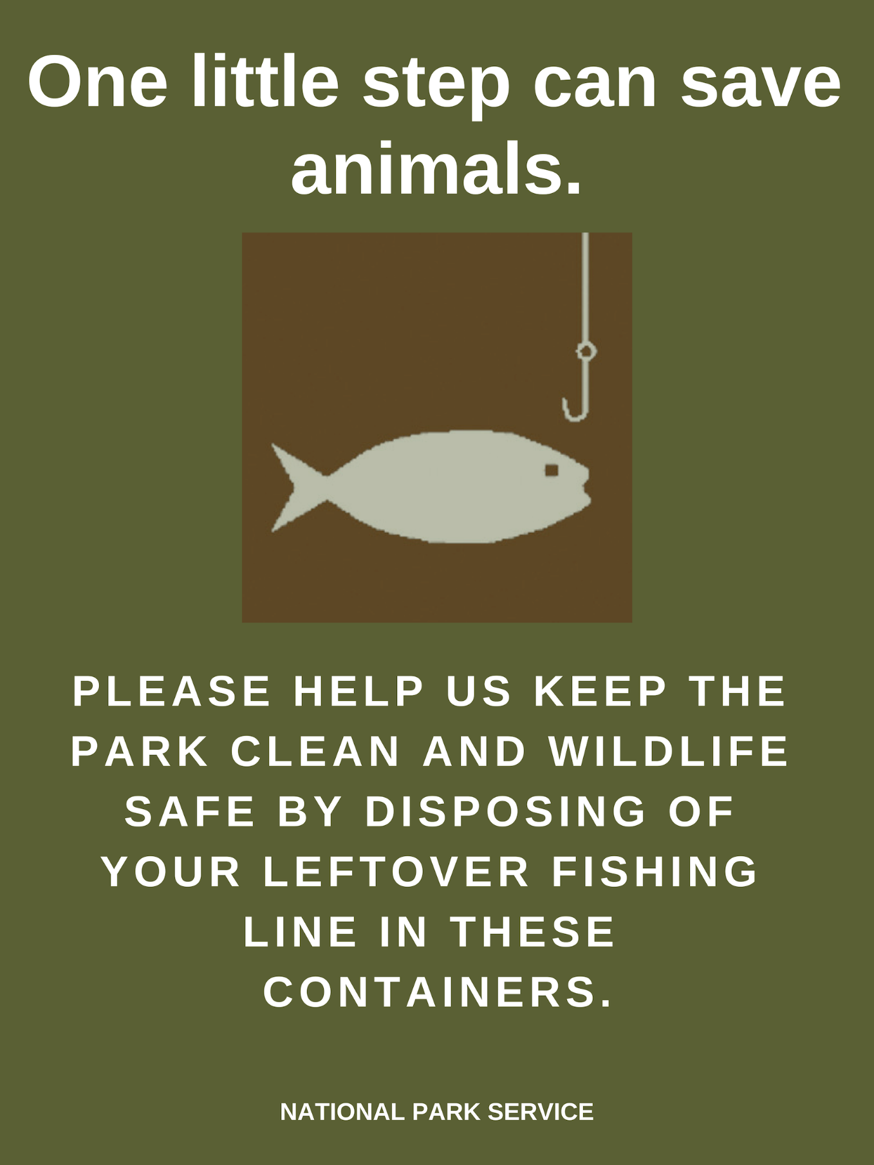

Part F – Proposed Lesson Plan for East Potomac Park Education Program
A Detailed Lesson Plan in Environmental Science (Middle School, Grades 6-8)
“Trash Rangers”
- Objectives
At the end of the lesson, students will be able to:
- Recognize the impacts that litter has on wildlife and the environment
- Identify ways to reduce littering and its impacts
- State whether the observed park employs any of the strategies they identified to be useful

- Subject Matter
Cause and Effect Relationship
Reference/s:
Materials: Visual aids
Value Focus: Develop a knowledge of the impacts they have on their environment

- Procedure
- Pre-Visit
Teacher’s Tasks | Students’ Tasks
Introduce that trash is a problem for wildlife and the environment.  Create a cause and effect board to fill out as the students answer the following questions:  What are the impacts of trash on wildlife? Why is a problem?  What are the causes of too much trash? What causes wildlife to get access to trash?  What are the impacts of trash on the environment (soil, water, air, plants)? Are they good or bad? Why?  What are the impacts of trash on humans? Are they good or bad? Why?  What types of trash do you think are common in the park? What kind of impacts could they have on the park?  What could happen if these problems continue?  Create a board to fill out as the students answer the following question:  What do the students think can be done to reduce littering and its impacts? Why do they think that will help?  Create an observation table using the topics identified in the discussion. (sample provided below) | Give thoughtful responses with explanations into why they chose those impacts  Give thoughtful responses with explanations into why they think it will be helpful
- Visit
Teacher’s Tasks | Student’s Tasks
Split the park into sections (shown in the example below) and divide the students into teams to complete data collection in those sections  Encourage students to think about the impacts the trash has while they are collecting it  Especially regarding the impacts different types of trash can have | Observe the type, amount, and location of trash in their section by completing the observation table (provided below)  Observe any immediate impacts of trash in their section (i.e. Wildlife in/around the cans, soil degradation)  Observe any strategies the park employs in attempt to reduce littering (i.e. signs, trash bins, etc.)
- Post-Visit
Teacher’s Tasks | Student’s Tasks
Discuss each team’s observations as a class and document the findings from each section. Compare each section’s findings to find similarities/differences in trash problems for the park. Have the students verbally answer the following questions:  Based on our observations, what do you think is the worst problem for the park? Why? What kind of impacts does this specific problem have on the park?  What do you think causes the difference in trash problems? Why? Is it a difference in management in certain areas?  How much trash was there? How much of it was recyclable? What does this mean for the park (in terms of what they can do to reduce trash impacts)?  Pose the following questions for the students to complete a summary of the visit:  What observations did they make into the impacts of trash (regarding soil/water)?  Was the park using any strategies we identified before we visited that could be useful in reducing trash? Were they using any that we didn’t identify? Were these strategies effective?  What do you think this park could do to improve the effectiveness of their strategies?  Inform the students that these summaries will be shared with the park. | Give thoughtful responses using evidence from their observations.  Write a summary of their visit to the park using information from the class discussion and by answering the questions posed by the teacher. Explain what they are going to do to reduce trash impacts in their own lives.

SAMPLE ANSWER KEY FOR PRE-VISIT
Teacher’s Tasks | Student’s Tasks
Create a cause and effect board to fill out as the students answer the following questions:  What are the impacts of trash on wildlife? Are they good or bad? Why?  What are the impacts of trash on the environment (soil, water, air, plants)? Are they good or bad? Why?  What are the impacts of trash on humans? Are they good or bad? Why?  What types of trash do you think are common in the park?  What could happen if these problems continue?  Create a board to fill out as the students answer the following question:  What do the students think can be done to reduce littering and its impacts? Why do they think that will help? | Give thoughtful responses with explanations into why they chose those impacts  - Can hurt wildlife because animals mistake it for food  - Hurts wildlife because it can get tangled in their limbs and get caught in their mouths  - Attracts wildlife to the park/trash bins; wildlife are carriers of disease  - Wildlife becomes habituated to human food  - Causes soil degradation (shown through missing or patchy grass, no foliage)  - Causes problems in water because it depletes oxygen, fishing line or trash can be eaten by fish or tangle them  - Plastics contaminate water streams and degrade into microplastics that are consumed by fish  - Attracts wildlife to the park/trash bins, wildlife are carriers of disease that can harm humans and increases human-wildlife conflicts  - Impairs visitor experience  - No one wants to visit a dirty park  - Picnic waste, plastic bottles, food wrappers, fishing line  - Park could see a higher density of wildlife at artificial levels  - Park could be overrun by trash, decreasing visitation  - Wildlife in park could be injured/die  - Pollution/contamination of water  - Park soil degradation  Give thoughtful responses with explanations into why they think it will be helpful  - Provide trash bins, people will throw their trash into the bins and not on the ground  - Provide signage, it will inform the visitors to not litter  - Tell visitors that trash harms wildlife

SAMPLE OF PARK SECTIONS
Section 5 is the picnic area, circled as its own section.
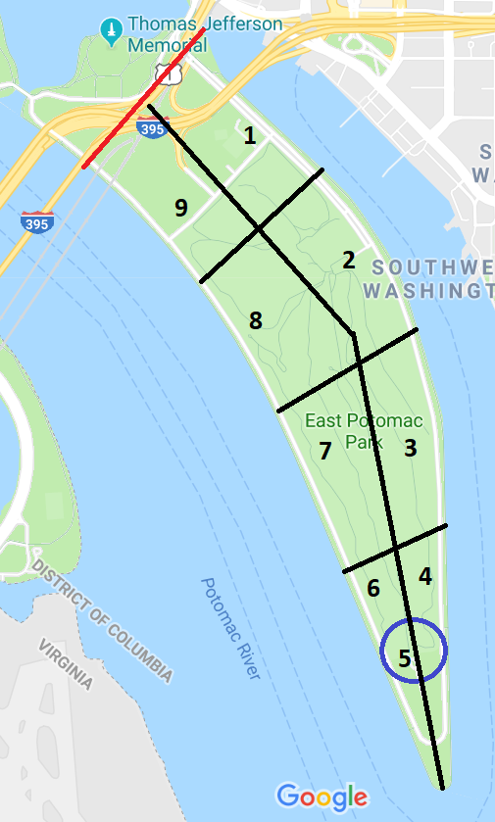

SAMPLE Observation Recording Table
Team Name: |  |  |  | Section Number:
Team Members:
Trash
Location (mark on map)
Type
Plastic bottles
Food wrappers
Bottle Caps
Fishing Lines
Recyclable or nonrecyclable
Other
Impacts
On Soil
On Water
On Wildlife
Other
Management Strategies
Infrastructure
Information
Enforcement
Other
SAMPLE OBSERVATION TABLE BASED ON CLASS DISCUSSION

Potential resources to help with the Pre-visit discussion
Bateman, P. W., & Fleming, P. A. (2012, April 19). Big city life: Carnivores in urban
environments. Retrieved from https://zslpublications.onlinelibrary.wiley.com/doi/full/10.1111/j.1469-7998.2011.00887.x
Blanchfield, D., Cuffe, C., Culjak, A., Gileece, O., Lochlainn, M. N., Lucey, J., Mansary, Z.,
Thomas, N., & Zhao, L. (2015). Darndale Park Report. Group assignment prepared as part of Msc Sustainable Development in Environmental Design and Management, Dublin Institute of Technology, April 2015.
Dau, B. K., Gilardi, K. V., Gulland, F. M., Higgins, A., Holcomb, J. B., Leger, J. S., & Ziccardi,
M. H. (2009). Fishing Gear–Related Injury In California Marine Wildlife. Journal of Wildlife Diseases, 45(2), 355-362. doi:10.7589/0090-3558-45.2.355
Fishing. (2018, June 1). Retrieved from https://www.nps.gov/nama/learn/nature/fishing.htm

Part G – Interview Summaries

Jeffrey Hitchcock (10/30)
Jeff thinks that the switch to wildlife safe trash cans will have a big effect on the trash problem in the park because there are so many animals (racoons, birds, etc.) that will go into the trash cans looking for food and leave various trash they dug out of the cans on the ground. He agreed with us that the most trash comes from visitors during late spring and throughout the summertime, so that helps explain why we haven’t seen as much trash. The landscaping company is supposed to pick up all litter on the ground and they are supposed to go out two times a day, however they are probably only going out when they mow. Jeff’s park service staff goes out two times during the day and once in evening to collect the trash in and around the trash cans. They currently only have two trucks and two people who can drive them, hoping to get a third driver and go back to three routes so drivers can go back to areas more often and shrink time taken.
Trash that comes into the park from the river may not be required to be picked up by the contractors if it doesn’t make its way onto mow-able areas so park staff have to go out and collect it, thought this problem might be solved if there was a better, more closely-knit fence to keep stuff from slipping through (unless of course the flooding is bad enough that the trash makes its way over the fence).
Maintenance crews are supposed to clean both the inside and outside layer of the trash bins: they pull bins and take a poker to clean out the trash from the outside layer and replace the metal plate on bottom because of rust when necessary: they are short staffed right now and in process of hiring, if they had more people, they could give more attention to detail. They don’t use trash bags currently for monetary reasons, if they did use any they would be required to use clear ones. This makes it easier for the trash trucks but also obviously makes the bins get dirtier faster, requires them to pay someone to power wash them occasionally and eventually replace them. Emptying the fishing line containers is not their job, it is done by volunteer groups, told to contact James Pierce.
He said that he would get us information on the cost of the trash removal, etc. He also said to contact Tom Testa, who we don’t know how to contact, and Keith Kurney COR for contract in yellow building, which we also don’t know.
He agreed with us that there was a conflicting message with the sign at the picnic area saying to take your trash with you but still having trash cans; said that they needed the trash cans because the amount of trash was so bad. In the long-term future, they want parking meters along the street but can only have better enforcement for now. April and Jeff explained how lots of buses take all their trash out of their bus and throw it out there, which is especially annoying after the maintenance crews have just cleaned the cans, most of the time it's on the ground and not in the trash cans, possibly set box on the ground, one guy unloaded eight garbage bags and just left it around the trash cans happens everywhere even in West Potomac, they leave bags and boxes and piles of trash.
They provided visitors with trash bags for a 4th of July event in 2016 and it helped reduce the amount of trash by a significant margin, he wasn’t completely opposed to the idea of providing bags at Hains Point but also noted that picnic areas aren’t the main problem, the sidewalks along the road and sea wall have more trash.
April’s thoughts:
- Over the summer, lots of issues with litter in Hains point from flooding and visitation
- Things have cleaned up a bit because they are holding the contractors responsible
- They stopped paying the contractors and their work quality has gone up dramatically since then which is good
- Still haven’t gotten all the mowing down all the way down to the sidewalk
- RUPPERT Landscaping is the contractor
- New trucks in, looking into how much it would cost to repair the ones right now as possible recycling trucks, maybe recommend recycling bins to start that up?
- More staffing to enforce things and patrol for trash might be good suggestion
- can get numbers for cost of hire

Robert Mocko (10/31)
Robert is responsible for maintaining the Anacostia River and the many streams that feed it since it often dumps trash into the 20 mostly urban parks in DC and Maryland under the supervision of NACE. They are very understaffed, so they rely on volunteer groups to pick up trash from the flooding rivers (the other primary place he thinks trash is most likely to be found is just along the road). They use trash traps in the streams that feed the Anacostia in an effort to reduce the amount of trash going to the main river, and they are very effective, collecting 30-50 bags of trash from them every week.
Robert thinks that education and outreach are very important factors for trying to fix the trash problems in the park; however, he didn’t really have many concrete examples for us on how to do that when we tried to ask him to elaborate. He told us that several trucks go through each of the parks in NACE, and that they just implemented a new recycling program that was a requirement from the federal government. He told us to talk to Diana Bramble about information for the waste management strategies at Anacostia.
He didn’t particularly like the TITO method and had never considered it for NACE parks, since he had talked to people at Great Falls who had tried it at their picnic areas on the weekend and it didn’t go very well, thought it would need good outreach program to be effective. We learned that there is no signage about throwing away your trash at Anacostia Park. He also told us to contact Volunteer Coordinator Julie Kutruff and that he’d get back to us on names of volunteer groups that help maintain/empty the trash traps.

James Pierce and Jacklyn Meyer (11/1)
From his section for National Park and Memorial Mall, there are roughly around 215 volunteer groups and 4500 volunteers in 2017. Most of the groups are reoccurring groups and some of groups have been here for last 5 years.
Volunteer groups started to pick up the fishing line container since April of 2018. The volunteer groups are mainly the YOUTH CONSERVATION CORPS which technically are not volunteers because they will get paid. Most volunteers group are not interested in cleaning them out because of the long walking road around Hains Point.
Generally, NPS-NAMA needs to find a group of people who are very interested in this to start volunteers' program. NPS-NAMA will not reach out the volunteer groups themselves and those groups should fill the information through Volunteer.gov (America's Natural and Cultural Resources Volunteer Portal) => Group Service Opportunities for NAMA (which requires group numbers >= 15), to set up time for volunteering.
The volunteers’ activities vary week to week, so they did not have a regular/SET schedule for volunteers, but they do have one for requesting which volunteers tell NPA-NAMA what days that work for them, unless that schedule does not work for NPS-NAMA. James is traying to move to a proactive system where they will program a defined schedule activity like “Mondays are for trash picking”. They are willing to share the spreadsheet of all projects throughout the whole mall.
Jeff Hitchcock said volunteers cannot pick up trash from the contractors’ working area because it is against the contract. However, if the contract states they can, they will bring projects to start picking up trash. Jacky does not think that contractors do their job and that is why it is a problem at Hains Point. She told us that especially for summer weekends people are out grilling and using park a lot. As a result, there would be trash everywhere on Monday because people put trash in bags and leave it and animals get into it and people dump their coals at base of trees and leave their grills.
They both think that it is a valuable option to start a volunteer group for picking up trash/littering at Hains Point if the contract permits. But they need to go through superintendent’s office with rules and regulations because they are engaging the outside. And they just posted on volunteer websites a specific trash event on every Monday which might have to wait until spring because volunteering is slowing with weather.
They recommended that Anacostia watershed (helping Anacostia and waterways getting cleaned up; they helped on earth day and did a good job and came for the waterways here) is a great option for building partnership. The official partners at NAMA is “Trust for the national mall” which is a nonprofit organization, (5013c). They recommend Rae Emerson who controls all friends group and grants, such as Friends of the titanic and each memorial has one (WWII, Vietnam, Korea).
They recommend other volunteer groups like GWMP, Harper ferry (Not sure) and there is a huge program in San Francisco that they have dropped in volunteer that come in and do that.
They recommend that Nick Solomon who is a regional manager and volunteer coordinator which may put us into contact with partners for SOLVE sites. Also, Lenny Tay is a national coordinator. Jason is program manager at NAMA, we spoke to him and introduced ourselves and our project.
Jeff Gowen is chief of facilities and maintenance which is the person we want to talk to about contracts. And he wants to talk to April about recycling and he recommended we do that. He can also develop programming to set up volunteers to help with recycling removal can be a set schedule.

Denise Coogan (11/2)
The report cataloged what they did: waste characterization study, infrastructure, containers, labeling, what was purchased for the parks to get the project going, personnel involved, marketing, media, get the word out, let the NPS and visitors know they are doing zero landfill, to reduce their waste and to recycle better.
They measure visitors’ behavior and awareness by judging people’s behavior about recycling, asking how people feel about recycle. The questions they ask include, in the park, will you recycle? How easy for you to recycle in the park? How to reach people? What is the best message?
More parks would definitely benefit from recycling bins/composting bins. Every park should co-locate recycling bins next to trash bins, so people have that option. But budget is an issue.
There are also a lot of fishermen in Grand Teton, but they do a good job on collecting fishing lines to keep them out of the lakes and nature, they also put up the containers along the lake. The Leave No Trace study shows that 95% of the people who use the park are willing to help recycle.
NPCA chose the three parks Yosemite, Grand Teton, Denali because they are all iconic parks, many visitors, staff willing to, good infrastructure.

Rock Creek Conservancy (11/6):
Rock Creek Conservancy is a contribution organization to protect Rock Creek watershed and the surrounding natural areas that impact it. They host volunteer related activities all throughout the watershed; they also work closely with Montgomery County Park. Their Extreme Cleanup is part of Alice Ferguson Foundation’s Trash Free Potomac Watershed Initiative.
One of the main volunteer program opportunities they offer is called the Stream Team initiative which basically equips individuals or organizations or private groups to help clean up RC and its park lands at least 2 times a year. Besides the 2 required cleanup, many people will go out and organize a one day event.
The Rock Creek Conservancy get close to 5000 volunteers every year. They currently have 75-80 Stream Team leaders.
Stream Team leaders will bring families, friends, neighbors on board. Some individuals and groups will come to them and seek volunteer opportunities.
Rock Creek Conservancy will equip the volunteers with tools and materials. Alice Ferguson Foundation also helps to equip the volunteers with gloves and trash bags.
They think volunteers absolutely raise people’s awareness about the negative impact of the trash in the parks.

Jeffrey Gowen (11/7)
Jeffrey said that litter in the parks was not as much of a problem now as it was a few years ago. He said this is because they have a better handle on the trash management now. They removed trash cans in a lot of areas, which reduced route times and man hours necessary for proper removal. They also contract out litter now which has helped, although the contractors are not completing the required work, so they have been withholding pay for the past 3 months. He said they will continue to withhold pay until they reach their required level of work. He says their work quality has improved but they’re not quite where they need to be yet.
Because they contract out litter removal, he does not think it would be useful to have volunteer groups pick up the litter. In the contract it states that litter must be removed 7 days a week by 11am. He does not think volunteer groups would be able to handle this and that sometimes they might not show because of weather problems. However, he did say that volunteer groups picking up litter would not be a breach of contract, but it does seem unnecessary.
Jeff thinks the worst area for all of NAMA is Hains Point and Ohio Drive. He says it is because of the bus drivers who take advantage and dump their trash in Hains Point cans or just dump it in piles next to them.
He does not think adding signs to the park or signage in general has any effect on visitor littering behaviors. However, he does think that removing trash cans reduces the amount of litter in the park. He said this during the meeting and Jeffrey Hitchcock interjected and stated that can removal did not work in Hains Point and that they had to add cans back in.
He said that a few improvements could be more staffing and equipment. They do have the money and approval to get more staffing but going through HR is a very slow process.

Kathyrn Tyler and Nick Solomon (11/7)
Rock Creek Park runs most of its volunteer efforts through their partner organizations, usually with partners through the SOLVE program. SOLVE has 15 group leaders, with groups ranging in size from one person to large groups like the Rock Creek Conservancy. People usually meet up at an event and express interest in forming a partnership.
The SOLVE program was created in 2015 as a more structured way for people in the community to reach out and help the park. Every SOLVE agreement has a list of tasks they agree to do every so often, with every agreement containing two required tasks: picking up trash and reporting hazards in your specific site. This program is extremely site focused, not task focused – people do this work to make a particular place cleaned up, with the frequency of cleanup depending on the site. There is a quarterly site assessment and annual renewal/modification process for every site/agreement. There are essentially three types of SOLVE agreements:
- First type: basic agreement, they can go out onto their site on their own
- Second type: they have a deeper agreement and a permit but need park staff supervision every time they go out
- Third type: they have a permit and don’t need supervision, but might still want to have park staff with them depending on the activity
The only problem they told us about the program is that they have one group who thinks they have an exclusive claim on a particular site and another group that wants to take care of a specific part of that site, and they have to put a revision in the first groups contract to take that section away, and for them to make it more clear in future agreements that if you take care of a site, you don’t have exclusive control over it.
They also discussed Weed Warriors and Potomac Appalachian Trail Club who are groups that work in the park and function as if they had a SOLVE agreement without a formal one because they predate the program. Of course, they also don’t have a problem getting people interested in volunteering to help the park, in fact they have so many volunteers they don’t have enough staff to supervise everyone. They recently tried to reach out to colleges in an effort to get more people from that demographic but don’t have a real defined idea of what they want from that, that’s the only outreach they have attempted.

Jennifer Epstein (11/9)
Jennifer Epstein works with programs that are more focused on history. She says the Alice Ferguson Foundation (AFF) works more with science programs that focus on trash. She gave us a contact, Heather Zdobysz, at the AFF. She works with a lot of schools from all over the country. She says they accommodate anyone who calls and asks for a program. Typically, she works with elementary school students, especially with the 4th grade “Every Kid in a Park” program. She does not usually talk about trash/littering in her programs. She goes over the arrowhead in her pre-visits to the schools/classrooms to get the kids excited for the trip. Sometimes the kids will bring it up on their own but talking about trash/littering is not consistent in every program. However, when she goes over the arrowhead and its meaning, she said she can add a part about not littering when she talks about the animals.
Because Jennifer works more on the history programs, she did not know about most of the programs we asked about. However, she was able to tell us a bit more about the AFF. She said they do modules/programs about trash and water quality. They go to all different parks in the region but lately have been doing a lot of programs at the FDR memorial. She said they could do them in Hains Point. She also told us about an annual trash summit cleanup they have every year in April, which helped us when developing questions for Heather.
Jennifer said she is willing to try out a new program if we came up with something. Because she is the only person running the programs, she does not have the time to create one on her own but lead us in the right direction on how to develop one ourselves. She told us to look into the common core and education standards in the area to see if/where a program about trash/littering would fit. Unfortunately, because of the difference in education standards, not all programs work across age ranges or across state lines. She thought it could be a good idea to tie it in with the cherry blossoms in the park and also said she knows of people in the NPS as well as as teachers in the DC area who are looking into new programs with STEM in the parks.
Jennifer again noted that understaffing is a big challenge for her. She talked about the large number of requests she receives and says she could be doing much more with more staff. With the size and scope of the parks in the DC area alone, there is a huge scope of topics to cover. Another challenge is the number of visitors and students that arrive for the programs. She says it can be difficult to develop a program for a large number of students that will keep them engaged and entertained.
Jennifer directed us to another park that is trash free. The Cheasapeake Ohio Canal runs from Georgetown, DC to Cumberland, OH and runs through the Maryland Great Falls park which is trash free. She provided us with a contact to find the best person to speak with there.

Officer Conn (11/13)
In the morning, during their first lap, the park polices check for any trees down in a road, any cars that are left overnight, tide flooding condition to make sure everything is okay to open. During the day, they start checking people; they check out and talk to fisherman, picnickers. But they don’t talk to them very often though. They sometimes get calls about disputes in picnic area mainly because of reservation and walkin conflicts.
There are not a lot of bus parking in DC, so they are constantly here driving around and park. The park polices see illegal bus parking in Hains Point all the time. The buses are supposed to park in the bus area in the park, but they park by the sideways parking. If it is not too busy, they are not a problem, polices have other things going on, the polices will not bother them. If there are park users trying to use the area, polices will tell them to move on.
He has never seen bus driver dumping trash or big furniture dumping. If he sees it, he will stop it. But he was not sure about the regulations regarding bus trash dumping, because vehicle trash is legal.
He mainly notices trash and litter on the grass. Most of the trash is from raccoon tearing the trash from the cans and spread them all over.
The park polices have the rights to arrest and fine people when they see littering. Rangers do not; rangers can only educate people or call the park polices.

Don Kirk (11/15)
He says the majority of the trash they pick up is food waste or waste from packaged goods, told us the two biggest areas for them are Georgetown Waterfront Park and Meridian Hill Park. We then asked about his maintenance crew’s general procedure for trash removal and he went into the specifics for those two parks, Georgetown is under contract with trash from cans and litter from ground collected everyday while Meridian is done with in house staff, during summertime on weekends the trash cans are emptied twice a day by contractor, during week maybe twice a week. I think park of the problem is that cleanup is so divided between so many different areas at Rock Creek, there isn’t a definitive answer, between areas cleaned by contractors, park staff and SOLVE partners. He said the park staff still does the majority of the work when it comes to SOLVE agreement sites, usually go out three times a week but it varies.
He is extremely happy with his contractors, Allstate Contractors, even has some areas that are completely monitored by them, for a good cost too, but afraid about being able to keep them because they are primarily a construction company and the contract with them is almost up, said he would send us the scope of their work and a copy of the contract, doesn’t really have them working in the same areas as volunteers so no conflict there.
They use either similar cans as here or Rubbermaid cans with a spring-loaded door for depositing trash, considers them pretty wildlife proof. He doesn’t think they are perfect though, people often put their trash on top because they don’t want to touch the inside of the can or not sure if the can is full, they do use bags.
Their busiest time of the year is also summer as expected, they don’t really get the same type of dumping we get here, they mostly get big stuff like mattresses or construction equipment. We asked about getting info on how much he spends on trash removal, said it would take some work to get that kind of info, seemed reluctant but said okay. He wishes they didn’t have to go around and empty so many trash cans but every time they have tried to remove some it makes the situation worse. He said that they don’t have any general signs discouraging littering, just signs about picking up waste from pets. He recommended we contact Alvin Cromer, alvin_cromer@nps.gov

Heather Zdobysz (11/15)
Heather told us about the trash related programs the AFF is currently running. There is the trash free initiative that involves the annual trash summit in April. The summit is called the Potomac Watershed cleanup. She believes it is in its 34th year. The watershed cleanup covers sites in MD, DC, VA, and WV. They did a cleanup of 300 sites in the month of April this year alone and collected over a million pounds of trash. East Potomac Park is included in the cleanup sites. She said the watershed cleanup is done entirely by volunteers, and she can provide us with the number of volunteers that participated this year. To recruit volunteers, they have people that are interested come to them. Those people become site leaders and go through site specific training. Once they have the site leaders, they are the ones who get volunteers for the sites. The site leaders setup and oversee the cleanup of their site. She told us about a similar program that the Anacostia Watershed does every year, which we have looked into previously.
Heather also told us about the litter campaigns. They create posters and put them out into the community about what is trash versus what is recycling. They also conduct community outreach programs in DC along with the campaign and hold community events for the residents who are interested in learning more about how trash/recycling relates to them and their community.
The Alice Ferguson Foundation also runs programs in high schools. One is called “Talking Trash” where students do trash cleanup in a park. The program is typically run along the Potomac side of Ohio Drive. Heather said that every time they run the program, the students clean up 20-30 bags of trash. The bags contain trash and recyclables. Once the trash is collected, they do a “trash timeline” where the students put what they have collected in the order they think it will decompose. The categories include plastics, styrofoam, aluminum, and others. It gives students a perspective of how long the litter leaves and impact on the environment. They also weigh the trash they find to find the percentages of how much of it was recyclable and how much was plastic waste, among other categories. She says the program can and has been adapted for younger age groups. She said they run the program once or twice a year with 3rd and 4th graders, where half of the kids will do a memorial tour and half will do cleanup, and then they will switch.
Another program the AFF runs in schools is called “Trash Free Schools.” This program has people from AFF go into schools and educate teachers/students on choices they can make to reduce their trash production. She said she can provide us more information on this program, and she will provide us with contact information for Lauren who runs the trash programs. Lauren can give us more information on the outreach events they do in the programs.
Heather also mentioned that the trash initiative sites they run are grant specific. They work with the DC Department of Environment to get grants for trash cleanup and litter campaigns. They also receive NOAA grants for trash and watershed cleanup. She also said they do have sponsors for the bigger cleanups, but most are done with the grants.

Rita Knox (11/29)
Rita is in charge of maintaining the Cumberland Visitor Center in C&O Canal National Park and runs education programs working with children in grades Pre-K to 5th, and an additional Reduce Reuse Recycle program with 7th graders. They work with the Alice Ferguson Foundation fairly regularly, running the Talkin’ Trash program throughout the park and get several thousand students per year. Rather than trash cans, C&O Canal provides only trash bag dispensers for their visitors, giving this message on both their website and wooden signs on or near every dispenser. They based their program based on the one run by the Maryland State Park system and was implemented in 1999. They have around 60-70 signs and 130 dispensers at the different access areas to the park, and Rita thinks they are very effective, since the volume of trash in the park went down by 75% in the first year, and she felt like it has stayed at that reduced level since then. The switch had obvious financial savings, since they no longer had to pay people to empty, clean or replace the trash cans or buy large trash bags, and they feel it helps give the visitors a sense of stewardship over the park.
They of course still get trash in the park, even get the same kinds of dumping problems as East Potomac Park, but they don’t particularly do much to combat this other than the Talkin Trash program. They have either US Park Police officers in the D.C. section of the park or police officers leased to the park by the local police stations, and interpretive park rangers, but don’t have nearly enough staff to constantly have people out looking for litterers. She said they do have a decent amount of fishermen in the park and she notices that they tend to leave a lot of trash behind, but didn’t know too much more, said to contact Brenden Wilson at brendan_wilson@nps.gov

Part H – Alumni Programming Poster

Part I – Additional References

Calendar of Events. (n.d.). Retrieved from
https://www.nps.gov/nama/planyourvisit/calendar.htm
Evolution of an Idea. (2009). Retrieved from
https://www.nps.gov/americasbestidea/templates/timeline.html
Flowers, A. (2016, May 25). The National Parks Have Never Been More Popular. Retrieved
from https://fivethirtyeight.com/features/the-national-parks-have-never-been-more-popular/
Foundation Statement for the National Mall and Pennsylvania Avenue National
Historic Park. (2007). Retrieved from https://www.nps.gov/nationalmallplan/Documents/National%20Mall%20Plan%20-%20Park%20Foundation%20Statement.pdf
History & Culture. (2017). Retrieved from
https://www.nps.gov/nama/learn/historyculture/index.htm
National Park Service Overview. (2018). Retrieved from
https://www.nps.gov/aboutus/upload/NPS-Overview-07-03-18.pdf
National Malls and Memorial Parks Foundation Document Overview. (n.d.). Retrieved
from https://www.nps.gov/nama/learn/management/upload/NAMA_OV_508.pdf
Outdoor Activities. (2018, January 27). Retrieved September 12, 2018, from
https://www.nps.gov/nama/planyourvisit/outdooractivities.htm
Total Recreation Visitors for National Capital Parks Central. (n.d.). Retrieved from
https://irma.nps.gov/Stats/SSRSReports/Park Specific Reports/Annual Park Recreation Visitation Graph (1904 - Last Calendar Year)?Park=NCPC

