Supplemental Materials for Assessing the Impacts of COVID-19 on Water Usage

David Datta, Pranjal Mann, Patrick Spillane

A-Term 2021

Advisors
Professor Jason Davis
Professor Sarah Stanlick

Sponsor
Massachusetts Department of Environmental Protection

This report represents the work of one or more WPI undergraduate students submitted to the faculty as evidence of completion of a degree requirement. WPI routinely publishes these reports on the web without editorial or peer review.
Table of Contents
Authorship Page 2
About the Sponsor 4
Graphics and Charts 5
GIS Map 24

Authorship Page
Abstract - Written and edited by David Datta and Pranjal Mann
Introduction - Written by David Datta, edited by Pranjal Mann and Patrick Spillane
Background - Intro and Summary written and edited by David Datta and Patrick Spillane
Water Use and Infrastructure - Written by David Datta, edited by Patrick Spillane
COVID-19 Effects on Water Usage - Written and edited by Patrick Spillane
Drought’s Impact on Water Consumption - Written and edited by Patrick Spillane
Gathered and Relevant Data - Written by David Datta, edited by Pranjal Mann
Methods and Tools - Outline by Patrick Spillane, Intro written and edited by David Datta and Patrick Spillane
Organizing Data - Written by David Datta, edited by Patrick Spillane
Analyze Patterns and Trends - Written and edited by David Datta and Patrick Spillane
Mapping Water Use against Socioeconomic Factors - Written and edited by Patrick Spillane
Results and Discussion - Intro written and edited by Patrick Spillane
Total Volume Change - Written and edited by Patrick Spillane
Seasonal Volume Change - Written and edited by Patrick Spillane
Residential Water - Written and edited by Patrick Spillane
Sectoral Water Use - Written and edited by Patrick Spillane
RGPCD and UAW Comparison - Written by David Datta, edited by Patrick Spillane
Mapping Residential Use against Median Household Income - Written and edited by David Datta
Municipalities of Interest - Written and edited by Pranjal Mann
Changes in Total Usage - Written and edited by Pranjal Mann
Changes in Sectoral Data - Written and edited by Pranjal Mann
RGPCD per Municipality - Written and edited by Pranjal Mann
Conclusions and Recommendations - Conclusion written by Patrick Spillane, edited by David Datta
Recommendations - Written and edited by David Datta and Patrick Spillane

About the Sponsor
“MassDEP serves the Commonwealth. We enforce laws that protect our air, land and water. We help cities and towns with local environmental issues. We write permits that support natural resources, public health and our economy. We inspect contaminated sites and ensure proper cleanup. We work with federal, state, local and citizen partners for a cleaner environment.” - MassDEP Homepage
Our contacts from the MassDEP are Duane LeVangie, Water Management Program Chief with the Bureau of Water Resources and Linjun Yao with the Bureau of Water Resources.

Graphics and Charts
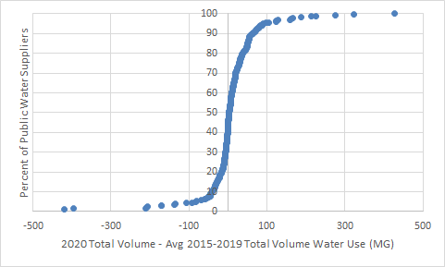
Boston and Worcester not shown on low end
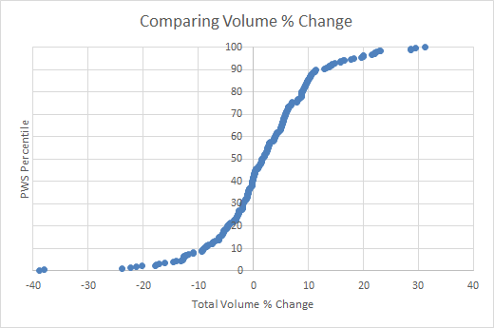
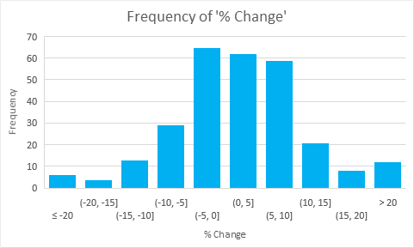
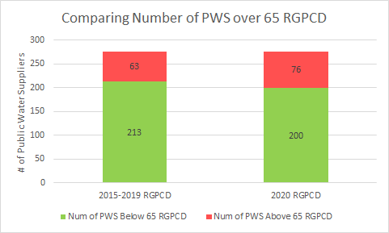
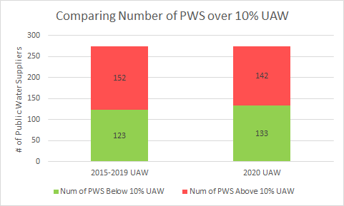
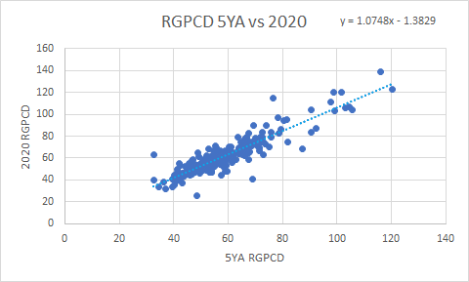
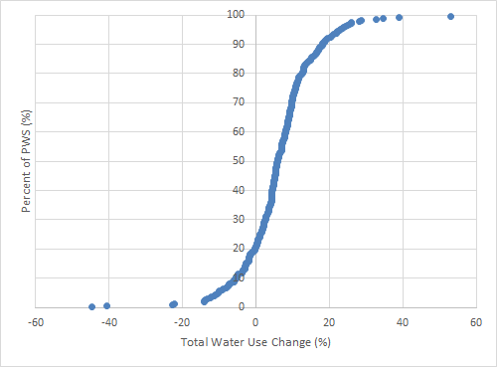
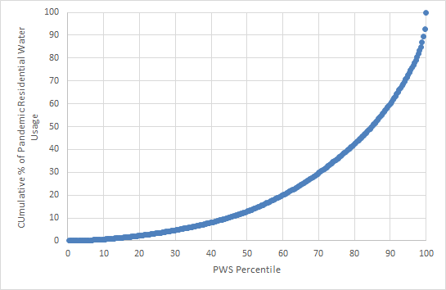
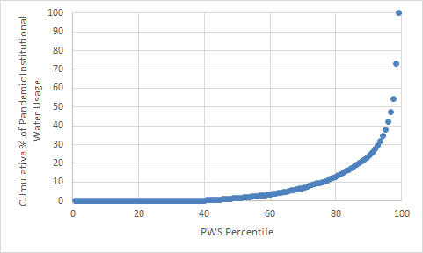
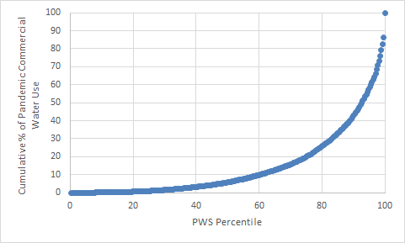
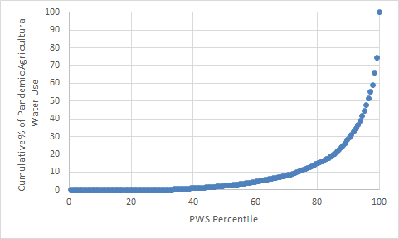
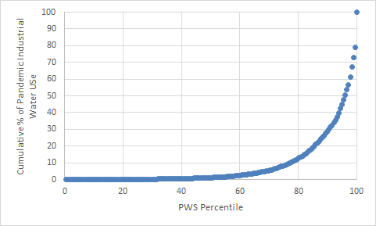
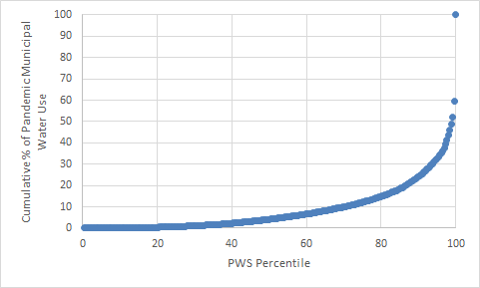
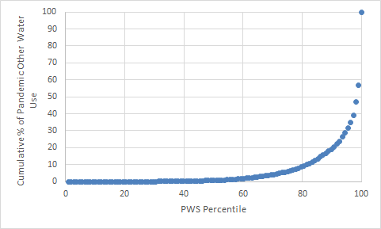
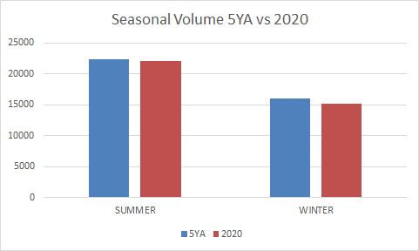
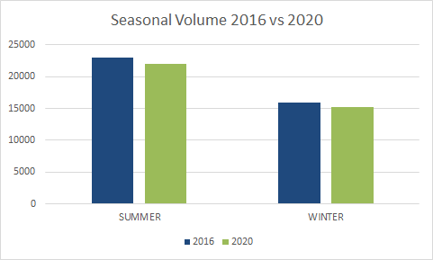
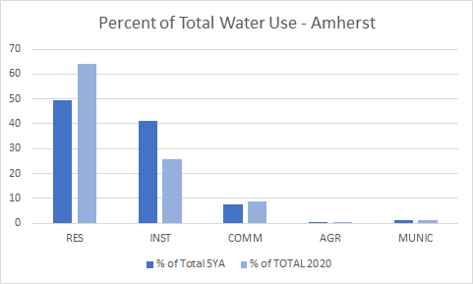
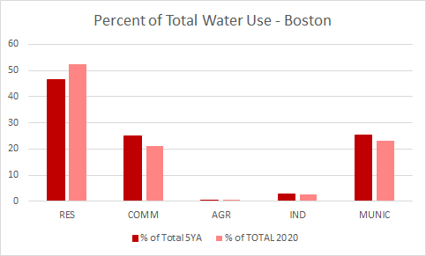
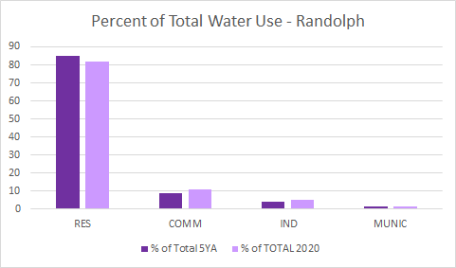
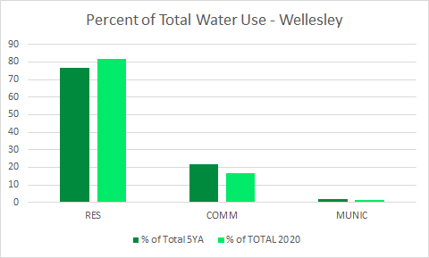
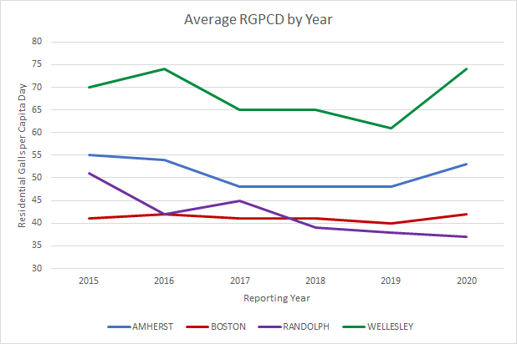
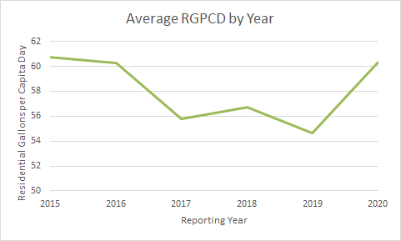
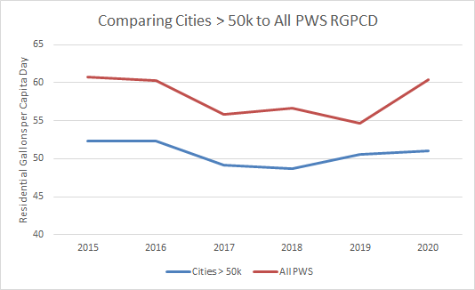
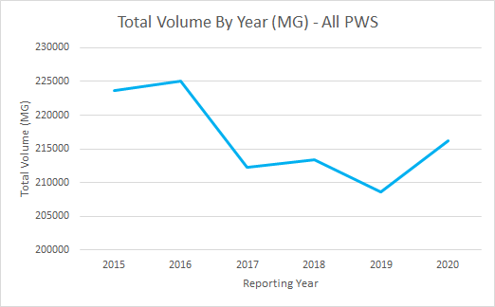
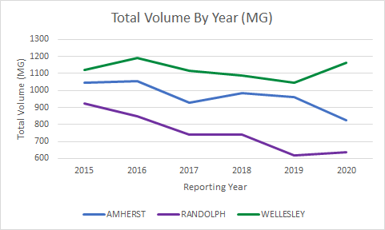
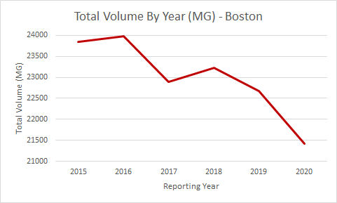
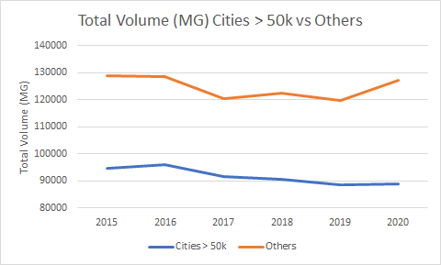
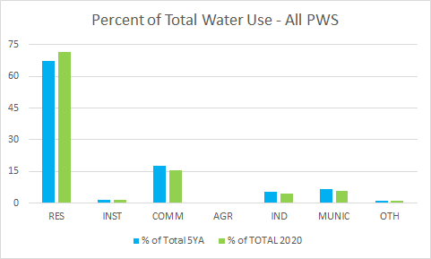
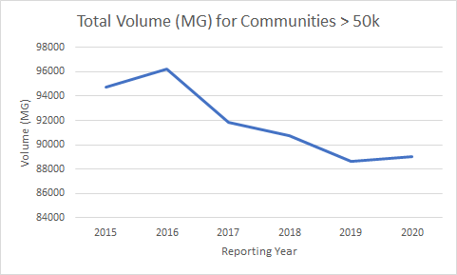
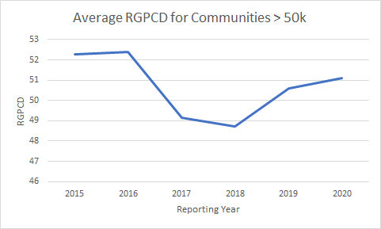
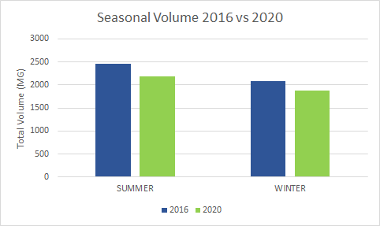
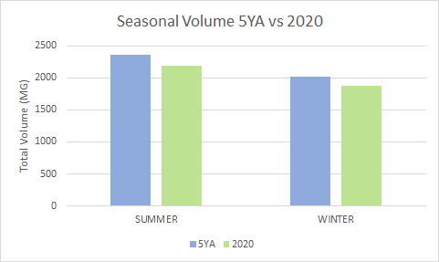
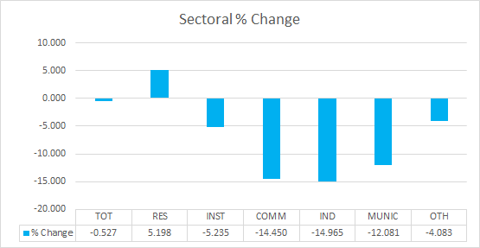
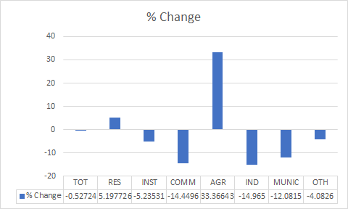
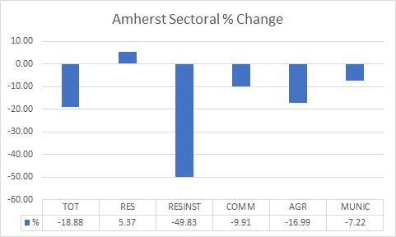
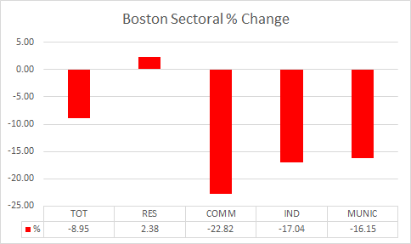
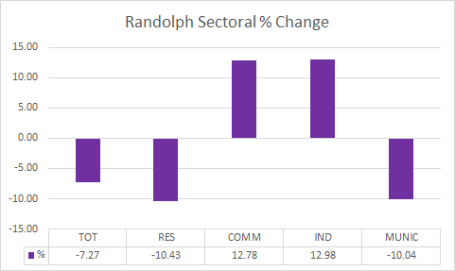
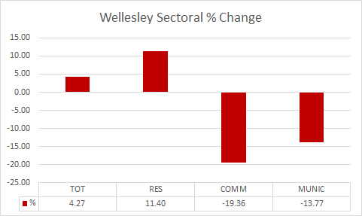

GIS Map
