FOOD PERMIT
The Public Health Office issues food service permits. If your establishment does not have a common victualler license but wishes to serve food for a one-time event, please contact the Public Health Office at 508-228-7200 x-7014. If your business wants to put out a lemonade stand, bake sale table or any other outdoor sales stand, please seek approval from the Public Health Office. If you want to set up a stand on public property, we ask that you get permission from Town Administration at 508-228-7255.

STAGES AND OTHER STRUCTURES
If you are doing any construction, including a temporary stage, additional seating, tent or other structure, please contact the Building Office at 508-325-7587 to request a Building Permit.

CIGARETTES/LITTER/SWEEPING
Nantucket is a beautiful place, and we all have to do our part to keep its streets and sidewalks clean. All businesses are encouraged to keep the sidewalks outside their establishments free of cigarette butts, wrappers and other garbage. If you want to put up a cigarette disposal container or urn, you can do so if it is on private property.

STREET FURNITURE
If you wish to put a bench, bike rack, reservation stand or other street furniture outside your business, you may do so if it is placed on private property. To put street furniture on sidewalks or other public property, please contact Town Administration at 508-228-7255 to get special permission.

OCCUPANCY
Make sure to know the occupancy limits of your building or establishment. If you have questions about the allowed occupancy in your establishment, please contact the Public Health Office at 508-228-7200 x-7014.
****

Helpful Contact Numbers

Entertainment Licenses:
Licensing Agent 508-325-4137

One-Day Pouring Licenses:
Licensing Agent 508-325-4137

Event Permit:
Event Coordinator 508-325-4166

Food Permit (non-restaurant, in-store)
Public Health 508-228-7200 x-7014

One-Time Noise Bylaw Waiver:
Town Administration 508-228-7255

Temporary Structure/Tent Permit:
Building Inspector 508-325-7587

Street/Sidewalk Blocking:
Town Administration 508-228-7255

License and Permit Enforcement:
Enforcement Officer 508-325-4137

HDC/Sign Advisory Committee:
HDC Administrator 508-325-7587

Lighting Enforcement:
Lighting Officer 508-325-7587

All Other Queries or for Guidance:
Town Administration 508-228-7255

Best Wishes for a Terrific Season!

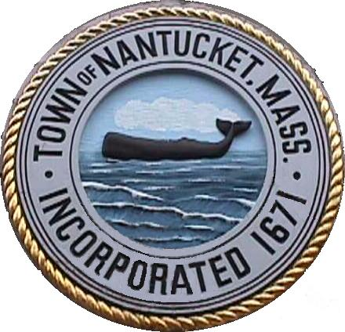

Town of Nantucket
16 Broad Street
Nantucket, Massachusetts 02554

QUICK REFERENCE
GUIDE
FOR BUSINESSES

Updated November 2020

GREETINGS!

As you are aware, Nantucket has many bylaws and regulations that govern the way businesses add to the unique character of the island. All Town codes and regulations can be found on the Town’s website at www.nantucket-ma.gov/197/licensing or by a call to one of the numbers provided. Whether you are a long-time, year-round business owner or a new seasonal manager, please familiarize yourself with the policies that make Nantucket such a wonderful place to live and visit.

Below are some common reminders to help make EVERY season the best ever!

ALCOHOL
If your business wants to pour alcohol for public consumption, you will need a liquor license. Whether you require a year-round license, seasonal, or just for One-Day, contact the Licensing Agent at 508-325-4137 or licensing@police.nantucket-ma.gov.

ENTERTAINMENT
All entertainment in areas where the public has access or is invited - from DJ’s to amplified live bands - requires licenses. The Town Code Chapter 105 Article IV: Public Entertainment allows for One-Day Temporary Entertainment Licenses to be issued by the Town. For more information, please contact the Licensing Agent at 508-325-4137 or licensing@police.nantucket-ma.gov.

SIGNS AND MERCHANDISE DISPLAYS
Nantucket has a unique ambiance that attracts thousands of visitors each year. In order to preserve downtown’s quaint atmosphere, we ask you that you do not put out sandwich boards, merchandise displays or signs on the exterior of your building. However, feel free to decorate your windows/exterior with flowers, potted plants or window boxes! If you have questions about signs or allowed advertisements, or wish to make a change to your official business sign, please contact the HDC Administrator at 508-325-7587. For information about merchandise displays, contact Town Administration at 508-228-7255.

BALLOONS
If you want to display balloons at your business, you may do so if they are not helium-filled and are not attached to the outside of your business structure. Helium balloons are not allowed anywhere on the island, but regular air-filled balloons are ok.

ZONING
Nantucket has several business zones, with different uses allowed in each. Many businesses have special permits in place that allow them to operate. Check with the Planning and Land Use Services Department (PLUS) prior to making any changes to your business, such as adding seating, making changes to the use of the property, altering exterior features like patios or parking lots, or adding additional services. PLUS can be reached at 508-325-7587.

SIDEWALK /
STREET BLOCKING
On Nantucket, we are often limited by our sidewalk space and narrow streets. To keep our streets and sidewalks clear, we ask that you do not put out signs or other obstructions on the sidewalk, street, or otherwise in the public way. If you require the use of public streets or sidewalks for a temporary purpose (such as needing ladders to paint building, clean windows, make necessary repairs) you can do so by requesting a One-Time Street or Sidewalk Blocking Permit from Town Administration at 508-228-7255.

LIGHTING
Seeing the stars and taking in Nantucket’s undisturbed natural beauty is one of the best things to do on the island. To preserve Nantucket’s scenic skyline, we ask that you keep lights or lighted signs to those that do not flash, blink, change intensity or change color except for temporary holiday displays, public safety or traffic control. For more information on the Town’s lighting bylaws, see Town Code Chapter 102: Outdoor Lighting or contact the Lighting Enforcement Officer at 508-325-7587.

