Welcome to Nantucket: An Island Guide Revisions
The “Welcome to Nantucket: An Island Guide” is a tool the Town uses to deliver information on Nantucket’s customs and bylaws to new Nantucketers. As 2020 has been a tumultuous year, our team has made suggestions on how to update the guide to incorporate new pandemic information and data from our study to more accurately reflect the issues that need messaging.

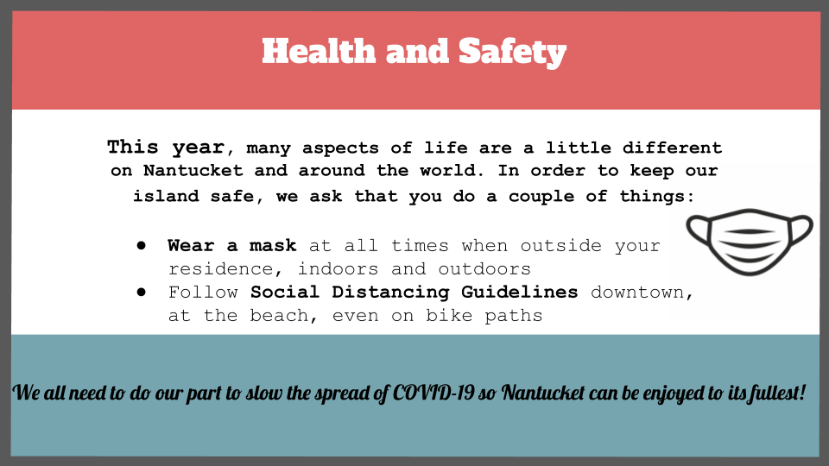
This slide can be inserted anywhere near the beginning of the guide, for obvious reasons. In a 2020-2021 updated Welcome Guide, a slide addressing concerns of COVID-19 is essential.

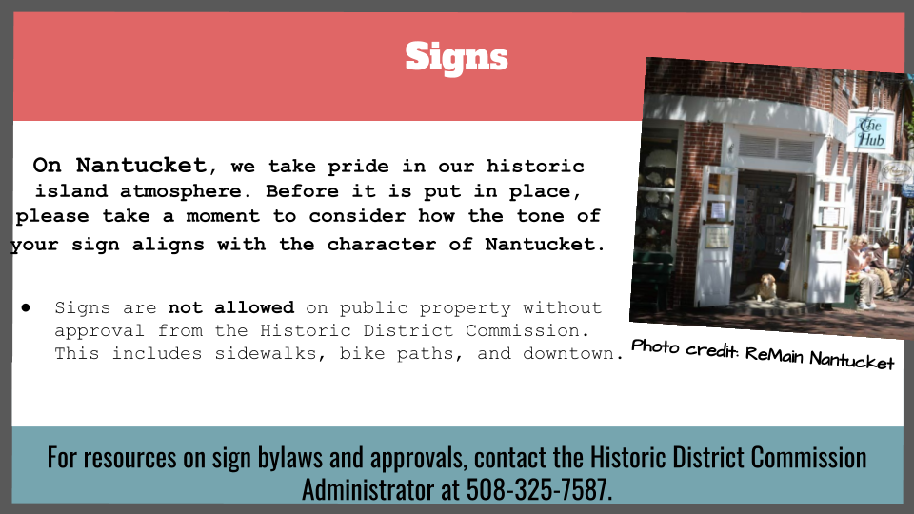
Due to the increased number of signs on the island, we recommend including a slide like this to emphasize their regulations. As the Town transitions back to “normal”, we recommend an increased attention to the sign bylaw; and this addition to the Welcome Guide could help.

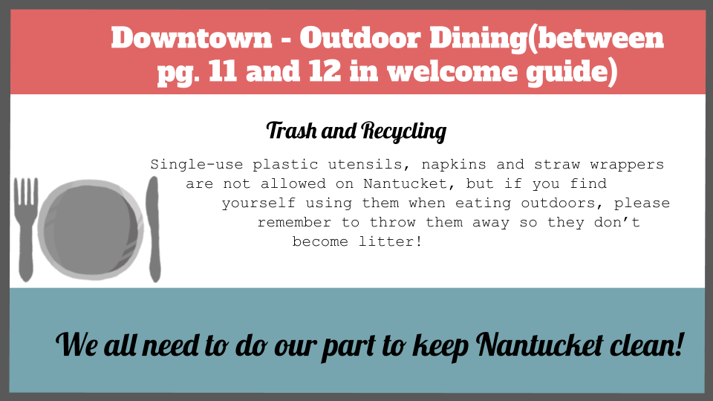
From our interviews, a concern identified with outdoor dining is the trash and litter it can cause. We recommend this slide be inserted between pages 11 and 12 in the 2016 Welcome Guide, after the other pages about Downtown.

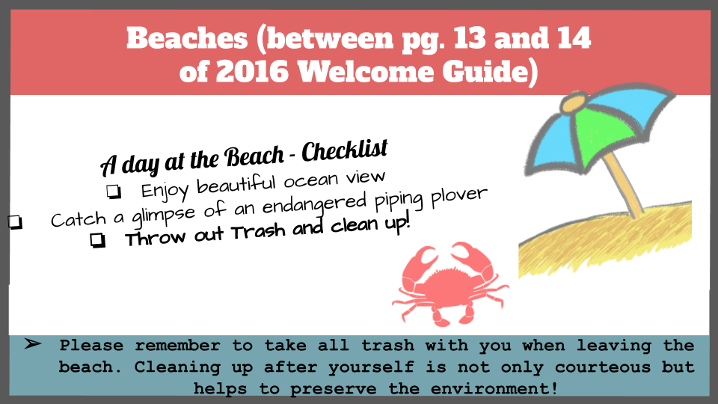
Our survey results indicate the majority of respondents feel trash and litter on the beach is a significant problem. As such, we recommend a slide dedicated to beach trash and litter be inserted into the Island Welcome Guide, between pages 13 and 14.
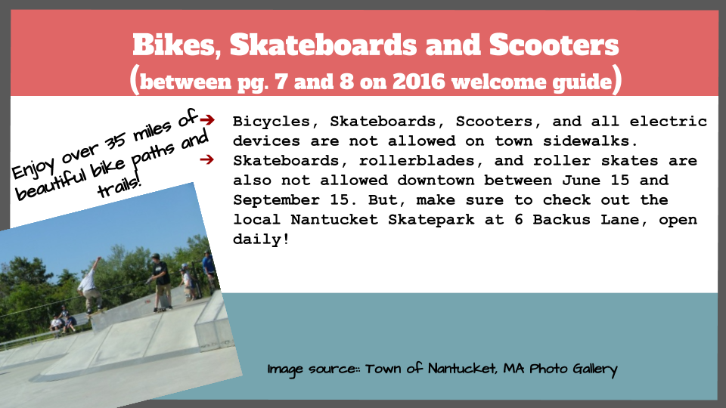
A main concern identified in our interviews and surveys was bicycles and other electric and non-electric devices on sidewalks. We recommend the Town insert a slide between page 7 and 8 of the 2016 Welcome Guide dedicated to keeping these devices off of the sidewalks.

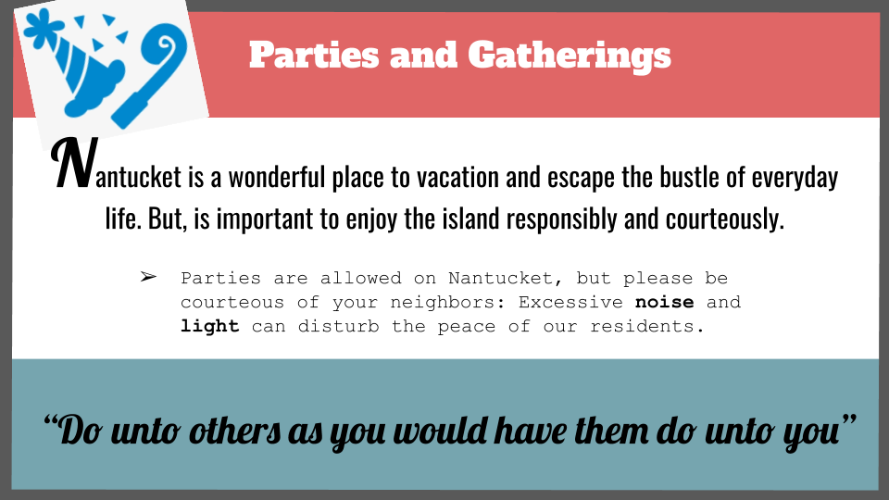
We recommend the Town insert a slide dedicated to responsible gatherings in an updated Welcome Guide. In a pandemic-changed world, this not only reflects common neighborly courtesy, but also its importance to public health and disease prevention.

