Video Creation Guide

Table of contents:
- Introduction
- Before leaving the U.S.
  - Video creation session with the Global Lab
  - Borrowing equipment
- Tips for constructing Interview questions and outline
- Tips for editing videos
  - Procedures
  - Premiere Pro tips

Introduction
We were asked by our sponsor to create a series of informational short videos on given topics. We decided to interview and film experts in the Arava on the topics and use the footage to be part of the videos.
Before we leave the U.S., we did a lot of background research on the topics and on making informational short videos. We established that we want the videos to be linguistically simple, have subtitles, and with effective visual tools such as infographic.
It wasn’t until we had our first draft of a video that we knew exactly what we wanted and needed to do.

Before leaving the US

2.1 Video creation session with the Global Lab
Before leaving the US, it is important to set up a meeting with Jeremiah Valero, the Project Manager of the WPI Global Lab. When meeting with him, he’ll go through the script outlines as seen in our Methods chapter, and by the end of the meeting you’ll have created a video (with a concept you think up at the start of the meeting) based around that outline. If you don’t have anyone in your group who is knowledgeable in video editing, it might be a good idea to set up an additional meeting with the Global Lab to go over editing in Premiere Pro too.

2.2 Borrowing Equipment
Before leaving the US, it is important to set up a meeting with Ellen Lincourt (eml@wpi.edu) from the ATC (Academic Technology Center). Depending on what you want to film, Ellen will give you a breakdown of pieces of equipment. If the plan is to just film in-person interviews and b-roll footage, you shouldn’t need anything more than: a phone rig (for outdoor filming), a tripod (for indoor interviews), and a clip-on mic pack (for outdoor interviews). Note that these mics run out of battery quickly, so make sure they are charged before each interview.

Tips for Constructing Interview Questions and Outline

3.1 Introduction
We interviewed seven people in total, two of whom were in the U.S., interviewed through Zoom. Given their area of expertise, we made lists of questions before interviewing. What the interviewees will say is not entirely predictable; however, if we ask the right questions, the answers will most likely be something we use in the video. In a few cases, we ended up using something the interviewees said which we weren’t initially looking for.
In this chapter, we will describe how we construct our interview question list, how we constructed our video outline, and a list of questions that will help us to think about the video outline and thus what to ask.

3.2 Constructing Question List
Most of our interviewees were provided by our sponsor with some background information. So, we know the area of their expertise, and what general questions to ask.
The first question is always what they or their company is doing, and what is the purpose. This part of the interview will most likely be in the video, so think about how the answer will be presented or edited when the interviewee finishes answering and ask relative additional questions to get a more complete answer for putting in the video.
The rest of the questions depend on the work they do and questions we have when researching their company or area of expertise. For example, when interviewing Maya Ruderman – head of sales and business development at HomeBiogas, a more general question we asked was how their company and offgrid technology can benefit the developed countries, a more tailored question was what’s the lifespan of their system.

3.3 Constructing Video Outline
We used the structure guide from the Global Lab as a general template to produce our outline (Table 1). Once we have ideas for the script, we think about the shot. The final video doesn’t need to follow the outline exactly, as what the interviewees provide is not controllable. The structure guide is only there to help give a general direction for constructing interview questions and shots.
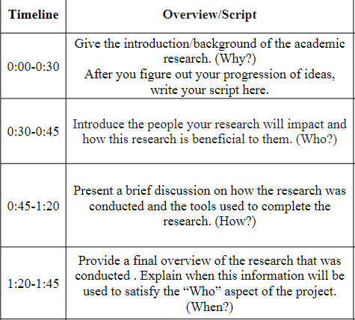
Table 1. Overview of video structure (Araujo, J. V., 2021)

3.4 Question List for Helping Constructing Interview Questions and Outline
- What is the relation between the video topic and the interviewee?
  - What do you want to show in the video? Their product? Their goal? Their idea?
- Is a demonstration of their product needed?
  - How would it be related to the topic?
  - How would it fit in the video?
  - What length and prospect of their product would be a good fit?
- Is the location of the interview easily accessible?
  - If not, take more B-roll shots, with multiple angles, static, and moving in different directions.
- If choosing one section of the video outline to be the core of the video, what would it be?
  - Why is this section the most important?
  - How deep should the information be? Should the details be included in the video?
  - What kind of shot would you want to use for this section? Interview? Voice over film? Should the camera be steady or moving?
- What shot do you want with the narration?
- What background would be good for the interview?
  - If sitting down, should the team member present in the shot?
    - If not, ask the interviewee to look at the person instead of the camera.

Tips for Editing Videos

4.1 Procedures
These are the steps we took after the interviews and outlines are done.
- Went through the interview footage.
- Updated the outline with completed interviews. Interview content will almost never adhere to your original outline and often times the footage you do get provides a much better narrative than you originally thought of.
- Made a more specific outline/script with narration and sections of the interviews
- Started to cut the clips
- Put the clips together then either had a peer review or asked the advisor(s) to review
- Updated the video draft with new suggestions

4.2 Editing shortcuts in premiere:
- C for cut
- V for select (mouse)
- Ctrl+K for the shortcut for splitting video/audio
- G for adjusting audio gain
- Hold on to Shift to select multiple items

4.3 Tools we find useful
- Add auto-generated subtitles, go to Window -> Text
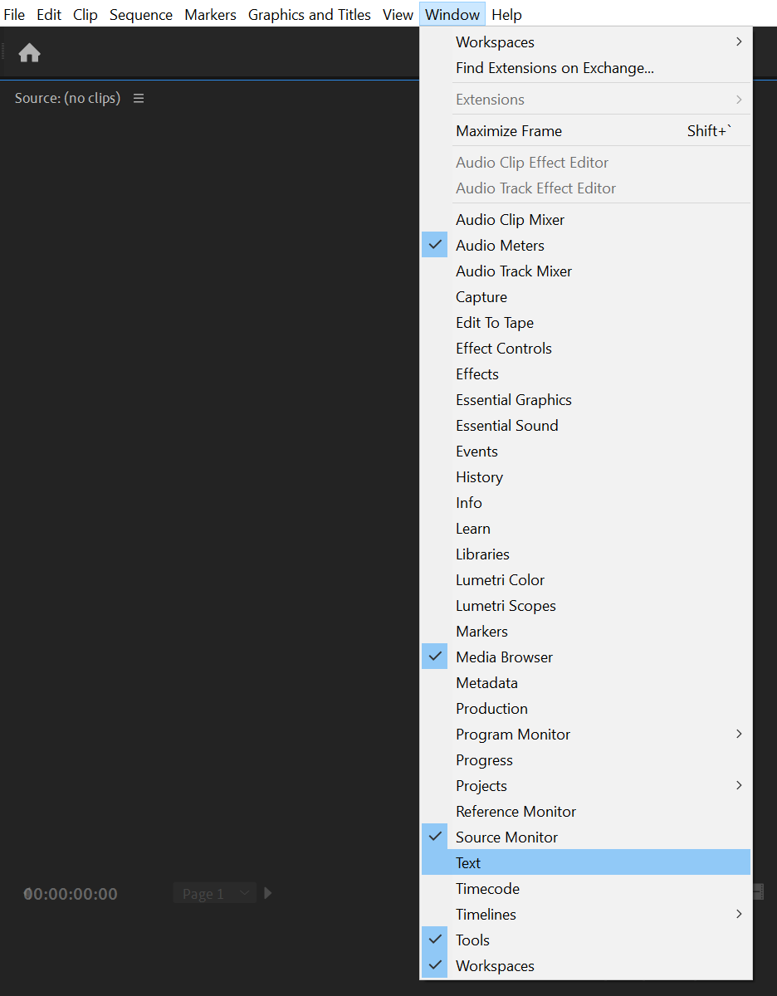
Go to Transcript, then click on create captions
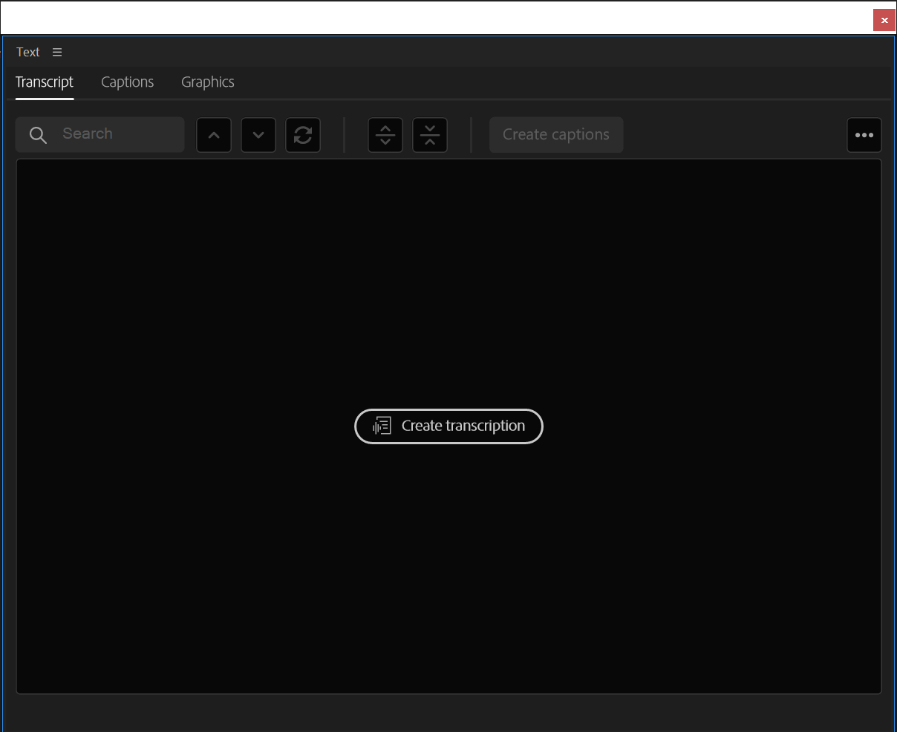
This window should show up, and click transcribe
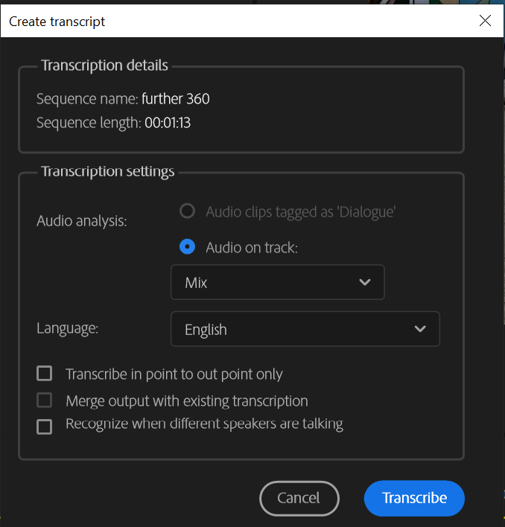
After premiere finishes transcribing, click on create captions
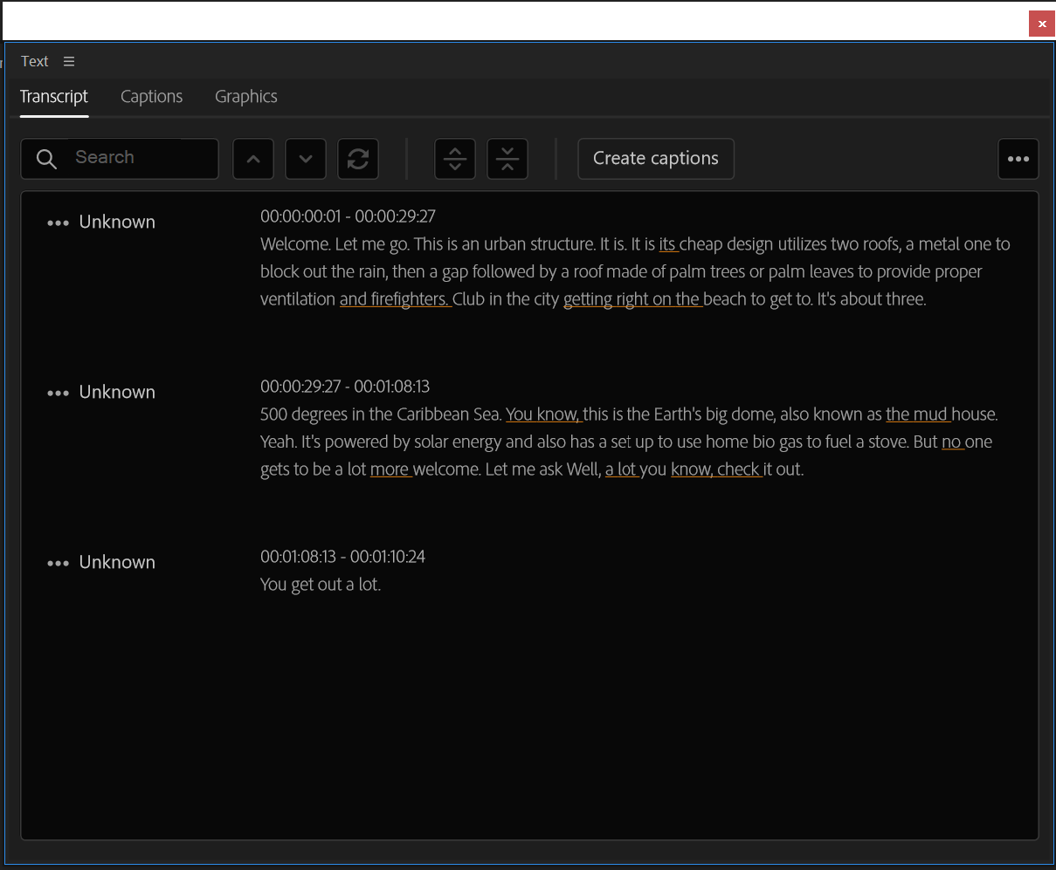
Then you should have captions on top of the tracks

You can do audio processing in premiere, go to Window -> Audio Track Mixer
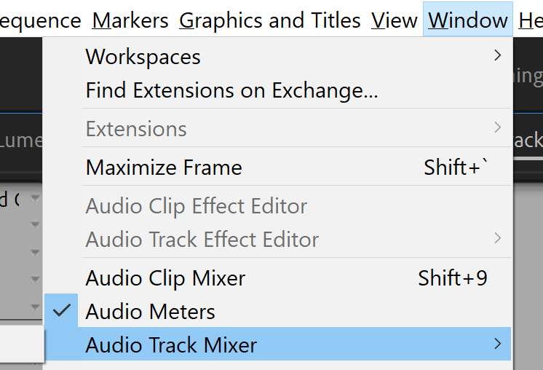
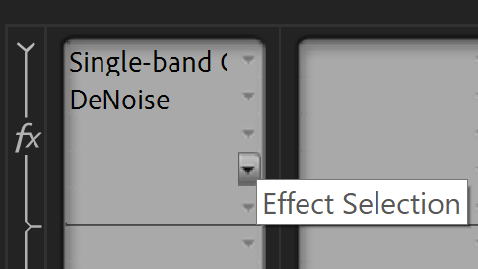
For shaky footage, use the warp stabilizer tool to smooth it out.
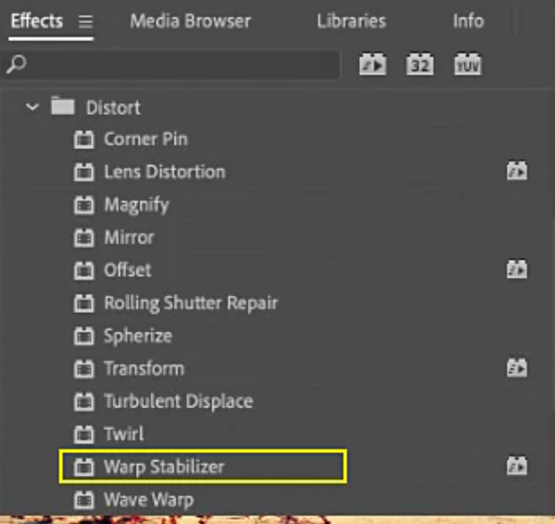
If you don’t know how to do something odds are you can find it on google or youtube
Stylistic recommendations:
When editing someone speaking pay attention to their intonation, you want to cut audio when it sounds like they’re done talking.
Be careful with your use of video and audio transition effects, they’re not necessary a lot of the time.
In general simple is better. You want a low amount of things on the screen at any given time, but you want screen elements to be changing enough that the audience’s attention doesn’t wane. Closed captions are very good for providing “movement” of on screen content even when nothing is happening.

