RESPIRATORY TARGETED GENE THERAPY IN AN ALS MOUSE MODEL

A Major Qualifying Project Report
Submitted to the Faculty of the
WORCESTER POLYTECHNIC INSTITUTE
in partial fulfillment of the requirements for the
Degree of Bachelor of Science
in
Biochemistry

by

_________________________
Victoria A. Semple

April 27, 2017

APPROVED:

_________________________ _________________________
Mai ElMallah, MD Robert E. Dempski, PhD
Department of Pediatrics Chemistry and Biochemistry
UMass Medical School WPI Project Advisor
MAJOR ADVISOR

This report represents the work of WPI undergraduate students submitted to the faculty as evidence of completion of a degree requirement. WPI routinely publishes these reports on its website without editorial or peer review. For more information about the projects program at WPI, please see http://www.wpi.edu/academics/ugradstudies/project-learning.html

ABSTRACT

Amyotrophic Lateral Sclerosis (ALS) is a fatal neurodegenerative disorder that affects the upper and lower motor neurons resulting in muscle atrophy, paralysis, respiratory failure and death. 5-10% of ALS is familial and 20% of familial ALS overexpresses mutant SOD1. The ALS mouse model (the SOD1^{G93A} mouse) overexpresses mutant SOD1 and recapitulates ALS pathophysiology making it an ideal model to study novel therapies for this disease. Using an adeno-associated viral vector (AAV) carrying a microRNA to knock down SOD1 (AAVrh10-H1-miR^{SOD1}) we sought to correct the respiratory pathology in SOD1^{G93A} mice with the goal of improving respiratory function and overall survival. An intralingual and intrathoracic injection of AAVrh10-H1-miR^{SOD1} to target the respiratory system was injected at 60 days of age. A one time injection given at 60 days was able to extend survival of ALS mice and improve respiratory function.

TABLE OF CONTENTS

Signature Page ……………………………………………………………………. 1

Abstract …………………………………………………………………………… 2

Table of Contents …………………………………………………………………. 3

Acknowledgements ……………………………………………………………… 4

Background ……………………………………………………………………… 5

Project Purpose …………………………………………………………………… 9

Methods ………………………………………………………………...………… 10

Results ……………………………………………………….…………………… 14

Discussion ………………………………………………………………………… 21

Bibliography ……………………………………………………………………… 23

ACKNOWLEDGEMENTS

I would like to thank my UMass advisor Dr. Mai ElMallah for allowing me to be a part of her research and for her insight. I would like to thank Allison Keeler and Marina Zieger for their guidance and instruction. Finally, I would like to thank my WPI advisor Professor Dempski for overseeing this project.

BACKGROUND

Amyotrophic Lateral Sclerosis
Amyotrophic lateral sclerosis (ALS) is a fatal neurodegenerative disorder affecting three out of 100,000 people every year (Kinsley, 2015). Upper and lower motor neurons are largely effected by ALS causing muscle atrophy, lower limb paralysis, and death by compromised respiratory muscles (NINDS, 2013). ALS disease duration is typically three to five years (Zoccolella et al., 2007). Early stage ALS can manifest either as bulbar or limb onset. Bulbar onset presents as difficulty speaking or swallowing. Limb onset can present with fasciculation’s, cramps, and weakness in arms and legs. As degeneration worsens both types progress with similar symptoms spreading across the entire body. These include dysphagia, dysarthria, dyspnea, weight loss, and limp paralysis. In late stage ALS patients can no longer walk and are dependent on a ventilator. There is currently no cure for ALS and Riluzole is the only FDA approved medication. Riluzole only extends survival by a few months and does not reverse disease progression (NIH, 2013).
Superoxide Dismutase One
Ninety percent of ALS cases are sporadic and the remaining ten percent are familial. One of the known dominant mutations responsible for familial ALS causes a single amino acid substitution in Cu/Zn superoxide dismutase one (SOD1^{G93A}). This protein is localized in cytoplasm and the intermembrane space (IMS) of the mitochondria. The wildtype function of SOD1 is to convert superoxide radicals into oxygen and hydrogen peroxide and prevent cell damage by oxidative stress (fig 1).
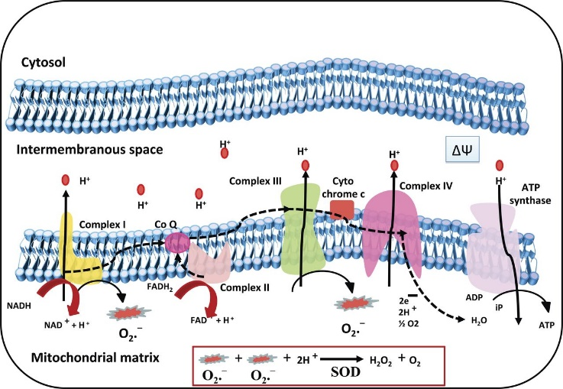

Figure 1. Wild type function of SOD1 in the mitochondria: This diagram depicts cellular respiration in the mitochondria and the role of SOD1 in the process. SOD1 is localized to the IMS of the mitochondria and is used to remove superoxide radicals produced during cellular respiration. (Argwel et al., 2016)

A single amino acid substitution causes protein misfolding that consequently leads to oligomerization. It is theorized that these oligomers form aggregates in the IMS of the mitochondria, leading to improper mitochondrial function. This mitochondrial damage is thought to cause cell toxicity responsible for ALS symptoms (fig 2). The specific events leading up to cell toxicity caused by SOD1^{G93A} are still unknown (Kawamata et al., 2010).
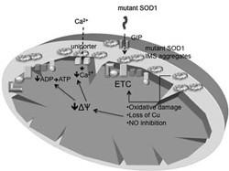

Figure 2. mutant SOD1 aggregates in the IMS of the mitochondria: This diagram of the mitochondria shows the effects of SOD1 aggregates in the IMS. The major cause of cell toxicity is thought to be oxidative stress. (Kawamata et al., 2010)
Former research using human SOD1 mouse models has shown SOD1^{G93A} causes ALS symptoms but the lack of SOD1 does not, so knockdown of expression could be a possible form of ALS therapy. (Zundert et al., 2016)
Gene Therapy for ALS
Past ALS researchers have used gene therapy to knock down SOD1 expression. A commonly used method is knockdown by injection of an adeno associated virus vector containing SOD1 micro RNA (miR^{SOD1}) (fig 3).
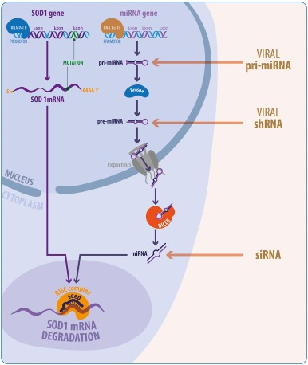

Figure 3. Steps of SOD1 silencing with miR^{SOD1}: This diagram shows the steps of SOD1 mRNA degradation induced by miR^{SOD1}. Both RNAs are transcribed in the nucleus and exported to the cytoplasm where they hybridize. This hybridization signals the RISC complex to degrade the RNA. (Zundert et al., 2016)

Micro RNA knocks down expression by hybridizing to SOD1 mRNA and marking it for degradation by RNA-induced silencing complex (RISC). This prevents translation of the mutated SOD1 (Zundert et al., 2016). Adeno associated virus is used as a viral vector because of its ability to conduct retrograde transduction. This allows axonal transport from the motor unit of the injection site to the spinal cord and to other motor units from there (Gowanlock et al., 2016; Borel et al., 2015).
Former Research at UMass Medical School
The SOD1^{G93A} mouse model is commonly used for ALS studies. A former research project done at UMass Medical School studied the pulmonary function of this mouse model. Stoica et al. proved this model provides a phenotype similar to human ALS pulmonary insufficiency (Stoica et al.). With this mouse model, Stoica et al. (2016) used an AAV9 mediated microRNA as a therapy for ALS. This experiment was done with cerebral lateral ventricular injections in neonatal mice. Their work proved the therapy could decrease SOD1 expression, delay inflammation in the spinal cord, maintain motor neuron integrity, and increase survival by an average of 69 days. Borel et al. (2016) used this mouse model with AAVrh10 mediated microRNA therapy. This experiment was done with a tail vein injection for systemic delivery in adult mice. Their work proved the therapy could silence SOD1 expression in the spinal cord and showed the ability of AAVrh10 to transduce the entire spinal cord. This improved motor function in lower limbs, pulmonary function, and extended survival by either 22 or 34 days, depending on the use of promoter. Both studies showed SOD1 knockdown improves survival in the SOD1^{G93A} mouse model.

PROJECT PURPOSE

For this project AAVrh10-H1-miR^{SOD1} is used as the therapy with intralingual (IL) and intrathoracic (IT) injections in an adult ALS mouse model. The aim is to create a therapy capable of targeting respiratory insufficiency caused by ALS by transducing the hypoglossal (innervating the tongue/ upper airway) , phrenic (innervating the diaphragm), and intercostal motor units.
.
METHODS

- Mice
There were four groups of mice used for this project. The first was non-transgenic (NTG) mice. These mice did not express hSOD1^{G93A}, nor did they receive any injected therapy. The sample size for this group was eight with seven females and one male. The second group was the untreated, B6/SJL transgenic mice (Jackson Laboratory, Bar Harbor, ME.) expressing hSOD1^{G93A}. The sample size for this group was eight with six females and two males. The third group was the treated transgenic mice. These mice received IL and IT injections of AAVrh10-H1-miR^{SOD1}(1x10¹¹vg). All injections were done at 60 days old. The sample size for this group was nine with eight females and one male. At endpoint, untreated mice were sacrificed alone and treated mice were sacrificed with an NTG mouse.

- Behavioral
  - Inverted Screen
Mice were placed on a wire screen that was then inverted. The amount of time the mice could hang, in seconds, was tracked with a maximum time of 120 seconds. This was done at 60, 90,120,135,145,160, 175, and 190 days old. Two trials were done fifteen minutes apart on each mouse.

  - Four-Limb Strength Test
Mice were placed on a wire screen connected to a sensor (Mark-10 force gauge model M4-2) that tracks the maximum force exerted by the mouse. This was done at 60, 90,120,135,145,160, 175, and 190 days old. Two trials were done fifteen minutes apart on each mouse.
  - Neurological Screen
A numerical score, ranging from zero to four, was given to each mouse based on hind limb paralysis progression at 135, 145, 160, 175, and 190 days old. A zero indicates full extension of hind limbs when suspended, one indicates collapse of hind limbs when suspended, two indicates the toes curl while walking, three indicates rigid paralysis, and four indicates the mouse cannot correct itself within 30 seconds of being placed in its side. (Hatzipetros et al., 2015)

- Ventilation
  - Whole Body Plethysmography (WBP)
At 120, 145, 160, and 175 days old and at endpoint each mouse went through one round of WBP. The mice are placed alone in the plethysmography chambers and received normoxia (21% oxygen; nitrogen balance) until ten minutes of baseline breathing was achieved. They were given a hypercapnia (7% carbon dioxide, 21% oxygen; nitrogen balance) challenge for ten minutes. The WBP was done with IOX2 software (EMKA Inc.). (Stoica et al., 2016)

- Tissue Harvest
  - Molecular
The diaphragm, intercostal muscle, lung, liver, hind limb muscle, tongue, cervical spinal cord, thoracic spinal cord, and medulla were removed, cut into less than 50mg size pieces, and flash frozen. All samples were stored at -80°C. Tissues from ten mice were harvested for molecular testing.
  - Histology
The diaphragm, tongue, and whole spinal cord were cut out and drop fixed in 4% PFA overnight. After 24 hours, all tissues samples except the spinal cord were put into 30% sucrose. All bone tissue was removed from the spinal cord and was then placed in 4% PFA for another 24 hours before being placed in sucrose. Half of the diaphragm, and the whole tongue and spinal cord were then embedded in OCT and stored at -80°C. Tissue from ten mice were harvested for histology.

- Histology
  - Diaphragm neuromuscular junction staining
1:1,000 fluorescently tagged bungarotoxin was used as a postsynaptic stain. 1:100 anti-neurofilament was used to stain nerve fibers. 1:200 synaptotagmin was used as a presynaptic stain. Colocalization of all three was used to determine if the NMJ in the diaphragm was innervated, fragmented, or degraded.

- Survival and Onset
  - Onset determination
The mice were weighed every Monday, Wednesday, and Friday. Disease onset occurred when the mice dropped 10% below their maximum weight without recovery through endpoint.
  - Endpoint determination
The transgenic mice were sacrificed when they could no longer correct themselves within 30 seconds of being placed on their sides.

RESULTS

Behavioral
From the day of injection until endpoint, progression of hind limb paralysis was tracked. Although the goal was to target pulmonary function, records of hind limb paralysis were kept allowing for documentation of other possible benefits from the injections. At 60, 90, 120, 135, 145, 160, 175, and 190 days old the mice went through behavioral testing. The inverted screen tested the ability of mice to hold their own weight for a maximum of 120 seconds. In figure 4A the untreated mice start dropping below 120 seconds by 90 days old and are all between zero and 12 seconds by 145 days old. Some treated mice stayed above zero seconds up through 160 days old. Any drop off in time from the NTG mice can be attributed to the mouse being overweight or not complying. The strength test measured the amount of force the mice could still exert from their limbs. Figure 4B shows the four-limb strength of the mice over time. The untreated mice reached their weakest point by 145 days old, while some treated mice could still use their muscles up through 175 days old. A neurological score was also given starting at 135 days old that directly reflected the hind limb paralysis with a score of zero meaning no paralysis and a score of four being the most severe. Figure 4C shows the untreated mice dropping down to a score of three by 145 days old and the treated mice staying at a score of two until 190 days old. No mice are shown dropping to a four because the criteria for that score qualify as endpoint and the mice were sacrificed when they reached that level of paralysis. Increased variance at later timepoints is caused by decreasing sample sizes as the mice die.

A
B
C

Figure 4. Behavioral analysis of hind limb paralysis: These graphs show the three behavioral tests done to track hind limb paralysis during disease progression. Panel A shows the inverted screen test. Panel B shows the four-limb strength test. Panel C shows the neurological scores. The red squares are the untreated transgenic mice (SOD1), the green triangles are the treated transgenic mice (AAV-mir treated), and the blue triangles are the non-transgenic mice (NTG).

Ventilation
The respiratory system was the target for this miR^{SOD1} therapy so function was checked at 60, 90, 120, 145, 160, 175, 190 days old, and at endpoint using plethysmography. The mice were given normoxic air flow for baseline breathing and hypercapnic air flow for challenged breathing. Seven different parameters of lung volume and function were calculated for percent change from baseline to the challenge (fig. 5). Peak inspiratory flow (PIF) and time of inspiration (TI) (fig. 5A and C) are both reflective of diaphragm function. Peak expiratory flow (PEF) and time of expiration (TE) (fig. 5B and D) are both reflective of intercostal muscle function. The untreated mice (red bars) in these four graphs all dropped to endpoint level of functioning by 160 days old. The treated mice (red bars) sustained function through 190 days old without any significant drops in volume or time. Percent changes in tidal volume (TV), frequency (f), and minute volume (MV) (fig. 5 E-F) reflect the ability of the mice to respond to increased CO₂ during the hypercapnic challenge. All three of these parameters should increase in response to hypercapnic conditions to restore normal blood pH that has dropped due to increased CO₂. Untreated mice showed a decrease in ability to mount a response and dropped to endpoint by 160 days old. Treated mice maintained a consistent response to the through 190 days old.
A
B
C
D
E
F
G

Figure 5. Response to hypercapnic challenge: These graphs show the percent change of seven different respiratory parameters form baseline breathing with normoxia to the hypercapnic challenge. The percent change of peak inspiratory flow is shown in panel A, peak expiratory flow in panel B, time of inspiration in panel C, time of expiration in panel D, tidal volume in panel E, frequency of breaths in panel F, and minute volume in panel G. The red bars are the untreated transgenic mice (SOD1), the green bars are the treated transgenic mice (AAV-mir treated), and the blue bars are the non-transgenic mice (NTG).

Molecular
The goal behind using miR^{SOD1} as a form of gene therapy was to knockdown hSOD1^{G93A} expression and prevent cell death from the toxic protein. RT PCR was used to quantify the levels of hSOD1^{G93A} expression in tongue, diaphragm, spinal cord, and medulla tissue in untreated and treated mice (fig. 6). There is nothing preventing hSOD1^{G93A} expression in the untreated mice, therefore any decrease in expression in the treated mice is due to miR^{SOD1} expression knockdown. The highest levels of knockdown are shown in the tongue and diaphragm. There is also knockdown shown away from the sites of injection, in the spinal cord and medulla tissue samples.
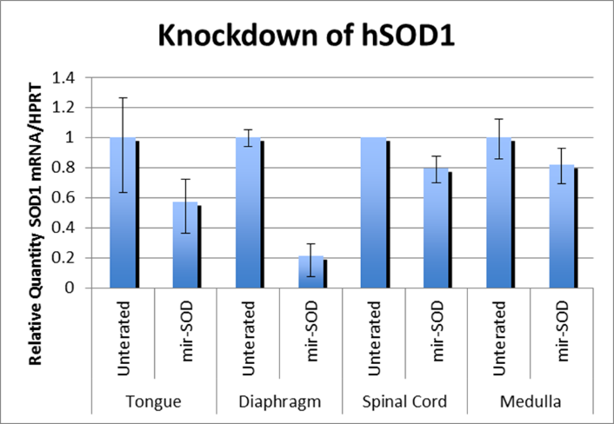

Figure 6. qPCR for knockdown of hSOD1^{G93A}: This histogram shows the level of knockdown of expression of hSOD1^{G93A} in the tongue, diaphragm, spinal cord, and medulla of untreated vs. treated mice.

Histology
Knockdown of hSOD1^{G93A} targeted at the respiratory system was done to increase neuromuscular junction (NMJ) integrity in muscles of the respiratory system and delay paralysis. Immunohistochemistry (IHC) was done to view NMJs in the diaphragm of one endpoint mouse from the NTG, untreated, and treated groups. Figures 7A-E are images from an NTG mouse and are a representative of a healthy NMJ. The red bungarotoxin in figure 7C shows a postsynapse, the green synaptotagmin in figure 7D shows a presynapse, and the gray anti-NFH in figure E shows nerve fibers. There is no fragmentation, degradation, or inflammation in any of these three images. Figure 7A shows colocalization of all three stains and figure 7B shows colocalization of the the presynapse and postsynapse. The colocalization depicts innervation of the NMJ in the NTG mouse diaphragm. Figures 7F-J are images from a treated mouse diaphragm. The postsynapse, presynapse, and fibers in figures 7H-J are fragmented but still present. Colocalization shown in yellow in figures 7F and G means the diaphragm of the treated mouse had innervation maintained through endpoint. Figures 7K-O are images from an untreated mouse diaphragm. Figure 7M shows a fragmented postsynapse, figures 7N and O shows no presence of the presynapse or fibers meaning they were completely degraded at endpoint. The lack of yellow in figures 7K and L indicate the untreated mouse diaphragm was not innervated at endpoint.
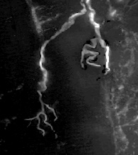
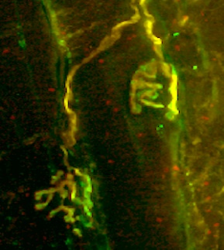
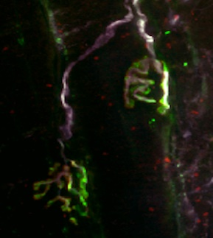
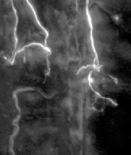
Figure 7. NMJ staining in the diaphragm: These staining images show the integrity of NMJs in diaphragm tissue samples. Panels A-E are from an NTG mouse, F-J are from a treated transgenic mouse, and K-O are from an untreated transgenic mouse. The green stain is presynaptic synaptotagmin. The red stain is postsynaptic bungarotoxin. The gray stain is anti-neurofilament used to show nerve fibers.
synaptotagmin
bungarotoxin
anti-NFH
A
B
C
D
E
F
G
H
I
J
K
L
M
N
O

Onset and Survival
One major symptom of ALS that the IL injection can combat is weight loss; this data was therefore tracked over time and eventually used for onset determination. Figure 8A shows the weekly percent change in weight form date of injection for reach group. The NTG group displayed a steady increase in weight overtime. The untreated mice showed extreme weight loss with one mouse dropping 16.67% below its baseline weight by week 13. All but two treated mice stayed above the baseline weight through week 20. The increased variance in later weeks was caused by a decrease in samples sizes as the mice die. Disease onset was defined as a mouse dropping 10% below its maximum weight without recovery through endpoint. Figure 8B shows a very clear trend of delayed onset in the treated group (green line) relative to the untreated group (red line). Figure 8C shows a clear trend of extended survival in the treated group (green line) relative to the untreated group (red line). There was an average of a 37 day extended survival with a p value of less than 0.05.

A
B
C
Average increase in survival is 37 days p<0.05.

Figure 8. Survival and Onset: Panel A shows the percent change in weight every Wednesday after injection. The red squares are the untreated transgenic mice (SOD1), the green triangles are treated transgenic mice (AAV-mir treated), and the blue triangles are non-transgenic mice (NTG). Panel B and C show the percent onset and percent survival with red for SOD1 mice, green for AAV-mir treated mice, and blue for NTG mice. The treated mice had an average increased survival of 37 days with p<0.05.

DISCUSSION

Gene therapy using AAVrh10-H1-miR^{SOD1} was done to target the respiratory symptoms of ALS in a mouse model expressing hSOD1^{G93A}. IL and IT injections were done at 60 days old to transduce hypoglossal, phrenic, and intercostal motor units. Results from the behavioral analysis performed throughout disease progression showed the therapy delayed paralysis in hind limbs allowing mice to maintain motor function. Plethysmography data tracked ventilation parameters as affected by disease and treatment. The sustained ventilation function in the treated group throughout disease progression demonstrated delayed paralysis of lower respiratory muscles such as the diaphragm and intercostal muscles. Tracking of weight throughout disease progression showed the ability of treated mice to maintain their weight. Their steady weight supported the therapy targeted at upper respiratory muscles, such as the genioglossus, can decrease dysphagia caused by paralysis. RT PCR results showed the ability of the therapy to decrease hSOD1^{G93A} expression in targeted areas such as the tongue and diaphragm. The decreased mutant expression lessens levels of the toxic protein in cells. IHC in the diaphragm showed maintained NMJ innervation through endpoint with treatment. Increased integrity of NMJs ultimately led to delayed disease onset and extended survival by an average of 37 days in the ALS mouse model. These results are consistent with previously done studies at UMass Medical School such as Borel et al. (2015) and Stoica et al. (2016). All three studies showed the ability of⁻ miR^{SOD1} mediated gene therapy to knockdown expression of hSOD1^{G93A} and decrease cell toxicity to prolong survival. This study specifically demonstrated the ability of respiratory targeted therapy in adult mice (with 1/10th the doe given systemically by Borel et al) to delay paralysis progression in targeted muscle groups as well as off target muscle groups in the ALS mouse model.
Future projects to continue this study could be done to increase sample sizes. This project intended to have larger sample sizes but mice were lost at endpoint. Three mice had a low copy numbers of the disease causing mutation, so their previously gathered data was void. Two mice were found dead before they could be sacrificed so the tissue was not harvested and could not be included in molecular or histological studies. There can also be groups ran with the intent of sacrificing all mice on the same day. This would remove age as a variable for all endpoint data.
This project was aim one of a longer study plan. Aim two is the next step and involves treatment of all ALS symptoms, rather than just targeting the respiratory ones. This would be done with the same respiratory targeted injections and a systemic injection using AAV9-H1-miR^{SOD1}. The goal of this study is to further improve respiratory function, improve motor function, and further prolong survival in an ALS mouse model.

BIBLIOGRAPHY

“Amyotrophic Lateral Sclerosis (ALS) Fact Sheet”, NINDS, Publication date 2013. NIH Publication No. 13-916

Agrwal A., and Mabalirajan U. (2016). “Rejuvenating cellular respiration for optimizing respiratory function: targeting mitochondria.” American Journal of Physiology – Lung Cellular and Molecular Physiology., 310(2):103-113.

Borel, F., Gernoux, G., Cardozo, B., Metterville, J. P., Cardozo B., Metterville J., Toro Cabrera G., Song L., Su Q., Gao G., ElMallah M., Brown R., & Mueller, C. (2015). “Therapeutic rAAVrh10 Mediated SOD1 Silencing in Adult SOD1 G93A Mice and Nonhuman Primates.”, Human gene therapy, 27(1):19-31.

Gowanlock D., Tervo R., Hwang B., Viswanathan S., Gaj T., Lavzin M., Ritola K., Lindo S., Michael S., Kuleshova E., Ojala D. (2016). “A designer AAV variant permits efficient retrograde access to projection neurons.” Neuron., 92(2):372-382.

Hatzipetros T., Kidd J., Moreno A., Thompson K., Gill A., Vieira F. “A Quick Phenotypic Neurological Scoring System for Evaluating Disease Progression in the SOD1-G93A Mouse Model of ALS” J Vis Exp; (104): 53257. Published online 2015 Oct 6. doi: 10.3791/53257

Hibiki K., and Manfredi G. (2010). “Import, maturation, and function of SOD1 and its copper chaperone CCS in mitochondrial intermembrane space.” Antioxidants & Redox Signaling, 13(9):1375.
Kinsley, L., & Siddique, T. (2015). “Amyotrophic lateral sclerosis overview.”

Stoica L., Todeasa S., Cabrera G., Salameh J., ElMallah M., Mueller C., Brown R., DPhil, Sena-Esteves M. (2016). “Adeno-associated virus–delivered artificial microRNA extends survival and delays paralysis in an amyotrophic lateral sclerosis mouse model.” Annals of Neurology., 79(4):687-700.

Stoica L., Keeler A., Xiong L., Kalfopoulos M., Desrochers K., Broen RH Jr., Sena-Esteves M., Flotte TR., ElMallah MK. (2017) “Restrictive lung disease in the Cu/Zn superoxide dismutase 1 G93A Amyotrophic Lateral Sclerosis mouse model.” Cell Mol Bio., 56(3):405-408

Zoccolella, S., Beghi, E., Palagano, G., Fraddosio, A., Guerra, V., Samarelli, V., ... & Logroscino, G. (2007). Riluzole and amyotrophic lateral sclerosis survival: a population‐based study in southern Italy. European journal of neurology, 14(3):262-268.

Zundert, B., & Brown, R. H. (2016). “Silencing strategies for therapy of SOD1-mediated ALS.”, Neuroscience Letters. 636:32-93.

