Authors
Victor Agudelo-Ortiz
Devan Beaulac
Alexander Sunde-Brown
Arman Uygur

Advisor
Prof. Frank Hoy

03/23/2014

Abstract
The report being presented explains the process taken by the project group to generate research and recommendations to improve the WPI Projects Website. For this project, suggestions were fielded from Students, Faculty, and Companies to create a more user friendly and aesthetically appealing website while falling in line with WPI’s marketing strategy. The present Projects Website is difficult for students, faculty, and potential sponsors to utilize effectively. The recommendations made by this project aim to repair errors within the page and improve the user experience overall.

Acknowledgements

We would like to take time to thank all of the people who have given us feedback and input on our project. Most notably we would like to thank:
- Frank Hoy - Project Advisor
- Dr. Mark Rice - Vice Provost of WPI
- Sharon Deffley - Director of Corporate Engagement Office
- Dave Ortendahl - Director, Corporate Relations
- Dianne O’Keefe - Marketing Program Manager
- Maureen Deiana - Executive Director of Marketing
- Wendy Beaulac - Web Consultant, Final Site
- The WPI Project Center
- The WPI Marketing Team
These individuals and groups have made invaluable contributions to our project, and were a crucial part of the development of our project.

Table of Contents
Table of Contents
Acknowledgements 1
Executive Summary 2
Introduction 3
1 Literature Review 4
1.1 Web Aesthetics 5
1.2 Sponsoring a Project 6
1.2.1 Sponsoring Process 4
1.2.2 Intellectual Property 4
1.2.3 Cost 4
1.3 MQP Process 4
1.4 Business Mentoring 4
2 Methodology 4
2.1 Revision Process 4
2.1.1 Initial Meeting with Sharon Deffley 4
2.1.2 Communicating With Marketing 4
2.2 Our Initial Round of Suggestions 4
2.3 Meeting with Wendy 4
3 Recommendations 4
3.1 Path Navigations 4
3.1.1 “Projects Main Page” 4
3.1.1.1 Recommendations for the “Projects Main Page” 4
3.1.2 Recommendations for “Resources for Faculty and Students” 4
3.1.3 Consideration for Mobile Devices 4
3.2 Features 4
3.2.1 Programs Page 4
3.2.2 MQP Link 4
3.2.3 Recommendations for the “For Public and Private Partners” Page 4
3.3 Context 4
3.3.1 MQP Link 4
3.3.2 The “For Public and Private Partners” Page 4
3.3.2.1 Recommended Text “For Public and Private Partners” Page 4
3.3.3 Sponsoring a Project 4
3.3.3.1 Recommended Text for “Sponsoring a Project” 4
3.3.4 The “Starting a Project” Page 4
3.3.4.1 Recommended Text for the “Starting a Project” Page 4
4 Conclusion 4
5 Appendix 4
5.1 Consulting Report 4

Chapter 5

Table of Figures

Executive Summary
In a world where more and more of our interactions are becoming web based, a strong and memorable web experience becomes increasingly important. WPI has made its name from its reputation as a university that prepares students for the real world through practical education gained from programs such as the Interactive Qualifying Project ( IQP) and Major Qualifying Project ( MQP). At a university growing at the rate of WPI, more and more sponsors for projects become necessary and the WPI project website does not provide these potential sponsors with a clean, structured, and informative web page. Internally there are also issues with Students and Faculty’s interactions with the website. The site is presently not user friendly nor aesthetically pleasing and this makes it difficult for students and faculty to interact; text blocks are cumbersomely large, navigation is confusing, and some crucial information is out of date. In an effort to rectify these problems, and to both better represent the university and transform the page into the tool that it should be for students, faculty, and prospective corporate partners; this project proposes a redesign.

Introduction
WPI has, since its inception, been a place where technology and real world problem solving meet; defining examples of this “theory and practice” approach to education have long been the Interactive Qualifying Project (IQP) and Major Qualifying Project (MQP). For these projects WPI has always relied on a constant stream of new challenges for its students to work on, many of these coming from companies both large and small to sponsor these challenges. Since WPI created the “WPI Plan” in 1970 requiring IQPs and MQPs to be completed as degree requirements, the university has produced thousands of projects. Simultaneously the student population and majors offered by WPI are constantly growing. While WPI has had constant partners every year to sponsor projects, corporate engagement continues to be important. Strategic partnerships are always beneficial to the university, and more and more students will enroll and need projects to do. What our project focuses on is creating recommendations based on the opinions of the WPI Marketing Department, the Office of Corporate and Professional Development, and the collection of suggestions and observations of students, faculty and companies with regards to their experience with the WPI project website. The Web page being redesigned will be an easy, user-friendly way for businesses to educate themselves about the WPI project based learning programs and how they can get involved. The involvement of businesses is essential to WPI and our group discussed that the page should facilitate this. Our programs web site stands as a main resource to learn about the many ways companies can get involved with hands-on learning projects. The projects companies can sponsor can impact communities that are in need of basic needs and projects that develop new technologies that could impact the future. Currently the web page doesn’t gain the attention of businesses or market opportunities to sponsor a project. The recommendations will ensure that the web page provides clear and helpful information so a business that wants to expand their reach will know exactly how, and what they need to do. The site can be considered a marketing tool for the project program and help Corporate Engagement in the process of developing projects. With this page serving as a main form of communication, our group has the opportunity to help facilitate the relationships between WPI and Public and Private Partners that could further create hands-on learning experiences that impact our community.
For students the site poses many challenges; information is not easy to find, links are broken, and often project sign up on the website does not work. Thus, projects that students want to work on going unfilled because of errors in the system. In addition, some key information (often forms or documents) on the page is entirely wrong or at least out of date.
For faculty, some faculty are so displeased with the site they have started their own IQP/MQP sites that run in parallel to the main site. This creates a fractured information base that prevents the easy updating of documents and key information, and prevents singularity across the WPI Project identity.
With these flaws in perspective, the group has sought to rework, restructure, and reorganize the WPI Projects Website. Our team did proper research such as web aesthetics, the MQP process, and business mentoring to facilitate the process of redesigning. The process of our project started with essential business meetings, we met with Sharon Deffely of Corporate Engagement, to learn more of the process that businesses go through to develop MQP’s with WPI. We went along meeting with marketing as well and a professional to get further information. Our team gained information from surveys that were available to the students and faculty of WPI. Through the surveys and professional advice our group put together detailed recommendations of the page that are shown explicitly in the recommendations portion of the paper. (Here we explicitly went through the flow of the paper)
- Literature Review
  - Web Aesthetics
Web aesthetics is a combination of several fields: photography, typography, HTML coding, and many more. In addition, it is a rapidly changing topic that reacts to the newest technology constantly. As a result, researching it was less about researching what constituted a good website and more about the traits that make a website bad, as these are more established and less volatile.
The first, and most evident, principle of aesthetics is image layout. Most web pages have a balance, with either a focus on symmetry or asymmetry. Some designers recommend splitting a page vertically into thirds, making sure that each third has at least one element in it. It is very important that the designer commits to a layout and doesn't vary too much from it, as page inconsistency can look very unprofessional. This commitment involves keeping image placement limited and their sizes restricted. This insures page doesn't have one giant image on one page and then a similarly placed, but much smaller image on another, making the pages seem unconnected and poorly constructed.
Similarly, the text on a page must be consistently laid out and appealing to the eye. This is even more important than images, as all of the text on the page is there to be read, and having poor layout can lead to the reader skimming over sections of important information. As a result, it is generally good to break up text blocks into manageable chunks, spread out across the three thirds of the page. Research conducted on 232 web users by Jakob Nielsen, of the Nielsen Norman Group, showed that people reading a page do so in an “F” shaped pattern; two horizontal sweeps of the eyes, and one longer vertical one. Thus, the massive block paragraphs tend to get scanned and ignored. Thus, a more summarized, bulleted list is more ideal, as the longer vertical scan can pick up bullet headers and draw more attention to them. Additionally, it is advised to avoid centering key content, as this tends to leave the edges of the page neglected and causes the text to feel cramped.
Not only is the placement of images and text important, the placement and organization of the pages themselves is also critical. It is extremely important to strike a balance between a few, cluttered pages, and too many, mostly empty pages. As was detailed before, text needs to be broken up within the page, but often a better approach is to spread this text out over several pages. This allows for individual pages to focus on a single topic, which allows the reader to more effectively pick what they want to read. The more structured these pages are, the more intuitive it is for a reader to navigate to the information they need. However, this can get out of hand. Subdividing a website into too many subpages results in a confusing and cluttered navigation system. In addition, the reader will often navigate to a page with little to nothing on it, and be forced to go digging through additional pages to get the information they need.
Besides the content in the pages, the design of the pages is equally important. Currently, the popular styles tend towards minimalism, simple menus, and good graphics. However, as previously stated, these styles change frequently and are nearly impossible to predict. Thus, it is much more valuable to understand principles of color and design theory, rather than learning and relearning new styles as they change. The main principles of color theory only apply cursorily, such as picking appropriate complementary colors. However, menu design is incredibly important. Most modern websites are going for more of an application structure to their menus, with tabs for initial division, and drop down menus for increased depth. Menus should be readable and consistent, so that the viewer isn’t confused or frustrated with the interface.
The field of aesthetics is a medley of different fields, both artistic and technical. It is incredibly difficult to predict if a website is going to have excellent design, even using aesthetics. However, there are a few ground rules that can be used to insure that a website is readable, usable, and conveys all the information desired as effectively as possible. Using these ground rules allows a web page to become an effective and professional representation for a company or organization.
  - Sponsoring a Project

As a part of degree requirements, WPI students need to complete usually two 3 – term long projects called IQP and MQP’s. Students can perform their projects in on campus or in a different location – usually a foreign country- with or without a sponsor. Generally MQPs create traction for companies since they generate more technical outcomes which could make a major pivot in the company’s product line. MQPs, which encompass research and development with analysis, synthesis, experiment and theoretical study, are especially appealing for corporations and companies to reduce their cost involved with product development.

The benefits for sponsoring a MQP to the organization include
• Solutions to problems of interest to the sponsor;
• Close sponsor-faculty cooperation;
• A unique opportunity to screen for future technical recruitment;
• Increased professional satisfaction on the part of liaison personnel of the sponsor resulting from participation in the educational process;
• Faculty development with an orientation to the needs of the sponsor.¹
There can be different agreements such as yearly basis, single occasional contracts or on-going agreement with WPI to open a project center, based on sponsors’ needs.

    - Sponsoring Process

Most of time sponsors have to work in conjunction with Office of Corporate Engagement based on the mutual agreement set between faculty member and the company. There are certain criteria that sponsors must fulfill including assigning a project liaison, financial support for the direct cost involved with the project, WPI Project fee if applicable. The Project Liaison needs to be assigned by the company to coordinate students, faculty advisor and company to ensure project progress and possible outcomes meet the requirements and the milestones set by the contract. Direct cost involves mailing, copying, local travel, supplies and other related expenses related to the project. All these unforeseen expenses needs to be authorized by the sponsor however the initial planned expenses needs to be paid directly to WPI. In some cases (mostly WPI related startups), WPI Project Fees can be waived. However corporations and companies need to negotiate with Faculty Advisor and WPI’s Corporate Engagement to determine a viable fee to cover WPI’s cost of operating the project. Once the sponsor agrees to cover expenses and assign a project liaison, they can fill Sponsored Student Project Agreement, Mutual Confidentiality Agreement and Financial Commitment Letter of Intent forms and send them to the Office of Corporate Engagement.

    - Intellectual Property

“When intellectual property is created, it is important that its disclosure be made in a timely manner in order to protect its commercial value and to permit its being made public. To protect intellectual property rights, it is important that inventors be aware of the legal requirements for protecting those rights. The purpose of this document is to set forth WPI's general policies on intellectual property such as inventions, copyrights, trade and service marks, mask works, tangible research, and trade secrets.”
There are certain conditions while determining the ownership of an invention. In this case, for an invention made by student for a sponsored project – MQP - the invention would be owned by WPI which is subject to the initial agreements with the sponsor. However copyright to individual MQP is generally owned by its authors (students), which is also subject to the agreement.
Generally, using the sponsor’s trade secret, tools, and notable consultancy from the project liaison, any development throughout the project will be owned by the sponsor. If a significant contribution by the faculty member or students, there will be a joint ownership of the rights.
    - Cost

WPI generally requests a project fee to provide the support necessary to complete the project. “This fee is generally negotiated to be between $5-15K plus direct expenses, depending on the level of difficulty of the project, and the number of students needed to accomplish the goal.”¹
There is always a negotiation process between the sponsor’s logistics liaison and Project’s Office. The project fee will cover costs associated with operating the program and development activities. In exchange, WPI will provide broad insurance coverage on sponsored project including Voluntary Workers Compensation which insures students for Workers Compensation benefits similar to the College's obligations under State Workers Compensation Laws to its employees, Comprehensive General Liability which covers injuries up to $1,000,000 and property damages up to $1,000,000, and Excess Liability which increases the coverage of liabilities related to sponsored project up to $10,000,000.
  - MQP Process

The Major Qualifying Project (MQP), is a project that is normally taken your senior year of college here at WPI, this project applies students’ knowledge of their major to a project that will give students real-life experience.
Sharon Deffley is the executive director of corporate engagement, dealing with the processes of creating MQPs with companies. Working side by side with her team we learned how they currently are setting up MQPs with WPI. The current process isn’t a cookie cutter as many would think. Each time connecting with a company they have to lay out the basics, sometimes the first conversations are even discussing what the WPI projects are. Then the company would look over the paperwork that WPI has put together. The paperwork consists of a “Sponsored Student Project Agreement”, which is followed by four additional documents, labeled Exhibit A, B, C, and D.
Within the Sponsored Student Project Agreement the company reads through the nine page agreement covering major topics including, the
- Purpose of the Project
- Project Reports and their Publication
- Confidentiality
- Intellectual properties and patentable subject matter
- Invoicing and payment
Exhibit A gives the personal contact information of the sponsor and faculty adviser, the description of the proposed project, the area of study, the desired outcome, as well as the cumulative cost.
Exhibit B covers the project’s budget and financial commitment. The paperwork goes over the project fee, material fee, travel fee, and any other costs it may include.
This form is important so all the parties involved are educated about all terms.
Exhibit C is a student agreement and release which binds the student to the MQP project and all the terms that go along with such responsibility.
Exhibit D is a faculty agreement and release which binds the adviser to the MQP project, similarly to Exhibit C.
All of this paperwork was recently streamlined into these documents by Patricia Lee, Contracting Administrator. Previously there were several long worded documents that companies had to read through.
After the applicable paperwork is out of the way, Sharon can approve the MQP. What the company needs to find is a faculty member as an adviser and students to work on the project. The project would be focused towards certain majors so the department is notified of ideas via email. After they get behind a project they find students from core classes in their disciplines or at MQP fairs.
  - Business Mentoring

Corporate engagement is not limited to only the very large and wealthy companies. Through an improved project website, greater transparency and ease of contacting the University for Project Work will emerge, which could lead to a greater amount of projects from smaller up and coming start-up companies.
The new frontier for WPI is one of start-ups, incubators, and new ventures. A university that has prided itself on creating some of the most coveted engineers for companies has had a new breadth of the spirit of entrepreneurship and innovation. With recent initiatives to “innovate everything” the university has positioned itself as an environment conducive to the young start-up that could be on the verge of the next big thing. WPI is willing to share its resources with these companies which include:
- Network of experienced Faculty and Alumni to serve as Mentors
- Programs that work to grow a start-up such as accelerators and incubators
- Wealth of undergraduate knowledge, and labor
- Vast and varying capital resources including machinery, labs, and other equipment
- Space for a start up to call its own
WPI has been in many ways creating a vast network of alumni entrepreneurs and mentors for up and coming startups that are started by members of the WPI community or employ WPI graduates in an effort to create new avenues and opportunities for graduates and the university. Through meeting with Mark Rice, Vice Provost, we became aware of many of the resources available to WPI founded/affiliated startups. He has assembled a Tech Advisory Network, as well as set up a mentorship program where faculty and experienced entrepreneur alumni can partake and guide younger entrepreneurs through the business world.
On a local level, WPI has also aligned itself with organizations such as Mass Challenge which seeks to promote and empower entrepreneurs through mentorship and financial backing and the WPI Venture Forum which provide funding from angel investors to tech startups.
An obvious need for up and coming startups is space and this is another need that WPI is also conscious of and will be addressing with the repurposing of Alumni Gym. The space will be transformed into an innovation studio for students and this will provide an excellent space for startups to grow, learn and innovate as its features will include:
- A 1,400-square-foot atrium will showcase innovations and achievements of WPI students and alumni with interactive digital displays.
- The old swimming pool will be converted to a robotics laboratory.
- Levels One and Two will serve as maker space for projects of all disciplines, with open-access instrumentation and facilities for rapid 3D prototyping.
- Level Three will include classroom spaces for the Great Problems Seminars (GPS) and a business development incubator to nurture entrepreneurship.
- Level Four will have tech suites with flexible configurations and collaborative workshop space for MQP, IQP, Humanities, and GPS project work.
Between the technical space for technical innovation, and the business development incubator, alumni gym will provide all the necessary resources for innovation to arise.
All of these resources at the disposal of start-ups and the respective project groups, paired with the individual mentorship young entrepreneurs can receive all become selling points making a partnership with the university a worthwhile venture.
- Methodology
The IQP team started with the mission of finding ways to enhance and improve the representation of WPI’s brand with regards to its project offerings. The university is renowned for producing excellent work, both in MQPs and IQPs. However, the WPI projects website does not convey this image effectively. It is wordy, poorly organized, and even sometimes incorrect in its information. Brand identity is huge for a historically small and private institution and thus making an impression on the outside world becomes increasingly important.
WPI integrates project based learning extremely well within its curriculum. With the “theory and practice” approach to education, learning is hands on at WPI and problems tackled by students come from the real world. Real preparation such as this is attractive to organizations both large and small, especially those where research and operational costs are crucial to the future advancement of the organization. Thus, the smaller organizations become a new possible source for projects to become available for students to fulfill their project requirements. This is why emphasizing project based learning is a pivotal part of WPI’s marketing efforts.
The capacity of what WPI students can do is something that has gained a great reputation for the university, and despite this reputation, finding partners for the university to give students projects to work on is an arduous task for the employees of the Office of Corperate and Professional Development. When considering this issue, the team considered the various aspects of sponsoring an MQP at WPI from a sponsor’s perspective: these ranged from the negotiable project fee that negligibly affects endowment, but also the prestige, the branding, a better alumni network and connections that can be generated. After this initial thought, the issues causing low attendance in sponsorship with WPI were studied, and brought to light were the lapses, and at times complete lack of communications within the sponsorship dealings. In addition, the unintuitive presentation of information in the WPI Projects Website is a huge hinderance to the unaccustomed mind of one who has no experience dealing with WPI; this is the largest obstacle which our group hopes to address.
In this phase, the WPI Project Website comes into play. In the world we live in today, as a result of technology; organizations have the opportunity to make an impression on potential students, faculty, and corporate partners and this is all before any mutual contact is even initiated. Digital footprints and presence are as important to generating and fostering relationships and partnerships and thus having a simple and elegant website is important. For example, when a company decides to commission work from technical institutions such as WPI, they would presumably go through WPI’s website for Corporate Sponsorship. From this, they could ideally learn about policies, requirements and expectations beforehand. The easiness of access to information, correlates positively with the first impression of potential sponsor and trustworthiness of corresponding institution. In this fashion, enhancing the user interface and content management of WPI’s Project Website is found to be the main goal that can eventually boost the sponsored projects.
  - Revision Process
To develop changes to the Projects Program web page we started with looking in depth at the web page and all the paths and features. The site had obvious flaws and features that did not function, these went on to become the major areas of concern to be addressed on our list of issues with the site. For further changes we wanted to ensure that we were educated enough on the subject matter to make the changes, and furthermore that these changes and recommendations would be welcomed and considered in order to improve the site.
  - Initial Meeting With Sharon
In the process of implementing these changes, the Major Qualifying Project (MQP) portion was something we wanted to stay focused on, since this project is a staple in the curriculum at WPI. In addition, MQPs tend to attract corporate sponsors more often as their topics more closely resemble projects that a company would be doing internally. This in mind, we contacted Sharon Deffley, the head of the Corporate and Professional Development Department (C&PD). The C&PD oversees the interactions between WPI and the majority of its corporate sponsors, with the exception of long standing or otherwise established partnerships. Everything from legal contracts to budgetary requests is moderated by the employees of the C&PD. During our first meeting, we met with David Ortendahl, Director, Corporate Relations and Sheila Bailey, Marketing and Communications Manager. Between their statements (CITE TO APPENDIX), we were able to identify that the MQP sponsorship process was grossly inefficient. Many incoming companies would spend hours on the phone entering a time consuming back and forth discussion gathering simple information that could much easily be provided online. As a result of such time consuming exchanges with the C&PD addressing these things that could be much more simply conveyed, their projects were delayed or even canceled. In addition, we found other issues in there being a huge amount of miscommunication between the C&PD and the project groups, and in some instances no communication at all. The most worrying of these miscommunications came with regards to budgets; every project group had to quantify their budget through the C&PD, which led to some serious miscalculations. For example, a project working with medical equipment may not have recorded in their initial report that they needed an expensive piece of medical equipment. Halfway through the term, they approach the C&PD and this would mean having to negotiate a new budget with the sponsor, well after the time when they needed the equipment for the completion of their project. Not only are these budgetary concerns an issue for the group and the C&PD, they also send a negative image of WPI, as projects are halted and sometimes left uncompleted as a result of simple misinformation. After these inefficiencies were revealed to us, we wanted to focus on some method of getting information to both the project groups and their sponsors in all stages of the project. To this end, we decided that the WPI Project Website would be our target for reform. We hoped that easier to access information would eliminate the lengthy educational phone calls, and an online repository up to date forms would help with frequently asked questions, and to avoid future miscommunication.
  - Meeting With Marketing

In addition to offering us suggestions for improving the projects page, Sharon also put us in touch with WPI Marketing, who were an invaluable resource for our project. We met with Maureen Deiana, Director of Marketing and Programs and Dianne O’Keefe, Marketing Program Manager. They informed that the WPI website has a very rigid style guide which limited the scope of our suggestions significantly. All of the pages must fit into a “web template” that matches the existing WPI pages. This limited our suggestions, as originally we were going to suggest a total redesign, going so far as to suggest an entirely new navigation system, page layout and text structure. However, once we were informed of our restrictions, we focused our efforts on page counts and content. Marketing requested we give them a short list of our suggestions so that they could transition the site over to the newer template. After providing them with general suggestions, the WPI projects website was transitioned over to the current template, which was an enormous step forward with regards to the readability and presentability of the page. However, much of the content remained completely unchanged, allowing us to focus on the more narrow details of reforming an informational page.
  - Our Initial Round of Suggestions

The original website (Figures 1-8) was rife with issues. First and foremost was the path required just to get to the homepage. The most direct path we were able to find was to go through the “Students” tab on the main WPI website and navigate through there, which is a path that is very unintuitive for a company that is coming to research WPI’s Project Program. Our first suggestion was to make a front facing link on the main page. Beyond the pathing (getting from the WPI main page to the WPI Projects Website), the actual content of the page was extremely cramped. Almost every page had over a dozen lines of dense text that could be easily rewritten into easier to consume more concise information. Some pages had several links, all of which linked to pages containing anywhere between a few paragraphs to several pages of text. Thus, our next several suggestions were targeted at some of these more massive sections of text in an attempt to make the pages more readable. In addition, not only was the content much too dense, some of it was outdated, outright wrong, or lead to a broken form or page where there was no information. The most glaring area in this regard was a section in “Sponsoring a Project”. In this section, there are a half dozen links to important documents such as Student Release Forms, WPI Industrial Property Policy, and a Mutual Confidentiality Agreement. These documents are clearly important to an interested company. However, when clicked on, several of these links would not function or would link to extremely outdated material. This was a clear flaw in the website and was one of the first things we identified when making our suggestions.
  - Meeting with Wendy

We also had many other outlets of research to analyze before making changes. We met with Wendy Beaulac, a Web Developer/Designer that works for Final Site, a company that specializes in creating websites for educational institutions ranging from elementary and high schools to private universities. We had her evaluate the web page acting as if she was a potential corporate sponsor looking to gather more information about projects at WPI. After she had trawled through the website for approximately a half hour, we had her take a survey on her experience. In addition, Wendy gave advice on issues that she thought needed attention:
- Page was difficult to navigate to, even with the use of the search bar
- Too much text on pages, not enough visuals
- Navigation headers were not used enough
Wendy gave us a preview on the web designs she was creating for other schools. She particularly highlighted her company’s use of popular trends such as info graphics and responsive web pages, allowing the page to change formats to best fit any screen (tablet, smart phone, or computer). As someone in the field, Wendy emphasized the importance of content that connects with the user and she stressed that the content could be the best in the world but the layout and media that surrounds it, is ultimately what can support something and make it easier for someone to take in.
Addressing possibly the largest user base of the website was our next step, and this required sending surveys out to the WPI community. We created surveys targeted toward faculty and students asking about the site (APPENDIX 6.1). Our survey was very successful in attracting responses from the student body. In addition, our use of open-ended questions gave us plenty of genuine feedback to help better formulate our recommendations.
Though the WPI Project Program is extremely unique, we also conducted research into other college project websites. We specifically looked at the MIT E-Lab which is focused on entrepreneurship related projects. It was most related to the idea of attracting corporate sponsors, so we took notes on features that we thought would fit well in the existing page. For example, survey based applications for projects, clean navigation, and a memorable user interface. We researched Web aesthetics and learned how the average person views a website, what features attract them and how effective your web page is to them. Some of the major things of note that really turn a person off to navigation of a website are things like a bad content structure, boring content, difficult to read content, and a failure to regularly update and this not only applies to content but also to the web layout used by the site. From looking at the WPI Project website at the beginning of our project, it was guilty of all of these.
Collecting all the information allowed us to build the recommendations portion of the paper, we looked at key things such as navigation, new features, and the context. We went through each individual link discussing the issues and how we like it to change, even what the text should be changed to. This allowed us to formulate a new structure that did not conflict with what WPI’s template, while making the site easier to navigate and more appealing.
- Recommendations
In this chapter, we detail a number of different recommendations for changes to be made on the Website. This changes include Path Navigation, Features and Context.
  - Path Navigation
This section focuses on issues with navigating both to and within the WPI Projects Website. The path necessary to get from the WPI Home Page to the Main Page of the WPI Projects Website is not only long but also unintuitive. In addition, the navigation within the site is extremely confusing, poorly organized, and often redundant. This sections covers our recommendations for rectifying the aforementioned issues, broken down into the individual sections of the website.
    - “Projects Main Page”
One of the biggest issues that our team found with the Projects Programs Web Page was the path someone had to take to navigate to the site from the main WPI website (wpi.edu). The main WPI website is almost certainly the first website seen by anyone interested in anything WPI related, and should serve as a springboard to every other part of the site, with that being said, considering the emphasis and focus placed on “project based learning”, navigation to the project website is very difficult. Currently, to arrive at the projects sub-site from the main WPI website, your navigation path begins by clicking the link “Students”, this is demonstrated in Figure 9.
This thought process is not one that a faculty member, or a company would instinctively navigate toward and as such it makes the flow of information already very difficult because it is not effectively and easily delivered to 2 of the top 3 audiences for the materials. Another issue with the main page is the link that says “CORPORATIONS”, as the link brings companies to a page that covers some aspects of partnering with WPI, but not the resources to inquire about sponsoring a project, or information about student projects.
      - Recommendations for the “Projects Main Page”

Our team recommends that the main page includes a link that catches the attention of students, faculty, and companies and directs them to projects.wpi.edu, this should be done through a tab with a related title such as “Projects Program” that clearly defines what it will lead to, and it can be placed somewhere near the “Students” link. Upon clicking the “Projects Program” tab you should be redirected to this page, Figure 10.

    - Recommendations for “Resources for Faculty and Students”

The link itself reaches out to two different audiences with the same information, so we sugges dividing faculty and students into separate resource links would be easier navigation, or even more organized sub navigation within the side navigation. (See Figure 11.)
An example would be the “Resources for Faculty and Students” dropped down to separate “Students” and “Faculty” sub category then under “Students” would be the categories: starting a project, finishing a project, find available projects, search completed projects. The faculty section would have subcategories such as “Faculty Project Proposal”. Another link could be the sources that are on the advising web page currently.
    - Consideration for Mobile Devices
The websites are not optimized for mobile devices, however, mobile web traffic makes up a large amount of web traffic globally across the internet, but even more so among the present generation of students at WPI. “As of November 2013, web traffic from mobile devices accounted for 28% of ALL web traffic and this was a 67% growth Year over Year (YoY)”
  - Features
This section focuses on suggested features for the WPI Project Website. Primarily, the issues addressed within this section are regarding broken links or out of date content. We also address concerns regarding the projects database, though such suggestions are likely out of the range of possibility, given the current WPI template.
    - Programs Page
We also would suggest an interactive database that allows public and private partners to propose a project through the page, then Sharon and her team can connect with the company and have them sign official paperwork or they can submit them via the website. Then the approved project will automatically be viewable to all faculty, instead the email system they now have.
    - MQP Link

The MQP page is an opportune page for features; currently there is a video of an old MQP, which is a great feature as long as it is updated yearly to different projects to showcase.
    - Recommendations for the “For Public and Private Partners” Page
This page is perfect for info graphics, video testimonial and all these popular features to really market the MQP.
  - Context
This section contains recommendations for the “context” of a page, which includes both the textual content of the page and its placement in the overall organization of the pages as a whole. This section also contains samples of the current page text and our suggestions for what should be displayed on the reworked site. When we display these suggestions, a bold, underlined phrase indicates that line is a header, and any subsequent bold, but not underlined phrases are sub headers.
    - MQP Link

Upon clicking the link for MQP you are introduced to small text that introduces what an MQP is (See Figure 12). This page should be more attractive to the user this page is where they should address the differences between the user type, for example a student, faculty member, or company. The image could be rotating between student testimonials and company testimonials.
We also recommend links that are easy to see in the main body in a bolder font, these links are also available in the side navigation (“Public and Private Partners” and “Resources for Faculty and Students”) but with two locations the user can’t miss them. For the links themselves we also suggest that the language is clearer, for example “Public and Private Partners” should change to “Company Resources”.
(See Figure 12)
    - The “For Public and Private Partners” Page
(See Figure 13)
This page seems overwhelming with text and won’t capture the attention of a viewer for more than a minute. We suggest the use of headers to break apart the info, this way a Company can skim the info and be directed to where they need to be.
So far the page context is as follows:
The Worcester Polytechnic Institute Projects Program offers industrial, private, governmental, and non-profit organizations the opportunity to join us in providing a real-world educational experience for future engineers, scientists, and managers. At the same time, the program provides sponsoring organizations with fresh and creative approaches to problems from university upper class students with advice from WPI faculty. Sponsored projects may be conducted either on- or off-campus.
The program is administered by the WPI Office of Projects Administration, and is overseen by WPI faculty members who participate as project advisors.
Since the beginning of WPI's projects requirement in 1972, thousands of projects have been completed in cooperation with industry and with private and public organizations. In many instances, completed projects have resulted in mutually beneficial relationships that continue year after year. The purpose of WPI's off-campus projects program is to provide an improved system of instruction through pre-professional educational experiences with selected organizations.
Every WPI students completes two significant projects under faculty supervision to qualify for graduation.
The WPI projects program is unique in two ways:
- students are under the supervision of at least one faculty member throughout the project, and
- In order to earn the degree of Bachelor of Science, students must successfully complete two such projects to the satisfaction of the faculty member.
Each project is undertaken by the students usually through the completion of a proposal accompanied by an approximated budget. The mutual agreement of all parties to the scope and cost of the project constitutes a commitment to proceed. Students must submit complete, professional-quality reports to their advisor and sponsor before receiving credit for their projects. They are encouraged to make formal oral presentations at the sponsor's work site. Abstracts of all projects are published and widely circulated annually. Several competitions for best projects of the year are conducted, and outstanding project sponsors are recognized through these WPI publications and at major college events, and at regional and national professional conferences.
      - Recommended Text “For Public and Private Partners” Page
We recommended that the text below replace the current text entirely, as it is more succinct in conveying critical points and is more broken up by the use of headers.
What is an MQP?
The Worcester Polytechnic Institute Projects Program offers organizations the opportunity to join us in providing a real-world educational experience for future engineers, scientists, and managers. At the same time, the program provides sponsoring organizations with fresh and creative approaches to problems from university upper-class students with advice from WPI faculty. Sponsored projects may be conducted either on- or off-campus.
The program is administered by the WPI Office of Projects Administration, and is overseen by WPI faculty members who participate as project advisors.
Background of the Projects Program
Since the beginning of WPI's projects requirement in 1972, thousands of projects have been completed in cooperation with industry and with private and public organizations. In many instances, completed projects have resulted in mutually beneficial relationships that continue year after year. The purpose of WPI's off-campus projects program is to provide an improved system of instruction through pre-professional educational experiences with selected organizations.
Every WPI students completes two significant projects under faculty supervision to qualify for graduation.
The WPI projects program is unique in two ways:
- students are under the supervision of at least one faculty member throughout the project, and
- In order to earn the degree of Bachelor of Science, students must successfully complete two such projects to the satisfaction of the faculty member.
How Does It Work?
Each project is undertaken by the students usually through the completion of a proposal accompanied by an approximated budget. The mutual agreement of all parties to the scope and cost of the project constitutes a commitment to proceed. Students must submit complete, professional-quality reports to their advisor and sponsor before receiving credit for their projects. They are encouraged to make formal oral presentations at the sponsor's work site. Abstracts of all projects are published and widely circulated annually. Several competitions for best projects of the year are conducted, and outstanding project sponsors are recognized through these WPI publications and at major college events, and at regional and national professional conferences.

    - Sponsoring a Project
(see Figure 14)
This page is overwhelming to read. The blocks of text are poorly organized and overly wordy. However, much of the information is critical to a company looking to work with WPI on a project.
      - Recommended Text for “Sponsoring a Project”
This page is filled with info which is scattered throughout the page. The page should read with main points in this order:
- Sponsoring a project
  - Then under should be the question as a header: “Interested in becoming a project sponsor?
  - “Features- benefits-Process-Cost” as well as the link for what every sponsor needs to know should follow.
  - The FAQ should be a separate link to a page dedicated to the FAQs, or a drop down section to show the facts and the answers.
  - Then finish the page with the existing links.
  - We should finish the page with a header to explain the rest of the process, such as: “Your Next step”
In addition, include the existing paragraph that reads:
“If you have not had direct contact with a WPI faculty member already, you can submit a project proposal by writing a description of the project, including objectives and expected outcome. Once received, your proposal will be forwarded to targeted faculty for review, in the hope that one or more will endorse it as appropriate to advertise to our students. If you have already had contact with WPI faculty, it may not be necessary to complete this form.
If you have any questions about any form or document on this page, please call +1-508-831-5635 to speak to Sharon Deffely, Executive Director - Academic and Corporate Development, or send an e-mail to sdeffely@wpi.edu.”
    - The “Starting a Project” Page
This page is meant to show a student how easy it will be to start a project and immediately they are overwhelmed with text. We suggest keeping most of the text but organizing it with headers allowing a user to skim the page, also to alleviate the user and delete non-essential text. The original text can be seen in (Figure 14).
      - Recommended Text for the “Starting a Project” Page
For students, getting started on the right foot with your Humanities & Arts requirement, IQP or MQP is often critically important to a successful and rewarding project experience. Some factors that contribute to a good start are:
- Register early! The IQP and MQP are worth one unit of credit - the equivalent of 3 courses. The project is a central part of every student's course schedule, not an addition to it. Students who work on an IQP or MQP spread over 3 terms register for two courses plus the project activity instead of the usual 3-course full load per term. Registration Forms are now available on the Registrar’s Form Page
- When a Humanities & Arts requirement is completed, the student submits a Completion of Degree Requirement (CDR) form to the faculty advisor in order to have the final grade transmitted to the Projects & Registrar's Office.
  - Learn more about CDR (Drop Down)
- On this form, you will place an abstract description of your project (up to 80 words). That abstract is transcribed onto your transcript along with the project title and grade. The abstract remains a part of your transcript for all time. It will be read by graduate school admissions committees, potential employers and others. You, therefore, should put much thought into selecting your project, and make every effort to complete your project in an excellent manner.
- When an, IQP, or MQP is completed, the student submits online and after advisor approval students print an electronic Completion of Degree Requirement (eCDR) form to give to the faculty advisor in order to have the final grade transmitted to the Projects & Registrar's Office.
Suggestions to students for selecting a project and getting off to a good start in project work
- Examine your project options carefully and completely (Attend the Global Project Opportunities Fair and review the Directory of Available Projects).
- Choose your project partners with care. Be confident that your team will share the work proportionately and that they share your same enthusiasm for the topic of the project.
- Choose your faculty advisor with the same care. With a faculty advisor who proposes a project topic weigh the compatibility you and your team will have with him/her as well. Be comfortable with this relationship right from the start.
- As a first step, with input from your advisor, develop a scope statement, action plan, and budget (if applicable). This may be in the form of a project proposal.
- Discuss the expectations of your advisor (and a sponsor's liaison if there is one) as to the expected end result of the project. (e.g., what is expected to be delivered upon completion of the project) Discuss such matters as frequency of meetings and progress reports. Set up a schedule.
More information on Getting Started
How to Propose Your Own Project
Students are encouraged to propose their own ideas for an IQP or MQP. Follow these suggestions for writing a brief description that you can show to potential faculty project advisors.
How to Write a Project Proposal
This guide details how to structure a proposal for an IQP or MQP. A proposal is usually required if you are seeking financial support for your IQP or MQP.
Handbook for IQP Students and Advisors
This handbook, produced by the Interdisciplinary and Global Studies Division, provides helpful information for all students and faculty participating in IQPs, both on and off-campus.
myWPI Project Site Request Form
You can use the features of myWPI to manage your project, communicate with your group members, and maintain documents pertaining to the project. Use this electronic form to request a group within myWPI.
Project Advisors and Codes
Each faculty member is assigned a two or three letter advising code. What's your advisor's code? Find out here.
Project Topic Codes and Faculty Consultants
MQP's, IQP's, and Sufficiencies have topic codes, indicating the field of study the project involves. Each code has at least one associated faculty member who serves as a consultant for students interested in pursuing a project within that topic area. Find out what topic code your project should be here.
WPI Global Perspective Program
If you are considering going abroad to do a project, look here for a list of project centers and available terms, complete with pictures, deadlines, and cost information for the current academic year.
Confidentiality in Social Science Research
Students intending to conduct individual interviews or a survey of a limited group as the basis for forming opinion related to the subject of an Interactive Qualifying Projects (IQP), either at a global project center or site, or at a domestic location within the United States, is advised to read this statement as a guide for conducting such research, and recognizing some of the related issues.
Human Subjects
Students that undertake projects in which human subjects are involved are advised to read the attached statement as the WPI position on such activities.
Finishing a Project
The approval checklist should be a PDF link. This way you don’t have a web page full of text.

This chapter needs a concluding paragraph.

- Conclusion

Worcester Polytechnic Institute as an institution has focused and prioritized the project based learning approach as a staple of the curriculum that separates and makes the institution unique to other colleges, the projects program however has still failed to garner the exposure and attention needed to have potential partners both public and private to flock to the university.
The web site redesign we have recommended hopes to attract attention from partners as well as make the web site a better platform for students and faculty.
To go about creating recommendations of the site we went through meetings with necessary outlets such as the marketing department and corporate engagement. From our meetings we decided that we would create recommendations that marketing could consider. Meanwhile we researched subjects to help with the process such as web aesthetics, the advising process, the sponsoring process, and business mentoring.
We gathered information from surveys and professionals and created a final list of recommendations that the marketing department can use to help enhance the website. We separated our recommendations into sections of context, navigation, and features. These sections offer advice on minor and major issues, creating new as well as adjusting the old. Within these sections our team decided on advice that would make the page more efficient and user friendly.
This chapter needs to repeat what you state at the beginning is the purpose of your study, giving the why and how and what you accomplished. The preceding paragraphs touch on that. You just need to be more definitive. The paragraph below looks ahead, so it wraps things up appropriately.
In addition to our findings and the changes that have been brought about by them, our team would like to establish that next steps be as follows:
- Continued, regular maintenance of the WPI Projects page to keep a current and relevant website.
- More audits of other WPI sub-sites to ensure a current and consistent brand.
- Ongoing improvement through future student projects, with this project being used as a foundation for yet to be seen improvements.

- Appendix
  - Consulting Report
We suggest:
- Slimmed down large blocks of existing text.
- Break up text with headers.
- More intuitive language for links/headers.
- Simple navigation from WPI main page.
- Organized side bar navigation to trim extraneous pages.
- Make web page resolution adaptive for mobile devices.
- Add more images to break up aesthetic flow.
- Regular upkeep of project listings
- All documents in “For Public and Private Partners” are up to date.
- Info graphics, video testimonials, and images to illustrate benefits of working with WPI.
- For future project groups:
  - More audits of other WPI sub-sites to ensure a current and consistent brand.
  - Ongoing improvement of the WPI project programs website, to stay up to date with current web standards.

- Starting a Project was a page that included a large amount of text. In our revisions we revised the existing text and identified key points. From there, we composed a more succinct block of text that still hit the necessary points. This makes the text both quicker to read and easier to comprehend.

- A specific example of slimming text would be the page “For Public and Private Partners” this page had a large amount of text, in our recommendations we suggest edited text as well as the use of headers.

- Language such as “For Public and Private Partners” is clear to the WPI community, but may not be clear to outside users.

- The projects program page needs it’s own independent link available on the WPI main page, the current path makes it almost impossible to find.

- Recommend that the “Resources for Faculty and students” separate into their own subcategories, filtering the necessary information they both need.
- Create an adaptive web site that forms to the device of the user. Mobile devices are popular and grab a large amount of web traffic.
- The use of images on the “MQP” link would create a better experience for users.
- The web page needs to be updated regularly, when going through pages we noticed the last edit dates of information to be years ago.
- When looking through the site our team found broken, and outdated PDFs that were meant for Public and Private Partners, all documents presented should be up to date and relevant.
- On the page “For Public and Private Partners” we suggest the use of info graphics, video testimonials, or images that create a better experience for users.
- We would like to see a future project group continue with the constant improvement of the project program page.

There should be one appendix here, a consultants’ report. The report should be addressed to your client/sponsor. In the case of this project that could be the Vice Provost and/or Corporate Engagement and/or Marketing/Communication. The first section of the consultants’ report should be one page with bullet points of your recommendations. The second section is all the documentation that justifies your recommendation. In other words, it is what you have currently in these appendices, just adding a paragraph at the beginning explaining what’s here and a paragraph at the end giving the reader(s) yoru conclusions. The third section provides two or three alternatives. If the readers do not agree with your recommendations or if they know something that is in the works here at WPI that you have not been told, they may want to know about an alternative approach. What are other ways besides the website where you could add value to the MQP process? The alternatives don’t need to be more than a paragraph or two. But they should be alternatives. If you could do everything described in the primary report and still do what you include as alternatives, they are not alternatives.
  - Website Images
    - Old Website Images

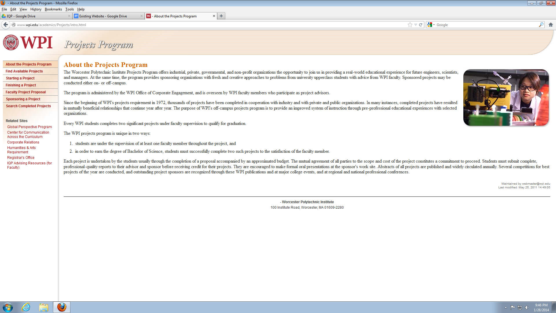
Figure : About the Projects Program

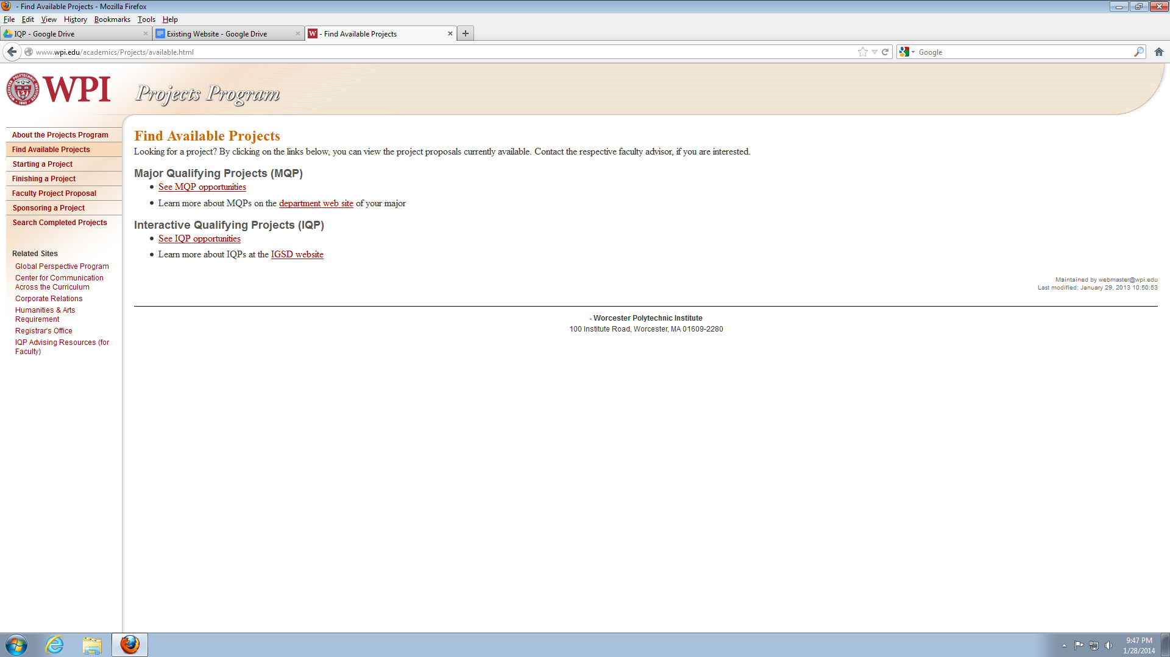
Figure : Find Available Projects
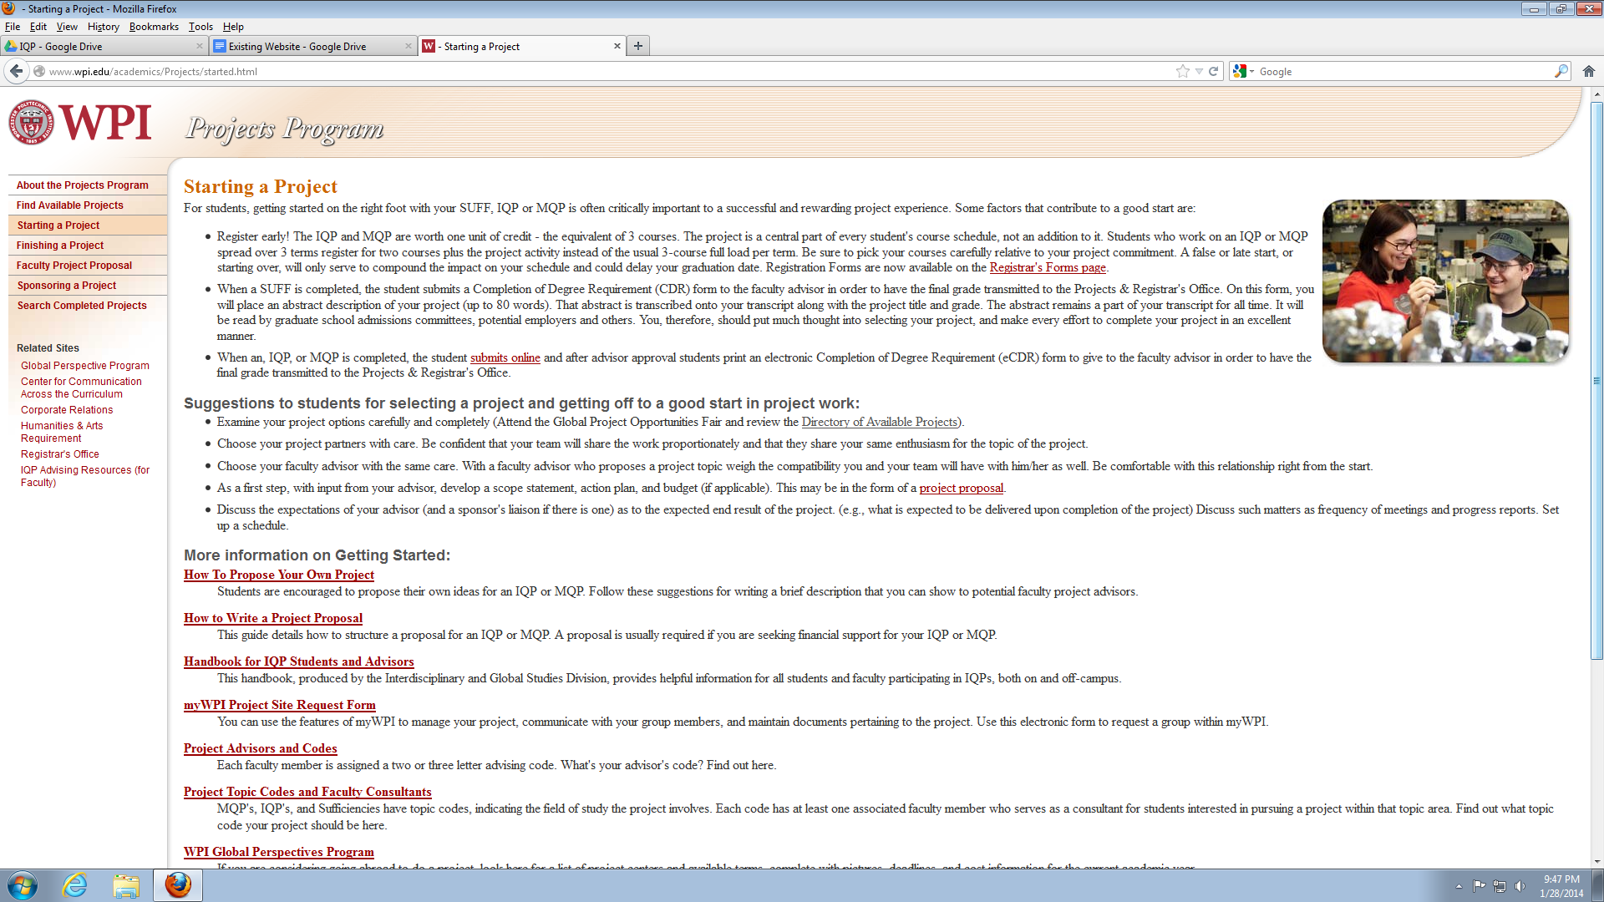
Figure : Starting a Project (Part I)
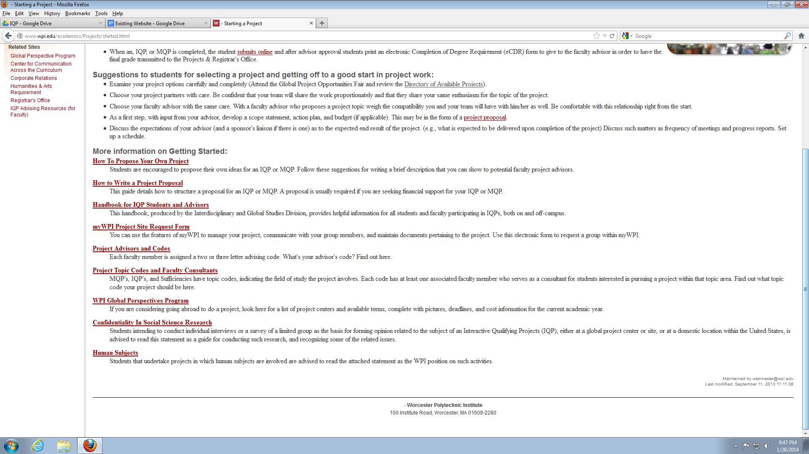
Figure : Starting a Project (Part II)
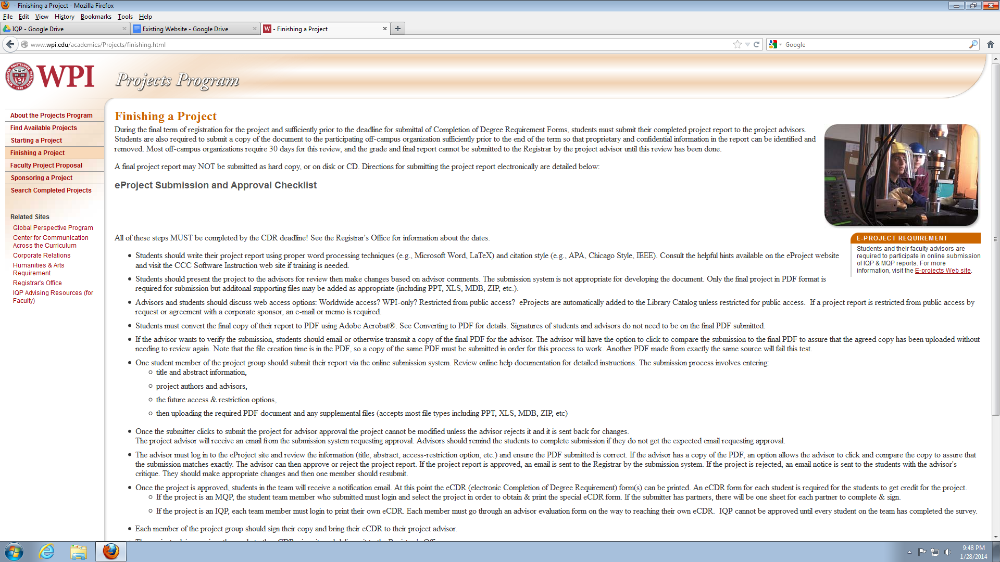
Figure : Finishing a Project (Part I)
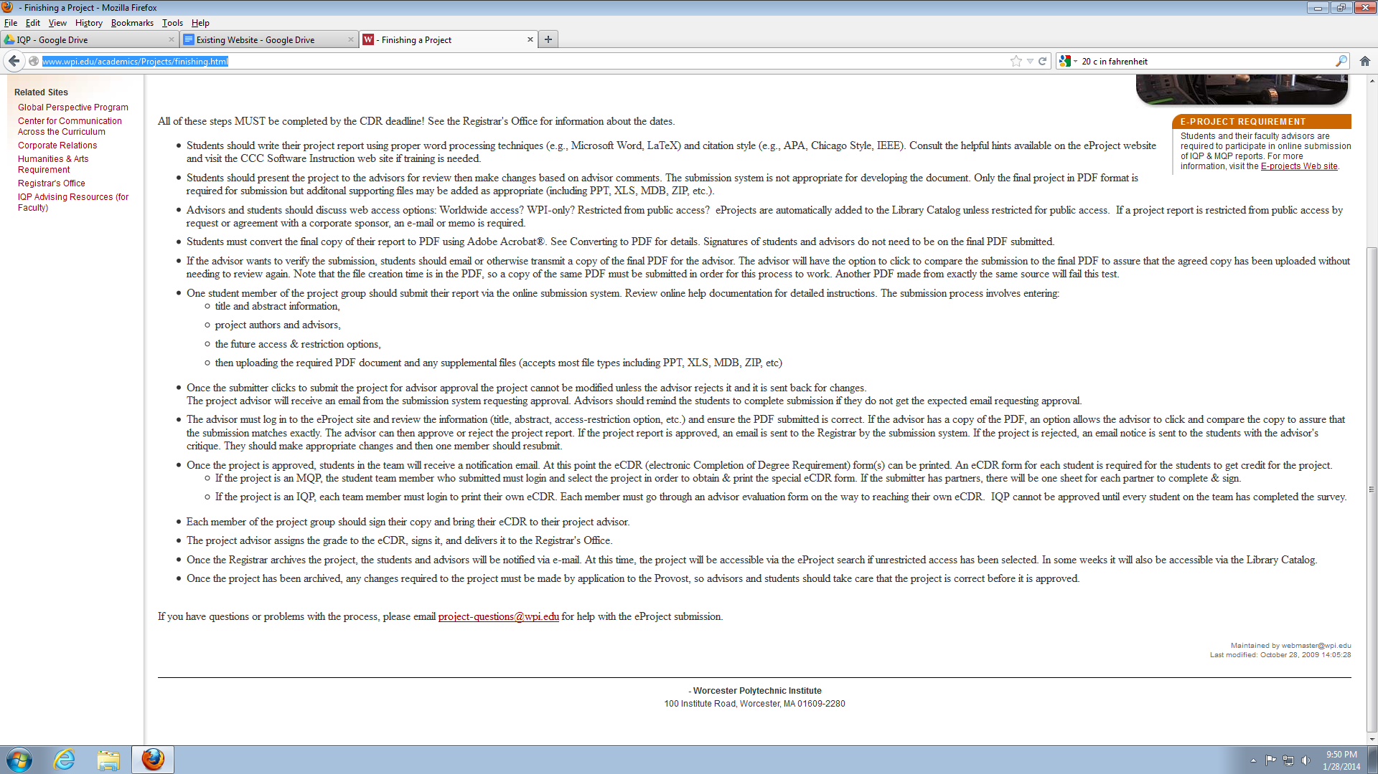
Figure : Finishing a Project (Part II)
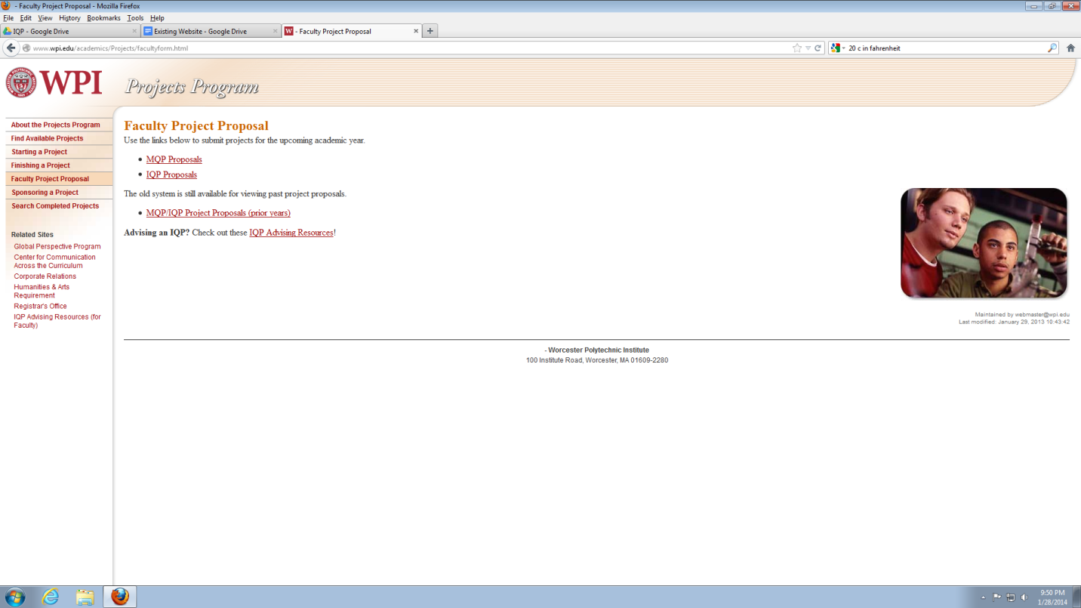
Figure : Faculty Project Proposal
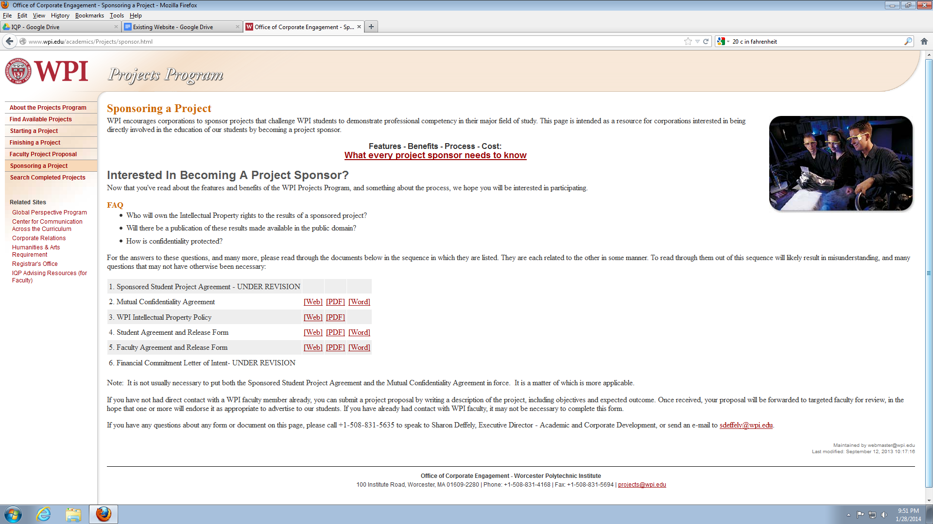
Figure : Sponsoring a Project
    - New Website Images
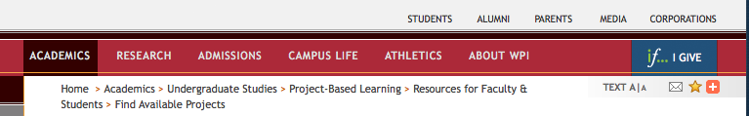
Figure : Main Navigation
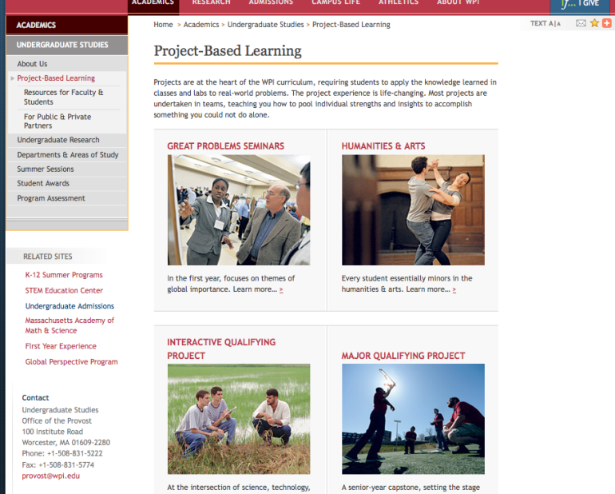
Figure : Project-Based Learning

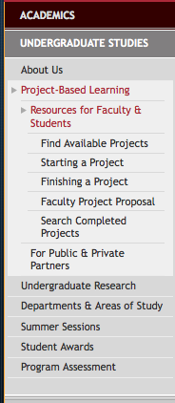
Figure : Side Bar Navigation

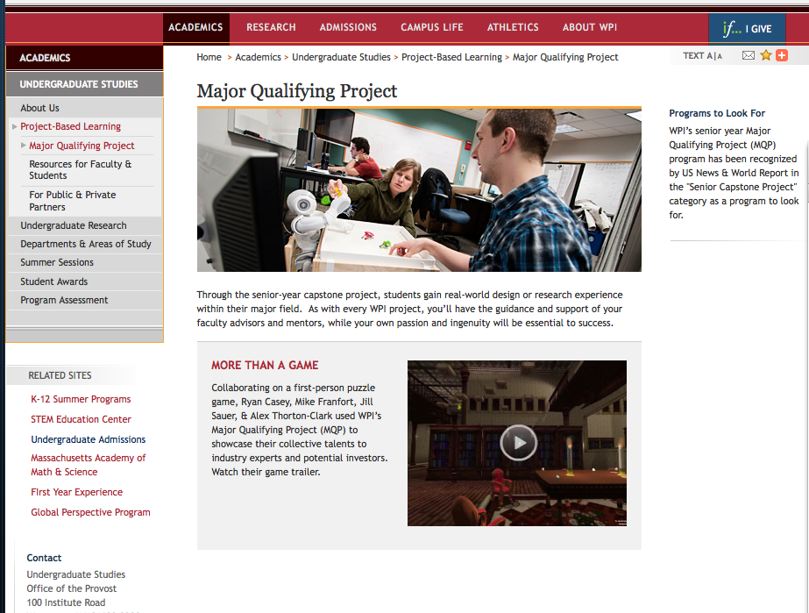
Figure : Major Qualifying Project

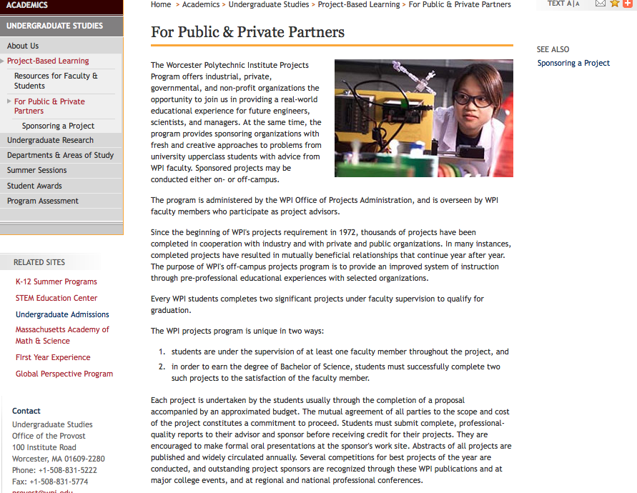
Figure : For Public & Private Partners

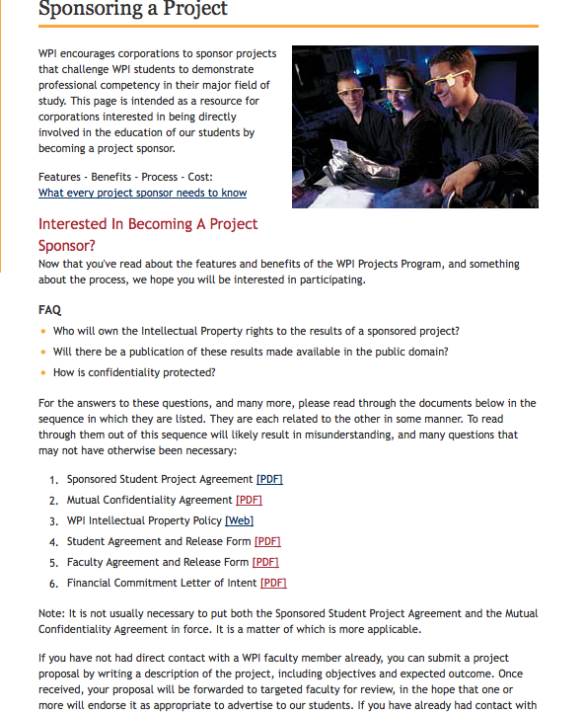
Figure : Sponsoring a Project

  - Faculty Survey
Following questions were asked to faculty:
- How long have you been employed by WPI?
- 0 - 2 years
- 3-5 years
- 5-10 years
- +10 years
- How many MQP or IQP project have you advised? If none enter 0 (zero)

- Have you ever advised a project sponsored by a company (IQP/MQP)? If so how many distinct companies/sponsors? If none, please write 0 (zero)

- Have you ever looked at, or used WPI's Project Website?
LINK: http://www.wpi.edu/academics/ugradstudies/find-projects.html
- Yes
- No
- If you have used the site, please tell us what comments you have about your experience on the site, things you would like to see more/less of, or features you feel the site should have?

- Do you have any suggestions? (In terms of interface, content etc.)
I.e. More Graphics, Less Tabs

    - Faculty Suggestions
Following suggestions were acquired from the faculty:
- “Make the web site more prominent, perhaps on the wpi front page!”
- I make my own site and advertise it to students in my major
- The ECE department maintains its own site for MQP recruiting. We perform the big push for MQP recruiting in the fall of the junior year. At that time, the university web site is still set up for the prior year's recruiting. So, use of the university site has not made much sense for our department.
- Less fanciness, more relevant content.
- Anything posted by professors should expire after 8 months or so, perhaps with an e-mail to that professor (including all the text to be deleted) so that the professor may re-post if this is appropriate. But there are too many dead ends on the site.
- I imagine that both sponsors and students find the system we have a limitation.
- I think that advising on-campus projects is different from advising Project Center
- I like that there are so few graphics. It should be all text, in my opinion!
- I do not use it and changes will make no difference.
- The site looks very internal. It'd be great if companies can have their own interface to suggest projects.
- Some buzz about projects
- Should contain more information or links to more detailed information about the projects and the centers.
- Make provision for students to sign up as teams

    - Faculty’s Challenges/Problems
Following problems were determined by the faculty:
- Works, no big deal, just have to do it.
- Compared with other IT needs on campus, I feel it is good enough as is. It is functional. There are other higher priorities for improvement. Of course it could have better features like the ability to upload graphics or for students to find each other or to post their interest on the site.
- I've used it for registering a few IQPs. We have our own departmental mechanism for dealing with MQPs
- I just checked it out. It looks like it has minimal features needed (search and browse). More faculty should use it because the add feature seems quite easy to use.
- It is confusing to find things. It seems half the site is an old look, while the other half is a new look. It seems incomplete.
- February is too early to have specific projects lined up. I would like to see each faculty member's general interests and past projects listed. Interested students can begin meeting with the potential advisor in February, but a project won't be clearly defined, in many cases, until April or May.
- Finally, note that MOST sponsors of WPI projects are not companies, but rather nonprofits, NGOs, and government agencies.
- I cannot remember clearly, even though 6 of my projects were last term. I do recall that the website has some non-obvious behavior and that I had to search for ways to cause things to happen, not always getting it right. One big irritant was this: The web site offers a way for the faculty member to verify that the PDF is the same one that I previously reviewed. However, was under time pressure, so I took the students' word for it with the intention of reviewing it later. But after click approval, there was no way to access the PDF anymore, so that I could review it after the fact. Another irritant: We often want students to upload supporting material in addition to the PDF report. It seems that this can be done, and one team did it. But there also appear to be no clear instructions that I (as advisor) could provide to other teams on HOW to do it.
- I have to remind myself to update my advertised projects on the site to make sure they are accurate. I like the fact that old projects can be "reactivated" fairly easily to start a new project group.
- Used it years ago, but no longer. Not good for my type of projects. Prefer to recruit students that I know have more interest in a specific topic and whose performance quality is known to me or to others whose evaluative
- It is a good source of information for students. However most of my projects are contacted in a more direct way
- It is very useful to communicate project proposals to the interested students.
- Mostly showed it to students, put one project there once. All in all, haven't used it very much.
- Greater categorization and filtering would be useful.
- Too few faculty post projects. Registration itself is very difficult. One has to know what one is looking for in order to find what you want
- No. Not very useful. We need more than a website; rather, more active Industry-University relationships/coordinators.
- I have used it mainly for IQP Centers, to find out specific details about the terms, advisors, and projects.
- The separate sortability of the Advisor/Co-advisor columns is strange. Would it be not more useful to have a global sorting by advisor names?
- It did not work for me. BME department requires that students work on their MQP in teams. But there is no provision on the web site for students to register as teams. Therefore it becomes very cumbersome for faculty to out together teams from individual students who sign up on the site. Also there is no way for students (that I know of) to provide project preferences. No one in BME uses this web site.
    - Faculty Survey Data
From the faculty survey, the IQP team collected 33 responses. 59% of faculty that answered had more than 10 years’ experience working at WPI. However only 16% of faculty had worked with more than 20 companies. Most faculty advised less than 50 IQP and MQP projects combined.

Figure : Faculty Experience Demographics

Figure : Each Faculty’s distinct company sponsors

Figure : Faculty’s total projects
  - Undergraduate Student Survey
Following questions were asked to undergraduate student body:
- What year are you?
- Freshman
- Sophomore
- Junior
- Senior
- Have you done your IQP or MQP?
- Yes
- No
- Have you ever used WPI's Project Website?
LINK: http://www.wpi.edu/academics/ugradstudies/find-projects.html
- Yes
- No
- If so, what are the challenges you have faced?

- Would you recommend using Project's Website to a friend?
- Yes
- No
- Do you have any suggestions?

    - Undergraduate Student Suggestions
Following suggestions were acquired from the students:
- Maybe have professors introduce this to students earlier?
- List applicable concentrations.
- Have more MQP's there.
- It might be useful to color-code the statuses so that students can see available projects at a glance.
- Be able to sort by different categories
- Let students submit project ideas to get student-suggested MQPs on the site.
- Increase awareness of the page
- The projects need to be presented in an organized way.
- talk to professors you are friends with to get the good IQP/MQP's
- easier access
- Perhaps a better organization of programs, and better search features
- Don't use the website, just sack up and talk to the professor you want to work with.
- Simply finding the website could be easier - e.g. if we could just type wpi.edu/+projects.
- Keep it updated. Have the professor adviser's email right next to the project.
- Make a way to filter them by major and time they are for.
- Organize by project interests.... Some of those offered by department might have the opportunity for collaboration among majors.
- It would be nice if the MQPs and projects listed for the current year were taken down from the site as they reach closed status, or at least make the projects searchable by year.
- don't have ones up that you can't apply for
- LIVE updates when professors post new projects( by major)
- Make the site better known. Didn't know this existed
- Improve the UI by making it more user friendly by making the website a bit faster and making things easier to find.
- Increase communication between professors and students in individual departments about how to find an MQP and how the process of this works.
- It would be nice to be able to compare and contrast the projects side by side or print out pages easily (pdf download or something) past projects, links to featured papers. Past presidents awards and testimonials.
- Make updates easier for advisers.
- That this website needs to be better marketed and students/sponsors who ever should be notified of its existence.
- Rearrange everything
- make it use html5 and css3 and not look like crap
- Haven't used the site really, mostly because I had other ways of getting my IQP scheduled. That said, the appearance of the site could be a little less ugly and dump a little less text. That would make me more likely to use it.
- Maybe have something like the library does with the live chat box thing.
- Keep information relevant.
- Clean it up. Make it more intuitive to use and more user-friendly rather than the easiest code possible. Websites are about user-friendliness not coder-friendliness.
- Make everything clear or like how the international project are listed.
- If you get professors to promote it, students will look
- Recommended for proposed IQPs not for MQPs.
- I think it needs to be advertised more. I also think that professors need to take off past projects.
- Publicize the website and the purpose of the website better, as I have never heard of it.
- Send out email notifications to students of actions that need to be taken and their
- update the page every year
- Options and tools are always good to have, even if they aren’t used much. I never looked at this website but I’m sure it could be useful.
- Talk with professors and create your own MQP/IQP rather than take one offered by professors. You will find more enjoyment out of the projects and will be willing to invest more into the project
- Make it more visible and easy to find links to.
- Marketing and better define need
- Make it more clear it is kind of confusing
- Better publicity - never heard of it before.
- More links to already completed projects (examples for the new comers)
- better organize site
- There should be a system to coordinate MQP-groups together. Have students, advisors, and sponsors all use one system where MQPs are listed.
- I think that most of the problems could be resolved by the project site becoming more universally used. I found my IQP through a professor and MQP through my department (they ensure everyone has a project). Especially for the IQP, I think that having an online system would be extremely beneficial.
- I haven't use the website yet. But, by checking it right now, I can clearly see that the MQP list lacks detailed information. Also, informative visuals would be nice to have.
- Improve site navigation so that I know exactly what I need to click to get the information I went on the website for.
- I've never heard of that site
- Let it be more well know and easy to access. I've never heard of it and I have no idea where to look
- Make the locations of important things in more obvious places like the application
- more advertising about the link, never even used it
- Make sure the professors actually respond to the students and vice versa.
- I didn't know the page existed and I am a senior!
- Make it easier to find the webpage. Do not hide it under so many layers.
- Organize projects by major and have a page where you pick what major you are in and then there is the list of projects.
- I might suggest using it as a way to get ideas for projects. But I think the best option is to go to advisors/professors and ask what kinds of projects they have available.
- Have all students present their MQP to a council beforehand and the council then determines how much money out of a budget to give each MQP. If an MQP is not building anything they do not need a budget. Teams that are collaborating with other companies or schools should have a high budget to better represent WPI.
- Add a section for students to form their own MQPs.
- The site is alright, but it is not capable in using other software and programs seamlessly to present projects in a creative and professional manner. I'm really hoping that future versions of the site will be more multilateral.
- Expand the link from the home website to see all needed links with Projects, Upcoming important events, networks and setup your wireless connect into your devices, and etc... Overall home website could reconstruction to be able to use without instructions to find a link your looking as for new students prospective coming to WPI
- Better organization.
- Reorganize and provide more links on main pages also have it come up in a google search
- Make a cleaner, simpler interface and allow more user input to find interesting projects or submit ideas
- Make information and especially browsing (like seeing a list of all the IQPs without the MQPs and vice versa, for example) more accessible and intuitive.
- suggest more professors to post their projects to the web
- Better advertisement of the site. Perhaps putting it on the wpi.edu homepage in a way that is visible
- I would suggest advertising the project site more so it is better known on campus.
- More searchable
- Much of the material can be scattered and not logically organized. Maybe a more user friendly set-up
- Make it easier to navigate
- I would only suggest it out of necessity to research possible MQPs. It isn't very helpful
- Make it easier to find the list of global locations, and make it easier to find each location's project website.
- Get more professors to use the website so that it becomes a more standard thing.
- make it more accessible and better directions, placement, and processing
    - Undergraduate Student’s Challenges
Following problems were determined by the students:
- I was not aware of it.
- Don't know what they are, didn't use it, I've just heard it no good.
- Difficult to navigate
- Projects list majors, but not necessarily applicable concentrations within the majors.
- Not many MPQ's there. What major people are should be the first thing asked. Also what about people that have two majors?
- Sorting through the projects
- Last year I tried clicking on a link for my IQP and it said the project was full. When I asked the professor about it he said he had never received a single sign up for it. I don't know if that was fixed this year or not.
- The font and look of the site does not look appealing. Everything is too clustered.
- How to find my profile and send in my information while applying to IQP sites.
- Vague descriptions and difficult to navigate. Could be more user friendly. Only recommend because has needed info.
- Most projects available weren't listed. The ones that were listed were not up to date.
- Simply finding the website could be easier - e.g. if we could just type wpi.edu/+projects. otherwise I haven’t had to have much interaction with the website because I applied for an off-campus IQP so I used the global perspective program website mostly
- Only certain departments posting their MQP's, the advisor not delineating if they are still recruiting or not (frequently it is already closed)
- Searching for current ones.
- Was a lot of projects for the past year
- Wasn't sure how to actually apply to project
- Finding an E-term project
- most of the projects are not updated
- Searching through is difficult because of the limited choice of search filters.
- Search function
- no updates when new projects are posted-->projects you want fill up before you see them
- Project list not updated and many outdated projects still listed.
- The website is very slow and lagging in general. The interface isn't very user friendly and it is hard to find where things are located or how to access them.
- a little challenging to navigate, takes longer than desired
- very old web-formatting, not high-tech or informative, bad display of info
- It wasn't laid out well, much of the information is out dated, things are confusing to find again. I felt like I was just poking around in tide pool looking under rocks but not finding anything I was looking for.
- The projects are not up to date- there are many old projects, and this makes it difficult to find projects for my upcoming junior year.
- I didn't know it existed.
- Project availability was not updated, so I would waste time applying to projects that were closed, but still proclaimed themselves as open online.
- Nothing, I didn't even know it existed.
- It is impossible to find anything you’re looking for, things are poorly organized and categorized
- My eyes aren't adapted to websites from 1992.
- The search doesn't work too well. Slightly confusing without being told what to look for.
- Not hearing back from professors after e-mailing them
- Not up-to-date in terms of the IQP page.
- The website is disorganized and hard to navigate.
- It should be clear cut in letting students know about the availability of projects
- I don't think professors care enough to post there, so I didn't look
- As a chemistry major searching for MQPs is nearly impossible. Professor do not even post on it. It is a nice tool on the other hand for searching for faculty proposed IQPs.
- It’s better than it used to be. I'd say the biggest challenge currently is how difficult it is to find the page unless you already have the URL.
- It’s easy to forget to check year range on projects so you can get really excited about a project that has already passed because it hasn’t been taken down yet.
- Lack of notification
- finding projects that are still being offered
- Difficult interface
- Very hard to find and navigate.
- I didn't use it because I didn't know it existed. I also didn't feel a need for such a site because I applied to go away for IQP and spoke with a professor to find an MQP. Marketing and Need
- Getting to this page
- overwhelming information
- It's not very clear where things are listed. It's hard to navigate. It's also not clear if you can sign-up for projects from this site.
- I haven't use the website yet. But by checking it right now, I can clearly see that the MQP list lacks detailed information. Also, informative visuals would be nice.
- Finding the information I went onto the website for is challenging.
- It's hard to find an MQP site abroad that fits for each major.
- It sucks! It freezes and never works properly.
- I was confused about how the site was set up to even apply for IQP.
- The IQP's are not listed by Term away making factoring them into a potential schedule more laborious. Also the MQP section is just confusing…
- could be better organized so it is easier to find projects
- Navigation is weird I’m not always sure of where to go to find information.
- Some professors don't email you back.
- Clunky interface.
- Missing information, difficult to navigate
- It was impossible to find via the search box on the WPI website, but 5 or more different Google searches got me there.
- I find the long list of projects overwhelming
- Time consuming work, lots of essays
- WPI's project site is a bit limited in the types of features available to students. Designing a web page specifically for a project can be tedious and difficult when trying to make something stand out compared to projects that just use what is available. My IQP project team had to rewrite code on the site just to try and re-design our homepage to improve the presentation of our project.
- I found it user friendly, just finding where to log on initially was confusing.
- Not understanding the criteria and objects of the projects goals to be accomplished. I do understand students make their goals, but not don't always know the graders expectations in the project. Also the link is barred with other links from the home website to find this one (could be more user friendly).
- Meeting with my partners
- Not always up-to-date. Not all professors seem to use it.
- Hard to navigate and find application page
- Difficult to list only available projects, cannot submit potential project ideas to connect with other students, inconsistent formatting
- I had trouble finding this page.
- There are old projects from previous years still listed.
- As an MGE major with a BME concentration, it was difficult to determine which projects I qualified for.
- Searching, availability of information--it isn't intuitive.
- too few projects listed
- Not all MQP's are shown there. Aerospace engineering has its own website for AE related MQP's.
- Narrowing down to a particular term.
- Difficult to navigate
- It is difficult to navigate and I wish it showed upcoming projects.
- Teradata is a little bit non-intuitive. I would change how some of it is laid out
- It's difficult to find the global project sites. It should be really easy to see where the different locations for IQP are.
- Unclear how to carry out certain less common but probable tasks
- Contacting professors after finding a project online.
- Very hard to navigate. Not very intuitive.
- None, just looked up the different places to go

    - Student Survey Data

From the student survey, the IQP team collected 362 responses, 20% of students were seniors and 28% of students were juniors who are the main target of the IQP team. Among students responding to the survey, only 43% had IQP or MQP experience, 35% of students used the WPI Project’s website but 60% of them recommended the website. Even though if we assume all 35% who used the website had positive impression, the 25% difference clearly indicates the student’s trust on WPI’s resources. Afterwards, IQP team filtered the data to get more accurate results based on student’s previous experience with IQP or MQP. Among all these who have finished either IQP or MQP, 81% used the Project’s website, however, 72% of this 81% students who used the website recommend using the website. This means, students trust in WPI’s project website’s functionality without using it, but after interacting with the site, some of them change their minds. This proves the deficiency of providing the right material in the optimum way, and marketability of resources, which Marketing and Communications team should be focus on.

Figure : Student Class Demographics

Figure : Students who finished IQP or MQP

Figure : Students who used the Project’s Website

Figure : Students who recommends using Projects Website

Figure : Correlation between students and website usage

Figure : Feedback from students for Projects Website

  - A Sample Transcription of Meeting with Corporate Engagement Team
Below shows the first 15 minute transcription of IQP team’s meeting with Corporate Engagement team:
Sharon: My name is Sharon Deffley. I am the director of Academic and Corporate Development and we met with Devan and Alex on the 19th. We kind of get some overview of what you folks are doing. There are 4 members of MQP team and they are all new to the MQP team. So I am overseeing it. David is the associate director of career development center and this is the gentleman that you should be best friends with to get a job. So David is basically part of the front end customer service piece so when opportunities for MQPs come in whereas from student, a company, a faculty member, an alum, we kind of trying to filter them, we kind of doing upfront work to make sure and we start the process. Patricia came on board in 3 months ago, she is a lawyer for state of Massachusetts but she is not acting as legal counsel for the university, she is acting as an our contracting administrator so the minute there is an MQP and a faculty advisor, Patricia takes over and the stuff, so all negotiations which are quite intense as far as making sure all the equipment are in place, everybody is right to be protected, there is no questions afterwards about IP and you have to give up all your children because you signing on forms so she make sure everything is all set. And then Sheila who is not here is our operations manager, she handles all the paperwork, all the billing, receiving, all that type of staff. So we took all these MQP process in pieces in May, and tried to develop a process that is more comprehensive, more user friendly, easier to deal with from the point of company and faculty and stuff. From the feedback that we have received, from companies and faculties, it is so much easier now so. We are trying make this as simple as possible. So we would like to hear your updates from our last meeting.
Devan: Last meeting we got together and we were just really focusing on how we could kind of work along with you guys really help you streamline the process without cutting into anyone's job and the stuff like that. So we figured that the best way to kind of do that was to go along with the projects website which is kind of mess.
Sharon: It is coming down!
Devan: Because when we are on it before we met, we were trying to figure out just anything and I was just going through the website and it was just really hard and messy. So we all went together and followed such like in comparing with other project websites for other schools similar like. This could be so much better, we really looked into it and we could set with far different things to separate it by like students perspective, by company's perceptive, faculties perspective and we got together, we wrote like a little bit … like a proposal that we wanted to do and then we bullet pointed a lot of issues with the website.
David: How many pages is this?
Devan: And we thought that you guys obviously had headaches over this website and we were thinking that this could just cut out the a lot of initials, you know when you get the companies sometimes they don't know anything about the projects program. So this was that unfriendly, this could cut out a lot of first conversations of that, it could decrease that time and so they know what exactly they will get themselves into.
Sharon: Okay, and could you introduce yourselves, we haven't met you officially.
Arman: Okay, I am Arman Uygur. I am a senior right now and I’m doing my MQP and IQP together. Last year I had an IQP but I thought that having an IQP with business school would be better so I dropped last years. I am mechanical engineer and I will be graduating in May.
Victor: I am Victor Agudelo, I am a management engineering major, junior.
Sharon: Where are you folks from?
Victor: I am from Worcester
Sharon: Oh so you have a bad, do you?
Victor: Yeah, you know it is though! I don’t always make home for holidays, do my best
Arman: I am from Turkey. I will be going back to Turkey this winter.
Sharon: Oh okay, do you have job lined up yet?
Arman: I have almost 3 offers, but I'm having interviews as well so.
Sharon: Do you use CDC?
Arman: Yes, I used job finder.
Dave: Familiar face.
Sharon: I just want to give you a little bit of background just so you can understand what happening in website. Academic and Corporate development the division that we work in is comprised of 3 pieces. So the first piece is corporate and professional education and their place is upstairs, on the second floor of this building. It is about 42 people working at that particular group and they are responsible for all of the training programs, the nontraditional training programs that are run by university online, other graduate certificate degrees at companies. So the corporate means that we are doing something with companies. Companies sponsoring master’s degree, MBA, master’s degree in systems engineering, master’s degree in any kind. So companies will allow us to go onsite, sometimes it is bonded, some of the courses they don’t face to face with the professor. actually both of the company on Friday afternoon, Saturday afternoon, whenever company wants it and they actually pay for the employees to be upgraded , get a master’s degree and hopefully retain them. We also do a group of technical sharp courses on any subject that any company wants to do. They do a lot of training programs, professional development training programs, there are project management, lean, and all the improvement things like that. We also as a part of corporate professional education, our bio manufacturing education and training center which is located in Gateway Park II which is 50 Prescott St., is a brand new facility that is dedicated to training and educating folks in life sciences. We have a beautiful hands on training center and it is absolutely gorgeous. Companies are sending and coming us, again go on and use the facility to train. We also run health care delivery institute which is an institute on campus that basically looks that delivering and monitoring and tracking health care services outside of hospital and clinics. If you ever at home and you know you are diabetic or something. You can use your mobile phone to take things and send them to your doctors and staff and track it rather than meeting them again. So it is all kinds of issues how to deliver health care outside of hospital and clinics. The second piece of division is David's office which is the career development center, it is about ten folks, I think everybody knows what CDC does but you know they are responsible for obviously you look at the corporate piece again but you know the companies, corporations coming to WPI to hire students, there wouldn't be no jobs so. The third of part academic and corporate development is the office of corporate engagement, it is to help companies navigate through university to help develop partnerships and relationships so when a company looks at WPI, they look at it as an opportunity to do a lot of things not just a side load approach. That is only about two years old. So corporate development 3 years old and CDC came under this division last year so it is relatively new. Part of the decision that is made by senior administration was that when companies are involved and MQPs and now GQPs which is long story, that needs to have an office to oversee it because what was happening before, faculty and students were signing off the contracts on behalf of university and they are not authorized signatories. So they put themselves at risk, students at risk, and companies at risk and university at risk. So about a year and half ago, the administration decided that the office of corporate engagement to just oversee the corporate sponsored MQPs so everybody has to do an MQP and majority are not cooperate sponsored. We would like to see more corporate sponsors however that needs a lot of supply into management and we need to make sure we have the right students on the right projects so. This office is relatively new, we just took the ownership of it as a team, at the end of May to develop the process. The website has not been touch since the previous people who were running it and there has been discussion on high level that we have to develop in entire academic and corporate development website that makes more sense. So any help that we can get as far as making it... it will be iterative approach I will see that we started making some recommended changes and then it eventually kind of morphine into something much different than it looks simply because we are still developing the process and we are finding out that there is a lot of redundancies and steps that really don’t need to be done. All of the documents need to be taken down because Patricia has so revised. I think we gave you several of those. Those documents are so revised, the agreement and attachments to make them much more user friendly and easier for folks to use. And it is going to take a good year to kind of work on all the kinks so if you are looking from a fresh perspective and especially from the students perspective trying to explain it to folks, you know I think any other suggestions going to be helpful to be there. So, looking at the website, did you shift your sort of goal or focus of IQP to now the website, as oppose to partnering with Dean Rice.
Arman: Yes.
Sharon: Okay. Certainly it could be... and that could be run with Frank right?
Devan: Yes
Sharon: Okay I just wanted to make sure
Arman: We are wondering that who is maintaining the website, do you know anyone so we can talk to him or her.
Devan: He was just asking whomever had the website before?
Sharon: Basically we have to go through marketing and communications. They assign representatives from their office. So they are on the 3rd floor Boynton, there is probably about 40 people or something up there. They do marketing, communications and so that office has been shifting too. They had some changes and personnel, assignments. Right now we don't have a dedicated person focused on academic and corporate website. Corporate and professional education which is the bigger parent of the division has their own marketing group but they still have to go through marketing and communications. I know Dave's group CDC is working with their contract person, he's been assigned to CDC. He is in process of updating their whole website too. We don't have a dedicated person yet because our vice president hasn't decided what he wants. The vision of the division's works, so there is no one person in particular however I can certainly call and let them know what is going on. We sat with Marlin I think and…
Dave: When it comes to content, I, you look at the content owners who really be the MQP team in terms of developing the content. As you start to upload into , right now the website is in old format, but actually the second oldest format, so I think part of division's at least I heard from marketing is that anything is that corporate facing would be upgraded to the new template of the website. So you know you have the new template framework coming in but I feel is when it comes to content that is, at least for my perspective, that is a little bit more of blank but that is something that marketing isn't necessarily going to tell us what the content is.
Sharon: So how would you approach this, since you are doing this in CDC?
Dave: Well one of the things that as we are working on the CDC website is we are defining what is important. Then, essentially evaluate when we presenting well some of the best practices might be this or user friendliness or maybe just challenge something just to make sure that we are in firm ground and yeah this is what we want to be or we should take a different look into that. But in CDC we control the raw content.
Devan: For the CDC website, are you guys focusing both directions in students and companies?
Dave: Yes, in fact what you will see is there will be three landing pages, there will be students, there will be alumni and then there will be essentially hire WPI and then there will be a separate break out. It will look in field more in direction of under the academic and corporate development umbrella for my understanding and main page of CDC is really going to be a student focused. We should roll that out in a few months.

http://www.webcredible.co.uk/user-friendly-resources/web-credibility/website-design.shtml
http://alistapart.com/article/the-web-aesthetic
http://www.shire.net/learnwebdesign/aesthetics.htm
http://www.nngroup.com/articles/f-shaped-pattern-reading-web-content/
https://www.wpi.edu/academics/Projects/information.html
http://www.wpi.edu/offices/policies/intell.html
http://bgr.com/2013/11/08/mobile-devices-internet-traffic-q3-2013/

