Study of Workforce Development at WPI/QCC Lab for Education ​ and Application Prototypes (LEAP) in Central MA ​
-- Its Role on Silicon Photonics and Electronics Industries in New England​

Authors: Donald Coley¹, Ashley DeFrancesco²
Advisor: Yuxiang Liu²
¹Chemical Engineering, Worcester Polytechnic Institute, Worcester MA
²Mechanical Engineering, Worcester Polytechnic Institute, Worcester, MA
March 24, 2020

Abstract
As one of the initiatives of Manufacturing USA, American Institute of Manufacturing (AIM) Photonics aims to accelerate the technology transition of integrated photonics from research labs to industrial deployment. Funded by the MA state, the WPI/QCC Lab for Education & Application Prototypes (LEAP) was established in Worcester, MA in 2018 and is an affiliate of AIM Photonics. LEAP aims to establish an ecosystem with academia, industry, and government to boost the adaptation of integrated photonics in Central Massachusetts. LEAP will provide user facilities, training opportunities, and expertise to prepare for and leverage the next technological advancements in photonics. One major role of LEAP is to enhance workforce development in photonics. However, the needs, existing resources, and the gaps in the local ecosystem are poorly understood, making the LEAP roadmap planning difficult.

This work will investigate the existing educational resources on integrated photonics and the current needs in the ecosystem in central Massachusetts. The student team conducted surveys and interviews on the campus of Quinsigamond Community College (QCC, Worcester, MA) which provided profound knowledge of the needs, current status, and gaps that can be present between the expectations of the industry and resources in schools, including two-year community colleges and four-year universities in central MA. The outcomes of this study will guide the student investigators into understanding the roles of LEAP in order to close the gap and further provide suggestions for LEAP. This work will help establish a workforce development hub in central MA and provide the needed educational resources for the photonics industry, and eventually benefit the whole society.

Chapter 1 Introduction
In recent years, Integrated Photonics had countless hours alongside huge grants poured into this field of research. One grant, through the aid of Massachusetts Manufacturing Innovation Initiative, establish a new facility LEAP (the Lab for Education and Application Prototypes) in Gateway Park at Worcester Polytechnic Institute for the use of WPI and QCC alongside local industry. The initiative was funded for the fabrication of prototypes and initial proof of manufacturing along with the creation of new high-tech integrated photonics manufacturing jobs. Through open-access facility and service model, the facility will help enable new communication channels between the industry and academia. With this new industry initiative, the need for a roadmap of the current industry is necessary. The work and research done by us will give the LEAP initiative the footing it needs to assess the needs of the industry and apply them to the academia that is being formed around this new field.
For our study to be effective in identifying specific gaps in this field of research, the state of the art and the history of the field became required knowledge. In the following sections 1.1 and 1.2 we explore the birth of Silicon Photonics and AIM Photonics and how it gave rise to the LEAP facility at Gateway Park. Section 1.3 will identify the goals of our study and their relevance to LEAP.
1.1 Silicon Photonics and AIM Photonics
Silicon photonics is a branch of study that was adopted based on transmission speed manipulation in silicon as a substrate. During experiments with this substrate, evaluated linear optical properties in the mid-wave and longwave infrared spectrum, alongside excellent thermal conductivity and high optical damage threshold characterize silicon’s establishment as the new material on everyone's scope when finding ways to enhance transmission speeds. While silicon is a poor conductor of electricity, unlike copper wires in used today, the theory behind silicon states instead of electrons as the data transfer medium, photons utilize the medium for data transfer.
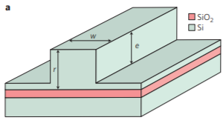
The centrosymmetric crystal structure and no useful electro-optic coefficients allows for a smooth and quick transfer of these photons. While the new form of data transfer increases data carrying capacities, silicon photonics main issue is proper light emitters and modulators due to the indirect nature of its band gap. Despite the issue, optics as the main application has led to the steady increase in attention of photonics experiences.
Figure 1a. SOI ridge waveguide and single-mode dimensions [13].
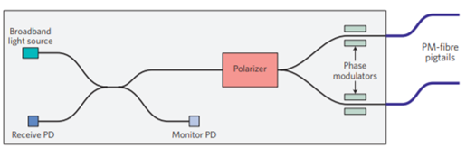
A few examples of early applications are the Silicon-on-insulator (SOI) wafer structures and fibre optic gyroscopes. The SOIs’ were proposed to operate in the telecom fibre-optic wavelength of 1.2-1.6um [12]. In 1991, a multi-micrometer ridge waveguide in SOI with certain dimensions could be single mode since all higher-order modes will couple into the lowest-order mode of the surrounding slab waveguide and be lost [12]. Photons and electrons in the configuration in Figure 1a are much different due to 10 nm (wavelength of electron) being an order of magnitude smaller than the integrated circuit size. Figure 1b illustrates the 1998 prototypes of fibre optic gyroscopes that were fabricated and successfully tested for use in guided munitions.
American Institute for Manufacturing Integrated Photonics is an industry driven public-private partnership focused on developing capabilities and expertise in this technology. Through AIM’s goal of accelerating the transition of integrated photonic solutions from innovation to manufacturing, we get partnerships like the Lab for Education and Application Prototypes (LEAP) for WPI and QCC. Initiatives of AIM Photonics such as LEAP will provide state of the art fabrication, packaging, and testing for small to medium enterprises. In order for their goals to come to fruition, the current central MA industry climate needs to be observed so both academia and industry can open the channels of communication and make sure to address gaps and potential problems before they come up and leave initiatives like AIM Photonics behind during this crucial stage in this technology’s lifetime.
Figure 1b. Schematic of a 1998 silicon-photonic-based fibre optic gyroscope chip prototype [13].
1.2 LEAP at WPI/QCC
The WPI/QCC Lab for Education and Application Prototypes (LEAP) is located at WPI’s Gateway Park. The major role of LEAP in the coming years is to grow and enhance workforce development that will stand as the groundwork of AIM Photonics as they establish themselves at the forefront of Integrated Photonics manufacturing in the United States. WPI/QCCs LEAP’s mission provides a space for prototyping, education and training, and research collaboration, specifically in the field of integrated photonics. This space for prototyping allows for an environment from academia, industry, and government sectors to create and test prototypes that incorporate photonic integrated circuits for new advancements in technology. Education and training in this industry at LEAP promotes an environment for continuing education and hands-on training. Research collaborations at LEAP will provide research opportunities and expertise in photonics related fields such as; optical and electrical device characterization, fiber optics, noninvasive optical metrology, nano/microscale prototyping development, terahertz sensing, and fiber-chip interfacing. [11]
Photonics is the next technological wave for microelectronics and data transfer, and with it comes a need for field of expertise and infrastructure. The goal of the inaugural years of the facility will be to secure a major footing in the photonics field in Central MA through state-of-the-art fabrication methods and high-level manufacturing jobs. LEAP is available to both Quinsigamond Community College (QCC) and Worcester Polytechnic Institute (WPI) students interested in photonics but is also open to companies engaged in photonics and interested in what student research projects at a state-of-the-art facility can do for them. Students from QCC and WPI with access to this facility will be engaged in research projects in the field of photonics gaining the education and experience with the state-of-the-art fabrication equipment required to excel in the upcoming industrial wave photonics seems to promise. For our students to be well equipped for this, an understanding of where the students at QCC and WPI are in their development in this field is necessary. For this research we will survey QCC students to help the overarching goal of identifying the needs, existing resources, and any gaps that present themselves in the transition from academia to the workforce that the new LEAP facility hopes to offer.
1.3 Topic and Goal of This IQP Project
1.3.1 Identifying the Needs, Resources, and Gaps
In order to identify the needs, resources, and gaps between academia and industry, there needs to be communication between the two. The purpose of this study is to gather research and data on the current climate of these two areas and how they are the same and different and identify possible problems LEAP will have to tackle during their inaugural years at Gateway Park. With Worcester MA economy booming, there are a slew of industry members that are attracted to this location with the emerging Integrated Photonics being no different considering the selection of schools Worcester has to offer. According to Lisa Eckelbecker’s February 2019 report in the Telegram, “The Worcester Economic Index, a measure of the area’s economy, grew at an annualized rate of 3.1 percent during the final three months of 2018...For the full year 2018, the index rose 3.2 percent from the previous year. According to Mr. White [Assumption college professor], the 2018 index growth was the highest since the 1990s.” [21]. With Worcester being a hub for economic growth and LEAP at WPI opening its doors, it is the perfect time for a study like this to happen on behalf of AIM Photonics for a better understanding of its projected societal impact.
1.3.2 Where LEAP is needed
With an increased representation of the photonics industries and life sciences in Worcester, LEAP will want to set their scopes on the advantages Integrated Photonics can have on chemical and biological sensors. With light as the medium of detection, methods of fluorescence spectroscopy such as Surface Enhanced Raman Scattering (SERS) are being researched for their uses in industrial process monitoring, water quality, leak warning/mapping, pharmaceutical drug testing, food quality, or even health diagnosis. With the almost limitless avenues that this technology can affect in the growing economy Worcester is seeing, the time to research where this field is really at is more important than ever.
1.3.3 Goals of the IQP
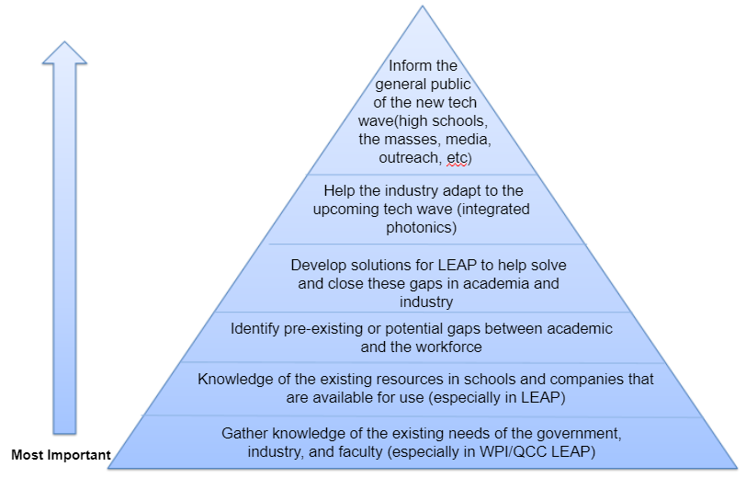
In the early stages of the project six goals were established to formulate an effective survey to be delivered to both academia and industry. Below, Figure 2 was designed to visually represent the goals of the study. The main goal of the study is to enhance the workforce development through identifying the needs, existing resources, and gaps in Central MA between academia and industry.

Figure 2. Goals diagram

Chapter 2: State of the Art: Manufacturing methods used in Silicon Integrated Photonics
To better understand the needs of the workforce development for silicon photonics, we first did a literature review to get ourselves familiar with existing and potential methods used in integrated photonics industries. Such knowledge allows us to convey the right information to the subjects of our survey and enable us to provide right interpretation of the survey results. Chapter 2 is laid out to illustrate the difference between methods in the existing silicon electronics industry and the methods and facilities available or soon to be available at WPI/QCC LEAP. Section 2.1 focuses on the fabrication and packaging methods in existing literature; Section 2.2 goes into great detail on the facilities that will be at LEAP and in the open access workspace; Section 2.3 goes into detail on the types of devices and equipment established in the field today.
2.1 Fabrication and Packaging Methods in Existing Silicon Electronics Industry
From the literature review we were able to distinguish a few categories of fabrication and packaging methods used in the silicon industry. These categories include additive methods, subtractive methods, and packaging methods. Additive methods are methods that add material to a substrate. On the other hand, subtractive methods remove material that is on top of the substrate. Packaging methods involve ways of bonding and connecting wafers and integrated circuits. Under additive methods we have photolithography, sputtering metal deposition, evaporation metal deposition. In the subtractive methods we identified wet etching, dry etching, and I-MacEtch (inverse metal-assisted chemical etching) [5]. Packaging methods include wire bonding, wafer dicing, wafer bonding [14], plastic-encapsulated microcircuit (PEM), plastic-leaded chip carrier (PLCC), and plastic ball grid array (PBGA) [2]. The next section will discuss facilities available or to be available at WPI/QCC LEAP. Additionally, a few of fabrication and packaging methods will be discussed in greater detail.
2.2 Facilities at WPI/QCC LEAP
Equipment available at the LEAP facility on WPI’s campus may not be necessarily available to industry sectors yet. The equipment falls into six categories: Testing and Characterization Equipment, Wafer, Die, and Chip Prototyping, PIC (Peripheral Interface Controller) Functionalization, General Purpose Equipment, Metrology (science of measurement) and Inspection, and Nano 3D Printing Capabilities [10]. Available at LEAP under Testing and Characterization Equipment are Lightwave component analyzer, Lightwave measurement systems, Arbitrary waveform generator, PIC probe station, Visible/IR spectroscopy, and a Digital signal generator. The Wafer, Die, and Chip Prototyping category includes a Plasma system, Wire bonding, Sub-micro micro-assembly and positioning system, and a Sputter deposition system. The PIC Functionalization category is comprised of the Comcore PFS-500i (Fiber fusion splicer), Apogee spin coating system, Deep UV aligner, a Meyer Burger Pixdro LP50 inkjet printer, and an Optical fiber prep station for cleaving. General Purpose Equipment available at the LEAP facility consists of Optical sensors, detectors, and instrumentation, Fiber-based laser systems, Optical tables with vibration isolation, Opto-mechanical hardware and components, Fume hoods, and Chemical storage. Metrology and Inspection equipment include Toolsmaker/Inspection microscopy, 3D laser scanning microscopy, Thermal imaging, Atomic force microscopy, and Optical surface profilometry. The last category is the Nano 3D Printing Capabilities at LEAP which is not widely used in the industry yet. The LEAP facility has the Nanoscribe Photonic Professional GT+ that can print 3-dimensional microscale and nanoscale. The 3D printing too is optimal for replicating photonics structures as well as patterning [15].
The literature continued to understand techniques most used in silicon photonics today. Below are the detailed descriptions of what we found to be the most common techniques used by industry and WPI/QCC LEAP. Each of the techniques were listed previous in section 2.1 under their respective fabrication or packaging methods category. Out of the techniques described below, dry etching is the only technique not available at the LEAP facility just yet.
2.2.1 Photolithography
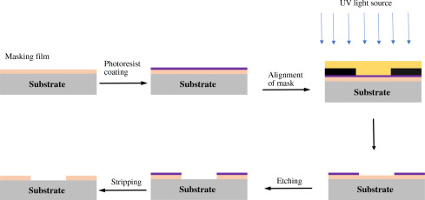
Photolithography is the method of transferring a pattern onto a substrate through optical means. Figure 3 illustrates the process beginning with a photoresist coating being placed on the substrate. The substrate is then exposed to electromagnetic radiation adjusting the molecular structure which changes the solubility of the material all while aligning the mask of the pattern. Following exposure of the UV light source, etching takes place. Once the etching has been completed, the substrate is submerged into an aqueous solution to dissolve away the areas where photoresist was exposed to the UV light. [17]
Figure 3. Photolithography process of etching a substrate.[17]

2.2.2 Metal Deposition-Sputtering
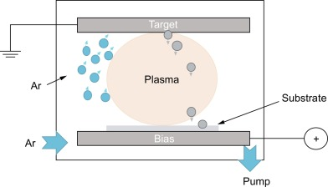
Sputtering deposition applies the production of a plasma through electrical discharge and the electrostatic acceleration of ions [9]. Typically, Ar+ ions, as demonstrated in Figure 4 are utilized during the sputtering process and accelerated towards the material to be deposited. The target location is positioned as a cathode within a vacuum chamber is usually grounded as shown in the figure above. The accelerated ions cause collisions with the substrate. The collisions cause the atoms within the substrate to be ejected and eventually become part of the thin film forming on the target.
Figure 4. Sputtering deposition diagram. [1]

2.2.3 Metal Deposition-Evaporation

Metal deposition under the application of evaporation, also known as thermal evaporation, encompasses evaporating materials in a vacuum chamber then condensing the evaporated atoms on a substrate. Materials are evaporated by a resistively heated boat or filament made of metals that are resistant to heat Molybdenum, Tungsten, and Tantalum.[15] The metals
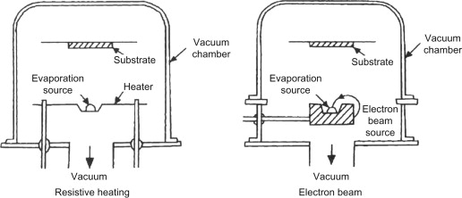
cannot be evaporated by resistive heating therefore, they are evaporated by electron beam deposition. Vacuum resistive heating and vacuum electron heating are both depicted in Figure 5.
Figure 5. Evaporation deposition using resistive heating and an Electron beam. [15]

2.2.4 Wet Etching

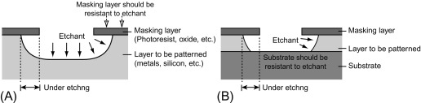
Wet etching utilizes chemical solutions to remove solid material from a wafer, commonly is specific patterns illustrated by photoresist masks on the wafer. Material exposed to the chemical solution are etched away. Figure 6A shows when a thick material is being etched, while Figure 6B shows a thin film being etched on top of a substrate that is resistant to the chemical solution. Wet etching is commonly isotropic where it proceeds in all directions at the same rate. However, any etching process that is not isotropic is anisotropic where the process proceeds in only one direction. [6]
Figure 6. (A) Wet etching of a thick material. (B) Wet etching of a thin film on top a
substrate.[6]
2.2.5 Dry Etching

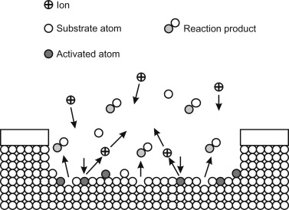
Dry etching utilizes an etchant gas to etch small patterns with less of an undercut and higher aspect ratio than wet etching. Illustrated in the Figure 7 is a common form of dry etching is Reactive Ion Etching (RIE) that uses gas at a high pressure known as a plasma. Applying a magnetic field, RIE utilizes combinations of chemical reaction or physical bombardment of ions. The ions strike atoms in the material being etched. RIE results in anisotropic etching because the ions collide more on the horizontal surface rather than the sidewalls, thus the etching rate is faster in the vertical direction.
Figure 7. Reactive Ion Etching (RIE), common form of dry etching.[4]
2.2.6 Wire Bonding

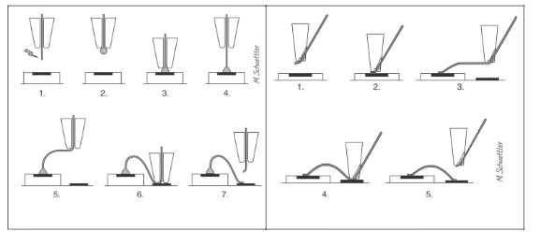
Wire bonding technology included two processes: Ball-wedge or Wedge-wedge. The ball-wedge method presented in Figure 8a uses a capillary through which the bond wire (usually aluminum or gold) is threaded. A ball of material at the end of the bond wire is formed from an electrical spark then pressed to a bond pad under heat or ultrasound energy applications. The capillary is then moved to the target pad and removed while the wire is clamped then teared. The wedge-wedge method presented in Figure 8b utilizes a fine point capillary that includes an integrated wire feeding channel. The wire bond treads through the feeding channel and forced onto the bond pad. The first wedge is formed through the same heat or ultrasound energy applications, then the bonding capillary is carried to the target pad creating the second wedge. The wire tears the same way as the ball-wedge method [8]. In the illustration above, the difference in the wire ends of each method can be observed.

Figure 8. (a) Ball-wedge wire bonding method. (b) Wedge-wedge
wire bonding method. [8]

2.2.7 Wafer Dicing

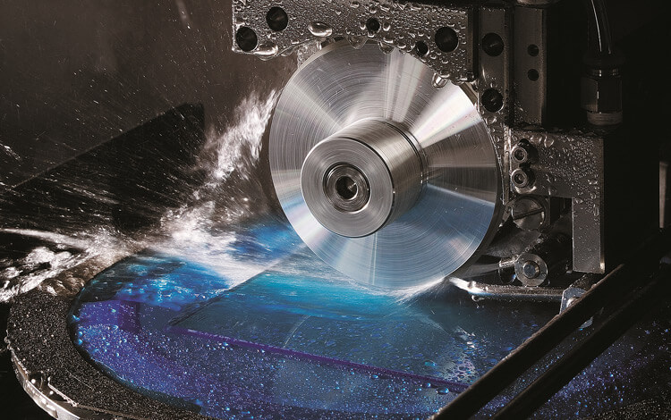
Wafer Dicing is the process of cutting thin silicon wafers into dies. It involves mechanical or laser dicing. Blade (mechanical) dicing utilizes a diamond blade as depicted in Figure 9. The diamond blade is used to cut through the wafers that are mounted onto a metal frame using an adhesive. The blade rotates between 15,000 to 30,000 rpm to cut through the wafers [3]. Cooling agents are lightly showered during the process within the cutting lines to prevent silicon dust particles from damaging the substrate surface. Laser or stealth dicing uses lasers with a semi-transparent light wavelength that cuts through the substrate. The wafers are cut from the inside out which produces less silicon dust particles that could damage the surface of the substrate. In contrast with blade dicing, laser dicing does not require cooling agents because it produces minimal heat transfer.
Figure 9. Blade dicing by a diamond blade.[3]
  - Examples of Silicon Photonic Devices and Their Applications
Along with the literature review of techniques commonly used in the photonics industry and at WPI/QCC LEAP, we dug a bit deeper into examples of silicon photonic devices and their applications. The following subsections discuss four differing devices that are among many more that are used in the photonics industry and at WPI/QCC LEAP. Detailed descriptions of the a few devices below are On-chip waveguides, On-chip couplers, On-chip light sources, and Detectors. Chapter 2 concludes after this section with a summary to recap all the literature that had taken place.
2.3.1 On-Chip Waveguide
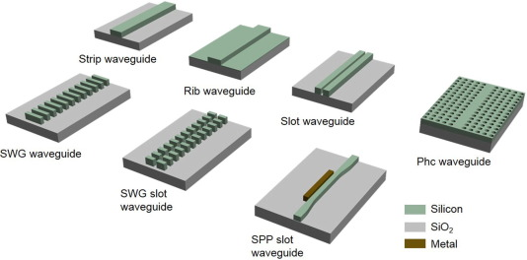
Silicon waveguides are used to carry signals across a chip. Different waveguide structures allow for signals to have diverse directions or routes as well as differing speeds the signals travel. Various waveguide structures are illustrated in Figure 10. The most used waveguide structure is the strip waveguide that allows for a tight bending radius, thus is commonly used for compact signal routing. The rip waveguide allows connections to be made on either side of the waveguide and is used for electrooptic devices. The subwavelength grating (SWG) waveguide allows additional degrees of freedom compared to the strip and rib waveguides. The SWG waveguide uses a recurrent grating structure to guide the optic signal. The SWG slot waveguide adds a longitudinal slot in the SWG waveguide that can be designed to attain lower nonlinearity. To flexibly control the nonlinearity of the strip and rib waveguides, the slot waveguide was designed, adding an additional degree of freedom. The slot waveguide restricts light in the low refractive index region. Out of all the waveguides in the figure above, the photonic crystal waveguide (PhC) looks completely different. Due to the slowdown of light through the PhC waveguide, light-matter interaction is enhanced. The last waveguide depicted in Figure _ is the surface plasmon polariton (SPP) slot waveguide, which is the only one out of the seven waveguides discussed that incorporates a metal and allows for tighter light confinement. [13]
Figure 10. Various silicon waveguide structures. [13]
2.3.2 On-Chip Coupler
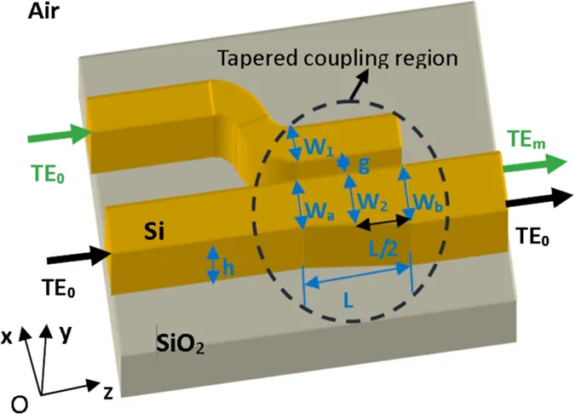
In the sense of silicon photonics, a coupler connects multiple waveguides into one. The silicon waveguides carry optical signals across the chip. Figure 11 depicts two silicon waveguides on a silicon oxide chip that connect in a coupling region, thus becoming one waveguide. The tapered directional coupler to the right couples light from each narrow silicon waveguide to a wider, tapered waveguide. Different signals are sent through each waveguide, then after the coupling region exit through the waveguide that was a result of the coupling. [18]
Figure 11. On-chip coupler that tapers two waveguides to be a single waveguide. [18].

2.3.3 On-Chip Light Source
On-chip light sources can obtain higher integration density with a condensed size. Additionally, they display enhanced performance in energy efficiency and proportionality. An example of an on-chip light source can be seen in Figure 12 to the left of Germanium-on-Si laser. The unique band structure induces Germanium to perform correctly at the optical telecommunication wavelength of approximately 1550 nm and introduces the possibility of obtaining valuable light emission by engineering its band structure [19]. The Germanium-on-Si laser illustrated above is an idealized structure for generating tensile stress by etching through the Si substrate which greatly improved the light emission.
Figure 12. On-chip light source of Germanium-on-Silicon laser [19].
2.3.4 Detectors

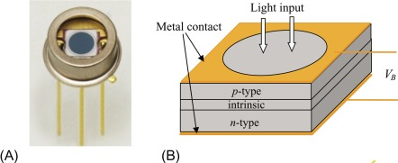
A photodetector converts optical signals into electrical signals. Photodiodes, also known as semiconductor photodetectors are used for optical communication systems. They are small, have fast detection speed, and high detection efficiency [7]. Each photon of the incoming optical signal is translated by the photodiode into a free electron. The translation aids the photocurrent to be linearly proportional to the power of the incoming signal. Depicted in Figure 13 above is a packaged large area photodiode and a diagram of the layer structures, respectively. The large optical window allows for greater efficiency when accepting incoming photons. Shown in Figure 13B, the signal comes from the p-type layer of the wafer and since there is a large detection area and thick intrinsic layer, the photodetection response time is increased. The response time is increased due to the longer photon and electron transient time [7].
Figure 13. (A) Packaged large area photodiode. (B) Diagram of the layer structures.[7]
2.4 Summary
Chapter 2 discussed state of the art manufacturing methods that are used in silicon photonics. A literature study was conducted to better understand the needs of the workforce development for silicon photonics as well as existing manufacturing and packaging methods. We listed techniques used in the industry, especially those not necessarily available at the LEAP facility. However, we did list the techniques and devices available at the LEAP facility. Several techniques and devices were explained in detail following the list available at LEAP such as, wafer dicing, photolithography, wire bonding, and sputtering. Following the techniques were examples of silicon photonic devices and their applications. These included detailed descriptions of on-chip waveguides, on-chip coupler, on-chip light source, and detectors. Chapter 2 shows the difference between what is available in the industry as opposed to the LEAP facility. The techniques and devices at the LEAP facility will be available to both WPI and QCC students and faculty as well as industry sectors.

Chapter 3: Methods of this IQP Study
3.1 Statement of Research Methods

The main form of data collection for our research will be done through a survey/questionnaire. The survey will be completely voluntary and can be ended at any time for those surveyed. The students and teachers will primarily be questioned and surveyed in person, whether through a professor allowing us to take time out of their class or asked individually but could also be sent through email. The survey is split into two parts and we will keep them separated depending on who we are surveying. The second half can be sent as an attachment to industry and government officials, but during B term we plan to attend meetings and conferences to engage with people in the field and LEAP. An interview based on the survey questions shown will be implemented to see if we can get more information from these conferences and meetings. The data will be collected by the two student investigators and then collected and reformatted statistically to help us identify trends in the needs and resources of this field.

Above is the statement of Research Methods that was sent with the IRB application for us to continue our work into B term. The surveys changed a little after the initial IRB application approval and revised during our second round of surveys. Our surveying was primarily focused inside of QCC and various conferences we went to during A term. The iMAPS conference in Boxborough gave us a definitive deadline to decide how our project was going to move forward in B term, as it was the first day of B term we attended this conference, and the New England chapter of the Optical Society of America conference at the LEAP facility itself gave us some insight into the industry that is accumulating in this area around Photonics. At this point in the study the Industry has not given us a good reception to utilize in our results, but this will be continued into C term. Because we focused our study in QCC, we decided to focus our efforts into the student population at QCC. To add to the survey we made a PowerPoint presentation spanning no more than five minutes, since most of our surveys were held at the beginning of a professor's class and immediately after this the students would voluntarily fill out the student/professor side of our survey and with the answers in those we would compile them into the results section and with those determine trends in the QCC side of the academics LEAP will be utilizing. PowerPoint slides are also inside the Appendix.

3.2 IRB Application process
For the majority of IQPs when surveying other students, due to liability concerns, an Internal Review Board application must be filled out so that the focus of our project, can be reviewed for approval. This part of the project was brought to our attention from our IQP who then got us in touch with someone on the IRB so we can better articulate our project’s goal in our application. Due to the timing of our project we needed to act quickly and effectively when completing our IRB. Because this group does not meet often, our IRB needed to be concise and clear to a board for our project to continue.

The person we got in contact with was Ruth McKeogh who is the Director of Human Subjects Research. We scheduled a meeting with her where we discussed the project and why we need the surveys done for the overarching goal of the project. This cut our application in half and left the focus of the study as the main concern of our IRB application. The concern for our project up to this point was rushing our questionnaire but Ruth McKeogh calmed our nerves telling us our project fell under the circumstance of “exempt”. This cut our application in half and left the focus of the study as the main concern of our IRB application. This application was a bottleneck for our process since our surveys would be held if this IRB was not approved. The news from Ruth made A term much easier to digest and carry out in time for our first conference at the beginning of B term. Because of this, the application’s approval was important if A term was to be successful. Thankfully we submitted the application on September 26th with two weeks left of A term and we were accepted on October 4th allowing us to continue our project. The IRB online application that we submitted for approval is located in the Appendix.

3.3 Goal Maps
In order to form a questionnaire, goals need to be established. Setting goals of the study allows for efficient questions to be formulated in a timely manner. Without established goals, questions can still be formulated but provide no valuable data. When establishing the goals of this study, expected outcomes were put into consideration. Below are two goal maps that were created to relate questions designed for industry and academia to the desired goals, respectively.
.
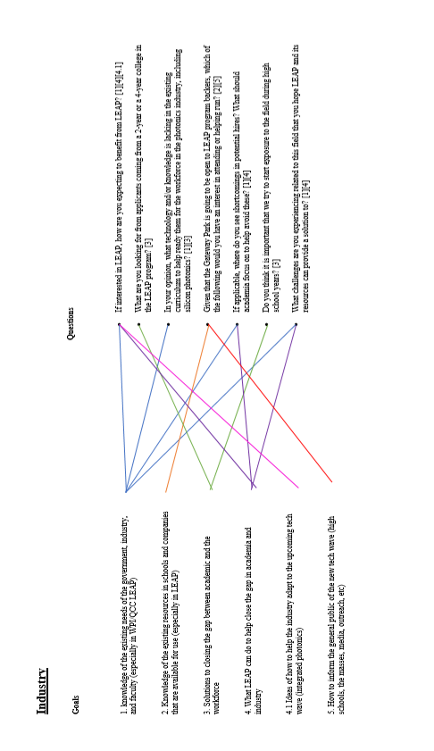

Industry Goal Map Figure 14

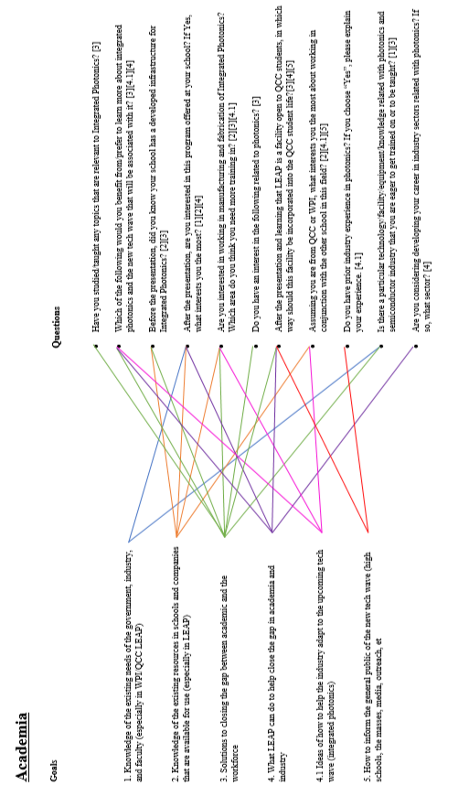

Academia Goals Map Figure 15
3.4 Questionnaire
The questionnaire was developed based on the goals established in section 1.3.2: Goals of the IQP. A questionnaire was made for both industry and academia to understand the needs, gaps, and existing resources of both. While the Industry questionnaire was not utilized during this work, the Academia one is reflective of the final version we used on most of our sample set. Both questionnaires we split up into a first part consisting of multiple choice or yes and no questions for ease of use, and a final section marked optional that was there to gain better insight from the students who are interested in the LEAP facility.
Industry

- Are you a Government Official or a Company Representative?(Circle one)
What is your Job Title?_____________________________________________________

- What category best describes your organization? (Circle what applies)
- Part of infrastructure development
- Involved in new technology and advances in the field
- Potential customer or beneficiary of LEAP or other associated Integrated Photonics movements
  - If not LEAP what movement are you backing or a part of:
___________________________________________________________
- Other:____________________________________________________________

- If interested in LEAP, how are you expecting to benefit from LEAP? (Circle all that apply)
- Education (retraining, curriculum development targeted at a specific industry sector, workshop, training on cutting-edge equipment)
- Infrastructure (equipment, cleanroom, lab space, user facilities)
- Technology (new fabrication methods, packing, testing )
- Workforce development (sponsored student project; internships; career fair)
- Other:____________________________________________________________

- What are you looking for from applicants coming from a 2-year or a 4-year college in the LEAP program? (Circle all that apply)
- Lab experience (Understanding of equipment used in processing)
- Research Background (Know what is functional and in circulation but also up to date on cutting edge)
- Working Knowledge of the Infrastructure necessary
- Other:____________________________________________________________

- Do you think it is important that we try to start exposure to the field during high school years? ( Yes / No ) If you answered yes, would you be interested in holding seminars, classes, or workshops to high school students to help develop a basis before college enrollment?( Yes / No )

- Given that the Gateway Park is going to be open to LEAP program backers, which of the following would you have an interest in attending or helping run? (Check all that apply)
- Company and Industry lead workshops
- Individual guidance to students for research projects (IQP and MQPs)
- Teaching courses of varying topics at WPI or QCC
- For those that you chose, underline the one you think would make the biggest impact.
____________________________________________________________________________
(Optional Questionnaire)
- In your opinion, what technology and/or knowledge is lacking in the existing curriculum to help ready students for the workforce in the photonics industry, including silicon photonics?

- If applicable, where do you see shortcomings in potential hires? What should academia focus on to help avoid these?

- What challenges are you experiencing related to this field that you hope LEAP and its resources can provide a solution to?

Academia

- Which Institute are you from:________________________________________________

- Are you a Professor or a Student? (Circle one)
Please state your major/department:___________________________________________

- If you are a student, What best describes your circumstances:
a.) 4 year college student
b.) 2 year student with plans to transfer
State institute you plan on attending after QCC:
____________________________________________________________
c.) Specialized Student getting their certificate
State your field of expertise you are striving for:
________________________________________________________________________
- Before the presentation, did you know your school has a developed infrastructure for Integrated Photonics? (Yes / No)
If Yes are you involved? ( Yes / No )
If Yes how are you involved?
- Student Research Projects
- Courses
- Other_______________________________________________________

- After the presentation, are you interested in this program offered at your school?(Yes /No)
If Yes, What interests you the most
a.) Student Projects with WPI students to help Industry leading companies
b.) Learning how to operate these state-of-the-art fabrication equipment
c.) Learning more about the Industry as a whole.

- Have you studied/taught any topics that are relevant to Integrated Photonics?
(Circle all that apply)
- Fibre Optics (Or other mediums of Infrastructure)
- Light sensors (emphasis on Technology and application)
- Manufacturing requirements (use of equipment)
- No topics taught/learned
- Other:____________________________________________________________

- Which of the following would you benefit from / prefer to learn more about Integrated Photonics and the new tech wave that will be associated with it? (Circle all that apply)
  - On campus workshops
  - Topic geared courses (either taught by professors or industry heads)
  - Seminars presented by industry
  - Other:____________________________________________________________

- Are you interested in working in Manufacturing and Fabrication of Integrated Photonics? (Yes / No)
If you answered Yes, which area do you think you need more training in? (Circle all that apply)
- Infrastructure Development
- New Technologies
- Equipment Usage
- Knowledge of topics related to integrated photonics

- Do you have an interest in the following related to photonics? (Circle all that apply)
  - Involvement in research projects
  - Developing new equipment and infrastructure
  - New targeted curriculum/courses
  - Local high school visits/seminars
  - Other:____________________________________________________________

- After the presentation and learning that LEAP is a facility open to QCC students, in which way should this facility be incorporated into the QCC student life?
(Circle all that apply)
a.) Courses geared in Photonics allowing for a smoother transition into the facility
b.) Open Workshops at Gateway park for students to attend
c.) Other:______________________________________________________________

- Assuming you are from QCC or WPI, what interests you the most about working in conjunction with the other school in this field (Circle all that apply)
- LEAP driven seminars
- IQP and MQP projects driven by both schools
- Utilization of both school’s expertise and resources
- Other:____________________________________________________________
______________________________________________________________________________
(Optional Questionnaire)

- Do you have prior industry experience in photonics?
  - Yes
  - No
If you choose “Yes”, please explain your experience.

- Is there a particular technology/facility/equipment/knowledge related with photonics and semiconductor industry that you are eager to get trained on or to be taught?

- Are you considering to develop your career in industry sectors related with photonics? If so, what sector.

Chapter 4: Results
The Study conducted at QCC composed of 6 classes as shown in the table below ranging from General Physics classes to Electrical Engineering specialized classes. The survey was conducted with the help from Professors Dadbeh Bigonahy of QCC who specializes in preparing students for their BS, MS and PhD. in Engineering and Health Services and Jacob Longacre, the professor of Electronics Engineering – Photonics at QCC. Jacob Longacre is known for his heavy involvement in the WPI/QCC LEAP and was used as a separate group of QCC students due to their preexisting relationship with LEAP through their professor. Professor Jacob Longacre’s mission at QCC is developing a photonics program that provides students with a solid understanding of the technology and how it is being employed locally as well as a strong base for continued education. During our first encounter with Jacob Longacre he told us that QCC has many different groups of students that comes through. QCC students are mainly split into students taking classes for transfer to a 4-year college or students who are trying to finish their certificate in two years and get into the workforce. These two groups need to be segregated and analyzed accordingly.
Table 1: Professors, Course Name, Course Number, Course Meeting Time, Total Students.
Instructors | Course Name | Course Number | Course meeting time | Total students
Dadbeh Bigonahy | Physics I (General) | Physics 101-50 | Wednesday 5:00-7:30pm | 7
 | Physics I (Calculus based) | Physics 105-50 | Monday 5:00-7:30pm | 7
 | Physics III (Calculus based) | Physics 205-50 | Friday 5:00-9:50pm | 11
 | Eng. Computation and Modeling | ERG 280-01 | Tuesday/Thursday 2:00-3:15pm | 16
Jacob Longacre | Intro to Photonics | ELT 120-50 | Wednesday 5:00pm-10:00pm | 6
 | Digital Electronics | ELT 121-01 | Friday 9:00am-2:00pm | 6
Total |  |  |  | 56

4.1 Data Disparities
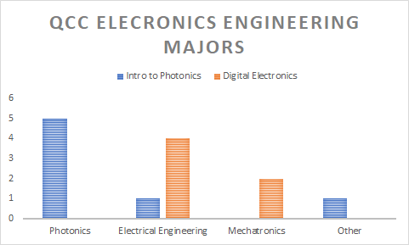
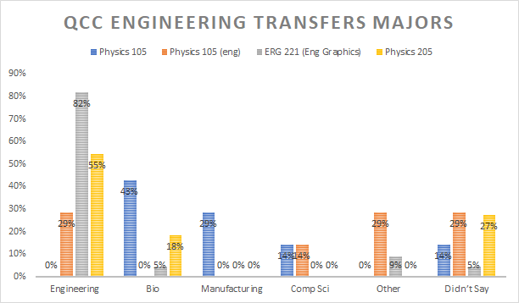
Between the two groups of QCC students surveyed we gathered enough evidence to give us a better picture of the type of QCC student LEAP will utilize. Most students attending QCC we surveyed had an emphasis in Engineering with plans to complete an Associate in Sciences for a transfer to a four-year college. The other students, under the guidance of Jacob Longacre, were more dialed into LEAP and its initiative at Gateway Park and as such his “Intro to Photonics” class although the smallest, showed the most interest in LEAP. The biggest divide between the two groups is the focus that the two groups differ in. Engineering Transfer students are looking to their four-year transfer college for opportunities in how they advance their career so a specialized opportunity like LEAP can often still scare the general population.
Figure 17. Majors breakdown for Professor Longacre’s Classes.
Figure 16. Majors breakdown for Professor Dadbeh’s Classes.
The students from Professor Longacre have the luxury of him as their professor so he is able to expand on the ideas presented in the slideshow presented to the engineering transfers showing the students why an opportunity like this can help for a variety of career paths. As seen in the diagram, Photonics and Electronic Engineering are the most popular majors among Jacob Longacre’s students. Below we will show in detail how Dadbeh’s students and Jacob’s students responded to LEAP and what it can offer.
4.2 Knowledge of LEAP
Despite the school being a partner of the LEAP initiative, and having Photonics established into its curriculum for Electronics Engineers, most of the student body surveyed still were unaware of programs like LEAP and what they can offer. Out of the 56 students that were surveyed across both Engineering Transfer students and Electronic Engineering students in more specialized classes from Professor Longacre, only 10 students were aware of LEAP, with half of them being from Professor Longacre’s Intro to Photonics. When comparing all the courses, Introduction to Photonics was a major outlier in this study.
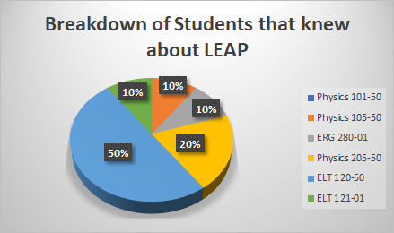
Across the board, 80-100% of students were unaware of LEAP, except the class taught by Professor Longacre aptly named “Intro to Photonics”. While LEAP is a new facility, if it were not for our intervention into these classes, the students most likely would not know about the exciting opportunities LEAP offers to QCC students, especially the Engineering Transfers where 44% had plans of transferring to WPI from QCC. While Photonics is only really appealing for Electronic Engineering students, the QCC students on the Engineering transfer track are very interested in the prospect of working with WPI in any way they can.
Figure 18. Breakdown of Students that knew about LEAP.

4.3 QCC Survey sample deviations
The Engineering program at QCC allows students to simultaneously receive an Associate in Science alongside preparing them to transfer into a four-year college. This group, although a larger portion of our sample set, is not most students that go to QCC. The most common group at graduation are those who are there to receive their certificates in specializations. Unfortunately, due to the nature of certificates, the classes are much smaller as the certificates offered are plentiful, but they aren't well attended classes. This is true for the Electronics Engineering side of our sample set. Both classes taught by Professor Longacre fall under this theme since the Electronics Engineering Technology - Photonics Option can be a 2 year associate for a job right out of QCC or it could be used as a tool to move their education further at a 4 year school, preferably WPI with Jacob Longacre as their professor and the course requirements so reliant on where LEAP wants to go. Regardless it's these 2 classes that we need to separate from the herd since these classes are filled with students eager to work with LEAP even before we surveyed them. Contrasted with this is Engineering Transfer students who have classes that can have up to 20 students which gives a larger data set.
Keeping the Electronics Engineering Students apart from the transfers allows us to at least identify trends that QCC students follow. These students, as the data starts to reveal to us, are more concerned with entering the workforce rather than the 4-year college they want to attend. This will present an interesting correlation in the data later as the Electronic Engineering students are more interested in the QCC ecosystem and what they can do with QCC.
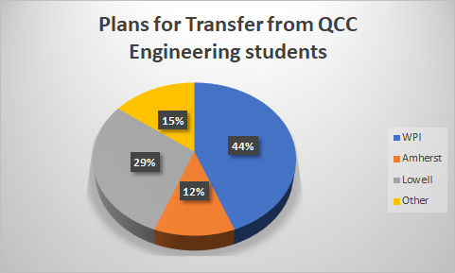
4.3.1 Specialization at QCC
When reading what the Electronics Engineering students had to say in their surveys, the question that had the best reception was if they were interested in working in Manufacturing and Fabrication of Integrated Photonics with 92% saying they were interested. Of the two classes, the entirety of Introduction to Photonics was interested and 83% of Digital Electronics was interested. The Question was split into a second part which gives us insight into what the students still needed training in. The three areas of training we found most important for students in Manufacturing and Fabrication of Photonic Systems were, Infrastructure Development as Photonics require complex systems for fast data transfer in sensors or other state of the art fabrication and manufacturing equipment, Equipment Usage since a familiarity to the equipment can help the student better adapt to the facility and make them valuable to the Industry that utilize the open space, and finally, Knowledge of topics related to Integrated Photonics. The last one, Knowledge of Topics was a huge draw to transfer students in a program where their education is considered generalized for multiple different pathways within the umbrella of Engineering.
Figure 19. Plans for Transfer QCC Engineering Students.
The Graph above shows what percentage of students were interested in working in Manufacturing and Fabrication. From this data set we see Digital Electronics students were all interested in New Technologies while the Intro to Photonics was much more diverse with New Technologies and Knowledge of Topics split for first while Equipment Usage and Infrastructure are taking up one third of the class. Since both classes had New Technologies as a top priority, we can assume that the state-of-the-art fabrication equipment will be a huge draw for QCC students already interested in the Photonics field.
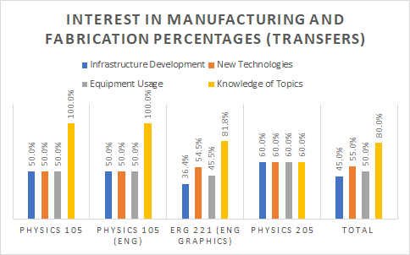
The Engineering Transfer Students regarding this question are much less interesting. The only class that showed diversity in their answers was Engineering Graphics, although we see across the board, Knowledge of Topics was the biggest draw unsurprisingly from a college based around the first two years of college education. Because of the nature of the data set, the only real determining set was Engineering Graphics since the rest of the classes have a constant number of answers in each set, even the Physics 205 class was 2 votes in each category meaning any distribution of is not from the three physics classes. The majority of those interested in the 3 physics classes chose all or most of the options but because of the size of the classes, only the Engineering Modeling class gave us a better distribution and as such affected the total distribution much more than the other classes. An important factor to consider it these interests are from those who were interested in Manufacturing and Fabrication to begin with. Since our sample set for the is 20 out of the 56 surveyed the biggest takeaway should be where interest is not how many are interested.
Figure 20. Interest in Manufacturing and Fabrication.
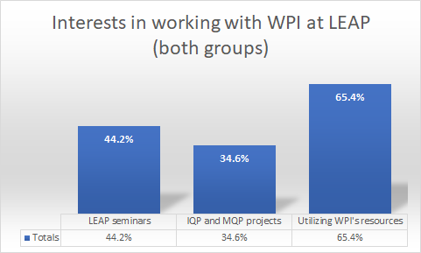
4.3.2 What do both groups share
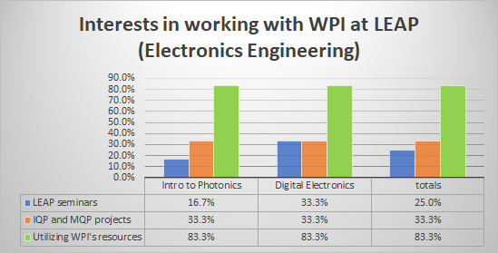
While the largest divide between the two classes is in how eager they are to be working in Manufacturing and Fabrication, there are some similarities in their answers that can most likely speak to the average QCC student. Towards the end of our survey we ask them what interests them the most about working with WPI at LEAP. The three options were, LEAP driven seminars, IQP and MQP projects driven by both schools, and Utilization of both school’s expertise and resources. From the survey sample set we see that although the more popular option changes based off the class and even by what year they are in, the most popular option across all QCC students is Utilizing the resources of WPI at LEAP with a 65.4% interest among all people who said yes. This is interesting since the divide is even more self-evident when we look at the Electronics Engineering students from Professor Longacre’s classes. It's the Electronics Engineers that are the most eager to work with WPI and their resources despite them being the ones who are the closest to the Fabrication Lab and the state of the art equipment that QCC has recently opened up at the Quest center. This may be due to these students being the most eager to work in Manufacturing and Fabrication and wanting to delve into this field more since their courses are geared toward getting them into the field within two years.
Figure 22. Interests in working with WPI at LEAP (Electronics Engineering).
Figure 21. Interests in working with WPI at LEAP (Both groups).
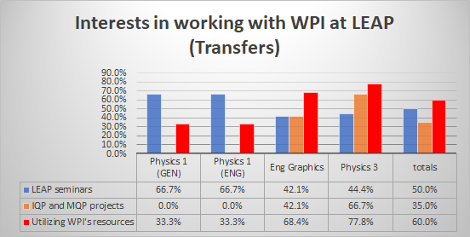
General Engineering is where the data is scattered. Following from left to right we see the progression of students through their two years before transferring. In the beginning we see students much more interested in seminars where they can learn more about the topic and decide for themselves. In these classes there is no interest at all in working on projects most likely since their initial goals or courses do not line up with LEAP and Photonics. When these students fill out the survey they either wrote “Engineering” or “Mechanical Engineering” not totally understanding how broad their discipline is. As the semesters progress, the students become much more inclined to utilize WPI’s resources and delve deeper into topics such as Photonics as they are starting to consider the next half of their career and with a general Engineering associate they can go into any engineering discipline.
Figure 23. Interests in working with WPI at LEAP (Transfer students).

Chapter 5: Industry Involvement
For the purpose of our study, industry involvement was necessary to find what we want the LEAP facility to provide. From an early stage in our industry study, we decided that if our involvement was to be limited by time restraints, our data set needed to contain various stages and positions in the corporate ladder in the photonics field. This allowed us to get qualitative data from various companies and positions to better understand the scope of our impact, rather than gathering quantitative data to understand a specific impact.
The following sections will outline the data sources we utilized for our industry involvement during our study. Section 5.1 follows our iMAPS NE conference; Section 5.2 follows our in-depth tour and interview from Headwall Photonics; Section 5.3 covers a conversation with an individual from a Photonics Industry specialist from CYC Tech Valley. In the discussion section the ideas presented will be explored as a potential continuation of this study.
5.1 Data Source 1: Industry Conferences
To gather our data from the industry, we set our sights on iMAPS and OSA/NES conferences dense with industry members interested in networking and expanding. Our rational with this decision was the members of companies the most interested in networking and expanding their company’s reach would be the most susceptible to interviews and potential collaborations in the future with a facility like LEAP. The sections that follow are focused on the two main conferences we attended and what people we got in contact with from those sources.
5.1.1 iMAPS NE Conference
Our first conference we attended was a poster presentation we presented our work at. This poster is available in the appendix. From this conference we got feedback from one MRSI individual who worked in Sales. Although the input was valuable, the glaring issue we had was in the survey format. While our questions were specific, there was no real divide in answers meaning we knew they were interested in what we had but were not able to identify what we needed to investigate. Instead of black and white they were shades of black. Our survey was focused on hiring of students from LEAP not how LEAP could help the Industry. To combat this and help put us back on course we attended the OSA/NES meeting at WPI where the Industry came to see firsthand the LEAP facility and what it could provide. With this meeting we got a better understanding of what the Industry looks at in terms of the facility.
5.1.2 OSA/NES Meetings
After our surveys at QCC, we wanted to investigate a way to get Industry feedback outside of the iMAPS NE conference. After we re-evaluated our interview questions the OSA/NES meeting on January 23rd at the MIT Lincoln Laboratories was an opportunity for us to reach out to the Industry one more time before our IQP project ended. During the networking period many OSA members were eager to hear from a student who braved the journey into Lexington based on getting to know the industry and reach out. From this meeting we got two crucial contacts who helped us better understand the Photonics industry and how OSA is a great tool for LEAP to utilize for its students in the coming years.
5.2 Data Source 2: Headwall Photonics Tour
Our efforts to understand the industry needs for the workforce development were mainly focused on a photonic sensor company in Massachusetts, Headwall Photonics. Dr. Carson B. Roberts -a Senior Applications Engineer at Headwall Photonics- kindly offered an extensive two-hour tour for the IQP team through the design, manufacturing, assembly, testing and packaging facilities of his company. The Question and Answer session that followed the tour helped our team understand the needs and resources of the industry through the categories of, student projects, equipment LEAP can offer, field expertise and qualifications and future connections between the company and LEAP/WPI.
Headwall Photonics is a company that uses Spectral Imaging Instruments for various purposes from small remote sensing with their Commercial Off-The-Shelf sensors to uses in Civil Infrastructure, Mining and Exploration, and even Crop Health. All applications of Spectral Imaging can be used with their “Turnkey Systems” which allow the user to utilize their technology in an all-inclusive package. It’s the company’s goals shift that is highlighted in many of the answers provided from this data source. When we saw how everything from Research and Development to even testing and working out manufacturing kinks is done in house, it was important to figure out what was left that LEAP could offer this company. When we got to sit down and interview Dr. Roberts on what LEAP could provide, he was a valuable tool in understanding how some of our resources and needs would not be met. The needs of Headwall Photonics from our tour go as follows:
- While WPI can offer hundreds of IQPs and MQPs to companies such as Headwall Photonics, Dr. Roberts helped us understand that these projects often span the period of 3-4 academic terms and if they end in failure can be a burden on the company. While this is beneficial to WPI, Headwall Photonics is at a loss having invested over half a year into a group of students who were unable to successfully solve a problem that they had. Despite the disclaimer provided, the idea of a one term intensive student project that reduced the time commitment of the company and saw a stronger focus from students was a very appealing offer. Dr. Carson Roberts also assured us that there are plenty of areas students can explore his concern comes from structuring a project student can solve that he just does not have the time to do himself.

- The prototyping and experimenting equipment were an area that Dr. Carson Roberts showed a genuine interest in. With a mid-sized company like Headwall, one of the biggest hurdles for them to overcome is finding out what types of testing and prototyping are financially viable to have done in house. This problem was one LEAP was founded on trying to solve with the grant to buy the necessary equipment to meet this preexisting need. The list of equipment that would draw Headwall to LEAP included:
- 4-5 axis machining
- AFM (Atomic Force Microscopes)
- Zygo Optical Profilers, CNC Rapid Prototyping
- Interferometers
Fortunately, these are all equipment that LEAP will be stocked with for companies that want to utilize the open space that LEAP has to offer for testing and prototyping. This opportunity was one Headwall was very interested looking into after LEAP was established.

- Needed expertise in the workforce was an area of contention once we introduced QCC as a partner in the establishment of this facility. Dr. Carson B. Roberts made it clear that the employment of Headwall Photonics looked for a bachelor’s and above when finding their new recruits. This makes QCC student’s involvement in the future of LEAP an area of focus moving forward.
- Towards the end of our conversation he opened the possibility for him to host a talk at LEAP giving us the Industry Experience and attention that LEAP wants to provide. He was more than open to the idea of hosting for the purposes of teaching and growing interest in the field he works in. One such way was demonstrating the capabilities of the drones they package as turnkey systems to sell their lidar technologies.
The data that Dr. Carson B. Roberts generously offered us during this tour helped us better understand the packaging and testing capabilities of mid-size companies in the Central MA area today. In the Discussion section the application of these areas to the goals of LEAP will be explored further when compared with the other Data Sources we had access to.
5.3 Data Source 3: CYC Technology Group Inc.
While attending the January OSA/NES meeting we met another connection, Dr. Stephen P Smith, Vice President of Business Development at CYC Tech Valley. Our conversation spanned about an hour due to time constraints, but Dr Smith spoke to us on the current climate of OSA/NES and where he wants to see the organization go. One startling discovery I made was the meeting at WPI/QCC LEAP back in November was the beginning of a movement OSA wanted to make towards a younger society by attracting more students. While Dr. Smith understood that students often move on after their time at WPI or QCC, the spread of the society into schools is an avenue that OSA/NES wants to take in the coming years. Our conversation during our time together focused on what OSA/NES needs from the LEAP program.
- Student presentations in conjunction with the keynote speaker can help increase the interest in OSA from schools like WPI and QCC and allow for another channel of communication to open.
- Facilities like LEAP offer a great space for conferences to happen and was received very well from OSA. Continuing this partnership in the future can help get the industry in the doors of the facility more often, one of LEAPs goals.
- Membership into the society is another concern that split the society for a while. Going forward they will consider students to become members to help fund their talks, but they offer the dinners for free to students especially ones that are looking to present or do research concerning the society.
Hosting OSA/NES conferences at the LEAP facility or MIT Lincoln Laboratories was a huge step forward for them, but like most groups collecting membership fees, new faces are their focus. With overhauls in OSA/NES’s structure, the focus changed to allow for outreach. Dr. Smith mentioned the idea that OSA/NES wants student presentations during their meetings to increase student and industry relations. This puts OSA/NES into a favorable position for LEAP to utilize their industry connections with our student research. In the next chapter a discussion will be had on how these data sources affect our study’s goals.
\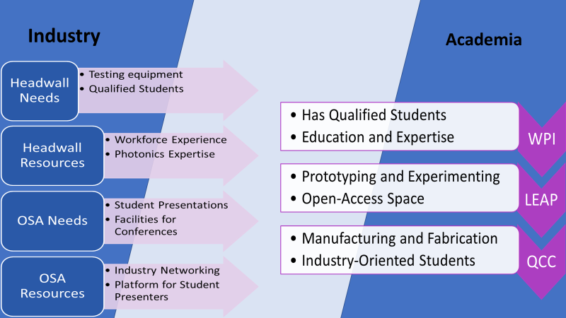
Industry and Academia Flow Diagram Figure 24
Chapter 6: Discussion
From the data collection carried out through B and C term we got a large enough sample to start drawing trends on how relations between Academia and Industry will continue. Our data from Academia contains a vast majority of QCC students who have a great interest in working with WPI. Industry data although small shows trends that we can explore in the coming years as LEAP establishes itself as a player in the Photonics field. Our Industry data comes from separate areas of outreach giving us a wide scope on the impact LEAP can make. However potential biases from individual companies means our data cannot be applied to most if not all Industry in the area. Throughout the discussion on the impact we can have on Industry should be kept to only the interested companies we spoke to and their affiliated areas that responded. For example, the needs of an Applications Engineer of Headwall cannot be met with the same resources as the Applications Engineer of MRSI systems. While this statement may be true, our evidence cannot back this up. The rest of this chapter will explore the Impacts our data sources had on the study and the resulting impact LEAP can have on them. Section 6.1 Focuses on the QCC impact, Section 6.2 on the various Industry Impacts and Section 6.3 will provide a comprehensive list of suggestions for LEAP and concluding the study.
  - Discussion based on QCC
From our data gathered during B term at QCC we were able to identify the types of students who would be interested in working with LEAP. From the Industry we also got a reception on how QCC students would be accepted into the Industry in today’s climate. The main takeaways from this study are as follows:
- Our Study’s information questions how QCC students will fit into the mold of LEAP. While LEAP gives QCC students a huge opportunity to work closely with the Industry, the need for students without a bachelor’s is quite low. This was a sentiment that was given from Dr. Carson Roberts of Headwall Photonics. This makes QCC students a tough sell to companies for employment. However, QCC students should not be dismayed from utilizing LEAP for equipment training as the prototyping and fabrication sector does not require a Bachelors, giving us an avenue for QCC students to pursue.
- From the results section we were easily able to identify the characteristics of the two distinct types of students that come through QCC. Students in Electrical Engineering classes from Professor Longacre are our target audience. With the role Jacob Longacre plays in the QCC/WPI partnership, his students are told about the LEAP facility and how their education on the current class subject can be expanded through what LEAP can offer.
- Engineering transfer’s levels of interest teach us that LEAP projects will not look for QCC students from this group. However, these students will be continually chosen for transfer into the school for their 4-year bachelors. The most popular option for transfer among these students was WPI with Amherst and Lowell being the other front runners. Although some of the students are more concerned with finishing in two years, the classes surveyed were students with a preference for transferring to continue their education. This means LEAP seminars can get students in the door since they want to continue at WPI.
- With WPI ‘s resources as a huge selling point to the seminars, students at QCC are motivated to show up to get a foot in the door at WPI. Since Engineering Transfer students want to be at WPI, we can give the students the time necessary to study Integrated Photonics concepts and use the facility to help build a career.
- With earlier courses wondering how Quantum Physics and Computing differs from Integrated Photonics, QCC outreach seminars through LEAP can avoid confusing perspective students. With a PowerPoint presented to educate students on the LEAP facility before distributing surveys, the hope was that questions could be answered during the PowerPoint so optional questions could have more specific answers. Unfortunately, students’ questions during the presentation were few and optional questions were met with more questions that could have been answered during the presentation.
While Engineering Transfers show a high interest in WPI, Jacob Longacre’s students are more valuable to LEAP’s manufacturing and fabrication efforts. In the results section Transfers were more concerned with the Knowledge of Topics related to Photonics while the Electronics Engineering students were more interested in learning how to operate the state-of-the-art equipment. Considering that LEAP wants the students to be trained on this equipment, broadcasting to the students how they can learn to operate the equipment at LEAP, we can get these eager students into the door. Moving forward the two main forms of outreach to QCC should be LEAP driven seminars at WPI informing the students on the various applications of Integrated Photonics in the industry and showing students how to operate the state-of-the-art manufacturing equipment at the LEAP facility.
6.2 Suggestions for Future Involvement with Industry
From the industry feedback, we got to identify their actual needs and resources. While the resources we wanted to draw upon from industry were available for LEAP, the needs of the industry are where our focus should be for a healthy relationship moving forward. In the following sections we will identify the major areas of impact LEAP can have on companies and provide specific suggestions and solutions.

6.2.1 MRSI Impact
MRSI systems feedback during the break between B and C term was our first feedback from the industry. This feedback from our iMAPS conference was centered around a survey that focused on what companies look for in potential hires. Because this was an early version of the survey, our feedback was limited to critiquing what the industry wants from the students.
- The most important answer that was provided was the relationship MRSI naturally sees between Academia and Industry. The relationship he sees goes as follows, “The advancement of technology from Academia drives innovation that Venture capitalists fund spawning growth. Once an economically feasible path is determined, the initiation of standards will optimize efficiencies creating the product.” This relationship makes sense but questions if MRSI thinks LEAP is a correct addition.
- Since the venture capitalists are the natural middleman between Academia and Industry, the addition of LEAP could be mistaken for a replacement of venture capitalists. When advertising the facility to industry, the promoted features should be the open space for industry feedback on innovation and allowing involvement during the early stages of discovery.
6.2.2 Headwall Discussion
Our second industry outreach, Headwall Photonics, made it clear that while they understand student projects are a part of the WPI curriculum, the prospect of a 3-term student project to them does not seem like a good use of time. At the top of the study we made our surveys thinking student projects were an enticing offer we could give to companies. While MRSI’s feedback was focused on how students can be better with communication skills, Headwall’s discussion focused on what makes LEAP appealing. Instead of student projects, the open space prototyping and testing capabilities are what interested Headwall.
- For a mid-size company transitioning to turn-key systems an open space facility’s strongest draws are their prototyping and machining capabilities. Interest in perfecting their spectrometers in the drone application is shown through the list of machines which fortunately are all on the list of equipment LEAP will have in its open workspace.
- Alongside the equipment, their shift in focus as a company makes Photonics students with a background in software development desirable. In the future, when working with companies like Headwall, introducing our students to software development in the Photonics industry should be a focus of the facility.
- Through a clearer understanding of the practical application industries use when considering facilities like LEAP, we can better predict the aspects of LEAP we need to advertise to these Industries. This includes catering student projects to industry needs and focusing open space to prototyping and experimenting to draw in industry interest.

6.2.3 CYC Tech and the effect on OSA/NES
After speaking with Dr. Smith of CYC, the impact LEAP can have has already been in the works during the duration of the study’s timeline. Allowing for OSA/NES to utilize the LEAP facility for conferences was a big step forward for OSA/NES. OSA/NES primarily wants access to the students from the facility. With student presentations and projects at these meetings it allows for both groups to benefit from the networking conference meetings and talks OSA/NES is best known for. The two main suggestions for LEAP from CYC Tech and OSA/NES are as follows.
- In the future, OSA/NES hopes LEAP creates an atmosphere that promotes a healthy interest in Photonics from students. With student outreach from LEAP, the exposure to OSA/NES gives students a rare opportunity to network with companies in a field before they finish their undergraduate degree.
- While student projects are not advised to be the main focus of LEAP, the opportunity to have student projects financed by a company they get to network with can bring students into LEAP and OSA/NES and help boost membership and attendance at OSA/NES meetings.
By helping OSA/NES, LEAP can see a boost in Industry relations which is even exemplified through this study. By implementing these suggestions and keeping OSA/NES close to LEAP we can expect a boost in relations between the Industry and students through student presentations. Having access to an organization very willing to have students come to their conferences and get the exposure they need is an invaluable resource.
6.3 Suggestions Developed for the Industry and Academia
After identifying the societal impact LEAP can have on the industry and academia, the main takeaway of the study is the suggestions and solutions we can provide. With these suggestions we hope to provide a clear understanding of where LEAP will impact this field the most both in terms of the societal impact and the technological advancement and impact the open space model will provide. By splitting the suggestions up by group we attempt to make this paper user friendly to anyone from either group who wants to understand the potential impact or assumed impact based on the current climate in Central MA.

6.3.1 Academia (QCC/WPI LEAP) Suggestions
The suggestions for Academia focus on what tools we need to provide to the students from our industry response. Based on the QCC surveys, we crafted suggestions for the schools to help develop better students for LEAP to utilize. While the LEAP facility will have state of the art equipment and industry involvement, the students are what facilitate the change. Student interest in the facility must be high enough to ensure the facility can operate efficiently. The following are suggestions we provide for Academia based on the data sources from our study.
- In the coming years LEAP should put an emphasis on finding an area where these students can fit in and fully utilize LEAP. With a QCC partnership, a potential issue that can surface is marketing Associate degrees to mid-size companies. When speaking to Dr. Carson, providing the suggestion that they would be more involved in the prototyping and experimenting technology at LEAP. Since Headwall Photonics testing facilities do not require a bachelors, pushing QCC students towards this equipment can help benefit the facility and the QCC students in the future.
- From our industry feedback, the students that LEAP create need to have great communication skills, be open to other areas like Software Development, and have an interest in networking conferences like OSA/NES and iMAPS. This will make our students easy to market to this ever-changing field of Photonics. By shaping these students, LEAP can have a positive societal impact on the industry and develop a better workforce out of college for Photonics.
- In the future, LEAP’s aim should be to provide and promote Industry and Academia partnerships in the open space without the need to have student projects be the only avenue. The experimental and prototyping capabilities can help photonics industries in the area have an avenue to work alongside students in the discovery of new technologies.
- With Industry involvement early on in discovery the hope is the refinement period when creating a product can be limited, making product development faster. When companies like Headwall are utilizing Lidar and Spectrometry, a technology founded in the 60s, the hope is that product development will make Academic discoveries into practical applications much faster with Industry feedback and involvement. The hope is that LEAP will make a positive societal impact on the Photonics Industry through a molding of involved students and advertising the right aspects of LEAP.

6.3.2 Industry Suggestions
From our meetings and conferences attended as data sources for our industry involvement, we established a good understanding of where the industry stands in this field at this time. From these data sources we reviewed after our QCC surveys, the general idea was to see how much involvement the Industry was willing to have and what resources they wanted to give. Our suggestions are tailored based on the reception we received from the Industry and should exemplify a reasonable list of requests to make from the Central MA Industry. After reviewing the data sources, we had access to during our study, our suggestions we came up with are as follows.
            - While LEAP has the equipment and open space to help spawn growth between Academia discovery and Industry innovation, It is the industry involvement in these projects and equipment usage that can help facilitate a faster life cycle of a potential product. The involvement of Industry in student’s access and use of LEAP can be a beneficial addition to the effect LEAP can have on the student.

            - One of the biggest takeaways from this project was that student projects needed restructuring or flexibility on the students end for them to work. From the Industry we hope to get feedback on what timelines they wish their projects to adhere to and what size they want their student teams to be.

            - Because this LEAP facility is a new tool the Central MA photonics field has access to, Industry feedback while involved would be suggested. In a time where the goals of a company can alter and shift entire areas of the company, so will LEAP in order to meet these shifts in the growing industry.

            - Because conferences like OSA/NES and iMAPS are looking for student presentations to take up an early part of their meetings, There should be a way to market and incentivize these meetings further. The iMAPS conference gave our group an award recognizing the efforts of our project back in A term which helped our student members stay focused on the project goals.

Chapter 7 Conclusion
7.1 Conclusion of Work
In conclusion, the intended impact of this study was to benefit LEAP as it approaches its official launch. The Industry in the area show high levels of excitement when told what LEAP’s goals are for the Industry and Academia relationship. From the various conferences attended and people we spoke to, the suggestions we provide are easy to implement into the agenda of both the Industry and LEAP. While we accomplished our goal of gathering industry data from sources in distinct areas of the industry ladder, a further study should be made once LEAP is established. This idea will be covered in Section 7.3 Outlook. The relationship between the Industry and Academia will undergo a radical shift once LEAP is established and brings the two together. With this shift a further study should be conducted so the Industry’s initial needs are met and our resources available continue to meet these needs. While company goals will shift and new technologies are discovered, the heavier involvement of the Industry in discovery and Academia in the testing and prototyping of current products can result in a melding of future ideas with present products. This potential impact will require further research.
7.2 Contribution of Team
The work done on this study by the two student members are as follows: Donald Thomas Coley went out to QCC to survey students, attended iMAPS poster presentation and both OSA/NES meetings, toured the Headwall Photonics Facility, met with Ruth McKeogh to discuss the IRB form and completed the IRB form and worked on this paper’s chapters 3-7. The terms of his IQP were A, B and C term. Ashley Defrancesco went out to QCC to survey students, attended iMAPS poster presentation, met with Ruth McKeogh, worked on this paper’s chapters 1-2 and completed paper references. Her terms were A, and B for 2 course loads. Our IQP professor Yuxiang Liu helped us at every step and attended the OSA/NES meeting at LEAP and the Headwall Photonics tour.
7.3 Outlook
To conclude this study our outlook focuses on what was learned. Considering this project was done by two transfers students fresh into WPI, the lessons learned outside of the suggestions in chapter 6 concern the utilization of the resources of WPI. During the infancy of the study we needed to not only craft our study’s goals but also present the study to an Internal Review Board at WPI. The process of multitasking and going through the necessary procedures and speaking to the right people within a timely manner helped adjust the student team to its application in real life. The transition from QCC student to WPI helped us gather over 50 individual student surveys to give us a quantitative basis for identifying the student that would be interested in LEAP. Our lack of established roots in WPI was evident in our lack of surveys from WPI students. As time has gone on though, we got a few surveys to compare to our QCC students. Because of the nature of the student surveys coming from students also interested in Integrated Photonics at WPI, the only useful correlation we could draw was their interest in classes and courses to learn more about the field for their individual projects. One potential extension to this study we suggest would be a deeper dive into the WPI students and their interest in LEAP and correlate this to QCC students in a similar circumstance.
In the future, this study’s suggestions hope to help steer the direction of LEAP towards a more successful establishment and a better relationship with the Industry. Through conferences like OSA/NES and iMAPS we have access to industry input necessary to monitor the effect of LEAP. An extended study on these conferences in the future could provide LEAP the necessary information to continue a positive societal impact during its inaugural years. If this study is continued utilizing the same data sources with an established focus from LEAP, the societal impact LEAP could have in the future could be quite remarkable and help close the Industry and Academia gaps present.
Acknowledgements
Many Thanks go out to iMAPS for hosting our poster and allowing us to present our work in its infancy; OSA/NES for giving us a platform to understand how Networking is done in this field; Ruth McKeogh for guiding us through the IRB process and helping to alleviate the stresses our student team were feeling at this stage in the study; James Eakin for organizing and inviting us to OSA/NES meeting at LEAP; Jacob Longacre of QCC for giving us the platform to survey QCC Students; Dadbeh Bigonahy for allowing us to take time out of his classes for us to present our survey; Dr. Carson B. Roberts for the generous tour and time out of his day for an interview; Dr. Stephen Smith for an in person discussion on OSA/NES; LEAP WPI/QCC for access to the facility and their staff when pitching the facility; and finally many thanks go out to Yuxiang Liu the study’s advisor. His mentorship through every step of the process gives his as much credit to this paper as the student team. This study would not be the same without anyone above.

References
[1]Baino, F. (2019). Bioactive Glasses and Glass-Ceramics for Ophthalmological Applications. Biomedical, Therapeutic and Clinical Applications of Bioactive Glasses, 357–382. doi: 10.1016/b978-0-08-102196-5.00013-6
[2]Buschow, K. H. J. (2001). Encyclopedia of materials: science and technology. Amsterdam: Elsevier.
[3]Dicing (Kiru) - Blade Dicing. (n.d.). Retrieved from https://www.dicing-grinding.com/services/dicing/.
[4]Doi, T. K., Marinescu, I. D., & Kurokawa, S. (2012). Advances in Cmp/polishing technologies for the manufacture of electronic devices. Amsterdam: Elsevier/William Andrew.
[5]Fabrication Process Produces Nanostructures for Electronic Devices. (2018, May 30). Retrieved from https://www.techbriefs.com/component/content/article/tb/techbriefs/electronics-and-computers/29031.
[6]Hoshino, K., & Zhang, J. X. (2019). Molecular Sensors and Nanodevices. Principles, Designs and Applications in Biomedical Engineering. doi: 10.1016/c2017-0-02290-5
[7]Hui, R. (2020). Introduction to fiber-optic communications. London, United Kingdom: Academic Press.
[8]Inmann, A., & Hodgins, D. (2013). Implantable sensor systems for medical applications. doi: 10.1533/9780857096289
[9]Koster, G., Huijben, M., & Rijnders, G. (2015). Epitaxial growth of complex metal oxides. Amsterdam: Elsevier Woodhead Publishing.
[10]Laboratories and Facilities. (n.d.). Retrieved from https://www.wpi.edu/research/core-research-facilities/leap/laboratories-and-facilities.
[11]Lab for Education & Application Prototypes. (n.d.). Retrieved from https://www.wpi.edu/research/core-research-facilities/leap.
[12]Rickman, A. (2014). The commercialization of silicon photonics. Nature Photonics, 8(8), 579–582. doi: 10.1038/nphoton.2014.175
[13]Wang, J., & Long, Y. (2018). On-chip silicon photonic signaling and processing: a review. Science Bulletin, 63(19), 1267–1310. doi: 10.1016/j.scib.2018.05.038
[14]Wallace, J. (2018, June 1). Silicon photonics fabrication now uses latest CMOS process. Retrieved from https://www.laserfocusworld.com/optics/article/16555299/silicon-photonics-fabrication-now-uses-latest-cmos-process.
[15]Wasa, K., Kanno, I., & Kotera, H. (2012). Handbook of sputtering technology: fundamentals and applications for functional thin films, nano-materials and Mems. Waltham: William Andrew.
[16]What is telecom optical wavelength bands ? (n.d.). Retrieved from https://www.fiberlabs.com/glossary/about-optical-communication-band/.
[17]Yilbas, B. (2019). Self-Cleaning of Surfaces and Water Droplet Mobility. doi: 10.1016/c2017-0-02187-0
[18]Zhang, Z., Hu, X., & Wang, J. (2015). On-chip optical mode exchange using tapered directional coupler. Scientific Reports, 5(1). doi: 10.1038/srep16072
[19]Zhou, Z., Yin, B., & Michel, J. (2015). On-chip light sources for silicon photonics. Light: Science & Applications, 4(11). doi: 10.1038/lsa.2015.131

Appendix
Poster Presented at the iMAPS Conference
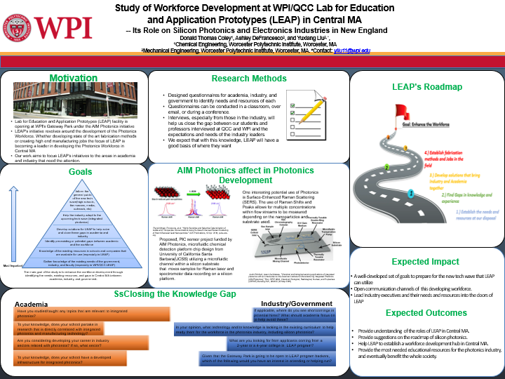

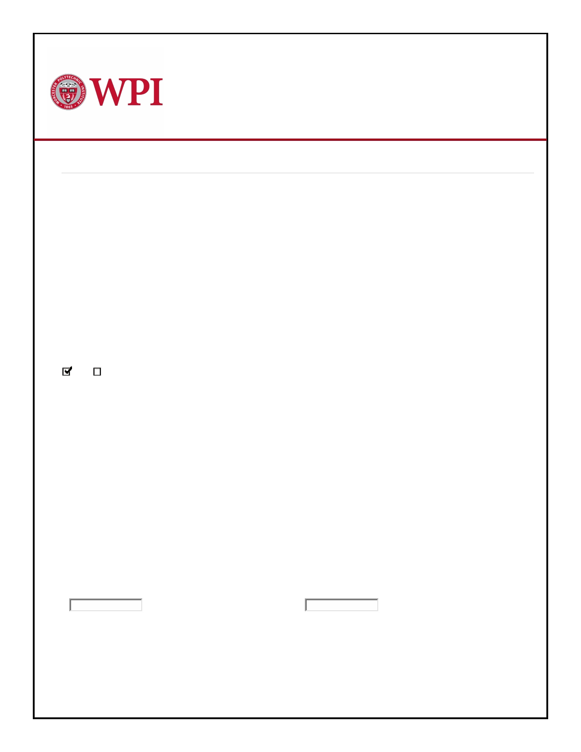IRB Application
Updated By: Donald Coley 26-Sep-2019 10:02:40 PM

GENERAL INFORMATION

APPLICATION TYPE

R e c o r d # : IRB-20-0062

* What type of application are you submitting?
Exemption Application for student project involving minimal or no risk

* There are 3 application types available

Use this application for student projects involving interviews, surveys, focus groups, observation of public behavior or benign
behavioral interventions, where there is minimal risk to research subjects. "Minimal risk" means that the risks to research subjects are no greater than those ordinarily encountered in daily life. Benign behavioral interventions include testing on-line games, websites and
other behavioral studies that are brief, harmless, and could not be embarrassing or offensive. (This exemption is not appropriate for
studies that involve survey/interviews of children. Please select the standard application.)

* Is this a student project?
Yes No

* Student project type:
Undergraduate project (MQP, IQP, Suff., other)

* (Specify):
Interview and Survey

* Title of Study
Integrated Photonics Workplace IQP

* Locations of Research: (If at WPI, please indicate where on campus. If off campus, please give details of locations.)
WPI and QCC primarily with some government and industries in the Central Massachusetts area. The campus
research will be primarily on students in the up and coming field and the faculty who are interested in this field.

Anticipated Dates of Research:

* Start Date: * Completion Date:
22-Aug-2019 06-Feb-2019

* Which of the following categories best describes your study?
Social Sciences, management and other non-biomedical disciplines

* Purpose of Study:
(Please provide a concise statement of the background, nature and reasons for the proposed study. Insert below using non-technical
language that can be understood by non-scientist members of the IRB.)
The purpose behind our study is to identify the needs, resources and any gaps between the current academia and industry behind this new manufacturing wave of Integrated Photonics. The data collected will help our LEAP (Lab for Education and Application Prototypes) opening in Gateway Park better prepare students to meet industry demands.

* Has an IRB ever suspended or terminated a study of any investigator that will be listed on this protocol?
Yes No

Please indicate if your study involves:

* Investigational drugs or investigational medical devices
Yes No

* Hazardous Materials
Yes No

* Special diets
Yes No

* C o l l a b o r a t i n g I n s t i t u t i o n s : (Please list all collaborating Institutions.)
QCC

FUNDING INFORMATION

FUNDING INFORMATION

How will the study be funded?

Grant/Contract/Subaward (Federal)

Grant/Contract/Subaward (Non-Federal)

Departmental funds

Faculty start-up or incentive funds

Investigator out-of-pocket

No funding anticipated

STUDY PERSONNEL

All study personnel having direct contact with subjects must take and pass a training course on human subjects research. There are links to web-based training courses that can be accessed under the Training link on the IRB website https://www.wpi.edu/research/support/compliance/institutional-review-board.

Name
C o l e y , Donald

Involvement Start Date
14-Sep-2019

End Date

Role
Student Investigator

Please upload a copy of your relevant HS training certificate(s):

Name
Defrancesco, Ashley

Involvement Start Date
14-Sep-2019

End Date
13-Dec-2019

Role
Student Investigator

Please upload a copy of your relevant HS training certificate(s):

Name
Liu, Yuxiang

Involvement Start Date
14-Sep-2019

End Date
06-Feb-2020

Role
Principal Investigator

Please upload a copy of your relevant HS training certificate(s):

STUDY INFORMATION

* Expected Research Subjects:
(e.g. museum visitors under the age of 12)
The research subjects of our study will be WPI and QCC students and faculty within the Integrated Photonics academic
ecosystem alongside government officials and people within the industry . Officials in government and the industry tied to this
movement in AIM Photonics lead by LEAP will be gathered from various conventions and get togethers such as during
iMAPSNE (International Microelectronics Assembly and Packaging Society) and a special unveiling of the LEAP chapter at Gateway Park where government officials involved in the funding and overseeing of this chapter will be there to meet with students and faculty at the school.

* Project Mission Statement and Objectives:
To identify the needs of Integrated Photonics and help our students create and grow the manufacturing wave that the field will
r e q ui r e .

* Brief Methods Listing:
(e.g. "Survey of public to ascertain knowledge and opinions about climate change" or "Interview of professionals working on climate
change regarding effective city climate change program")
Surveying students and faculty to see where academics in this area are in relation to standards set by LEAP. Survey
government and industry officials associated with funding and maintenance of LEAP program to see where their focus for this
chapter should be. Surveys will be done through Questionnaires either by hand distributed in classrooms or online through
hyperlinks sent via email. Interviews will be carried out at the conferences and government events we will attend throughout the
duration of our project

* Does the proposed research involve vulnerable research subjects?
(e.g. children, prisoners, students, persons with mental or physical disabilities)
Yes No

* D o e s t h e r e s e a r c h i n v o l v e h u m a n s u b j e c t s i n w a y s o t h e r t h a n as participants in interviews, focus groups, or surveys?
(e.g. observation of public behavior, use of archived data or experimental procedures)
Yes No

* Will the researchers collect information that can be used to identify the subjects?
Yes No

* Could the disclosure of a human subject's identity and responses place the subject at risk of criminal or civil liability
or be damaging to the subject's financial standing, employability or reputation?
Yes No

* W i l l t h e r e s e a r c h e r s d i s c l o s e t h e i d e n t i t y or t h e i n d i v i d u a l r e s p o n s e s o f a n y h u m a n s u b j e c t s ?
(e.g. by quoting an individual, whether or not identified by name or title)
Yes No

Appendix 1

Attach the statement of research methods or draft methodology chapter:

Attach a draft of surveys and/or a list of questions to be used for interviews or focus groups:

If sample questions are included in Appendix 1, Methodology chapter, indicate the page numbers here:

ADDITIONAL DOCUMENTS

If you have any additional documents you would like to include with your application, you can upload them here.

*

*

*

*

*
INVESTIGATOR'S ASSURANCE

All participants in this research project are agreeing to abide by the following instructions:

You agree to inform subjects orally or in writing that:
Participation in the research is voluntary .
Participants may end their participation at any time.
Participants need not answer every questions in an interview or suvey .

If your research is a n o n y m o u s , y o u a l s o i n f o r m s u b j e c t s t h a t y o u a r e n o t c o l l e c t i n g n a m e s o r a n y i d e n t i f y i n g information from them.

If your research is c o n f i d e n t i a l , y o u i n f o r m s u b j e c t s t h a t n o i d e n t i f y i n g i n f o r m a t i o n w i l l b e d i s c l o s e d w i t h individual responses.

If your research is NOT completely anonymous and confidential, you must obtain each subject's permission to
publicly disclose his or her identity and/or responses. All requests for anonymity and confidentiality must be honored. The subject must be offered the opportunity to pre-approve the publication of any quoted material.

I certify that I have added all Study Personnel, including students, to the study personnel page.

WPI
Worcester Polytechnic Institute
Research
P: 508-831-5000 https://www.w
E m a i l - IRB@wpi.edu

Appendix 1

EForm Name: IRB Application
Page : Study Information
Section:
Question: A tt ac h th e st at em en t of r es ea rc h me th od s or d ra ft m et ho do lo gy c ha pt er :
F i l e N a m e: Research Methods.pdf
Appendix 2

EForm Name: IRB Application
Page : Study Information
Section:
Question: At ta ch a dr af t o f su rve ys a nd/ or a li st o f q ue st ion s to be u se d f or i nte rv ie ws or f ocu s gr oup s:
F i l e N a m e: R ou g h D ra f t of P o t en t i a l S u r v ey Q u es t i o n s. p d f
Poster Presented at February Board of Trustee Meeting

