  - Day 1 Class Activity/ HW1

Restoration Success Case Study
Group Project
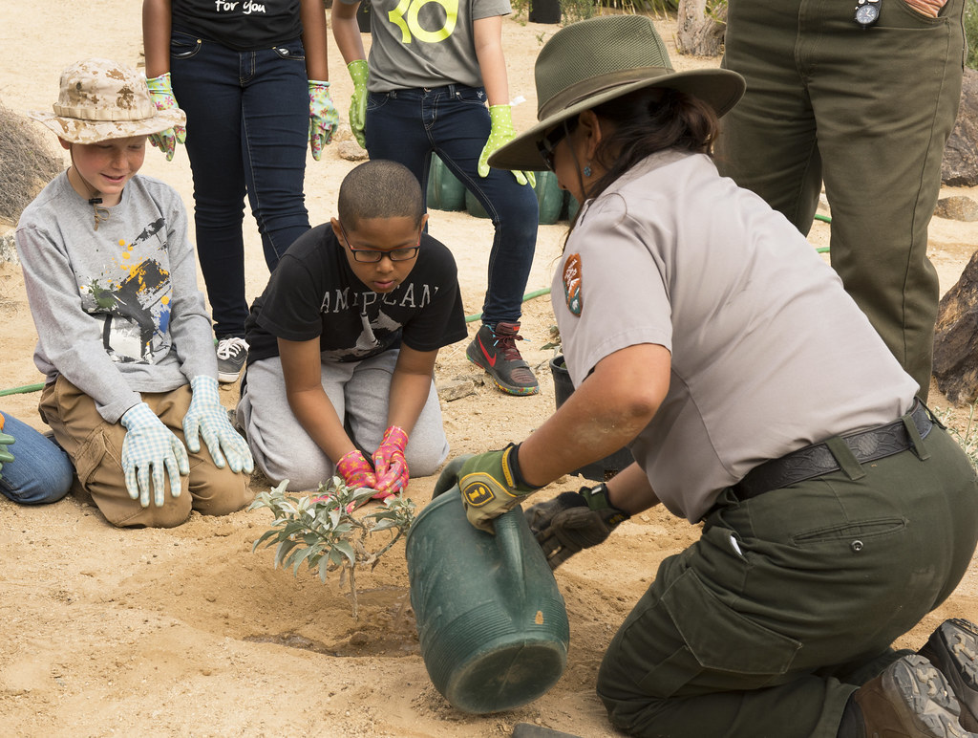
"The Restoration Ecology Ranger Giving Instructions" by Joshua Tree National Park is marked with CC PDM 1.0.

Overview:
Now that you have a basic understanding of restoration ecology and the practices and principles it entails, it’s your turn to investigate a real-life example! Each group is tasked with reading an assigned case study on a successful restoration project and will become experts on the matter. Create a short, 5-10 minute slideshow detailing your case and the following requirements:

Questions/topics to Address:
- Name your ecosystem case: what is it and where?
- What type of ecosystem is in question? Provide some background it:
    - Physical description/characteristics
      - Climate
      - What types of plants/animals does it foster?
      - Any special abiotic factors?
    - Parts of the world it’s found in/its range & distribution
    - Does it provide any special ecosystem functions/processes?
  - Dive into your specific case: what lead to its degraded state?
    - History/backstory of your specific site
  - What was done, or what steps were/are being taken to restore your ecosystem?
    - Were there any big struggles/obstacles in the way?
    - Was it costly? Time-consuming/slow? Tedious?
  - What is the current state of the ecosystem if you can find it?
  - Any additional important points or key concepts

Assigned Case Studies:
- Riparian reforestation in South Africa
- Soil & water table restoration in India
- Quarries rehabilitation in Albania
- Coastal restoration in Puerto Rico
- Oak savannah restoration in Minnesota

Rubric:
 | Poor | Sufficient | Excellent
Content | Depth and complexity of  information is weak for 10-minute presentation  Significant time spent on  repetition and/or non-specific information | Depth and complexity of information is reasonable for 10-minute presentation  Minimal time is spent on repetition and/or non-specific information | Depth and complexity of information is especially strong for 10-minute presentation. All time used in on-topic, relevant information
Clarity | Topic is not clearly described verbally and/or on slides  Information presented is not clearly explained and/or is not relevant to the topic. Visual and/or text information in the slides is confusing with or without verbal explanation | Topic is clearly described verbally and/or on slides  Information presented is mostly well explained either verbally or on slides,  most information on slides is clearly relevant. Verbal and visual information is clear and understandable | Topic is clearly described verbally and/or on slides. Information presented is exceptionally well  explained either verbally or on slides, all  information on slides is clearly relevant and is  explained verbally  Verbal explanations are clear and understandable
Presentation | Presentation is not well-  organized, team shows lack of preparation through confusion over roles or  lack of mastery of information, with significant difficulty responding to audience questions | Presentation is mostly well-organized, team shows some evidence of preparation, with roles clearly defined and all information mastered by at least one team member  Most audience questions can be answered, but not all team members have equal mastery over all parts of the  presentation | Presentation is very well-organized, team shows evidence of substantial preparation, with roles clearly defined, and all team members are well-versed in all components of the presentation. Most audience questions can be answered thoroughly, with evidence that all team  members mastered a broad scope of the information.

