Project Number: DZT 2103

Stock Market Simulation

An Interactive Qualifying Project Report:
Submitted to the Faculty of
WORCESTER POLYTECHNIC INSTITIUTE
In partial Fulfillment of the requirements for the
Degree of Bachelor of Science
BY:

Adam Szatkowski
Cam Morreale

Submitted:

May 4, 2022

Approved by Professor Dalin Tang, Project Advisor

This report represents the work of two WPI undergraduate students submitted to the faculty as evidence of completion of a degree requirement. WPI routinely publishes these reports on the web without editorial or peer review.

Abstract
The goal of this project is to learn stock market trading strategies and get experiences by simulation. A seven-week stock market simulation was conducted using the simulation engine Investopedia. This project was completed by 2 members who used two investing strategies to try and beat the market in a short-term time span. One member used Value and Recommendation trading for Simulation 1 and Cryptocurrency trading for Simulation 4. Another member used Position trading for Simulation 2 and Speculative trading for Simulation 3. Trading decisions were made using both fundamental analysis as well as deeper analysis based on each strategy that led to the results of +10.98% for Simulation 1, +9.20% for Simulation 2, +24.73% for Simulation 3 and finally +8.82% for Simulation 4. Performances from all the four simulations were better than that from the overall market which by the end of the simulation was only up 1.36% by the S&P500. By experimenting with multiple investing techniques, the members of the project could build the groundwork for future investments.

Acknowledgements
We would like to dedicate the success of our Interactive Qualifying Project to all the individuals and institutions that made it possible to get here. The biggest thank you we would like to give is to Professor Dalin Tang whose assistance and patience was instrumental in making this project happen. Without his continuous support and guidance there would have not been a project to show for. Additionally, Adam would like to thank his close friend, Marcin Knara, who inspired him to become a more experienced investor. We would also like to express our gratitude towards WPI for providing us with the time in our busy schedules to pursue a project both members were passionate about completing. Lastly, none of this would be possible without the continuous moral and financial support of our parents who helped us get where we are. Once again, we’d like to give a huge thank you to all of those who made it possible for us to get here.

Table of Contents
Abstract……………………………………………………………………………………….....2
Acknowledgements………………………………………………………………………….......3
List of Figures:….….…………………………………………………………………………....7
List of Tables:………..……………………………………………………………………….....10
Chapter 1: Introduction………………………………………………………………………..12
1.1 History of the Stock Market………............……………………………………….12
1.2 Stock Market Crashes…………………….................……………….…………….13
1.3 Stock Market Indexes and What They Mean……............……………………….16
1.4 Stock Market basics…………....……………...........……………………………...20
Chapter 2: Trading Strategies and Simulation Plans……………………………...………...25
2.1 Investopedia/Cryptoparrot – The Chosen Simulation Engine…………….…….25
2.2 Putting our Trust in Investopedia’s Ticker Chooser………...............…………..31
2.3 Speculative Trading………..………………………........………………………….32
2.4 Position Trading………………………………………..........…………………...…33
2.5 Cryptocurrency Trading……………………………..........………………………34
Chapter 3: Stock selections and research..................................................................................35
3.1 Simulation 1 Analyst Recommendations…..……....……………………………...35
3.2 Simulation 2 Speculative Trading………………………..………………………..38
3.3 Simulation 3 Position Trading………......…………………………………………39
3.4 Simulation 4 Cryptocurrency………......…………………………………….…….41
Chapter 4: Simulation 1 Analyst Recommendations and Value Trading……….….………44
4.1 Week 1.........................................................................................................................44
4.2 Week 2.........................................................................................................................45
4.3 Week 3.........................................................................................................................47
4.4 Week 4.........................................................................................................................48
4.5 Week 5.........................................................................................................................48
4.6 Week 6.........................................................................................................................49
4.7 Week 7.........................................................................................................................50
4.8 Week 8.........................................................................................................................50
Chapter 5: Simulation 2 Speculative Trading………..…...………………….…………….....52
5.1 Week 1.........................................................................................................................52
5.2 Week 2.........................................................................................................................52
5.3 Week 3.........................................................................................................................56
5.4 Week 4.........................................................................................................................57
5.5 Week 5.........................................................................................................................60
5.6 Week 6.........................................................................................................................61
5.7 Week 7.........................................................................................................................65
5.8 Week 8……………………………………………………………………………….66
Chapter 6: Simulation 3 Position Trading………………...………………….………..….…..67
6.1 Week 1.........................................................................................................................68
6.2 Week 2.........................................................................................................................68
6.3 Week 3.........................................................................................................................71
6.4 Week 4.........................................................................................................................72
6.5 Week 5.........................................................................................................................74
6.6 Week 6.........................................................................................................................76
6.7 Week 7.........................................................................................................................77
6.8 Week 8……………………………………………………………………………….78
Chapter 7: Cryptocurrency Simulation………..…………………………….………..……....80
7.1 Week 1.........................................................................................................................80
7.2 Week 2.........................................................................................................................81
7.3 Week 3.........................................................................................................................82
7.4 Week 4.........................................................................................................................83
7.5 Week 5.........................................................................................................................83
7.6 Week 6.........................................................................................................................84
7.7 Week 7.........................................................................................................................85
7.8 Week 8.........................................................................................................................86
Chapter 8: Analysis and Comparison…..……………………….…………………….………87
8.1 Profit/Loss for Each company…………………………………………………...…87
8.2 Option Vs Stock Data Analysis…………………………………………………….94
8.3 Profit Vs Time Comparison………………………………………………………...98
Chapter 9: Conclusion………………………………...………………………………..……..100
References:……………………………………………………………………………………..101

List of Figures:
Figure 1.2.1 Dow Jones Industrial Average During and After the Great Depression.....................14
Figure 1.3.1 The Current S&P500 Companies and Their Weight Visualized.................................19
Figure 2.1.1 Opening Screen Investopedia.....................................................................................25
Figure 2.1.2 Investopedia Trading Screen......................................................................................26
Figure 2.1.3 Research Screen.........................................................................................................27
Figure 2.1.4 Ticker Example..........................................................................................................28
Figure 2.1.5 Fundamental Data Example.......................................................................................29
Figure 2.1.6 Opening Screen for CryptoParrot...............................................................................30
Figure 2.1.7 Make a Trade Screen..................................................................................................31
Figure 3.1.1 CNC Chart Marked with Dates of Earning Calls.......................................................35
Figure 3.1.2 GPRO Highs and Lows..............................................................................................37
Figure 3.2.1 Bitcoin Stock to Flow Model.....................................................................................39
Figure 3.3.1 SLB Price History Over the Past 40 Years..................................................................40
Figure 3.3.2 Crude Oil Price Over the Past 40 Years......................................................................41
Figure 3.4.1 Bitcoin Chart 1 Year...................................................................................................42
Figure 3.4.2 Ethereum Chart 1 Year...............................................................................................42
Figure 3.4.3 Litecoin Chart 1 Year.................................................................................................42
Figure 4.1.1 GameStop Chart Nov-Feb..........................................................................................44
Figure 4.2.1 Intel Chart Over 4 Years.............................................................................................46
Figure 4.2.2 AMD Chart Over 5 Years...........................................................................................46
Figure 4.2.3 NVIDIA Chart Over 5 Years......................................................................................47
Figure 4.5.1 October 2020 - March 2022 PLTR Chart...................................................................49
Figure 5.2.1 DKNG Yearly Chart...................................................................................................53
Figure 5.2.2 GME 5-Year chart......................................................................................................55
Figure 5.2.3 AMC 5-Year chart......................................................................................................55
Figure 5.4.1 Bitcoin Forms Bearish Head and Shoulders Pattern...................................................58
Figure 5.4.2 Double Top Pattern With Lower Highs and Lower Lows, a Bearish Indicator…………….…………………………………………………………………...……….59
Figure 5.4.3 Bearish Double Top Pattern Forming for TSM...........................................................59
Figure 5.5.1 6-Month SPY Chart…………………………………………………………………61
Figure 5.5.2 25-Year Inflation Chart……………………………………………………………..61
Figure 5.6.1 6-Month SPY Chart…………………………………………………………………62
Figure 5.6.2 FCEL 6-Month Chart……………………………………………………………….63
Figure 5.6.3 1-Year PLTR Chart…………………………………………………………………64
Figure 5.6.4 6-Month GME Chart………………………………………………………………..65
Figure 6.2.1 BABA Free Cash Flow From 2013 to 2022 (Projected) in Billions............................69
Figure 6.2.2 BABA Discounted FCF Valuation.............................................................................69
Figure 6.2.3 BABA Yearly Chart...................................................................................................70
Figure 6.2.4 TLRY Yearly Chart....................................................................................................71
Figure 6.3.1 Yearly Chart for SPY..................................................................................................72
Figure 6.4.1 AMD Chart.................................................................................................................73
Figure 6.5.1 SPY Chart...................................................................................................................75
Figure 6.5.2 PLTR Chart................................................................................................................75
Figure 6.7.1 6-Month PLTR Chart……………………………………………………………....78
Figure 7.2.1 Monero (XMR) 2022 Chart…………………………………………………………81
Figure 7.2.2 Ethereum (ETH) Early February Chart……………………………………………..81
Figure 7.2.3 Bitcoin (BTC) early February Chart………………………………………………..82
Figure 7.4.1 Bitcoin Chart for Week 4……………………………………………………………83
Figure 7.5.1 Bitcoin Chart for Week 5……………………………………………………………84
Figure 7.6.1 Bitcoin Chart for the Sixth Week……………………………………………………84
Figure 7.7.1 Monero (XMR) Chart for Most of the Simulation…………………………………..85
Figure 7.7.2 Cardano (ADA) Chart for Most of the Simulation ………………………………….85
Figure 8.1.1 Profit/Loss for Each Company Traded in Simulation 1............................................87
Figure 8.1.2 Profit/Loss for Each Company Traded in Simulation 2............................................89
Figure 8.1.3 Profit/Loss for Each Company Traded in Simulation 3............................................91
Figure 8.1.4 Profit/Loss for Each Currency Traded in Simulation 4.............................................93
Figure 8.2.1 Simulation 4 Net Profit for Stocks vs Options in Each Company……....................94
Figure 8.2.2 Simulation 3 Net Profit for Stocks vs Options in Each Company…………………96
Figure 8.3.1 Profit vs Time Comparison Graph…………………………………………………99

List of Tables:
Table 1.3.1 12 Original Companies on the Dow…………………………………………………16
Table 1.3.2 Current 30 Companies on the Dow………………………………………………….16
Table 1.3.3 86 Surviving Companies that are Still Listed on the S&P500………………………..18
Table 3.1.1 Possible Future Valuations of GoPro Depending on Growth……………………….37
Table 4.1.1 Transaction Table for First Week……………………………………………………45
Table 4.2.1 Transaction Table for Second Week…………………………………………………47
Table 4.3.1 Transaction Table for Third Week…………………………………………………..48
Table 4.5.1 Transaction Table for Fifth Week……………………………………………………49
Table 4.6.1 Transaction Table for Sixth Week…………………………………………………..50
Table 4.7.1 Transaction Table for Seventh Week………………………………………………..50
Table 4.8.1 Transaction Table for Eight Week…………………………………………………..51
Table 5.2.1 Transaction Table for Second Week………………………………………………...56
Table 5.3.1 Transaction Table for Week 3………………………………….……………………57
Table 5.4.1 Transaction Table for Week 4……………………………………………………….60
Table 5.6.1 Transaction Table for Week 6…………………………………..……………………65
Table 5.7.1 Transaction Table for Week 7………………………………………………………..66
Table 5.8.1 Transaction Table for Week 8……………………………………………………….68
Table 6.2.1 Transaction Table for First Week………………………………………………….…71
Table 6.4.1 Transaction Table for Third Week……………………………………….…………..74
Table 6.5.1 Transaction Tables for Fourth Week.………………………………………….……..76
Table 6.6.1 Transaction Tables for Fifth Week…………………………………………………...77
Table 6.7.1 Transaction Tables for Sixth Week………………………………………………….78
Table 6.8.1 Transaction Tables for Seventh Week.….…………………………………………..79
Table 7.1.1 Transaction Table for Week 1………………………………………………………80
Table 7.2.1 Transaction Table for Second Week.………………………………………………..82
Table 7.7.1 Transaction Table for Week 7………………………………………………………..86
Table 7.8.1 Transaction Table for Week 8………………………………………………………..86
Table 8.3.1 Net Changes in Each Trading Strategy……………………………………………...99

Chapter 1: Introduction
The main goal for this project is to gain a greater understanding of the stock market as well as learn the impacts of two investing strategies that will be chosen. This will be done using Investopedia to simulate investments over the course of 15 weeks. To choose our four strategies some preliminary research will be done and by the second week of the project duration we will begin investing in a simulation. From there we will keep track of every investing move we make along the way and take note of any major policy/news changes that may have impacted our results. To have a comparison to chosen strategies a control group consisting of an investment in the S&P 500 will also be made to see how the strategies compare to the market action. The scope of the project will be small compared to a realistic investing portfolio but in this short time we will have the opportunity to learn a lot of new things about the stock market.

1.1 History of the Stock Market
The earliest indicators of the idea of trading stock in a company date all the way back to the 1400’s when Belgian merchants and tradesmen were recorded in buying excess stocks of certain goods from companies these merchants believed would increase greatly in price [21]. This was a rudimentary and early example of merchants trying to predict and time markets to make big profits in the future. This continued for some time in Belgium and the idea spread quickly throughout Europe until 1611 when the Dutch East India company created the very first version of a modern stock exchange in Amsterdam where companies were encouraged to offer stock in their company so the public and other merchants could invest in their futures. However, for many years the DEI company was the only company actively trading and was able to pay for many of its exploits in India through trading of its stock [21]. The market, as we know it, today started during a secret meeting of 24 stockbrokers in New York on a street called Wall Street. Here they agreed to meet daily with each other and only each other to actively trade their held stocks. This meeting was called the Buttonwood Tree Agreement in 1792 [28]. Shortly after the men visited the first official securities exchange in America, called the Philadelphia Merchants Exchanged where they learned the correct processes of running a stock exchange and decided to bring those lessons to New York and open the New York Stock Exchange in 1903 quickly becoming the most widely used stock exchange in America [33]. In 1971 the NYSE finally sees its first competitor in what is called the National Association of Securities Dealers Automated Quotations. The NASDAQ as it’s called now was a huge leap forward for the stock market as it became the first form of digital stock trading where brokers could automatically trade stock through a network of computers that could also instantly access real-time quotes of international stocks [2]. This wringed in the digital age of trading that not only accelerated how quickly trading could be done, but also made it a more mainstream form of investing in one's future. The next and final step in the evolution of the stock market in the U.S. happened in 2013 when a company called Robinhood became the first company to offer a commission free trading platform available on pretty much anyone's smartphone. This revolutionized the idea of retail investors, the common everyday man and woman who wanted to take a shot at investing in their future could do it for free now right from their fingertips.

1.2 Stock Market Crashes
With the extreme highs of the Stock Market that have been seen naturally there also have been some serious lows with major long-lasting effects of over speculation in hopes of quick riches. It is important to remember these major crashes as it is nearly impossible to predict when they can happen, and they can act as a sobering reality check for investors who believe they can outperform the market through active trading. The first major crash the American Stock Market went through happened in 1929 at the close of the decade known as the “Roaring 20’s” during which for almost a decade straight the market soared, and speculators began making leveraged bets in the market. This caused the prices of many companies to be incredibly overvalued. Finally at the close of the decade reality struck when a mix of low wages, reduced production and higher levels of unemployment caused investors to panic pulling out their positions in a single day called Black Tuesday. By November of that year the Dow had lost nearly half of its value, meaning the strength of the economy dropped by nearly 50%. This downturn in the economy was so sudden and extreme that it led to the most severe and longest lasting crash in the WORLD economy not just in the U.S. A period now widely known as the Great Depression [26]. Figure 1.2.1 [26] shows a chart of the Dow Jones Industrial Average taking some 20 years to recover from crash:
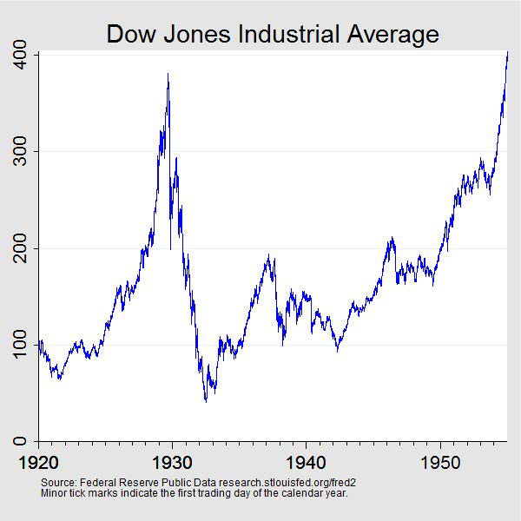
Figure 1.2.1 Dow Jones Industrial Average During and After the Great Depression
Another major crash in the U.S. economy happened in 2008, now known as the Great Recession. Leading up to 2008 there was a huge bubble brewing in the housing industry causing prices to skyrocket while banks continued to lend out mortgages to people who could not afford these houses [28]. Once again reality came crashing down as investors slowly began to realize what was happening and warning that people would never be able to pay these crazy mortgages. Panic quickly arose as the Dow tanked once again leading to banks going bankrupt as loans could never be paid back and tons of corporate buyouts were necessary as the crash could have gone even deeper if the government hadn’t assisted. For an entire year, stocks didn’t start recovering their value until late in 2009 [28]. Many more examples such as this exist like in the 1980’s with corporate buyouts and 1990’s during the Dot Com bubble, all serving to remind investors that the worst times of the stock market are sudden and nearly unpredictable so care should always be taken when investing into the stock market. Thankfully for situations such as these there exist several “Indexes” that use different weight distributions for companies in the stock market for a quicker and easier understanding of what exactly is happening with the stock market.

1.3 Stock Market Indexes and What They Mean
The first Stock Market Index to be widely used throughout the U.S. is called the Dow Jones Industrial Average, founded in 1896 by Charles Dow and Edward Jones it is often referred to as “The Dow” [9]. This index started as a simple average of 12 of the largest companies in America’s industrial sector which at the time was by far the largest on the stock market. These first 12 companies are listed by Table 1.3.1 [9] below:

Table 1.3.1 12 Original Companies on the Dow
American Cotton Oil | American Sugar | American Tobacco | Chicago Gas
Distilling & Cattle Feeding | General Electric | Laclede Gas | National Lead
North American | Tennessee Coal and Iron | U.S. Leather | U.S. Rubber

However, as America's economy shifted more and more to the service sector, the Dow quickly began changing out the companies included and even how many companies are included settling finally to 30 companies which are given by Table 1.3.2 [9]:
Table 1.3.2 Current 30 Companies on the Dow
Salesforce | Procter & Gamble | DowDuPont | Amgen | 3M | IBM
Merck | American Express | McDonald’s | Boeing | Coca-Cola | Caterpillar
JPMorgan Chase | Walt Disney | Johnson & Johnson | Walmart | Home Depot | Intel
Microsoft | Honeywell | Verizon | Chevron | Cisco Systems | Travelers Cos.
UnitedHealth Group | Goldman Sachs | Nike | Visa | Apple | Walgreens Boots Alliance

Since the time of being a simple average of the 12 most important companies to the American economy the Dow has changed significantly in how it is calculated. Now it is what’s called a price weighted index, meaning companies with higher prices of stock weigh towards the value much more greatly than stock with smaller share prices [9]. When the 30 companies are picked for the Dow, they are added together while being accounted for their weight due to share price and then they are divided by what is called the Dow Divisor that counteracts the effects of structural changes that may happen to the chosen stocks [9]. This means that the Dow is a good indicator of how well the big companies are doing but since there are over 5000 stocks listed on the NYSE and NASDAQ it doesn’t do an incredible job considering the entirety of the market. Also, the fact that the index is a price weighted index rather than market weighted index means it gives a very unfair advantage to companies with huge stock prices even if there are companies listed with lower prices that are much more integral to the economy.
To compete with the Dow and act as a better indicator of the economy in 1923 Henry Barnum Poor’s company created the predecessor to the S&P500 (Composit Index) however it was not called such until 1941 when Poor’s Company merged with Standard Statistics creating the Standard and Poor’s Composite Index [31]. At this time, they included 90 companies, 86 of which are still listed in Table 1.3.3 [31]:
Table 1.3.3 86 Surviving Companies that are Still Listed on the S&P500
3M Co | Eaton Corp | Merck & Co | Dynegy Inc | General Mills Inc | Honeywell Sealed Air Corp  Inc | Motorola Inc | PPG Industries Inc | TXU Corp
Abbott Laboratories | Burlington Northern | Consolidated Edison Inc | Eastman | General Motors Corp | Ingersoll-Rand Co Ltd | Norfolk Southern Corp | Procter & Gamble Co | Union Pacific Corp
Alcoa Inc | Santa Fe | Constellation Energy Grp | Edison International | Goodrich Corp | IBM Corp | Northrop Grumman Corp | Progress Energy Inc | Unisys Corp
Allegheny Energy Inc | Campbell Soup Co | Cooper Industries Ltd | Entergy Corp | Goodyear Tire Rubber Co | International Paper Co | Occidental Petroleum Corp | PSEG Inc | United Technologies Corp
Allstate Corp | Caterpillar Inc | CSX Corp | Exelon Corp | Xcel Energy Inc | Kimberly-Clark Corp | Penney (J C) Co | Quest Diagnostics Inc | Wrigley (Wm) Jr Co
Altria Group Inc | Chevron Corp | CVS Corp | Exxon Mobil Corp | Halliburton Co | Kroger Co | PepsiCo Inc | Raytheon Co | Wyeth
American Electric Power | CMS Energy Corp | Deere & Co | Ford Motor Co | Hartford Financial | Lockheed Martin Corp | Pfizer Inc | Rockwell Collins Inc | Xcel Energy Inc
Archer Daniels Midland Co | Coca-Cola Co | Dow Chemical Kroger Co | Fortune Brands Inc | Heinz (H J) Co | Marathon Oil Corp | PG&E Corp | Schering-Plough
Boeing Co | Colgate-Palmolive Co | DTE Energy Co | General Dynamics Corp | Hercules Inc | McGraw-Hill Companies | Phelps Dodge Corp | Schlumberger Ltd
Bristol-Myers Squibb Co | ConocoPhillips | Du Pont (E I) de Nemours | General Electric Co | Hershey Co | MeadWestvaco Corp | Pitney Bowes Inc | Southern Co

In 1951 the number of companies listed increased to 500 creating the name S&P500. The current 500 companies on the list are seen in Figure 1.3.1 [31] below:
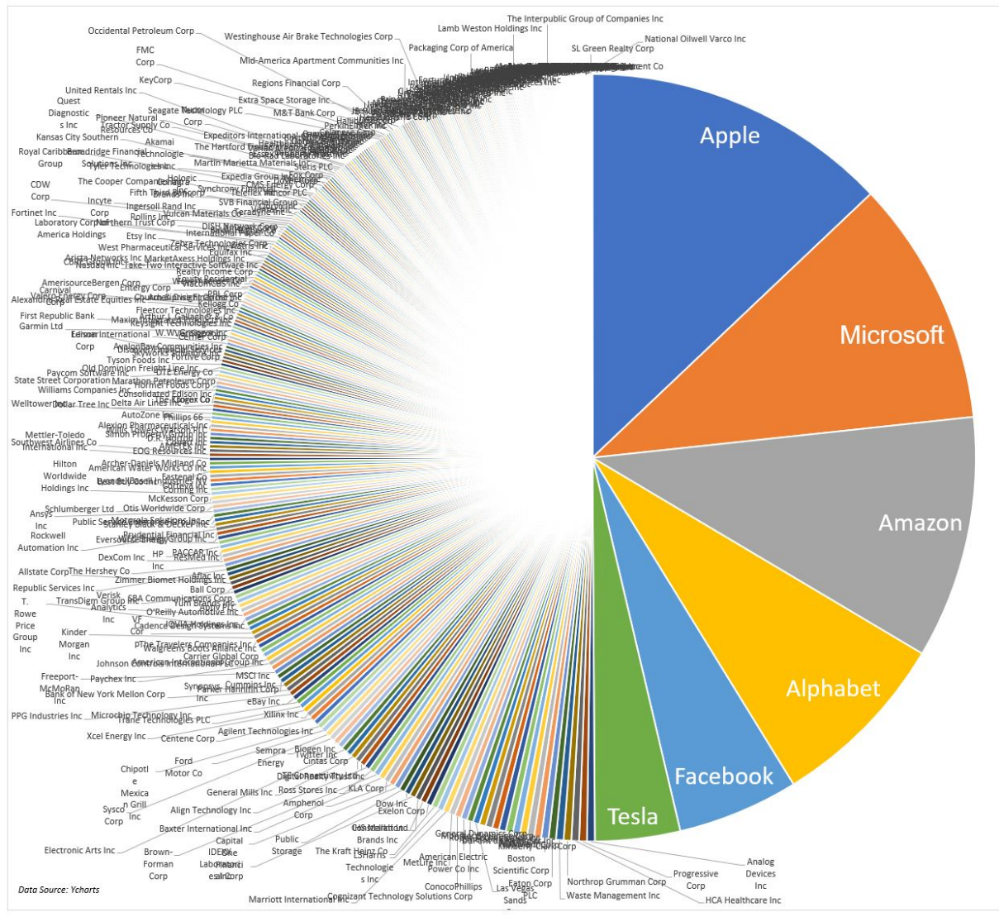
Figure 1.3.1 The Current S&P500 Companies and Their Weight Visualized
However, you can see the weight distribution in the chart and how 6 companies make up almost half of the index!
This index differs from the Dow as rather than being a price weighted index it is a market weighted index. This means that rather than companies' value being weighted just by its share price it is instead weighted by its market capitalization, or share price multiplied by available shares [4]. 500 Companies are chosen by a specialized committee who decides the most important representatives of America’s current economy. This means these companies are often added and deleted by the committee. The actual value of the index is calculated by adding the adjusted market capitalizations of the 500 companies then divided by a factor called the Divisor which is proprietary to the firm that runs the S&P500 [4]. The third most followed market index in the United States is called the NASDAQ Composite Index and as the name implies it was created by the NASDAQ in 1971 [2]. This index differs quite greatly from the other two as it does not only account for stocks listed on the NYSE but instead it compiles over 3000 common equities listed on the NASDAQ Stock Exchange [2]. It also stands out as it does not limit itself to companies that are headquartered in the United States giving it a slightly more global overview of the stock market [2]. Similarly, to the S&P 500, however, the methodology of this index is also market capitalization based. However, its calculation is much more complex as it adds the value of the share weights of each of the constituent securities and then multiplies them by each securities' last price. This number is then divided by an index divisor which scales the values. The index is calculated all throughout the trading day while also being reported once every second till 4:16 pm of each trading day. The NASDAQ, as it’s commonly called, stands out for having outperformed both the other indexes year to year quite often [2].

1.4 Stock Market basics
The stock market is defined as a venue for buying and selling stocks and other securities. Although the stock market is primarily known for trading stocks, other securities such as options, certain types of bonds, and ETFs are also traded on the market. Cryptocurrencies are not listed on the New York Stock Exchange, though certain brokers such as Robinhood give the option to invest in certain cryptocurrencies [30].
The primary security traded on stock exchanges are known as stocks. A stock is a security that represents a fraction of ownership in a corporation, with each unit being called a share. Stock owners are known as shareholders of a company. As a shareholder, you are entitled to profits proportional to the amount of stock you own. Often, companies will issue shares of stock to raise capital and expand their business. This is known as dilution, which helps the company bring in money, but reduces the percentage of ownership in current shareholders, and the value of the stock often declines in the near term as a result. You are also entitled to the right to vote on key executive decisions, such as members of the board, mergers with other companies, whether the company sells stock or not, etc. Stocks are bought and sold on stock exchanges and are often a major part of an investor’s portfolio. Historically, stocks have outperformed other investment strategies over the long run, with an average real return (inflation adjusted) of 6.8% per year, vs 2.9% for bonds, 0.5% for bills, and 1.8% for gold [30].
Another avenue for participating in the stock market is to invest in mutual funds. A mutual fund is a pool of money from many investors that is invested in a wide variety of companies. Investors will pay an annual fee to the fund manager. There are different types of mutual funds, passive and actively managed ones [18]. An actively managed mutual fund has a fund manager who picks stocks to invest in to try and beat indexes such as the S&P 500. A passively managed mutual fund will directly invest in major indexes. Mutual funds don’t necessarily need to be just stocks, they often will give the investor exposure to a wide variety of other securities such as bonds, equities, commodities, currencies, and derivatives. Due to the diversification of mutual funds, the risk is lessened [18].
Another form of investment is buying bonds. When an investor buys bonds, they agree to a contract to loan money to a borrower. The borrower that writes the contract is often the government or a corporation. This contract includes details of when the money is expected to be returned to the lender (the investor), and terms for the variable or fixed interest rates, which ends up being the profit for the investor [13]. The amount of money the bond is worth at maturity is known as the face value, and bonds can be bought or sold before maturity [13]. The interest that the investor will collect yearly is calculated by multiplying the face value (typically 1000) by the interest rate. The risk for bonds is the borrower defaulting, or not repaying the debt. This risk is assessed via credit scores, with lower credit scores indicating a higher default risk. Bonds with low credit scores are known as junk bonds, which are often issued by struggling companies that compensate investors with a higher interest rate to offset the increased risk [13].
Options are financial derivatives that give the buyer the right to buy or sell 100 shares of an asset at a set price, known as the strike price [6]. Options also have an expiration date, by which the option holder must either exercise the option, sell it, or let it expire worthless. When an option holder exercises their option, they are exercising their right to buy or sell 100 shares of a stock at the strike price. There are 2 different types of options, call options and put options. When an investor purchases a call option, they are purchasing the right but not the obligation to buy 100 shares of a stock at a set price. An investor will do this if they believe the stock will increase in price, so that the price of the underlying stock is higher than the strike price of the option. On the other hand, if an investor believes the price of a stock will decrease over time, they could buy a put option, or a contract that gives them the right to sell 100 shares of a stock at an agreed-on strike price until the expiration date [6].
For example, if I am bullish on GameStop and believe that the price will increase to 150 dollars a share in 6 months, I can purchase a contract that gives me the right to buy 100 shares of GameStop within 6 months at 120 dollars a share. If by expiration date GameStop increases to 150 dollars a share or more like I thought, then I will be able to exercise my option, which allows me to purchase 100 GameStop shares at the strike price, 120 dollars a share, despite the underlying being 150 dollars a share. However, the risk is that if I am wrong and GameStop were to fall below the strike price, my option will expire worthless and I will lose my entire investment, which exposes me to significantly more risk than if I were to just buy 100 shares of GameStop outright. The other side of this is that if GameStop has a big increase in stock price, I would profit significantly more than I would have if I were to just buy and hold the stock. Due to the elevated upside as well as elevated risk of purchasing options, they will often be used to increase leverage or expose the investor to elevated upside if they believe the potential upside outweighs the risk of losing their entire investment in the option [6].
ETFs, or exchange traded funds, are securities that track indexes, sectors, commodities or other assets [5]. They are listed on the New York Stock Exchange and can be traded in the same way that stocks can. This gives the investor an exposure to a more diverse pool of stocks and or other securities, much like mutual funds do [5]. It also reduces commission fees, as it counts as only one translation to purchase an ETF, whereas to purchase every stock in the ETF it would take many transactions. However, some ETFs, especially the actively managed ones, have fees, though these are often lower than the fees of mutual funds, making investing in ETFs a good alternative to mutual funds. Unlike mutual funds, ETFs are traded on the NYSE and are more liquid as the stocks are bought and sold on the market, unlike mutual funds which are not traded on the exchange [5].
A relatively new form of investing is Cryptocurrency. Cryptocurrencies are digital, decentralized currencies that offer investors an alternative to fiat, with the idea of acting as a hedge against inflation as well as protection from the potential collapse of the financial institution, which nearly occurred in 2008 [14]. The largest cryptocurrency by market cap is Bitcoin, which was created by Satoshi Nakamoto and introduced in 2008 [14]. It was made available to the public in 2009. Bitcoin is traded with the use of a ledger system known as blockchain, and bitcoins are held in online wallets, which are encrypted using a private key [14]. The pros are that Bitcoin, ever since its creation, has had an extremely high growth rate over time. Bitcoin has gone from $1 in April of 2011 to roughly $38000 today [3]. As a result of Bitcoin halving every 4 years, where the number of Bitcoins that are mined per block getting cut in half, the supply is declining [7]. Assuming demand remains equal or increases, this should lead to a major price increase. We have seen exactly this play out, with big spikes in price a year after halving events [3]. The cons are that Bitcoin and other cryptocurrencies are extremely volatile, and are subject to huge losses, at times dropping more than 50% in a matter of days [3]. Bitcoin is also relatively new, so there is still a lot of unknowns about how sustainable its growth will be long term, unlike the stock market which has been around for over a century and thus has proven to be able to deliver sustainable growth long term. For cryptocurrencies, there is still a lot of debate among economists on whether it is a bubble or a viable long-term investment. Also, if you forget your password or it gets hacked, you will not be able to recover your bitcoins, which is a big risk [14]

Chapter 2: Trading Strategies and Simulation Plans
Right at the beginning of the simulation 20,000$ was put into the S&P500 as a control group to compare our trading to. If we came out ahead of the S&P500 that means, there is a very strong chance our strategies beat the market during the time of investment. However, if we came out below that means we would have made more money if we just invested in the top 500 companies measured by market capitalization.

2.1 Investopedia/Cryptoparrot – The Chosen Simulation Engine
For the purpose of this project, we have selected Investopedia as our simulation engine meaning all of our investing will be done through their website. We chose Investopedia for several reasons, the first of which being that the interface is incredibly easy to understand and use, making it a good practice tool for beginner investors such as us. Figure 2.1.1 shows the opening screen of the website [25]:
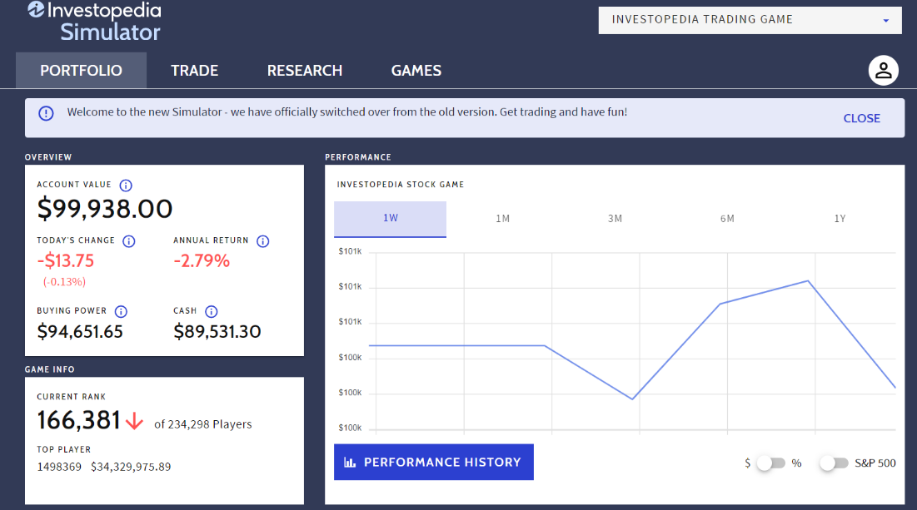
Figure 2.1.1 Opening Screen Investopedia
As you can see the opening screen gives a very quick summary of the portfolio giving your total value in the top left and graph to the right showing your overall performance. Since we are using a limit of only $20,000 the fact that the opening screen also shows a cash value to the account is very helpful as you always start with $100,000 in Investopedia’s simulation. This means to stick to our limit we must make sure the cash value never falls under $80,000.
The second reason we decided with Investopedia is because it is easy to navigate. As seen in the opening screen there are only 3 tabs you ever really must keep track of: Portfolio, Trade, and Research. The Games section allows you to create a new investing game, but we will not be using that tab for the purposes of this project. When you click on the trade tab you are brought to the trading screen that can be seen in Figure 2.1.2 which looks like this [25]:
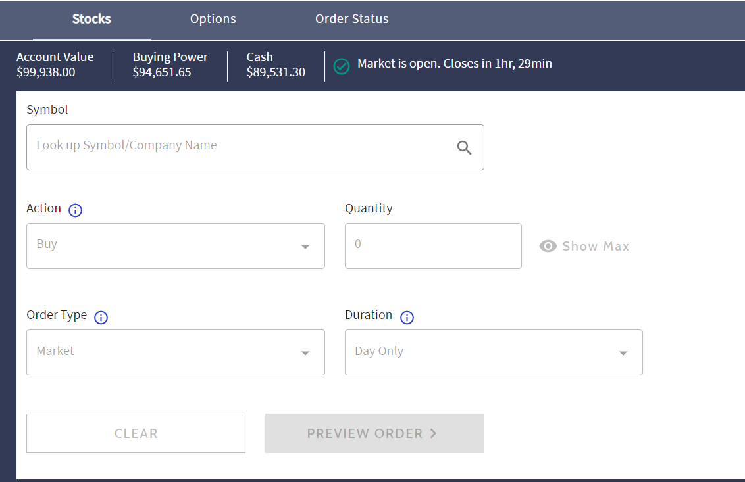
Figure 2.1.2 Investopedia Trading Screen
This screen continues the theme of easy navigability as at the very top they give you all your important values such as available cash and buying power to make buying stock easier. Under that is a very simple selection table to fill out for either buying or selling stock. At the top they also include a section to buy Options, an important option for the purposes of our project.
Finally, is the research tab which can be seen in Figure 2.1.3 [25]:
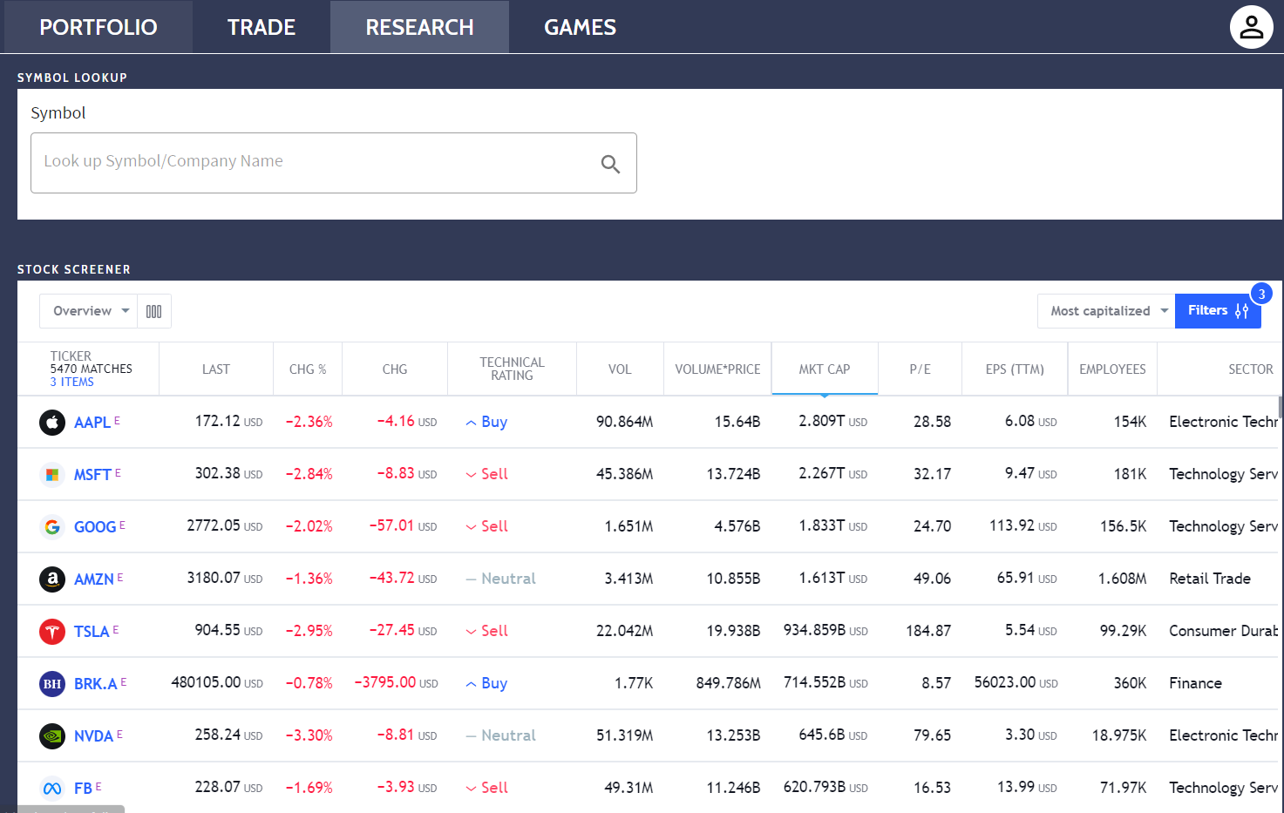Figure 2.1.3 Research Screen
This tab is the main reason it was decided to use Investopedia as our simulation engine. There is much information available immediately through their research section that it quickly became the favored tool for using new tickers to invest in. Clicking on any of the companies listed in the tab will give you a large interactive chart, as seen in Figure 2.1.4 that can be customized to show almost any information you might need on a ticker [25]:

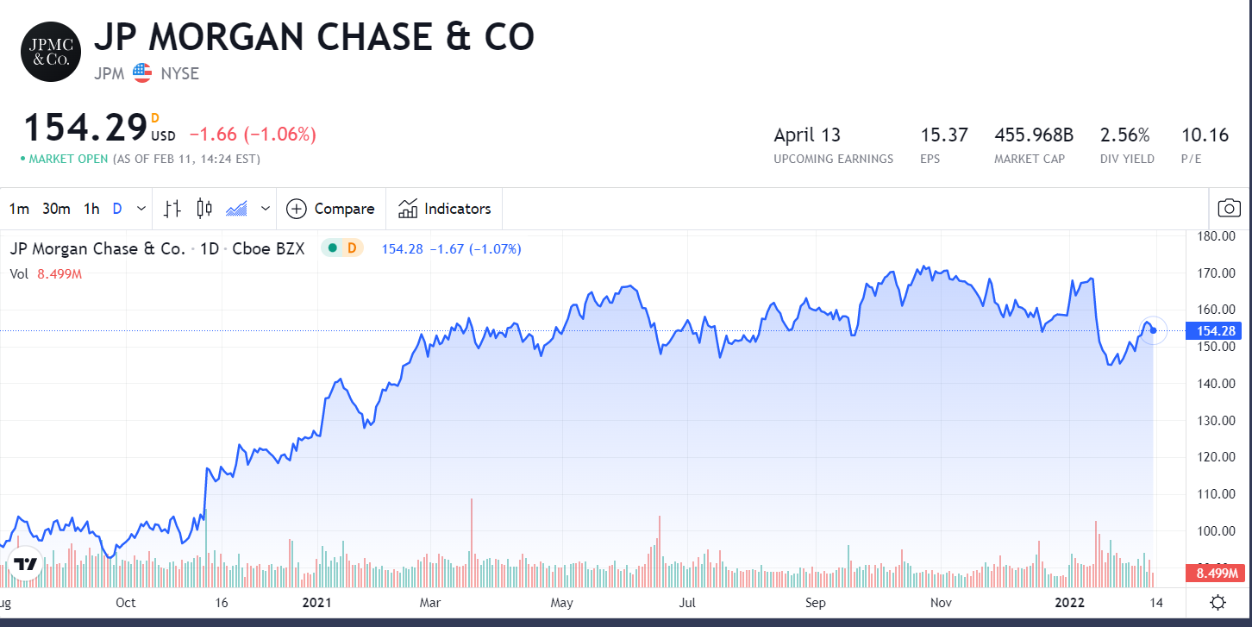
Figure 2.1.4 Ticker Example
The chart can be zoomed in or out to whatever date is necessary or you can put in exact dates for a more specified chart. On top of all this information being instantly available, the ticker’s financial and fundamental data is all available right under the chart for quick viewing, as seen in Figure 2.1.5 [25] :

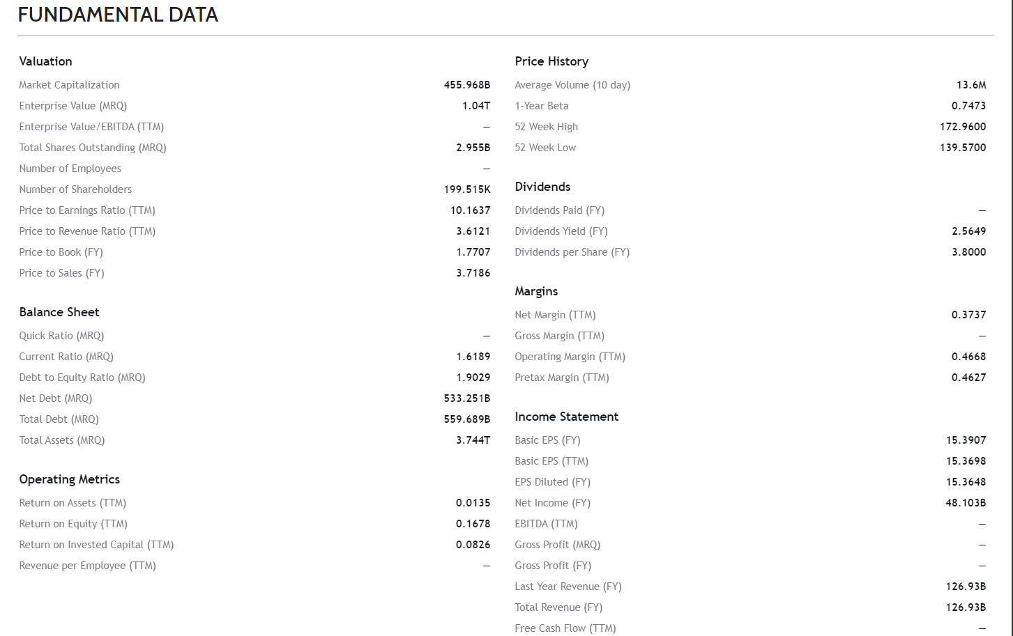Figure 2.1.5 Fundamental Data Example
None of this data is necessarily hard to find, including the charts but having everything readily available in a single easy to navigate tab makes the ease of use of Investopedia leagues ahead of other simulators that were explored.
The one drawback for the purpose of our project is that Investopedia does not offer the option of trading cryptocurrency through their website. For this reason, a different simulation engine had to be used for simulation 5 which was planned to be a simulation completely dedicated to comparing crypto investments to regular stock/option investments. Through some online recommendations the best simulation engine for crypto trading seems to be a website called Cryptoparrot. When comparing it to some of the other free websites it makes sense. The UI on the website is extremely simple, it's very easy to get started and its available cryptocurrency options are higher than most other websites. Figure 2.1.6 shows the opening screen for CryptoParrot [14]:
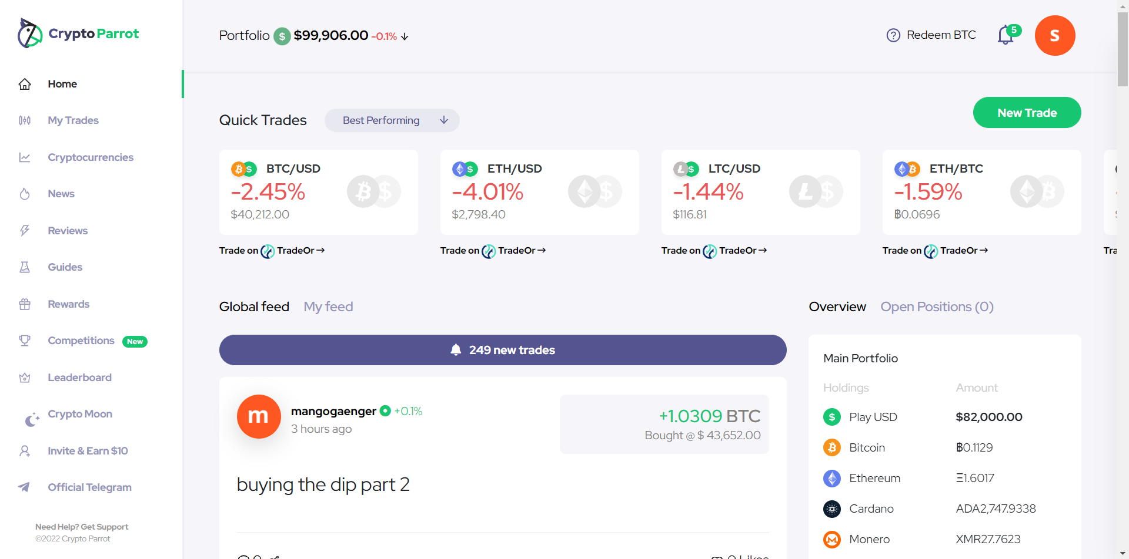Figure 2.1.6 Opening Screen for CryptoParrot
The home screen UI has all the most important information readily available with portfolio value at the top of the screen under which are some quick daily breakdowns of fastest moving cryptocurrencies. To the bottom right of the screen shows a breakdown of the user’s portfolio broken down to each type of crypto that is bought in the portfolio. Across the right of the screen there are some very useful tabs, like trade history to keep track of everything, a breakdown of every available crypto on the website, news related to crypto and things that might affect the prices, and some reviews and guides provided by the website.
In the top right of the screen is where you can buy crypto with the allotted $100,000 available to each simulation. Just like with Investopedia we will only be spending $20,000 of this so we have to make sure the account USD never goes below $80,000. By pressing the “New Trade” button at the top right we get the screen seen in Figure 2.1.7 [14]:
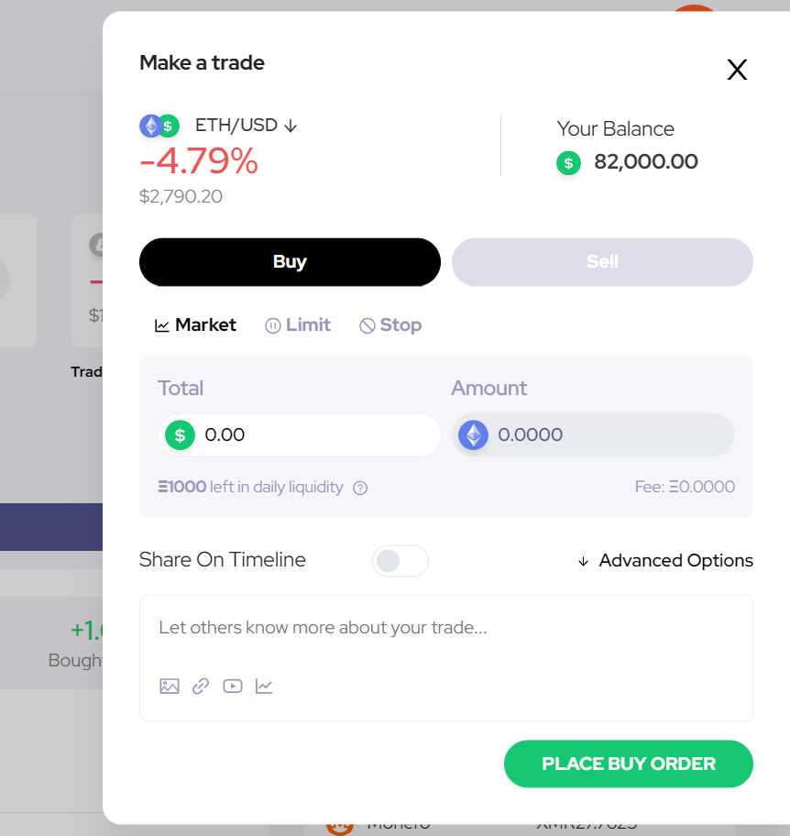
Figure 2.1.7 Make a Trade Screen
In the overlay screen you can choose which crypto you’d like to trade at the very top by pressing the “ETH/USD” button and to the right of that is the available cash to make it easy to know how much you can buy. Below that are some options for how you can make the trade: “Market” buy, “Limit” buy, or “Stop” sell and finally below that you can chose the amount in USD to buy of the chosen cryptocurrency. This screen makes buying on this simulation engine easy and intuitive.

2.2 Putting our Trust in Investopedia’s Ticker Chooser
For the first few weeks of the simulation, we were wondering just how effective Investopedia's ticker chooser was. In their research section of the application there is a way to filter tickers by their buy or sell preferability according to Investopedia. To see just how correct these choices are Adam decided to invest part of his base capital in stocks he found to be graded as a “Strong Buy”. This means Investopedia strongly suggests buying these as they are likely to rise within the near future [19]. But how exactly does Investopedia choose these? To find out further research was conducted. One reason Investopedia often chooses to give a stock a “Strong Buy” rating is because that stock has often outperformed its own growth forecasts during earning calls. As such one way to use this indicator is to look for “Strong Buys”, then check their chart against earnings call dates and finally see if they will be having an earnings call soon [19]. If history shows good earnings previously it might be a good option to buy some of this company's stock short term [19]. Another reason Investopedia will have this rating on certain stocks is due to analyst beliefs that the market the company participates in is either under-utilized or undervalued. This gives Investopedia the confidence that these companies have a lot of room to grow quickly. On average they say that companies with the “Strong Buy” rating will have a 30-50% increase in stock value in the next 12 months [19].

2.3 Speculative Trading
When determining what trading strategies we would test in this simulation, one of the things we wanted to figure out is whether or not it is a viable strategy to trade extremely volatile, high sentiment stocks that have issues with their balance sheet, such as high debt, a high p/e ratio, declining revenue, negative growth rate, etc. by using technical indicators [34]. Often, these type of stocks are able to attract investors despite having these warts in their balance sheet due to promise of future growth, often because they are relatively new businesses or are failing companies that are pivoting their ideas.
For example, bitcoin miners were for a long time considered to be unprofitable due to the costs to run the high-powered computers used to mine bitcoin outweighing the price of bitcoin itself. However, the price of bitcoin has increased from $5165.25 on March 13, 2020, to $64400 as of November 12, 2021 [3]. As a result of the value of bitcoin increasing by more than tenfold in less than 2 years, bitcoin miners that were previously unprofitable are now profitable. The long-term outlook of these miners is very uncertain, as the viability of the business model for these companies is dependent on the price of bitcoin, which has historically been extremely volatile.

2.4 Position Trading
We also wanted to compare and contrast more active trading strategies with a more passive, longer-term hold approach. To satisfy this, we are going to be employing a position trading strategy. This strategy is more reliant on fundamental analysis and for technical analysis, we will be looking strictly at the longer-term (more than 6 months) chart to determine entry and exit points [15]. Since we are more concerned with the longer-term outlook, this simulation will have less active trading than the other ones. When we do make trades, they will be due to a change in the fundamentals and or long-term outlook of the company, rather than on momentum and short-term technical indicators like monthly charts. For example, if there is a big dip and the price breaks the support level on a monthly chart, in several of our other simulations we would sell and cut our losses. However, since for this simulation we are employing a position trading strategy we would either hold or buy the dip, willing to accept the possibility of a short-term loss with the idea that this would pay off a couple of months down the line. Some of the pros of position trading is due to the lower number of trades initiated, if you are using a broker that has trade fees those will be significantly lower than they would be for those who employ more active trading strategies [15]. Theoretically, a position trader would perform best in bull markets, as the position trader would ignore short-term price fluctuations, leading to them holding the stock longer. In a bull market, this would typically lead to position traders selling their stock at a much higher price than more active trading strategies, leading to significantly higher profits. The drawbacks of position trading are that sometimes those short-term price fluctuations end up turning into a longer-term reversal, and by the time the position trader realizes this the stock has already significantly declined, leading to the position trader either being forced to sell at a lower price than they would like or bag holding a stock. There is a significant opportunity cost here, as more active trading strategies would be able to exit a trade that goes south more quickly, leading to the more active trading strategies limiting their losses more than a position trader would be able to in these situations.

2.5 Cryptocurrency Trading
One of the newest and now biggest investment groups on the modern stock market has become trading of cryptocurrency [14]. In a sense it works just like trading foreign currency to try and make a profit on betting which currencies will be growing in value over time. The biggest difference with regular fiat currency is that Cryptocurrency is completely digital, with very little to no regulation on it [14]. For this reason, it is seen more as a speculative venture to try and capitalize on possible future currencies. This leads a lot of currencies in the space to be incredibly volatile as well as the production of thousands of new currencies each month most of which end up worthless [14]. Since this space is so incredibly volatile for the purposes of this simulation, we will keep this simulation as more of a set it and forget it account rather than actively trading it as this can prove to be difficult with how much prices in the space fluctuate.

Chapter 3: Stock selections and research
For this chapter, we will be including every stock we use along with our research, which includes price charts as well as fundamental analysis.

3.1 Simulation 1 Analyst Recommendations
So, the option that comes to mind is a company called Centene Corp, which has a history of strong earning calls followed by a slump and then a big spike in share price [25]. For this reason, it was decided for Simulation 1 to buy 50 shares, amounting to nearly 5000$. By looking at Figure 3.1.1 we can get a sense of how the company has been doing since 2020 and how the price has fluctuated after earning calls [25]:
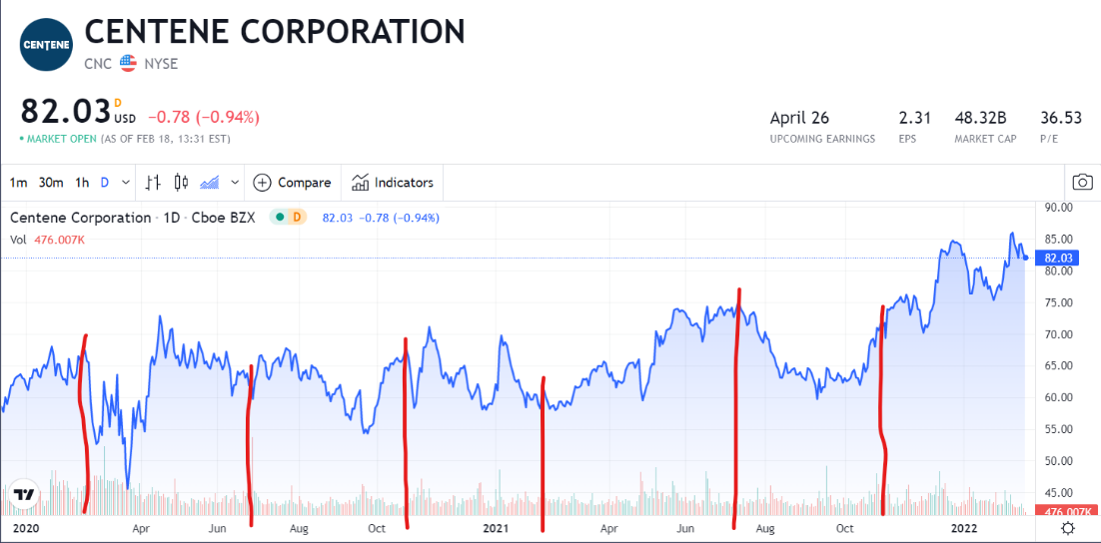
Figure 3.1.1 CNC Chart Marked with Dates of Earning Calls
The company has had many ups and downs from its earning calls, but it would seem that the longer you hold the stock the higher it has been going. With some lucky timing there is a large chance for profit on this ticker.
Another company found with some promising growth data is GoPro whose stock has been sitting at about 9$ after reaching almost 100$ after IPO [27]! Next, we will look at why it is believed that GoPro will be a good buy for Simulation 1.
The first realization that was had with GoPro is that it is incredibly undervalued right now. Of course, that doesn’t necessarily mean that there will be a huge spike in the share price soon, but it does mean there is a good chance of it rising year to year. Here are the key takeaways from my research [27]:
- Company made 1.2B in revenue in both 2017 and 2021, seemingly no change, maybe even a loss due to inflation, however when considering the pandemic and the effect it had on travel, staying even is pretty good for a niche market like this
- Operating expenses have decreased since 2017:
  - R&D went from 19% to 12% - sometimes a sign of stagnation sometimes a sign of efficiency
  - Marketing and sales expenses went from 20% to 13% - social media presence brought marketing budget down
  - SG&A dropped by one percent from 7 to 6%
- Has 100M in free flow cash and half a billion in cash with only 300m in debt
- Holding onto 280M in deferred tax assets which will be a huge help in lowering taxes in future years
- Only a P/E ratio of 3.71 - very very low compared to S&P500
- Plugging their finances into a DCF gives a valuation of $15.95 with a generous growth forecast
- From the DCF valuation even if the company starts losing revenue growth it is still undervalued and therefore fits the bill for an account focusing on undervalued stocks.
- Some other scenarios can be seen in Table 3.1.1 [27]:

Table 3.1.1 Possible Future Valuations of GoPro Depending on Growth
Revenue/Op. Margin | 12% | 14% | 16%
-10% (1B) | $11.8 | $13.1 | $14.4
25% (1.4B) | $14.2 | $16.0 | $17.7
50% (1.7B) | $15.8 | $17.9 | $19.9
75% (2B) | $17.9 | $19.8 | $22.1

By looking at GPRO’s chart in Figure 3.1.2 you can see the extreme of how low valued the company is now compared to when it first opened its doors even though it’s only done well since it started [25]:
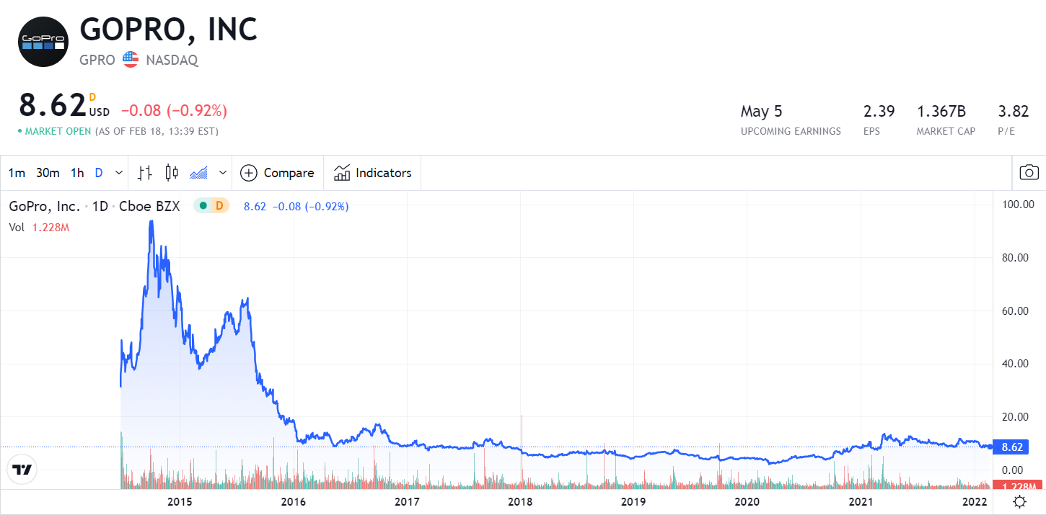
Figure 3.1.2 GPRO Highs and Lows
The next stock found to follow the theme of strongly undervalued stock was Intel, ticker INTC. Key takeaways from the research [25]:
- Client computing division of Intel's business is making them tones of money with a very steady growth and operating margins of 40+%. This is not a division that is normally thought of when it comes to Intel due to them being huge PC chip makers, but could very well be the future for the company as client computing is becoming more and more necessary.
- Over all margins in the company business are at a steady 30% showing strong profitability.
- Considering a 5% revenue growth Intel’s intrinsic value comes out to be $86.09 against its current price of being around 50$
In summary: Intel still makes a ton of money of the huge amounts of services they provide outside of chip making even if its market share of the chip business has shrunk from competitors. There’s a very good chance this company will bounce back to help relieve chip shortages and will also grow its other services that have incredible margins.

3.2 Simulation 2 Speculative Trading
We hypothesize that by using a variety of technical indicators such as support and resistance levels on the yearly price chart for bitcoin, we can identify price targets to buy in at. Cam noticed when doing his research that Bitcoin dropped from $64400 on November 12th 2021 to $42559 as of February 6th 2022, approximately a 33.9% decrease in value [3]. However, for two bitcoin miners that go by the tickers MARA and RIOT, the decrease was much more significant, with MARA declining from $75.92 to $23.51, roughly a 69% decrease in value. RIOT declined from $44.19 to $16.57 during the same timeframe, roughly a 62.5% decrease in value [3]. Since these bitcoin miners declined by a much bigger percentage than bitcoin itself did, this is a sign that the sentiment has declined. Since the long-term outlook of these miners would be harmed significantly more than bitcoin itself if bitcoin declines for an extended period of time due to the possibility of bitcoin mining becoming unprofitable again, it makes sense for these miners to be harmed more than bitcoin itself by a significant decline in bitcoins price.
According to my research, the price of bitcoin has closely followed the stock to flow model posted in Figure 3.2.1:
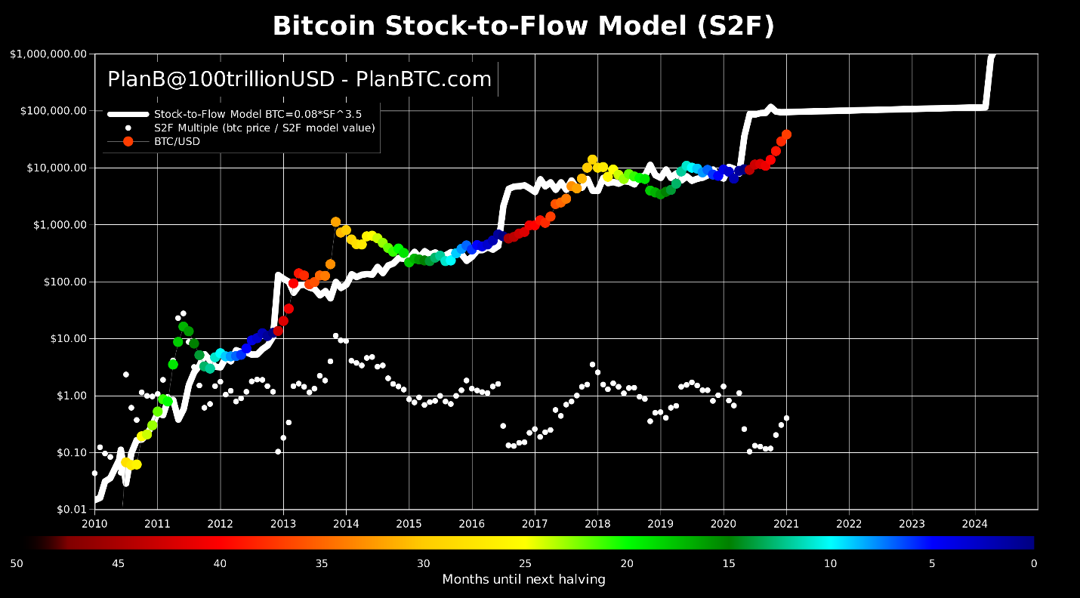
Figure 3.2.1 Bitcoin Stock to Flow Model
Historically, we have seen that the price of bitcoin tends to peak above the white line every 4 years approximately a year after the halving that occurs every 4 years. If this model is correct, the actual price of bitcoin is currently below the expected price according to the model, and thus is undervalued. On the yearly chart, bitcoin has been trading in a channel between roughly $30000 and $60000, and we have recently seen bitcoin bounce at $36000 up to $42559 as of February 6th, 2022, confirming the resistance level in the $30000 range [3]. Therefore, Cam plans on purchasing $5000 worth of RIOT and MARA on Monday February 7th, 2022, in Simulation 2.

3.3 Simulation 3 Position Trading
For a Position Trading strategy, we are looking for a stock that is undervalued, has more limited downside risk and has a good long-term outlook. We are willing to accept that the stock we invest in may not produce significant returns in the near term, with the idea that investing in companies with solid fundamentals and favorable technical indicators for the long-term charts would lead to significant returns towards weeks 7 and 8 of the Simulation. The company that fits this profile would be Schulmberger, which is traded under the ticker SLB [25].
In the past 2 years, crude oil has increased from 18/barrel to 90/barrel, yet the price is only $39.80, lower than the price when SLB dipped to 34/barrel after peak 2, and the same as when the price dipped to 42/barrel after peak 1 [8]. In my opinion, this recent divergence of the share price of SLB from the price of crude oil is not going to last. A big reason why is that SLB makes its money by selling oil. Oil is an inelastic good, so as prices of oil increase, the demand does not decrease proportionally. Therefore, as oil prices increase, we can expect SLB to make more money, as the demand for their services would remain unchanged, while they would be making more for each barrel sold due to an increase in price in crude. This is shown in Figures 3.3.1 and 3.3.2 below [8]:
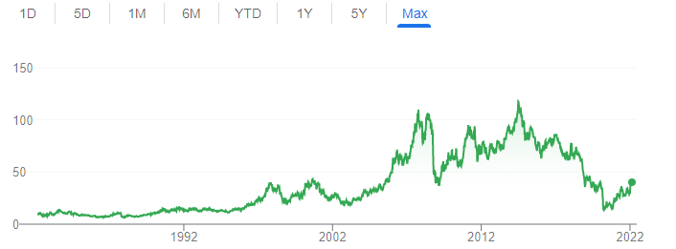
Figure 3.3.1 SLB Price History Over the Past 40 Years
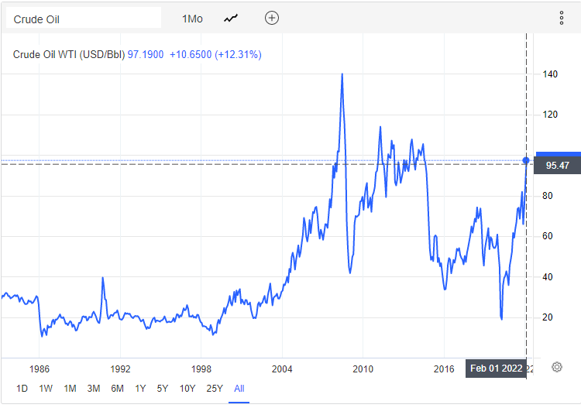
Figure 3.3.2 Crude Oil Price Over the Past 40 Years

3.4 Simulation 4 Cryptocurrency
Investing in cryptocurrency can be much different from trading in any other types of securities as with crypto there are large levels of uncertainty surrounding basically every part of it. As of right now the cryptocurrency market is much more of a speculative market as its uses are still quite limited compared to that of fiat currencies such as USD. The other thing that makes crypto a very weird market to invest in is that a lot of the most notable cryptos move very similarly [22]. Meaning when there are spikes in Bitcoin for any reason lots of times there will be spikes in all other major cryptocurrencies as well with the belief that Bitcoin will lead the way for others. This exact phenomenon can be seen in Figures 3.4.1-3.4.13 [22]:

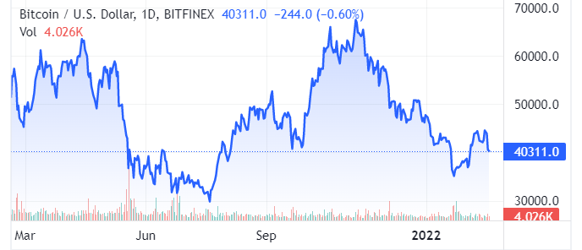
Figure 3.4.1 Bitcoin Chart 1 Year
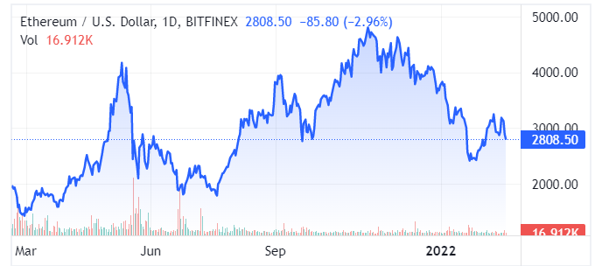
Figure 3.4.2 Ethereum Chart 1 Year
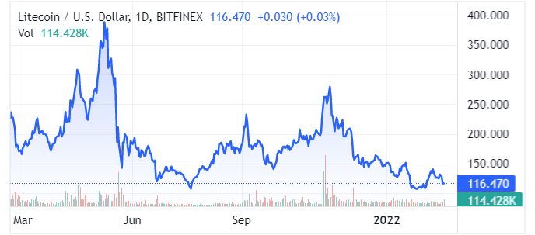
Figure 3.4.3 Litecoin Chart 1 Year
Looking at the past year of trading for the top 3 coins by market capitalization you can see that they have all mimicked each other in terms of when the price drops and when the price rises. For this reason, investing in crypto is all about timing [22]. In the past 5 years the market has gone from some very high highs to some incredibly low lows so buying into the drop that has been currently happening can be lucrative for Simulation 4.

Chapter 4: Simulation 1 Analyst Recommendations and Value Trading
Simulation 1 will be centered around a mix of taking analyst recommendations directly from Investopedia’s ticker chooser as well as some in depth independent research into stocks with low P/E ratios and prices that are much lower than valuations put them at. This can be seen in our research in section 3.1.

4.1 Week 1
The first week of trading for Simulation 1 was heavily focused on both buying outright undervalued stock and a stock highly recommended by Investopedia. The two undervalued stocks chosen were GoPro due to the analysis provided in section 3.1, and GameStop due to its recent fall by almost half its value, as seen in Figure 4.1.1, making it seem like a very undervalued stock at the moment [25]:
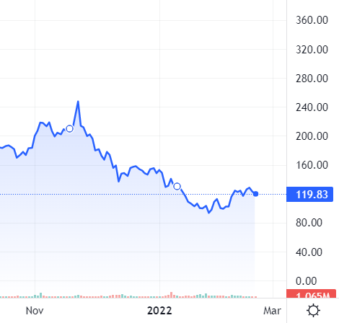
Figure 4.1.1 GameStop Chart Nov-Feb
The ticker CNC on the other hand was chosen and bought due to the anticipation of its upcoming earnings call that have previously gone very well for the company. With a strong buy recommendation from Investopedia this would be guinea pig for simulation 1 to show how well Investopedia’s ticker chooser works. In Table 4.1.1 we can see the exact trades this information led us to make:
Table 4.1.1 Transaction Table for First Week
Date | Symbol | Buy/Sell | Price | Shares/  Contracts | Value | Profit/  Loss | Total Cash | Total  Profit
02/04/22 | GME | BUY | $96.79 | 50 | $4,839.50 |  | $15,160.50
02/04/22 | CNC | BUY | $79.88 | 50 | $3,994.00 |  | $11,166.50
02/07/22 | GPRO | BUY | $8.83 | 340 | $3,002.20 |  | $8,164.30

4.2 Week 2
This week GameStop had risen from 96-114 dollars giving a healthy level of profit for this simulation for this reason half of the GameStop holdings were sold in anticipation of a fall back down to below 100$ prices [25]. With the money made from GameStop it was then decided to buy some GPRO options as it is still believed that the company has a good future ahead of them and the options will appreciate nicely.
During this week there was another focus on finding a stock that seems deeply undervalued and Intel was a large company that seems to be a good choice. First, good indicator for Intel was its chart, seemingly year to year, after each large drop in its share price Intel has been able to make very good recoveries [25]. Secondly, as mentioned in section 3.1 the valuation of the company is almost double what it is currently trading at [25]. Thirdly, chip manufacturers such as Nvidia and AMD, Intel's strongest competitors, have not been able to keep up with demands for chips, this means Intel with its new factory will have room for growth to match their ridiculous growth over the last 2 years [25]. Finally, Intel only has a P/E ratio of 9.6, criminally low compared to its competitors at 61 and 44 respectively [25].
In Figures 4.2.1 - 4.2.3 we can see the chart comparisons of Intel and its closest competitors and how in terms of stock price Intel seems forgotten behind its competitors even though its financials are solid as mentioned previously [25]:
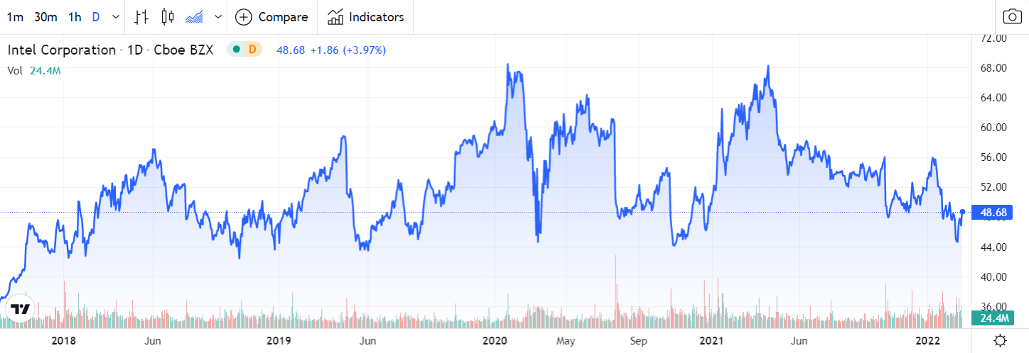
Figure 4.2.1 Intel Chart Over 4 Years
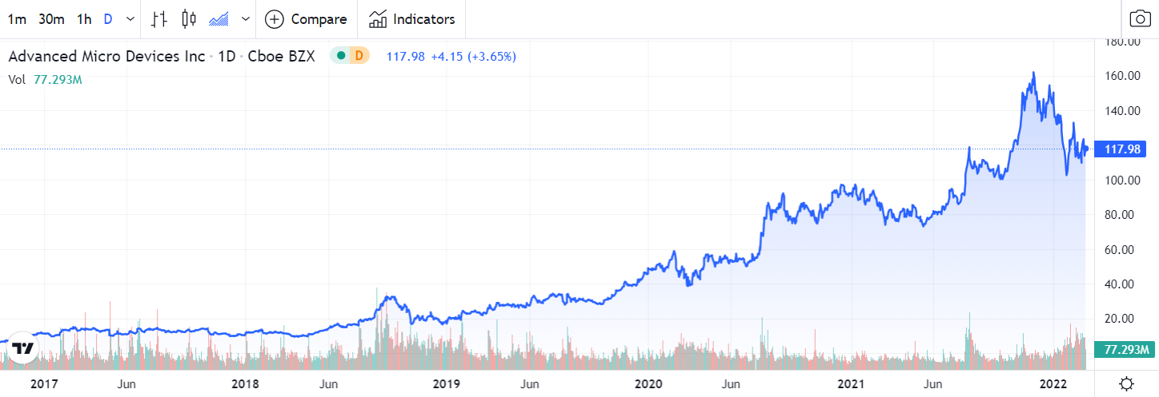
Figure 4.2.2 AMD Chart Over 5 Years
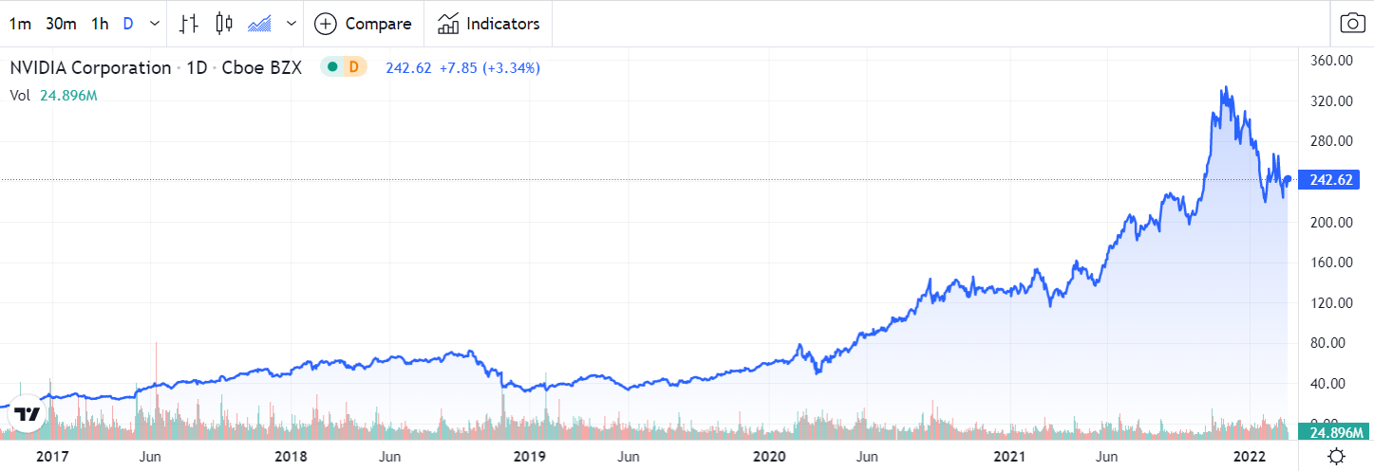
Figure 4.2.3 NVIDIA Chart Over 5 Years
In Table 4.2.1 we can see the transactions for the second week of trading:
Table 4.2.1 Transaction Table for Second Week
Date | Symbol | Buy/Sell | Price | Shares/  Contracts | Value | Profit/  Loss | Total Cash | Total  Profit
02/08/22 | GME | SELL | $114.44 | 25 | $2,861.00 | $441.25 | $14,027.50 | $441.25
02/08/22 | GPRO | Calls/BUY | $0.09/Contract | 166 | $1,494.00 |  | $12,533.50
02/11/22 | INTC | BUY | $48.09 | 120 | $5,770.20 |  | $6,763.30

4.3 Week 3
During this week I wanted to give Investopedia’s ticker chooser another go since it gave me the suggestion of CNC, which has been doing well. For this reason, I decided to load up on some UpWork stock as it was under their list of “Buy” recommendations [19]. These are recommendations that are likely to raise in price, but the outlook isn’t as clear cut as their “Strong Buy” recommendations. I want to see if I will have similar results with this choice or if it’s a riskier trade than the “Strong Buy” in terms of relatively short-term growth [19]. In Table 4.3.1 the transactions for this table can be seen:

Table 4.3.1 Transaction Table for Third Week
Date | Symbol | Buy/Sell | Price | Shares/  Contracts | Value | Profit/  Loss | Total Cash | Total  Profit
02/18/22 | UPWK | BUY | $24.35 | 152 | $3,701.20 |  | $3,062.10

4.4 Week 4
On Week 4 of Simulation 1 the decision was made to not make any new moves as this was a huge week in terms of world news. Russia had decided to invade Ukraine this week practically starting a new global scale war meaning that the stock market was going to make a lot of unexpected moves [2]. By staying out of active trading this week it was hoped that we could assess the situation with a bigger lens and make good moves in week 5 instead.

4.5 Week 5
This week a lot of the market was bouncing back after the news of the war in Ukraine broke out tanked the market a good bit. For this reason, I decided it might be a safe bet to start taking more profit from stocks that were doing well at the time, hence the rest of the stake in GameStop was well as all of CNC was sold as it had done well but was mostly stagnant now. With this influx of cash, I had more money to buy something else this week, so I began a search for a military contractor who seemed to be relatively undervalued. This led me to the company Palantir, a military contractor that sells software to the American military [24]. The company has been on a steady decline this year, putting it lower than it has been for two years as you can see in figure 4.5.1 [24]:
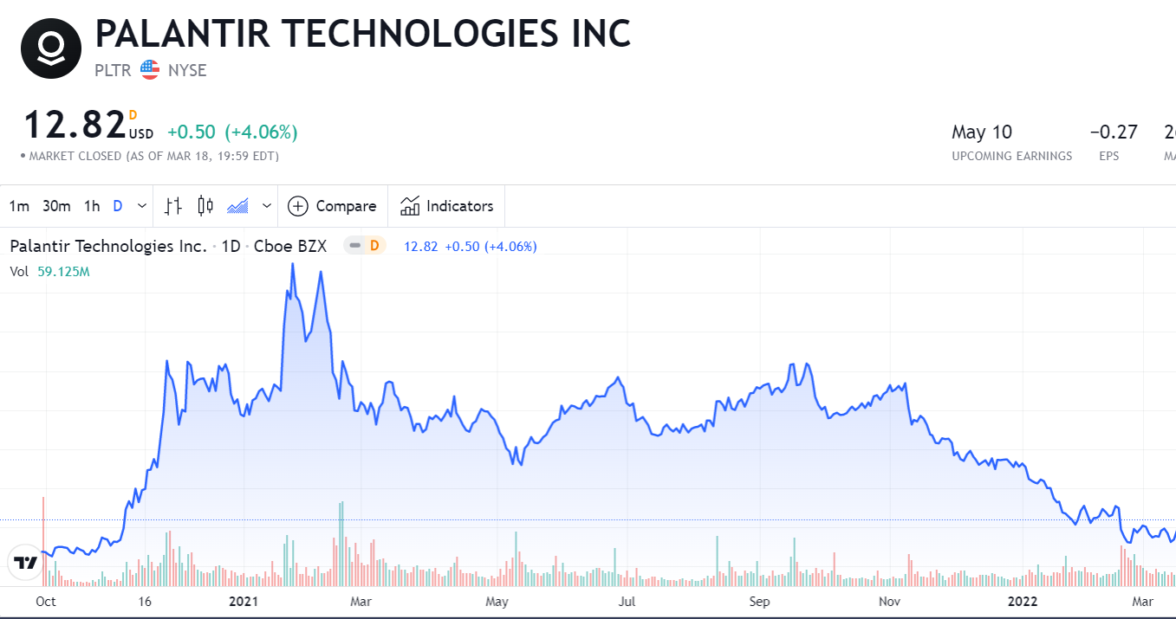
Figure 4.5.1 October 2020 - March 2022 PLTR Chart
Believing the company would get a boost in price like other contractors in the US have from the war about $5000 of stock was bought along with about $2000 of call options. The exact numbers for these trades can be seen in Table 4.5.1:
Table 4.5.1 Transaction Table for Fifth Week
Date | Symbol | Buy/Sell | Price | Shares/  Contracts | Value | Profit/  Loss | Total Cash | Total  Profit
03/01/22 | GME | SELL | $122.18 | 25 | $3,054.50 | $634.75 | $6,116.60 | $1,076
03/01/22 | CNC | SELL | $82.26 | 50 | $4,113.00 | $119.00 | $10,229.60 | $1,195
03/02/22 | PLTR | BUY | $11.86 | 429 | $5,085.80 |  | $5,144.10
03/02/22 | PLTR | Calls/BUY | $0.60/Contract | 35 | $2,100 |  | $3,044.10

4.6 Week 6
This week started with the selling of Intel. Even though the stock is very undervalued the price mostly fluctuates downwards rather than upwards. It is still strongly believed that it is a very good hold for a long-term investor rather than an 8-week investing project. Finally getting nearly back to the price it was bought at we were able to sell it for a very minor loss of $2. The stock that caught my eye again this week as a buy was once again GameStop who previously netted a very nice profit from its fluctuation price of $90-$120. Seeing it fall to below $100 again seemed like a good catch so more GameStop was bought once again to try and get a nice profit on its upward trend. The transaction for the sixth week of trading can be seen in Table 4.6.1:
Table 4.6.1 Transaction Table for Sixth Week
Date | Symbol | Buy/Sell | Price | Shares/  Contracts | Value | Profit/  Loss | Total Cash | Total  Profit
03/07/22 | INTC | SELL | $48.06 | 60 | $2,883.60 | $1.80 | $5,927.70 | $1,193.20
03/07/22 | GME | BUY | $102.61 | 25 | $2,565.25 |  | $3,362.45

4.7 Week 7
This week the belief that PLTR was very undervalued seemed to be correct as the stock raised in price by over a dollar so to make sure some profit was made and so money was had for further trading 200 shares were sold and over $600 was made. It is still believed that even at this price PLTR is undervalued so for this reason we will hold the other 229 shares hoping for some more rise in the price. Taking the $600 profit is a safe bet since if the price falls a bit, it will probably at worst even out and not be a total loss. The one trade done this week can be seen in Table 4.7.1:
Table 4.7.1 Transaction Table for Seventh Week
Date | Symbol | Buy/Sell | Price | Shares/  Contracts | Value | Profit/  Loss | Total Cash | Total  Profit
03/18/22 | PLTR | SELL | $12.88 | 200 | $2,576.00 | $619.08 | $5,938.45 | $1,812.28

4.8 Week 8
Being the final week of trading there was a lot of trading to be done this week to try and maximize profits before the trading time period ran out. All the transactions for this week can be seen in Table 4.8.1:

Table 4.8.1 Transaction Table for Eight Week
Date | Symbol | Buy/Sell | Price | Shares/  Contracts | Value | Profit/  Loss | Total Cash | Total  Profit
3/22/2022 | PLTR | SELL | $13.06 | 229 | $2,991.08 | $274.80 | $8,929.53 | $2,087.08
3/22/2022 | GME | BUY | $100.31 | 25 | $2,507.75 |  | $6,421.78
3/22/2022 | BNFT | BUY | $11.46 | 297 | $3,403.62 |  | $3018.16
3/22/2022 | GPRO | SELL | $8.20 | 340 | $2,786.30 | $214.20 | $5,804.46 | $1,872.88
3/22/2022 | ASTS | BUY | $10.25 | 260 | $2,665.00 |  | $3,139.46
3/23/2022 | PLTR | Calls/SELL | $0.67/Contract | 35 | $2,345.00 | $245 | $5,484.46 | $2,117.88
3/23/2022 | GME | Puts/BUY | $9.65/Contract | 2 | $1,930.00 |  | $3,554.46
3/23/2022 | GME | SELL | $138.28 | 50 | $6,913.93 | $1,840.93 | $10,468.39 | $3,958.81
3/23/2022 | INTC | SELL | $48.78 | 60 | $2,926.80 | $41.4 | $13,395.19 | $4,000.21
3/25/2022 | ASTS | SELL | $10.21 | 260 | $2,654.60 | $11 | $16,049.79 | $3,989.21
3/25/2022 | BNFT | SELL | $12.55 | 297 | $3,727.35 | $324 | $19,77.09 | $4313,21
3/25/2022 | UPWK | SELL | $23.04 | 152 | $3,502.08 | $199.12 | $23,279.17 | $4,114.09
3/25/2022 | GME | Puts/SELL | $0.06/Contract | 2 | $12.00 | $1,918 | $23,291.17 | $2,196.09

Chapter 5: Simulation 2 Speculative Trading
Simulation 2 will be centered around high volatility stocks, newer companies, turnaround plays, and sometimes companies with overall questionable balance sheets. Short term technical indicators, momentum trading, and a higher percentage of option trading will be conducted as described in my research from Section 3.2 [34].

5.1 Week 1
For the first week, we decided to use the Investopedia Simulator research tool to try to identify highly volatile stocks with favorable technical indicators, as well as fundamental indicators such as an upcoming earnings report. This week was thus used to gather data on a few stocks that fit the profile described above, with the plan being to begin trading week 2 after doing the research needed to get a feel for what could potentially be good, high upside plays.

5.2 Week 2
For Week 2, we purchased MARA and RIOT stock and options, as stated in Section 3.2. Another stock that caught our eye was DraftKings (ticker DKNG). DraftKings is a sports betting company that allows users to enter fantasy sports leagues. DraftKings IPOed a year ago, and since then it peaked at $71.98 on March 19th, 2021 [25]. DraftKings is a rapidly growing company, with revenue increasing from roughly 226 million dollars in 2018, to 323 million dollars in 2019, to 614 million dollars in 2020, to 1296 million dollars or roughly 1.3 billion dollars in 2021. This is roughly a 42.92% increase in 2019, and a 90.09% increase in 2020, and a 111.075% increase in 2021 [10]. However, DraftKings is not profitable, with DKNG reporting 1.523 billion dollars of debt in 2021. There is a lot of potential in the sports betting market, with federal legalization potentially being on the horizon. As recently as 2018, the federal ban on sports betting was overturned by the supreme court, with 32 states and Washington DC having some form of legal sports betting now. Therefore, we see significant growth potential in the industry. When combined with the rapid growth of DraftKings over the past few years, a reduction in stock price from 71.98 to 23.42 dollars over the past year, and signs that DKNG is starting to bottom out on the chart shown in Figure 5.2.1 below, we believe there is both short term and long-term upside for DKNG, and decide to invest. We purchased 200 shares and 2 option contracts with a 4/14/22 expiration date and 20-dollar strike price [25].
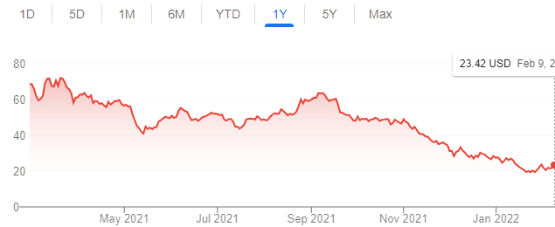
Figure 5.2.1 DKNG Yearly Chart
Two other companies we looked at were GameStop and AMC, which trade under the tickers GME and AMC respectively. These companies have a few things going for them that led me to the conclusion that there is potentially significant near-term upside with investing in them. First of all, both GME and AMC are pandemic plays, with both companies potentially benefitting from people returning to their normal lives, going out to the theaters to watch movies and going out to buy video games. This would theoretically lead to revenue returning to pre pandemic levels. However, there is also the whole wallstreetbets short squeeze event that happened last year, which lead to the share price of GME increasing from less than 5 dollars a share to closing at a high of 325 dollars a share in late Jan 2021 [25]. AMC increased from 2 dollars a share to a high of 59.26 dollars a share in late June 2021 [25]. The major driver behind these events was major hedge funds such as Melvin Capital and Citadel shorted struggling companies that were hit hard by the pandemic, such as GME and AMC. These major hedge funds would borrow millions of shares of both companies, and sell them at the current share price. Since they don't own the stock and are borrowing it, they need to buy back the stock eventually. These hedge funds believed that GME and AMC would continue to decline in share price like they had been doing for a while, which would have led to a profit for these hedge funds [35].
However, with the share price having been driven so low, these stocks became fundamentally undervalued and were attractive turnaround plays. We also had Ryan Cohen, CEO of Chewy invest in GME and was voted chairman of GMEs executive board. Cohen discussed his plans of pivoting GME from a purely brick and mortar business to e-commerce, with the idea of utilizing GMEs name recognition to attract online buyers and revive the struggling company [35]. These catalysts led to investors buying the dip, which caused a significant increase in share price. Then, Hedge funds who were short were forced to cover their positions, which means buying millions of GME shares, increasing the share price further. At this point, online communities such as wallstreetbets on reddit were FOMO-ing in a variety of heavily shorted stocks, including GME and AMC. It eventually got to the point where these hedge funds were margin-called, and brokers such as Robinhood blocked investors from buying GME and AMC shares, but they were allowed to close their positions. After this, the price tanked and never got back up to its record highs, but the price remained well above its pre short squeeze levels [25]. We are not convinced that the whole saga is over yet, as we have continued to see big spikes up after every major dip, which suggests that the investor sentiment is still high for these companies [25]. We recently have seen the biggest dip in both GME and AMC since right after the big short squeeze event. GME has gone from $247.55 a share on November 22nd, 2021, to $102.34 on Feb 4th. AMC has gone from $45.06 on November 8th, 2021, to $15.35 on Feb 4th, 2021. Due to the recent dip in price combined with the still elevated investor sentiment, we decided to invest. Cam purchased 50 shares of GME, 100 shares of AMC, and 4 contracts of AMC expiring 4/14/2022 with a 16-dollar strike price. Shown below in Figures 5.2.2 and 5.2.3 are the charts for GME and AMC respectively. At the very bottom is Table 5.2.1, our transaction tables for Week 2 [25].
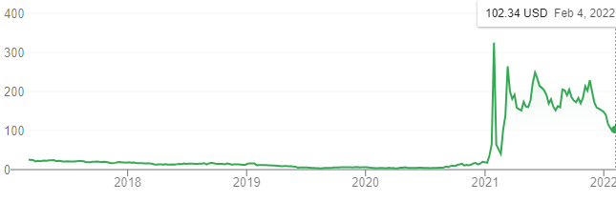
Figure 5.2.2 GME 5-Year Chart
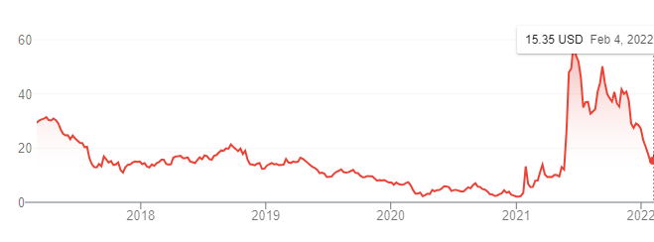
Figure 5.2.3 AMC 5-Year Chart

Table 5.2.1 Transaction Table for First Week
Date | Symbol | Buy/Sell | Price | Shares/  Contracts | Value | Profit/  Loss | Total Cash | Total  Profit
02/07/22 | AMC | BUY | $14.96 | 150 | $2244.24 |  | $17755.76
02/07/22 | MARA | BUY | $25.66 | 40 | $1026.40 |  | $16729.36
02/07/22 | RIOT | BUY | $17.60 | 70 | $1232.01 |  | $15497.35
02/07/22 | MARA | Calls/BUY | $5.40/Contract | 2 | $1080.00 |  | $14417.35
02/07/22 | RIOT | Calls/BUY | $4.80/Contract | 2 | $960.00 |  | $13457.35
02/09/22 | AMC | Calls/BUY | $4.80/Contract | 4 | $1920.00 |  | $11537.35
02/09/22 | DKNG | Calls/BUY | $5.15/Contract | 2 | $1030.00 |  | $10507.35
02/09/22 | GME | BUY | $120.58 | 50 | $6029.00 |  | $4478.35
02/09/22 | DKNG | BUY | $23.06 | 200 | $4612.00 |  | ($133.65)

5.3 Week 3
This week we decided to take a wait and see approach until Thursday, with the big event this week being DraftKings’s Q4 earnings report. Unfortunately, DraftKings (DKNG) dipped by 21.62% on Friday. Typically, with a dip that big after earnings, the financials are a disaster. However, this is not what we saw. Revenue increased 46.9% to $473.3 million compared to last year. According to DraftKings co-founder and CEO Jason Robins, “DraftKings’ strong fourth-quarter performance exceeded our expectations on the top and bottom line.” “Our excellent quarter capped off a year in which five of our states were Contribution Profit positive, further demonstrating the effectiveness of our state playbook and supporting our positive view of the industry’s TAM. We enter 2022 positioned to grow our market share, further optimize our user experience and continue to strengthen our multi-product suite of offerings [11].”
According to CFO Park, “Our key performance indicators reflected excellent player retention, acquisition and cross-selling in the quarter, as Monthly Unique Payers increased by 32% and Average Revenue Per Monthly Unique Payer grew by 19%. We are increasing the midpoint of our 2022 revenue guidance to $1.93 billion given new state launches and strong underlying performance trends and introducing guidance for Adjusted EBITDA of negative $825 million to $925 million.” This quote from the CFO lists both positives and negatives with the company. DraftKings is seeing growth in its userbase, and its revenue per user is also increasing [11]. The increase in 2022 revenue guidance is a promising sign, with rapidly growing companies this revision upwards in forward guidance suggests the company is growing faster than expected. However, the adjusted EBITDA decreased to negative $825 to $925 million. This suggests that the company is taking on more debt than expected, which is likely a big reason behind the dip in share price on Friday. Often with speculative companies in the early phase of their growth, we will see them take on a significant amount of debt, as they need to borrow money to help them expand and grow. Therefore, we feel that the market is overreacting to the concerning adjusted EBITDA figures and increased our position. We decided to sell some of our AMC because it is still up 20% since we bought it despite a downtrend this week and used that capital to purchase 70 more shares of DKNG. This is shown in Table 5.3.1 below.
Table 5.3.1 Transaction Table for Week 2
Date | Symbol | Buy/Sell | Price | Shares/  Contracts | Value | Profit/  Loss | Total Cash | Total  Profit
02/18/22 | AMC | SELL | $18.03 | 75 | $1351.88 | $230.25 | $1218.23 | $230.25
02/18/22 | DKNG | BUY | $17.96 | 70 | $1256.85 |  | ($38.62)

5.4 Week 4
Unfortunately, Bitcoin went down quite a bit. Bitcoin looked like it was starting to break out from resistance in the mid 30k range, but there was a big drop again last week. The yearly chart looks bearish in the near term, with a head and shoulders pattern shown from August to December, with a decline in price afterwards. This is shown in Figure 5.4.1 below. When the trade was first initiated, we were closely watching how high Bitcoin would rise before a pullback. With the pullback starting at the 42k range compared to the 50k range during the last smaller spike, we are seeing lower highs [3]. With the new data from last week, we are now expecting to the see lower highs and lower lows pattern that began since late fall continue in the near term, especially with the current overall market sentiment being bearish. We remain bullish long term, but do not expect a recovery big enough by mid-April to get RIOT and MARA high enough above the 15 and 25 strike prices respectively to see profits in our option trades. Therefore, Cam decided to close 2 of his MARA contracts and one of his RIOT contracts to cut losses. He also sold half his RIOT and MARA stock. With the leftover capital from selling MARA and RIOT stock and options, Cam bought a put on TSM, expiring 4/14/22 with a $120 strike price. This is shown in our transaction tables in Table 5.4.1 shown below. TSM historically has moved with the market and a double top is beginning to form, a bearish indicator, shown below in Figure 5.4.3. In the near term, we feel that with the Russia situation, rising inflation and double top pattern for SPY forming, shown in Figure 5.4.2, there is a very strong bearish signal.
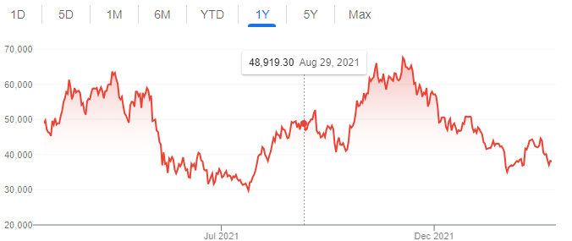
Figure 5.4.1 Bitcoin Forms Bearish Head and Shoulders Pattern
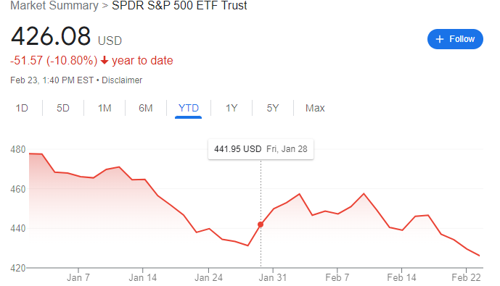
Figure 5.4.2 Double Top Pattern with Lower Highs and Lower Lows, a Bearish Indicator
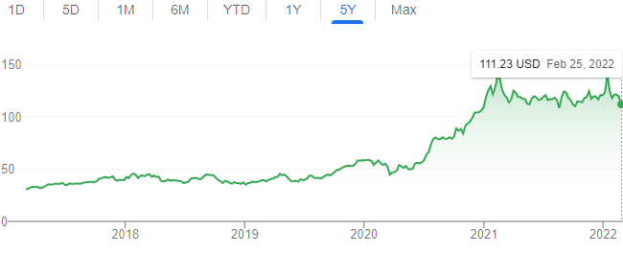
Figure 5.4.3 bearish Double Top Pattern Forming for TSM

Table 5.4.1 Transaction Table Week 4
Date | Symbol | Buy/Sell | Price | Shares/  Contracts | Value | Profit/  Loss | Total Cash | Total  Profit
02/23/22 | RIOT | SELL | $15.48 | 35 | $541.80 | $74.21 | $503.18 | $156.04
02/23/22 | MARA | SELL | $21.71 | 20 | $434.20 | $79.00 | $937.38 | $77.04
02/23/22 | RIOT | Calls/SELL | $3.00/Contract | 1 | $300.00 | $180.00 | $1237.38 | $102.96
02/23/22 | MARA | Calls/SELL | $2.76/Contract | 2 | $552.00 | $528.00 | $1789.38 | $630.96
02/25/22 | TSM | Puts/BUY | $12.35/Contract | 1 | $1235.00 |  | $554.38

5.5 Week 5
For this week, the near-term outlook remains bearish with a descending triangle pattern forming on the 6-month SPY chart, shown in Figure 5.5.1 below. We also have the Russia-Ukraine situation escalating quickly, and unfortunately, I do not expect Putin to back down any time soon. We will likely see other countries respond by putting sanctions on Russian goods, which would lessen supply. By laws of supply and demand, assuming demand remains constant, which for inelastic goods like oil it would, theoretically the price would be expected to increase. Therefore, we are anticipating inflation to increase further, despite being the highest it has been in 25 years, shown in Figure 5.5.2 below [32]. It is likely that the recent downtrend in the market is partially due to elevated uncertainty surrounding the inflation rate. Despite Federal Reserve chair Jerome Powell downplaying inflation as transitory, the inflation rates have continued to increase, and we have had a major catalyst with the Russia-Ukraine situation that worsens the outlook for inflation. Due to this combined with bearish technical indicators, we do not think the market has fully priced in the bearish macroeconomic outlook and anticipate the downtrend for SPY to continue. We plan on taking a wait and see approach this week, holding onto the TSM put we purchased last week to act as a bearish hedge for our portfolio.
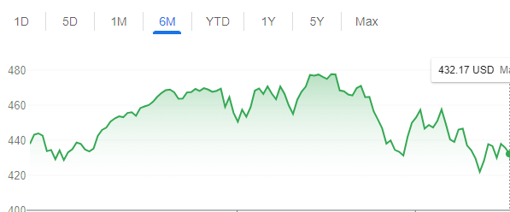
Figure 5.5.1 6-Month SPY Chart
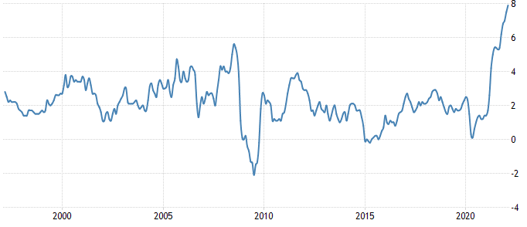
Figure 5.5.2 25-Year Inflation Chart

5.6 Week 6
Our hypothesis from last week ended up being correct, with Biden announcing that the US is banning Russian oil. The downtrend in the overall market continued, with SPY dipping from $432.17 at the end of last week, to $420.07 this week. Fortunately, the TSM put we purchased as a bearish hedge to our portfolio offset the losses in the rest of our portfolio. Since the TSM put was up well over 50%, we decided to take profits on that. Due to the descending triangle pattern on the SPY chart being confirmed with the SPY making a new low this week, shown in Figure 5.6.1 below, we do not anticipate our crypto options, AMC options, and DKNG options recovering enough to expire in the money by expiration. Therefore, we decided to cut losses and sell them.
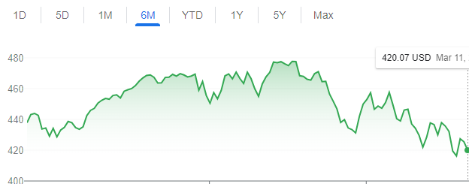
Figure 5.6.1 6-Month SPY Chart
However, despite the bearish overall outlook in the market, the same macroeconomic indicators that are bearish for the overall market are bullish for the energy sector. We have people going out more, traveling and buying goods. Although we are still in a pandemic, the pandemic has been going on for 2 years now so pandemic fatigue is kicking in. We are seeing restrictions slowly be relaxed over time as a result, and demand for goods and services such as oil has therefore increased. On the supply side, with the US banning Russian oil, that lessens our supply. When supply decreases and demand increases, by laws of supply and demand, we should see the price of oil increase, and it has [8]. As described in chapter 3, this is bullish for the oil and gas industry. In the near term, Cam looked for a stock in the energy sector that is undervalued and has significant near-term upside, and FCEL appears to fit the criteria. FCEL is not an oil and gas stock, but it is in the energy sector, so we anticipate it moving with the energy sector rather than the overall market in the near term. FCEL has also dipped from $26.20 a share in mid Feb 2021 to barely over 6 dollars a share now [25]. With both the significant dip in price from last year combined with bullish catalysts in the energy sector as a whole, there is the potential for a significant increase in price in the near term for FCEL. On the 6-month chart shown in Figure 5.6.2 below, we can see that a bullish ascending triangle pattern is starting to form, with higher lows and higher highs after bottoming out slightly below 4 dollars a share. Therefore, Cam decided to use some of the capital freed up from selling other stocks and options to purchase 15 FCEL call contracts.
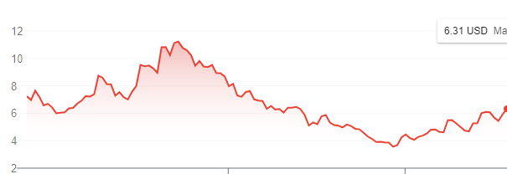
Figure 5.6.2 FCEL 6-Month Chart
Another stock with bullish macroeconomic indicators is PLTR. PLTR is a defense contractor company and has recently gone from over 30 dollars a share to roughly 11 dollars a share in less than a year. It looks like PLTR is starting to form a double bottom pattern on the chart, as it bounced off the 10-11 level once already and appears to be doing so again. This is shown in Figure 5.6.3 below. We will need to see the price movement the next couple of weeks to confirm, and if it does, we will buy more. However, we feel that the Russian war will be a catalyst that will lead to an increase in price in the short as well as long term, so Cam purchased 10 PLTR call contracts [25].
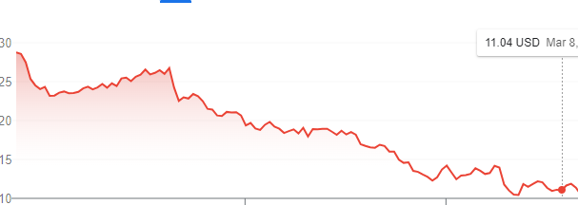
Figure 5.6.3 1-Year PLTR Chart
With the remaining capital leftover from cutting our losses described above Figure 5.6.1, we looked at GME. GME is currently down to 100 dollars a share, shown in Figure 5.6.4 below, and has declined with the market. While it is possible GME keeps going down with the market, GME reports earnings next week, which could be a catalyst for a short-term spike if earnings are good. GME also has its plans to launch an NFT marketplace, which would be a bullish catalyst for both the short and long term [35]. If a timeline and concrete plan for how the NFT marketplace will be launched is discussed during the earnings call, we anticipate that would lead to improved sentiment. We have seen in the past that positive catalysts can lead to significant price increases, sometimes in excess of 10% in one day [25]. Although GME has been struggling recently, the factors discussed in section 5.1 remain present, and investor sentiment is still elevated. Therefore, Cam increased his position in GME and bought 15 more shares. Next week, the plan is to wait for GME earnings, and reevaluate then. The transaction tables for this week are shown in Table 5.6.1 below.
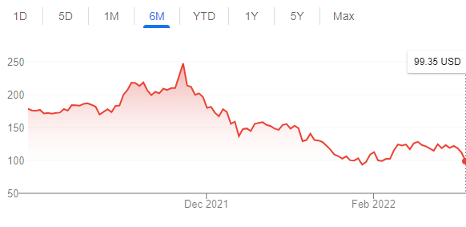
Figure 5.6.4 6-Month GME Chart
Table 5.6.1 Transaction Tables for Week 6
Date | Symbol | Buy/Sell | Price | Shares/  Contracts | Value | Profit/  Loss | Total Cash | Total  Profit
3/07/2022 | TSM | Puts/SELL | $21.60/Contract | 1 | $2160 | $925 | $2714.38 | $294.04
3/07/2022 | AMC | Calls/SELL | $2.21/Contract | 2 | $442.00 | $518 | $3174.38 | $223.96
3/07/2022 | DKNG | Calls/SELL | $1.59/Contract | 2 | $318.00 | $712 | $3474.38 | $935.96
3/07/2022 | RIOT | SELL | $15.03 | 35 | $526.05 | $89.95 | $4000.43 | $1025.91
3/07/2022 | MARA | SELL | $21.74 | 20 | $434.80 | $78.40 | $4435.23 | $1104.31
3/07/2022 | PLTR | Calls/BUY | $1.16/Contract | 10 | $1160 |  | $3257.23
3/07/2022 | GME | BUY | $99.38 | 15 | $1490.7 |  | $1775.53
3/08/2022 | FCEL | Calls/BUY | $0.90/Contract | 15 | $1350 |  | $434.53
3/11/2022 | AMC | Calls/SELL | $1.35/Contract | 2 | $270 | $690 | $704.53 | $1794.31
3/11/2022 | RIOT | Calls/SELL | $2.22/Contract | 1 | $222 | $258 | $926.53 | $2052.31

5.7 Week 7
This week, GME had its earnings report. Unfortunately, GME tanked from roughly 100 dollars a share to below 90 dollars a share after earnings. A big reason for the drop in my opinion is because GME reported an adjusted net loss of $1.86 per share, when an adjusted net gain of 85 cents a share was expected, which is significantly worse than expected [23]. A big takeaway from GMEs Q4 earnings report is that currently, the retail video game seller is struggling more than anticipated right now. However, there are a couple of positives to be taken away from the earnings report as well. GME did report revenue slightly higher than anticipated, 2.25 billion reported vs 2.24 billion expected. In the filing, GME reiterated its commitment towards its pivot into the e-commerce space, and most importantly it laid out a timeline for the launch of the NFT marketplace, the end of Q2 in 2022, sometime during June [23]. Although the adjusted net loss is concerning, I do feel the market is overreacting to the adjusted net loss considering the positive catalysts ahead as well as the factors discussed in section 5.1. Therefore, I am anticipating a bounce back, and decided to sell some DKNG shares to free up capital to buy the dip in GME, shown in Table 5.7.1 below.
Table 5.7.1 Transaction Tables for Week 7
Date | Symbol | Buy/Sell | Price | Shares/  Contracts | Value | Profit/  Loss | Total Cash | Total  Profit
03/16/22 | DKNG | SELL | $18.14 | 70 | $1269.80 | $12.60 | $2196.33 | $2039.71
03/16/22 | GME | BUY | $85.89 | 20 | $1717.80 |  | $478.53

5.8 Week 8
This was the final week of the simulation, and since my FCEL call was close to break even and the expiration date was the end of the week, I sold it early rather than risk it dropping below the strike price and expiring worthless. I used that capital to buy some RIOT shares, as crypto had been going back up over the past week so I figured maybe I could make some money short term on this uptrend. I also went into the week with the plan of giving it a few days to see if GME bounces back after earnings. Fortunately, there was a major positive catalyst, insider buying. GME chairman Ryan Cohen increased his position, purchasing 100k GME shares on Tuesday. When combined with the elevated sentiment discussed in Section 5.1, this insider buying proved to be the spark that caused a drastic increase in share price, with GME going from $85.89 per share when I bought the dip just after earnings on 3/16/22 to over $146.27 per share on the last day of the simulation, 3/25/22. This is the price that I cashed out and sold my last 75 GME shares. As the share price increased, I slowly began selling my GME shares to lock in profits and held 75 shares until the last day of trading. This is approximately a 70.3% increase in share price over a very short period of time, which gives credence to my hypothesis discussed in Section 5.1. Since this was the final week, I cashed out and sold all of my call options as well as my other stocks on 3/25/22. My transactions for this week are shown below in Table 5.8.1.
Table 5.8.1 Transaction Tables for Week 8
Date | Symbol | Buy/Sell | Price | Shares/  Contracts | Value | Profit/  Loss | Total Cash | Total  Profit
3/22/2022 | FCEL | Calls/SELL | $0.94/Contract | 15 | $1410 | $60 | $1888.53 | $1979.71
3/22/2022 | RIOT | BUY | $21.00 | 60 | $1259.70 |  | $629.03
3/23/2022 | GME | SELL | $140.60 | 10 | $1405.95 | $547.10 | $2034.98 | $1432.61
3/25/2022 | AMC | SELL | $21.05 | 75 | $1578.38 | $456.75 | $3613.36 | $975.86
3/25/2022 | DKNG | SELL | $18.59 | 200 | $3717.72 | $894 | $7331.08 | $1869.86
3/25/2022 | GME | SELL | $146.27 | 75 | $10970.33 | $2591.65 | $18301.41 | $721.79
3/25/2022 | PLTR | Calls/SELL | $2.25/Contract | 10 | $2250 | $1090 | $20551.41 | $1811.79
3/25/2022 | RIOT | SELL | $21.49 | 60 | 1289.48 | $29.4 | $21840.89 | $1841.19

Chapter 6: Simulation 3 Position Trading
Simulation 3 will be centered around a longer-term approach, with an added emphasis on fundamental indicators such as net cash, revenue, price to earnings ratio, price to book ratio, etc. There will be less reliance on technical analysis than in Simulation 3, but even for a longer-term approach taking a look at support and resistance levels for the 6 month and yearly price charts is a useful tool. Technical indicators are especially useful for gauging entry and exit points, as discussed in my research in Section 3.3. This Simulation will be weighted with a slightly lower percentage of options than Simulation 2, and there will be more emphasis on large scale macroeconomic factors like inflation, supply and demand, etc to help guide me towards certain industries.

6.1 Week 1
For the first week, we decided to use the Investopedia Simulator research tool to try to identify stocks with strong fundamental indicators in industries that appear to be primed to thrive given the current macroeconomic landscape. We also are keeping an eye on technical indicators such as support and resistance levels on the longer term charts. This week was thus used to gather data on a few stocks that fit the profile described above, with the plan being to begin trading week 2 after doing the research needed to get a feel for what could potentially be good, longer term plays that will pay off towards the end of the simulation.

6.2 Week 2
Due to the bullish long-term outlook on oil as a whole as discussed in Section 3.3, we decided to invest in SLB and OXY stock and options. We purchased 100 shares of SLB and 50 shares of OXY. For options, we purchased 3 OXY contracts expiring 4/14/22 with a 36-dollar strike price, 3 SLB contracts expiring 4/01/22 with a 38-dollar strike price, and for a high-risk high upside play we purchased 10 SLB contracts expiring 3/25/22 with a 42-dollar strike price.
Another stock that jumped out to us is Alibaba (ticker BABA), which is a Chinese e-commerce company that is essentially the Chinese version of Amazon. As shown in Figure 6.2.1 below, BABA has a high and steadily growing free cash flow. BABAs cash flow increased from 106.2 billion in 2017 and is projected to be 234.5 billion in 2022 which averages out to approximately a 24.2% growth rate since 2017, which is during the time period with the slowest rate of growth [1]. If you use the growth rate over the past 5 years of 24.2% for the discounted FCF valuation method shown in Figure 6.2.2 below, we come up with a valuation of $458 a share for BABA [20]. This is a conservative projection (we are erring on the side of caution) since interest rates have been below 10% over the past 30 years. Therefore, BABA is extremely undervalued fundamentally, and is showing signs of bottoming out on the chart shown in Figure 6.2.3 [25]. Therefore, we decided to purchase 25 shares of BABA as well as 1 BABA call contract expiring 4/14/22 at a 125-dollar strike price.
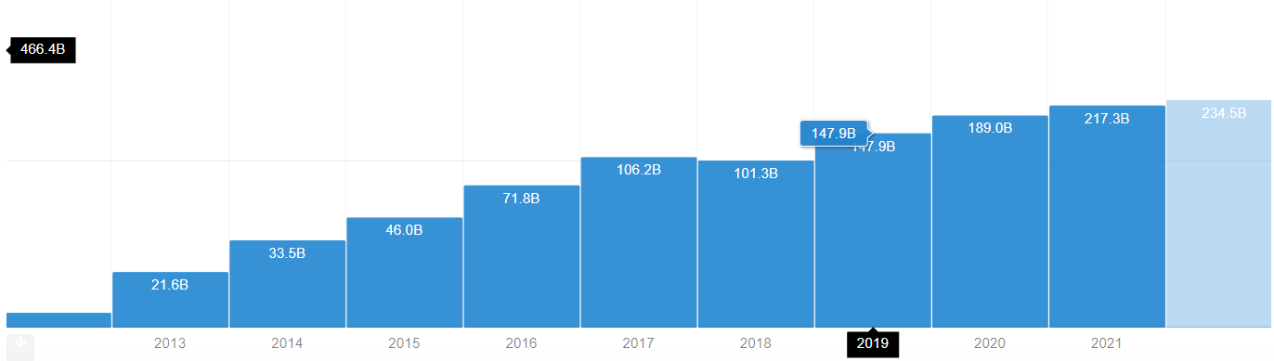
Figure 6.2.1 BABA Free Cash Flow From 2013 to 2022 (Projected) in Billions
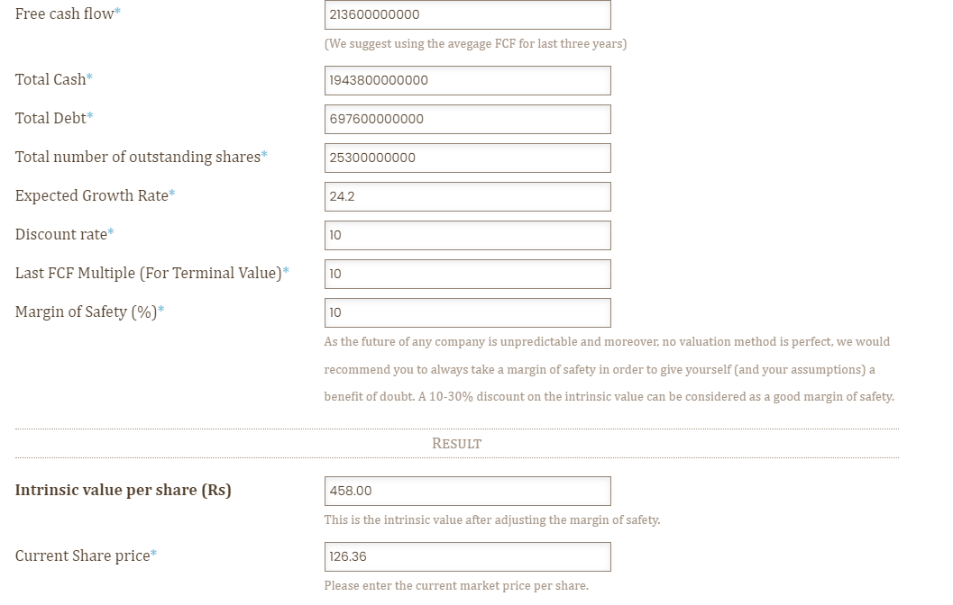
Figure 6.2.2 BABA Discounted FCF Valuation
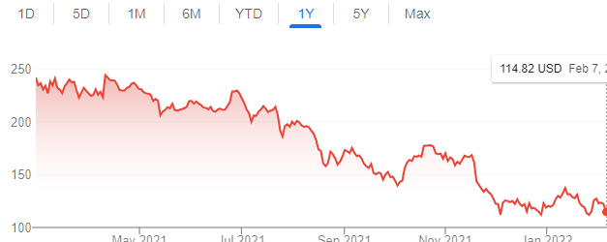
Figure 6.2.3 BABA Yearly Chart
For the rest of our money, we decided to invest in TLRY, as we noticed that it appeared to be bottoming out at slightly over 6 dollars a share, down from 30.47 on March 15th, 2021. This is shown below in Figure 6.2.4. Unlike BABA, TLRY is a newer company (founded 2013) still in debt. The field it is in, the marijuana industry is still in its infancy. Due to this, there is a fairly high risk here, higher risk than most companies we look at in the position trading simulation. However, we made an exception for TLRY due to its book value compared to the price [29]. The book value is calculated by dividing shareholder equity by total outstanding shares. For TLRY, its shareholder equity as of 2021 is roughly 4.465 billion, with 270 million shares outstanding [29]. This calculates to a book value of roughly $16.54 a share, more than double the current price. Therefore, TLRY is extremely undervalued, so we purchased 500 shares of TLRY and 15 TLRY call contracts, expiring 4/14/22 with a 6-dollar strike. Our transactions for this week are shown below in Table 6.2.1.
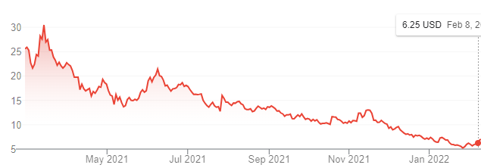
Figure 6.2.4 TLRY Yearly Chart
Table 6.2.1 Transaction Table for Week 2
Date | Symbol | Buy/Sell | Price | Shares/  Contracts | Value | Profit/  Loss | Total Cash | Total  Profit
02/09/22 | TLRY | BUY | $6.87 | 500 | $3434.85 |  | $16565.15
02/09/22 | TLRY | Calls/BUY | $1.52/Contract | 15 | $2280.00 |  | $14285.15
02/09/22 | BABA | BUY | $126.36 | 25 | $3159.00 |  | $11126.15
02/09/22 | BABA | Calls/BUY | $12.25/Contract | 1 | $1225.00 |  | $9901.15
02/10/22 | SLB | BUY | $39.45 | 100 | $3945.00 |  | $5956.15
02/10/22 | SLB | Calls/BUY | $3.25/Contract | 3 | $975.00 |  | $4981.15
02/10/22 | OXY | BUY | $40.67 | 50 | $2033.50 |  | $2947.65
02/10/22 | OXY | Calls/BUY | $6.50/Contract | 3 | $1950.00 |  | $997.65
02/10/22 | SLB | Calls/BUY | $1.21/Contract | 10 | $1210.00 |  | ($212.35)

6.3 Week 3
Shown below in Figure 6.3.1 is the yearly chart for the S&P 500 (SPY). This week, the market overall tanked, and my stocks followed the market and went down as well. SPY declined from roughly 440 to 435 this week, and by the yearly chart we are nearing an inflection point that will determine what our next moves will be. The SPY previously has dipped to the 430 range twice in the past 6 months, once in October and once in late January, approximately 3 weeks ago [25]. This week, we decided to hold all of our stocks and options, and not conduct any trades until we either bounce off the 430 level to confirm that we are holding support, and would also lead to a double bottom formation, or continue to drop which would indicate a possible reversal. If we do get that double bottom next week, we will maintain a bullish outlook and hold our stocks even with the recent dip. If we continue to dip and start seeing signs of a reversal, we are going to take a more bearish outlook and start looking to cut losses.
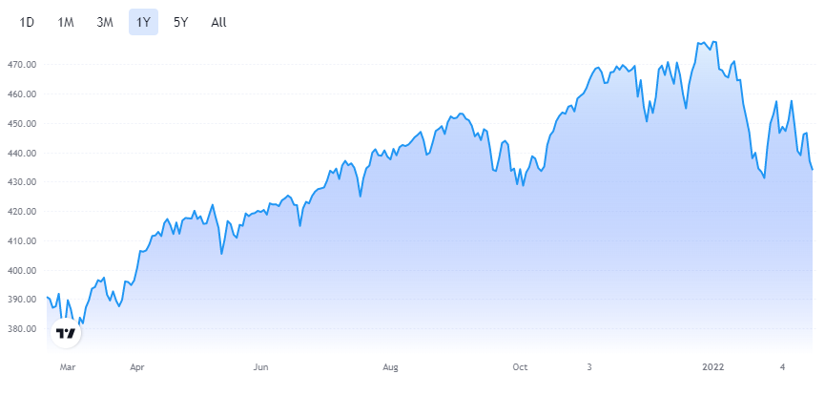
Figure 6.3.1 Yearly Chart for SPY

6.4 Week 4
For this week, we had a major catalyst with Russia invading Ukraine. This shifts our outlook for the overall market to be more bearish, as there is unfortunately the possibility that the global situation continues to escalate, with several military analysts saying that Russia’s invasion of Ukraine could potentially embolden China to invade Taiwan. Historically, stock markets have not done well during times of war, and we feel that this opens up more downside risk with the Chinese e-commerce giant, BABA. Therefore, we decided to close our positions in BABA, selling all of our stock as well as our call contact at a loss. While the Russian invasion of Ukraine is a negative overall catalyst, defense contractors such as Raytheon will theoretically profit from global instability. Therefore, we purchased 1 call contract of RTX. We also decided to pull the trigger and buy some shares of AMD, which has gained significant market share over intel in the GPU market. With the rise of bitcoin mining, the demand for GPUs will likely increase if crypto grows as we anticipate as discussed in chapter 3. On the long-term charts shown in Figure 6.4.1 below, AMD appears to have bounced off support in the 100-110 range after a pullback from the 150 level, so we feel that right now is a good entry point [25]. Due to the situation with Russia, there is some near-term downside risk, as if the overall market continues to tank it will likely pull AMD down with it. However, the positives outweigh the negatives in the long term. Our transactions for this week are shown below in Table 6.4.1.
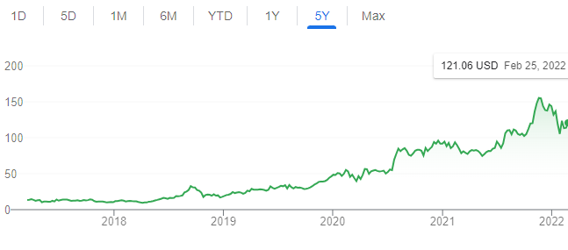
Figure 6.4.1 AMD Chart
Table 6.4.1 Transaction Table for Week 4
Date | Symbol | Buy/Sell | Price | Shares/  Contracts | Value | Profit/  Loss | Total Cash | Total  Profit
02/25/22 | BABA | Calls/SELL | $2.70/Contract | 1 | $270 | $955 | $58.00 | $955
02/25/22 | BABA | SELL | $107.25 | 25 | $2681.25 | $478 | $2739.25 | $1433
02/25/22 | AMD | BUY | $119.51 | 20 | $2390.20 |  | $349.05
02/25/22 | RTX | Calls/BUY | $3.95/Contract | 1 | $395 |  | ($45.95)

6.5 Week 5
For this week, our OXY and RTX options were up well over 100%, so we took some profits on those. Our overall view on the market as a whole is bearish in the near term, with the yearly SPY chart showing a descending triangle pattern in Figure 6.5.1, with lower highs before pulling back and bouncing off support again [25]. On top of this, we have crude oil quickly rising, with factors described in chapter 3 still holding [8]. Since we initially invested in oil and gas companies such as OXY and SLB week 1, the fundamentals for the oil and gas industry have gotten even more bullish. Historically we have seen that when there is a war going on overseas, that can lead to the United States as well as other countries putting sanctions on one or more of the countries involved to try and force said country to back off. This leads to an increase in oil prices early in the war, as supply is cut while demand remains strong. If the war drags on for an extended period of time, we could see sanctions on Russian goods such as oil remain, and oil prices would theoretically remain elevated for an extended period of time. For major oil and gas companies like SLB, these companies are pricing in crude oil to hover around 40 dollars a barrel. As of early March, crude oil has risen to the 105-110 range. There is no sign that oil prices will drop back to 40 any time soon, if anything with the war in Russia escalating its possible that the price continues to increase. Therefore, we are even more bullish on the oil and gas industry than we were in week 1. Since our OXY calls are up over 150%, we took profits on those and doubled down on our bullish position in the oil and gas industry. Cam reinvested those profits in SLB stock and options, a company that he feels has a better valuation with OXY’s recent rapid price increase. We also decided to invest in PLTR, a company we have been keeping an eye on for a while. PLTR is a defense contractor company and has recently gone from over 30 dollars a share to roughly 11 dollars a share in less than a year. It looks like PLTR is starting to bottom out on the chart shown in Figure 6.5.2, and we feel that the Russian war will be a catalyst that will lead to an increase in price [25]. PLTR is also a rapidly growing company, with a 47.15% increase in revenue in 2020 and a 24.7% increase in revenue the year before. PLTR has approximately 1.116 billion dollars of debt right now, so there is some risk involved, which is why at 30 dollars PLTR was overvalued [24]. At 11 dollars a share, it is a lower risk high reward play, as it is the cheapest valuation-wise it has ever been with positive near term as well as long term catalysts. Our transactions for this week are shown below in Table 6.5.1.
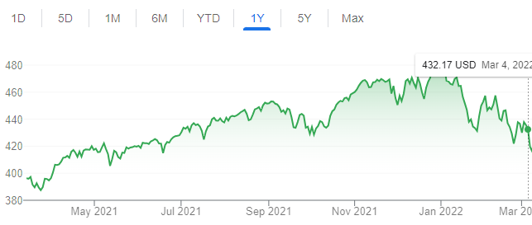
Figure 6.5.1 SPY Chart
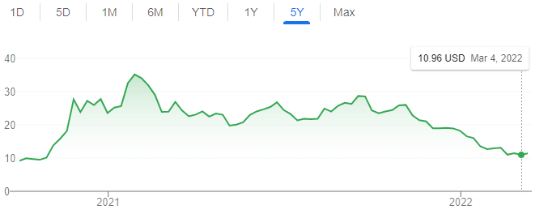
Figure 6.5.2 PLTR Chart
Table 6.5.1 Transaction Tables for Week 5
Date | Symbol | Buy/Sell | Price | Shares/  Contracts | Value | Profit/Loss | Total Cash | Total  Profit
03/01/22 | RTX | Calls/SELL | $7.50/Contract | 1 | $750 | $355 | $704.05 | $1078
03/01/22 | OXY | Calls/SELL | $11.15/Contract | 2 | $2230 | $930 | $2934.05 | $148
03/01/22 | TLRY | Calls/SELL | $0.71/Contract | 15 | $1065 | $1215 | $3999.05 | $1363
03/02/22 | SLB | BUY | $38.71 | 50 | $1935.25 |  | $2063.80
03/02/22 | PLTR | Calls/BUY | $1.55/Contract | 5 | $775 |  | $1288.80
03/02/22 | SLB | Calls/BUY | $1.24/Contract | 5 | $620 |  | $668.80
03/04/22 | OXY | Calls/SELL | $19.80/Contract | 1 | $1980 | $1330 | $2648.80 | $33

6.6 Week 6
For this week, Biden announced that the US would be banning Russian oil. Since we have a large portion of our stocks and options in companies in oil and gas industry, this news, which we have suspected would happen for a couple weeks has strengthened our bullish position in oil. With a major source of our oil supply cut off, combined with demand remaining constant, by laws of supply and demand this theoretically would lead to an increase in the price of oil. After taking a bit of profit last week, for this week we are going to hold our oil and gas stocks and take a bit of profit in our call contracts towards the end of the week. Due to our bullish position in the oil and gas industry, we are going to use the profits from selling our OXY and SLB call contracts to exercise a few of our remaining contracts later on, and purchased some PLTR stock, to diversify our portfolio a bit more and keep the percentage of our portfolio value that is options below 25%. Our long-term outlook on the overall market remains unchanged from last week, the plan going forward is to take profits and cash out of our options a couple weeks before expiration, and transition from a 75/25 stock option blend to 100% stock over the final couple of weeks of the simulation. Our transactions for this week are shown below in Table 6.6.1.
Table 6.6.1 Transaction Tables for Week 6
Date | Symbol | Buy/Sell | Price | Shares/  Contracts | Value | Profit/  Loss | Total Cash | Total  Profit
03/07/22 | SLB | Calls/SELL | $2.87/Contract | 5 | $1435 | $830 | $4083.80 | $797
03/07/22 | PLTR | BUY | $11.53 | 250 | $2281.25 |  | $1202.55

6.7 Week 7
This week, the price of oil tanked from above 120 to the mid-90s this week. As a result, my oil stocks tanked, with SLB dipping from 45 to 38. Fortunately, I took some profits on my options the past couple of weeks, so I'm not too far in the red. Looking at the catalysts behind the increase in crude oil prices, we still have the war with Russia and Ukraine going on. Sanctions have not been lifted yet, and there is still a possibility that we could see more countries impose sanctions on Russian oil. Therefore, the major drivers behind the rise in oil prices remain in place, and we anticipate this dip to be temporary. We will be holding onto our oil stocks and options, and only plan on selling the ones with a 3/25 expiration early in the week. We then plan on holding the rest until the end of the simulation. We have some capital left over from taking profits in our SLB options over the past couple weeks and noticed a double bottom forming on the 6-month PLTR chart shown in Figure 6.7.1 below [25]. With the technical indicators trending bullish combined with possible longer-term catalysts discussed in Section 6.5, we decided to add more PLTR calls to our portfolio. Our transactions for this week are shown below in Table 6.7.1.
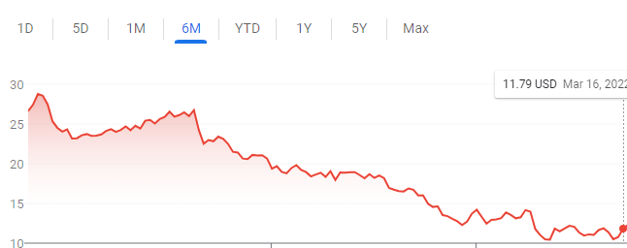
Figure 6.7.1 6-Month PLTR Chart
Table 6.7.1 Transaction Table for Week 6
Date | Symbol | Buy/Sell | Price | Shares/  Contracts | Value | Profit/  Loss | Total Cash | Total  Profit
03/16/22 | PLTR | Calls/BUY | $1.27/Contract | 8 | $1016 |  | $186.55

6.8 Week 8
This was the final week of the simulation, so I decided to sell the 5 remaining contracts of my SLB calls expiring at the end of the week a few days early as described in Section 6.7. Fortunately, towards the end of the week the price of crude oil rebounded, and my oil stocks and options went up accordingly. TLRY also had a significant jump in share price due to a bill that was proposed to potentially decriminalize marijuana nationwide, which turned what was one of my worst preforming stocks throughout the simulation to a stock I ended up selling at a profit on the last day of the simulation. Since this was the final week, I cashed out all of my remaining stocks and options in my account on 3/25/22. My transactions for this week are shown below in Table 6.8.1 [25]:
Table 6.8.1 Transaction Table for Week 8
Date | Symbol | Buy/Sell | Price | Shares/  Contracts | Value | Profit/  Loss | Total Cash | Total  Profit
3/22/2022 | SLB | Calls/SELL | $0.57/Contract | 5 | $285.00 | $320 | $471.55 | $477
3/24/2022 | SLB | Calls/SELL | $5.10/Contract | 3 | $1,530.00 | $555 | $2001.55 | $1032
3/25/2022 | TLRY | SELL | $7.89 | 500 | $3,945.50 | $510 | $5947.05 | $1542
3/25/2022 | PLTR | Calls/SELL | $2.33/Contract | 13 | $3,029.00 | $1238 | $8976.05 | $2780
3/25/2022 | SLB | Calls/SELL | $1.93/Contract | 5 | $965.00 | $345 | $9941.05 | $3125
3/25/2022 | AMD | SELL | $119.95 | 20 | $2,398.93 | $8.80 | $12339.98 | $3133.80
3/25/2022 | OXY | SELL | $58.04 | 50 | $2,902.00 | $868.5 | $15241.98 | $4002.3
3/25/2022 | PLTR | SELL | $13.27 | 250 | $3,316.25 | $435 | $18558.23 | $4437.3
3/25/2022 | SLB | SELL | $42.58 | 150 | $6,387.00 | $506.5 | $24945.23 | $4943.8

Chapter 7: Cryptocurrency Simulation
As mentioned earlier in Chapter 3 cryptocurrencies tend to act very similar to each other, at least the most popular and biggest by market capitalization. When this simulation first started a lot of cryptocurrencies were at their all-time highs so buying into the market was incredibly risky but for the purposes of this project it was done anyways. As expected, the cryptocurrencies dropped hard soon after and for this reason it was decided that this account would be more of a set and forget simulation just like our control group. In our control group we bought $20,000 worth of S&P500 as a simulation of the stock market, similarly we decided to buy $20,000 worth of the biggest and most popular cryptocurrency and forget about them for 8 or so weeks to see how the cryptocurrency market compares to the regular market.

7.1 Week 1
As seen in the figures of chapter 3.4 crypto has just been coming off a strong bull run and is still relatively high in value for this reason it was decided to buy the most popular cryptos that were offered on CryptoParrot as there are many, many cryptocurrencies that are currently not listed on that simulation engine to see the original purchases for week 1 see Table 7.1.1:
Table 7.1.1: Transaction Table for Week 1
Date | Symbol | Buy/Sell | Price  ($) | Shares/  Contracts | Value | Profit/  Loss | Total Cash | Total  Profit
02/07/22 | BTC | Buy | 44,151 | .1132 | $5000 |  | $15000
02/07/22 | ETH | Buy | 3113.70 | 1.6058 | $5000 |  | $10000
02/07/22 | ADA | Buy | 1.09 | 2754.8209 | $3000 |  | $7000
02/07/22 | XMR | Buy | 179.650 | 27.8319 | $5000 |  | $2000

7.2 Week 2
This week there was a rather large crash in the crypto market with many coins falling 5 to 10 percent in value as you can see in Figures 7.2.1 - 7.2.3 [22]:
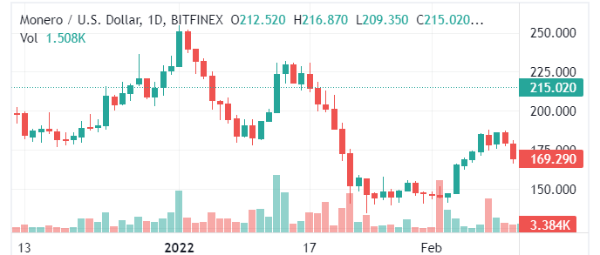
Figure 7.2.1 Moneron (XMR) 2022 Chart
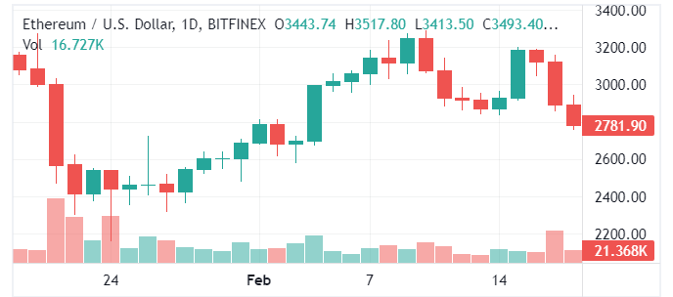
Figure 7.2.2 Ethereum (ETH) Early February Chart

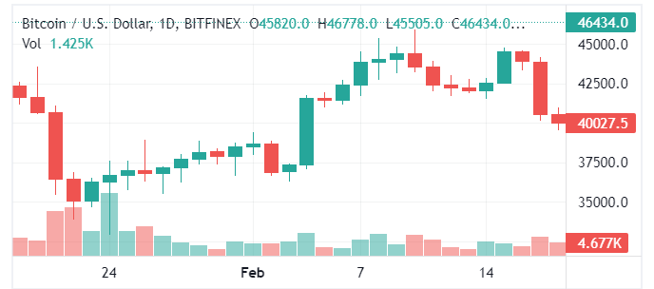
Figure 7.2.3 Bitcoin (BTC) Early February Chart
With such a large dip in the prices of crypto in such a short period now seemed like a good time to spend the rest of the money the account still had to try and make some profit. Since Ethereum particularly took a large dip in its price the last $2000 in the account was spent to buy Ethereum as can be seen in Table 7.2.1:
Table 7.2.1 Transaction Table for Second Week
Date | Symbol | Buy/Sell | Price  ($) | Shares/  Contracts | Value | Profit/  Loss | Total Cash | Total  Profit
02/14/22 | ETH | Buy | 2786.20 | .7178 | $2000 |  | $0

7.3 Week 3
With the harsh downturn in the Crypto market after last week there was much to sell for profit and seems like this will be true for the foreseeable future as most crypto follow each other in terms of trading patterns so for now the best thing that can be done is hold the account value [22]. Since so much of the account value was purchased right before the major downturn in the market it is possible it will be a while before anything recovers to profitability.

7.4 Week 4
During this week there was very little to no movement in the Crypto space. With the sideways trading for the past two weeks, it has been hard to make any meaningful trades to make profit in this account. By looking at the Bitcoin chart for this week in Figure 7.4.1 [22] we can see how little change has occurred in the crypto spaced this week:
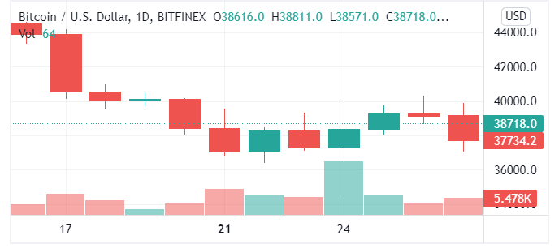
Figure 7.4.1 Bitcoin Chart for Week 4

7.5 Week 5
This week there was a small surge in the Crypto space in the middle of the week but it was very short lived and long enough for me to feel comfortable enough to make trades this week as it was hard to tell which way the space would continue trading. The week really put an emphasis on just how volatile this space can be at times. The small surge in the prices of crypto can be seen in Figure 7.5.1 [22]:

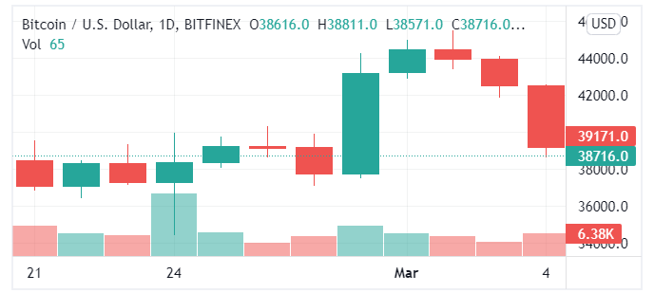
Figure 7.5.1 Bitcoin Chart for Week 5

7.6 Week 6
With another week of very quick surges and sideways trading it was another week that made it very difficult to make a concrete profit in the space. The volatility in the space is starting to prove to make this simulation difficult. We can see how the space traded this week by looking at Figure 7.6.1 [22]:
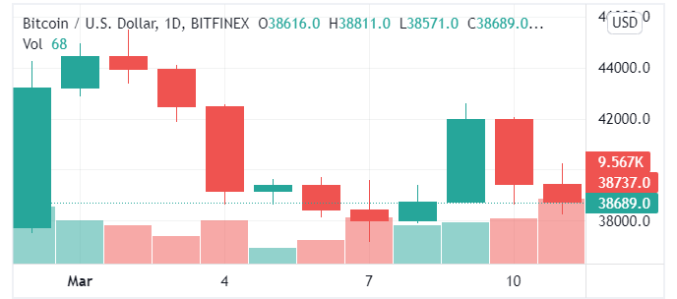
Figure 7.6.1 Bitcoin Chart for the Sixth Week

7.7 Week 7
After holding all the crypto for over 7 weeks the market is finally having a small bull run and this seems like a good time to start selling some of the currencies held. Monero and Cardano in particular have been up quite a bit this week, so both were sold [22]. Their prices over the 7 weeks can be seen in Figures 7.4.1 and 7.4.2 [22]:
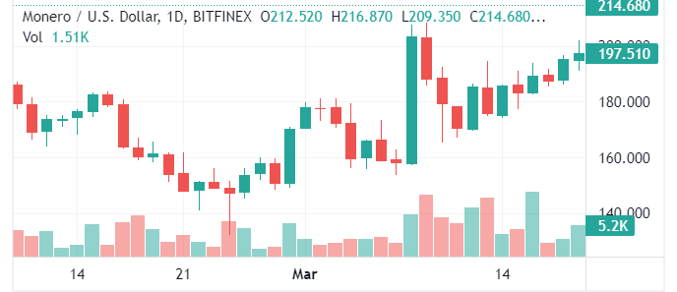
Figure 7.7.1 Monero (XMR) Chart for Most of the Simulation
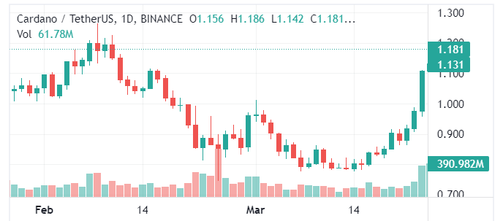
Figure 7.7.2 Cardano (ADA) Chart for Most of the Simulation
The profits from both these sales can be seen below in Table 7.4.1:

Table 7.4.1 Transaction Table for Week 7
Date | Symbol | Buy/Sell | Price  ($) | Shares/  Contracts | Value | Profit/  Loss | Total Cash | Total  Profit
03/18/22 | XMR | Sell | 193.51 | 27.7623 | $5372.30 | $372.30 | $5372.30 | $372.30
03/18/22 | ADA | Sell | 1.16 | 1.6058 | $3193.10 | $193.10 | $8562.40 | $565.40

7.8 Week 8
Being the final week of trading for the cryptocurrency simulation (5) it was time to sell the rest of the holdings in the account and this could be seen in Table 7.5.1:
Table 7.5.1 Transaction Table for Week 8
Date | Symbol | Buy/Sell | Price  ($) | Shares/  Contracts | Value | Profit/  Loss | Total Cash | Total  Profit
03/24/22 | BTC | Sell | 46,510 | .1129 | $5251 | $251 | $13813.40 | $816.40
03/24/22 | ETH | Sell | 3429 | 2.3178 | $7947.70 | $947.70 | $22375.80 | $1,764.10

Chapter 8: Analysis and Comparison
In this chapter we will gather all the totals in each account and compare them against each other as well as the control group, which worked as our simulation of the market. By doing so we will be able to figure out which accounts did the best, worst, and which managed to beat the market by a meaningful margin. Another statistic we would also like to look at is how each company we invested in compared in terms of profit and loss, by doing so we can tell which companies beat the market in our time period of trading.

8.1 Profit/Loss for Each company
Here we can take a step away from all the transactions to look at how profits and losses look at company by company level. The first simulation we will look at is Simulation 1, the value/recommendation trading simulation. Below in Figure 8.1.1 we can see which companies made us a profit and which made us a loss:
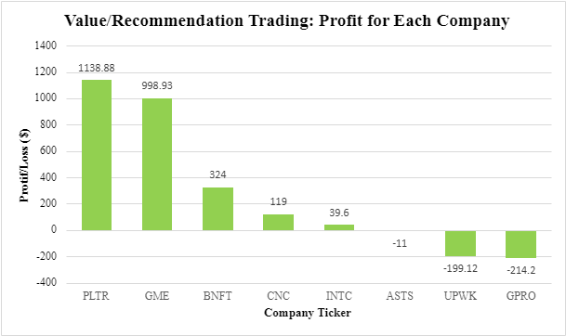
Figure 8.1.1 Profit/Loss for Each Company Traded in Simulation 1
The clear big winner here seems to be Palantir (PLTR). This is for a few reasons. First, as stated in chapter 3, PLTR has recently been on a very sharp decline with no actual bad news coming out about the company. They make healthy revenue and are overall undervalued in the sector they work in, military contracting. Which brings us to the second point PLTR hit its lowest just as the war in Ukraine was beginning. During this period most military contractors saw huge upticks in their stock prices including Raytheon and Lockheed. The one that lagged behind at first was PLTR but after about a week of being stagnant it bounced back pretty hard giving the simulation a nice healthy profit of $1,138.88 equal to 5.7% of the total amount invested during these 8 weeks.
The other major winner for this account was GameStop, something of an anomaly in the stock market recently. Calling the company that rose from $4 to nearly $500 then back to $100 undervalued isn’t exactly correct, however with its fluctuations in price there has been somewhat of a cycle in them. Whenever the stock would go longer periods of falling in price it would also shoot back up to about 100-120$. So, any time the stock was below or at $100 I considered it an undervalued buy and thus was able to make a nice profit on it. The only time that a profit was not made on GameStop was when betting on its downfall and buying weekly puts that expired worthless.
The biggest loser in this simulation was unfortunately GPRO, the company looks like it has a bright future ahead of it but news about the products as well as the sheer quality of their products has stifled their growth lately. Neither of these things have been very newsworthy so GoPro ends up being forgotten by many investors even if it is criminally undervalued. This company may prove to be a strong long-term investment but with only 8 weeks of trading to spare it is not enough for GoPro to have a meaningful rise in its stock price.
The other main takeaway from this chart is that Investopedia’s recommendations can be quite strong. Of the 3 tickers chosen through the recommendations two made decent profits for the account and only one made a loss. These gains were not on a scale comparable to the value trading strategy, but they did seem to be safe, profitable choices that can be used by anyone with an Investopedia account and 15 min of time.
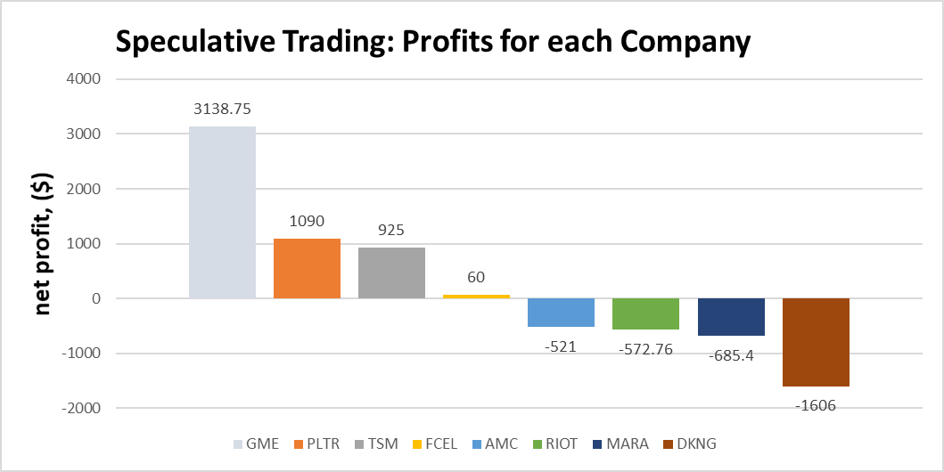
Figure 8.1.2 Profit/Loss for Each Company Traded in Simulation 2
In Simulation 2, which was made for applying a speculative trading strategy as described in Section 5, the big winner was GameStop. There are a few factors behind this, with the biggest one being that GME Chairman Ryan Cohen increased his position significantly. Often a big thing that investors look at when determining which companies, they want to invest in is insider buying. GMEs rapid rise in share price appears to have been drive by a combination of this insider buying on top of an already elevated investor sentiment, evidenced by GME having more than doubling in share price in a short period of time over the past year multiple times on good news.
The biggest loser was DraftKings. Although DKNG appeared promising at the time, it did have a worse than expected earnings report. When combined with the market as a whole struggling during the middle weeks of the Simulation, this worsened the outlook for my DKNG call options, and I ended up selling them at a loss. This ended up being a good decision, because those options would have expired worthless if I had kept them. I still remain bullish on DKNG long term, but there is still a lot of risk involved with the competition in the industry, the high debt on the DKNG balance sheet, and the possibility that many states who still don’t have legal sports betting continuing to keep it illegal for longer than expected. While DKNG may prove to be a great investment long term, the company has a long way to go, and it very well may end up taking a couple of years for an investment in DKNG to pay off.
The big takeaway is that speculative trading is a high risk but high upside strategy that can pay off if a trader applying this strategy is quick to move off of a trade if things go south. There will be large swings in a speculative traders’ bankroll, but especially during times where the market overall is doing well, the upside of having one of your stocks potentially double in a week (such as GME) makes it a viable strategy to hold stock in these companies. As fast as these stocks can go up, they go down twice as fast so traders need to make sure they lock in profits if one of their stocks has a GME like rise.
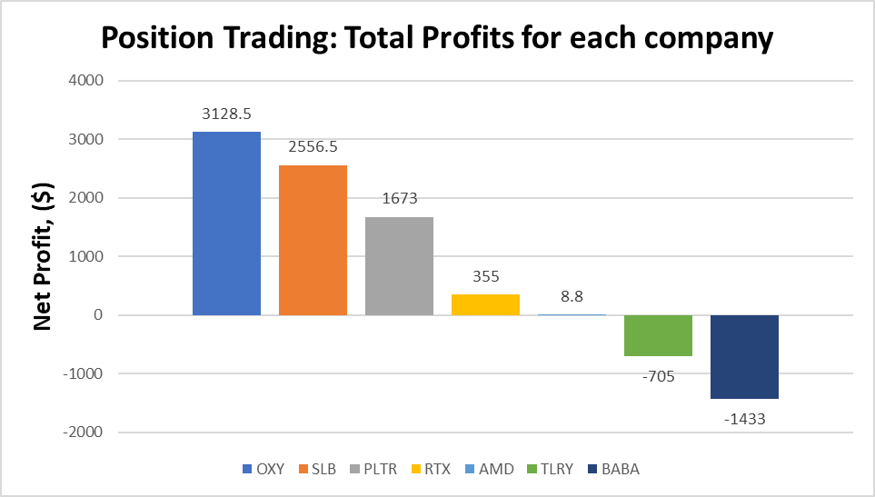
Figure 8.1.3 Profit/Loss for Each Company Traded in Simulation 3
In Simulation 3, which used a Position Trading strategy as described in Section 6, the big winner was Occidental Petroleum. Early in the Simulation when doing research, I argued that the price of oil would increase due to an increase in demand due to pandemic fatigue. Due to oil being an inelastic good, if the price were to increase people would keep purchasing oil at the same rate, as people need to drive cars to get around. Therefore, I expected the higher oil prices to remain for an extended period of time, which was not priced in according to discounted free cash flow analysis. Not only did this end up being correct, but additional factors were introduced over the simulation, such as Russia invading Ukraine, and the United States banning Russian oil, reducing supply. By laws of supply and demand, when supply decreases and demand increases you should expect a significant increase in price, which is exactly what happened. Then on top of this, investor Warren Buffet significantly increased his position in OXY. When combining all of these factors, we saw a 50% increase in share price over the course of the simulation, which led to significant profits on my OXY stock and options.
The big loser for this Simulation was BABA. BABA was significantly undervalued according to discounted free cash flow analysis, but with the Russia invading Ukraine situation there was a significant risk introduced. There was a lot of speculation that Russia invading Ukraine could embolden China to invade Taiwan. If that were to have happened, it is likely that we would have seen BABA tank like Russian stocks tanked after Russia invaded Ukraine. Due to the geopolitical situation, the risk for BABA remains significantly more elevated than I anticipated it would be at the beginning of the Simulation. I do still remain bullish on BABA long term, but it is very possible if not likely we could see the geopolitical situation cause the share price of BABA to remain low for the next couple of years.
The big takeaway is that position trading is a very effective strategy, with this simulation having the biggest profit out of all 5 simulations. Although with Position Trading you are not going to have your stocks double in a week, you will be exposed to significantly less risk than a Speculative Trading strategy due to the companies being solid, established companies with solid balance sheets. Due to the longer-term approach, as well as the companies being well established with solid balance sheets, a position trader has more tools to lean on. A Position Trader can use a combination of fundamental analysis and technical analysis to determine entry and exit points, as well as look at large-scale macroeconomic indications to key them in on what industries have the potential to thrive. Therefore, a trader applying a position trading approach would theoretically be more successful buying longer-dated options than other strategies.
In Figure 8.1.4 we can see the results per cryptocurrency for simulation 4:
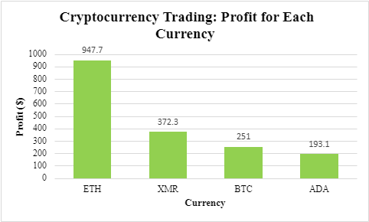
Figure 8.1.4 Profit/Loss for Each Currency Traded in Simulation 4
The final simulation we followed, 4, was one made for following crypto at that same time as following the market. Though the profit in this account wasn’t quite as large as the others it is still very impressive that every investment made in this account was able to produce a profit. Cryptocurrency can be a very volatile trading environment so the hypothesis was that there would be at least some losses in this simulation but with the big push from each cryptocurrency towards the end of the simulation we didn’t lose a single dollar in this account.
The clear winner for this account was Ethereum, which made a healthy profit of $947.70 in a span of 8 weeks. The main reason for this is that the most money was invested just into Ethereum and being the second biggest market cap of any cryptocurrency, it still moves very strongly in correlation with Bitcoin. From the transaction tables in Chapter 8 we can see that at first, we bought $5000 worth of Ethereum and then when there was a big slump in the market the following week, we averaged its price down by buying $2000 more, which was everything that was left in the account. By having the largest sum in it, it will produce the most profit with any growth it shows, and in the last week it experienced strong growth.

8.2 Option Vs Stock Data Analysis
Here we will be looking at the data to draw conclusions about Stock vs Option trading as well as the risk vs reward tradeoff of each strategy in different market conditions. In Figure 8.3.1 below, we can see the profits and losses for each company below for simulation 4, with the net profit for option trading in said company being highlighted in orange, and the net profit for stock trading in said company being highlighted in blue.
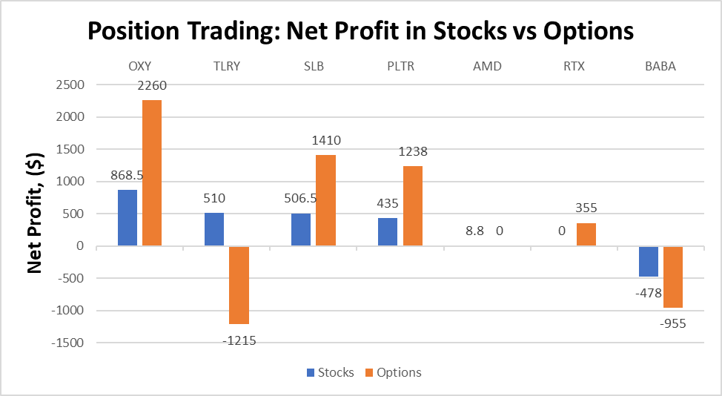 Figure 8.3.1 Simulation 3 net profit for stocks vs options in each company
In the position trading section, my net profits for stock trading was I made 1850.80 dollars, whereas for option trading I made 3093 dollars. Therefore, both stock and option trading were successful, but option trading was more successful. To explore these results more in depth, I performed regression analysis between stock and option profits. The result was there is a correlation coefficient of .820715, which suggests there is a strong correlation between stock and option performance. This is explained by the fact that when I expect a stock to move a certain way, I tend to purchase both stocks and call options. If the price increases, both of these would go up and vice versa. However, the standard deviation for the net profit from stocks for each company was approximately 447.0961 dollars, and the standard deviation for the net profit from options for each company was approximately 1276.45 dollars. This suggests there is significantly increased variability with option trading, which when combined with the high R squared value suggests that if I am right about the direction I think a company’s share price will move, I will make more money trading options, but if I am wrong, I will lose more money.
A key takeaway from this data is that in general, for trades I have the strongest conviction in (such as my oil plays), I should be more aggressive in purchasing options, whereas with the lower probability high upside plays like TLRY, I should purchase stock instead to limit the downside risk. TLRY in particular is a good example of one of the cons of option trading, even if I am right about my conviction that the stock was undervalued and that share price would increase, if it takes too long for the share price to increase, due to the time decay factor caused by the expiration date on options, I would lose a significant amount of money trading options, whereas if I used that capital to purchase stock instead I would have made a small profit. This is exactly what happened, as my net profits for TLRY for options were negative $1215, and for stock they were $510.
Another key takeaway is that market crashes would hit my portfolio much harder if I am holding options than stocks, unless I predict it and am holding puts, which is unlikely and not something that I can practically count on happening. Also, due to the time decay factor of options, if the market as a whole crashes my options will not only tank more than my stocks, but they will also not recover when the market bounces back, because my options will have expired worthless by then. Therefore, I will be forced to sell my options at a loss at the bottom. Where as if I am holding stock, since stocks do not have an expiration date, I can just hold them through the crash so not only will the lower volatility of stocks limit the downside, but since stocks have no expiration date I can just hold them until the market recovers. Therefore, since both the risk of options trading is higher as well as the reward, the best course of action would be to have a small portion of my portfolio of trades I have the most conviction on as options (25% at most), and the rest of my portfolio as stock to ensure I don't go broke in the event of a market crash.
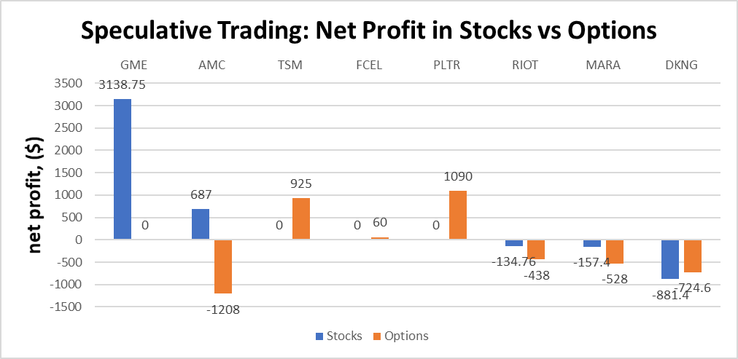 Figure 8.3.2 Simulation 2 net profit for stocks vs options in each company
For the speculative trading section, my overall results were different than the Position Trading section, with my net profits for stock trading being $2652.19, and for options trading I had a net loss of 823.6 dollars. Therefore, for Speculative Trading I had success with trading stocks, but not trading options. I also performed regression analysis between stock and option trading for this section as well, and it produced different results than what I got for the Position trading section. The correlation coefficient was .686624, which suggests a moderate correlation between stock and option performance. While the correlation still exists, it is not quite as strong as it was for the position trading section. Although theoretically it would seem that option trading would be more successful for higher volatility stocks due to the bigger upside moves that occur in speculative trading, the data suggests the exact opposite. In my opinion my lack of success in option trading for the speculative account is a combination of several factors. One of the factors is these companies don’t have great balance sheets and are often newer and or unproven companies. Since these companies don’t have a solid and established balance sheet, I cannot argue that due to the price to book ratio, price to earnings ratio, or discounted free cash flow valuation method the company is undervalued. Instead, I am reliant on always changing short term technical indicators as well as anticipating investor sentiment, which is much more variable than long term fundamental indicators. Therefore, I found myself on the wrong end of trades more often than I did in the Position Trading account.
Another key factor is the implied volatility metric. For options, a big part of the premium I pay for purchasing an option contract is the implied volatility metric, which is determined by the rate of change in share price. For companies with a higher rate of change in share price, they have a higher implied volatility metric so I would have to pay a higher premium for said option. Therefore, the higher volatility of the stocks I traded on the speculative account was essentially priced in. It not only took a bigger price movement to profit, but when there wasn’t a big movement in share price, the implied volatility would decline and therefore the value of my options would decline as well, despite the actual share price not changing much. This hypothesis of the higher implied volatility metric capping the upside while not capping the downside risk for option trading in this Simulation is backed up by the standard deviation data as well as Figure 8.3.2 above. Unlike with Simulation 3, option trading had a lower standard deviation than stock trading, 794.396 dollars and 1210.918 dollars respectively. We can also see that the highest profit for options in Simulation 2 was 1090 dollars compared to 3138.75 dollars for the highest profit for stocks. On the other hand, the highest loss for option trading was 1208 dollars compared to 881 dollars for stock trading. Simulation 2’s option trading having a lower standard deviation despite having a higher maximum loss than stock trading suggests that the upside is being capped, but the downside is not.
Due to the capped upside resulting from higher implied volatility, the correlation coefficient for speculative trading was lower than it was for Position Trading. It appears that my incorrect assessment in the risk vs reward of trading higher volatility stocks due to a poor understanding of how implied volatility works is why I was so unsuccessful with trading options in the Speculative account. A key takeaway of this data is that due to the poor tradeoff of risk vs reward when it comes to option trading for high volatility stocks, I should stay away from option trading altogether when applying a Speculative Trading strategy and hold 100% stock rather than a 75% stock 25% option blend when applying a Position Trading strategy.

8.3 Profit Vs Time Comparison
In figure 8.3.1 we have a comprehensive look at how each simulation did during the time period of the project:
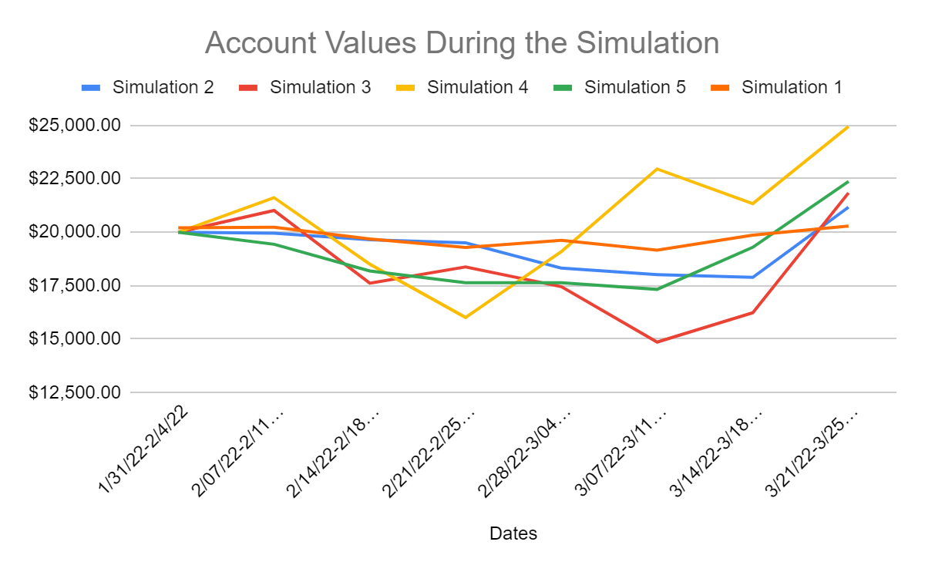
Figure 8.3.1 Profit Vs Time Comparison Graph
By looking at the graph we get a better view of how each simulation did throughout the simulation, with the orange bar being the S&P500 or the control for the project. When comparing the four other trading strategies we used compared to the orange bar we can see that every single simulation did better than the market. However, on the opposite side of that argument we can also see that every simulation other than the control also fell much harder than the market ever did, exasperating losses to much higher levels. By looking at table 8.3.1 we can also finally see how each simulation ended in terms of their % changed.
Table 8.3.1 Net Changes in Each Trading Strategy
Trading Method | Value/  Recommendation | Position Trading | Speculative  Trading | Crypto-  Currency | S&P500
% Change | 10.98% | 24.73% | 9.20% | 8.82% | 1.36%

Chapter 9: Conclusion
Our partner based IQP ran for about 14 weeks between C and D. In this project we spent 8 weeks simulating the U.S. stock market to gather a more comprehensive knowledge of what it means to be an investor in the United States. The other 6 weeks were used to get better at understanding what it means to build a large project from scratch with the use of many tools from Microsoft Word and web-based research.
From spending so much time with the stock market the two members of the group were able to garner a much better understanding of four new trading techniques: value trading, speculative trading, position trading, and cryptocurrency trading. By doing comprehensive research into the 4 techniques as well as countless companies the two members learned how to use these 4 techniques in a way that out paced the standard practice of investing in the S&P500.
The two members of the project were very happy with their results as they had gained a large amount of new knowledge in varying fields as well as were able to achieve their goal of matching or outpacing the stock market in terms of profit. With only and increase of 1.36% in the market during the period of trading each trading technique comfortably was able to beat this, one strategy even being over 20%.

References:
- “Alibaba Group Holding Limited (Baba) Balance Sheet.” Yahoo! Finance, Yahoo!, 22 Apr. 2022, https://finance.yahoo.com/quote/BABA/balance-sheet?p=BABA.
- Bajpai, Prableen. “What Is the Nasdaq Composite, and What Companies Are in It?” Nasdaq, Nasdaq, 12 May 2021, https://www.nasdaq.com/articles/what-is-the-nasdaq-composite-and-what-companies-are-in-it-2021-05-12.
- “Bitcoin Price History 2013-2022.” Statista, 22 Apr. 2022, https://www.statista.com/statistics/326707/bitcoin-price-index/.
- Britannica, The Editors of Encyclopaedia. "S&P 500". Encyclopedia Britannica, 12 Apr. 2019, https://www.britannica.com/topic/SandP-500. Accessed 19 April 2022.
- Chen, James. “Exchange-Traded Fund (ETF).” Investopedia, Investopedia, 15 Apr. 2022, https://www.investopedia.com/terms/e/etf.asp.
- Chen, James. “How Options Work for Buyers and Sellers.” Investopedia, Investopedia, 11 Mar. 2022, https://www.investopedia.com/terms/o/option.asp.
- Conway, Luke. “Bitcoin Halving: What You Need to Know.” Investopedia, Investopedia, 17 Mar. 2022, https://www.investopedia.com/bitcoin-halving-4843769.
- “Cl.1: Crude Oil WTI (Nym $/Bbl) Front Month Overview.” MarketWatch, https://www.marketwatch.com/investing/future/crude%20oil%20-%20electronic.
- “Dow Jones Industrial Average (DJIA).” Corporate Finance Institute, Corporate Finance Institute , 5 Feb. 2021, https://corporatefinanceinstitute.com/resources/knowledge/trading-investing/dow-jones-industrial-average-djia/.
- “DraftKings Inc. (DKNG) Income Statement.” Yahoo! Finance, Yahoo!, 22 Apr. 2022, https://finance.yahoo.com/quote/DKNG/financials/.
- “DraftKings Reports Fourth Quarter Revenue of $473 Million; Increases 2022 Revenue Guidance to $1.85 Billion to $2.0 Billion; Introduces 2022 Adjusted EBITDA Guidance.” Yahoo!, Yahoo!, 22 Apr. 2022, https://www.yahoo.com/now/draftkings-reports-fourth-quarter-revenue-120000960.html
- Edwards, John. “Bitcoin's Price History.” Investopedia, Investopedia, 2 Mar. 2022, https://www.investopedia.com/articles/forex/121815/bitcoins-price-history.asp.
- Fernando, Jason. “Bond.” Investopedia, Investopedia, 21 Apr. 2022, https://www.investopedia.com/terms/b/bond.asp.
- Frankenfield, Jake. “What Is Cryptocurrency?” Investopedia, Investopedia, 15 Apr. 2022, https://www.investopedia.com/terms/c/cryptocurrency.asp.
- Ganti, Akhilesh. “What Is a Position Trader?” Investopedia, Investopedia, 19 May 2021, https://www.investopedia.com/terms/p/positiontrader.asp.
- Gartenberg, Chaim. “Robinhood Blocks Purchase of GameStop, AMC, and Blackberry Stock.” The Verge, The Verge, 28 Jan. 2021, https://www.theverge.com/2021/1/28/22254102/robinhood-gamestop-bloc-stock-purchase-amc-reddit-wsb.
- “GoPro Announces Fourth Quarter and Full Year 2021 Results.” GoPro Investor Relations, GoPro, Inc, https://investor.gopro.com/press-releases/press-release-details/2022/GoPro-Announces-Fourth-Quarter-and-Full-Year-2021-Results/default.aspx.
- Hayes, Adam. “Mutual Fund Definition.” Investopedia, Investopedia, 27 Mar. 2022, https://www.investopedia.com/terms/m/mutualfund.asp.
- Hayes, Adam. “Strong Buy.” Investopedia, Investopedia, 13 Sept. 2021, https://www.investopedia.com/terms/s/strongbuy.asp.
- “How to Calculate a DCF Growth Rate.” Old School Value, 22 June 2020, https://www.oldschoolvalue.com/stock-valuation/how-to-calculate-dcf-growth-rate/#:~:text=science%20should%20balance.-,Easy%20Method%20to%20Calculate%20DCF%20Growth%20Rates,result%20by%20the%20beginning%20value.
- Hwang, Inyoung. “A Brief History of the Stock Market.” SoFi, SoFi Learn, 8 Jan. 2021.
- “Learn about Bitcoin (BTC) and Other Cryptocurrencies Listed on Cryptoparrot.com.” CryptoParrot.com., CryptoParrot, https://cryptoparrot.com/app/cryptocurrencies/BTC.
- Melissa Repko. “GameStop Shares Fall as Retailer Reports Loss during Holiday Quarter, Says It Will Launch NFT Marketplace.” CNBC, CNBC, 17 Mar. 2022, https://www.cnbc.com/2022/03/17/gamestop-gme-q4-2021-earnings.html.
- “Palantir Technologies - Stock Price History: PLTR.” Macrotrends, https://www.macrotrends.net/stocks/charts/PLTR/palantir-technologies/stock-price-history.
- “Research Tool.” Investopedia, Investopedia, https://www.investopedia.com/simulator/research
- Richardson, Gary, et al. “Stock Market Crash of 1929.” Federal Reserve History, The Federal Reserve , 22 Nov. 2013, https://www.federalreservehistory.org/essays/stock-market-crash-of-1929.
- Simply Wall St. “Is GoPro, Inc. (NASDAQ:GPRO) Potentially Undervalued?” Nasdaq, Nasdaq, 22 Oct. 2021, https://www.nasdaq.com/articles/is-gopro-inc.-nasdaq%3Agpro-potentially-undervalued-2021-10-22.
- Teweles, Richard Jack; Bradley, Edward S.; Teweles, Ted M. (25 September 1992). The Stock Market (6th ed.). Wiley. p. 97. ISBN 9780471540199.
- “Tilray Brands Balance Sheet 2016-2022: TLRY.” Macrotrends, 22 Apr. 2022, https://www.macrotrends.net/stocks/charts/TLRY/tilray-brands/balance-sheet.
- “Time in the Market – Long Term Returns from Stocks, Bonds, T-Bills and Gold.” InvestorsFriend, https://www.investorsfriend.com/time-in-the-market/.
- The Investopedia Team. “What Is the History of the S&P 500?” Investopedia, Investopedia, 13 Dec. 2021, https://www.investopedia.com/ask/answers/041015/what-history-sp-500.asp.
- “United States Inflation Rate March 2022 Data - 1914-2021 Historical - April Forecast.” United States Inflation Rate - March 2022 Data - 1914-2021 Historical - April Forecast, https://tradingeconomics.com/united-states/inflation-cpi.
- Vitiello, Domenic, and George E. Thomas. The Philadelphia Stock Exchange and the City It Made. Univ. of Pennsylvania Press, 2010.
- “What Is Speculative Trading? A Beginner's Guide / Axi.” Axi, https://www.axi.com/int/blog/education/what-is-speculative-trading.

