Insect Identification Through Citizen Science

Developing an Application for User-Friendly Insect Identification

Supplementary Materials

Arman Saduakas
Jacob van Steyn
Jessica Wang
Weizhe Wang

Appendix A: Sponsor Description
Appendix B: Authorship
Appendix C: Twenty-Four Insects for Classification
Appendix D: Collected Feedback from User Testing Round 1
Appendix E: Feedback from User Testing Round 2
Appendix F: Table for Manual Data Entry
Appendix G: Feedback from User Testing for Data Entry
Appendix H: A flowchart of Our Objectives
Appendix I: Draft of Dichotomous Key after Objective 1

Appendix A: Sponsor Description
The Leibniz Institute of Freshwater Ecology and Inland Fisheries (IGB) is Germany’s largest and one of the leading international research centers for freshwaters. Its vision is “the understanding of all fundamental processes in freshwaters and their communities''. It conducts research to “tackle global environmental changes and develop measures conducive to sustainable water management” (IGB, About Us). IGB incorporates scientists from many disciplines, such as “hydrologists, biogeochemists, physicists, microbiologists, ecologists, evolutionary ecologists, fish ecologists, and fisheries” in their research (IGB, Profile). Bringing people across disciplines together; IGB believes that an “integrative research approach” is key to developing solutions and bringing significant changes to the future (IGB, Profile). Specifically, it prioritizes citizen science by involving “social stakeholders” in its research (IGB, Profile).
IGB’s mission is “Research for the future of our freshwaters.” (IGB, Profile) It is deeply concerned with achieving a deep understanding of the science of freshwaters through interdisciplinary research. (IGB, Profile) Its research findings “help to predict responses to natural and human-induced environmental changes and to develop measures for sustainable water management” (IGB, Profile). One of its goals is to “generate objective and evidence-based knowledge for the conservation and management of inland water and to make it publicly available” (IGB, Profile). It aims to conduct research to contribute to the scientific community as well as educate the general public using its findings. Being an organization that is deeply concerned about environmental issues and scientific discoveries, IGB’s objective is to “combine scientific freedom and excellence with social responsibility and effectiveness to make a double impact” (IGB, About Us).
The history of IGB can be traced back to the late 19th century. IGB has three predecessors. The Institute for Inland Fisheries (IfB) in Berlin-Friedrichshagen is the oldest, founded in 1893 (IGB, History of IGB). It was one of the first research facilities on biological and fishery experiments. Department of Experimental Limnology Neuglobsow was established in 1959, which firstly researched the effect of the first German nuclear power plant on the Stechlinsee and provided the most detailed long-term limnology data series of the Stechlinsee (IGB, History of IGB). The Section Hydrology Berlin was founded in 1976 in Leipzig as a branch of the Institute for Geography and Geoecology (IGG). Its research field is in environmental protection and water supply. At the end of GDR, German academic institutions' reforming led to the establishment of the IGB as part of the Forschungsverbund Berlin e.V. in 1992 (IGB, History of IGB).
IGB started with a headquarter at Müggelsee and an experimental station on Stechlinsee in 1992, after it joined Leibniz Association in 2000, the institute had further spread to Berlin-Friedrichshagen, Berlin-Adlershof, Berlin-Dahlem and Neuglobsow at the Stechlinsee. IGB has around 230 employees, including about 140 scientists today (IGB, History of IGB). According to “Stellungnahme zum Leibniz-Institut für Gewässerökologie und Binnenfischerei (IGB) Berlin” by Leibniz Association (2012, p.A-11), the average total budget of IGB was about 14.9 million euros. 10.3 million euros in this budget is from the Federal Government, and another part of this budget is from the competitive allocation inside the Leibniz Association. Moreover, IGB receives 3-5.3 million euros of third-party funds each year. These funds mostly came from the Federal and Länder Governments, the German Research Foundation (DFG), and the European Union. Industry, foundations, and other sources also contributed to the funds. (Stellungnahme zum IGB Berlin, 2012) More details about IGB’s revenues and expenditure in 2008, 2009, 2010 are attached to Figure 1.
IGB has many diversified research topics related to water and environmental protection. The IGB’s website groups its research topics and activities into ten categories: Angling, which focuses on fishery sustainability management; Aquaculture and Aquaponics, which includes the topics that explore the sustainability of circulating the waste of fish as the nutrient in agriculture in economic and social aspects; Behavioral Ecology and Swarm Intelligence is more of a social study to analyze social networks and group decision-making; Biodiversity, that study on maintaining a diversified environment efficiently; Dialogue and Transfer, which provide information and consulting for the public; Environmental Change, that study on the lake as an early warning of the global environmental change; Freshwater Ecosystems, which research on the implicit interaction inside the ecosystem; Multiple Stressors and Pollutants, that study the impact of human activities along with the pollutions on the freshwater resource. Use and Management are about developing a method for maintaining the freshwater resources at a proper ecological state and efficient management; Water and Matter Cycles includes studies on water circulation and nutrient and carbon balance (IGB, IGB's topics in a nutshell).
The project IGB has our group working on (AuBe) is focused on ensuring street lights don’t emit light or heat that would affect native insect populations. The AuBe project attempts to design insect-friendly street lighting to shield light emissions. This shielding will reduce the street lights’ radiation and reflection at the flight height of insects. Reducing this light emission will help insect populations not be affected by light, disturbing their natural habitat. The project will design and test many different coverings to establish what design best solves this problem. To understand the effectiveness of various coverings, insects will be trapped nearby various designs, then counted and identified to see what species are still attracted to what methods. The AuBe project has additional funding through the Federal Agency for Nature Conservation (BfN), the Federal Ministry for the Environment, and Nature Conservation and Nuclear Safety (BMU). These programs and the resources from IGB make up a part of the federal program for biological diversity.
Ensuring biodiversity retention is increasingly important as cities expand and take over animals' natural habitats. Insects are a critical part of the food chain, and thus ensuring they’re protected is essential for the preservation of all types of animals. Specifically relating to insects, IGB is an organization that helps to preserve fish and wetlands, which are breeding grounds for insects. Many species of fish feed on insects and the light emission from street lighting redirects that food source away from natural locations, thereby removing it from the food chain.
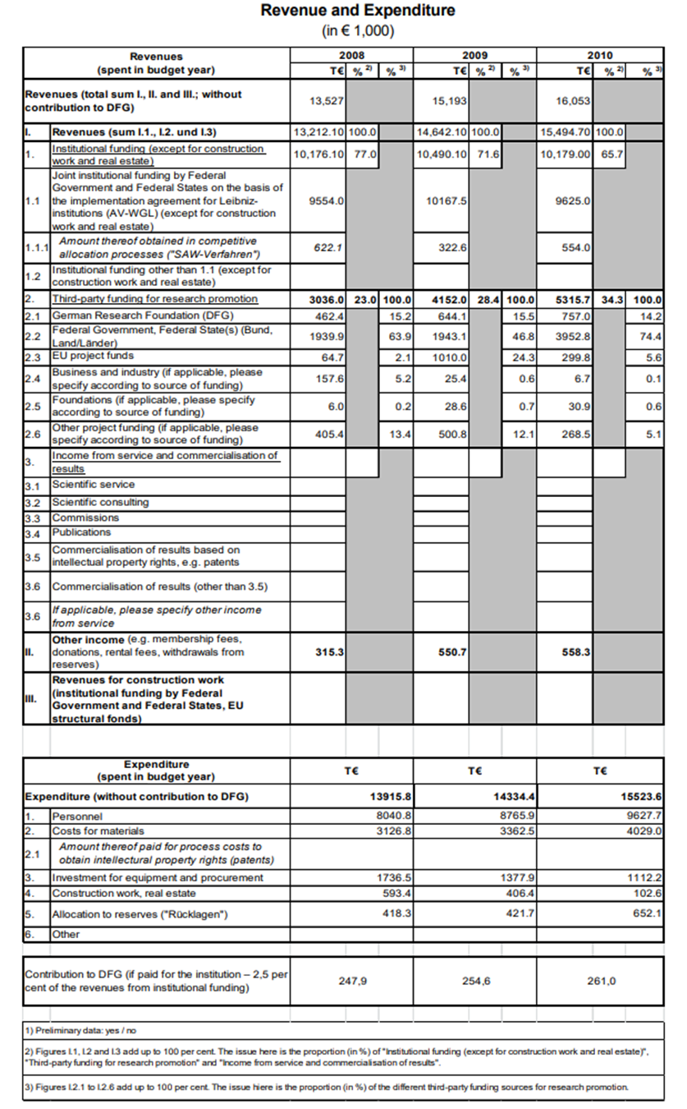
Figure 1. The Revenue and Expenditure of IGB from 2008 to 2010.

Appendix B: Authorship

Task | Completed By
Booklet Content
Introduction | Jessica
Background | Arman, Jacob, Jessica, Weizhe
Methods | Jessica
Results | Jessica
Conclusion | Jessica
Booklet Graphics
Graphics | Weizhe
Layout & Design | Weizhe
Insect Identification Key
Interviews & Research | Jessica, Weizhe
Design | Weizhe
Desktop Application
Implementation of code | Jacob
UI/UX Design | Jacob
Bug Testing | Jacob
Revision | Jacob
UI Mockup | Weizhe
Mobile Application
Implementation of code | Arman, Jacob
UI/UX Design | Arman
Bug Testing | Arman
Revision | Arman
UI Mockup | Weizhe
Outreach
Communication | Jessica
Interviews | Arman, Jacob, Jessica, Weizhe

Appendix C: Twenty-Four Insects for Classification

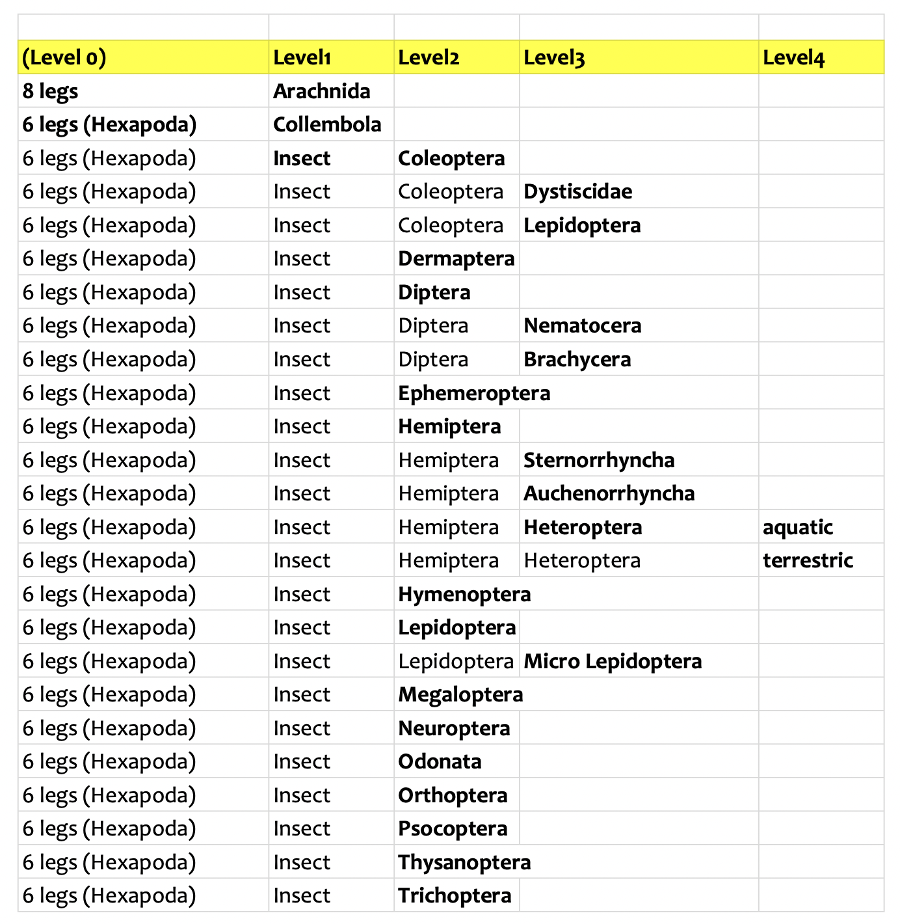

Appendix D: Collected Feedback from User Testing Round 1
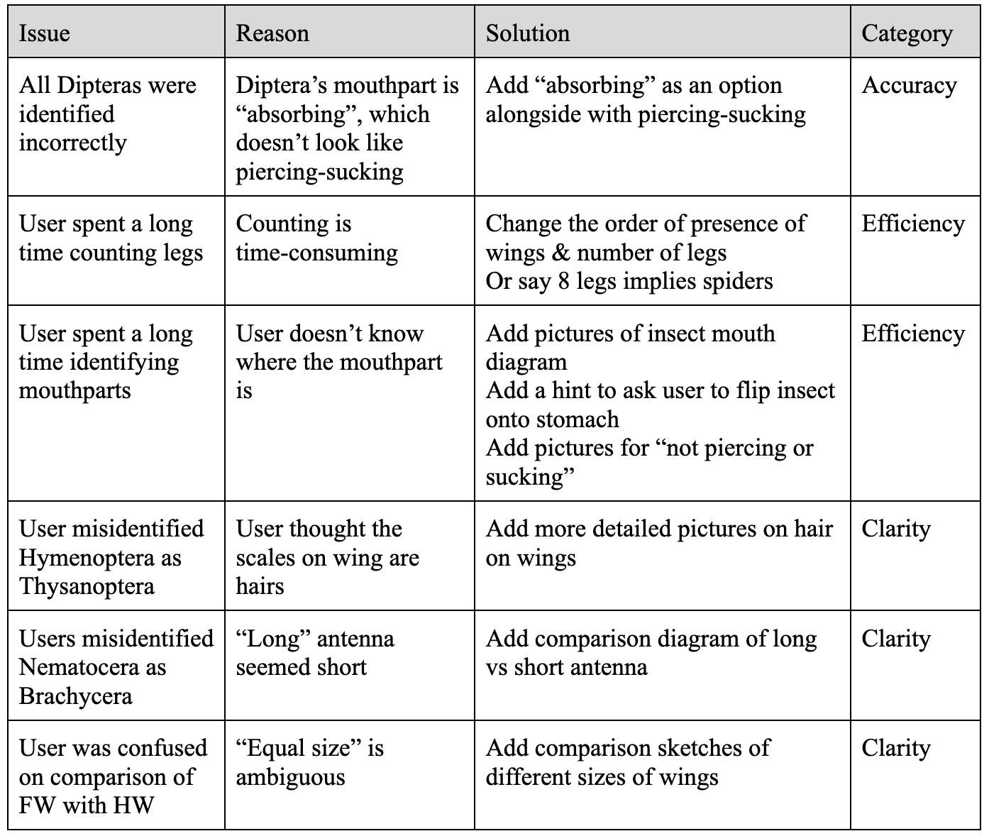
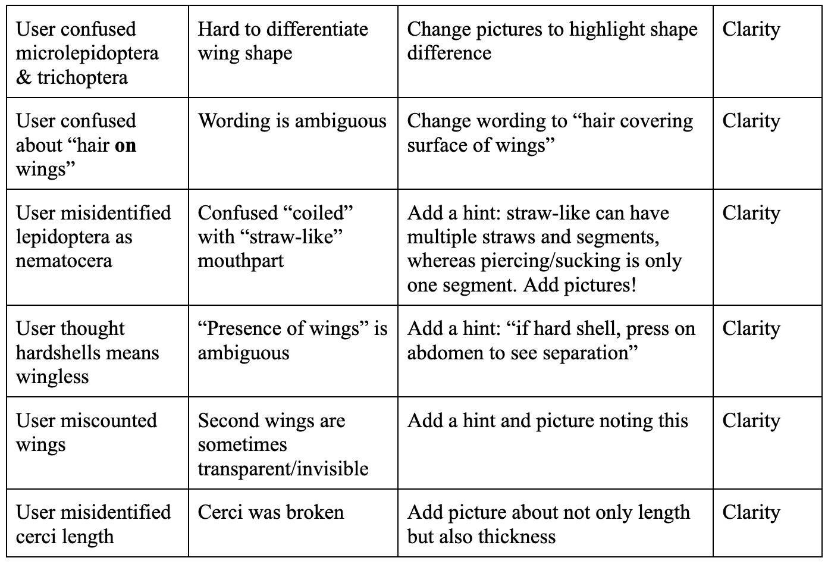

Appendix E: Feedback from User Testing Round 2

Question Number | Issue | Category
2,7,15,30 | Need more description | Clarity
21_1 | Bad picture | Clarity
2 | Mouthpart | Clarity
16_2 | Picture is bad for description | Clarity
35 | Clarity in description | Clarity
35 | Title clarity | Clarity
30_2 | Change picture to dragonfly | Clarity
4 | Also use body shape to differentiate Nematocera and Brachycera | Clarity
18_2 | Combine pictures | Clarity
18 | Terrestrial vs aquatic coleoptera can be ambiguous | Clarity
16_2 | Emphasis on bottom | Clarity
40 | Mayflies can have 1 pair of wings | Accuracy
15_1 | Misleading picture | Accuracy
General | Ephemeroptera and Trichoptera have weird mouthparts that look like diptera | Accuracy
36 | Needs description when cerci are broken | Preservation
16 | Description for no cerci | Preservation
0 | Needs description on what to look for | Instruction
1 | Presence of wings needs emphasis on hard shelled wings | Instruction
1 | Description needs to be on Q1 | Instruction
General | Some mouthparts are folded | Instruction
2 | Piercing mouthparts can be very small | Instruction
2 | Mobile - users didn’t see 3rd question | UI
General | Mobile needs to display ID | UI
General | Mobile - restart button folds when navigation is turned on | UI
General | Desktop - font too small | UI
25 | Trichoptera has a page button bug | UI

Appendix F: Table for Manual Data Entry
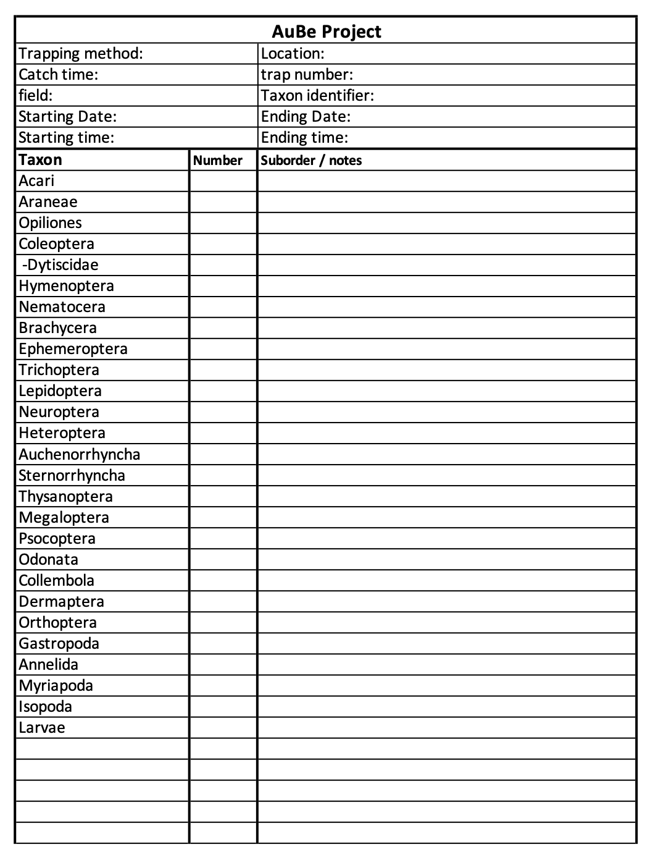

Appendix G: Feedback from User Testing for Data Entry
*table of feedback here*

Appendix H: A flowchart of Our Objectives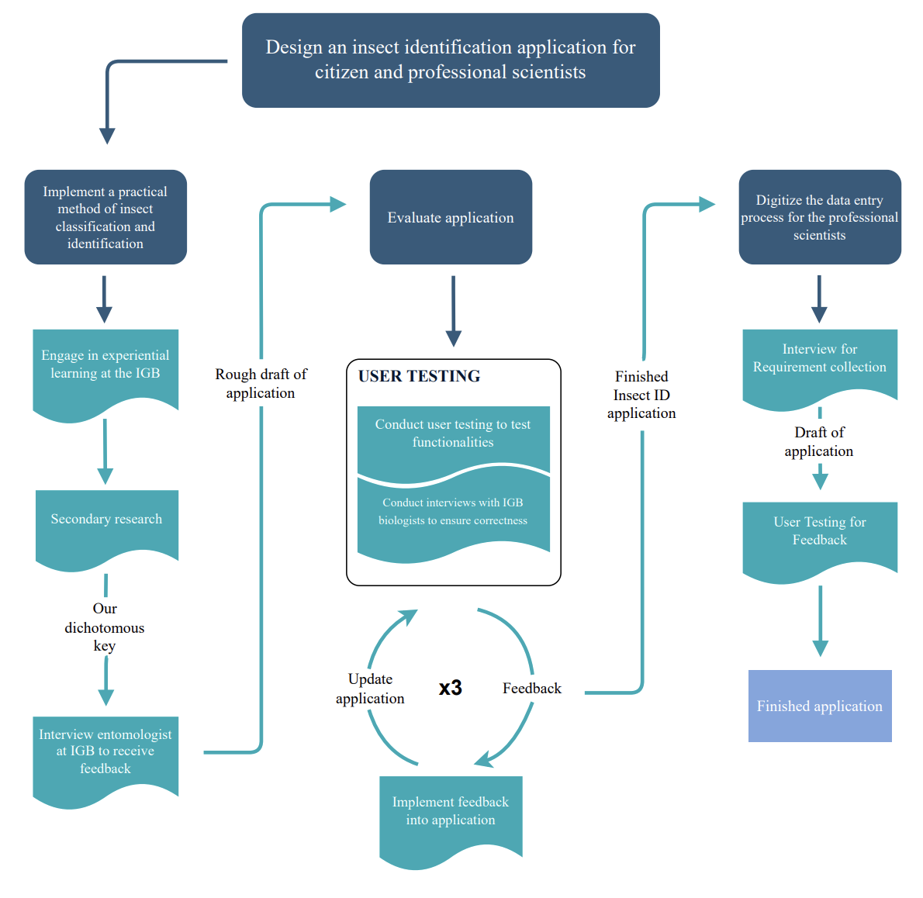

Appendix I: Draft of Dichotomous Key after Objective 1
