Project Number:
MQP EY1 - 001

An Investigation of CHO Cell Metabolism
In Transient-Overexpressing SLC15a1 Cultures

A Major Qualifying Project Report Submitted to the Faculty of:

Worcester Polytechnic Institute
In partial fulfillment of the requirements
for the Degree of Bachelor of Science

Report Prepared by:
Alexandra Connor

Advised by:
Professor Eric M. Young

This report represents work of WPI undergraduate students submitted to the faculty as evidence of a degree requirement. WPI routinely publishes these reports on its web site without editorial or peer review. For more information about the projects program at WPI, see ​http://www.wpi.edu/Academics/Projects​.

Abstract

This project investigated differences in the metabolism of CHO cells that had been modified to overexpress a dipeptide transporter (SLC15a1) and IgG1. SLC15a1 and control cultures were grown in media with either glutamine (Q) or alanine-glutamine (AQ) added over 10 days in shake-flasks. VCD and cell culture metabolic data were measured over the duration of the run. Results indicated that SLC15a1 cells grown in Q media maintained a higher VCD compared to the control, while results from the AQ SLC15a1 & control groups were indistinguishable. These observations suggest that SLC15a1 may be regulated by the concentration of monomer peptides such as Q present in media. The results may also suggest that SLC15a1 may be capable of weakly transporting glutamine as well as dipeptides.

Table of Contents
Abstract 1
Acknowledgements 3
Introduction 4
Methodology 6
CHO Cell Culture 6
Plasmid Selection & Synthesis 9
Plasmid Generation & Purification 9
Cell Transfection Procedure & Experiment Procedure 13
Cell Metabolic Measurements 17
Data Collection & Analysis 17
Results and Analysis 18
Transfection Efficiency 18
Media Decay 19
Metabolic Analysis 21
Statistical Analysis 26
Conclusions and Discussion 26
Transfection Efficiency 27
Viable Cell Density & Growth Rates 27
Metabolic Profiles 28
Bibliography 33
Appendix 35
Appendix A: Plasmid Maps 35
Appendix B: Transfection Efficiency Raw Data 37
Appendix C: Cell Metabolic Raw Data 38
Appendix D: Two-Tailed T-Tests 41
Appendix E: VCD & Metabolic Raw Data 48

Acknowledgements

I would like to thank the following people and entities for assisting and supporting me throughout this project:
- Eric Young, my project advisor, for establishing my project and providing experience, guidance, and funding. Your proposal to me for this work challenged me to design and produce unique research with creative solutions to work around time and equipment limitations. Thank you for believing in me and my research, even when I hit snags along the way. Thank you for providing me lab space, equipment, DNA synthesis expertise, and freedom to complete my independent research project.
- Christopher Bellerive, Susan, and the Biological Education Training Center (BETC), thank you for access to the BETC lab, materials, and guidance. Completing this project would have been impossible without your guidance and access to the BETC cell culture core and analytic equipment. Thank you for your generosity.
- PhD candidate Kevin Keating, for his patience with synthesizing the custom plasmids that the project required. Thank you for your time and persistence. Without the plasmid constructs, my research would have been impossible.
- PhD candidate Joseph Collins for his assistance and expertise in the laboratory. Thank you for your time.

Introduction
The cultivation of Chinese hamster ovary cells (CHO cells) has been a mainstay of the biopharmaceutical industry and currently numerous pharmaceutical processes utilize CHO cells to produce high quality monoclonal antibodies (mAbs) & other protein-based therapeutics. Although CHO cells are currently some of the best hosts for the production of complex mAbs², the processes that use them are very costly³ and produce vast amounts of biologic wastes.
One way to decrease the economic burden that CHO-pharmaceutical processes make is to increase the efficiency of CHO-cell processes, with the cells producing higher yields in each batch process. Many methods have been employed to do this, including media optimization, process optimization, and genetic optimization. Both media and process optimization have been utilized extensively to improve the production rate of mAbs with great success, although there are still cellular limitations on how fast nutrients can be absorbed and how these nutrients are processed.
In particular, genetic optimization to improve the efficiency at which the CHO cells produce mAbs has only been lightly explored⁴, as genetic modification efforts have been concentrated in making CHO culture only express the desired pharmaceutical product. One target of interest for improving the efficiency of cellular mAb production is the membrane dipeptide transporter protein, SLC15a1 (PEPT1). This protein has been extensively studied⁵ and is known to transport several dipeptide nutrients across the cell membrane in their native cells, intestinal brush border epithelium cells.
On their own, CHO cells are known to readily absorb peptide monomers, but express more difficulty in absorbing dipeptides & higher linked amino acids. Accordingly, media for CHO cells used for biopharmaceutical processes contains large amount of single unit peptides. The most essential of these peptides for CHO metabolism is glutamine (Q). Glutamine, however, rapidly decays in cell culture media, with most glutamine-containing media having a shelf life between 1-3 months⁶. These media also decay during cell culture processes, introducing more of the toxic waste ammonia than can be produced by cell metabolism alone & limiting cell culture processes⁶.
To combat media decay and media-related ammonia buildup, media producers have supplemented some of their media with a stable dipeptide form of glutamine, alanine-glutamine (AQ), also known as GlutaMAX. Medias supplemented with AQ have longer shelf lives than Q supplemented medias, and do not decay during cell culture processes⁶. These media, however, are not readily absorbed by CHO cells; CHO cells must first break the AQ dipeptide bonds to access the usable glutamine. Correspondingly, CHO cell processes grown in AQ media have prolonged culture processes and reach their maximum viable cell density more slowly than processes grown in Q media. AQ-supplemented processes have also been demonstrated to produce more mAb than traditional Q media processes⁶, possibly due to the lack of toxic ammonia buildup from free Q peptides. Indeed, the toxic ammonia buildup, along with Q & glucose depletion, halt cell growth & kill the cell cultures in Q-media processes earlier than in AQ-media processes.
Although there is some debate as to whether the enzymes which break the AQ bond reside inside the CHO cells or are excreted into the cell culture media¹, it has been proposed that the addition of a dipeptide transporter may improve the cellular uptake of AQ, leading to faster AQ metabolism and higher viable cell densities without the excess ammonia buildup plaguing cultures grown in Q supplemented medias. To test this hypothesis, the dipeptide transporter protein SLC15a1 was transiently expressed in an industrial CHO cell line, CHO-S, and the viable cell density and other cell culture metrics (glutamine, alanine-glutamine, ammonia, glucose, lactate, and titer IgG yield) were measured throughout the process. Results between SLC15a1 transfected cells and controls, each grown in both AQ and Q supplemented media, were then compared.

Methodology
This section contains the procedures used to culture CHO cells, design & produce plasmids, transfect cells, and carry out experiments.

CHO Cell Culture
Suspension grade Freestyle CHO-S cell culture and FreeStyle CHO expression growth medium were obtained from Invitrogen (ThermoFisher). The following thawing & passaging procedures were adapted from Invitrogen’s original procedure⁷. The Trypan blue viable cell density assay was adapted from a standard protocol published by Thermofisher^{A} used for standard practice in the BETC.

Thawing Procedure
- Freestyle CHO expression medium was mixed with sterile L-Glutamine to an 8mM concentration under sterile conditions. This media was then briefly warmed to 37C in an incubator.
- A sterile 125-ml shake flask with a vented cap was sprayed with isopropanol and placed inside a sterile cell culture hood, along with the prewarmed media, a pipette, and several pipette tips.
- The 125ml shake flask was opened & 25ml of culture medium was transferred to the shake flask.
- A vial of CHO-S cells were then removed from cryogenic storage & warmed in a hot water bath for 3 minutes.
- The cell vial was then quickly transferred to the sterile hood & the entirety of its contents were transferred to the waiting cell culture flask via a 2ml sterile pipette tip.
- The flask was then vigorously swirled, 0.5ml were removed with a sterile pipette tip & added to an Eppendorf tube, & the viable cell density (VCD) was determined with the Trypan Blue Exclusion Assay (see below).
- The VCD, passage number, operator initials, & date were then recorded in indelible ink on masking tape & this tape was applied to the new cell culture shake flask.
- The flask was then added to an incubator operating at 37C, 8% CO₂,& 125RPM shaking under humid conditions.
- The cell culture was then passaged when it reached a cell concentration between 1-1.5 million cells/ml (see passaging procedure).

Trypan Blue Exclusion (Viable Cell Density) Assay Procedure
Hemocytometer Procedure
- Remove 100ul of well mixed cell culture from source & add to an Eppendorf tube with a micropipette.
- Remove 100ul of Trypan blue dye & mix this with the 100ul of cell culture.
- Prepare a single use hemocytometer for samples.
- Add 10ul of well mixed Trypan-Blue cell culture to each side of the hemocytometer.
- Turn on & focus the confocal microscope on the square on one side of the hemocytometer.
- Count the number of live and dead cells in each of the squares in the outer corners of the big square for each side of the hemocytometer.
- Use the following equation to calculate the cell culture VCD:

$$VCD= \frac{Total Viable Cells*2*{10}^{4}}{8}$$

Innovatis Cedex Cell Counter Procedure
- Remove 1ml of well mixed cell culture from source & add to an Eppendorf tube with a micropipette.
- Pipette 1ml of cell culture into a Cedex cuvette & attach to the Innovatis automatic cell counter
- Initiate cell counting with a display monitor running the automatic cell counter.

Passaging Procedure
- Cells were passaged when a VCD between 1-1.5E6 cells/ml was obtained through growth. This typically took between 30-40 hours between passages.
- Cell culture media (FreeStyle CHO-S expression medium + L-glutamine) was prewarmed to 37C before starting.
- 1 ml was removed from the fully grown cell culture & a Trypan Blue exclusion assay was performed on the sample to determine VCD.
- The following calculation was performed to determine the amounts of media & cell culture to add to the new CHO flask.

$$Cell Culture Media Volume=\frac{New Seed Density*New Volume}{VCD}$$

$Fresh Media Volume=New Volume-Cell Culture Media Volume$

The new volume is 30ml unless expanding in which case the volume would be larger. The new seed density is 0.3E6 cells/ml unless preparing for an experiment, in which case it is 0.5E6 cells/ml.

The following are materials required for maintenance of the CHO cell culture:
- Freestyle CHO-S Cells (1 frozen vial, Invitrogen)
- Freestyle CHO-S Expression Medium (Invitrogen)
- Serological Pipette (VWR)
- Sterile pipette tips, various sizes (VWR)
- Sterile 125ml shake flasks with vented caps (Corning)
- Eppendorf tubes (1.5ml, Eppendorf)
- Hemocytometer
- Trypan Blue Dye, 0.4% (SigmaAldrich)
- Micropipettes, 100 & 10um (VWR)
- Micropipette Tips (100 & 10um) (VWR)
- Indelible Ink sharpie
- Masking Tape, small strip size
- Confocal light microscope

Plasmid Selection & Synthesis
pRVL5
This plasmid was selected from the AddGene cell bank⁷. It codes for the expression of the active binding units (VH domains) of Human IgG1 antibody proteins (specifically CH1, CH2, and CH3). In addition, this plasmid includes genes for ampicillin resistance in bacterial cells and hygromycin in mammalian cells.
pcDNA3/SLC15a1
This plasmid was custom built in Young Lab, using a pcDNA3 backbone. It codes for the expression of SLC15a1 & features ampicillin resistance in bacteria & kanamycin resistance in mammalian cells.
pcDNA3/eGFP
This plasmid was custom built in Young Lab, using a pcDNA3 backbone. It codes for the expression of GFP & features ampicillin resistance in bacteria & kanamycin resistance in mammalian cells. This GFP plasmid was created for use as a transfection efficiency assessment tool & as a positive control in the experiment.

Plasmid Generation & Purification
Plasmid Generation
To carry out the experiment, large amounts of plasmid were required for transfection into cells. The following procedure was used to grow large amounts of plasmid in E.coli for each of the 3 plasmids:
- 125ml sterile glass shake flasks (3) were filled with 100ml LB media each.
- 50ul ampicillin was added to each flask as a selecting agent for the plasmids (all plasmids had ampicillin as the selecting agent).
- Frozen stores of each plasmid were scraped with pipette tips & the tips were carefully ejected into the shake flasks.
- Flasks were incubated at 37 ⁰C & 235 RPM for 24 hours.
- Flasks were removed from the incubator for immediate further processing.

Plasmid Purification
This procedure details the purification of the large quantities of plasmid DNA produced by E.coli. The following procedure was adapted from Invitrogen’s Purelink HiPure Plasmid Maxiprep Kit protocol⁸:
- The Resuspension Buffer (R3) was combined with the RNAse A solution.
- The Lysis buffer was checked for precipitates & dissolved by heating at 37⁰C if present.
- Materials were put into a sterile bacterial cell culture hood.
- Columns were placed on top of the 500ml Erlenmeyer flasks with column holders.
- 30ml of equilibration buffer (EQ1) were added to each of the (3) columns & allowed to gravity-filter through the columns.
- Each LB culture was then added to 2 sterile conical tubes & centrifuged at 4000g for 10 minutes. The supernatant was then removed under a sterile hood & disposed of.
- 10ml of resuspension buffer (R3) was then added to each cell culture (mixing the pellets from the 2 centrifuge tubes), & cells were resuspended until homogenous.
- 10 ml lysis buffer was then added to each tube & gently mixed by inverting the tubes several times. The lysis buffer solution was incubated for 5 minutes.
- 10ml precipitation buffer (N3) was then added & mixed thoroughly until homogenous through vigorous inversion of the sealed conicals.
- Homogenous precipitated material was then loaded onto the gravity flow columns & was allowed to filter for 15 minutes, until the flow stopped.
- The column’s inner filter cartridges were then removed & disposed of.
- 50 ml of wash buffer (W8) was then applied to each column & allowed to drain.
- The columns were then transferred to sterile 50 ml conical tubes (placed on a conical tube rack)
- 15 ml of elution buffer (E4) were then applied to each column & allowed to drain (approximately 15 minutes) to elute the plasmid DNA from the columns.
- The columns were then discarded.
- 10.5ml of isopropanol were then added to each conical & mixed well by inverting vigorously.
- The tubes were then centrifuged at 12,000g & 4⁰C for 30 minutes.
- Under the sterile hood, the supernatant was discarded from the tubes.
- 5ml of 70% ethanol was then added to the conicals to resuspend the plasmid pellets.
- The tubes were then centrifuged again at 12,000g & 4⁰C for 5 minutes.
- Under the sterile hood, the supernatant was then removed from the pellets. The pellets were allowed to air dry for 10 minutes.
- The pellets were then resuspended in 500ul of TE buffer.
- The DNA harvested were then sterile filtered with 0.2um filters.
- Each of the 3 plasmids harvested were then tested for plasmid purity & concentration on the Nanodrop (5ul plasmid samples taken with Eppendorf tubes and were diluted 10X in TE buffer).

Nanodrop Analysis
The 50 ul (10X diluted) plasmid samples from the harvest were ran on the Nanodrop to measure their purity & concentration.
- 0.2 ul of water was used to clean the nanodrop.
- 0.2 ul of TE buffer was used to calibrate the Nanodrop.
- After vigorous mixing, each plasmid solution was measured 3 times. Outputs included the 260/280 wavelength ratio (determining solution purity), & plasmid concentration. Results were averaged.

The following materials were required for plasmid generation & purification:
- 3 separate E. coli strains expressing pRVL5, pcDNA3/SLC15a1, & pcDNA3/eGFP plasmids, (frozen stabs).
- LB Broth media
- Ampicillin (5:1000 ml concentration)
- Sterile 125ml shake flasks
- Pipette
- Various sized pipette tips
- Micropipettes
- Various sized micropipette tips
- MaxiPrep Hi-Pure Plasmid Purification Kit (Invitrogen)
  - Resuspension Buffer (R3) (100 ml)
  - RNAse A (650 ul)
  - Lysis Buffer (L7) (100 ml)
  - Precipitation Buffer (N3) (100 ml)
  - Equilibration Buffer (EQ1) (300 ml)
  - Wash Buffer (W8) (2*300 ml)
  - Elution Buffer (E4) (250ml)
  - TE Buffer (TE) (15ml)
  - HiPure Gravity Flow Filter Columns (10)
  - Column Holders (3)
  - Large (500ml+) Erlenmeyer flasks (3)
  - Eppendorf tubes (1.5ml) (3)
  - Isopropanol
  - Ethanol 70%
  - Sterile 50ml Conical tubes
  - Centrifuge w/speeds greater than 12,000g & refrigerating element
- Sterile Bacterial Hood
- Sterile 0.2um syringe filters

Cell Transfection Procedure & Experiment Procedure
The following procedure was adapted from Invitrogen’s FreeStyle MAX CHO Expression System suspension CHO cell culture transfection kit⁹.
Cell Culture Media Preparation
Culture Media The day before transfection, 700 ml of fresh FreeStyle CHO Expression medium was split (350ml*2) into two 500 ml sterile media containers. The media was combined with either:
- Glutamine (Q) to 8mM concentration (14 ml)
- GlutaMAX (AQ) to 8mM concentration (28 ml)
In addition to this, each batch of media was spiked with 1.75 ml of Pen-Strep 0.5X to inhibit bacterial contamination & growth.
Feed Media The day before transfection, 100ml of each culture media (+Q & +AQ) was taken & added to 2*50ml conicals each. The following antibiotics were then added to each of the 4 conicals:
- 200 ul Hygromycin
- 50 ul Kanamycin

Cell Culture Preparation
- Once cells were passaged at least 5 times, the cells were expanded from 30 ml to 90 ml of culture using 3*30 ml, vented-cap shake flasks.
- The next passage, the cells were expanded to 180 ml at a concentration of 0.3E6 cells/ml, using 6*30 ml vented cap shake flasks.
- When the cells (collectively, mixed) reached a VCD of approximately 1.5E6 cells/ml, the volume of cell culture required for 30E6 cells/flask was calculated & the culture then split evenly into 4 sterile 50 ml conical tubes. These tubes were then centrifuged at 800 RPM for 5 minutes.
- Under the sterile hood, the supernatant was discarded.
- 2 of the conical cell pellets were then resuspended in 120ml of fresh +Glutamine cell culture media in a sterile mixing vessel. This population was then split evenly into two sterile mixing vessels.
- The other 2 conical cell pellets were likewise suspended in +GlutaMAX cell culture media & were separated into 2*60ml portions in sterile mixing vessels.
Lipoplexing Plasmid Material & Cell Transfection Experiment
- Under a sterile hood, the FreeStyle MAX transfection reagent was gently inverted several times to mix.
- pRVL5 was mixed & added to cell culture first, followed by either the pcDNA3/SLC15a1 plasmid or the pcDNA3/eGFP plasmid.
  - For the eGFP experimental group:
    - 2,854 ul of OPTI-Pro serum free media was added to a 15ml conical tube.
    - 60.2 ul pRVL5 plasmid was added to the tube.
    - 286 ul GFP plasmid was added to the tube.
    - 2800 ul of OPTI-Pro serum free media was added to a separate 15ml conical tube.
    - 400 ul FreeStyle-Max Transfection Reagent was added to this tube.
    - The FreeStyle Max Transfection Reagent was then immediately added to the diluted plasmid & the solution was allowed to incubate for exactly 10 minutes.
    - After 10 minutes, 3.2 ml was added to each of the GFP- experimental group vessels (2).

  - For the SLC15a1 experimental group:
    - 2960 ul of OPTI-Pro serum free media was added to a 15ml conical tube.
    - 60.2 ul pRVL5 plasmid was added to the tube.
    - 180.2 ul SLC15a1 plasmid was added to the tube.
    - 2800 ul of OPTI-Pro serum free media was added to a separate 15ml conical tube.
    - 400 ul FreeStyle-Max Transfection Reagent was added to this tube.
    - The FreeStyle Max Transfection Reagent was then immediately added to the diluted plasmid & the solution was allowed to incubate for exactly 10 minutes.
    - After 10 minutes, 3.2 ml was added to each of the SLC15a1- experimental group vessels (2).

- After co-transfections were complete, the contents of each vessel were measured for VCD & metabolites using a CEDEX-BIO analytics machine.
- The 4 mixing vessels were then split into 2*30ml cultures in 125ml vented shake flasks each, for a total of 8 shake flasks. They were incubated at 37⁰C, 135RPM, 8%CO₂.
- The next day, a 1ml sample from each experimental group was taken & tested for transfection efficiency.
- 1.5 ml of cell culture material were removed from each flask to measure VCD, cell viability, glutamine, alanine-glutamine, ammonia, and lactate of each flask. These were subsequently measured every day for 10 days with a Cedex Bio-analyzer & a Cedex automated cell counter. In addition to this, IgG content was measured on days 4-10 of the experiment.
- The day after transfection, 1.5ml of fresh media, spiked with plasmid selection agents Hygromycin (pRVL5) & Kanamycin (SLC15a1 or GFP) were fed to each transfected sample. Each flask attained a Hygromycin concentration of 100mM & a Kanamycin concentration of 50mM.
Assessing Natural Decay of Glutamine in Media
Alongside the main experiment, two shake flasks were filled with either +Glutamine media or +GlutaMAX media and placed in the cell culture incubator. Their glutamine (Q), alanine-glutamine (AQ), and ammonia (NH₃) concentrations were measured every day with the Cedex Bio Analyzer. These measurements served as a baseline for the natural decay of glutamine & alanine-glutamine in cell culture media.
Assessing Transfection Efficiency
Approximately 24 hours after transfection occurred, 1ml samples of from all 4 sample groups were removed from culture flasks. These samples were then analyzed using a flow cytometer. The differences between the SLC15a1, non-transfected & GFP populations were visible through the GFP samples’ emission of green light in the flow cytometer. These differences were mapped through flow cytometer gating software to determine the ratio of transfected to non-transfected cells. The software then determined a % of cells transfected by the plasmids.
Data Analysis
After VCD & metabolic data was collected, it was added to an excel document for analysis. Growth curves were plotted for all raw data. In addition, the maximum cell growth rate & the maximum viable cell density were determined. Both anova & two-tailed T-tests were applied to the collected data to determine the efficacy of the results.
The following materials and equipment were required for the CHO cell transfection experiments:
- Glutamine (200 mM) (100 ml)
- Glutamax (200 mM) (100 ml)
- Serological Pipette (VWR)
- Sterile pipette tips, various sizes (VWR)
- Sterile 125ml shake flasks with vented caps (Corning)
- Eppendorf tubes (1.5ml, Eppendorf)
- Innovatis Cedex automatic cell counter & Cuvettes/Reagents (Cedex), including:
  - Trypan Blue Dye, 0.4% (SigmaAldrich)
  - Innovatis Detergent (Cedex)
  - Ethanol cleaner 70% (Cedex)
  - RODI water (Millipore)
- Micropipettes, 100 & 10um (VWR)
- Micropipette Tips (100 & 10um) (VWR)
- Indelible Ink sharpie
- Masking Tape, small strip size
- Cedex Bio Analyzer & Cuvettes/Reagent Packets (Cedex), including:
  - Glutamine Bio
  - Alanine-Glutamine Bio
  - NH3 Bio
  - Lactate Bio
  - Glucose Bio
  - IgG Bio
  - NaCl dilution solution
  - Calibrator A/B/D
  - Activator/Deprotonator
  - RODI water (Millipore)
- All materials in the FreeStyle MAX CHO Expression System (Invitrogen), including:
  - 1 vial of FreeStyle CHO-S cells, thawed & passaged at least 5 times, 360ml/1E6 density
  - FreeStyle MAX Lipid Reagent, 1ml
  - FreeStyle CHO Expression Medium (2*1000ml)
  - OptiPRO Serum Free Medium (1000ml)
- Plasmid DNA, ultrapure & concentrated, including
  - pRVL5 (300ug)
  - GFP (150ug)
  - SLC15a1 (150ug)

Cell Metabolic Measurements
Cedex Bio Analyzer Metabolic Measurement Assays
The suite of Cedex Bio Analyzer automatic metabolic assays were used as per direct protocol for the system¹. Each assay features its own setup information, although the machine operating procedure is the same for all assays.

Data Collection & Analysis
Excel Analysis
Viable cell density, viability, glucose, lactate, glutamine, alanine-glutamine, and ammonia were charted daily for 8 days, and again at day 10 for each flask. IgG was measured & recorded on days 4-8 and day 10. From this raw data, VCD was graphed, and all specific metabolic data was calculated using VCD information and plotted. Plots feature averages from sample runs & error bars.
In addition, the maximum rate of cell growth (maximum growth rates for all flasks occurred between days 3 and 4) and the maximum culture VCDs were calculated and tabulated. Two-tailed T tests were applied to these data for statistical analysis.

Results and Analysis

Transfection Efficiency
Transfection efficiencies for the experimental transfection method were determined with a flow cytometer 1 day after transfection occurred. Results are tabulated in tables 1 and 2 below and are graphically represented in figure 1 below. Note that efficiency was measured by determining cell florescence; only the control groups were transfected with GFP plasmids & expressed florescence. Thus, transfection efficiencies of SLC and IgG plasmids were assumed to match that of the reporter GFP plasmid in each group’s respective media. The difference between transfection in Q and AQ was determined to be 7.65% based on this data, for both plasmids it was 3.83%.

Table 1. Transfection Efficiency of GFP plasmid.
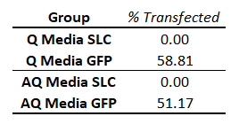

Table 2. Calculated Transfection Efficiency for Plasmid Cotransfection.
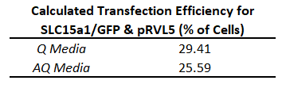

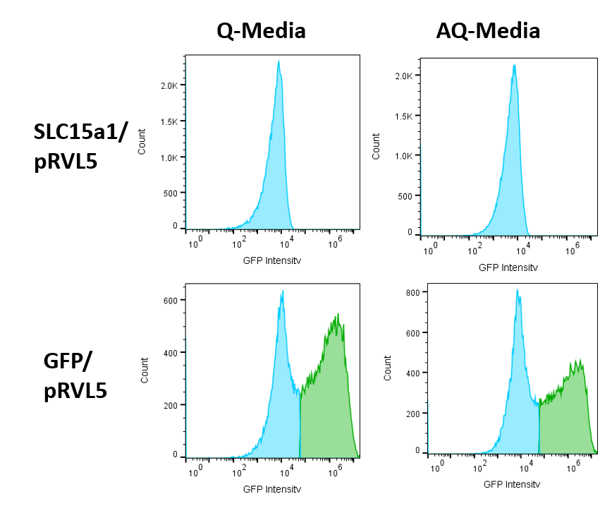
Figure 1. Transfection Efficiency of GFP plasmid. Flow cytometer analysis.

Media Decay
During the experimental run, the glutamine, alanine-glutamine, and ammonia of the Q and AQ supplemented media were measured to confirm media decay rates. The results are graphed in Figure 2 below.

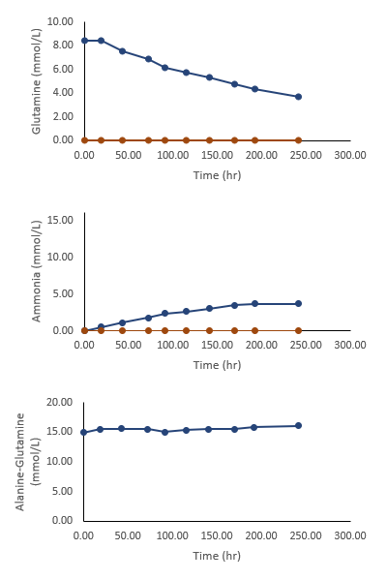
Figure 2. Concentration of metabolic compounds in media over the cell culture duration (10 days). Red represents Q media, blue represents AQ media. From top to bottom, glutamine (Q), ammonia, alanine-glutamine (AQ).

Metabolic Analysis
To better observe growth rate differences, the maximum viable cell densities that the cultures attained in the experiment were listed in table 3 below.

Table 3. Maximum Viable Cell Densities (cells/ml).
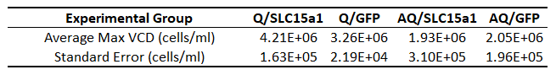
As seen from table 3 above, the samples containing glutamine supplemented media reached a higher maximum cell density than GlutaMAX supplemented AQ media. In addition, the maximum VCD average of the Q/SLC15a1 group is higher than the Q/GFP control group (the GFP group in glutamine media).
Table 4, below, further analyzes the maximum growth rate that the experimental cultures obtained (Note that all flasks experienced their respective maximum growth rates between days 3 and 4).
Table 4. Maximum Cell Growth Rate (cells/ml*hr).
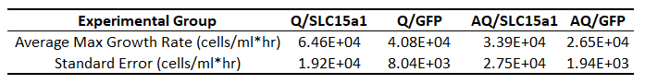
The maximum growth rate of the Q/SLC15a1 was the largest, followed by the Q/GFP growth rate. The AQ/SLC15a1 growth rate is the next largest, followed by the AQ/GFP growth rate. Of note, both SLC15a1 maximum cell growth rates are faster than their respective controls in Q & AQ media.
Corresponding with the maximum growth rates on the 4th day of the experimental run, average specific (per/cell) metabolic data was taken for each experimental group on the 4th day of the run and is listed in table 5 below.

Table 5. Specific Metabolic Data on the 4th Day of the Process Run.
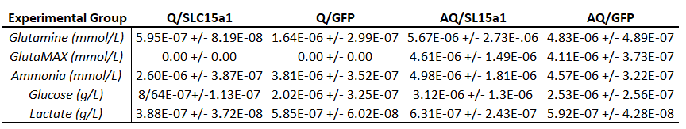
Overall it can be seen that there is less glutamine, ammonia, glucose, and lactate in the Q/SLC15a1 group compared to the control, Q/GFP. In addition to this, cells grown in AQ media have a distinctly different metabolite profile to those grown in Q media. Interestingly, the metabolite profile of AQ/SLC15a1 flasks is not very different from its control, AQ/GFP. All the metabolic data results are shown in detail for the duration of the experiment in figures 3 and 4 below, listed as specific (concentrations of each component have been divided by the VCD to normalize the metabolite data). In addition, the culture VCD profiles of each experimental group have been provided for reference.

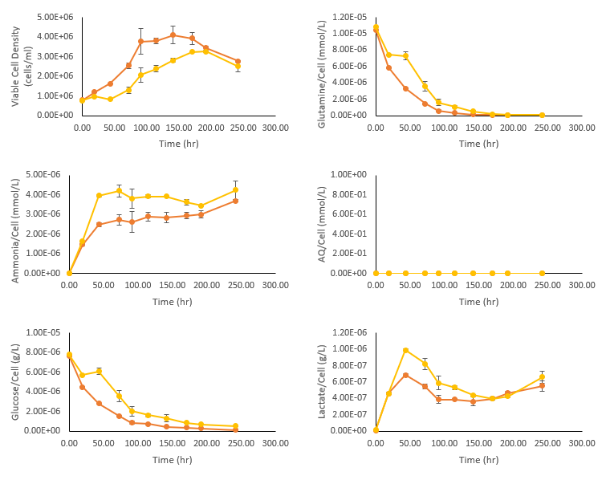
Figure 3. Glutamine (Q) supplemented flask VCD and metabolic profiles. Yellow represents the GFP control group, while red represents the SLC15a1 group. From left to right, top to bottom: VCD, specific glutamine, specific ammonia, specific alanine-glutamine, specific glucose, specific lactate.

It can be seen above that, compared to the Q/GFP control group, the Q/SLC15a1 group attains a higher VCD initially in the run and maintains a higher VCD until day 8 of the run. In addition to this, the SLC15a1 group had lower specific levels of glutamine, ammonia, and glucose, and lactate compared to the control group.
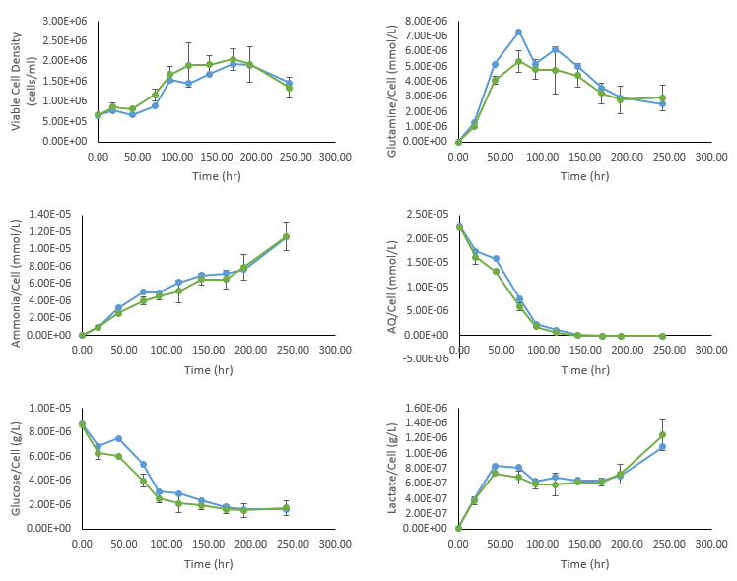
Figure 4. Alanine-glutamine (AQ) supplemented flask VCD and metabolic profiles. Green represents the GFP control group, while blue represents the SLC15a1 group. From left to right, top to bottom: VCD, specific glutamine, specific ammonia, specific alanine-glutamine, specific glucose, specific lactate.

It can be seen above that, compared to the AQ/GFP control group, the AQ/SLC15a1 group is comparable in VCD and all specific metabolite levels. Of note, there is a slight increase in the VCD rate between days 3 and 4 for the SLC15a1 group, and the specific glutamine present in media is slightly larger for the SLC15a1 group on day 3 of the culture process.

Statistical Analysis
Two tailed T-Test comparisons
Several two-tailed T-tests were used to test the significance of experimentally derived results. Table 6 below indicates which experimental results were revealed to be statistically significant using two-tailed T-tests (the threshold for significance for these experiments is to have a P-value at or below 0.05).
Table 6. Two-Tailed T-Tests of Metabolic Parameters, P-values Listed. Significant or near significant values bolded.
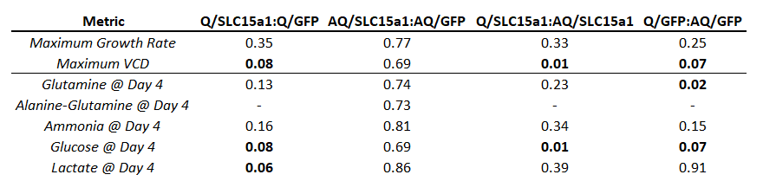
As can be seen from Table 6 above, only the maximum VCD and specific glucose on day 4 between SLV15a1 groups in Q & AQ media and the specific glutamine in GFP flasks grown in Q & AQ media on day 4 were determined to be statistically significant. However, it should be noted that all samples only had two replicates, making the ability to draw statistical significance from the data difficult. In addition, many results were close to significant, and may have been significant if the experimental groups were tested in at least triplicate. These results include differences between the maximum VCD, specific glucose, and specific lactate between Q/SLC15a1 & the control, Q/GFP. They also include maximum VCD & specific glucose on day 4 between the two control groups grown in Q & AQ media, Q/GFP & AQ/GFP, respectively.

Conclusions and Discussion

Transfection Efficiency
The information in Tables 1 and 2, and in Figure 1 show that the transfection efficiency is roughly 50%, although cells in Q media were transfected at slightly higher rates than those in AQ media (59% compared to 51%, respectively). Based off these efficiencies for 1 plasmid, the transfection of two plasmids was then calculated to be 29% in Q media and 25% in AQ media. This may have introduced process variability, as cotransfected cells were selected for by the addition of hygromycin and kanamycin. Cells in the culture which were not cotransfected experienced stunted growth, which would produce artificially lower VCD in AQ groups compared to Q groups. However, the growth profiles between Q & AQ groups were much different (as seen in Table 6), indicating that large growth differences observed between Q & AQ groups were caused by other factors.

Viable Cell Density & Growth Rates
As seen in Figure 2 and Tables 3 and 4, it was observed that the Q-containing flasks attained higher maximum VCDs (4.21E6, 3.26E6, 1.93E6, and 2.05E5 cells/ml for SLC15a1 and GFP transfected cells in Q & AQ media, respectively) and larger maximum growth rates (6.42E4, 4.08E4, 3,39E4, and 2.65E4 cells/ml*hr, respectively) than AQ flasks. This is most likely due to the readily available glucose in the cell culture media, which promotes faster initial increases in VCD¹⁰ within the first few days of cell culture. However, it was also observed that both SLC15a1 groups had higher maximum growth rates than their respective GFP control groups in Q & AQ media between days 3 and 4 of the culture process. This increase in growth rate may have been caused by the presence of the SLC15a1 transporter proteins. Through overexpressing SLC15a1 transporter proteins, cells may have been able to absorb peptide nutrients at a higher rate during their log phase of growth than the control groups.
Moreover, previous literature has suggested that the activity of SLC15a1 may be controlled post transcriptionally through the presence of monomer peptides, such a glutamine^{1,6}.
In the AQ samples, little difference between the SLC15a1 and control group was observed for VCD & all measured metabolic parameters, which supports the post translational regulation theory. Furthermore, SLC15a1 is a non-specific transporter protein, with over 400 substrates; if there were dipeptides undisclosed by the manufacturer in the cell culture media, it could be possible that the extra uptake of these unmeasured dipeptides could have caused the higher, maintained VCD in the Q/SLC15a1 group. It is also possible that the SLC15a1 transporter is capable of transporting monomer peptides as well as larger, oligo-peptides (the latter of which is more well-known for¹), although to a lesser degree. Combined with the theory of SLC15a1 activation in the presence of Q, together these suggested theories may explain the larger amount of glutamine uptake, overall higher VCD, and lower metabolic waste output observed in Q/SLC15a1 flasks compared to the Q/GFP control flasks.
The maximum VCD & maximum cell growth rate data were subjected to a two-tailed T-Test to determine if any results observed were statistically significant (see table 5 above). Of these analyses, only the maximum VCD was determined to be statistically different between the SLC15a1 group grown in Q-media and the SLC15a1 group grown in AQ-Media (P = 0.01). Although this at first glance would indicate there is no correlation between overexpressing SLC15a1, a higher VCD, and a higher maximum cell growth rate, it must be considered that each test was conducted with only 2 samples in each group, leading to high variability. If this experiment were conducted with more than two replicated for each experimental group, the weaker correlations may become more statistically apparent. For example, the P- value for VCD between Q/SLC15a1 & Q/GFP was 0.08 and the P-value of A/SLC15a1 & AQ/GFP was 0.08; having one more replicate may have made these metrics statistically significant.

Metabolic Profiles
In addition to viable cell density, cell metabolic data for glutamine, alanine-glutamine, ammonia, glucose, lactate, and IgG were collected throughout the cell culture run. Of these metabolites, it was observed that on day 4 of the culture process, that the Q/SLC15a1 group had somewhat lower levels of glutamine, ammonia, and lactate than the Q/GFP control (see figure 4 above). This, coupled with the observed higher VCD for Q/SLC15a1 samples, suggests that more metabolic fuels (glutamine & glucose) were directed to anabolic processes in the Q/SLC15a1 cells, producing the higher VCD while also creating less metabolic poisons (ammonia & lactate) than the Q/GFP control group.
Interestingly, this metabolic profile differentiation between SLC15a1 & GFP groups is not observed in the AQ-media groups. In all instances, AQ-media groups were within error range of each other. As mentioned before, one hypothesis for this is that SLC15a1 transporters are metabolically regulated (either directly or indirectly) by an abundant presence of monomer peptides, such as glutamine. In conditions without glutamine, (such as conditions present in AQ supplemented media groups), the SLC15a1 would have only a slight, if any, effect in transporting any of its substrates (such as AQ).
GlutaMAX media didn’t contain any monomer glutamine peptides (Q), nor did the AQ dipeptides in the media spontaneously decay into Q (see figures 2-4 above). Correspondingly, all cells cultured in AQ media were forced to both import and metabolize AQ to access the glutamine fuel source using native enzymes (see figure 5 above, glutamine increases in AQ samples then decreases as the AQ runs out & cells consume the Q). Sánchez-Kopper et al.¹ have suggested a mechanism for the intracellular import of dipeptides (including AQ) in CHO cells (see figure 5 below).

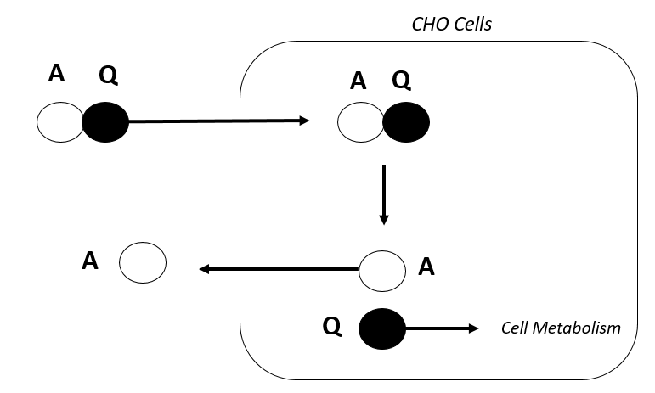
Figure 5. Sánchez-Kopper et al Theory for Dipeptide Transport in CHO¹⁰
In this theory, dipeptides (including AQ) were taken up as needed, which for AQ was almost immediately in Sánchez-Kopper’s dipeptide experiments. It was observed that Q was completely metabolized by the cell, while A was ejected into the cell culture media. However, during the SLC transporter experiments, AQ-only supplemented cultures had actively generated Q during the lag and exponential growth of the cell cultures (up to day 5); Q was not generated from the spontaneous decay of AQ in the media (see figures 2-4). After this point, AQ became almost depleted and Q was metabolized to an extent by the end of the 10-day culture period; this shift corresponded with a cellular metabolic shift towards stationary phase. This suggest that the specific metabolism of AQ in CHO is diffusion limited; this suggested theory is illustrated in Figures 6 & 7 below.

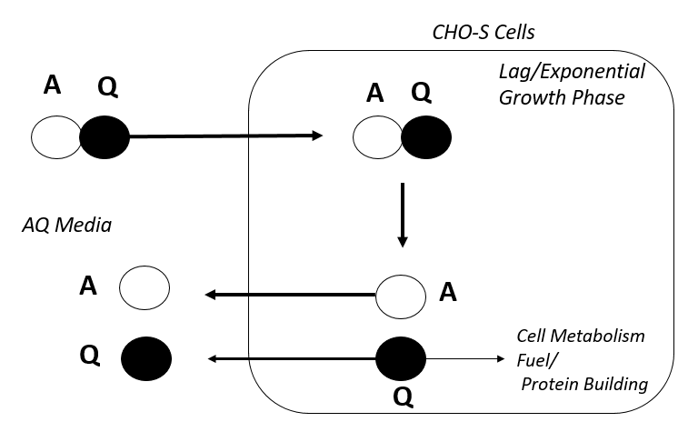
Figure 6. CHO-S AQ Dipeptide Transport (Days 1-5)
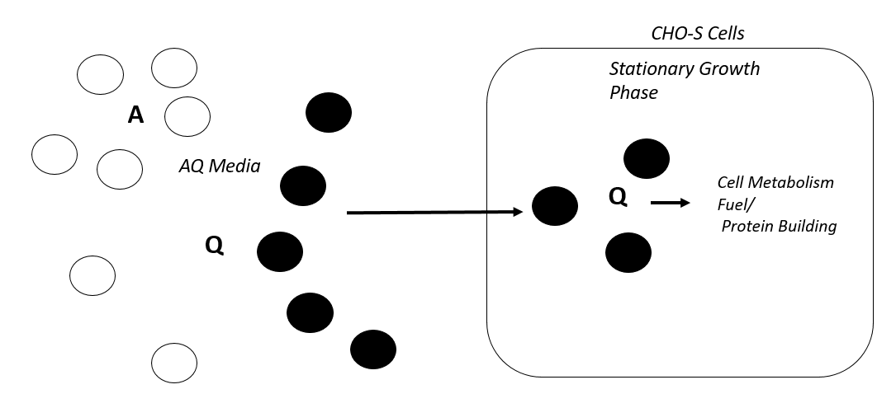
Figure 7. CHO-S AQ Dipeptide Transport (Days 5-10)

Moreover, major differences were observed between metabolic data from cells grown in Q and AQ media. For example, glutamine is only consumed in Q media samples, where as in AQ media groups it is produced from the breakdown of AQ in the media, then is gradually consumed as cell population density rises and AQ runs out. Additionally, glucose was consumed at a much lower rate and lactate and ammonia were produced at a much higher per cell rate than in Q-media cell culture groups. Overall, AQ-media groups maintained a much lower, although stable VCD than Q-media groups (the maximum VCD for AQ SLC15a1 & GFP were 1.93E6 and 2.05E6, while in Q media they were 4.21E6 & 3.26E6 cells/ml, respectively, see Table 2 & Figure 1 above). Overall this suggests that the overall cell growth is slowed from the lack of readily available glutamine in the media. Because of this, the cellular growth in this experimental setup was much less efficient in AQ media, with there being on average more metabolic wastes/cell in AQ media groups. Ultimately, it is difficult to directly compare metabolic data between Q & AQ supplemented runs because of large VCD and growth profile differences.
T-tests performed for each metabolic parameter analyzed on day 4 of the culture run revealed only two significant differences- the specific glutamine concentration/cell between Q/GFP & AQ/GFP groups, and the specific glucose concentration/cell between Q/SLC15a1 & AQ/SLC15a1. Although this initially seems odd that there are only two statistically significant differences between all the samples, given the large observed differences between Q&AQ groups, this can again be accounted for by the fact that there were only two replicates in every group measured. Such low replicate numbers make it difficult to prove more slight differences in data using the T-test method; if this experiment were conducted again with higher replicate numbers, more nuanced differences between the different experimental groups may be identified as being statistically significant. For example, the specific glucose (p = 0.08) & lactate (0.06) between Q/SLC15a1 & Q/GFP, as well as the specific glucose (0.07) between Q/GFP & AQ/GFP groups are nearly significant.
Notably, the VCD growth curves developed in this experiment vary substantially from literature growth curves for CHO in similar Q & AQ only processes⁶, in which CHO cells in AQ media grew slower but reached a similar maximum VCD to those grown in Q and produced more IgG titer than cells grown in AQ over a 14-day process. However, those processes were grown in Fed-batch style, whereas this experiment was conducted in batch style with no feeding past an initial feeding on day 1, which was used to add selecting agents for the transiently transfected DNA.
While it would have been interesting and informative for IgG data to be present in this experiment, either the IgG plasmid, pRVL5, failed to produce enough IgG to be read by the IgG bio assay kit, or pRVL5 failed to produce an IgG product at all that can be read by the Cedex Bio. If future CHO-transfection studies are pursued, it is recommended to use a different plasmid (either purchased or custom built) & to test IgG protein expression levels before a transfection experiment is set up.
Ultimately, differences were observed in maximum viable cell densities, maximum cell growth rates, and overall cell metabolism in CHO-S cells transfected with the dipeptide transporter SLC15a1 & GFP grown in Q & AQ supplemented medias. Because of these differences, and inconclusive IgG results obtained from this experiment, pursuing further research & replicating this experiment would prove an interesting endeavor for future parties.
Additional recommendations, should this experiment be repeated & expanded upon, include attaching either a GFP/BFP tag to both the SLC15a1 & IgG proteins or making their plasmids independently express the florescent proteins. Transfection efficiency was only measured through the reporter GFP plasmid, which was only measured in control samples, with relative transfections of two plasmids calculated based on the GFP transfection results in each media. Adding addition transfection efficiency measurement capabilities will remove true transfection efficiency speculation in the experimental groups. In addition, running the experiments in 4:4mM Q/AQ supplemented medias, as fed batch cultures over a period of 10 days, should improve general cell viability & allow for a direct comparison of results to those seen experiments conducted by Imamoto et. al.⁶.

Bibliography

- Sánchez-Kopper, A., Becker, M., Pfizenmaier, J., Kessler, C., Karau, A., & Takors, R. (2016). Tracking dipeptides at work-uptake and intracellular fate in CHO culture. AMB Express, 6(1), 48.
- Kunert, R., & Reinhart, D. (2016). Advances in recombinant antibody manufacturing. Applied microbiology and biotechnology, 100(8), 3451-61.
- Gronemeyer, P., Ditz R., & Strube, J. (2014). Trends in Upstream and Downstream Process Development for Antibody Manufacturing. Bioengineering, 1(4), 188-212.
- Ahmadi, S., Davami, F., Davoudi, N., Nematpour, F., Ahmadi, M., Ebadat, S., Azadmanesh, K., Barkhordari, F., Mahboudi, F. (2017). Monoclonal antibodies expression improvement in CHO cells by PiggyBac transposition regarding vectors ratios and design. PloS one, 12(6), e0179902. doi:10.1371/journal.pone.0179902
- Højmark Omkvist, D. et. Al. (2010). A Quantitative Structure–Activity Relationship for Translocation of Tripeptides via the Human Proton-Coupled Peptide Transporter, hPEPT1 (SLC15A1). The AAPS Journal, 12(3), 385-396).
- Imamoto, Y., Tanaka, H., Takahashi, K., Konno, Y., & Suzawa, T. (2012). Advantages of AlaGln as an additive to cell culture medium: use with anti-CD20 chimeric antibody-producing POTELLIGENT™ CHO cell lines. Cytotechnology, 65(1), 135-43.
- pRVL-5 was a gift from Daniel Christ (Addgene plasmid # 104583 ; http://n2t.net/addgene:104583 ; RRID:Addgene_104583).
- ThermoFisher Scientific. Invitrogen PureLink™ HiPure Plasmid Maxiprep Kit. K210007. https://www.thermofisher.com/order/catalog/product/K210007?ICID=cvc-plasmid-maxi-prep-c2t1 (accessed March 27, 2018).
- ThermoFisher Scientific. Gibco FreeStyle™ MAX CHO Expression System. K900020. https://www.thermofisher.com/order/catalog/product/K900020 (accessed March 27, 2018).
- TOKU-E. Hygromycin B Protocol and Selection Guide. file:///C:/Users/Alexandra/Downloads/Hygromycin-Protocol%20(1).pdf (accessed October 13, 2018).
- ThermoFisher. Trypan Blue Exclusion. https://www.thermofisher.com/us/en/home/references/gibco-cell-culture-basics/cell-culture-protocols/trypan-blue-exclusion.html (accessed October 10, 2018).
- Spanier B. (2013). Transcriptional and functional regulation of the intestinal peptide transporter PEPT1. The Journal of physiology, 592(5), 871-9.

Appendix

Appendix A: Plasmid Maps
The following are plasmid maps for the plasmid DNA used in the experiments. The plasmid maps were generated using Benchling.

Appendix A.1: CHO SLC15a1 Custom Plasmid
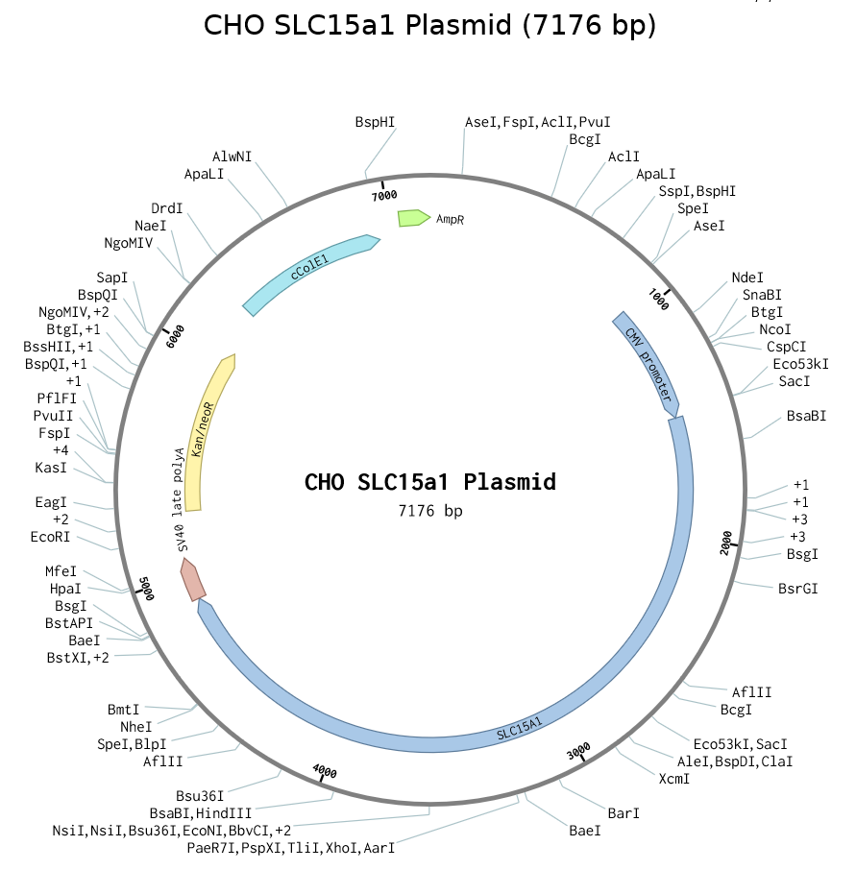

Appendix A.2: CHO GFP Custom Plasmid
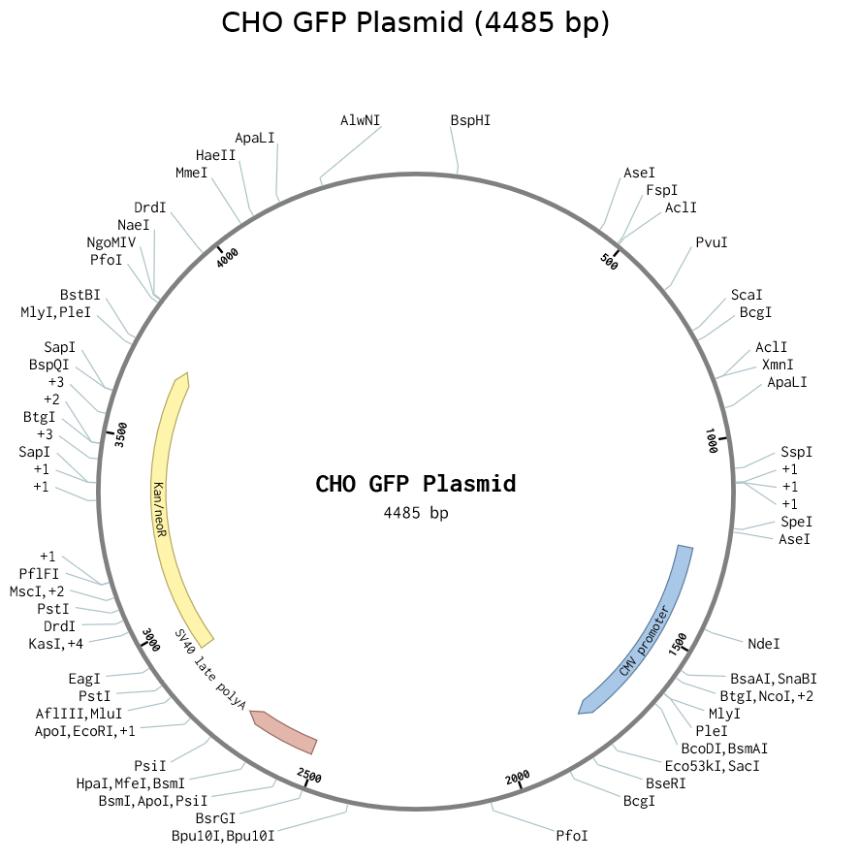

Appendix A.3: pRVL5 (IgG) Plasmid
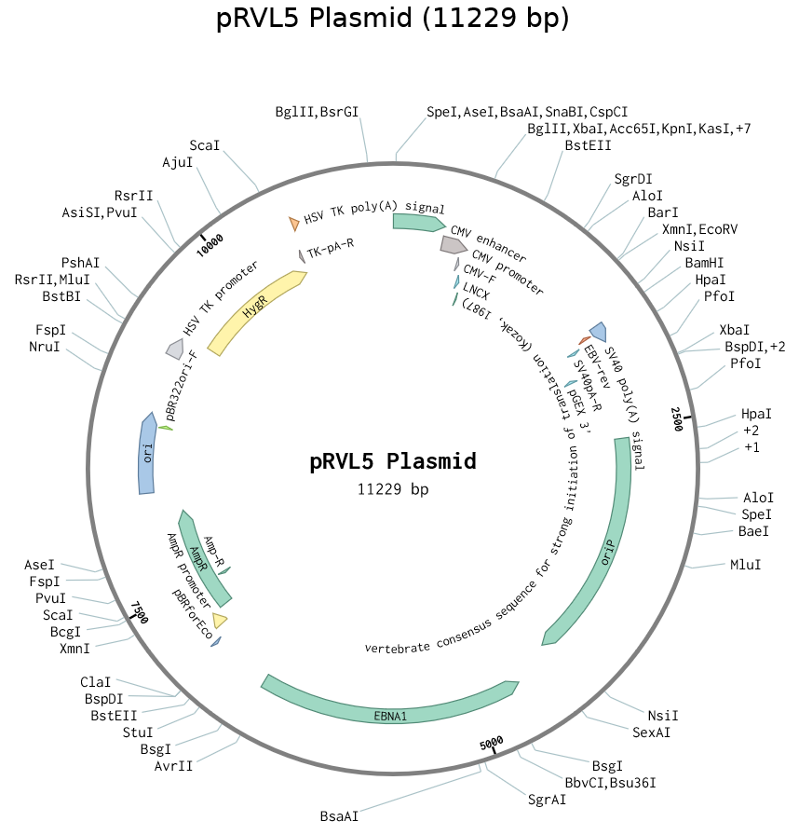

Appendix B: Transfection Efficiency Raw Data

Appendix B.1: Transfection Efficiency Raw Flow Cytometer Data
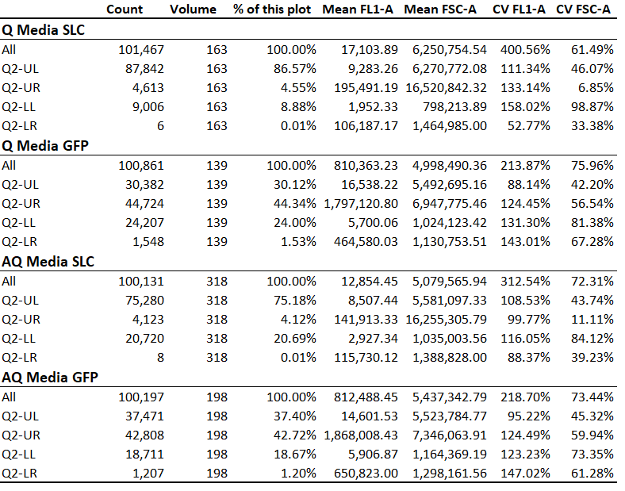

Appendix C: Cell Metabolic Raw Data

Appendix C.1: Total Lactate Over Time

Appendix C.2: Total Glucose Over Time

Appendix C.3: Cell Viability over Time

Appendix C.4: Total Glutamine over Time

Appendix C.5: Total Alanine-Glutamine over Time

Appendix C.6: Total Ammonia over Time

Appendix D: Two-Tailed T-Tests
Appendix D.1: Maximum growth rate T Tests (Q/SLC:Q/GFP, AQ/SLC:Q/GFP, Q/SLC:AQ/SCL, Q/GFP:AQ/GFP respectively.)
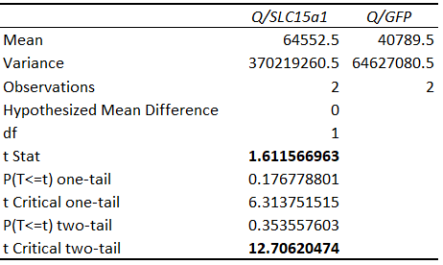
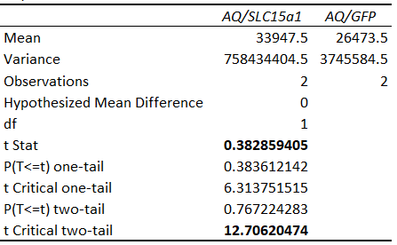
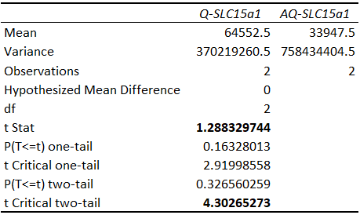
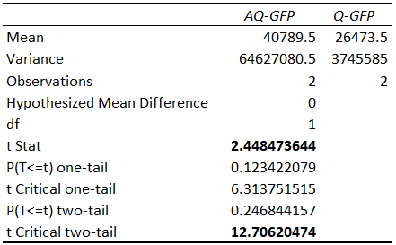

Appendix D.2: Maximum VCD T Tests (Q/SLC:Q/GFP, AQ/SLC:Q/GFP, Q/SLC:AQ/SCL, Q/GFP:AQ/GFP respectively.)
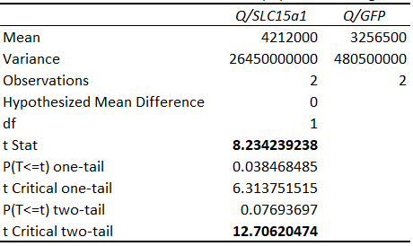
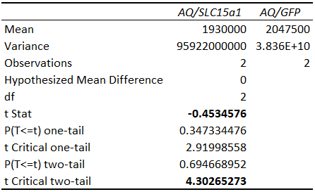
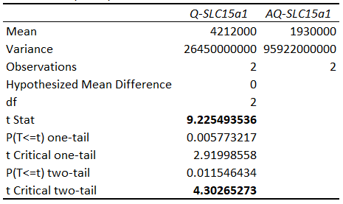
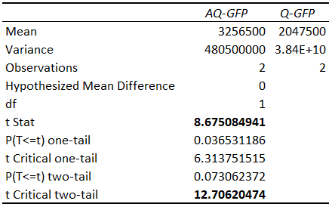

Appendix D.3: Specific Glutamine on Day 4 T Tests (Q/SLC:Q/GFP, AQ/SLC:Q/GFP, Q/SLC:AQ/SCL, Q/GFP:AQ/GFP respectively.)
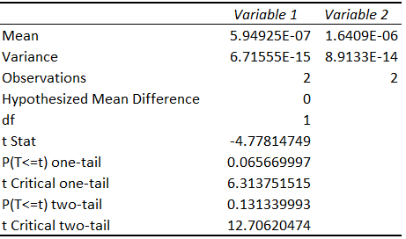
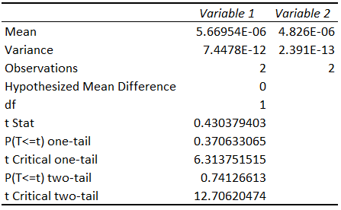
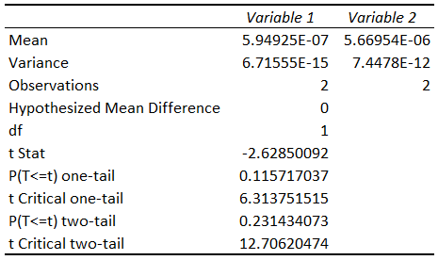
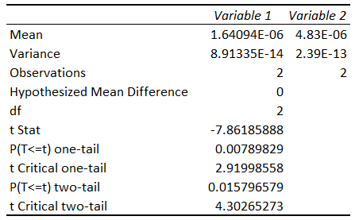

Appendix D.4: Specific Alanine-Glutamine on Day 4 T Tests (Q/SLC:Q/GFP, AQ/SLC:Q/GFP, Q/SLC:AQ/SCL, Q/GFP:AQ/GFP respectively.)
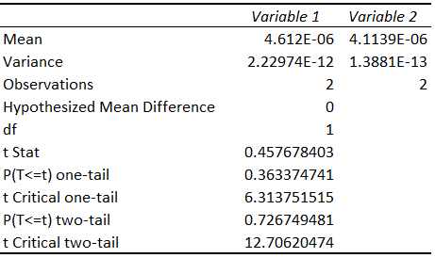

Appendix D.5: Specific Ammonia on Day 4 T Tests (Q/SLC:Q/GFP, AQ/SLC:Q/GFP, Q/SLC:AQ/SCL, Q/GFP:AQ/GFP respectively.)
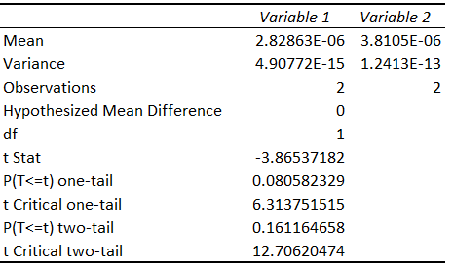
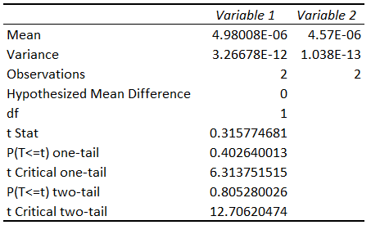
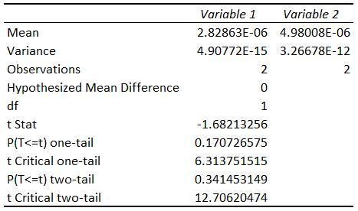
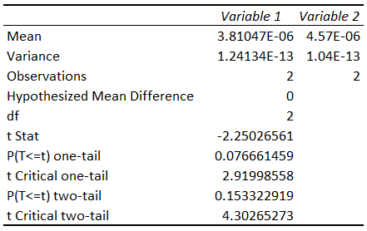

Appendix D.6: Specific Glucose on Day 4 T Tests (Q/SLC:Q/GFP, AQ/SLC:Q/GFP, Q/SLC:AQ/SCL, Q/GFP:AQ/GFP respectively.)
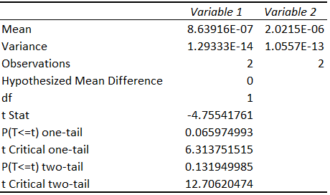
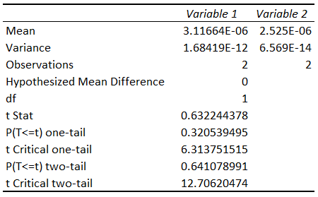
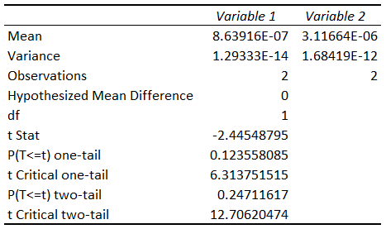
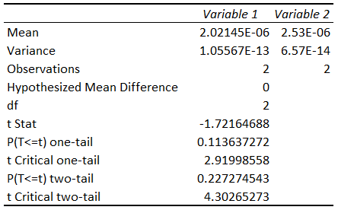

Appendix D.7: Specific Lactate on Day 4 T Tests (Q/SLC:Q/GFP, AQ/SLC:Q/GFP, Q/SLC:AQ/SCL, Q/GFP:AQ/GFP respectively.)
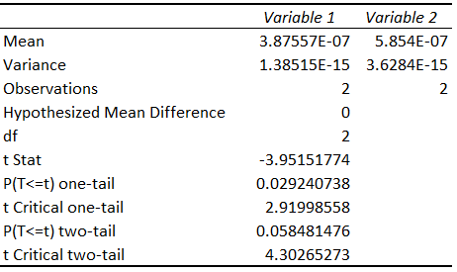
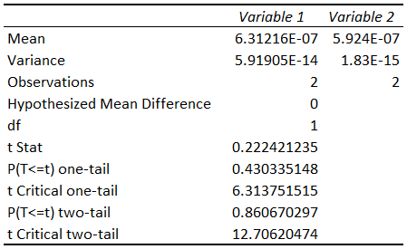
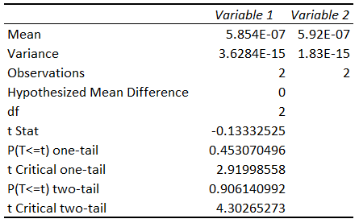

Appendix E: VCD & Metabolic Raw Data

Appendix E.1: VCD Raw Data (listed by flask)
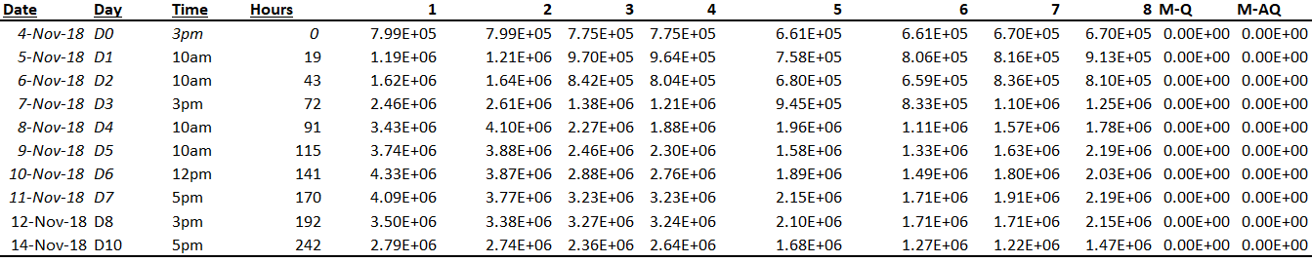

Appendix E.2: Cell Viability Raw Data
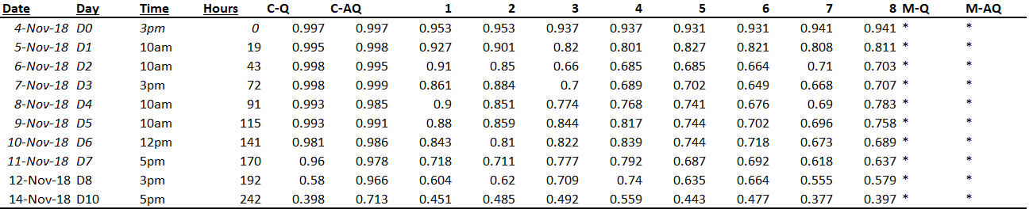

Appendix E.3: Total Glutamine Raw Data
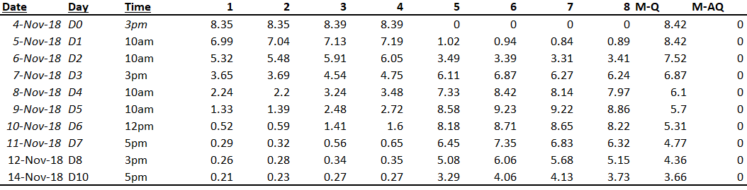

Appendix E.4: Total Alanine-Glutamine Raw Data
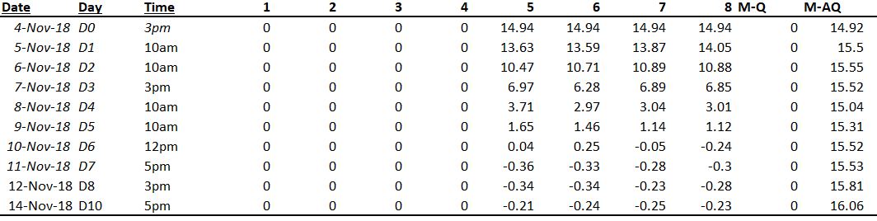

Appendix E.5: Total Ammonia Raw Data
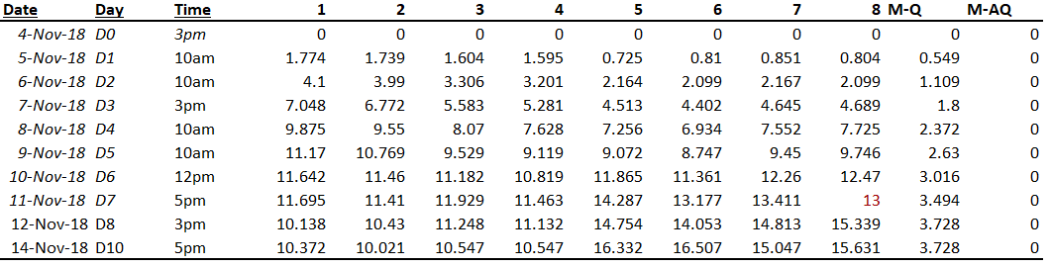

Appendix E.6: Total Glucose Raw Data
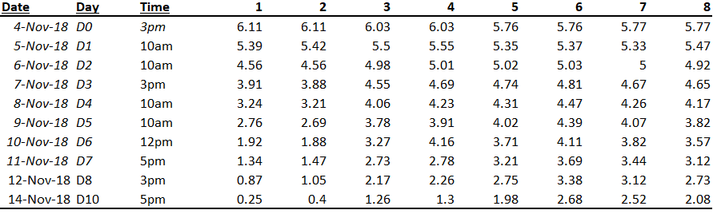

Appendix E.7: Total Lactate Raw Data
