March 29, 2022
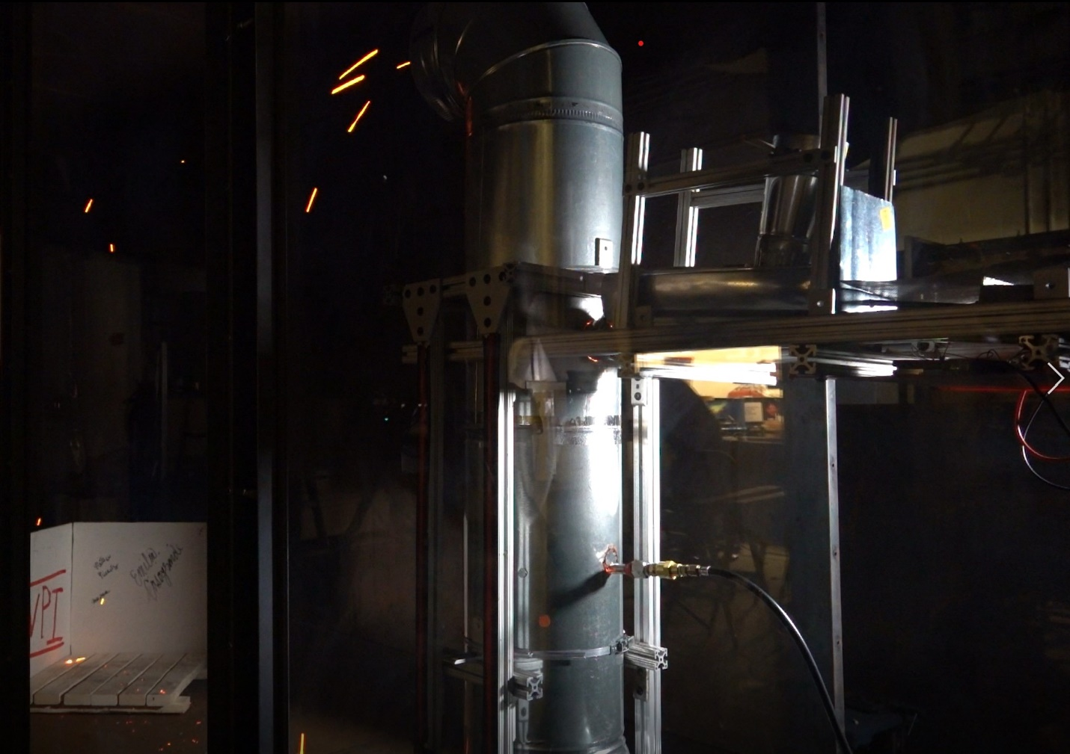

A Major Qualifying Project submitted to the faculty of WORCESTER POLYTECHNIC INSTITUTE In partial fulfillment of the requirements for the degree of Bachelor of Science

Emilia Casagrande, Matthew Nicastro, & Matthew Rotman
ADVISOR: JAMES L. URBAN

This report represents the work of one or more WPI undergraduate students submitted to the faculty as evidence of completion of a degree requirement. WPI routinely publishes these reports on the web without editorial or peer review.

Abstract
Firebrand generators are a relatively new tool used to research firebrands in a lab environment. The goal of the project was to create a user-friendly, inexpensive firebrand generator to produce firebrands comparable to wildland urban interface (WUI) fires, to facilitate further research in WUI spread. Individual firebrand velocity and size were measured with image processing methods to prove the effectiveness of the generator. The generator detailed in this report is a highly accessible device, able to recreate firebrand showers in both lab and field applications.

Acknowledgements
We would like to thank Professor James Urban for his support and guidance throughout the development of the Firebrand Generator. We would like to thank our lab managers, Ray Ranellone and Fritz Brokaw for their support with the construction of the generator and advice on testing and operating procedure. We would also like to thank Diane Poirier for her assistance with materials and component acquisition. We would like to acknowledge the help of Juan Cuevas and Gabriel Setti for helping to assemble and modify the wind tunnel used for testing. We would also like to thank the Mechanical Engineering and Fire Protection Engineering Departments which funded this work.

Table of Contents
Abstract i
Acknowledgements ii
Table of Contents iii
List of Figures v
List of Tables v
Section 1: Introduction 1
Section 2: Background 3
2.1: Wildfires and the Spread of Wildfires 3
2.2: Properties of Firebrands 4
2.2.1 Generation and Detachment 4
2.2.2 Lofting and Transportation 6
2.2.3 Landing and Ignition 6
2.2.4 Firebrand Study 7
2.3: Approaches to Firebrand Generation in Experiments 8
2.4: Measurement of Firebrands 9
Section 3: Design and Build Approach 10
3.1 Design Requirements 10
3.2 Design critical sub-systems 12
3.3 Building and Development 14
3.3.1 Framing and Central Structure 14
3.3.2 Burn Chamber 15
3.3.3 Feeding Mechanism 16
3.3.4 Blower Setup 19
3.4 Budget 20
Section 4: Testing Procedures 21
4.1 Calibrating the Generator Components 21
4.1.1 Flow Speed Tests 21
4.1.2 Burner and Unit Ignition Tests 22
4.1.3 Burner Ignition and Shutdown Procedures 22
4.2 Firebrand Production Tests 23
4.3 Firebrand Analysis Tests 25
4.4 Firebrand Post-Processing Procedures 25
Section 5: Results and Discussion 29
5.1 Travel Speed of Firebrands Results 29
5.1.1 Firebrand Test 1 Results 30
5.1.2 Firebrand Test 2 Results 31
5.2 Discussion of Firebrand Travel Speed Results 32
5.3 Size of Collected Firebrands 34
5.4 Discussion of Firebrand Size Results 35
Section 6: Conclusions and Recommendations 36
6.1 Conclusions 36
6.2 Recommendations 36
6.2.1 Controls 36
6.2.2 Blower 37
6.2.3 Burner 37
6.2.4 Feed 37
Appendix 39
Appendix A: Firebrand Generator Standard Operating Procedure 39
Appendix B: Total Generator Parts and Costs 45
Appendix C: MATLAB Code 46
Appendix D: Firebrand Data 50
Bibliography 51

List of Figures
Figure 1: Pile of firebrands on plywood under wind and the corresponding IR image 3
Figure 2: Sub-Processes of a firebrand in WUI fires 4
Figure 3: Free body diagram of forces acting on a firebrand in-flight 5
Figure 4: Firebrands produced by different vegetation at different windspeeds 5
Figure 5: Nomograph to find maximum spot fire distance 6
Figure 6: Composite showing different data analysis techniques for firebrands. 7
Figure 8: NIST firebrand generator showering a decking assembly in firebrands 9
Figure 9: SolidWorks render of the main body of the firebrand generator 11
Figure 10: Initial construction of the main body of the firebrand generator 11
Figure 11: Schematic of the firebrand generator and critical subsystems 12
Figure 12: Airflow diagram for the firebrand generator 12
Figure 13: Fully assembled firebrand generator 13
Figure 14: Upper support and duct mount 14
Figure 15: Bottom elbow duct support 14
Figure 16: Burn chamber inside the firebrand generator 15
Figure 17: Power supply and control devices for the stepper motor 18
Figure 18: The assembled feeding mechanism 18
Figure 19: 1604cfm adjustable blower for the firebrand generator 19
Figure 20: Example of firebrand streaks being measured using MATLAB 26
Figure 21: Histogram summarizing firebrand speeds for test 1 30
Figure 22: Histogram summarizing firebrand speeds for test 2 31
Figure 23: Comparison of the speeds of different sized firebrands 33
Figure 24: Firebrands drying after being collected in water pans 34
Figure 25: Histogram summarizing the sizes of collected firebrands 34

List of Tables
Table 1: Arduino code to control the stepper motor 17
Table 2: Generator windspeed test results 21
Table 3: Firebrand production test matrix 23
Table 4: Firebrand production test matrix parameter definitions 23
Table 5: MATLAB script for the firebrand area calculations 27
Table 6: Firebrand speed measurements summary table for test 1 30
Table 7: Firebrand speed measurements summary table for test 2 31

Section 1: Introduction
Wildfires are a consistent threat to communities globally, and the risks of these uncontrolled fires continue to grow as they become more frequent and severe [1]. Wildfires can quickly spread, consuming trees and other vegetation in wildland areas with minimal development, but also pose a risk to nearby urban areas with the same spreading mechanisms. The geographical area where structures and other human development meets or intermingles with wildland or vegetative fuels is defined as the wildland-urban interface (WUI) [2]. The developed areas near the WUI are at a high risk of firebrands, or lofted pieces of burning fuel, which can ignite structures from direct contact well ahead of the fire front [3].
It has been reported that from 2000 to 2018, 2777 wildfires resulted in the loss of 58,705 buildings across the United States. Additionally, 2.3% of the fires over this period accounted for over 77% of the building losses, with the most structural loss resulting from the Camp Fire in California in 2018 [4]. To prevent the rapid spread of fires within communities, an understanding of their spreading mechanisms must be established so structural fire resistance can be improved accordingly.
Fire protection engineering research and changes to the fire codes and standards cannot keep up with the increasing threat of wildfires. The current test for fire resistance of building materials involves burning a wood crib on an area of the material and evaluating time for failure. This does not account for the full scope of the wildfire spreading mechanisms, which include convection, radiation, and spot ignitions (firebrands) or realistic conditions [5].
Firebrand spotting can result in a compounding effect of fire spread across a large area, as they will ignite structures which, in turn, produce more firebrands. Firebrands have not been fully accounted for when designing buildings against WUI fires, in part because they have been difficult to replicate in a lab setting, and they are nearly impossible to safely observe in a WUI fire scenario. These small embers collect on decks, roofing, and other elements of buildings and homes. They can transfer heat into smaller cracks or crevices in the construction, causing ignition in ways that have not been considered by previous fire tests [6].
The National Institute of Standards and Technology (NIST) has developed a laboratory scaled device that aims to closely replicate firebrands from wildfires. The NIST Dragon and other similar devices have been created to transform wooden fuels into firebrands and blow them out in a way that can mimic a realistic wildland fire scenario.
To facilitate further research on firebrands, this project will create a user-friendly, inexpensive firebrand generator to produce and measure firebrands comparable to those in WUI fires. Individual firebrand velocity, size, and temperature will be measured with imaging methods. Understanding these properties will allow researchers to recreate firebrand showers in lab and field applications. The following sections of this proposal will discuss the background research that has been done as well as the design approaches, testing methods, and project plan the group has developed to create a firebrand generator.

Section 2: Background

2.1: Wildfires and the Spread of Wildfires
Researchers have put an immense amount of time into better understanding how these fires grow and spread to predict and stop them more quickly and accurately. Spread of wildfires has been tracked based on empirical data to create trends, which has allowed researchers to develop models that can predict how fires may develop in the future. These models consider fire spread influenced by three main mechanisms, each with unique ranges and impacts. Direct contact from flames (convection) will ignite fuel that is in contact with the flames. Thermal radiation heats up fuel sources near the fire but not in direct contact with the flames, to a point where they can ignite separate from the wildfire. Firebrands are embers from wildfires that can be lofted up and carried large (or short) distances. Direct contact or a buildup of firebrands can ignite vegetative or structural fuel at a large distance from the main front of the fire [1]. Together these different mechanisms of fire spread make firefighting a difficult task and make even the simplest of predictive models, complex.
Often, the technique for fighting Wildland and WUI fires is to cut large swaths of vegetation to form a fuel-free barrier that the fire cannot pass, while also attacking the fire with water, among a variety of other tactics. This is where firebrands become most dangerous, as they cause fire spread through fire spotting. This can discontinuously spread the fire, crossing these barriers, and hampering any progress made to contain the fire. Firebrands have also been known to trap firefighters and victims of WUI fires by igniting on the opposite side from which the fire is approaching [3].
Firebrands can travel long distances, and thus pose a serious threat to developed areas even if they are separated from the wildlands. Large collections of firebrands, such as those in Figure 1, have been observed to ignite wooden structures or vegetation against these structures, although smaller piles of firebrands can be just as dangerous. This is one of the most prevalent risks associated with WUI fire spread.
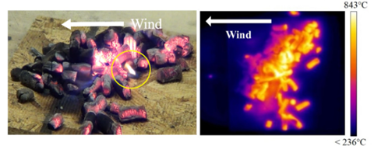
Figure 1: Left – pile of firebrands on plywood under 2m/s wind. Right – Corresponding IR image [7]

2.2: Properties of Firebrands
Firebrands are extremely dangerous in WUI fires due to their ability to ignite fuel significant distances from the fire front, enlarging WUI fires quickly. Firebrands continue to be a prominent topic for wildfire researchers, as structural fire-resistance to these firebrands may be an effective approach to preventing fire spread to urban areas. Currently, firebrands make up more than 50% of structural ignitions [6]. Firebrand spotting from WUI fires can be broken down into three distinct phases. The first phase involves the generation and detachment of burning materials. Phase two involves the lofting and transportation of firebrands, and phase three includes the process of firebrands landing and igniting new structures or vegetation [8].
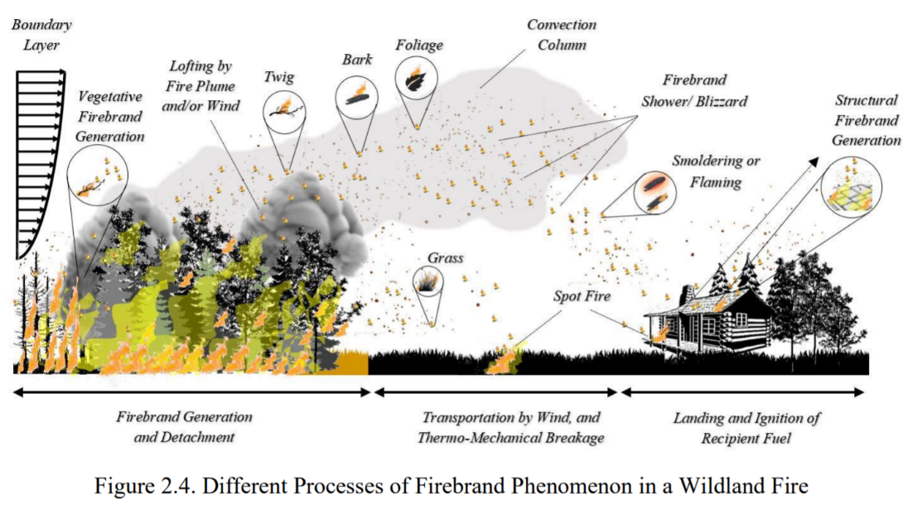
Figure 2: Sub-Processes of a firebrand in WUI fires [8]

2.2.1 Generation and Detachment
The first phase of firebrand spotting refers to firebrand generation through the burning of materials within the flames and the subsequent take-off of the burning debris once it is small and light enough to be picked up by the wind. This step is heavily dependent on windspeeds, as found in a 2020 study, lower speeds will often generate smaller firebrands, and higher windspeeds will generate larger firebrands. When testing different vegetative fuel sources, lower windspeeds (averaging 5-m/s) most often produced the smallest and lightest firebrands while higher windspeeds (averaging 18-m/s) produced the largest firebrands with the most mass [8]. Firebrand flight can be estimated with two different forces: drag forces from the flow and gravity [9].

Figure 3 shows a free body diagram of a firebrand and the forces acting upon it. This includes drag force pushing the firebrand with windspeed velocity and velocity of the fire plume, and the force of gravity on the firebrand [10].
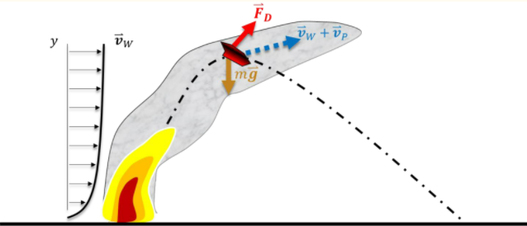
Figure 3: Free body diagram of forces acting on a firebrand in-flight [9]
The size of firebrands is strongly dependent on the ability of the forces from the flow (drag forces) to overcome the forces of gravity. This is possible when the surrounding airflow is fast enough, causing the firebrands to go airborne. Due to the variety of vegetation and building fuels in WUI fires as well as the different intensities of wildland fires, firebrands can range quite a bit in size. Below is a series of images depicting different firebrands generated by different vegetative fuel types. Trees and larger vegetation with shrubs were most likely to generate firebrands of larger mass with a good range in sizes, while smaller vegetation (grass, shrubs, leaves) would produce firebrands of far smaller mass and a very wide range of sizes [8].
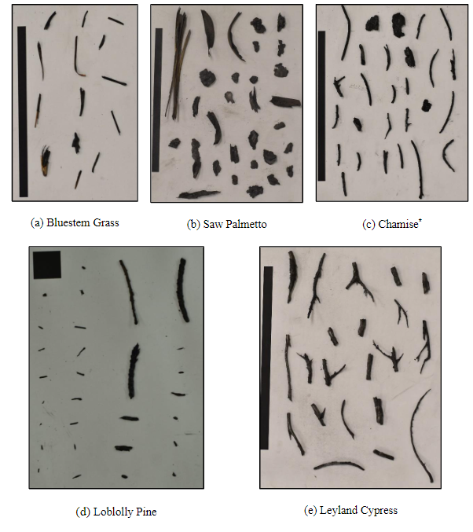
Figure 4: Firebrands produced by different vegetation at moderate to high windspeeds [8].

2.2.2 Lofting and Transportation
The second phase refers to the period in which firebrands are airborne. It is this step that makes firebrands such a crucial aspect of wildfire spread. Once detached, the firebrands are first lofted by the fire plume until exiting somewhere between the flames and the maximum height of the plume. At this point the firebrands are carried by wind and can sometimes be found miles away from their source. While in flight, the burning firebrand will be in a smoldering or flaming state and will continue to lose mass until burning up or landing some distance away.
Studies have shown a correlation between initial firebrand height, mean treetop height, windspeed, and maximum spot fire distance. Spotting distance can be limited or extended by changing any of these variables. If the firebrands start higher in elevation (on mountaintops or higher in trees) than they have more capacity to travel long distances than those lower in elevation. Additionally, higher windspeeds can handle firebrands with more mass and carry them further [11].
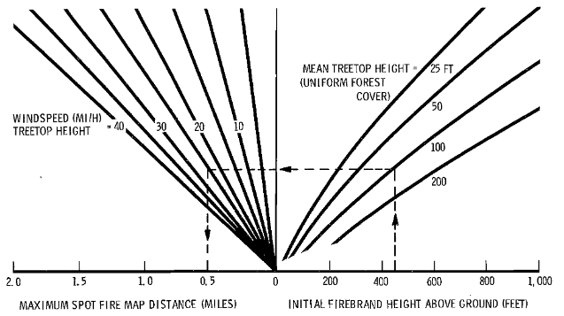
Figure 5: Nomograph of firebrand height, mean treetop height, and windspeed to find maximum spot fire distance [11]

2.2.3 Landing and Ignition
The third and final phase is the landing and subsequent ignition of fuel some distance away from the fire. Upon landing, firebrands tend to be in one of three states: flaming, smoldering, or cooling. Should a firebrand land on a fuel source in any of these states, it can be hazardous. Given enough energy transfer from multiple, or even just one firebrand, the fuel may begin to smolder and ignite. This process is dependent on several characteristics of the fuel and environmental conditions, but is an ignition threat,
nonetheless [10]. Spot ignition by firebrands is a problematic form of fire spread as it is extremely difficult for firefighters to combat and can cause fires to grow quickly and erratically.

2.2.4 Firebrand Study
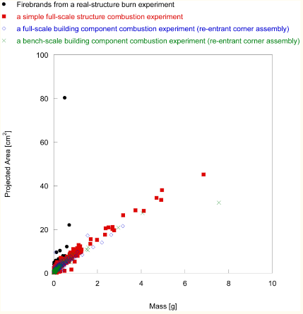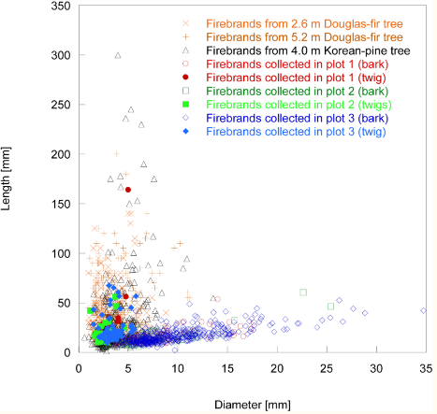
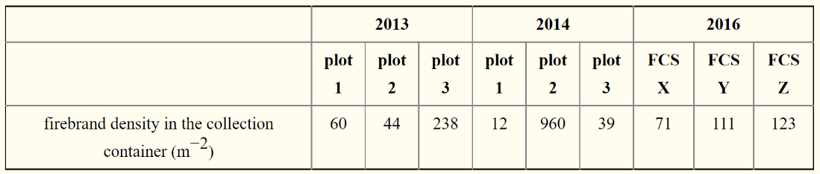
Figure 6: Composite showing different data analysis techniques for firebrands. [12]–[15]. [16]–[18]. [19].
Firebrands have been studied in both post-fire investigations as well as laboratory experimental studies. Most experiments have involved the burning of structural components or vegetation, the collection of firebrands in water pans, or measuring burn holes in polyurethane sheets [15]. After wildfires, as part of post-incident investigations, some firebrand data can be collected from burn holes in trampolines or other thin sheets that melt rather than burn. Additionally, firebrand debris has been collected from water sources such as pools. Firebrands are typically classified by size (projected area) and mass, although studying wildfires and experiments have uncovered more knowledge into firebrand temperatures and flight distances [8]. One study measuring firebrands found “Eighty-three percent of firebrands collected by pans filled with water were between 0.25 cm² and 1 cm² [20]. Firebrands collected after a three-story wooden school burn experiment reported the lengths of most of firebrands were between 1 cm and 3 cm. In post-fire investigation of an urban fire, firebrands were collected and analyzed [21]. The projected areas of most firebrands were smaller than 10 cm² with the mass of each firebrand less than 1 g. [21]”[15]. This data shows a wide range of sizes which can be partially attributed to the inconsistent conditions these firebrands were generated in. It is important to understand the conditions of generation and how it relates to the firebrands produced. This variability can be attributed to the fuel and type of fires producing these firebrands [22].

2.3: Approaches to Firebrand Generation in Experiments
Thus far there have been three main approaches to generating firebrands which include burning different fuel sources in the presence of a wind source, recreating firebrands for wind-tunnel burns, and most recently firebrand generators. Initially “generation” was done by wildfires, and researchers simply studied different evidence of spotting to better understand firebrands. Data from this research found firebrand area and mass to better understand how to artificially create them. Initial experiments involved the burning of full or partial structures near a wind source to generate firebrands [15], [23]. Other initial experiments involved burning firebrands in a wind tunnel to see burning properties, flight paths, and lifespans.
Most recently these experiments have been refined to a firebrand generator, which burns fuel in a chamber with a constant airflow, until the wood is small and light enough to be picked up by the wind.
The National Institute of Standards and Technology (NIST) has developed a lab-scaled firebrand generator, named the NIST Dragon. The Dragon has been replicated and developed upon, but the general principle of the firebrand generator has remained consistent. A blower directs air into a system of ducts, where burners ignite small pieces of wood. The wood is burned until it can be lofted up and out of the generator, thus expelling firebrands. The wood is fed into the generator through a feeding mechanism, which pushes the fuel (typically cut wooden dowels or wood chips) out of a series of gates. This system is controlled by hydraulic pistons and is designed to prevent any firebrands from igniting the wood in the feeder. The feed of wood is expected to result in a continuous flow of firebrands out of the generator for the duration of the experiment.
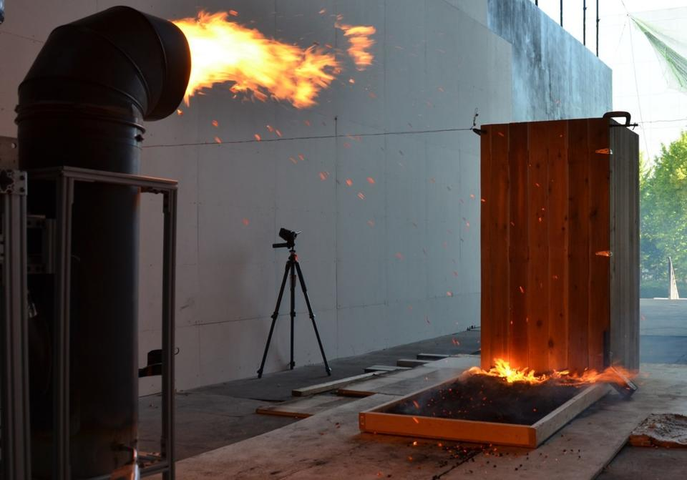
Figure 7: NIST firebrand generator showering a sample decking assembly in firebrands [24]
Most experiments using firebrand generators have focused on exposing building materials to a shower of firebrands to understand how these firebrands ignite structural components. Firebrand generators open the door for researchers to get a better idea of what buildings are up against in the event of a WUI fire. As experiments are conducted, there will be more opportunities to compare the firebrands from the generator to those from real wildfire scenarios. Firebrand generators with adjustable wooden fuel feed rates, wind speeds, and initial flaming ignition intensities, can adjust their outputs to result in a range of sizes of firebrands. Future research is expected to address this, as it could lead to a more accurate representation of firebrands from both structural and vegetative fuels.

2.4: Measurement of Firebrands
There are many methods of measuring firebrand temperatures that have been implemented in previous research. One robust method being “color-ratio pyrometry” (CP) which is possible with digital color cameras which are significantly more affordable compared to infrared cameras. This allows the user to measure the intensities of the red and green light and then calculate the surface temperature [25].
Firebrand motion has been measured using various methods which relate the firebrand location in an image to the lab reference frame. These can include simple video footage [26] or stereo-camera imaging of laser-illuminated firebrands [27]. For this work, we will be measuring firebrand size and velocity using similar methods to those used in a previous study [25].

Section 3: Design and Build Approach

3.1 Design Requirements
The key requirements for the firebrand generator in the development process have been as follows:
- The design must be readily adaptable to various firebrand fuels and experimental locations and procedures
- The design must be composed of readily accessible and inexpensive materials, with a total cost under $2000.
- There must be an option for a continuous feed of firebrand fuels into the generator.
- The wind speeds in the generator must be predictable and adjustable.
- The burner intensity must be adjustable.
The firebrand generator was developed and built based on initial models, but with adaptations to be inexpensive and highly modular, keeping each subsystem separate for ease of improvement and transportation. With a few hex keys and screwdrivers, the generator can be broken down in less than 10 minutes to smaller, more manageable pieces. The generator is composed of inexpensive components that provide effective structural and functional support, while keeping the overall cost to build low. A new feeding mechanism was designed to provide a continuous feed into the generator, so feed rate can be controlled more easily. Flow speed within the generator is controlled by a fan and the burner intensity is adjustable based on the flow of propane entering the burner. These elements allow experimenters to simulate a wide range of desired wildfire conditions. Further research into the effects of firebrands on structures or vegetation will be possible with this generator.
It is expected that the feed rate, burner intensity, and windspeed will be preemptively set but in cases where constant control is desired, all variables for firebrand production in the generator should be available for manual control on the fly. Minor adjustments were made to dimensions and connections, but the initial design of the main body remained relatively unchanged between the design and building phases. A render of the main body in SolidWorks is included in Figure 8, and a picture of the initial assembly of the main body is included in Figure 9.
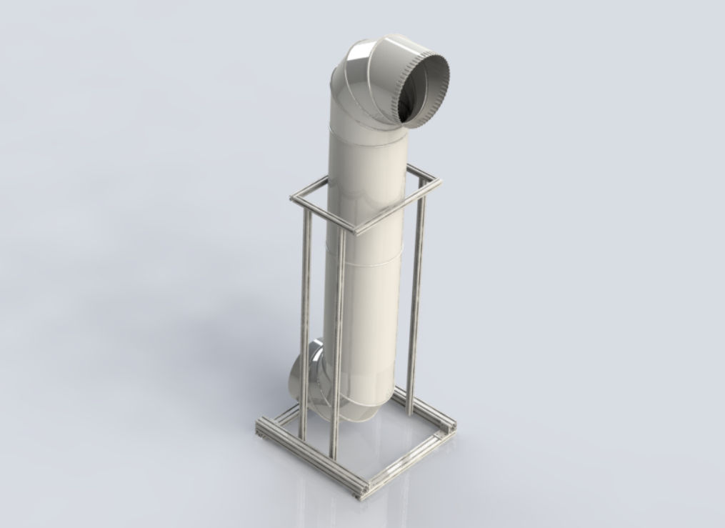
Figure 8: SolidWorks render of the main body of the firebrand generator
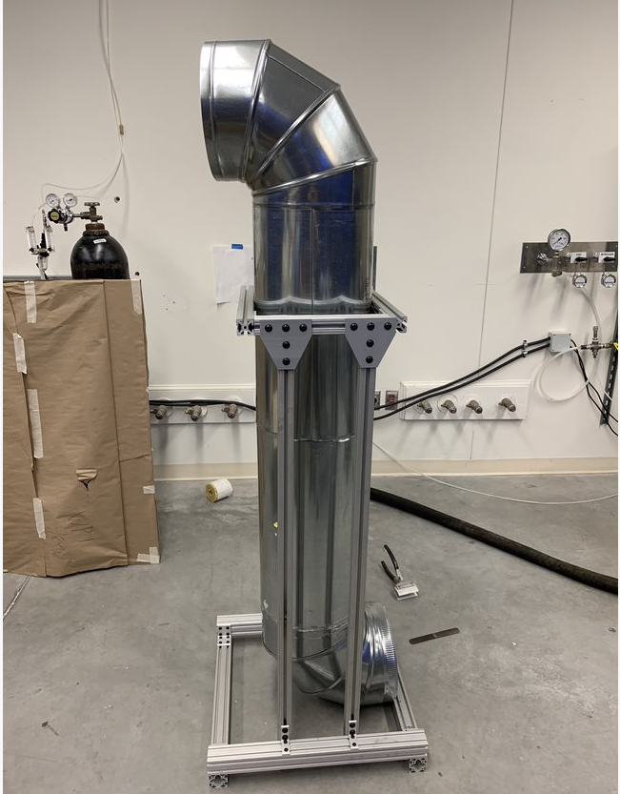
Figure 9: Initial construction of the main body of the firebrand generator

3.2 Design critical sub-systems
The generator can be broken down into three main sub-systems. The main parts are the central structure, the burn chamber, and the feeding mechanism, as outlined in Figure 10.
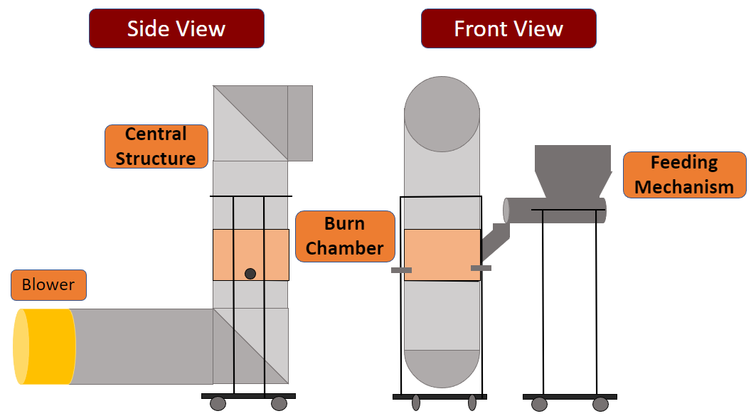
Figure 10: Schematic of the firebrand generator and critical subsystems
The main structure and blower are used to push air through the system and guide the firebrands out the front of the generator at a set speed. The feeding mechanism is a subsystem outside the main duct that drops a constant flow of feed into the burn chamber. The burn chamber is composed of one section of the main duct that includes a burner and a mesh basket to hold the feed in place. The flow of initially cool air then hot air and firebrands out through the generator is outlined in Figure 11.
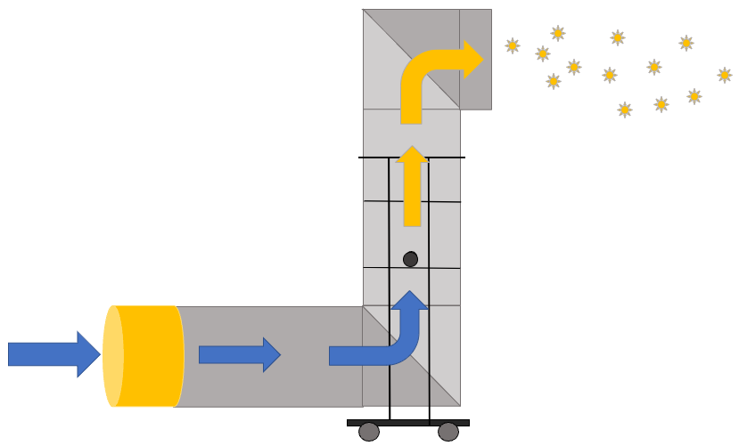
Figure 11: Airflow diagram for the firebrand generator

Each of these systems has a set of critical features that have been carefully selected to achieve the design objectives. Additionally, each sub-system is generally independent of the other and can be removed from the full assembly with minimal time or effort. The full assembly as it has been built to this point is included in Figure 12.
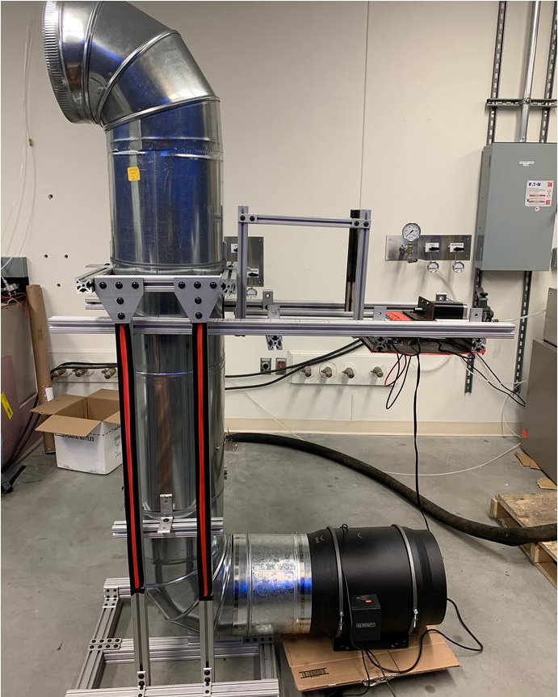
Figure 12: Fully assembled firebrand generator

3.3 Building and Development

3.3.1 Framing and Central Structure
The main structure consists of a base made of 80/20 aluminum framing. There are four supports rising from a square base of 2” quad 80/20. crossbars in the middle and at the top of these supports have mounts for the galvanized steel ducts to be held in place. The upper support and mounts are shown in Figure 13.
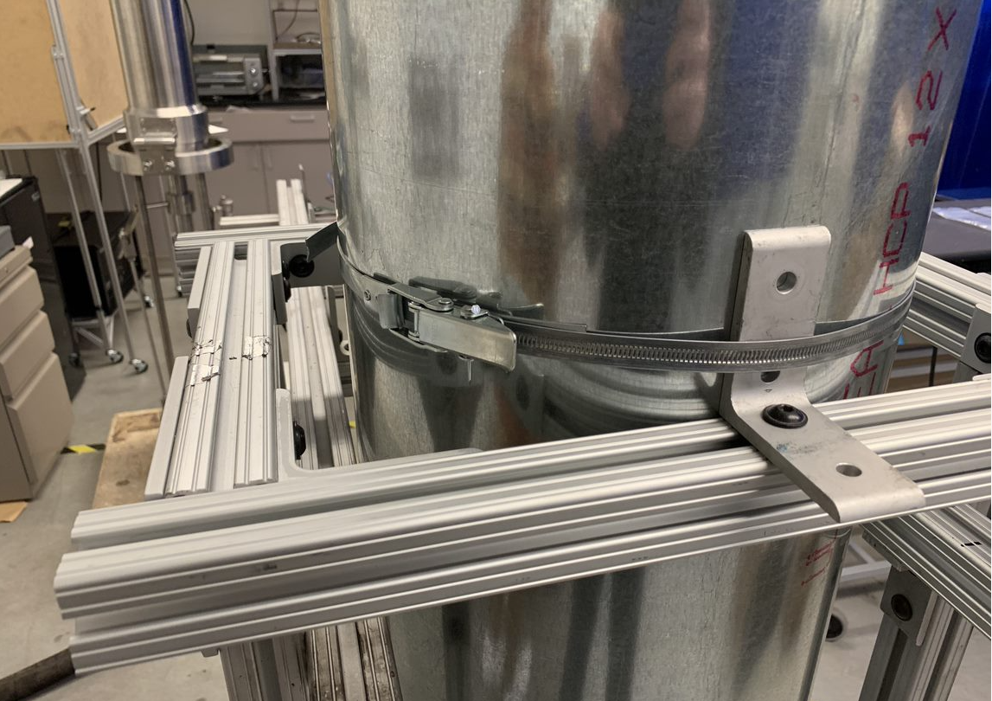
Figure 13: Upper support and duct mount
The middle crossbars hold the burner while the upper frame supports the feed system. There are five main duct components: a reducer from the fan to the generator duct, two 90-degree angles and two 2-ft straight sections, all connected male to female to not inhibit airflow. The straight ducts are secured to the mounts with worm-drive clamps, which have quick-release functionality for easy assembly and disassembly. The upper elbow sits directly on the top of the straight duct section with no additional support. The lower elbow is supported at the base with a short section of 2-inch 80/20, which can slide into of place to secure the duct, as shown in Figure 14.
Figure 14: Bottom elbow duct support

3.3.2 Burn Chamber
The lower 2-foot section of straight-duct houses the burn chamber which can be easily removed for modifications and maintenance between tests. This section of the generator consists of a ring-burner (and all subsequent parts for propane supply), as well as a mesh basket to hold the burning feed. The interior of the duct houses the ring-burner, with the basket secured directly above to keep feed as close to the flames as possible. Initially the feed would settle into the middle of the basket, and the convective cooling from the windspeed overcame the radiative heating from the burner, making our first tests result in a pile of unburnt feed in the generator. To rectify this, we made a small pyramid out of perforated sheet to keep the feed along the edge of the basket, so the burner flames were in direct contact.
Outside of the duct, the propane line to the burner connects to a propane tank with a series of valves and connections. A hose with a gauge and valve connects to the tank to provide control over the flow of propane. Finally, a set of adapters connect the mixer to the burner to complete the system. All components that would be used with a wall connection are rated to handle 50psi, allowing both in-lab wall connection, or stand-alone propane tank propane supplies.
After testing, it was found that the liquid-propane-air mixer was unnecessary as the windspeed in the generator produced just as clean of a burn without the mixer. Some adapters were removed from the final design which is reflected in the final budget in Appendix B: Total Generator Parts and Costs. Additionally, the feed would initially settle into the middle of the basket, and the convective cooling from the windspeed overcame the radiative heating from the burner, making our first tests result in a pile of unburnt feed in the generator. To rectify this, we made a small pyramid out of perforated sheet to keep the feed along the edge of the basket, so the burner flames were in direct contact.
The burners are lit using a piloted ignition mechanism (torch). A small opening is provided to allow the ignition source to start the burners. A diagram of the burn chamber is included in Figure 15.
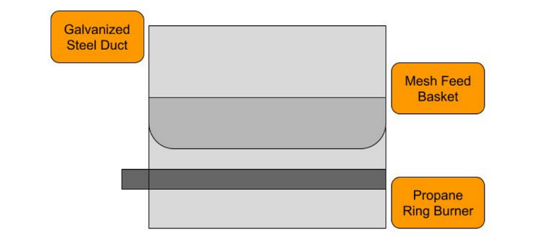
Figure 15: Burn chamber inside the firebrand generator

3.3.3 Feeding Mechanism
The feeding mechanism design was developed with the intent to provide a continuous flow feed into the burn chamber. Additionally, the feed rate is intended to be adjustable to account for a range of potential scenarios. A screw-hopper mechanism was chosen for this task. A hopper holds the feed for the test while a stepper motor drives a screw directly below the hopper. Feed is pushed into the main generator through an opening in the upper portion of straight duct. The screw is aligned horizontally to prevent any of the fuel from sliding out when not intended. The hopper was initially planned to be constructed with custom-cut sheet metal. To limit costs and maximize simplicity, this design was replaced with a segment of a duct reducer feeding into a T-shaped segment of duct, which is then connected to a straight segment of duct. This may be upgraded in the future to hold more feed for longer experiments.
The building and development of this sub-system has proven to be a challenge for a few reasons. The initial plans for controlling the generator involved a raspberry pi, which outputs its signal at 3.3V. The stepper motor controller requires a 5V pulse to work properly. A circuit involving a transistor was designed to supply the necessary 5V to the controller, however this proved to be ineffective. To achieve basic functioning for the motor, an Arduino Uno rev. 3 was installed in place of the raspberry pi. This unit outputs 5V to the controller, which is sufficient to move the motor. The Arduino provides control over the rotation speeds comfortably for any speed of feed that will be required for fire tests, but it declined in performance when any interactive features were added. This means that while the controller spins the motor with a high degree of accuracy, it is not as easily adjustable as the raspberry pi would be. The code currently used to control the stepper motor with the Arduino is included in Table 1.

Table 1: Arduino code to control the stepper motor
int rotationSpeed =50; // Rotations/min
int rotationSteps = 400; // Steps/Rotations
int stepsMin = rotationSpeed*rotationSteps; // Steps/min
float D = (60000/stepsMin) ; // ms (60000000/stepsMin)

void setup() {
#define pul 13 // Pin 13 controls the pulse/steps
#define dir 12 // Pin 12 controls the direction of the motor

pinMode(pul, OUTPUT);
pinMode(dir, OUTPUT);
digitalWrite(dir, HIGH);
}

void loop() { // Continuous pulse at the set delay
digitalWrite(pul, HIGH);
delay(D);
digitalWrite(pul, LOW);
}
Initial testing with feed into the hopper, and by extension the duct with the feed screw, resulted in some of the feed falling back behind the screw, which at best causes some inaccuracies with the amount of feed in the generator, but can also cause jams, stopping the feed completely. This problem was addressed with a simple metal disk that was installed directly at the back end of the feed screw. This means that feed cannot travel anywhere beyond where the feed screw will be able to push it out of the generator.
The feeding mechanism was initially designed to be a separate structure from the main generator; however, this has been changed to reduce costs and decrease complexity. Two horizontal 80/20 bars are secured to the vertical supports of the main structure. Additional 80/20 was used along these bars to create a deck for the feeding mechanism to sit on. The whole assembly sits securely in place, but it can also be quickly removed. There is also a small tray below the stepper motor so the power supply, stepper motor controller, and Arduino can sit close to the motor, which limits the number of extended wires on the exterior of the generator. The tray, including the power supply, Arduino, and stepper motor controller, is shown in Figure 16.
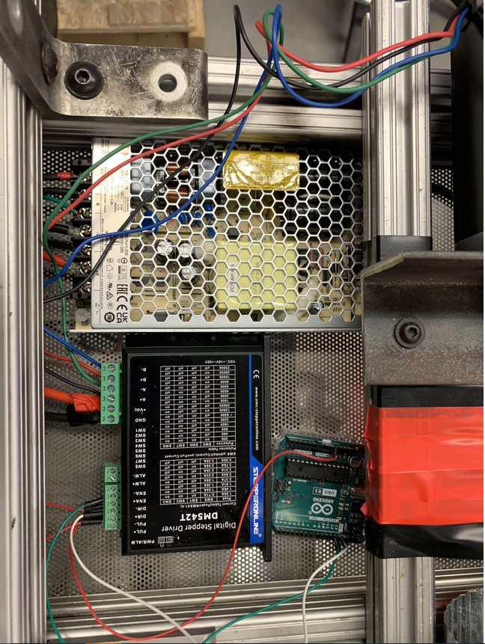
Figure 16: Power supply and control devices for the stepper motor
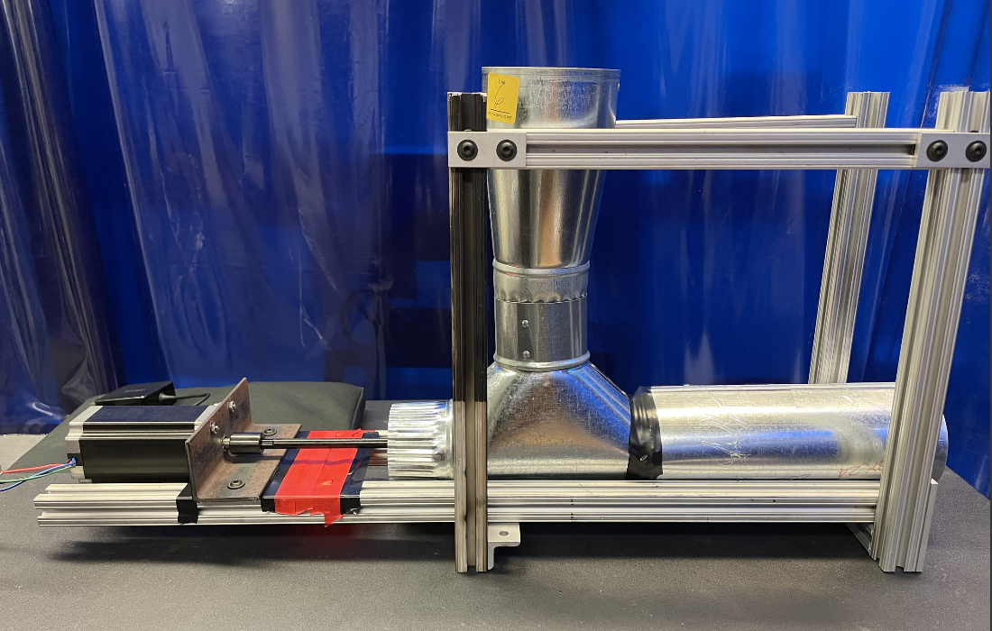
Figure 17: The assembled feeding mechanism

Once testing began with wooden feed, it was found that a buildup would occur just before the outlet of the T which would cause the screw to jam and spin the feed system itself out of place. Attempts were made at partial fixes with the T, but it was found to be more difficult than a more thorough redesign. The closed T-duct and straight duct were replaced by one longer piece of open duct shaped in a U, with the bottom diameter the same 3” as the original system. A hole was drilled through the upper part of the hopper, in which a dowel was placed to secure the hopper to the 80/20 at the top of the feed subsystem. This allowed the hopper to have adjustable height and the ability to rotate, which gave the flexibility to move if a jam was occurring below while still allowing the hopper to increase the capacity of the system.

3.3.4 Blower Setup
The blower is needed to carry firebrands out of the generator and into the wind tunnel to be analyzed. The goal for the blower is to simulate a range of windspeeds within the generator. Initial planning for the blower required adjustments to the fan to be achieved using a variac, which would modify the AC voltage into the fan, and therefore the fan speed. Our approach was modified to instead use a blower with 8 variable preset speeds. The maximum flow speed measured around 10m/s, but regular operational speed is expected to be less than that, at approximately 4m/s. The selected fan for this is a variable blower with a max flow rate of 1604 cfm. This blower is connected to a short reducer, which fits around the bottom elbow duct of the main body. Speeds can be varied using a controller that is wired directly to the blower. Figure 18 includes a picture of the blower selected for the firebrand generator.
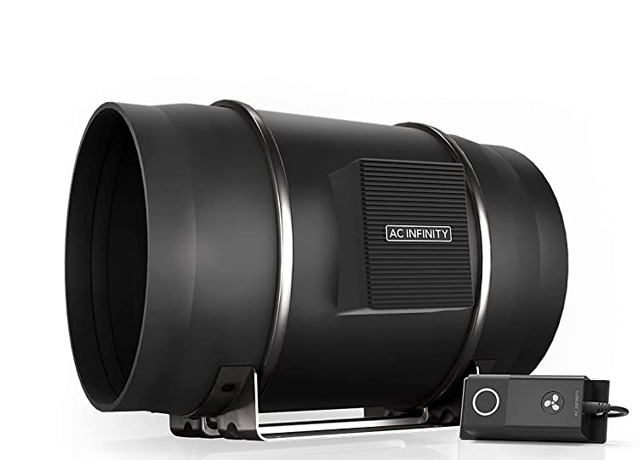
Figure 18: 1604cfm adjustable blower for the firebrand generator
During testing it was found that the blower will shut off if it gets too hot. When running a production test at the lowest windspeed and with the highest burner intensity, the radiative heat from inside the ducting caused the motor in the fan to heat up and subsequently shut down. This further exacerbates the problem as the blower helps to push the hot convective gases away from itself. In subsequent tests a thermocouple was attached to an inner metal panel to monitor the temperature of the blower, and all tests that were deemed harmful to the blower with no benefit of producing firebrands were cut from the test matrix

3.4 Budget
There are three main groups of parts associated with the generator: structural, functional, and experimental. Components were chosen from reliable suppliers with reasonable costs, shipping times, and inventory. A full bill of materials for the generator is included in Appendix A. The total costs for the generator, assuming a 20% buffer, is around $1800. This accounts for all materials up through running experiments. The main construction components of the generator are expected to last for as long as the generator is needed, but should there be any issues, most can be replaced easily without much modification. The only expected ongoing costs associated with the generator will be propane, and feed to run experiments.

Section 4: Testing Procedures

4.1 Calibrating the Generator Components

4.1.1 Flow Speed Tests
The fan used for the generator has eight preset speeds. A relation was created between the fan setting and the flow speeds measured from the generator. These measurements were taken during cold tests where the burner was not being run. This section outlined the procedures and results of the wind speed tests.
Materials:
- Firebrand Generator (with fan)
- Anemometer
Procedure:
- The anemometer was placed just above the burn chamber in the center of the ducting, with the top sections of the generator removed.
- The fan was turned on and set to the lowest speed.
- Readings from the anemometer were recorded once they stabilized on a single number.
- The flow speed setting on the fan was increased to the next setting.
- Steps 3-4 were repeated until fan speeds were recorded for each of the eight fan settings.
- Steps 2-5 were repeated with the anemometer positioned at the end of the fully assembled generator after the top elbow duct, again positioned in the middle of the duct.
Table 2: Generator windspeed test results
Fan Setting | Above Basket - Top Open (m/s) | Outlet of Generator - Fully Assembled (m/s) | Average (m/s)
1 | 2.6 | 2.6 | 2.6
2 | 3.8 | 3.8 | 3.8
3 | 4.8 | 4.9 | 4.85
4 | 5.5 | 5.8 | 5.65
5 | 6.6 | 6.8 | 6.7
6 | 7.7 | 7.8 | 7.75
7 | 9 | 9 | 9
8 | 10.3 | 10.5 | 10.4

4.1.2 Burner and Unit Ignition Tests
Tests were conducted with only the burn chamber before the firebrand production tests. These tests were conducted to develop safe and consistent procedures, while also evaluating the behavior of the flames in the burn chamber, as it may have an impact of the firebrands produced.
Once the burner was assembled, it was tested through incremental steps to ensure that the ignition and continued burning could be carefully observed. An initial bench test was used to check for any propane leaks in the burner and to understand the sensitivity of the burner controls. The basket was then placed over the burner to confirm ignition would occur. From there, the burner was added to one section of the generator and ignition was confirmed without wind running through the generator. Low flow was then added, and ignition was confirmed before finally adding the top section of the generator and igniting the burner with wind running. These steps of tests ensured that there was high confidence in the safety and effectiveness of the ignition procedures. The unit tests are summarized in the list below.
- Bench test with only propane tank and burner
- Bench test with basket and burner
- Test with basket and burner in bottom section of the generator (no wind)
- Test with basket and burner in bottom section of the generator with wind
- Test with basket and burner in fully assembled generator with wind

4.1.3 Burner Ignition and Shutdown Procedures
The following set of procedures have been outlined to ensure safety and consistency during the ignition and starting tests.

Firebrand Test Burner Procedures
- Position torch under the burner, pointing at outlets of burner
- Turn on torch
- Open propane valve(s)
- Confirm ignition of the burner
- Turn off torch and remove

Ignition Failure Procedures
- If ignition does not occur within 10 seconds of the propane being released, close the propane valve immediately.
- Continue to run the blower at low speed for approximately 20 seconds.
- Perform a full system check on the burner and associated connections/tubing.
- Restart ignition procedures.

Shutdown Procedures
- Turn propane off
- Turn blower up to high speed (Setting 8)
- Leave blower on for at least 60 seconds after the last firebrand exits generator, or until it can be confirmed that everything is completely cooled down and no burning or smoldering is occurring in the burn chamber.
- Turn off blower and wind tunnel
- Clear to enter wind tunnel, be careful with potentially hot elements

4.2 Firebrand Production Tests
Once the firebrand generator was fully assembled, tests were required to determine what conditions would produce the most reasonable firebrands for our studies. The size of the feed, the intensity of the burner, and the speed of wind in the tunnel were the main factors expected to impact the characteristics of the firebrands. A test matrix was developed to investigate the impact of each of these factors on firebrand generation.
Table 3: Firebrand production test matrix
Test | Fan Speed | Burner Intensity | Feed Size
1 | Low | Low | Small
2 | Low | Low | Large
3 | Low | High | Small
4 | Low | High | Large
5 | High | Low | Small
6 | High | Low | Large
7 | High | High | Small
8 | High | High | Large
These parameters are defined loosely in the test matrix to maintain simplicity and allow for adjustments based on any new information. It is difficult to define burner intensity in any measurable terms, however the fan speed and feed size have been defined more specifically below in Table 4.
Table 4: Firebrand production test matrix parameter definitions
Parameter Definitions: | High | Low
Fan Speed | 6.7 m/s (5) | 2.6 m/s (1)
Burner Intensity | High | Low
Feed Size | 3/4 in | 3/8 in
The feed size refers to the diameter of the dowels being used, which were cut such that they have an aspect ratio of approximately 2. The fan speed specifies both the approximate wind speed and the fan setting that would be required.
The evaluation of results focused on three main characteristics of the output from the tests. First, it is important to ensure that firebrands are being produced at all. If no firebrands are being produced at a given set of parameters, one or multiple parameters may need to be adjusted. The next important focus is on whether the firebrands are flaming or glowing as they come out of the generator. Glowing firebrands are desired, as this has been identified as a more accurate representation of firebrands produced in the wildfires we aim to replicate. Finally, the sizes of firebrands were considered in terms of the projected areas. It is important to understand how each parameter affects the size of the firebrand, as information on the effect of firebrand sizes may be important to understand for tests on construction or other materials in later experiments. This will also be important to ensure the repeatability of tests with a given firebrand size in the future.

Materials:
- Firebrand Generator
- Wooden Dowels (3/8 in and 3/4 in diameter)
- Camera
Procedure:
- The camera was put in place, turned on, and a horizontal/vertical scale had been shown to calibrate post-processing programs (if used).
- The burn chamber was ignited by following the procedures outlined in 4.1.3 Burner Ignition and Shutdown Procedures
- The fan and burner were adjusted to the desired settings incrementally to avoid blowing out the flames.
- The feeding mechanism was turned on to start moving the feed into the generator.
- The firebrands were observed as they were generated, and results were evaluated based on the criteria above.

4.3 Firebrand Analysis Tests
Once the desired firebrands were produced from the generator, analysis was conducted to understand some of the properties of lofted firebrands. The scope of the project focuses on the speed of the firebrands being produced, which was achieved using camera tracking techniques outlined in 4.4 Firebrand Post-Processing Procedures. Additionally, some firebrands were collected in water pans and their projected area was measured. The procedures for the camera analysis tests are included below.
Materials:
- Firebrand Generator
- Wooden Dowels (3/8 in diameter, 3/4 in length)
- Camera
- Water Pans
Procedure:
- Water pans were positioned on the ground 2-3 meters in front of the generator.
- The camera was set to point directly perpendicular to the firebrand generator and was turned on.
- A large measuring device (carpenter square) was held in front of the wind tunnel in the frame of the camera for a few seconds.
- The burn chamber was ignited by following the procedures outlined in 4.1.3 Burner Ignition and Shutdown Procedures.
- The fan and burner were adjusted to the desired settings (fan speed 4, relatively high intensity burner) incrementally to avoid blowing out the flames.
- The feeding mechanism was turned on to start moving the feed into the generator.
- The firebrands were observed and recorded as they were generated.

4.4 Firebrand Post-Processing Procedures
The firebrands were analyzed using a MATLAB code that measured the lengths of the streaks recorded by the camera and calculated the velocities of the firebrands from those lengths. This was done by comparing the exposure time of the camera to the length of the streak. This indicates the distance traveled over time, which is the velocity of the firebrand.

The lengths of the streaks were manually measured in MATLAB by manually clicking both ends of the streak. These pixel measurements were translated into lengths using a length scale from the video, and then translated into velocity using the exposure time. The MATLAB code for the analysis of the firebrands is included in Appendix C. An example of firebrand measurements in a single frame is shown in Figure 19.
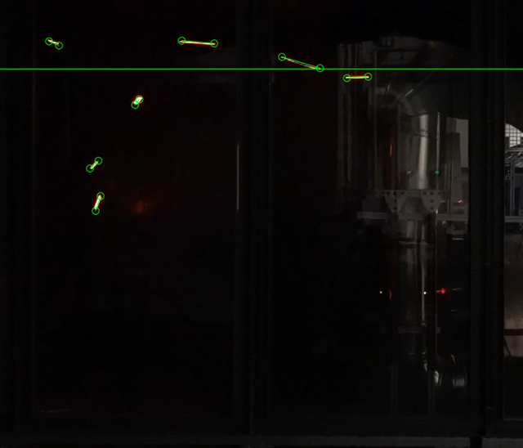
Figure 19: Example of firebrand streaks being measured using MATLAB
The projected area of firebrands collected in water-pans was analyzed after developing a MATLAB script. After the experiment had been shut down and cooled off, firebrands were carefully retrieved from the water-pans and placed on paper towels to dry. To accurately mass the firebrands, they were left to dry out for 3 days before any analysis was conducted. The mass of the firebrands was smaller than the precision of the scale, but the firebrands were still photographed with a length scale to determine the projected area in MATLAB. The code used for loading and processing the images of the firebrands to determine the area is included on the next page in Table 5.

Table 5: MATLAB script for the firebrand area calculations
%% ============= [STEP 0] =============================
% Written by Matthew Nicastro
% Based on code from James L Urban (Jurban@wpi.edu)
%
% For Major Qualifying Project: Firebrand Generator (2021-2022)
%
% no restrictions on use, adaptation, etc.
% ============================================

clear all
clc
close all

%% [STEP 1] - Setup of Picture
% video file (INPUT)

% pic_file_path = 'C:\Users\mjnbr\Documents\MATLAB\MQP\Firebrand Measurements\';
pic_file_path = 'C:\Users\mjnbr\Documents\MATLAB\MQP\Firebrand Measurements\'; % Don't forget the "\" at the end!
% pic_file = 'FB_X.jpeg';
pic_file = 'FB_23.jpeg';

i = imread(join([pic_file_path,pic_file]));

% INPUT: Reference Length-scale
Lx = 4; %cm

%% [STEP 2] Determine pixel length of length-scale

% By default brighten factor should be 1
Brighten_factor = 1;

close all
figure; hold on
title("CLICK ON the top and bottom of the length-scale")
ref_points = round(readPoints(i*Brighten_factor,2))';
hold off

%% [STEP 3] Determine the Size of the Firebrand

figure;
hold on

im = i(500:end-800,700:end-1500,:); % Set Frame - Get rid of any black surfaces (don't cut off the firebrand)
% Cut off:(top, bottom, left, right)
set(gcf, 'Units', 'Normalized', 'OuterPosition', [0 0 1 1]);

% Some black and white image processing magic
frame_gray = im(:,:,3);
threshold = graythresh(im);
frame_bin = imbinarize(im(:,:,3), threshold);
inv = imcomplement(frame_bin);

imshow(inv(:,:)); hold on
rp = regionprops(inv(:,:,1),'Area','BoundingBox');
[~,idx]=sort([rp.Area]); % Sort the regions by area - biggest is probably the firebrand
rp=rp(idx); % Actually sort them

bb = vertcat(rp.BoundingBox);
BB = bb(end,:);

% Draw rectangular bounding box around firebrand
rectangle('Position', [BB(1),BB(2),BB(3),BB(4)],'EdgeColor','r','LineWidth',2) ;
% Confirm that the box is around only the firebrand

%% [STEP 4] Calculate Firebrand Area

% Translate pixels to lengths
dx_pixels = max(ref_points(:,1)) - min(ref_points(:,1));
x_pixel_scale = Lx/dx_pixels;

% Calculate the area of the largest dark object in the frame (the firebrand)
FB = rp(end,:);
FBap = FB.Area;
FBa = FBap*x_pixel_scale^2; % Area in cm^2

% Output the calculated firebrand area
disp("The area of the firebrand is: "+ FBa(1,1)+"cm^2");

Section 5: Results and Discussion
Once all the tests were completed, analysis was done on the firebrands generated in the two main tests with the specified configuration described in Section 4: Testing Procedures. The analysis employed multiple MATLAB scripts to analyze the videos from the tests and the pictures of the firebrands collected in the water pans. Analysis was focused on the speed of the lofted firebrands as well as the size of the firebrands collected in the water pans.

5.1 Travel Speed of Firebrands Results
Using the MATLAB script outlined Appendix C, 281 streaks, and therefore firebrand velocities, were measured across the two filmed tests. The data from both tests are considered separately for this section of the results. Firebrand speeds were plotted onto a histogram, and the frequency of firebrands traveling within a certain range of speeds were tracked. Table 6 and Figure 20 include the results for test 1, while Table 7 and Figure 21 show the results for test 2.

5.1.1 Firebrand Test 1 Results
Table 6: Firebrand speed measurements summary table for test 1
Velocity (m/s) | Number of Occurrences
0-1 | 5
1-2 | 32
2-3 | 58
3-4 | 33
4-5 | 6
5-6 | 6
6-7 | 5
19-20 | 1

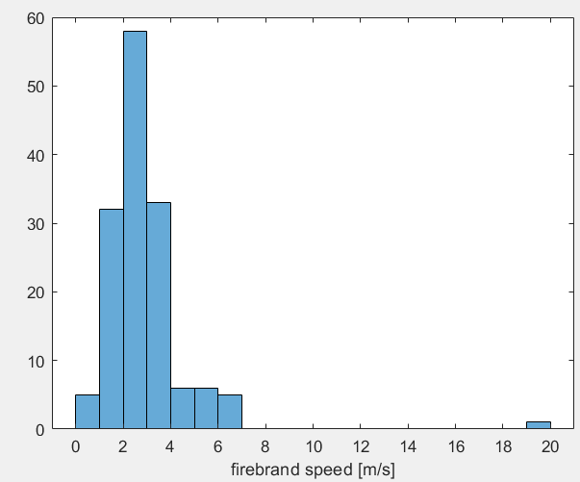
Figure 20: Histogram summarizing firebrand speeds for test 1

5.1.2 Firebrand Test 2 Results
Table 7: Firebrand speed measurements summary table for test 2
Velocity (m/s) | Number of Occurrences
0-1 | 7
1-2 | 31
2-3 | 54
3-4 | 20
4-5 | 13
5-6 | 9
13-14 | 1

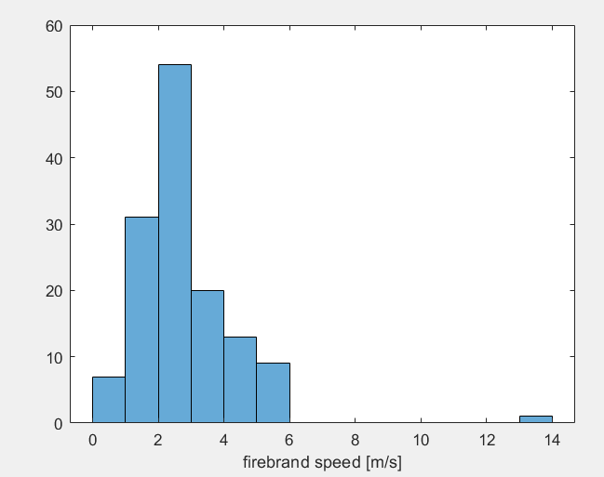
Figure 21: Histogram summarizing firebrand speeds for test 2

5.2 Discussion of Firebrand Travel Speed Results
The firebrand speeds across both tests appear to have a nearly symmetrical distribution around the most common range of firebrand speeds. Both tests clearly indicate that the firebrands were travelling between 2 and 3 meters per second most frequently. Almost 40% of all firebrand speed measurements taken were at 2-3 meters per second. The frequency of firebrands travelling faster than 3 m/s or slower than 2m/s is significantly less and continues to decrease as the speeds move away from the median.
Generally, the speeds of the firebrands were recorded to be between 0 and 7 m/s, however each test recorded one firebrand speed outside of this range. There are a few potential reasons for why these data points exist. The firebrands could have been accurately recorded going that fast, in which there was enough pressure and a small enough firebrand in a “perfect storm scenario.” Alternatively, multiple firebrands may have lined up perfectly, such that they appeared as a single long streak on the camera, and the speed was recorded as a single data point. There could have also been accidental measurements recorded in the MATLAB code that were not caught. It is the belief of the experimenters that this is the most likely reason for these unusual values, however further testing with the generator would be required to confirm this belief.
While relating the size of the firebrands to the speeds was outside of the scope of this project, some observations were made on their relation while recording the data. The size of the firebrand can be estimated by observing the thickness of the camera streak. Longer streaks, and therefore faster firebrands, were generally thinner, which would mean the firebrands in these cases were smaller. Smaller firebrands would be impacted more by the winds inside and outside the generator, and it would require less force to overcome the effects of gravity. This explains they were able to be launched out of the generator at faster speeds. These firebrands also cooled and stopped glowing much quicker in the tunnel, so less data was collected. This effect is shown in Figure 22. While this is not always the case, it is a common effect that can be observed while using the firebrand generator.
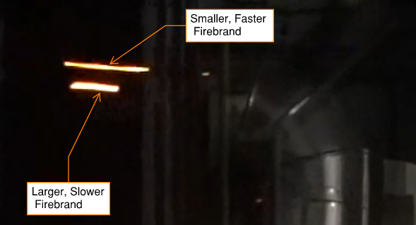
Figure 22: Comparison of the speeds of different sized firebrands
The results for firebrand speed are limited by a few key factors. First, the sample size of the firebrands is not enough to fully disqualify any outliers that are observed. This is not a significant issue as the trends are still clear but could be addressed with more tests and research. It is also difficult to accurately compare the speeds of firebrands due to varied factors contributing to the speeds based on where the firebrands are in their path of travel. Most of the horizontal movement of the firebrands is driven by the blower within the generator, with some smaller firebrands being lofted by the wind tunnel. After some travel, the main effects are due to gravity acting on the firebrand. Further research could be done by breaking down the velocity of the firebrands into x and y components to understand the wind and gravitational effects on a single lofted firebrand as it travels out of the generator and lands. Additionally, it may be beneficial to compare the speeds of all firebrands at a given distance away from the generator. These investigations would allow for more critical comparisons, rather than a summary of the speeds of firebrands, regardless of their location.

5.3 Size of Collected Firebrands
The firebrand area image processing MATLAB script was used to measure the area of each firebrand collected in the water pans during both firebrand tests. Figure 23 includes a picture of all collected firebrands from the test as they were drying.
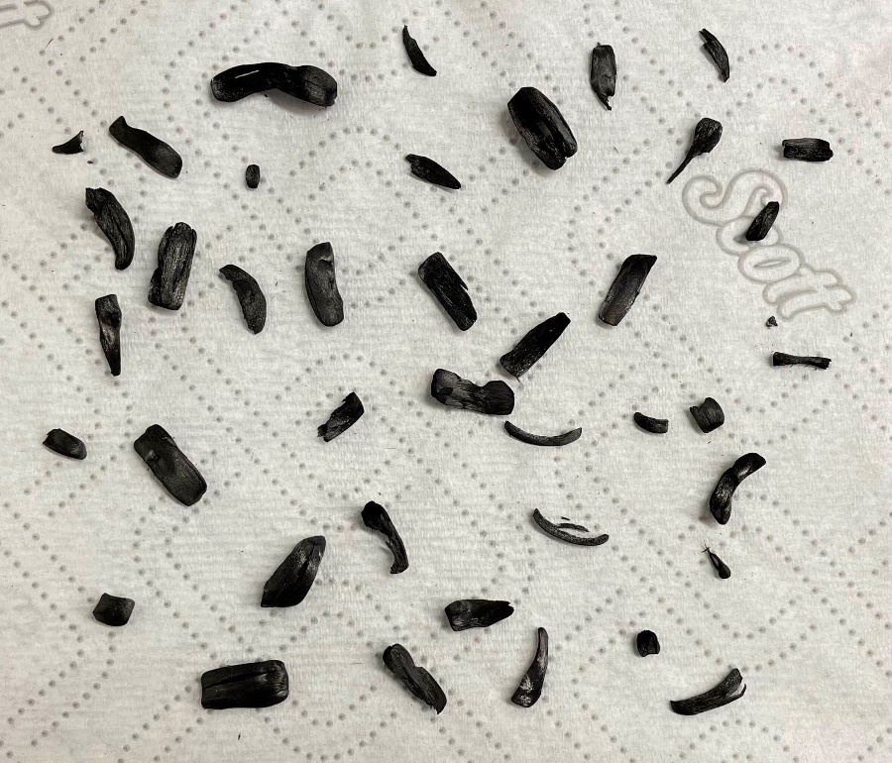
Figure 23: Firebrands drying after being collected in water pans
Across the two tests, 43 firebrands were collected. The data on each individual firebrand measured is included in Appendix D. The sizes of the generated firebrands were collected into a histogram shown in Figure 24.

Figure 24: Histogram summarizing the sizes of collected firebrands

5.4 Discussion of Firebrand Size Results
The firebrand projected areas measured from the two water pans set up across two tests ranged from 0.11 to 1.40 square centimeters. This is reasonable, considering the approximate projected area of the dowels used as feed for the generator is 1.815 square centimeters. The most common firebrands collected in the pans ranged from 0.11 to 0.40 centimeters, with almost half of the total firebrands collected in this range. The frequency of firebrands collected decreases as the size increases.
Further research would be required to gain a better understanding of the true size distribution of the firebrands produced by the generator. Based on these results, it can be concluded that of the firebrands that land in front of the generator, firebrands with less than a quarter of the projected area of the original feed are more common. It is much less common for firebrands larger than 1 square centimeter to be produced at the specified test conditions. This demonstrates the mechanisms of firebrand production, in which detachment occurs after sufficient burning, allowing firebrands to be lofted and carried by the wind. The firebrands in these tests must still burn enough to decrease their density before they can be lofted.
Firebrands smaller than 0.11 square centimeters were likely produced by the generator, but were lofted too far past the water pans, or were not properly retrieved after the tests. The water pans were arranged where the largest density of firebrands was observed to fall in previous tests, but these results do not show the complete summary of all firebrands produced. More water pans distributed across the space in front of the generator would be required to obtain a more complete idea of the size distribution of firebrands produced. The size of the firebrands could then be related to the distance from the generator more accurately. This is outside the scope of this project.
While these tests and analysis provide some understanding of the firebrands produced, and a clear trend towards smaller firebrands, further research will be required to draw significant correlations and conclusions. The process of collecting firebrands in water pans and analyzing them with the MATLAB script was effective and can be applied for further research. There is a small amount of inaccuracy from the script due to some sections of firebrands reflecting the light sources, resulting in pixels not being considered as part of the area of the shape.

Section 6: Conclusions and Recommendations

6.1 Conclusions
To address the growing threat of fires near the wildland-urban interface, a broader understanding of firebrands must be developed. Extensive research has been conducted to contribute to the design and development of a firebrand generator for more research into the properties of realistic firebrands. The generator developed during this project is expected to be used for more than the initial camera tests within the scope of this project. The generator can be used for future research into firebrand properties and interactions with structures. This may lead to innovations in structural fire resistance to wildfires, which could be completed as part of future MQP projects. Additionally, the framework for a simple and inexpensive firebrand generator could pave the way for more researchers to create similar generators. Eventually, firebrand generators may be used to conduct standardized tests for building materials. This project is one of the first steps towards further research at WPI, while also paving the way for more widespread use of firebrand generators in other labs.

6.2 Recommendations
The firebrand generator in its current stage of development is functional and adaptable, however, there are opportunities to improve the generator in the future. These recommendations are discussed in the following sections.

6.2.1 Controls
Implementation of a raspberry pi as the main controller of the generator would create opportunities to control more components of the firebrand production process in one place. Controls could be added to ideally automate windspeed adjustments, propane flow rates, and variable motor speeds without stopping the generator, but even just some of these would be a major improvement. This would require significant work to implement these features, but they would allow for more precise controls once enough testing and calibration is done.
The current controls could also use some improvements, namely the propane system. A hose with a regulator and a gauge was purchased to be able to read how much propane we were using and help make the tests more repeatable. The gauge proved to be completely ineffective, whether the pressure from the tank was too low to read, or the wind in the generator was creating an area of low pressure, “pulling” propane into the burn chamber. A volumetric flow meter would be the ideal replacement and allow for much more accurate repetition in testing.

6.2.2 Blower
The addition of a variac to control the fan would give more precise control over the flow speed in the generator. The fan currently has 8 pre-set speeds, which provide enough control for general firebrand production. A variac with more precise adjustments to the flow speeds would allow greater control over the conditions within the generator to better replicate different wildfire conditions. The minimum wind speed with the blower is around 2.2 m/s, which is quite high. Some firebrand tests have generated firebrands with speeds as low as 1 m/s or less in the generator. Ideally, a variac would offer a lower minimum flow speed to allow for testing with a wider range of speeds.
The blower also had some issues at higher temperatures, described in 3.3.4 Blower Setup. Solutions to this overheating problem include increasing the ducting between the blower and the bottom elbow, making the interior of the ducting non-reflective, or simply keeping the tests within reasonable parameters for blower operation. In any case, it is advised to attach a thermocouple to the front interior plate and monitor the temperature. During testing, temperatures on the front surface of the fan below 28°C were acceptable.

6.2.3 Burner
The Burner proved somewhat inefficient under larger loads. This worked for some tests but favored dropping feed on the same half of the generator as the feed system, again causing a build-up of unburnt feed. These piles of unburnt feed were due to the new feed covering burnt feed, so the potential firebrands were unable to fly out of the generator.
The perforated pyramid made a good quick fix, but this system needs more work to function efficiently and continuously. An updated burner with a line directly under the center of the basket would likely be able to burn feed from anywhere in the basket while allowing the airflow to remain relatively unaffected. This would eliminate the need for the pyramid and hopefully make continuous feed a reality, along with the capacity for larger feed loads.

6.2.4 Feed
Feed delivery proved more problematic than originally anticipated. The initial design caused frequent jams when using the smaller feed for our firebrand production. It was determined that this issue was mostly due to our tolerances. The auger would pinch feed on the side of the ducting, causing the feed system to catch and spin out of alignment. To fix this the closed duct was changed to an open U-shaped duct to allow any potential jams to simply move the auger up and out of the way temporarily.
The original design remade with tighter tolerances would theoretically work better than the current set-up, but either way some work needs to be done to improve the system. More stable supports for the feed system would likely improve the stability when the system jams and would improve the consistency that feed is dropped into the generator.
It was also found that flames from the burn chamber had the potential to ignite feed in the system. Flames would quickly spread across the feed in the screw, posing safety risks for the experimenters, and a substantial risk of damage to electronic elements of the generator. This was addressed by setting the feed system back from the generator and adding a 45° elbow connector to prevent most of the flames from reaching the feed in the delivery system. This was effective for a short-term fix, but further developments should be made to ensure the feed does not ignite during tests.

Appendix

Appendix A: Firebrand Generator Standard Operating Procedure

Start-Up Procedure
Check all safety measures are in place
- Main Hood is started up (Start-up time is approximately 10 minutes, so plan a bit ahead but do not run it if there is lots of set-up to do)
- Spray bottle of water at opening in the tunnel to the generator (more than half full)
- Some sort of temperature rated gloves with the bottle (welding gloves work well)
- Any highly flammable materials are moved clear of the openings of the tunnel
- Wind tunnel is all connected properly and there are no major openings unaccounted for
- Lab hose is turned on and ready to use (use to wet the floor under the wind tunnel if desired, ask lab manager)
Ensure all connections are properly secured
- Elbow is firmly seated atop the quad 80/20 to ensure it does not disconnect during testing
- Blower Is well settled in the reducer which is in turn well connected to the bottom elbow (a thermocouple attached to the inner plate is recommended to keep track of blower temperature)
- Check the burn chamber to be sure that the basket/burner is bolted into place and will not fall during testing (check perforated pyramid at this time)
- Check that all ducting is securely overlapping with the duct below it (straight duct 2x & top elbow)
- Check that hose clamps are clamped shut over the 80/20 elbow brackets (ideally with a locking pin but this is not required)
- Check that both screws on the auger/stepper connector are tightened with both the stepper and auger secured
- Check that all wiring is secured and functioning
- Check that auger is running at the desired speed (run the auger for a moment to ensure it will start at the desired feed rate)
- Check that the feed tube is flush to the duct at the feed inlet, so no feed falls out (or in the correct placement for the feed system configuration)
Pre-check test materials and variables
- Check that feed is properly loaded into the hopper/auger
  - pre-run the auger to load feed closer to the inlet to the generator if a quicker startup is desired
  - Additional feed is ready nearby if a larger load than the hopper capacity is desired
- Check propane levels (At the moment this is picking up the tank and estimating volume, ideally a tank fill gauge would give an accurate measure of this)
- Check that the propane is all securely connected (tighten well onto the tank)
  - If any connections on the generator have been disconnected recently, ensure they have Teflon and have been checked for leaks
- Check that any powered systems are plugged in and powered (charge the laptop running feed)
- Check that wind tunnel is on and set to the proper windspeed on both fans (Unless no wind is desired)
  - Plug in both fans
  - Click PU/EXT
  - Set desired speed and click SET to save
  - Select FWD or REV for direction to start the fans
Film testing checklist (Only if filming tests)
- Make sure the camera is charged (just charge during filming if possible)
- Ensure there is plenty of space on SD card (check film settings, if 4K is not necessary turn it down to save space)
- Make sure tripod is fully secured and camera is secured to tripod (cameras are expensive, this is an important step)
- Once film is rolling, hold up any necessary vertical/horizontal scales (carpenter’s T) and any necessary test notes (maybe a board with the current test variables being run)
Generator start-up procedure (Steps to begin a test once all steps above are complete)
- Turn on the fan at low speed (setting 1 or 2)
- Position torch under the burner, pointing at outlets of burner ring
- Turn on torch
- Open propane valve(s)
- Confirm ignition of the burner
- Turn off torch and remove
- Turn fan up to desired speed while turning up propane to ensure it does not blow out
- Set propane to desired setting
- When ready, begin feed/auger by connecting the Arduino
- Keep a close eye on all components of the generator to ensure nothing breaks (This should be done by all people present)
Ignition Failure Procedures
- If ignition does not occur within 10 seconds of the propane being released, close the propane valve immediately.
- Continue to run the blower at low speed for approximately 20 seconds.
- Perform a full system check on the burner and associated connections/tubing.
- Restart ignition procedures.

Shut-Down Procedure
- Turn propane off
- Turn blower up to high speed (Setting 8)
- Leave blower on for at least 60 seconds after the last firebrand exits generator, or until it can be confirmed that everything is completely cooled down and no burning or smoldering is occurring in the burn chamber.
- Turn off blower and wind tunnel
- Clear to enter wind tunnel, be careful with potentially hot elements

Emergency Procedures
Fan Shutdown (Overheating Likely)
- Shut off propane to burner immediately
- Shut off feed
- Check thermocouple if attached and make note of temperature
- Turn fan down to setting 1 or 2
- Once the fan starts running again, slowly turn up avoid overheating again (If it starts up too fast the motor will overheat itself and it will shut down again)
- Keep in mind firebrands may exit the generator if the fan begins running again so keep the tunnel/test area clear
- Once the fan has cooled down (currently 27°C is known as good) decide whether to simply start the test back up or restart/start new test
Start Back Up
- Fan on
- If a substantial fire is burning in the chamber, you may attempt slowly turning the propane back on without the aid of a blowtorch (we recommend a windspeed setting of 2-4)
  - Only attempt for 3-5 seconds before stopping and starting again using a blowtorch
- Start feed back up when desired (If not much is left in the chamber it can be started immediately, or wait for the feed to burn down a bit)
- Continue Testing
Restart/Start New Test
- Fan on or off (“on” will likely spray some firebrands, keep tunnel/test area clear)
- Ensure burner and feed are shut off
- Wait until fire burns out then run normal generator shut-down procedure and start up procedure

Feed Jam
- If the feed system if moving out of place stop immediately and follow Major Jam procedure, otherwise start with Minor Jam
- If system moved a large amount and appears difficult/dangerous to fix, skip straight to shut-down procedure
Minor Jam
- If deemed safe, attempt to unjam with a gloved hand and a poking implement (for poking feed) or lightly shaking (if not too hot and gloved, reaching in is okay but the feed should be off)
- If this does not fix the jam, follow Major Jam procedure
Major Jam
- Stop the feed/auger
- If deemed safe, take a closer look to determine the severity of the issue (gloves on, poking implement in hand)
- Attempt to fix the issue if possible
- If still jammed, follow shut-down procedure

Fire in the Feed System
Preemptively: If flames are coming out of the feed inlet, consider turning down the fan and burner to avoid this

- Immediately turn off Blower
- Turn off Burner
- Feed can be stopped, or continued to push burning debris into generator, if the latter, focus on step 4
- Keep a careful eye on electrical components and any other flammable/damageable components
- Spray fire with spray bottle (gloves on)
- If fire is difficult to put out just focus on step 4 and let it burn down
- Follow shut-down procedure

Clean-Up Procedure
Leaving Generator Out
- Follow full shut-down procedure
- Disconnect propane tank and disconnect blowtorch head from smaller propane tank and put in flammables storage (may smell some propane, this is left over from the hose)
- Remove remaining feed from the feed system (simply run it with a container to catch feed)
- Unplug all electronics (Just turn off the power strip if using one)
- Remove upper hose clamp and ducting and clean out basket/ensure nothing is actively burning (if not done already)
- Safely store any feed, and put away any tools used/out for testing
- Clean the testing area
  - Sweep firebrands away (ensure they are extinguished)
  - Do a final sweep for any leftover tools/stuff
  - Turn off camera if not already done and put away
    - Save necessary files from the SD card
    - Pack up the tripod
    - Put the lens cap back on
    - Charge the camera
  - Check with a lab manager that everything is all set and to shut down the hood
Full Storage
- Follow the steps above
- Fully disconnect the propane hose (unscrew last fitting from the generator [SAE threading with an O-ring/no Teflon])
- Pull blower and reducer off the bottom elbow
- Set up a dolly next to the tunnel to place the generator (Can be carried but a dolly is recommended as it is much easier)
- Lift generator (bottom elbow, bottom duct, empty feed system) The stepper is heavy so take care to hold the feed system (the generator will rotate if not held properly and the feed system could fall and be damaged)
- Bring the generator to its desired storage location (remove from dolly if needed)
- Bring all remaining parts to the storage space (If space permits, reassemble the generator partially, like reattaching the upper ducting, etc.)
- Clean the testing area (Steps noted above)

Appendix B: Total Generator Parts and Costs
Item | Quantity | Price per | Price
Main Generator Ducts
90 Degree, 12" Diameter Duct | 2 | $56.04 | $112.08
Open 2ft Length, 12" Diameter Duct | 2 | $32.88 | $65.76
Quick-Release Duct Hose Clamp, 11-3/8" to 13-1/4" | 2 | $18.70 | $37.40
Frame
Extended Double Width Corner Brackets, 2" x 2" | 4 | $10.64 | $42.56
Extended Single Width Corner Brackets, 1.5" x 3" | 16 | $8.43 | $134.88
Single Width Corner Brackets, 1.5" x 1.5" | 10 | $7.78 | $77.80
Surface T Bracket for 1.5" Rail | 4 | $12.32 | $49.28
Surface Bracket, 4" Long for 1" High Single Rail | 5 | $8.16 | $40.80
Surface Bracket for 20 mm High Rail, 1.5" Long | 4 | $8.46 | $33.84
90 Degree Surface Bracket for 20 mm High Rail | 2 | $12.53 | $25.06
Extended Bracket for 20mm High Rail, 40mm Long | 2 | $12.01 | $24.02
1.5" Single 80/20, 10ft | 4 | $93.80 | $375.20
2" Quad 80/20, 10ft | 1 | $116.03 | $116.03
20mm Single 80/20, 10ft | 1 | $28.79 | $28.79
20mm Single 80/20, 3ft | 1 | $10.90 | $10.90
Fan
Reducer, 315mm-12", Length: 8-1/2" | 1 | $30.00 | $30.00
Fan | 1 | $222.95 | $222.95
Burn Chamber
9.5" Diameter LP Ring Burner | 1 | $17.99 | $17.99
Propane Line with regulator and gauge | 1 | $31.91 | $31.91
Grill Basket | 1 | $10.48 | $10.48
Hex Reducing Coupling: Brass, 1/2" x 3/8", FNPT x FNPT | 1 | $22.43 | $22.43
Reducing Adapter: Steel, 1/2" x 1/4", FNPT x MNPT | 1 | $34.37 | $34.37
5/8"-18 SAE/UNF x 3/8" NPT Adapter | 1 | $8.99 | $8.99
3/4" MNPT x 3/4" MNPT Adapter | 1 | $9.58 | $9.58
High-Temp RTV Sealant | 1 | $4.97 | $4.97
Feed
Arduino Uno Rev 3 | 1 | $23.99 | $23.99
Open 2ft Length 3" Diameter Duct | 1 | $14.69 | $14.69
NEMA 23 Stepper Motor | 1 | $39.99 | $39.99
4" to 3" Hopper | 1 | $18.84 | $18.84
36V DC Switching Power Supply | 1 | $20.90 | $20.90
Stepper Motor Driver | 1 | $28.99 | $28.99
3"x24" Auger Drill Bit | 1 | $27.99 | $27.99
Set Screw Shaft Coupling | 1 | $13.46 | $13.46
15-Feet USB 2.0 A Male to B Male 28/24AWG Cable | 1 | $5.67 | $5.67
Total: |  |  | $1,762.59

Appendix C: MATLAB Code
Firebrand Clicking (Streak Tracking and Pixel Data)
%% ==========================================
% Written by James L Urban (Jurban@wpi.edu)
%
% no restrictions on use, adaptation, etc.
% ============================================

clear all
clc
close all

%%
len_scale_video_file = 'Test 2';
v_len = VideoReader([len_scale_video_file '.mp4']);

% INPUT! ==============================
length_scale_frame = 200;
horiz_scale = 406.4; % [mm]
vert_scale = 152.4; % [mm]
% =====================================

%%

frame = read(v_len,length_scale_frame);
figure; hold on
title("Horizontal lengthscale - Click 2 points")
dx_pts = round(readPoints(frame,2))';
hold off

dx = abs(dx_pts(1,1) - dx_pts(2,1));
pix_2_mm_x = horiz_scale/dx;
%%

frame = read(v_len,length_scale_frame);
figure; hold on
title("Vertical lengthscale - Click 2 points")
dy_pts = round(readPoints(frame,2))';
hold off

dy = abs(dy_pts(1,2) - dy_pts(2,2));
pix_2_mm_y = vert_scale/dy;

%%
streak_video_file = 'Test 1_Trim';
v = VideoReader([streak_video_file '.mp4']);
%% Click!!!
figure('units','normalized','outerposition',[0 0 1 1]);
hold on

spark_array = [];

streak_data = struct();
% for n = 2:7

% INPUT! ==============================
start_frame = 250;
frame_skip = 3;
% =====================================

n = start_frame;
l = 1;
while 1
frame = read(v,n);
[new_streaks, flag] = readPointsSpark2(frame);
% disp('================')
% disp(new_streaks)
% disp(size(new_streaks,2))
% disp(size(new_streaks,2)>=2)

if (flag == abs('q'))
disp('Quitting!')
break;
disp('Nobody should ever see this')
elseif size(new_streaks,2)>=2
streak_data(l).frame = n;
streak_data(l).streak = new_streaks;
streak_data(l).num_strks = size(spark_array,3);
l = l + 1;

% spark_array = cat(3, spark_array, new_sparks);
end
n = n + frame_skip;
end
disp('Done!')

close all

%% Save the data?
%%

save([streak_video_file '_strk_data.mat'], 'streak_data','pix_2_mm_y', 'pix_2_mm_y', '-mat')

Streak Data Processing (Pixel Data to m/s)
% INPUT! ==============================
t_expo = 1./30.;
streak_video_file = 'Test 1_Trim'; % NO file extension! (assumes mp4)
% =====================================
load([streak_video_file '_strk_data.mat']) % Load the saved data

% Figure out how many streaks
total_num_sreaks = 0;
for l = 1:size(streak_data,2)
total_num_sreaks = total_num_sreaks + streak_data(l).num_strks;
end

v_streaks_total = zeros([total_num_sreaks, 1]);

cntr = 1;
for l = 1:size(streak_data,2)
streak_data(l);
v_strk = zeros(size(streak_data(l).streak,3));
for j = 1:size(streak_data(l).streak,3)
dx_pix = abs(streak_data(l).streak(1,1,j) -streak_data(l).streak(1,2,j));
dy_pix = abs(streak_data(l).streak(2,1,j) -streak_data(l).streak(2,2,j));
disp(dx_pix)
dx_lab = dx_pix*pix_2_mm_x*1e-3; % Convert to [m/s] from [mm] !
dy_lab = dy_pix*pix_2_mm_y*1e-3; % Convert to [m/s] from [mm] !

dL = sqrt(dx_lab^2 + dy_lab^2);

v_strk(j) = dL/t_expo;
v_streaks_total(cntr) = dL/t_expo;
cntr = cntr + 1;
% break
end
streak_data(l).v_strk = v_strk;
% break
end

save([streak_video_file '_strk_VEL_data.mat'], 'streak_data','v_streaks_total', '-mat')

disp("done")
% cat(streak_data(:).v_strk)

figure
histogram(v_streaks_total)
hold on
xlabel('firebrand speed [m/s]')

Appendix D: Firebrand Data
Firebrand # | Area (cm²)
1 | 1.149
2 | 0.3216
3 | 0.8315
4 | 0.9169
5 | 1.3976
6 | 0.9294
7 | 0.7836
8 | 0.6587
9 | 0.7412
10 | 0.5042
11 | 0.9019
12 | 0.4782
13 | 0.5857
14 | 0.6005
15 | 0.6858
16 | 0.7562
17 | 0.5126
18 | 0.4798
19 | 0.567
20 | 0.513
21 | 0.5115
22 | 0.5143
23 | 0.4613
24 | 0.2548
25 | 0.272
26 | 0.4005
27 | 0.2925
28 | 0.3758
29 | 0.3476
30 | 0.1637
31 | 0.2604
32 | 0.3541
33 | 0.3124
34 | 0.1769
35 | 0.3922
36 | 0.2138
37 | 0.1725
38 | 0.3038
39 | 0.2049
40 | 0.1996
41 | 0.125
42 | 0.1095
43 | 0.1404

Bibliography
[1] N. Masoudvaziri, F. Szasdi Bardales, O. K. Keskin, A. Sarreshtehdari, K. Sun, and N. Elhami-Khorasani, “Streamlined wildland-urban interface fire tracing (SWUIFT): Modeling wildfire spread in communities,” Environmental Modelling and Software, vol. 143, Sep. 2021, doi: 10.1016/j.envsoft.2021.105097.
[2] International Code Council., 2018 IWUIC: International Wildland-Urban Interface Code.
[3] E. Koo, P. J. Pagni, D. R. Weise, and J. P. Woycheese, “Firebrands and spotting ignition in large-scale fires,” International Journal of Wildland Fire, vol. 19, no. 7. pp. 818–843, 2010. doi: 10.1071/WF07119.
[4] M. D. Caggiano, T. J. Hawbaker, B. M. Gannon, and C. M. Hoffman, “Building loss in wui disasters: Evaluating the core components of the wildland–urban interface definition,” Fire, vol. 3, no. 4, pp. 1–17, Dec. 2020, doi: 10.3390/fire3040073.
[5] S. L. Manzello and S. Suzuki, “Experimentally simulating wind driven firebrand showers in wildland-urban interface (WUI) fires: Overview of the NIST firebrand generator (NIST dragon) technology,” in Procedia Engineering, 2013, vol. 62, pp. 91–102. doi: 10.1016/j.proeng.2013.08.047.
[6] R. S. P. Hakes, S. E. Caton, D. J. Gorham, and M. J. Gollner, “A Review of Pathways for Building Fire Spread in the Wildland Urban Interface Part II: Response of Components and Systems and Mitigation Strategies in the United States,” Fire Technology, vol. 53, no. 2, pp. 475–515, Mar. 2017, doi: 10.1007/s10694-016-0601-7.
[7] R. S. P. Hakes, H. Salehizadeh, M. J. Weston-Dawkes, and M. J. Gollner, “Thermal characterization of firebrand piles,” Fire Safety Journal, vol. 104, pp. 34–42, Mar. 2019, doi: 10.1016/j.firesaf.2018.10.002.
[8] B. Bahrani, “CHARACTERIZATION OF FIREBRANDS GENERATED FROM SELECTED VEGETATIVE FUELS IN WILDLAND FIRES.”
[9] S. L. Manzello, S. Suzuki, M. J. Gollner, and A. C. Fernandez-Pello, “Role of firebrand combustion in large outdoor fire spread,” Progress in Energy and Combustion Science, vol. 76. Elsevier Ltd, Jan. 01, 2020. doi: 10.1016/j.pecs.2019.100801.
[10] H. H. Wang, “Analysis on Downwind Distribution of Firebrands Sourced from a Wildland Fire,” Fire Technology, vol. 47, no. 2, pp. 321–340, Apr. 2011, doi: 10.1007/s10694-009-0134-4.
[11] K. A. L. Fra, I. I. Ce, and F. A. Albini, “SP TFIREDIS FROMBURNIN A RED CTIVE OnEL SPOT FIRE DISTANCE FROM BURNING TREES-A PREDICTIVE MODEL,” 1979.
[12] S. Suzuki, S. L. Manzello, M. Lage, and G. Laing, “Firebrand generation data obtained from a full-scale structure burn,” International Journal of Wildland Fire, vol. 21, no. 8, pp. 961–968, 2012, doi: 10.1071/WF11133.
[13] S. Suzuki, A. Brown, S. L. Manzello, J. Suzuki, and Y. Hayashi, “Firebrands generated from a full-scale structure burning under well-controlled laboratory conditions,” Fire Safety Journal, vol. 63, pp. 43–51, Jan. 2014, doi: 10.1016/j.firesaf.2013.11.008.
[14] S. Suzuki, S. L. Manzello, and Y. Hayashi, “The size and mass distribution of firebrands collected from ignited building components exposed to wind,” Proceedings of the Combustion Institute, vol. 34, no. 2, pp. 2479–2485, 2013, doi: 10.1016/j.proci.2012.06.061.
[15] S. Suzuki and S. L. Manzello, “Investigating effect of wind speeds on structural firebrand generation in laboratory scale experiments,” International Journal of Heat and Mass Transfer, vol. 130, pp. 135–140, Mar. 2019, doi: 10.1016/j.ijheatmasstransfer.2018.10.045.
[16] S. L. Manzello, A. Maranghides, and W. E. Mell, “Firebrand generation from burning vegetation,” International Journal of Wildland Fire, vol. 16, no. 4, pp. 458–462, 2007, doi: 10.1071/WF06079.
[17] S. L. Manzello, A. Maranghides, J. R. Shields, W. E. Mell, Y. Hayashi, and D. Nii, “Mass and size distribution of firebrands generated from burning Korean pine (Pinus koraiensis) trees,” Fire and Materials, vol. 33, no. 1, pp. 21–31, 2009, doi: 10.1002/fam.977.
[18] M. el Houssami et al., “Experimental Procedures Characterising Firebrand Generation in Wildland Fires,” Fire Technology, vol. 52, no. 3, pp. 731–751, May 2016, doi: 10.1007/s10694-015-0492-z.
[19] J. C. Thomas et al., “Investigation of firebrand generation from an experimental fire: Development of a reliable data collection methodology,” Fire Safety Journal, vol. 91, pp. 864–871, Jul. 2017, doi: 10.1016/j.firesaf.2017.04.002.
[20] H. Yoshioka, Y. Hayashi, H. Masuda, and T. Noguchi, “Real-Scale Fire Wind Tunnel Experiment on Generation of Firebrands from a House on Fire,” 2004.
[21] S. Suzuki and S. L. Manzello, “Characteristics of Firebrands Collected from Actual Urban Fires,” Fire Technology, vol. 54, no. 6, pp. 1533–1546, Nov. 2018, doi: 10.1007/s10694-018-0751-x.
[22] K. Himoto and T. Iwami, “Generalization framework for varying characteristics of the firebrand generation and transport from structural fire source,” Fire Safety Journal, vol. 125, Oct. 2021, doi: 10.1016/j.firesaf.2021.103418.
[23] S. Suzuki and S. L. Manzello, “Garnering understanding into complex firebrand generation processes from large outdoor fires using simplistic laboratory-scale experimental methodologies,” Fuel, vol. 267, May 2020, doi: 10.1016/j.fuel.2020.117154.
[24] S. L. Manzello and S. Suzuki, “Exposing decking assemblies to continuous wind-driven firebrand showers,” in Fire Safety Science, 2014, vol. 11, pp. 1339–1352. doi: 10.3801/IAFSS.FSS.11-1339.
[25] Y. Liu, J. L. Urban, C. Xu, and C. Fernandez-Pello, “Temperature and Motion Tracking of Metal Spark Sprays,” Fire Technology, vol. 55, no. 6, pp. 2143–2169, Nov. 2019, doi: 10.1007/s10694-019-00847-3.
[26] N. Bouvet, E. D. Link, and S. A. Fink, “Development of a new approach to characterize firebrand showers during Wildland-Urban Interface (WUI) fires:,” Gaithersburg, MD, May 2020. doi: 10.6028/NIST.TN.2093.
[27] A. Tohidi, M. Gollner, C. Standohar-Alfano, and S. Quarles, “Computer Vision Techniques for Firebrand Detection and Characterization.”

