Future of the City (Water)

  - Water Resources Planning
    - History
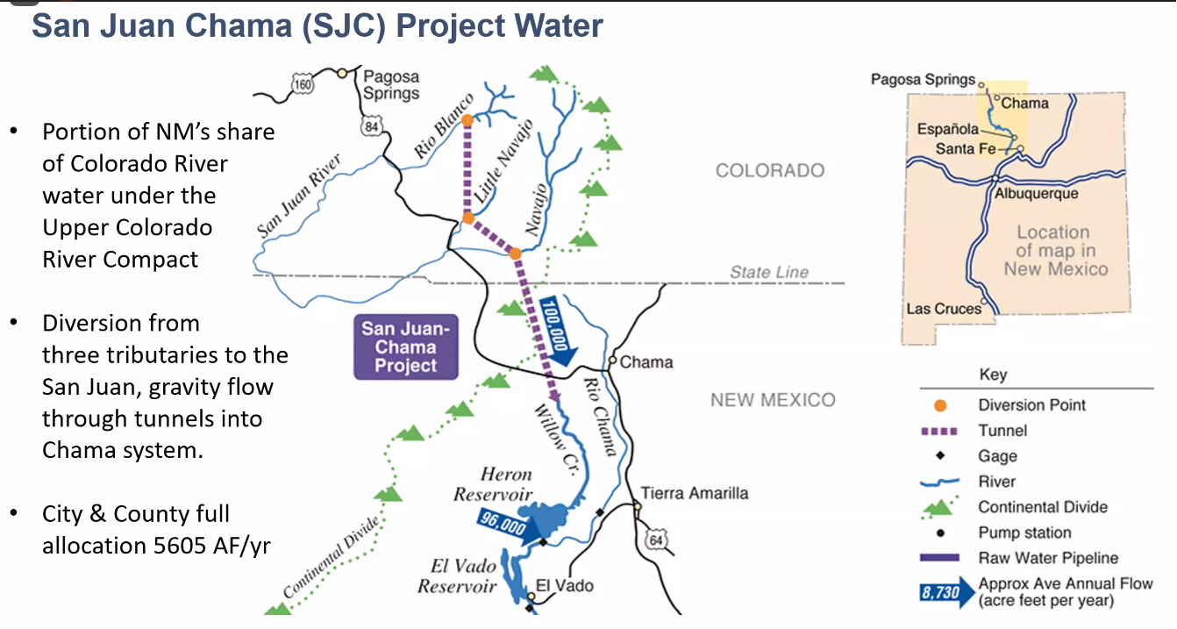
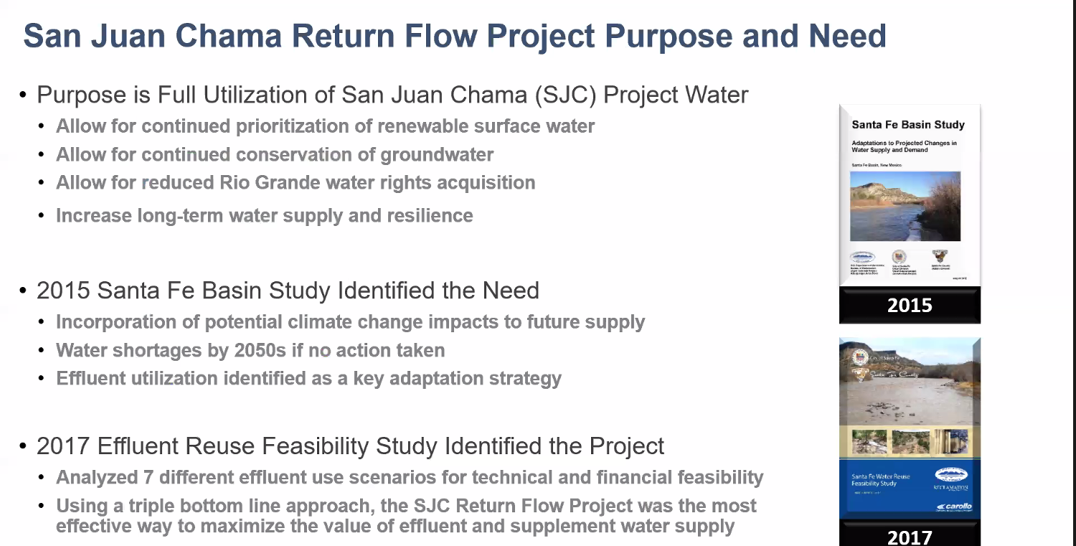
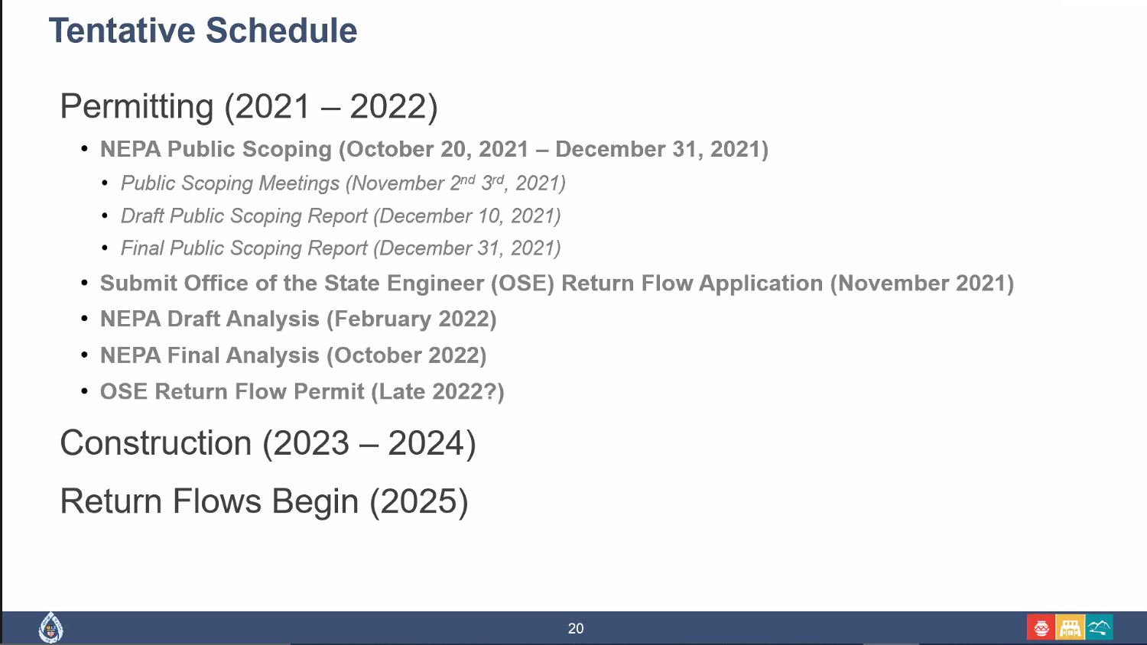
    - San Juan Chama Return Flow Pipeline Project
    - Santa Fe 2100*
  - Water and Growth
    - Water rights to offset added demand
    - Jesse definitely talks about this in the tours from Week 1
      - Potentially in LIV4-2021-10-18 10.09.14.mov Transcript
  - Conservation and Reuse
    - 5 year conservation plan (2020)

